Why Alternative Spring Breaks are a Great Idea
Alternative Spring Breaks have become increasingly popular over the past years, with college students heading off on volunteer or experiential learning trips instead of going to beaches for their mid-term week of freedom. Some Alternative breaks are run by the colleges themselves, are organized with funding and faculty supervision, or even offered as part of a credit-bearing class. Other Alternative break setups are student-driven, unaffiliated, and run by the students who are participating.
I’ve known students who have used their spring breaks to
- Volunteer with disaster relief and rebuilding efforts post-Katrina and after the Haitian Earthquake
- Work on Native American reservations for education and construction projects
- Visit and volunteer with organizations working on homelessness, gang prevention, or with at-risk youth in cities around the country
- Accomplish week-long intensive study of language or culture in other countries
Whatever the model, an Alternative Spring Break is a great idea. It’s a particularly good fit for students who place a high value on service learning and volunteering their time, and who want to pair those impulses with travel and/or augment what they can commit to while classes are in session.
Let the road trip begin!
I was involved in three spring break trips to the Arizona/Mexico border to work with a humanitarian aid organization. We held fund raisers, studied the issues ahead of time, and then packed up our parents’ cars to drive all the way to Tucson from Eugene, Oregon.
Those three spring breaks were the most meaningful and joyful of my college experience. I got to spend 24/7 with my friends and fellow students, while learning and working to make a difference.

How to Make Your Alternative Spring Break Go Well
If you plan to head out on a trip for your spring break, there’s quite a bit you can do beforehand to make it a better experience for everyone involved. Here are some thoughts to get you started:

1. Learn before you go
It’s tempting to assume that your enthusiasm and youthful energy are all you need to make you an effective volunteer for a week. Whether you’re planning to work in another culture or just another context, it’s a really good idea to prepare before you go. Just like preparing to study abroad, you should know about the organization you’ll be involved with, the culture you’ll be visiting, and ideally get some practice doing the kind of work you’ll be involved with.
If you’re going to be building, learn to swing a hammer. If you’ll be teaching kids English, learn some good vocabulary practicing exercises. If you’ll be talking with survivors of a natural disaster, learn about the event and get some advice on ways to respectfully engage with survivors of trauma.
Assume you’ll be trained when you arrive. But no matter where you’re going, you’ll have a better experience and be more effective assistance if you’ve done some prep work before you go.

2. Build Community With Your Group
If you’re about to spend 24/7 with a group of fellow students working outside your comfort zones you want to feel reasonably confident in each other before you go. Arrange several group meetings to discuss plans and also to begin to get a sense of who everyone is and how they’ll be during the spring break.
Develop a collective idea of what goals you have as a group and as individuals. It’s also smart to have some specific conversations about people’s strengths and weaknesses, and suss out who might need more support in certain circumstances, and who might make good leaders in others.
If you have the time and ability, I highly recommend that you have some kind of shared group experience before you go. If it serves to prepare/learn before you go, you get bonus points. If it’s just an exercise in getting to know and like one another, then that’s a good thing too.

Some examples:
- If you’ll be building houses, volunteer together with Habitat for Humanity for a day in your local town.
- If you’re traveling, find an event, film, or book that relates to where you’re going, and all attend/discuss together.
- If you could use a specific skill, such as language, medical skills, or sensitivity in talking with trauma survivors, invite a trainer to come and speak to your group.
- Go on a short travel experience together: hike, travel to an event, etc. Get out of your campus context and find out what your fellow travelers are like when they’re on the road.
- Hold a fund-raising party together. Ask for donations of items or money and get together with friends.
Traveling with others can be stressful in the best of circumstances. Get to know your fellow spring breakers, and begin to develop a sense of who you are as a community before you set off on your spring break. You’re more likely to have a successful trip if you do.

3. The Logistics
lan your trip. Really plan it. Know how you’re getting where you’re going, how much it will cost, who is paying for what, and what you’ll do in case of emergencies minor or major. If you’re organizing the trip, it’s a good idea to ask your fellow participants some tricky questions: do they have health insurance? Can they afford to pay you back for expenses incurred? Do drivers have good records?
A great travel experience is one in which things flow smoothly. Things rarely flow smoothly unless someone has taken the time to think through logistics ahead of time. Make sure you’ve given real thought to transportation, housing, food, and a few emergency scenarios.
Also, no matter how ‘not fun’ it feels, talk about money beforehand. Make sure everyone is on the same page about expenses. A spring break spent arguing about who’s paying for what or who forgot to book lodging for the last night of the trip… won’t be a good experience for anyone involved.

4. Record Your Experiences
If you’re a long-time reader, this advice will hold no surprise whatsoever. I think it’s a really good idea to write things down. Keep an outline list of your activities and projects each day. Journal to capture your emotional reactions. Take loads of photos. If you’re so inclined, do video and/or audio interviews of some of the people you meet.
Even if you don’t have a specific plan to produce something from your trip, it’s a great idea to record and capture both the specifics of what you did and the way these experiences made you feel. You’ll remember the trip in more detail, which means you’ll take those lessons with you as you move forward.

5. Produce Something
It’s a great idea to approach an Alternative Spring Break with a specific goal in mind. Beyond goals like “make a difference” and “have a good time,” plan to produce something in relation to the trip.
Plan to create a video, or a series of articles, or give a presentation for a student group to educate others about what you learned. Report back to anyone who helped fund your trip, whether that’s a university department, parent group, or the broader community. Get in touch with local groups who are interested in the kind of work you’ll engage with during your spring break, and find out what opportunities might be available upon your return. Be creative as you approach your departure date, and think about the ways that your trip can have implications outside your specific experience.

Some suggestions:
- Write an op-ed (or series) for your school newspaper
- Create a video, article, or photo series for your host organization to use in publicity materials or online
- Give presentations to student, community, or other interest groups
- Arrange to speak with high school students or prospective university students about your experience
Whatever the specifics, it’s a great idea to go with an idea for a project that will extend beyond the spring break itself. This will deepen your experience, and will also probably lead to more a more creative mindset while you’re there.
Most of all, plan to enjoy your spring break! I hope it’s a meaningful experience, and busy in all the right ways. Good luck to you!
This is from a blog called “My College Advice” http://www.mycollegeadvice.org/blog/alternative-spring-breaks
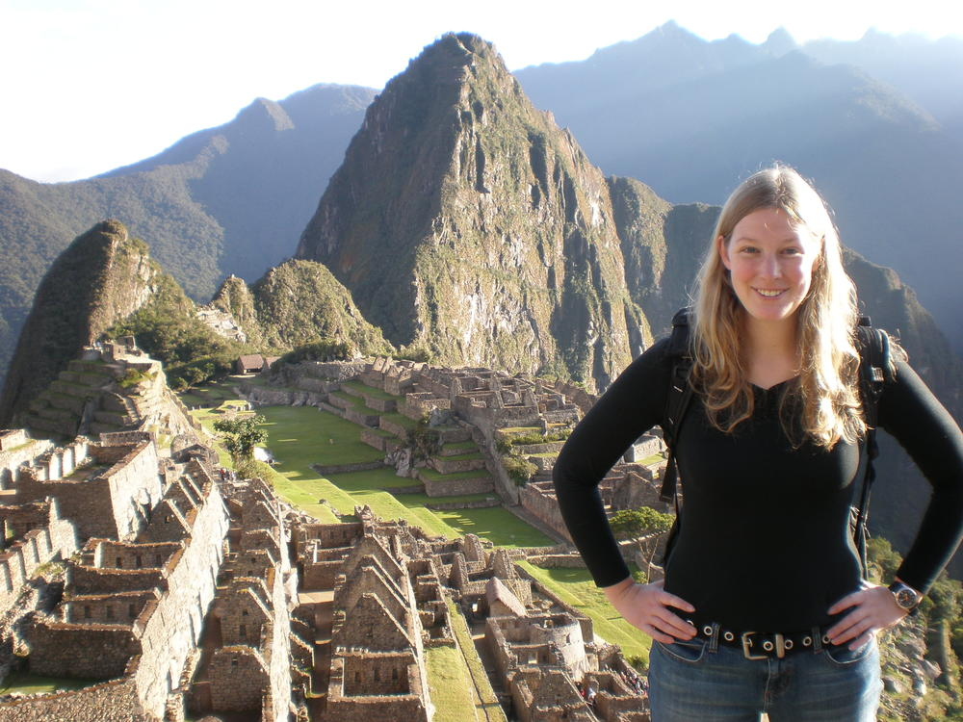
One of the happiest days of my life: at Machu Picchu at dawn, spring 2007.

Interests
When I started college, I left my hometown in the suburbs of Denver and went to school in a new city and state where I knew no one. Over the four years of my undergraduate experience I discovered true academic passions, made wonderful friends, and had my first of many experiences traveling the world. I have a broad range of passions, from academic interests in human rights and social justice to a whole set of non-academic pursuits, from attending concerts to bookbinding to rock climbing to creative writing.
I share a good amount of personal stories in this blog, so I hope you'll get to know me a bit as time goes on. I write about how important it was for me to first take to the road as an international traveler, and some of the very real challenges I faced as well. I use my life and experiences as an illustration of my advice. My experiences are unique to me, but the lessons learned apply to many in making the very best of college.

