Films for Global Engagement
These films were chosen for you on the basis of their themes and their high quality. They come from many diverse cultures and reflect many different value systems and ideas. Most focus on characters who are encountering people from different cultures or from different communities within the same culture trying to understand each other.

The list includes love stories, war stories, sports stories, comedies, dramas, and documentaries. Many involve journeys and coming-of-age stories. Some are pretty gritty, and many contain scenes of intense violence and/or sex, so do a little research and choose carefully according to what interests you and what you can manage. If you have one to suggest, let me know. The list will grow. Note: Most of the descriptions below are from the Netflix website, in most cases shamelessly stolen word for word (though on some I did a bit of editing and added a few comments). I can do this because I’m the teacher (and because I’m acknowledging the usage here).

Africa

Invictus (2009) This drama based on real-life events tells the story of what happened after the end of apartheid when newly elected President Nelson Mandela used the 1995 World Cup rugby matches to unite his people in South Africa. Morgan Freeman and Mat Damon star.
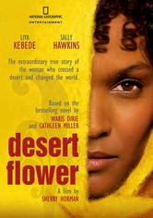 Desert Flower 2009R This drama tells the real-life story of Waris Dirie, a poor girl who flees an arranged marriage in Somalia, winds up in London and becomes one of the world's most recognizable supermodels -- who also speaks out against female “circumcism.” Film script based on a memoir written by a SJSU English professor.

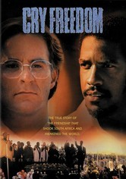 Cry Freedom In segregated 1970s South Africa, black nationalist Steven Biko (Denzel Washington) and white newspaper editor Donald Woods are unlikely friends with a common goal -- ending apartheid -- in this true story based on Woods's books Biko and Asking for Trouble. When Biko's beliefs lead him to prison and a deadly fate, Woods rallies to expose the injustice. Director Richard Attenborough's film earned Washington his first Oscar nod.
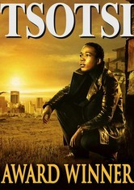 Tsotsi 2005R After shooting a woman and driving off in her car, a ruthless thug is surprised to discover he isn't alone, kept company by a crying infant in the backseat. But through his efforts to care for the baby, he slowly rediscovers his capacity to love. Academy award winner. (Set in South Africa)

Nowhere in Africa2001R Shortly before the outbreak of World War II, a Jewish couple and their young daughter emigrate from Germany to Kenya to escape the Nazis, and are forced to come to terms with a new life on an unfamiliar continent.
Lost Boys of Sudan2003UR As orphans living in the midst of civil war, Peter and Santino dealt with dangers like lion attacks and gunfire from militia. But even more daunting are the challenges they face in suburbia after they're chosen to start a new life in America. This award-winning documentary follows two Sudanese refugees throughout their intense journey from their native Africa to the US. Note: Some of them ended up in the Bay Area, and a few at SJSU.
The First Grader 2010PG-13 Based on a true story, this inspirational drama profiles the amazing determination of 84-year-old Kenyan Kimani N'gan'ga Maruge, a Mau Mau freedom fighter who wants to take advantage of a new universal education decree by learning how to read.

Out of Africa Hoping to forge a better life, Denmark native Karen Blixen (Meryl Streep) enters into a marriage of convenience with a womanizing baron. But when the couple moves to Nairobi, Karen falls in love with a free-spirited hunter (Robert Redford). Director Sydney Pollack's lush period drama earned seven Academy Awards, including statues for Best Picture, Best Screenplay and Best Cinematography.
Asia/ Pacific Islands
Lagaan 2001PG In 1890s India, an arrogant British commander challenges the harshly taxed residents of Champaner to a high-stakes cricket match. If the villagers win, they'll avoid taxation for three years; if they lose, they'll pay the tax thrice over.

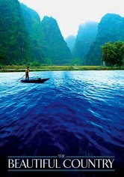 The Beautiful Country 2004R Looking to find a better life -- and his estranged American father -- a shy Vietnamese man in his 20s embarks on a personal journey with a beautiful young woman aboard a refugee ship bound for the United States.

Jodhaa Akbar 2008NR What begins as a strategic alliance of two cultures becomes a genuine opportunity for true love between a mighty Mughal emperor and a Hindu princess in director Ashutosh Gowariker's epic romance set in 16th-century India.
Asoka 2001R Based on the life of the Mauryan dynasty's Prince Asoka, this elaborate Bollywood epic dramatizes one man's transformation from a vengeful and cunning warrior into a legendary leader and teacher of Buddhism. After ruthlessly vanquishing a neighboring province, the guilt-ridden ruler (Shahrukh Khan) exiles himself and seeks redemption in this historical drama packed with battle scenes, political intrigue and a star-crossed romance.
Once Were Warriors Director Lee Tamahori's powerful adaptation of author Alan Duff's best-selling novel centers on the troubled life of a Maori family crippled by poverty, bigotry, alcoholism and domestic violence. Rena Owen stars as Beth Heke, a beleaguered mother who struggles to care for her three children while battling the demons of her erratic, often violent husband, Jake (Temuera Morrison). Warning: this one is really brutal. (New Zealand)

Not One Less Master Chinese filmmaker Zhang Yimou turns his lens on the travails of modern China's peasants. When teacher Gao (Gao Enman) leaves town for a month, 13-year old Wei (Wei Minzhi) is pressed into serving as his substitute at the school from which she just graduated. If she keeps her class intact, she will receive a bonus. But when a student leaves for the city, she follows and strives relentlessly to bring him back.
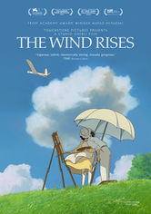 The Wind Rises (2013) Master animator Hayao Miyazaki spins a decades-spanning tale inspired by the life of Jirô Horikoshi, designer of the World War II fighter plane the Zero. Too nearsighted to become a pilot, Jirô settles for building planes, with spectacular results.

Eat Drink Man Woman Distracted by their complicated love lives and secret ambitions, three adult sisters reluctantly humor their widower father (Sihung Lung) by enduring the elaborate, traditional Taiwanese dinners he insists on having every Sunday. Ang Lee directs this charming tale that humorously examines the clash between modernity and tradition within the contemporary Taiwanese family.

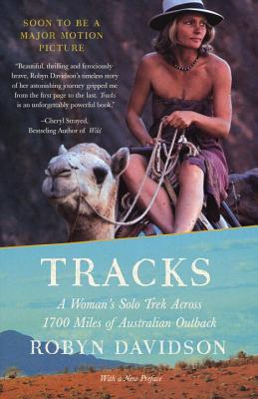Tracks: (2013) Australian drama film directed by John Curran and starring Mia Wasikowska and Adam Driver. It is an adaptation of Robyn Davidson's memoir of the same name, chronicling the author's nine-month journey on camels across the Australian desert.

Holly 2006R In this poignant drama, Holly (Thuy Nguyen), a young Vietnamese girl sold into prostitution by her family, tries to escape her dismal life by beginning a platonic relationship with a 40-year-old American named Patrick (Ron Livingston), a stolen-artifacts dealer. Twelve-year-old Holly has been smuggled into Cambodia, becoming one of countless children exploited in the sex trade; Patrick, who has his own troubles, may be her only hope.

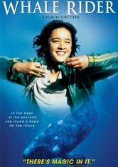 Whale Rider A Maori tribe must contend with the distinctly nontraditional concept of having a female leader when the intended heir to the throne dies during childbirth, leaving his twin sister, Paikea, to prove herself in this inspiring coming-of-age tale.

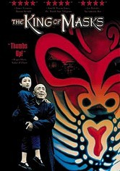 King of Masks Nearing the end of his life, Wang -- a locally renowned street performer and wizard of the venerable art of mask magic -- yearns to pass on his technique. But custom decrees that he can only hand down his craft to a male successor. Anxious to preserve his unique art, the heirless Wang buys an impoverished 8-year-old on the black market. But when the child divulges a dreaded secret, Wang faces a choice between filial love and societal tradition.

Europe

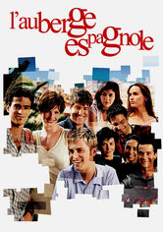 The Spanish Apartment When a French college student signs on to become an exchange student and learn Spanish so he can land a coveted job, he heads to Barcelona and moves in with a host of other young Europeans who help him discover how to enjoy life.
Girl in the Café (2005) Sometimes high-level international politics works—but only if there’s passion firing up the negotiators. After meeting a beautiful Scotswoman named Gina (Kelly Macdonald) in a London café, lonely civil servant Lawrence (Bill Nighy) asks her to join him at the G8 Summit in Iceland. The shy outsiders hit it off, but their attraction is tested when Gina's personal convictions contradict Lawrence's professional duties. But someone has to speak truth to power. (UK / Iceland)
Wondrous Oblivion 2006PG When his new Jamaican neighbor, Dennis Samuels, offers to coach cricket-mad adolescent David Wiseman, the gesture sparks racial hostility in this coming-of-age tale set in 1960 London. David -- who lacks the skills to play the game -- eventually earns a spot on his school's cricket squad thanks to Dennis and learns a few lessons about bigotry in the process. Emily Woof and Stanley Townsend play David's parents.

Dirty Pretty Things 2002R Undocumented immigrants Okwe and Senay work at a posh London hotel and live in constant fear of deportation. One night, Okwe stumbles across evidence of a bizarre murder, setting off a series of events that could lead to disaster -- or freedom.
Brick Lane 2007PG-13 Set in the 1980s, this cross-cultural drama follows young Nazneem (Tannishtha Chatterjee), a Bangladeshi woman who's immigrated to London for an arranged marriage to a middle-aged man, leaving her beloved family, including her sister Hasina, behind. While Hasina leads a life of adventure back home, Nazneem struggles to accept the isolation and unhappiness in her new life, until an unexpected visitor comes along and changes everything.

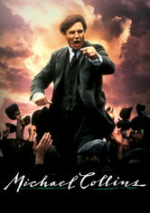 Michael Collins Neil Jordan directed this powerful biopic about the rise and fall of Michael Collins (Liam Neeson), the charismatic leader of Ireland's fight for independence. Collins and his companions de Valera (Alan Rickman), Broy (Stephen Rea), Boland (Aidan Quinn) and Kitty Kiernan (Julia Roberts) used guerilla warfare to attack the British empire, with historic results.
Before Sunrise This intoxicating film from director Richard Linklater stars Ethan Hawke as an American backpacker who strikes up a conversation with a lovely fellow traveler (Julie Delpy) on the train to Vienna and persuades her to spend his last day in Europe with him. Wandering the picturesque streets of the Austrian capital, the two share stories of their pasts and their dreams for the future, ultimately forging a bond that leads to love.
The Edukators Peter (Stipe Erceg), Jan (Daniel Brühl) and Jule (Julia Jentsch) -- a trio of anticapitalist radicals who call themselves the Edukators -- rankle Germany's elite by breaking into mansions, rearranging the possessions and leaving menacing messages that warn of an impending class war. But when Jule leaves her cell phone behind and they return to the scene to retrieve it, an unexpected visitor forces them to improvise.
North America

Smoke Signals On a Coeur d'Alene, Idaho, reservation, nothing ever changes -- until the estranged father of Victor Joseph (Adam Beach) bites the dust in Arizona, and Victor must go collect the cremated remains. The problem is, Victor can't afford the fare. But annoying nerd Thomas Builds-the-Fire (Evan Adams) will float Victor a loan ... if Thomas can tag along. This tender tale of self-discovery is based on acclaimed author Sherman Alexie's short stories.

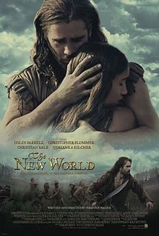 The New World 2005PG-13 Set in 1607 at the founding of the Jamestown Settlement, Terrence Malick's epic adventure chronicles the extraordinary actions of explorer John Smith (Colin Farrell) and Native American princess Pocahontas (Q'Orianka Kilcher).

The Visitor Disillusioned and burned-out economics professor Walter Vale finds himself drawn to a different rhythm when he discovers an immigrant couple (one from Senegal, one from Syria) squatting in his Manhattan apartment and becomes wrapped up in their lives.

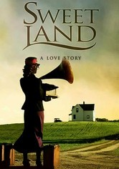 Sweet Land 2005PG Norwegian-American farmer Olaf Torvik and his rural Minnesota community must struggle to overcome years of anti-German propaganda and prejudice when he discovers that his mail-order bride, Inge, is not only a German but also a Socialist. A gorgeous film with both drama and comedy. Stars Tim Gunee and Elizabeth Reaser from Grey’s Anatomy.

Thousand Pieces of Gold In the late 19th century, Lalu (Rosalind Chao), a poor Chinese woman, is sold into marriage in America. She's sent to a tough Idaho mining town -- not to marry, but to work as a prostitute in a saloon run by fellow countryman Hong King. When Lalu refuses the job, her dignity proves irresistible to King's partner, Charlie. Based on a true story.

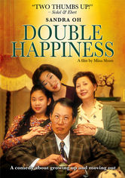 Double Happiness Old-fashioned values collide with the whims of youth in this modern romantic comedy about a dutiful Chinese-Canadian daughter who wants to please her parents without sacrificing part of herself when it comes to love. Deep down, Jade (Sandra Oh) knows her mother and father won't approve of her new boyfriend, a white college student named Mark (Callum Keith Rennie). But that doesn't stop her from hoping for "double happiness." The other plot line involves Jade’s ambition to be a “serious” actress, not a clerk in a dress shop—another desire her parents disapprove of.
South and Central America

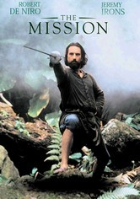 The Mission In the 18th century, a Jesuit missionary establishes a church in the hostile jungles of Brazil, but finds his work converting the indigenous Indians threatened by his superiors. Meanwhile, a slave hunter converts and joins the Father on his mission. Gorgeous film, great music, multiple award-winner, stars Robert De Niro, Jeremy Irons, Aidan Quinn.
The Motorcycle Diaries2004 R This foreign-language drama tells the incredible true story of a 23-year-old medical student from Argentina -- future revolutionary Che Guevara (Gael Garcia Bernal) -- who motorcycled across South America with his friend Alberto Granado beginning in 1951. Walter Salles's film is based on Guevara's diaries of the trek, a deeply personal odyssey that ultimately crystallized the young man's budding political beliefs.
Waste Land (2010) Renowned artist Vik Muniz embarks on one of the most inspired collaborations of his career, joining creative forces with Brazilian garbage pickers who mine treasure from the trash heaps of Rio de Janeiro's Jardim Gramacho landfill. (Brazil)

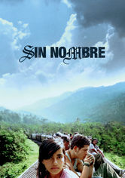Sin Nombre2009R Fleeing retaliation from the violent Central American street gang he's deserted, a young hood boards a northbound train, where he takes refuge atop the moving freight cars and hopes for a fresh start in a new country. The other story line features a beautiful young girl he meets while riding the freight train, who is trying to reach relatives in the US.
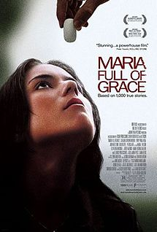Maria Full of Grace2004 R Maria Alvarez is a smart, independent 17-year-old from Colombia who agrees to smuggle a half-kilo of heroin into the United States for a shot at a normal existence in "El Norte" -- where she imagines the city streets are paved with gold.

