Critical thinking, Creativity: The Skills Workers Really Need

Rachel Burstein Sunday, August 31, 2014
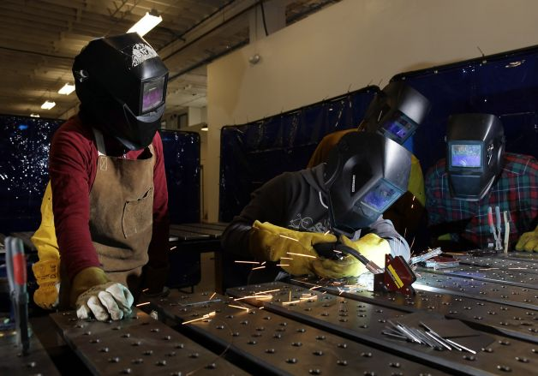
Pundits promote the learning of skills, such as welding, to address America's skills gap. The bigger need is for thinking. Photo: Carlos Avila Gonzalez, The Chronicle

Labor Day offers an opportunity for politicians and economists to offer their two cents on the state of labor. It's a good bet that some of that commentary will focus on the "skills gap" - the notion that millions of jobs in highly technical fields remain unfilled while millions of Americans without those skills remain unemployed.
The solution, according to the pundits? Education and training that focus on technical skills like computer engineering, or on crucial but scarce skills like welding. Match these newly trained employees with open jobs that require those skills and, voila, the skills gap is gone - and the labor market is steadied.
If only it were so simple.
Yes, more American workers need to learn skills that are underrepresented in the labor market. And yes, those technology titans who advocate for more challenging school curricula, for greater funding for science and engineering education, and for immigration reforms to bring in more skilled workers are responding to a real problem. But that's not all there is to it. The problem with the skills gap argument is that it accounts for only one set of skills that employers consider important.
I work at Books@Work, a nonprofit organization that brings university professors to the workplace to lead literature seminars with employees. The employers with whom we work want to provide professional development opportunities for all members of their organizations, and - we like to think - are more creative in their approach to doing so than most. Yet even this group of employers has few ways of helping their employees to develop skills that aren't about content or subject matter - skills like communication, critical thinking, creativity, empathy and understanding of diversity.
Such skills cut across sector, hierarchy and function - and are, according to employers, crucial to the success of their companies. According to research conducted by the Association of American Colleges and Universities, 93 percent of business and nonprofit leaders surveyed consider critical thinking and communication skills to be more important than a person's undergraduate major when it comes to hiring.
That's bad news because, while many public programs try to bridge gaps in the knowledge of future workers, there are few programs to address the gap in skills that are more difficult to measure, like creativity and critical thinking. My colleagues and I often hear from hiring managers who are hungry for programs that will encourage their employees (at all levels of the organization) to think more creatively, communicate more effectively and become more adept at reacting to changing circumstances.
The gap in these "soft" skills is very real. Professionalism/work ethic, teamwork/collaboration and oral communication rank among the top five skills valued by employers hiring candidates at any educational level, according to one study. Yet employers rank significant portions of those entering the workforce deficient on all these dimensions. The problem is particularly acute among those without a college degree. Employers rate those entering the workforce with a high school degree deficient in professionalism/work ethic, critical thinking/problem solving and oral communication. Meanwhile, employers do not regard a majority of college graduates deficient in any of these areas.
The introduction at the K-12 level of the Common Core State Standards, which are supposed to emphasize critical thinking and problem solving, may produce changes in these figures in the years to come. But for now, those without access to a university education - and even some workers with college degrees - enter the workforce lacking the interpersonal, reasoning and thinking skills necessary for success. Unlike direct knowledge areas - like computer basics - that can be taught through employer training sessions, there is no set curriculum for critical thinking or applied reasoning.
There is no silver bullet for addressing this gap, though our approach at Books@Work - having employees read literature and reflect on it - is one example of an attempt to disseminate some of the benefits of a liberal-arts education beyond the confines of the traditional university setting. We need many more such efforts. In discussing "Macbeth" or "Frankenstein," workers explore complex (and timeless) interpersonal dynamics - an opportunity that a training on the latest operating system or a review of safety regulations are unlikely to provide.
We've found that reading literature with colleagues can offer a new perspective on the practice of work itself, leading to greater professionalism and new ways of doing things. Themes of empathy in a powerful novella by May Sarton, "As We Are Now," which is about a woman in a terrible nursing home, led workers in one hospitality company to reconsider their approach toward customers, resulting in a renewed awareness of customer needs and expectations.
A conversation about the racial tension in the postwar Northwest in David Guterson's "Snow Falling on Cedars" became a platform to discuss personal integration issues in a company growing rapidly through acquisition and organizational acculturation.
Programs like Books@Work are not an adequate substitute for public policy solutions to the gap in thinking and interpersonal skills. We do not address disparities in such skills among job applicants - only among those who are hired. And they place the burden for addressing the problem squarely on employers. But programs that address the significant divide in soft skills are a first step toward realizing that solving the skills gap requires more than teaching kids to code, retraining the unemployed as welders or encouraging college dropouts to complete technical degrees.
We all need to continue to improve the most important skill of them all - our thinking.
Rachel Burstein, Ph.D., is academic director at Books@Work. She wrote this for Zócalo Public Square. www.zocalopublicsquare.org
http://www.sfgate.com/opinion/openforum/article/Critical-thinking-creativity-the-skills-workers-5725682.php
my_self Rank 4022
Common core will not create critical thinkers as long as the goal is have perfect scores at young ages (pre-7 years old). The lack of play, and continual hovering of parents creates adults that do not know how to think for themselves or solve real world problems. The creative thinking process is not going to be taught in the classroom, through common core. You get creative when there isn't anyone around to solve your problems and you have an abundance of free time to think and play. I bet Finland is laughing up a storm at common core. 21 hours ago 1 Like
*******************************
LongerView Rank 1537
I hold the uncommon degree in Geological Sciences which I earned at the University of California at Santa Barbara. At the time the faculty of the Department of Geological Sciences was unique for several reasons including having five faculty that were members of the National Academy of Sciences, and a complete dedication and focus on providing undergraduates with the very skills now sought after by corporations - team work in completing projects in the field and laboratory; the capacity to think creatively especially under the rigors of the field environment, thinking in four dimensions about geological problems usually observable in two dimensions; working in the field using the Method of Multiple Working Hypotheses [See: http://www.gly.uga.edu/railsback/railsback_chamberlin.html]; extensive critical reading of the literature; and writing all manner and types of reports.
This is not to suggest that youth should rush to enroll in programs to obtain a degree in Geology, rather to point out that many of the skills now required in corporate environments have endured for decades in one academic domain. I wonder what other domains have historically provided the skill set that has benefited me and generations of Geologists, whether they become professionally engaged in Geological work or any other type of work in a corporate environment. 2 days ago 2 Likes
******************************* Comments from Readers**************************
rplantz Rank 7224
I spent the first half of my career working as an engineer (electronic and computer software) and the second half teaching computer science (university level). Good engineering is almost entirely about creativity and critical thinking. I've also had tradespeople do work for me at my house. The good ones have most definitely shown creativity and critical thinking in their solutions to the problems.
As BigSquash points out, most (if not all) the problems I had in my design work came from people who were ill equipped to define what they wanted in logical terms. My main job was to tease out the technical requirements from these very general, and often rambling, descriptions provided to me. That most certainly required good communication skills and critical thinking. Engineering (design) is inherently a creative process.
From my dealings with non-technical people, I have not found them to be any better at these skills. For a good example, listen to almost any political speech. (Well, many are pretty good at creativity!) 2 days ago 3 Likes
*******************************
BigSquash Rank 201
In order to program computers it is necessary to apply critical thinking, plan ahead, and reason very carefully. Programming IS problem solving.
A very real problem for programmers is the ill thought out requests of non-programmers who define their desired program in very general terms and frequently fail to consider the interrelationships between the goals of their requests. 2 days ago 3 Likes

