Amber Kane Textile designer, creativity educator, stellar dreaming, and animal lover, striving to change the face of education through innovation.

Why Right Brain Thinkers Will Rule the World
Posted: 07/31/2015 11:01 am EDT Updated: 07/31/2015 11:59 am EDT
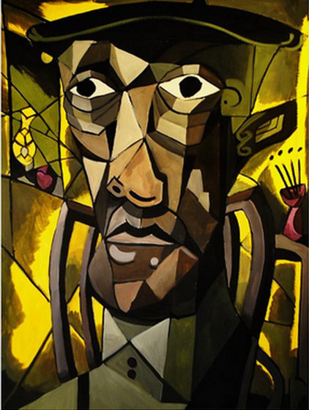
Artwork by former AP Art Student
When I first sat down at the loom, after a few years away, I was excited to create, but didn't trust my own voice or vision, I felt like I had to follow a pattern, and a put a check after each step on the very long list of weaving directions. I thought that I had to count all of the ends (yes most weavers know exactly how many strands of yarn are in a piece... I’m not one of them)
It didn't work.
There were endless knots, lots of holes, and it was taking forever. Nothing was working, making me want to give up.
But there was a voice inside of my head that told me to keep going. Plus I'd just purchased a loom and felt a deep need to justify this purchase. So I did what anyone does when they have no clue what they're doing.... I googled it. With the books title entered into the google search bar, I soon realized, that there was nothing wrong with me. Instead the book was on recall for missing pages, no wonder nothing was working.
I’m assuming that if there had been a logical person in the room, they would have recommended simply trying a different weaving book. However, there wasn't a logical person in the room. My creative brain seemed to take this as a sign that it was finally free to design and off I went.
In that moment, I remembered that I don't find joy in following directions, or doing something predictable. I didn't just want to weave something, I wanted to create. And that's where the right brain comes in.
So why will right brain thinkers rule the world?
Because most right brain/ creative activities and tasks are extremely hard to automate. Creative ideas and problem solving comes uniquely to each individual and the experiences that they carry. Everything else can be sent overseas to be done by someone else, who will work for less, or can be automated and done by a computer. You want to be the one in the room that can't be replaced by a set of step by step instructions.
"Creative individuals are remarkable for their ability to adapt to almost any situation and to make do with whatever is at hand to reach their goals. If nothing else, this distinguishes them from the rest of us." Mihaly Sikszentmihalyi
Do you want to be irreplaceable?
Then you need to work on strengthening your ability to produce and execute your ideas. You need to understand how to uncover your personal voice and vision.
You have a choice.You can choose to blend in and be replaced by technology. Or stand out, and be irreplaceable.
Now , if you already view yourself as a right brain thinker, you're probably ready to celebrate, but, not so fast. According to author Daniel Pink there are 6 areas that are going to help right brainers rule the world , and most of us could use some improvement in at least one of two of the areas, they are:
Sympathy: the ability to see the big picture and connect the dots. ( Drawing can help you with this one)
Daniel Goleman writes about a study of executives at fifteen large companies: Just one cognitive ability distinguished star performers from average: pattern recognition, the big picture thinking that allows leaders to pick out the meaningful trends from a wealth of information around them and to think strategically far into the future.
Meaning : people don't just want things anymore, they want their to be a meaning/ purpose behind what they buy.
Empathy: the ability to understand those around you, what they feel, why they do what they do.
Design : the ability to create something that is engaging, beautiful, and functional
Paola Antonelli,Italian author, editor, and curator, said that "good design is a renaissance attitude that combines technology, cognitive science, human need, and beauty to produce something that the world didn't know it was missing."
Play: the ability to laugh, have fun, not always take things seriously
Story: people no longer just wants facts, they want a story, something that they can connect with.
Are you ready to rule the world? Let's get started. Click here for a design challenge.
http://www.huffingtonpost.com/amber-kane-/why-right-brain-thinkers-will-rule-the-world_b_7907856.html

