Why young people are key to tackling climate change

It is essential to minimise the effects of climate change to safeguard future generations. Fortunately, young people today are also leading the wave of innovation and campaigning to fight climate change, says Ahmad Alhendawi.
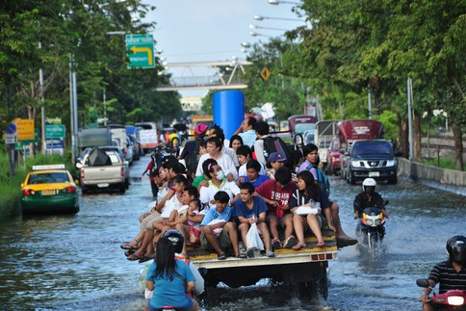
Not only will young people bear the brunt of climate change in coming years, their innovation, creativity and political action are an integral part of the solution as well. baitong333 / Shutterstock.com
By Ahmad Alhendawi
Tuesday 15 July 2014
“Inheritance” is a word often used when it comes to our responsibility to take care of the planet, but I don’t think it’s the right one. After all, when you inherit something, it’s yours to do as you like with. I prefer to say that we are “borrowing” the earth, from future generations; when you borrow something, you have to hand it back in good condition.
After all, it is today’s young generations who will pay the price if we neglect our duty to minimize the effects of climate change – and we will not go far in fulfilling that responsibility unless we engage young people in a meaningful way. Fortunately there is evidence that, around the world, young people are taking the lead.
Take the Bahamas, for example. After hurricanes devastated the sand dunes in 2005, students at Hope Town Primary School mobilized the community to plant sea oats, a kind of dune grass. When the next extreme hurricanes hit, in 2011, the roots held the dunes in place. The students were part of the Sandwatch programme, which helps schoolchildren in more than 50 countries monitor the state of their local beaches.
Such efforts to adapt to extreme weather events will become increasingly important in the near future as the effects of already-released greenhouse gases play out. However, just as important is finding innovative ways to mitigate further emissions. In Barbados, for example, students at Lester Vaughan Secondary School have made more than 3,000 litres of biodiesel by collecting used vegetable oil from around their communities. This greener approach to powering vehicles has the added advantage of preventing oil waste from damaging the environment.
The creativity of young people is invaluable in the search for innovative solutions to climate change. In Ghana, an award-winning project to make bicycle frames from bamboo instead of steel is reducing CO2 emissions and restoring local forests. These and many other encouraging examples are featured in a report by the United Nations, Youth in action on climate change: inspirations from around the world.
In addition to being natural innovators, young people are consumers (putting pressure on businesses to act responsibly) and they are also voters, with the power to make politicians pay attention.
Their role as global citizens will be especially important in the run-up to the UN secretary-general’s Climate Summit in September 2014. As the United Nations Framework Convention on Climate Change continues its push for a legally binding agreement by 2015, the volunteer group Youth Climate Action is organizing a month of high-pressure campaigning, to ensure that leaders arrive in New York already feeling the urgency to take action.
In support of this campaign, the World Economic Forum’s community of Global Shapers – young leaders and social entrepreneurs (aged 20-30) from around the world – are planning to present decision-makers with examples of local initiatives that could be replicated or scaled up to help achieve a better climate future. (I am serving on the jury of this challenge, called ClimateSHAPE; the winners will be announced in September, ahead of the Climate Summit.)
Above all, the message we need to relay to leaders in the run-up to the summit is that the time for blame games has passed. As UN Secretary-General Ban Ki Moon says, “there can be no Plan B, because there is no planet B”. We have to focus on what we can do now to protect the only earth we have.
Ahmad Alhendawi is the United Nations secretary-general’s envoy on youth. This post originally appeared on the World Economic Forum blog.
http://www.eco-business.com/opinion/why-young-people-are-key-tackling-climate-change/

