Samples of Profiles from the Press

Capitalist Crusaders
By JEFFRIES BLACKERBY December 5, 2010, 13 Comments
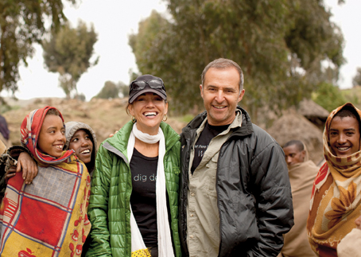
Esther HavensFIELD AGENTS Donna and Philip Berber with residents of the Ambaras community in the Simien Mountains of Ethiopia.
Eleven years ago, Donna and Philip Berber had a Texas-size life — a booming tech company in Austin (Cybercorp), three sons and, “you know, flowers in my garden,” says Donna, who started A Glimmer of Hope, a foundation to help the rural poor in Ethiopia. Then, after seeing a video of his wife handing out bread to the hungry in Addis Ababa, Philip made a trip there himself and decided to “turn my back on my commercial career.” With $60 million from the recent sale of Cybercorp to Charles Schwab (for $488 million), he joined the foundation full time, and the couple (he’s Irish, she’s English) became pioneers of philanthro-capitalism. The Berbers’ endowment covers all of Glimmer’s operating costs, which has allowed the foundation to spend $40 million and counting to help alleviate poverty in Ethiopia. “One hundred percent of the money, not 50 or 80 percent, needed to get to the people,” says Philip, comparing Glimmer’s business model with that of other charities. “We had to start with a clean piece of paper.”
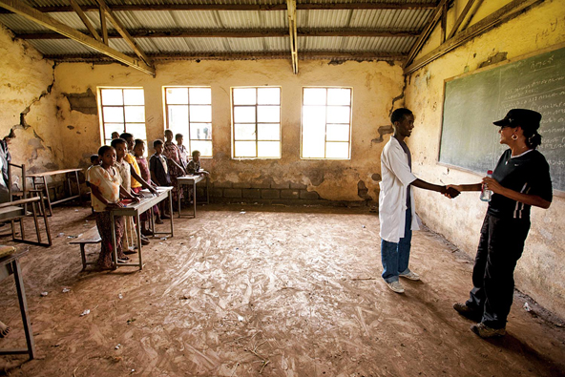
A Glimmer of Hope Donna with schoolchildren in the village of Robit.
Their first project was a school in the town of Dembi Dolo, and since then, they’ve built 3,500 water and sanitation facilities, 190 health clinics and 53 vet clinics; completed 400 education projects; and, through the Clinton Global Initiative, given $2.4 million in microloans. We don’t leave a village until all those structures are up and running,” says Donna, adding that there’s more to measuring success than money. “ There is the human part of it as well: engaged philanthropy. What does it mean to give in a way that doesn’t make the giver feel hollow? We had to overcome the skepticism that constantly shrouds the giving world and show that there is another way, that there is emotional philanthropy alongside structured philanthropy.” Says Philip, “For us, it was important to be engaged, and it was important for our children to be engaged.”
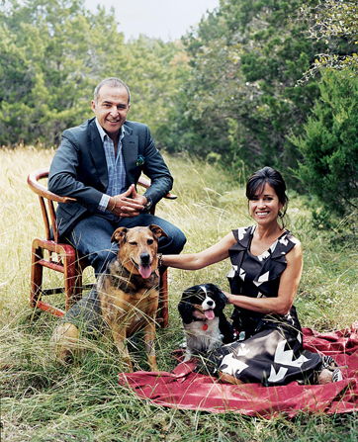
Photograph by Susanna Howe. Fashion Editor: Ethel Park. Fashion Assistant: Adam Ballheim. Hair by Shin Arima. Makeup by Carla Palmer. The Berbers athome in Austin, Tex., this year. On Philip: Tom Ford jacket (sold as suit), $3,450, and shirt, $520. A.P.C. jeans, $165. Hermès pocket square, $130. On Donna: Oscar de la Renta dress, $1,890. Manolo Blahnik shoes, $785. Pomellato earrings, $6,000.

What They Gave This Year With $1 million raised at A Glimmer of Hope’s first public fund-raiser, the foundation provided nearly 13,000 people in the Ethiopian villages of Burbax and Girargie with 30 wells, a rainwater harvesting system, six schools and two health clinics. It is also financing microloans for 365 people.
What They’ll Give Next Year For the village of Robit, population 11,000, Glimmer will build a health center for $170,500, three schools for $550,000 and a library for $50,000; it will also finance $226,000 in water projects and $90,000 in microloans.
http://tmagazine.blogs.nytimes.com/2010/12/05/capitalist-crusaders/
******************************************************************************

Student faces her 'worst case scenario'
by Leeta-Rose Ballester Sep 15, 2013

Hitting the gym early in the morning and then heading to work or class is nothing out of the ordinary for college students, but for sophomore advertising major LooLoo Amante, she worried about what she would do once night fell these first weeks of school.
“I had mentally prepared myself to sleep in my car,” Amante said. “I was trying to accept the fact that this was what I was going to have to do.”
Amante said she lived in Campus Village Building C her freshman year, but she had taken out a loan to pay for it. Since she moved out of campus housing this May, Amante said that a series of events led to her “worst case scenario.”
Toward the end of Spring semester, Amante said she had applied for a job with University Housing Services thinking that her housing situation would be settled for fall. When she didn't get the job she said she wasn't too worried because she had more than one backup plan. Amante said that she considered getting another loan for housing but “uncertainty” held her back.
“When we grow up with financial barriers, we don’t just second guess, we third guess," she said.
Plan of Action
She said she was determined to find a way to graduate without more debt and decided to try any alternative solutions. Amante said she looked into an opportunity to be hosted by a family for the semester, but at the last minute they were not able to accommodate her. She said that when she checked out the Student Union bulletin board for a room to rent, “things had changed" from the last time she had looked.
“It was all other people looking for rooms, too,” Amante said.
She said that her budget is limited, though she works on campus through the work-study program. “To even pay $300 would be hard,” Amante said.
Being a university athlete, Amante said she tried getting into shared housing with other athletes, but that didn't work out either. She said that one after another, her plans fell through and she was down to the last choice.
“Like a report card, plan F is the worst you can get,” she said. “That plan went into action.”
Amante said she took all the money she had been saving and bought a low-profile car that would work well as a home.“I had to strategize,” she said. “I bought a car with tinted windows.”
Stigma
On nights that Amante couldn't stay with friends, she said she would cover herself up completely with a blanket and avoid parking near campus where people she knew might see her. “I was conflicted about what people might think of me,” Amante said. “There’s always going to be judgment.”
Amante said she didn't feel like she could tell anyone she was sleeping in her car, not even most of her friends or classmates. “If they asked where I lived, the immediate reaction was, ‘That’s so dangerous,’ so I changed my answer," she said. "I would just tell them that I live off campus."
Amante said she was lucky not to have had any scary incidents, but she has accumulated "a lot of parking tickets" for parking too long in one spot.
She said her biggest concerns were not about safety, but where to brush her teeth or if she should skip breakfast and save money by just having a big lunch.
Amante said that she still has not told most of her family, in part, because she grew up having to be very self-reliant. “I feel like it would be a burden on them,” she said. “They would be so frustrated with me.” She said she questioned if she had “did this” to herself and came to a breaking point where she knew she had to get help.
Seeking Help
“I have finally come to terms and told an adult,” she said. “I didn't want to tell anybody … I thought I could figure it out myself.”
Amante said she told her Educational Opportunity Program counselor and they immediately helped her, and not just with resources, such as where to call for help with food and shelter. “The counselor was telling me I shouldn't blame myself,” she said. “It made me feel so relieved.”
Tova Feldmanstern, licensed clinical social worker at SJSU, said she has worked with about half a dozen students who were either sleeping in cars or shelters, or in danger of becoming homeless since she began working at the university one year ago.
“I’m guessing that it’s a much larger problem,” she said, “but a lot of people don’t find their way to Counseling Services.”
Feldmanstern said that the best thing students could do if they have nowhere to live is to start at a shelter like the Emergency Housing Consortium, Bill Wilson Center or InnVision to see what resources are available. “The more persistent you are, the more wait lists you can get on,” she said.
According to Feldmanstern, “the county is strapped” and most shelters are full each night, but Counseling Services is there to help guide students through the process of getting into one.“Sometimes students are stuck and I try to be there as a support person,” she said, adding that she has helped students fill out applications for transitional housing programs. Feldmanstern said that people often don't realize what other students on campus may be going through.
Homeless Youth
The 2013 San Jose Homeless Census and Survey reports that 25 percent of the homeless population surveyed were between the ages of 18 and 24, nearly doubling from 13 percent in 2011.
According to Lynn Morison, policy director for ending youth and family homelessness at the Bill Wilson Center, her organization helped collect data for the 2013 Homeless Census and she was “struck” by the increase of young adults. Morison works specifically with 18 to 24-year-olds at the Bill Wilson Center. She said she worries because youth are “much more vulnerable” to violence and street crime. She said that most of her clients come from a “troubled background” but there are new patterns emerging.
“Another trend we have seen more is youth leaving home so they are not a burden to their family,” Morison said. “It’s been an issue where it is so expensive to live in (Santa Clara Valley and) that has been exacerbated by the recession.”
She said that she understands how college students facing homelessness might feel out of place among their peers.“For those youth that find themselves homeless, who are surrounded by those who aren't, it can carry a stigma,” she explained.
Morison said that young people often don’t identify with the description of homeless and would rather call it something else. “Many of the youth often don’t relate to the term homeless because of the stereotypes,” she said. “They often have the same stereotypes we have.”
Hope
Amante said she is on a waiting list for transitional housing now and staying with a friend until she is placed. She said she knows the lists can be long, but she is remaining patient because she wants to focus on her college experience. Amante said she wants to be able to go to work, get her homework done and hang out with friends without worrying about housing.
“Since I was very young, I've done things on my own,” she said. “There’s a lot of mixed emotions and it’s overwhelming.” She said she can’t worry anymore about what people think and that she has to take care of herself. “There’s always going to be that person who doesn't understand and asks, ‘Why didn't you just go get a loan?’” Amante said. “I've learned to accept my situation.”
- See more at: http://spartandaily.com/108019/student-faces-worst-case-scenario#sthash.stSsAA2q.dpuf
******************************************************************************
Students’ journey takes them from Sudan to Bay Area

By Teresa Hou Spartan Daily Staff Writer

From the outside, Bol Bol, Mach Gong and Peter Thon may seem like any other San Jose State University students. They attend classes, have jobs and complain about campus parking. However, that is where the similarities end.
When they were about 8 or 9 years old, Bol, Gong, and Thon were forced to leave their families and the other members of their Dinka tribe behind when civil war broke out in their native country of Sudan.
“We left in 1997 and moved to Ethiopia for four years,” said Thon, a finance major.
“After that, war broke out in Ethiopia and we had to come back to Sudan where it wasn’t safe because the war was still going on (and) so we crossed the border to Kenya. We stayed in Kenya for nine years in a refugee camp where we went to school until 2000 when the United States government began to send the ‘lost boys’ to (America).”
According to the Red Cross Web site, “The Lost Boys of Sudan” is a name given by aid organizations to a group of 26,000 Sudanese boys like Bol, Gong and Thon who fled their southern Sudan villages as a civil war broke out between the predominantly Muslim north and the Christian south.
The lost boys walked hundreds of miles in search of peace and finally found it in the Kenyan refugee camp where they stayed for nine years until the U.S. government brought 3,600 of them to the United States, according to the Red Cross.
In 2001, Bol, Gong and Thon came from Kenya to the United States through sponsorships from the United States government and the Catholic Charity of Santa Clara. The United States, however, was nothing like what they expected.
“When I left Kenya, I thought (the United States) would be real cool,” said Bol, a marketing major. “But when I came here, I was worried about where to sleep (so) I went out to look for a job so that I (could have a) place to live. It (was) real hard.”
Gong, an international business major, agreed.
“Coming here, our No.1 goal was school,” Gong said. “But when we got here, school became second because we had to find a job and support one another. You have to work a lot of hours to make some money and then send some money to your family and basically start a whole new life.”
However, with the people they befriended in San Jose, especially American families, said Gong, life in the U.S. has become easier for Bol, Gong and Thon, who fondly says his new friends are a part of his “big African family.”
“I think our life would have been hard if we didn’t have many friends,” said Thon, “Now that we are established here, everything’s fine except that we have people back home in Africa.”
Bol said that he works 30 to 32 hours a week to help support other lost boys who don’t have a chance to come to America. Bol, Gong and Thon said that even though they are in America, they still have to help provide for the people back home.
“We work hard for (the) people in (Sudan), said Bol. “We work and we go to school to help any way we can.”
In the future, Bol, Gong and Thon all agree that once they get their degrees from SJSU they plan to go back to southern Sudan to help restore their country.
“We appreciate … the United States government and (our) American friends who helped us when we first came to this country,” said Gong.“ We have been helped and therefore we should help too. The only way that we can help is for us to get some skills here (and) to go back and rebuild the country.”
Although America has treated them well, Bol, Gong and Thon said they have no desire to stay any longer than necessary.
“America is a good place to be, but there is nothing like home,” Gong said.
http://files.thespartandaily.com/PDFarchive/022306.pdf
******************************************************************************

Eat Up [regular food feature on sfgate.com]

From little-known corner of China, Uighur cuisine pops up
By Anna Roth September 23, 2015
When Zulpukar “Carl” Bahtiyar moved to San Francisco from his native Xinjiang, China, in 2012, he encountered a particular type of homesickness: the culinary variety.
For all of the Bay Area’s international diversity, Uighur food — the cuisine of the Muslims of northwest China — hasn’t made many inroads here. So Bahtiyar teamed up with his dad, a retired history professor, to start making the food of their home country in an unlikely place: an underused kitchen deep within a pub in the Sunset District.
“I really love to eat our food and there is no place to find it,” says Bahtiyar. “This is for me.”

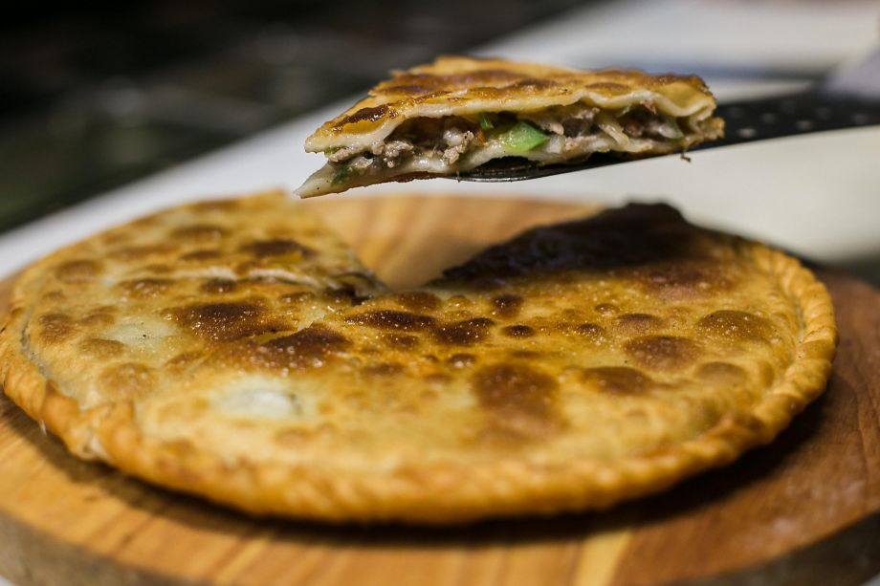
Photo: Jen Fedrizzi, Special To The Chronicle
Uyghur Taamliri is a pop-up that serves Uighur food — the cuisine of the Muslims of northwest China — in the Sunset District of S.F. Here, a chicken dish makes its way to a customer.
The inside of the Gosnan has lamb, veggies and a crisp bite from Uyghur Taamliri in San Francisco.
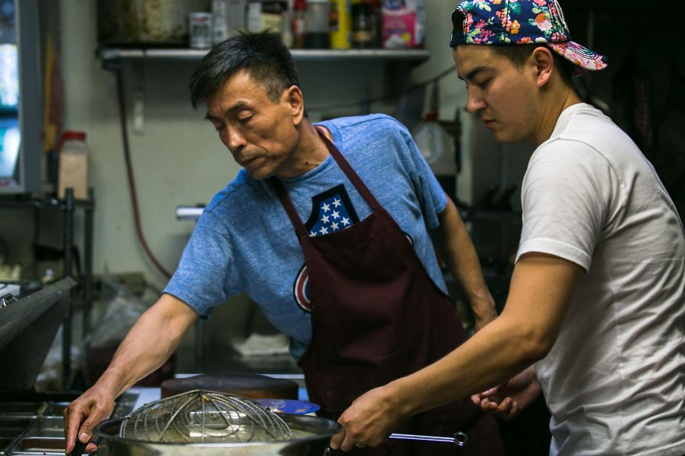
Photo: Jen Fedrizzi, Special To The Chronicle
Father and son Bahtiyar Tursun (left) and Zulpukar “Carl” Bahtiyar work together in the kitchen every day at Uyghur Taamliri in S.F.
It’s for the rest of us, too, even if we have to go to his 3-month-old Uyghur Taamliri (“Uighur cuisine”) pop-up at Chug Pub on Lincoln Way at 20th Avenue to get it. Bahtiyar is friends with the pub’s owner, who suggested that the father-son team might want to try out the whole restaurant thing there first before fully investing in it.
The setting is an odd fit. Dishes can take a while to come out, which means time spent waiting at the pub’s sticky tables and dodging pool cues. A soundtrack of Tom Petty songs mixed with beeps and blips from the Pac-Man machine is not exactly an ideal setting to experience an obscure cuisine for the first time.
I was willing to forgive more than that upon the arrival of the Big Chicken dish — hunks of bone-in chicken marinated in a broth fragrant with peppers, star anise, cinnamon and numbing Sichuan peppercorns, all of it soaked up by hand-pulled noodles.
Photo: Jen Fedrizzi, Special To The Chronicle
A dumpling is sliced open to reveal its lamb filling in the kitchen at Uyghur Taamliri, a pop-up that serves Uighur food — the cuisine of the Muslims of northwest China — at the Chug Pub in S.F.
Culturally and ethnically, the Uighurs are closer to Kazakhs, Uzbeks and other Central Asian people than the rest of the Chinese, and that’s reflected in their food. Like the cuisine of Xi’an, which we’ve seen spotlighted in a few new restaurants over the past year, Uighur food is heavy on Silk Road influences. There is some heat, but it’s the dull kind that hits you in the back of the throat. Expect a lot of lamb and a lot of cumin.
Maybe because father and son don’t have much restaurant experience, the menu is almost entirely Uighur. But even though they don’t make many allowances for those who aren’t familiar with the food, Bahtiyar is happy to explain whatever questions you have. The best way to try it is just to jump in.
The pop-up’s excellently chewy hand-pulled noodles are spotlighted in the laghman, where they’re draped with a richly spiced gravy and a heap of vegetables. Soups like sorpa, a traditional soup heavy on lamb fat, are good choices to cut through the Sunset fog. Lamb fans will be won over by a flat pie called gösnan, which covers chopped meat and vegetables with a flaky pastry shell glistening with butter. There are also juicy, thick-skinned dumplings, a rare sign of the Chinese influence, and the obligatory lamb and beef skewers.
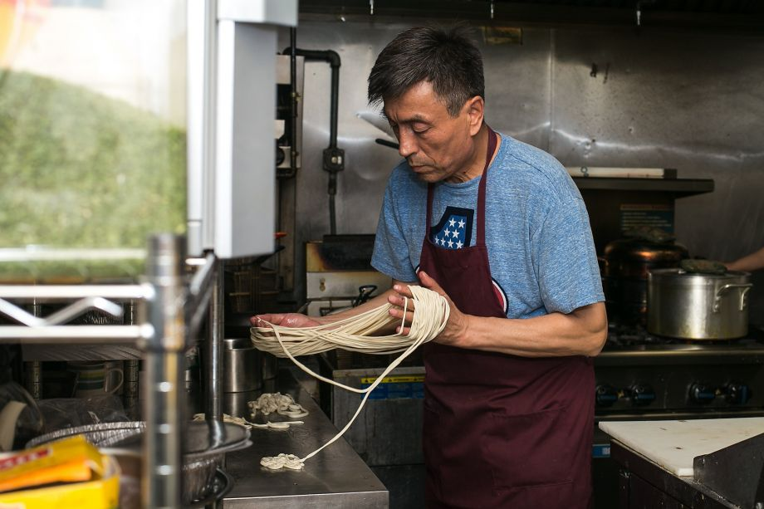
Photo: Jen Fedrizzi, Special To The Chronicle
Bahtiyar Tursun seperately strings noodles on his fingers in the kitchen of pop up restaurant Uyghur Taamliri.
I’ll readily admit that I don’t have much of a frame of reference for this cuisine, and though I loved several of the dishes, there were a few that I couldn’t get my palate behind, like the weekends-only polo, a take on pilaf that involves grated carrots, buttery rice and hunks of lamb. For some reason, I couldn’t square the sweetness of the carrots with the savory nature of everything else.
But polo is Bahtiyar’s favorite and, as he said, this is his way of reconnecting with the country that he left three years ago. Judging by the excited comments on Yelp and Chowhound, he’s not the only one whose homesickness has been cured.
Anna Roth is a freelance writer in San Francisco. E-mail: food@sfchronicle.com Twitter: @annaroth

(More samples below)
******************************************************************************

My True Nature products by creative mom

By Carolyn Said Updated 3:02 a.m., Friday, October 26, 2012
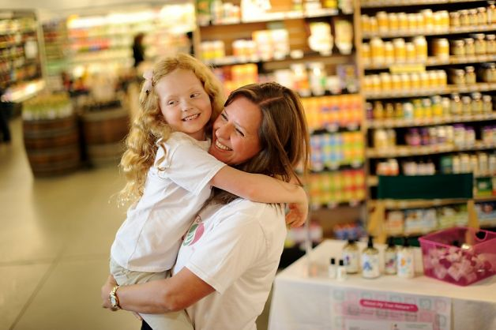
Kelly Boyd hugs her daughter Adeline, 6, while distributing samples at Berkeley Bowl. Photo: Noah Berger, Special To The Chronicle / S
Scampering through the aisles of Berkeley Bowl, Fletcher Boyd, age 7, buttonholed a woman pushing a toddler in a shopping cart and presented her with some small bottles.
"Would you like to try some natural kids' bath products?" he asked earnestly.
His sister Adeline, 6, chimed in: "For free."
Nearby, their mother, Kelly Boyd, stood at a small table stocked with sample bottles and brochures.
When Boyd, 42, a corporate securities lawyer, couldn't find organic, preservative-free skin cream for her babies' sensitive bottoms, she whipped up her own.
When the strain of juggling motherhood with a "work your tail off, crazy-hours career" became too much, she quit and became a "mompreneur."
Now her San Francisco company, My True Nature, markets her organic, locally sourced balms, bubble bath, soap and shampoo, racking up enough sales to generate a decent salary for her.
Boyd's story is a classic textbook - make that e-book - case study in how to start a business from scratch by leveraging social media and tapping into zeitgeist trends. The steps:
Find a need: "I have two very fair, strawberry blond children who have very sensitive skin," she said. "I couldn't find products that were free of synthetics and preservatives."
Fashion a solution: "I've always been a big cook, and making natural personal-care products is very similar to cooking," she said. "I started reading and taking classes. I really enjoy the creativity of it; it's crafty. I played around with formulations for a couple of years before I decided to turn it into a company."
Bootstrap financing: "I knew I didn't want venture funding because as a mom I wanted flexibility to focus on my kids; I don't want investors on my back trying to get my numbers up," she said. She and her husband, telecom sales executive Charlie Boyd, financed the company themselves, some of it on credit cards, putting in about $100,000 over the first few years, most of it for inventory. She said she's recouped that investment and is now profitable, with annual growth upward of 30 percent.
Market online: "There is no better time to start a company than now because there is so much free or close to free marketing available," she said. "It's all about the reviews - you can tell so much more readily than a couple of years ago what people really think about the products. That transparency helps smaller companies."
She sent hundreds of samples to mommy blogs, garnered good reviews and posted the links on her website, www.mytruenature.net.
Try it, you'll like it: "For bath products, you have to get people to try them," she said. "Daily deals helped me a ton. Mamapedia, MyHabit, Zulily and other sites are a great way to get people to try the products. You have to discount your product, but (it works out to) about the same as distributor pricing. It helped bring in cash to cover costs."
Ask for advice: Boyd tapped into a broad network of other mompreneurs through several online groups: Golden Gate Mothers' group for working moms called Works for Me; Women in Consulting; Savor the Success.
"I don't have time to go to meetings, but seeing other people's questions and the answers on the listservs helps a lot. There are only so many issues; the chances are that someone else is having the same problems you are. You can ask anything - what's the going rate for technical people, what are the typical margins for consumer products. They're a wealth of information."
Hire strategically: Boyd uses freelancers for all the job functions she can't fill herself. A broker who specializes in all-natural organic products helped get stores to carry her products. She pays a flat rate until store sales top a certain dollar amount, and then a percentage. How did she find the broker? By searching online and "asking everyone I know who's even tangentially involved" with related industries.
She found a graphic artist in the Netherlands by browsing online clip art. As needed, she hires a demo person and people to help with shipping.
Start small: The broker got about 100 West Coast natural groceries to carry the products, including Berkeley Bowl, New Leaf Market and Staff of Life. The downtown San Francisco Whole Foods will soon carry them as well.
Meanwhile, My True Nature also broke into Drugstore.com and Amazon.com, the former through the broker, the latter through a contact Boyd made at Amazon's flash-sales site MyHabit. E-commerce generates many more sales than stores, but a brick-and-mortar presence helps establish credibility.
"We found it works best to get into a few stores and really build up customer base and then go out from there," she said.
Go face to face: With trying the product being key, Boyd goes to the store with her demo table, often with her kids in tow, to hand out free samples. While she can hire others to do this, "I like doing it because you really get to know customers," she said. "We've heard all kinds of interesting stories. It's heartbreaking what some of these moms go through with their children and eczema or other skin problems."
Think local: Berkeley Bowl shoppers who stopped by Boyd's sample table often asked her where her products are made. She wanted to do everything locally, so she hired a contract manufacturer in Hayward and sourced the ingredients from local farms. Her bottles are 100 percent recycled plastic from a St. Louis company.
Aim broad: Boyd doesn't want to pigeonhole her products.
"I call them mainstream green," she said. "I try to get them to look and act like mainstream products. Even though they're 100 percent organic, and the packaging is made of recycled materials, I want them to look more like Hello Kitty."
Think ahead: The products' packaging features "bath time friend" characters such as Ollie the Octopus and Daisy the Skunk. Boyd and her graphic artist are working to expand the characters with a bath time book due out soon. A hooded towel and bath toys are also in the works, along with a bath time line for adults.
While Boyd still works 40 to 50 hours a week, it's nothing compared with her 80-hour workweeks as a lawyer.
Besides spending more time with her kids, she sees the business as an education for them.
"I love having them see how a small business runs," she said. "And they can earn money by helping me."

Start small: The broker got about 100 West Coast natural groceries to carry the products, including Berkeley Bowl, New Leaf Market and Staff of Life. The downtown San Francisco Whole Foods will soon carry them as well.
Meanwhile, My True Nature also broke into Drugstore.com and Amazon.com, the former through the broker, the latter through a contact Boyd made at Amazon's flash-sales site MyHabit. E-commerce generates many more sales than stores, but a brick-and-mortar presence helps establish credibility.
"We found it works best to get into a few stores and really build up customer base and then go out from there," she said.
Go face to face: With trying the product being key, Boyd goes to the store with her demo table, often with her kids in tow, to hand out free samples. While she can hire others to do this, "I like doing it because you really get to know customers," she said. "We've heard all kinds of interesting stories. It's heartbreaking what some of these moms go through with their children and eczema or other skin problems."
Think local: Berkeley Bowl shoppers who stopped by Boyd's sample table often asked her where her products are made. She wanted to do everything locally, so she hired a contract manufacturer in Hayward and sourced the ingredients from local farms. Her bottles are 100 percent recycled plastic from a St. Louis company.
Aim broad: Boyd doesn't want to pigeonhole her products.
"I call them mainstream green," she said. "I try to get them to look and act like mainstream products. Even though they're 100 percent organic, and the packaging is made of recycled materials, I want them to look more like Hello Kitty."
Think ahead: The products' packaging features "bath time friend" characters such as Ollie the Octopus and Daisy the Skunk. Boyd and her graphic artist are working to expand the characters with a bath time book due out soon. A hooded towel and bath toys are also in the works, along with a bath time line for adults.
While Boyd still works 40 to 50 hours a week, it's nothing compared with her 80-hour workweeks as a lawyer.
Besides spending more time with her kids, she sees the business as an education for them.
"I love having them see how a small business runs," she said. "And they can earn money by helping me."
Read more: http://www.sfgate.com/business/article/My-True-Nature-products-by-creative-mom-3982083.php#ixzz2BNZDMroE
Apr 19, 2011 @ 06:08 PM 6,271 views
******************************************************************************

NOTE: The sample below is in transcript format, which is NOT acceptable for this assignment!

Dambisa Moyo: An Economist With A Vision
World With A View

Eva Pereira,Contributor
Zambian-born economist and author Dambisa Moyo, Ph.D., has written two bestselling books: Dead Aid and How the West Was Lost. Her next book, Winner Take All: China’s Rush for Resources and What it Means for the Rest of the World is scheduled for publication in January 2012. Trained at Harvard and Oxford, she’s worked at the World Bank and at Goldman Sachs. In addition to her writing, she sits on the Board of Directors of Barclays, SABMiller, Lundin Petroleum and Barrick Gold.
Author and international economist, Dambisa Moyo
She wrote her provocative first book, Dead Aid: Why Aid is Not Working and How There is a Better Way For Africa while working at Goldman. The book describes how well-intentioned aid to Africa actually cripples local economies by fueling corruption and dependency. She calls for the West to gradually phase out aid programs, to be replaced with the Chinese development model which focUSes on trade and direct investment.
In her second book, How the West Was Lost: Fifty Years of Economic Folly and the Stark Choices Ahead, Moyo describes how shortsighted policies have set the West on a path of decline. She discusses how the fundamentals of economic growth: capital, labor, and technology have been misallocated because of bad incentives. Moyo argues that the scales of economic power will soon tip in favor of emerging economies if swift and severe corrective action isn’t taken by the West.
Forbes: You studied chemistry as an undergrad. Where did your interest in economics come from?
Moyo: I went into the sciences very early on, but to me economics pervades so much more of our lives and our existence. I was initially very interested in public policy, but then after my masters at Harvard, I felt that it was important to get a better handle on the economics of it as well. I did my PhD in macroeconomics, and my thesis–”Why Is It That Some Countries Save And Others Not?” — was on savings. The reason that I focused on this is because savings is a key component to economic growth.
Can you talk about your transition from a career as a Goldman Sachs banker to a world-renown expert in economic development?
The lesson here is that one has to be open-minded about everything. I grew up in a poor economy. Throughout my life there have been people who said things like, “You can’t do it. You can’t go to Harvard. You can’t go to Oxford.” But I grew up in a home where my parents never discouraged us from doing anything.
The transition [from Goldman] was borne out of advice from a friend of mine who suggested that I write a book. I was working full time when I published my first book, and they supported me later in terms of the marketing and preparations for its release. I’ve had a lot of help. I knew nothing about the publishing business before I jumped into it.
Your two books are bestsellers. Can you talk their respective messages?
I think there’s an overarching theme in my two books, which is this idea of unintended consequences. So although on the surface of it they may look like two very different topics, when you drill down it’s about the same issues: long term issues like poverty, economic development, growth and pensions and long term growth in developed countries and the dangers of using short term myopic policy to resolve it.
Dead Aid is about the inefficacy and the limitations of large scale aid programs in creating economic growth and reducing poverty in Africa. And How the West Was Lost, which focuses on developed countries such as the U.S., is really about the fact that capital, labor and technology, these three key ingredients of economic growth, are being eroded again by poor policymaking.
Let’s talk about that–why just focus on government policy? Is there anything outside the scope of policy that can be done?
If you take the financial crisis, for example, many people and institutions outside of public policy were culpable in exacerbating the problem. But I strongly believe that policymakers set the tone for what you get, whether it’s economic growth in Africa or in business strategy in the US.
To me, policymaking serves three roles: it has to set the environment to make it conducive for people to invest, be entrepreneurial and to innovate. The second thing is to provide public goods, things like roads, national security, education and so on. And the last thing is that you need government to regulate. The government needs to be the policeman for bad behavior. When people do illegal things, we want government to step in so that people are penalized for it.
Also you want to make sure that government steps in when the markets don’t clear. The subprime crisis is an example of that. We need the government to step in and to make policies to ensure that we don’t have repeats of the crisis.
Can you elaborate on why China’s model is better for the development of Africa than the Western aid model? What is China doing right?
It’s very important that we remember China is in Africa for China, not for Africa. They have a very daunting problem; China has a billion people living in poverty, more than the total population of Africa, and need to deliver sustainable economic growth to that population and reduce poverty. China needs resources–soft commodities like food products–but also harder commodities– metals, minerals, oil and so on. All of that together means that Africa is well placed to actually benefit from China’s demand for these products.
Traditionally, in contrasting the Chinese model to the Western model, Western countries have shut African produce out through subsidy programs such as the farm subsidy regime in the U.S. and the Common Agriculture Policy in Europe. That has actually decimated Africa’s agriculture markets and has put hundreds of millions of people out of work in Africa.
Now we have a real chance at delivering economic growth, not only because the Chinese are laying down infrastructure and so on, but actually because they want to buy food and resources from Africa. And that is what we need. We need to create jobs. There are a billion people in Africa, 60% of who are under the age of 24, so we’ve got to deliver economic growth by making sure it’s a job-led growth. We need to create jobs, and unfortunately the western model has not succeeded in delivering jobs to the extent that we need in Africa, and the Chinese model is doing that much more aggressively.
To what extent does China actually create jobs though? I’ve read that China prefers to import its own labor for their projects in Africa.
I think that’s exaggerated in the Western media. Those issues absolutely exist in the labor market and there are environmental concerns, but that’s what African policymakers are there for. Just because the Chinese are making mistakes doesn’t mean that we should shut off foreign direct investment.
It’s one very negative message that’s common in western countries and I think it might just be because there’s some ill-feeling about the fact that the Western development model hasn’t delivered for Africa and the Chinese method so far is delivering. In my first book I talk about the PEW survey, taken in 10 to 15 countries in Africa, where they were asked, “What do you think about the Chinese?” Consistently Africans are saying “We like the Chinese, we think they’re doing a good thing.”

How do you envision the aid industry changing in years to come?
Fundamentally, an aid model hurts incentives and discourages people from doing the right thing. And that is clearly what has happened across Africa. Am I sanguine that the model is somehow going to change? No, because there are so many vested interests in keeping things as they are today.
The two things that make me optimistic that there may be some sort of change to this malaise of development policy are:
1) Traditional donors like the U.S. and European countries are running out of money. They’ve got pension problems, poor education, bad infrastructure and concerns around their own welfare. All of this is going to put immense pressure for them at home. And therefore, I hope it will force African governments to focus on other ways to source development instead of aid.
2) You only have to look at North Africa and the Middle East to see that because the populations in these countries are so young, you end up in a situation where people are agitated. In many African countries, 50% of the population is under the age of 15, and they’re not in the mood for policies that don’t deliver economic growth. This will mean there will be much more pressure on the traditional aid agencies to innovate.
It’s time to re-asses what the goal is. The goal is not to keep things static or make them worse. The goal is to create economic growth and reduce poverty. And to the extent that that is not happening, it’s absolutely essential that NGOs, international aid agencies, African governments sit back, with a critical eye, and ask are we really doing what is necessary to generate economic growth? The answer is very clear. Remember, China reduced poverty immensely in just 30 years, as has India as has Brazil. They’re not doing that by relying on aid. I see no reason why we should not, as an international community, be pursuing their strategies across Africa.
Who’s your greatest inspiration/mentor and why?
The people I admire unreservedly are my parents. They are the real pioneers of Africa in many ways. They were born and raised in rural Africa during the colonial period. They are the ones who came to the U.S. long before I did. Their parents, my grandparents, waved goodbye to them at the airports and that was it; my grandparents hadn’t ever been to the U.S.
I’m in constant awe at what they did. I feel so lucky, but I also feel that compared to them, my life has been a cake walk. They’ve always told me what to do, not in a bullying way but to give me guidance and context. But they certainly didn’t have that; their lives were very pioneering.
http://www.forbes.com/sites/worldviews/2011/04/19/dambisa-moyo-an-economist-with-a-vision/

