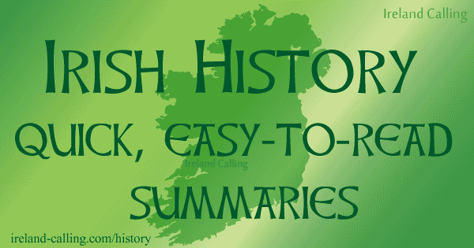

Note: All histories are shaped by the beliefs and priorities of the writer, including this one. I (Julie Sparks, your prof.) have taken the liberty of adapting this one to our course needs. It focuses on the political struggles but also includes some dates related to religion and literature. The blue words are hyperlinks leading to the website “Ireland Calling,” where you’ll find a lot more information. Most of the material below is from “Ireland Calling” (link at the bottom), but I added more dates from The Oxford Illustrated History of Ireland, edited by R. F. Foster, and a Thomas Cahill book called How the Irish Saved Civilization. I added all the material without a blue subtitle and cut out a lot of the original commentary.
Ancient Ireland—Where myth and history merge
Circa 7,000-8,000 BC Before the Celts – first people to live in Ireland arrive.
Circa 4,000 BC. The Neolithics – the first people to leave their mark on Ireland with their spectacular tombs, some of them older than Egypt’s pyramids.
Circa 100 AD: We’ll read about this period as it is recounted in The Tain, the “Irish Illiad.”

Medieval Ireland
401: Patricius (who later becomes St. Patrick) first taken as a slave to Ireland
Circa 550: Book of Kells created
793-1014: The rise & fall of the Vikings – the Vikings invade and rule in Ireland
1014 The Battle of Clontarf : Brian Boru defeats the Vikings, becomes High King
1170 Norman Invasion and rule in Ireland – overview

Cromwell and the Plantation of Ulster

1649 Oliver Cromwell sent by Queen Elizabeth to suppress the Irish; mass massacre of Catholics ensues; “Plantation” of Protestants in the north.
1690 Battle of the Boyne: English King William of Orange defeats uprising, “Flight of the Wild Geese (Irish nobility),” beginning a long period of severe repression of the Irish.
1798 Rebellion – United Irishmen rose up in a gallant but unsuccessful effort to throw out the Brits. The French tried to help. Wolfe Tone is the name to Google here.

1845-1851 The Great Hunger --“An Gorta Mór”

The Great Hunger – approximately a million died of starvation and a million more left Ireland in “coffin ships,” the largest Irish diaspora to date. The Kennedys arrive in America.
Why Ireland exported food amid mass starvation
1916-1923 Ireland gains freedom but splits in two

1916 Easter Rising, Overall summary – the rebellion begins, creates martyrs
1919-1921 Irish War of Independence

1922 Treaty with England: civil war breaks out in Ireland, partition into the Irish Free State and Northern Ireland (“the 6 Counties”). We’ll see the events of this section in the film Michael Collins, with Liam Neeson in the title role.

The Troubles in Northern Ireland and a Resolution
Overall summary – The Troubles in Northern Ireland.
1969 The Battle of The Bogside in Derry–very violent 3-day riot against police.
1972 Bloody Sunday – Derry, again: 14 protesters shot by police. (song by U2)
1998 Good Friday Agreement Peace finally established between warring factions in Northern Ireland. Pres. Bill Clinton sent Irish-American senator George Mitchell to help the Irish combatants (the IRA and the established government) come to terms. It held even after the terrible Omagh bombing in August 1998. We’ll see The Boxer, a film set at the end of the Troubles.
Contemporary Ireland
Mid 1990s-2007 Celtic Tiger Ireland: An economic boom period when Irish emigration essentially reversed itself and Ireland found itself suddenly becoming a magnet for immigration. We’ll read Roddy Doyle’s depiction of this period’s social changes.
21st Century Global Ireland: While not quite as prosperous as it was during the Celtic Tiger, Ireland is a thriving, dynamic member of the EU.
http://ireland-calling.com/history/

