Ireland a mysterious place to most Japanese, says Irish expat
Andy Kavanagh

@IrishCentral

July 10, 2016 04:09 AM
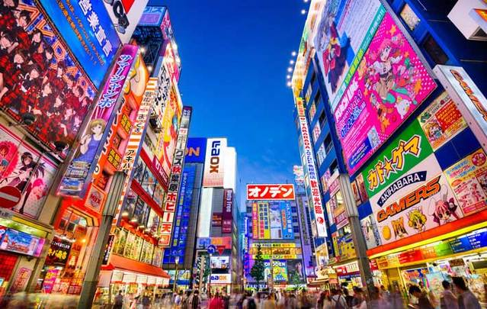
Tokyo, JapanISTOCK/GETTY IMAGES
Japan has always had a pretty unique relationship with the rest of the world. Despite the Portuguese and the Dutch visiting before anyone else, they don't seem to have left a very lasting impression. Britain and America are, of course, on the cultural radar, and Japanese people share an inexplicable fascination with France for some reason. After that though, the world seems to get lumped into some kind of generic 'not Japan' that no one really cares very much about.
Unfortunately, that means Ireland isn't perhaps as famous in the land of the rising sun as you might think. The assumption that we're still part of the U.K is bad enough. What's worse is when people assume I've simply mispronounced Iceland. I promise you, on more than one occasion I have had to clarify not only that I'm from Ireland, but that Ireland is in fact a place that exists.
6
an Irish Pub called An Sólás in Yoyogi, a small town close to Shinjuku. Image: Andy Kavanagh
Okay, I'm generalizing, and it would be absurd to claim that Irish culture has no presence in Japan. There are Irish pubs everywhere (because of course there are), football fans all know the name Robbie Keane, and Guinness is as popular here as anywhere else in the world. They celebrate Saint Patrick’s Day every year with a parade in Harajuku and the annual 'I Love Ireland' festival in Yoyogi Park, and it turns out even Japanese girls are no match for Niall Horan's baby blues. Enya is pretty famous here too, but we don't have to talk about that.
It's also unfair to place the blame entirely on my hosts. My flat west Dublin accent certainly doesn't help, completely unidentifiable in a sea of regional British cadences and creamy American drawls.
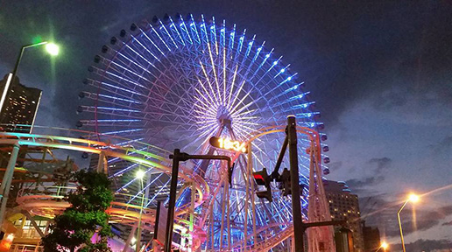
6
Image: Andy Kavanagh
It goes the other way, too. Coming from Dublin, where any kind of work is seen very much as an obstacle to the craic, Japan's work culture is just beyond my understanding. The first time someone told me they stayed in the office until 10pm I assumed they were lying. Many others have said similar things since and I'm still not sure I believe them either.
As different as we are, there are certainly similarities when you look hard enough. The Japanese, for instance, have a rather stressful relationship with the English language. While some people enjoy using it, many more are cripplingly insecure about it. When you consider that English is mandatory in the school system from age 13, it might seem a little strange that less than 10% of Japanese people consider themselves fluent in English.
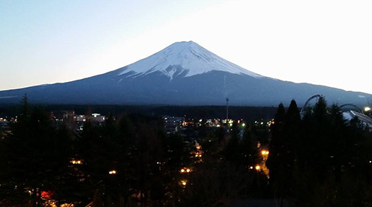
6
Image: Andy Kavanagh
It might seem strange, but ask yourself how many Irish people consider themselves fluent in Irish? Irish is a compulsory subject for 6 years in secondary school, so where are all the Irish speakers? They're not there, for the same reasons Japanese English speakers aren't there. English in Japan is not taught through conversation. Schools focus almost relentlessly on writing, reading and grammar translation to set students up for standardized tests. Out of the school systems in Ireland nobody speaks Irish. In Japan, with a foreign population of almost 2%, nobody speaks English. So as an Irish guy, and a fluent Irish speaker from Dublin, I get it; there's no one to practice with. No one to talk to. I sympathize.
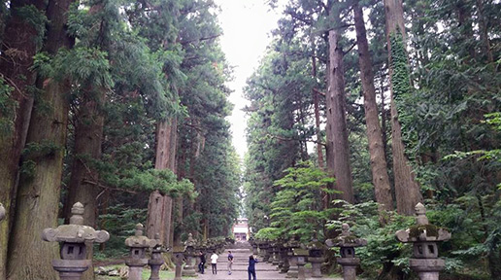
6
Image: Andy Kavanagh
Thankfully, there is a positive spin to all this. Foreigners are still something of a novelty in Japan, and if you're from a country they've never heard of, or if you're the first Irish person they've met, you're likely to get an enthusiastic response. With more Japanese people studying English abroad, Ireland's relative obscurity gives it a strange kind of hipster allure. Not only that, but our schools are usually cheaper, and the trademark Irish lilt presents an interesting challenge. A Japanese friend told me that once she'd tuned to the snappy banter of Dublin English, all other dialects were suddenly unlocked. Although I do have to wonder if she ever went to Wales.
In a culture so different, and at times totally indifferent, to your own, it's pretty easy to feel homesick. When that happens, try to remember why you came out here and how you can take advantage of your position. Instead of pining for Cadbury's and Tayto, indulge in your surroundings and get yourself some matcha chocolate or miso ramen crisps.
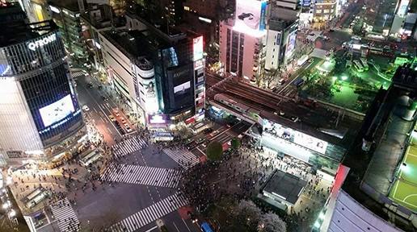
6
Image: Andy Kavanagh
Take the opportunity to inform people about your culture. Believe me, they want to learn, and for all our differences we share one very important similarity. The Irish and the Japanese both know all too well that no matter what your creed, color or culture, a few too many beers can lead a to a few new friends.
In the end, being Irish in Japan is pretty much like being Irish everywhere else. We might not be the most well-known nationality in the world, but we're undoubtedly the best craic.
http://www.irishcentral.com/opinion/ireland-a-mysterious-place-to-most-japanese-says-irish-expat

