Travel

In Ireland, Chasing the Wandering Soul of Yeats APRIL 17, 2015
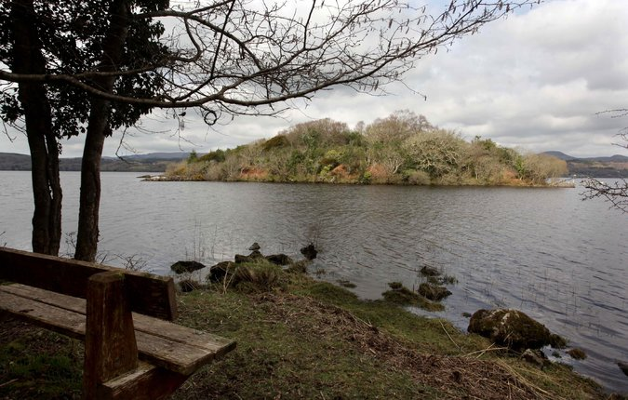
Innisfree sits in the middle of Lough Gill, a lake in County Sligo in northwest Ireland. Credit Derek Speirs for The New York Times
Footsteps
By RUSSELL SHORTO
I will arise and go now. …
Surprisingly often, when I get up from a chair to leave a room, those six melodramatic words will unfurl in my mind. Somehow William Butler Yeats’s poem “The Lake Isle of Innisfree,” which, like millions of other people, I first read in college, stays rooted in me:
I will arise and go now, and go to Innisfree. …
And I’m off, not to the dentist or the shopping mall but, mentally, striding emerald slopes, making for a place of myth.
Yeats named the poem after an actual place, an island in the middle of Lough Gill, a lake that spreads itself languidly across five miles of furiously green landscape in County Sligo in northwest Ireland. A few years ago, I found myself in Dublin and decided to do it for real: go to Innisfree. It would be a four-hour detour from the research I was doing for an article, but I had not the slightest doubt the journey would be worthwhile.
Thanks to the popularity of the poem (voted by readers of The Irish Times in 1999 as their all-time favorite work of Irish poetry), “Innisfree” is a bit of a brand. There are Innisfree cosmetics, an Innisfree Eau de Parfum, an Innisfree B&B, an Innisfree Hotel and a Rose of Innisfree tour boat that does the lake.
Photo
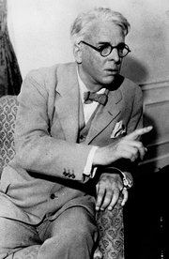
William Butler Yeats wrote longingly of the Irish island Innisfree when he was a young man of just 23. Credit Associated Press
But I know these things only from Google. Thankfully, none of it was evident on my drive. I didn’t use a GPS; I just relied on a couple of tiny handmade-looking road signs that popped up as I entered the region, which pointed the way to “Lake Isle of Innisfree.” The last stage of the journey involved no tourism bric-a-brac, only small, twisty, increasingly difficult to navigate roads, mossy tree trunks, wind, willows, heather, cloud knuckles and gray rock.
When I reached the lakeshore, I found the opposite of a tourist site. I could barely make my way out to the water to get a view, so thick was the shoreline with trees and brush. A farmhouse with a couple of S.U.V.s parked outside stood nearby, and there was a little concrete dock jutting out into the lake, pointed almost directly at Innisfree a few hundred yards away. I got out on the dock, sat cross-legged facing the island, and let the wind say what it had to say. For decades, this place had reverberated in my mind; now I was actually there.
Advertisement
Continue reading the main story
Yeats, born in 1865, the son of an artist, was a childlike intellectual. He would forget to eat, or put food in the oven and let it burn. He was devoted to mysticism and séances. He spent decades in love with the Irish nationalist and proto-feminist Maud Gonne; after she rejected his marriage proposal for a final time, he shifted his attention to her daughter.
Advertisement
Continue reading the main story
A few weeks after she, in turn, spurned his marriage offer, he proposed to another woman, Georgie Hyde-Lees, who, despite knowing where she ranked, became his devoted life partner. As she essentially said after his death, she saw the shimmer of his soul. “For him, every day he lived was a new adventure,” she once told the Yeats scholar Curtis B. Bradford. “He woke every morning certain that in the new day before him something would happen that had never happened before.”
Yeats was in his 50s when he married. “The Lake Isle of Innisfree” is a young man’s poem, written when he was 23. It is filled with a romantic longing for the past: the Irish past, the mythic past and also Yeats’s own. He had spent his childhood in County Sligo before moving to Dublin and then London. This countryside, the lake and its islands, this composition of greens and grays and blues, was fused within him.
When he was a boy, his father had read him Thoreau’s “Walden,” and its pastoral message resonated with the landscape of his childhood. As a young man living in London, trying to make a go of it amid the industrial throb, Yeats reached back to his youth and crafted the poem. The first line signals the self-consciously antiquated style he chose. (Even back in 1888, when the poem was written, people didn’t “arise.”) He filled it with rhyme, pumped it with unapologetically forceful rhythm. He made it, for all its romance, compact, athletic. This is the entire poem.
I will arise and go now, and go to Innisfree,
And a small cabin build there, of clay and wattles made:
Nine bean-rows will I have there, a hive for the honey-bee;
Photo
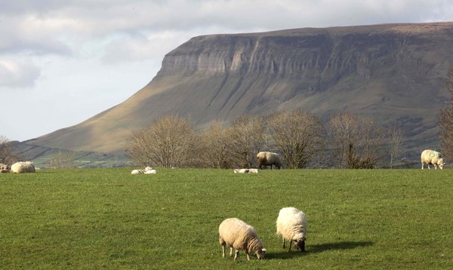
A few miles away from the lake is Ben Bulben, a mountain slab that also inspired Yeats. Credit Derek Speirs for The New York Times
And live alone in the bee-loud glade.
And I shall have some peace there, for peace comes dropping slow,
Dropping from the veils of the morning to where the cricket sings;
There midnight’s all a glimmer, and noon a purple glow,
And evening full of the linnet’s wings.
I will arise and go now, for always night and day
I hear lake water lapping with low sounds by the shore;
While I stand on the roadway, or on the pavements grey,
I hear it in the deep heart’s core.
By The New York Times
Of course, as I approached the lake, the poem was reverberating in my mind, and at first the imagery seemed to live up to it. The lake is five miles long, fringed with greenery; moody hills rise on the opposite shore. The furrowed water was dotted with little islands, some of them very atmospheric. As it happens, though, Innisfree is not one of the atmospheric ones. It’s tiny, and looks like a bur, a bristling seed pod, almost angrily sprouting trees and brush from its humpy back.
Some have speculated that Yeats chose it because of the poetry in the syllables of its name, and the last syllable’s suggestion of freedom. You’d have a hard time building a cabin on it, and it’s too lumpen for a glade.
But to leave it at that — to say that Yeats picked a dud — would be like declaring that you had no music in your soul. The whole landscape echoes the poem. You realize, sitting there, identifying the sound of the lake water with the deep heart’s core, that the Yeats who wrote the poem does not actually intend to retreat from the world and move to this spot. He is reaching for something. He is aware, at 23, of death and the inexorability of change. He is searching, trying to find his balance, his center. He knows he left it somewhere in his past, as we all have done.
The poem is a mental exercise, a meditation. You could perform the exercise in a parking garage. It isn’t meant to be enacted.
Then I realized that my meditation was different from Yeats’s. If he was using his mind to find his center, I was using him — using history, poetry, travel — to get to the same place.
And there I was. All of County Sligo is “Yeats Country.” He mined it, traced its contours, translated them to verse: “black wind,” “wet winds,” “noisy clouds,” “thorn-trees,” “the clinging air.” He did it so thoroughly, it’s almost as if the craggy loveliness of the countryside were carved to suit his poetry, rather than the other way around.
“Where the wandering water gushes / From the hills above Glen-Car,” from Yeats’s poem “The Stolen Child,” describes a misty waterfall to the north that seems like something out of Peter Jackson’s “Hobbit.”
A few miles away from the lake, the stupendous mountain slab called Ben Bulben rises like a natural acropolis, the home of some ancient race of Irish gods, a height whose purpose can only be to evoke awe. It became another geographic touchstone for Yeats — so much so that in his poem “Under Ben Bulben,” he eerily directs the reader to his own grave, in the nearby cemetery of Drumcliffe. Actually it’s the grave of another Yeats he refers to, an ancestor. But after his own death, in France, his body was transferred there, as if people treated his poem as a last will and testament.
It’s only a four-mile drive from the shore of Lough Gill to Sligo town, and civilization. Sligo is an ancient and lively enough little center, dominated by its cathedral and ringed with pubs where there’s nonstop rugby and soccer on the telly and you can order not just Irish stew and Guinness, but also chicken curry and New Zealand sauvignon blanc. For a tourist, it’s the practical base. But pleasant as this is, it was the antithesis of why I had come. Yeats’s meditations weren’t urban, and neither was mine.
I am told that there are enormous salmon lurking beneath the waters of Lough Gill, and that otters make the lake their home, and that the lush forest along the banks called Slish Wood, which Yeats in “The Stolen Child” calls Sleuth Wood, harbors rare orchids, ivies and thistles, and that, yes, the evening can be full of the linnet’s wings. I saw none of these remarkable things.
But I saw others.
Russell Shorto is the author of “Amsterdam: A History of the World’s Most Liberal City.”
Sign up to receive our NYT Living newsletter, a weekly roundup of lifestyle news from the Style, Travel and Food sections delivered to your inbox.
A version of this article appears in print on April 19, 2015, on page TR10 of the New York edition. Order Reprints| Today's Paper|Subscribe

