Readings (and 2 videos) related to Roddy Doyle’s Dublin ****Videos and Discussion Questions at the end
- Falling for the city: Nigerian street photographer Timi takes us on a tour of Dublin through a collection he shot for Culture Night called Guinness in the City
Tue, Sep 13, 2016, 09:00 Updated: Thu, Sep 15, 2016, 12:46

Sponsored by Guinness
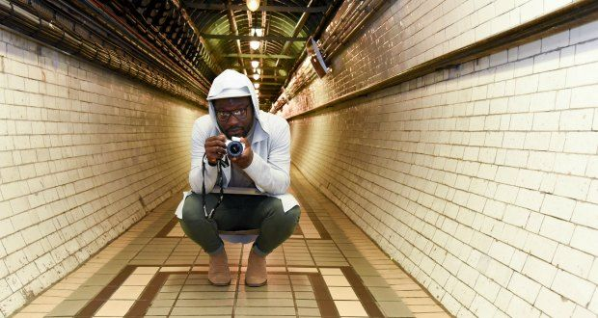

AddThis Sharing Buttons

Sometimes it takes someone else’s eye to make you fall in love with something all over again.

That’s exactly what street photographer Timi Ogunyemi’s exhibition, a collaboration with Guinness for this year’s Culture Night, is all about. Timi’s collection of photographs called “Guinness in the City” connects the stitches of Guinness woven through the tapestry of Dublin in the tiniest of details, movement and reflections around the streets of the city he loves.
“I’m a child of Dublin and that’s the way I see myself. Like with a lot of my work, I think in this project you’re coming for a walk with me through Dublin, but through photography.”
“I think people who come and see this exhibition will see my Dublin, but they will also see a bit of Dublin that they recognise. I call it “my Dublin” because Dublin has been really good to me. I think I’ve become the person I am because I grew up in Dublin. I’ve lived in Dublin since 2005. I was born in Lagos, and I’m Nigerian, but I was made in Dublin.”
Timi is an artist, a photographer, a consultant in his day job, and a new father to his baby boy Atlas, amongst many other things. He founded and edits “Picture This Dublin”. Timi is best known for his unique take on Dublin with his photography. He captures it in his own prism, reflecting the softer, quieter, sometimes poignant shades of the city, as well as the colourful, the vibrant and the energetic.
“It’s very difficult for me to describe what I do, and in some ways, I think, it’s a good thing, and in some ways I think it’s a bad thing. But I think I have embraced the fact that I don’t really fit into any shapes or sizes. So when people ask me what I do, I just tell them that I do a lot of things and I really enjoy all of them.”
Over its 250-year history, Guinness is intrinsic to what Timi calls the fabric of Dublin. “We all know Guinness, we all have probably tasted Guinness at some point. You can’t walk across the city without seeing something related to Guinness, so in many ways this was an impossible project to work on but at the same time it’s remarkably easy because everything is right in front of you. The challenge that I found was finding a particular story to tell about Guinness that had a beginning and had an end.”
“The collection has a definite structure to it. So it’s a two-tiered structure. The first tier being the journey through the city, the second tier mirroring the fabric of the city and the grandeur of the city within the images as well.”
“Guinness in the City” will be displayed on Culture night in The Open Gate Brewery, a beer lover’s equivalent to Willy Wonka’s Invention Room and Guinness’s home for experimentation and innovation at St James’s Gate Brewery.
Timi describes being part of this for Culture night as a double whammy. “I’ve always gone to Culture Night, but I’ve never been a part of the night. It’s an absolutely stupendous [experience] in the best way I can explain.”
Within the exhibition, the Liffey, city movement, and tiny details are all features that Timi tried to capture. He uses reflections too, because “to see into the future I think you must appreciate the past. But I also included lots of things I think a lot of people will recognise as being Dublin and also things they wouldn’t recognise and would probably walk past on a daily basis as well.”
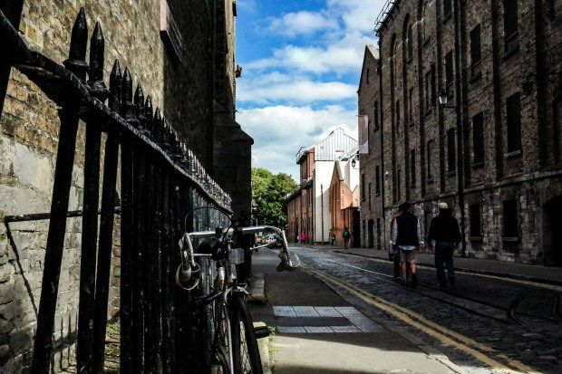
He said that he learned a lot more about Dublin through learning about the history of Guinness in the city, and how they pioneered and innovated.
“They really brought a lot of vibrancy into the city so trying to capture the fabric of that was part of it.”
As well as the photographic collection on display on Culture Night, Timi will be there to talk about the inspiration behind his collection. The photographs will also be projected on James’s Street, beside the 'Guinness Power Station', something he is still pinching himself about.
“Having my images being broadcast on James’s Street, beside the 'Guinness Power Station', is ridiculous. It’s one of those things that you don’t even think about because you don’t think it’s ever going to happen. It’s not within the realms of possibility. Being a part of this from start to finish has been an absolute dream. And I hope I never wake up from it.”

To book a place email info@guinnessopengate.com or call 01 471 2455. This ticketed event is free of charge and open to the public. Over 18s only.
Border Crossings

Born Irish, but With Illegal Parents
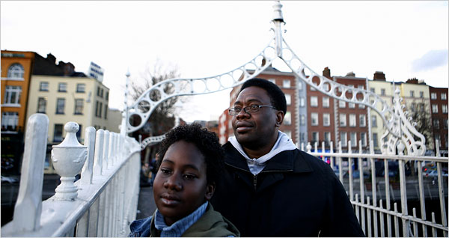
Kieran Dodds for The New York Times
George-Jordan Dimbo, 11, is an Irish citizen, but his father, Ifedinma, is not.

By JASON DePARLE Published: February 25, 2008
DUBLIN — Cork-born and proud of it, George-Jordan Dimbo is top to toe the Irish lad. He studies Gaelic, eats rashers, plays hurling, prays to the saints, papers his walls with parochial school awards, and spends Saturdays at the telly watching Dustin the Turkey, a wisecracking puppet, mock the powerful.
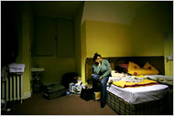
Photo by Kieran Dodds for The New York Times
Along with her husband and son, Ethelbert Dimbo lives in a single room in a Dublin hostel while facing the threat of deportation.
If the Irish government has its way, he may soon be living in Africa.
George, 11, is an Irish citizen and has been since his birth when Ireland, alone in Europe, still gave citizenship to anyone born on its soil. His mother and father, Ifedinma and Ethelbert Dimbo, are illegal immigrants from Nigeria, who brought him back to Ireland three years ago, judging it the best place to raise him.
Since then, the unusual trio — the Irish schoolboy and his African parents — have shared a single room in a worn Dublin hostel while facing a prospect dreaded by children on both sides of the Atlantic, a parent’s deportation.
“Dear justice minister,” George wrote when he was 9. “I heard my Mommy and Daddy whispering about deportation. Please do not deport us.”
“Remember,” he added, “I am also an Irish child.”
Thousands of Irish children face similar risks, living in a country where one or both parents do not legally reside. Their stories find abundant parallels in the United States, where an estimated five million children — including three million American citizens — have parents who are illegal immigrants. New efforts to catch them make fear of deportation a growing factor in American life, the flip side of generous laws that make infants instant citizens.
The battle over the “I.B.C.’s” — Irish-born children — stems from a decade of head-turning change that has brought this island of red-haired Marys and blue-eyed Seans the demographic version of an extreme makeover.
For centuries, Ireland was a racially homogenous land of emigrants. Now it is a multicultural nation of immigrants, whose share of the population, 11 percent, is nearly as high as that in the United States.
Years of Irish prosperity have drawn Polish plumbers, Lithuanian nannies, Latvian farm workers, Filipino nurses, Chinese traders, and sub-Saharan asylum seekers. The town of Portlaoise, about 40 miles southwest of Dublin, has the country’s first African-born mayor. The Synge Street School, where George Dimbo says his Hail Marys beneath a plaster Virgin, is walking distance from the city’s first mosque and rents classroom space to two Chinese academies.
“I went to bed in one country and woke up in a different one,” writes the Irish novelist, Roddy Doyle, in a collection of short stories called “The Deportees” (Viking, 2007). They depict characters as diverse as an African war survivor on his first day of class, and Fat Gandhi, a gay tandoori vendor who “quickly realized that his loud embrace of Christianity was very good for business.”
The Dimbos are the kind of memorable figures who might have tumbled from Mr. Doyle’s pages. A former graduate student in Cork, Ms. Dimbo, 42, wore a Yoruba headdress to a recent parent-student event, and has just written a feminist novel about a migrant prostitute. Mr. Dimbo, 43, releases his frustrations with a daily run through the Dublin streets, and George is so unusually courteous that his sixth-grade teacher thought he was “taking the mickey”—Irish for pulling his leg.
“He’s the most mannerly child I’ve taught in years,” said the teacher, Brendan O’Boyle. “He’s very, very good, very upright, very honest.”
“He’s one of the best guys we’ve ever had,” said last year’s teacher, Gerard Mooney.
Not long after George arrived, a classmate told him that he disliked black people.
“But I’m black,” George recalls answering.
“No,” the boy said. “You’re Irish.”
So Far, Little Conflict Ireland’s dash to diversity has so far provoked little of the conflict found elsewhere in Europe or the United States. There are no major anti-immigrant political parties and little anti-immigrant violence. When a Dublin high school student, Olukunle Elukanlo, was deported to Nigeria in 2005, his protesting classmates won his return.
Government officials here often credit Irish history for the tolerance. “There’s an emotional sense of understanding about what immigrants are going through because of our experience as immigrants,” said Conor Lenihan, the minister of integration.
But others see undercurrents of racial unease that could boil into conflict, especially if hard times return. “In Irish literature there’s a big fear of the returned immigrant who brings all sorts of chaos with him,” said Mary Gilmartin, a geographer at the National University of Ireland, Maynooth. “Many people here feel threatened.”
As recently as the 1980s, young Irish were fleeing unemployment in droves, many to work illegally in the United States. By the late 1990s, an economic boom called the Celtic Tiger was luring them home, along with droves of foreign construction workers, farm hands, waitresses and nannies. A wave of asylum seekers joined them, many from Africa.
Some had escaped harrowing wars or genital mutilation. But officials grew skeptical of their claims as their numbers surged to about 12,000 in 2002 from a trickle a decade before.
Ireland not only offered citizenship to children born upon arrival; until 2003 it also allowed their illegal-immigrant parents to stay, a shortcut many asylum seekers used to win residency. Word got out: with a visa to Britain, a pregnant woman could reach Northern Ireland, take a cab across the border, and gain residency by giving birth.
Ms. Gilmartin argues that reports of abuse were exaggerated. But a 2004 referendum changed the rules, reserving citizenship for the children of longtime legal residents. It passed with nearly 80 percent of the vote.
By then, Ireland had about 18,000 mixed families of Irish children and illegal-immigrant parents. Wary of the costs of large-scale deportation, the government ran a one-time legalization program that gave residency to about 95 percent of those parents. The Dimbos were among the 1,000 or so families whose cases were rejected, and they have appealed to the Supreme Court.
Their situation, like that of millions in the United States, pits competing interests: those of children (to live in their country with their parents) against those of states (to enforce borders for the perceived common good).
Odyssey to Ireland Ms. Dimbo first came to Ireland legally, to get a master’s degree in sociology in 1995. She was recently married, two months pregnant, and unaware, she said, that Irish law would make George a citizen. She gained legal residency through his citizenship, but they returned to Nigeria when George was 2 to join his father, who ran an import business.
With Ms. Dimbo working as a bank manager in Lagos, the family lived comfortably, but came back to Ireland twice, believing each time that George’s citizenship and their past residence gave them the right to stay. The most recent time was in 2005, to apply for the legalization program, not realizing, they said, that it only covered families who had remained in Ireland, which disqualified them.
With their savings gone, they have spent nearly three years in a government “accommodation center” — a dormitory where they share one room, line up for meals, and are barred from working.
“You feel like you’re a prisoner,” said Mr. Dimbo, a proud man dismayed by his forced dependency. “If we had known our lives would be like this, we never would have come.”
George said if his parents left, he would go with them — “every child needs his parents” — and wrote the justice minister to convey his fears. “I am very worried,” he wrote.
Gathered at another accommodation center, an hour outside Dublin in Mosney, many parents said their fears of deportation had begun to affect their children.
“My daughter knows I’m depressed,” said a single mother from Nigeria, who declined to be identified for fear of harming her case. “She goes, ‘Did I do anything wrong?’ ” Another single mother said, “I’m afraid I’m going to hurt my child.”
Other complaints come from men sneaking into Ireland, to join their children and wives who got residency through the legalization program. To avoid new waves of migration, the program gave no right to family reunification. “Unless we control the flows of people, public attitudes will turn against the whole process of immigration,” said Mr. Lenihan, the government minister.
But in denying children their fathers, the men say, the government may create the kind of immigrant underclass that plagues other parts of Europe.
“Our children are going to be growing up angry,” said one of four illegal-immigrant fathers from Nigeria who met with a reporter in Balbriggan, a Dublin suburb.
Another father blamed race. “If our kids were really Irish to them, they would not say, ‘Take the fathers away,’ ” he said.
At the same time, many of those facing deportation marvel at Ireland’s virtues, including the freedom to protest without getting shot and ambulances that come when summoned. When Lynda Onuoha joined Mosney mothers to demonstrate outside Parliament, they waved Irish flags. “We wanted people passing by to see that even though our kids are black, they are Irish by nationality, and we want to make a home here,” she said.
Even after tightening its rules, Ireland remains more generous than most of its European peers. The United States is the rare country that gives immediate citizenship to the children born inside its borders, whether their immigrant parents are legal residents or not. A 2007 bill to end the practice, which stems from the 14th Amendment, drew nearly 100 Congressional co-sponsors, though legal scholars have traditionally argued that a change would require a constitutional amendment.
Fear for U.S. Children Deportations in the United States have been rare, but with enforcement on the rise, migrant groups warn of a new generation of American children haunted by fear. Border control advocates respond that the parents have only themselves to blame, for migrating illegally.
At times, Ms. Dimbo says the same. “To come here without papers, we are wrong,” she said. “We are cap in hand, saying for George’s sake, let us forgive and forget.” Adding her own note of Irish chauvinism, she said it was only when she got to Donegal that she appreciated the phrase “deep, blue sea.”
Mr. Dimbo added, “I love this country.”
George has spent 6 of his 11 years in Ireland, including most of his school years. What he recalls of Nigeria is mostly the heat and the corporal punishment in school. Asked if he feels more Irish or Nigerian, he answered politely in a Dublin lilt.
“I think I feel more Irish,” he said. “For one, because I am Irish.”

Border Crossings
Diversity in Ireland
This is the seventh in a series of articles examining global migration and its consequences.
Previous Articles in the Series »
George-Jordan Dimbo's Letters to the Minister of Justice
http://www.nytimes.com/2008/02/25/world/europe/25ireland.html?pagewanted=2&_r=0
*********************************************************************************
3) Roddy Doyle on Video
Roddy Doyle on What it Means to be Irish (with a tip of the hat to The Quiet Man film) 9:35 min
https://www.youtube.com/watch?v=3EeXM7EgVsQ
A short film based on Roddy Doyle’s story “New Boy”
https://www.google.com/search?q=new+Boy+you+tube&oq=new+Boy+you+tube&aqs=chrome..69i57j0.5463j0j8&sourceid=chrome&ie=UTF-8
Discussion Questions:
- How do the two articles about Nigerians in Dublin add to your understanding of the character of Ben in “Guess Who’s Coming for the Dinner”? Is there any further information you’d like to have that isn’t in the articles?

- How do these articles shape (or try to shape) the readers’ attitudes about this new community in Ireland? Did you find them persuasive? Why or why not?

- What details or lines of dialog are especially effective or ineffective? Why?

- This short film is based on another story that, like “Guess Who’s Coming for the Dinner,” Roddy Doyle wrote for Metro Eireann and later collected in The Deportees. What point does it seem to be making about Dublin’s new population of refugees? What does it seem to be saying about how assimilation happens (or doesn’t happen)?

