Chapter 33  The Nature and Propagation of Light (14th Ed.) | 33
33.1. Identify: For reflection, 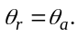
Set Up: The desired path of the ray is sketched in Figure 33.1.
Execute: 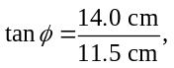 so 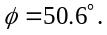 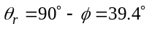 and 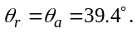
Evaluate: The angle of incidence is measured from the normal to the surface.
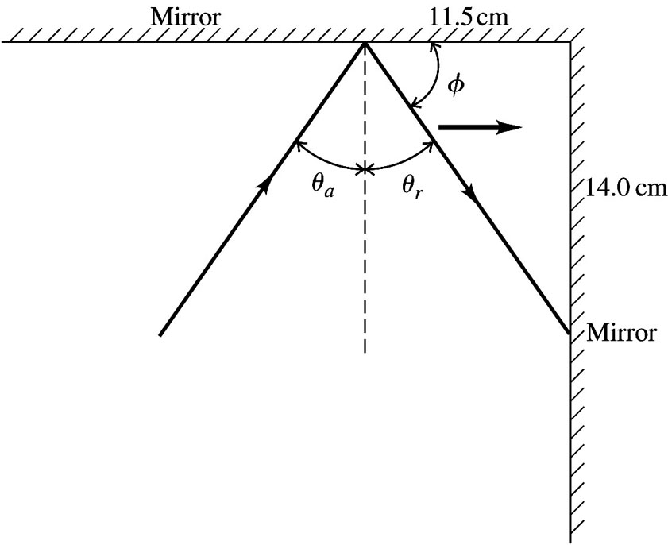
Figure 33.1

33.9. Identify and Set Up: Use Snell’s law to find the index of refraction of the plastic and then use
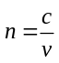 to calculate the speed v of light in the plastic.
Execute: 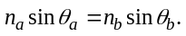
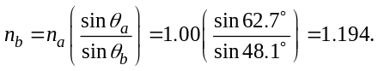
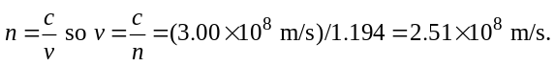
Evaluate: Light is slower in plastic than in air. When the light goes from air into the plastic it is bent toward the normal.
33.11. Identify: The figure shows the angle of incidence and angle of refraction for light going from the water into material X. Snell’s law applies at the air-water and water-X boundaries.
Set Up: Snell’s law says 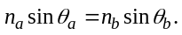 Apply Snell’s law to the refraction from material X into the water and then from the water into the air.
Execute: (a) Material X to water: 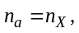 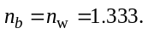 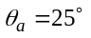 and 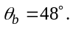 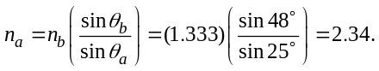
(b) Water to air: As Figure 33.11 shows, 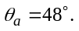 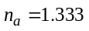 and 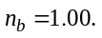 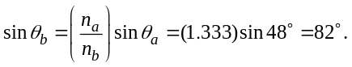
Evaluate: 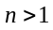 for material X, as it must be.
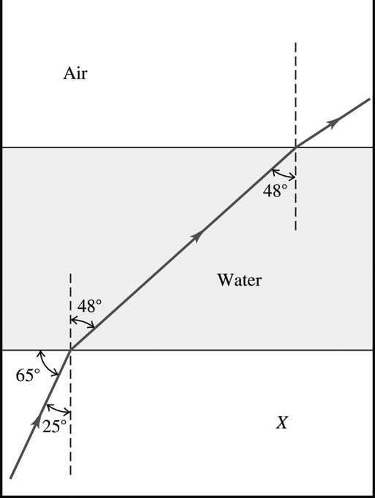
Figure 33.11

33.15. Identify: The critical angle for total internal reflection is 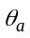 that gives 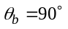 in Snell’s law.
Set Up: In Figure 33.15 the angle of incidence is related to angle by 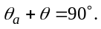
Execute: (a) Calculate that gives 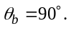 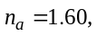 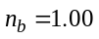 so 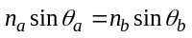 gives 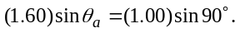 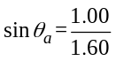 and 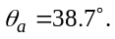 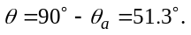
(b) 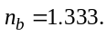 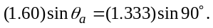 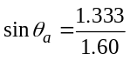 and 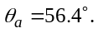 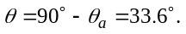
Evaluate: The critical angle increases when the ratio 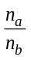 decreases.
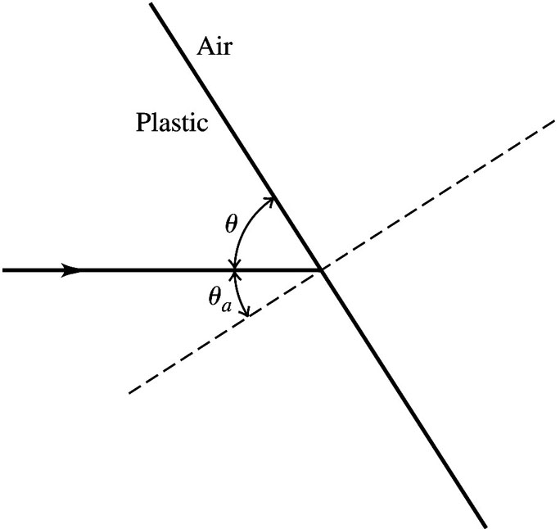
Figure 33.15

33.19. Identify and Set Up: For glass water, 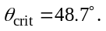 Apply Snell’s law with 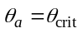 to calculate the index of refraction 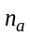 of the glass.
Execute: 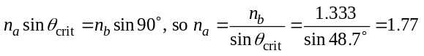
Evaluate: For total internal reflection to occur the light must be incident in the material of larger refractive index. Our results give 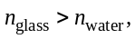 in agreement with this.

33.23. Identify: The index of refraction depends on the wavelength of light, so the light from the red and violet ends of the spectrum will be bent through different angles as it passes into the glass. Snell’s law applies at the surface.
Set Up: From the graph in Figure 33.17 in the textbook, for 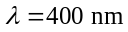 (the violet end of the visible spectrum), 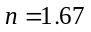 and for 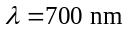 (the red end of the visible spectrum), 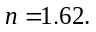 The path of a ray with a single wavelength is sketched in Figure 33.23.
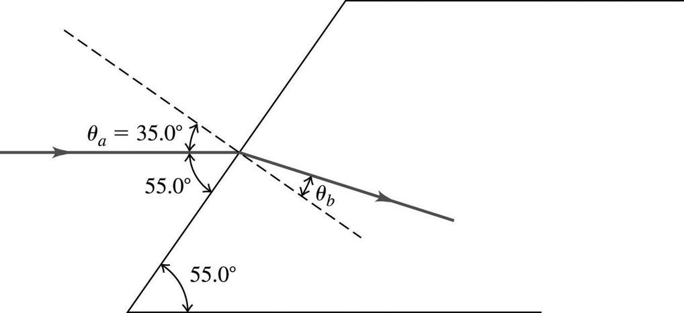
Figure 33.23
Execute: For 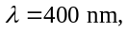 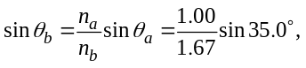 so 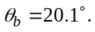 For 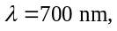 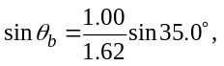 so 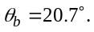 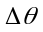 is about 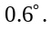
Evaluate: This angle is small, but the separation of the beams could be fairly large if the light travels through a fairly large slab.

33.29. Identify and Set Up: Reflected beam completely linearly polarized implies that the angle of incidence equals the polarizing angle, so 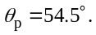 Use Brewster’s law, 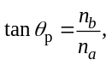 to calculate the refractive index of the glass. Then use Snell’s law to calculate the angle of refraction. See Figure 33.29.
Execute: (a) 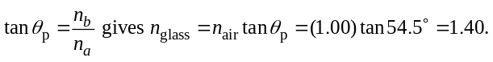
(b)
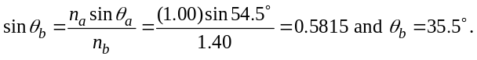
Evaluate:
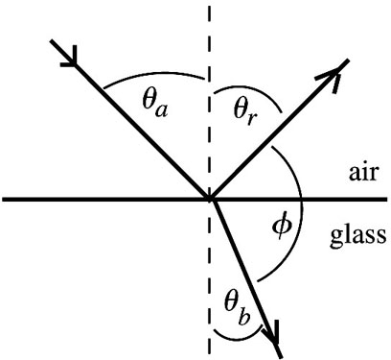 |  | Note: 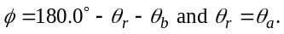  Thus 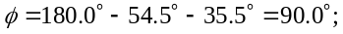  the reflected ray and the refracted ray are  perpendicular to each other. This agrees  with Figure 33.28 in the textbook.
Figure 33.29

33.42. Identify: Because the prism is a right-angle prism, the normals at point A and at surface BC are perpendicular to each other (see Figure 33.42). Therefore the angle of incidence at A is 50.0°, and this is the critical angle at that surface. Apply Snell’s law at A and at surface BC. For light incident at the critical angle, the angle of refraction is 90°.
Figure 33.42

Set Up: Apply Snell’s law: Use n = 1.00 for air, and let n be the index of refraction of the glass.
Execute: Apply Snell’s law at point A.
n sin(50.0°) = (1.00) sin(90°) = 1.00.
n = 1.305.
Now apply Snell’s law at surface BC.
(1.00) 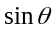 = (1.305) sin(40.0°).
= 57.0°.
Evaluate: The critical angle at A would not be 50.0° if the prism were not a right-angle prism.

33.45. Identify: Use Snell’s law to determine the effect of the liquid on the direction of travel of the light as it enters the liquid.
Set Up: Use geometry to find the angles of incidence and refraction. Before the liquid is poured in, the ray along your line of sight has the path shown in Figure 33.45a (next page).

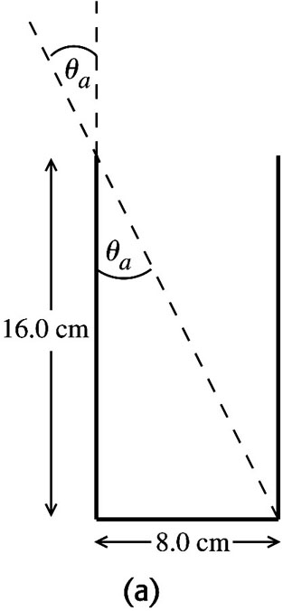 |  | 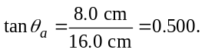  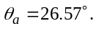
Figure 33.45a

After the liquid is poured in, is the same and the refracted ray passes through the center of the bottom of the glass, as shown in Figure 33.45b.

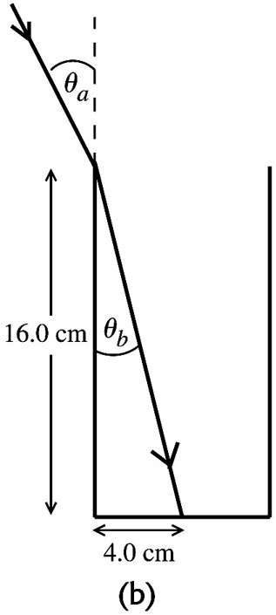 |  | 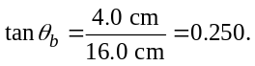  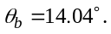
Figure 33.45b

Execute: Use Snell’s law to find 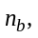 the refractive index of the liquid:
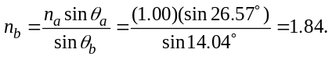
Evaluate: When the light goes from air to liquid (larger refractive index) it is bent toward the normal.
33.50. Identify: The ray shown in the figure that accompanies the problem is to be incident at the critical angle.
Set Up: The incident angle for the ray in the figure is 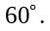
Execute: gives 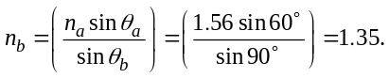
Evaluate: Total internal reflection occurs only when the light is incident in the material of the greater refractive index.

