Chapter 34  Geometric Optics (14th Ed.) | 34
34.3. Identify and Set Up: The virtual image formed by a plane mirror is the same size as the object and the same distance from the mirror as the object.
Execute: 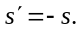 The image of the tip is 12.0 cm behind the mirror surface and the image of the end of the eraser is 21.0 cm behind the mirror surface. The length of the image is 9.0 cm, the same as the length of the object. The image of the tip of the lead is the closest to the mirror surface.
Evaluate: The same result would hold no matter how far the pencil was from the mirror.
34.6. Identify: Apply 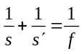 and 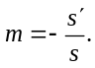
Set Up: For a convex mirror, 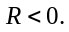 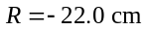 and 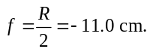
Execute: (a) The principal-ray diagram is sketched in Figure 34.6.
(b) 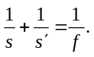 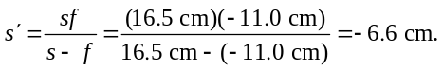 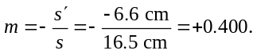 The image is 6.6 cm to the right of the mirror. It is 0.240 cm tall. 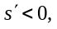 so the image is virtual. 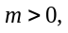 so the image is erect.
Evaluate: The calculated image properties agree with the image characterization from the principal-ray diagram.

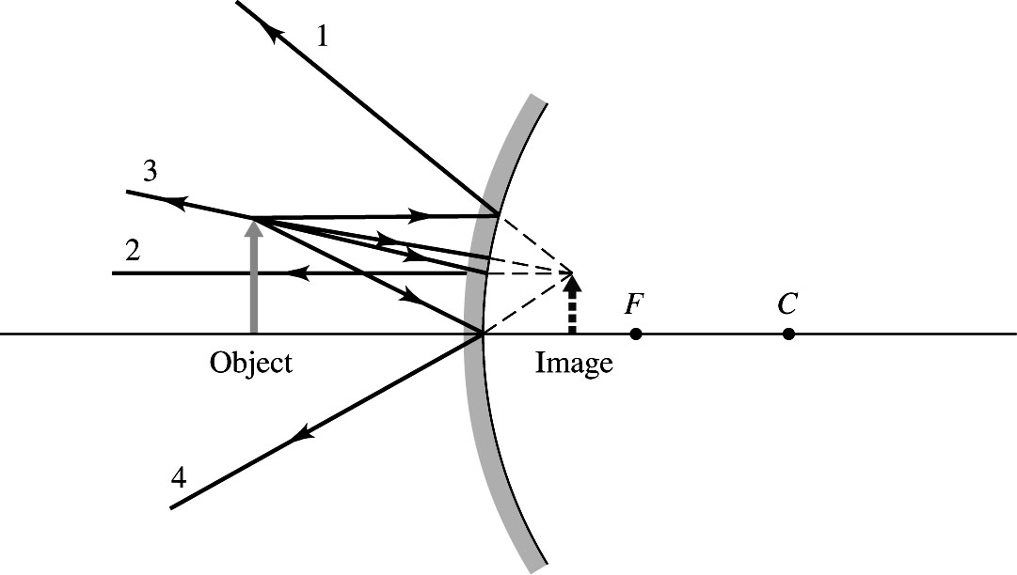
Figure 34.6

Evaluate: The image is virtual, upright and much smaller than the object.

34.11. Identify: Apply and
Set Up: For a concave mirror, 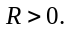 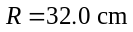 and 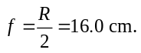
Execute: (a) 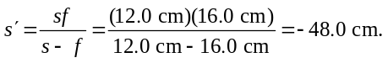 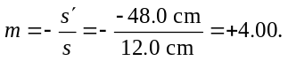
(b) 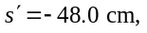 so the image is 48.0 cm to the right of the mirror. 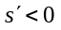 so the image is virtual.
(c) The principal-ray diagram is sketched in Figure 34.11 (next page). The rules for principal rays apply only to paraxial rays. Principal ray 2, which travels to the mirror along a line that passes through the focus, makes a large angle with the optic axis and is not described well by the paraxial approximation. Therefore, principal ray 2 is not included in the sketch.
Evaluate: A concave mirror forms a virtual image whenever 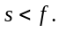
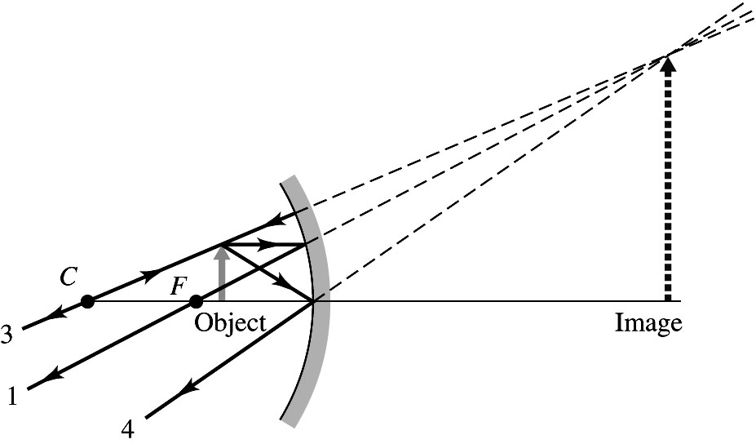
Figure 34.11

34.13. Identify: and 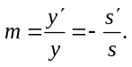
Set Up: 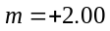 and 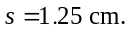 An erect image must be virtual.
Execute: (a) 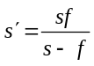 and 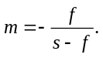 For a concave mirror, m can be larger than 1.00. For a convex mirror, 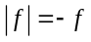 so 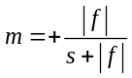 and m is always less than 1.00. The mirror must be concave 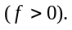
(b) 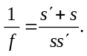 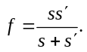 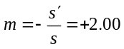 and 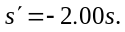 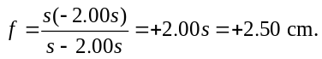 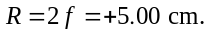
(c) The principal-ray diagram is drawn in Figure 34.13.
Evaluate: The principal-ray diagram agrees with the description from the equations.

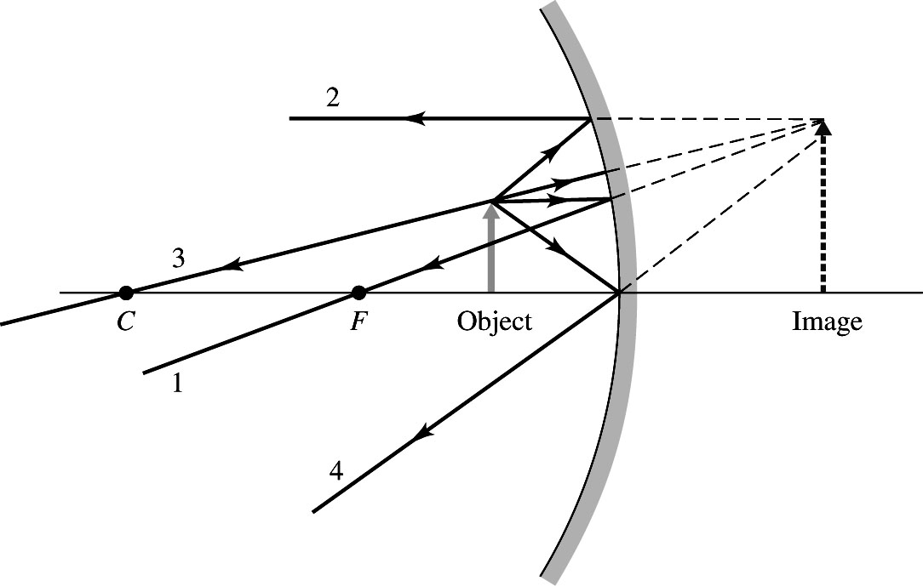
Figure 34.13

34.15. Identify: In part (a), the shell is a concave mirror, but in (b) it is a convex mirror. The magnitude of its focal length is the same in both cases, but the sign reverses.
Set Up: For the orientation of the shell shown in the figure in the problem, 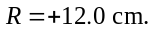 When the glass is reversed, so the seed faces a convex surface, 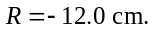 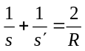 and
Execute: (a) 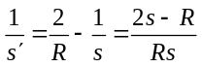 and 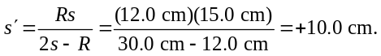 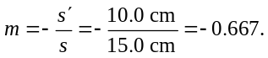 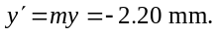 The image is 10.0 cm to the left of the shell vertex and is 2.20 mm tall.
(b) 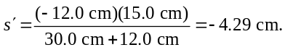 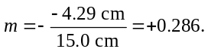 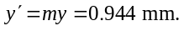 The image is 4.29 cm to the right of the shell vertex and is 0.944 mm tall.
Evaluate: In (a), 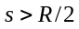 and the mirror is concave, so the image is real. In (b) the image is virtual because a convex mirror always forms a virtual image.

34.5. Identify and Set Up: Use to calculateand use 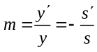 to calculate 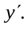 The image is real if is positive and is erect if 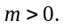 Concave means R and f are positive,
Execute: (a)

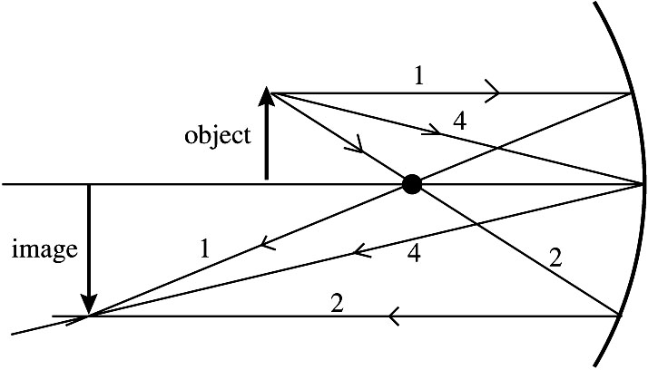 |  | Three principal rays,  numbered as in Section 34.2,  are shown in Figure 34.5.  The principal-ray diagram  shows that the image is real,  inverted, and enlarged.
Figure 34.5

(b)
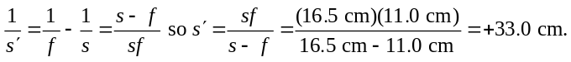
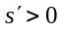 so real image, 33.0 cm to left of mirror vertex.
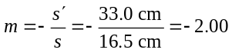 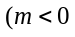 means inverted image) 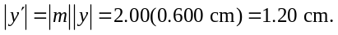
Evaluate: The image is 33.0 cm to the left of the mirror vertex. It is real, inverted, and is 1.20 cm tall (enlarged). The calculation agrees with the image characterization from the principal-ray diagram.
A concave mirror used alone always forms a real, inverted image if 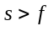 and the image is enlarged
if 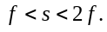

34.29. Identify: Use the lensmaker’s equation and the thin-lens equation.
Set Up: Combine the lensmaker’s equation and the thin-lens equation to get 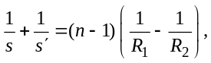 and use the fact that the magnification of the lens is
Execute: (a) 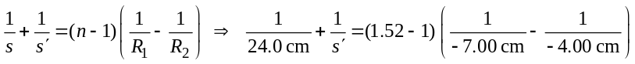
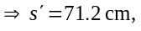 to the right of the lens.
(b) 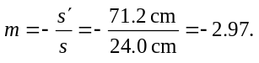
Evaluate: Since the magnification is negative, the image is inverted.

34.33. Identify: Apply 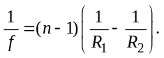
Set Up: For a distant object the image is at the focal point of the lens. Therefore, 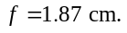 For the double-convex lens, 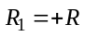 and 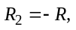 where 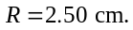
Execute: 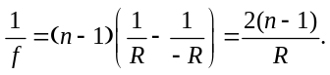 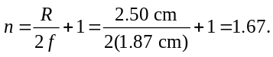
Evaluate: 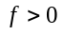 and the lens is converging. A double-convex lens surrounded by air is always converging.

34.41. Identify: The first lens forms an image that is then the object for the second lens.
Set Up: Apply to each lens. 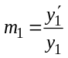 and 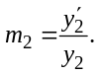
Execute: (a) Lens 1: gives 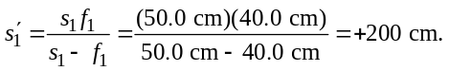 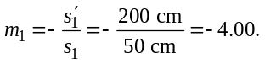 The image is 200 cm
to the right of lens 1, is 4.80 cm tall and is inverted.
(b) Lens 2: 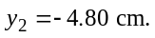 The image is 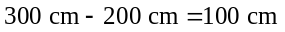 to the left of lens 2, so 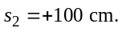 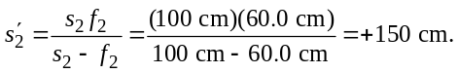 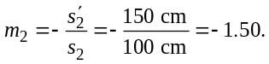
The image is 150 cm to the right of the second lens, is
7.20 cm tall, and is erect with respect to the original object.
Evaluate: The overall magnification of the lens combination is 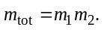

34.44. Identify: Use the lensmaker’s equation to find the radius of curvature of the lens of the eye.
Set Up: If R is the radius of the lens, then 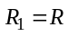 and 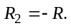
Execute: (a) 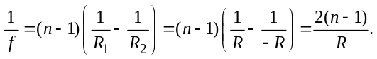
(b) 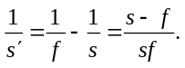 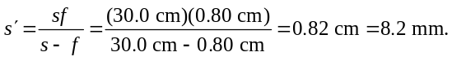 The image is 8.2 mm from the lens, on the side opposite the object. 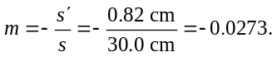 so the image is real. 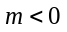 so the image is inverted.
Evaluate: The lens is converging and has a very short focal length. As long as the object is farther than 8.0 mm from the eye, the lens forms a real image.

34.58. Identify: For a thin lens, 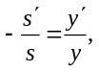 so 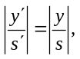 and the angular size of the image equals the angular size of the object.
Set Up: The object has angular size 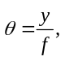with in radians.
Execute: 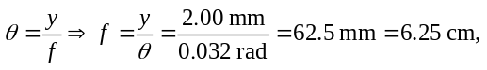 which rounds to 6.3 cm.
Evaluate: If the insect were at the near point of a normal human eye, its angular size would be 

