Physics 51
Homework Solutions
Chapter 26
Young and Freedman, 13th Ed

26.11. I dentify and Set Up: Ohm’s law applies to the resistors, the potential drop across resistors in parallel is the same for each of them, and at a junction the currents in must equal the currents out.
Execute: (a) 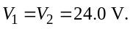
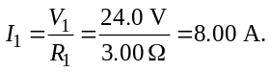
(b) 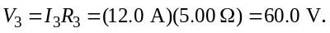
Evaluate: Series/parallel reduction was not necessary in this case.

26.17. Identify: Apply Ohm’s law to each resistor.
Set Up: For resistors in parallel the voltages are the same and the currents add. For resistors in series the currents are the same and the voltages add.
Execute: The current through the 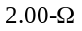 resistor is 6.00 A. Current through the 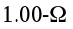 resistor also is 6.00 A and the voltage is 6.00 V. Voltage across the 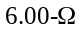 resistor is 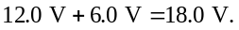Current through the resistor is 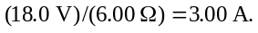 The battery emf is 18.0 V.
Evaluate: The current through the battery is 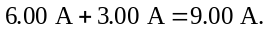 The equivalent resistor of the resistor network is 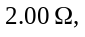 and this equals 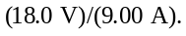

26.25. Identify: Apply Kirchhoff’s point rule at point a to find the current through R. Apply Kirchhoff’s loop rule to loops (1) and (2) shown in Figure 26.25a to calculate R and Travel around each loop in the direction shown.
(a) Set Up:

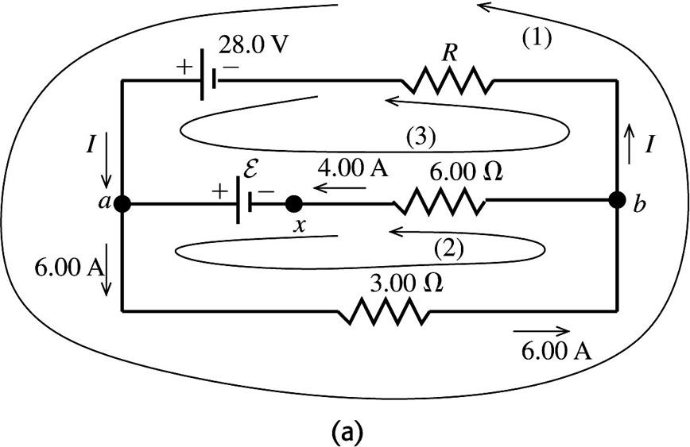
Figure 26.25a

Execute: Apply Kirchhoff’s point rule to point a: 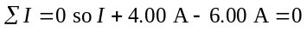
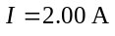 (in the direction shown in the diagram).
(b) Apply Kirchhoff’s loop rule to loop (1):
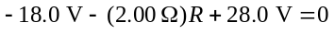
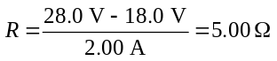
(c) Apply Kirchhoff’s loop rule to loop (2):
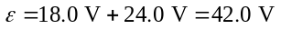
Evaluate: Can check that the loop rule is satisfied for loop (3), as a check of our work:
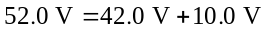
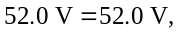 so the loop rule is satisfied for this loop.
(d) Identify: If the circuit is broken at point x there can be no current in the 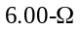 resistor. There is now only a single current path and we can apply the loop rule to this path.
Set Up: The circuit is sketched in Figure 26.25b.

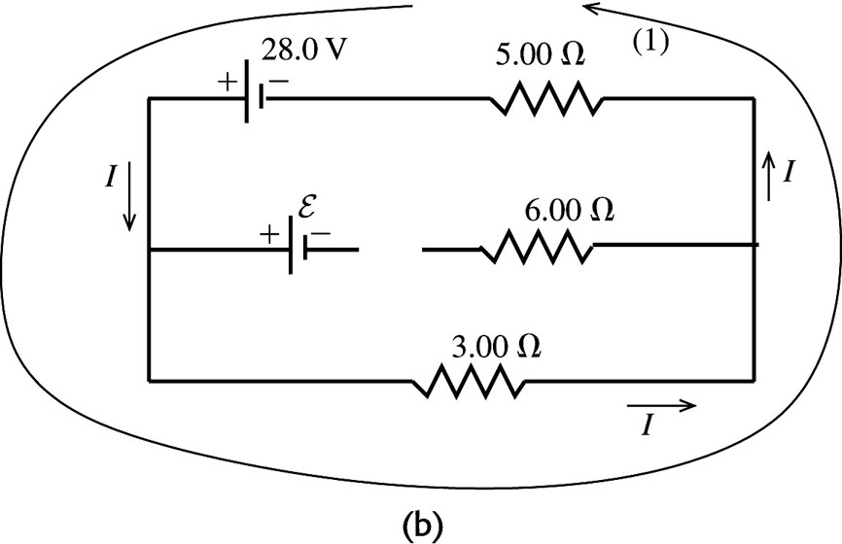
Figure 26.25b

Execute:
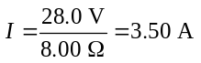
Evaluate: Breaking the circuit at x removes the 42.0-V emf from the circuit and the current through the 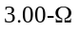 resistor is reduced.

26.27. Identify: Apply the junction rule at points a, b, c and d to calculate the unknown currents. Then apply the loop rule to three loops to calculate 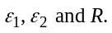
(a) Set Up: The circuit is sketched in Figure 26.27.

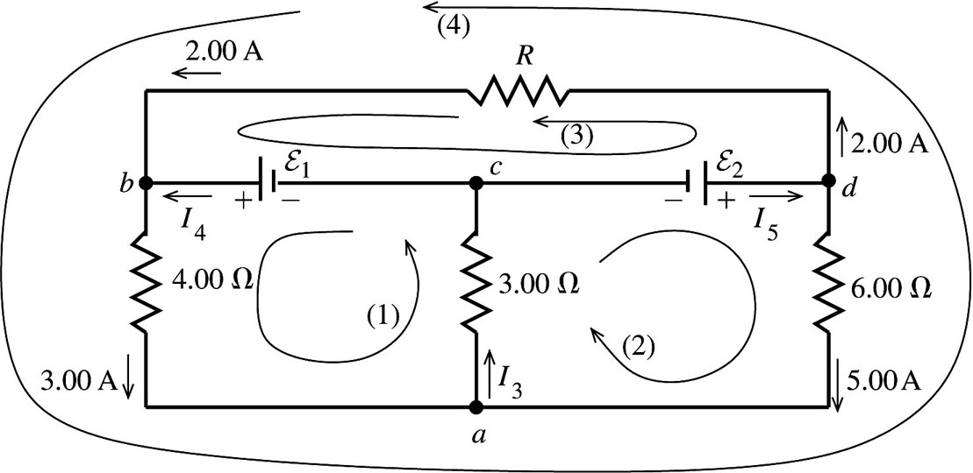
Figure 26.27

Execute: Apply the junction rule to point a: 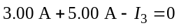
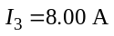
Apply the junction rule to point b: 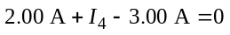
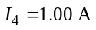
Apply the junction rule to point c: 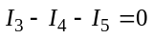
Evaluate: As a check, apply the junction rule to point d: 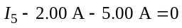
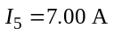
(b) Execute: Apply the loop rule to loop (1): 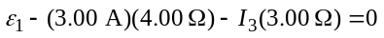
Apply the loop rule to loop (2): 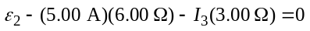
(c) Apply the loop rule to loop (3): 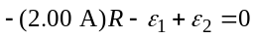
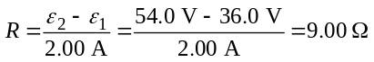
Evaluate: Apply the loop rule to loop (4) as a check of our calculations:
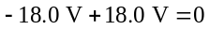
26.28. Identify: Use Kirchhoff’s rules to find the currents.
Set Up: Since the 10.0-V battery has the larger voltage, assume is to the left through the 10-V battery, 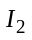 is to the right through the 5 V battery, and is to the right through the 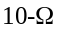 resistor. Go around each loop in the counterclockwise direction.
Execute: Upper loop: This gives 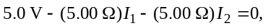 and 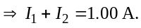
Lower loop: This gives 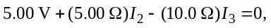 and 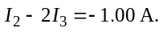
Along with 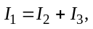 we can solve for the three currents and find:
(b)
Evaluate: Traveling from b to a through the 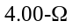 and resistors you pass through the resistors in the direction of the current and the potential decreases; point b is at higher potential than point a.

26.40. Identify: An uncharged capacitor is placed into a circuit. Apply the loop rule at each time.
Set Up: The voltage across a capacitor is 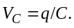
Execute: (a) At the instant the circuit is completed, there is no voltage across the capacitor, since it has no charge stored.
(b) Since 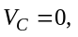 the full battery voltage appears across the resistor 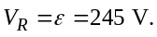
(c) There is no charge on the capacitor.
(d) The current through the resistor is 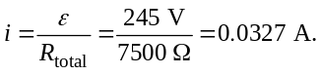
(e) After a long time has passed the full battery voltage is across the capacitor and 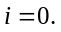 The voltage across the capacitor balances the emf: 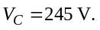 The voltage across the resistor is zero. The capacitor’s charge is The current in the circuit is zero.
Evaluate: The current in the circuit starts at 0.0327 A and decays to zero. The charge on the capacitor starts at zero and rises to 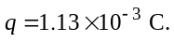

26.42. Identify: For a charging capacitor 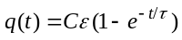 and 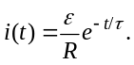
Set Up: The time constant is
Execute: (a) At 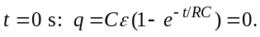
At
At
At
At
(b) The current at time t is given by: 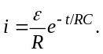
At 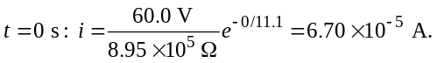
At 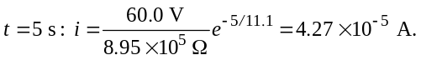
At 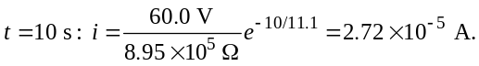
At 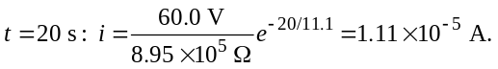
At 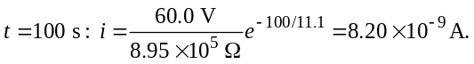
(c) The graphs of 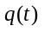 and 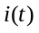 are given in Figure 26.42a and b.
Evaluate: The charge on the capacitor increases in time as the current decreases.

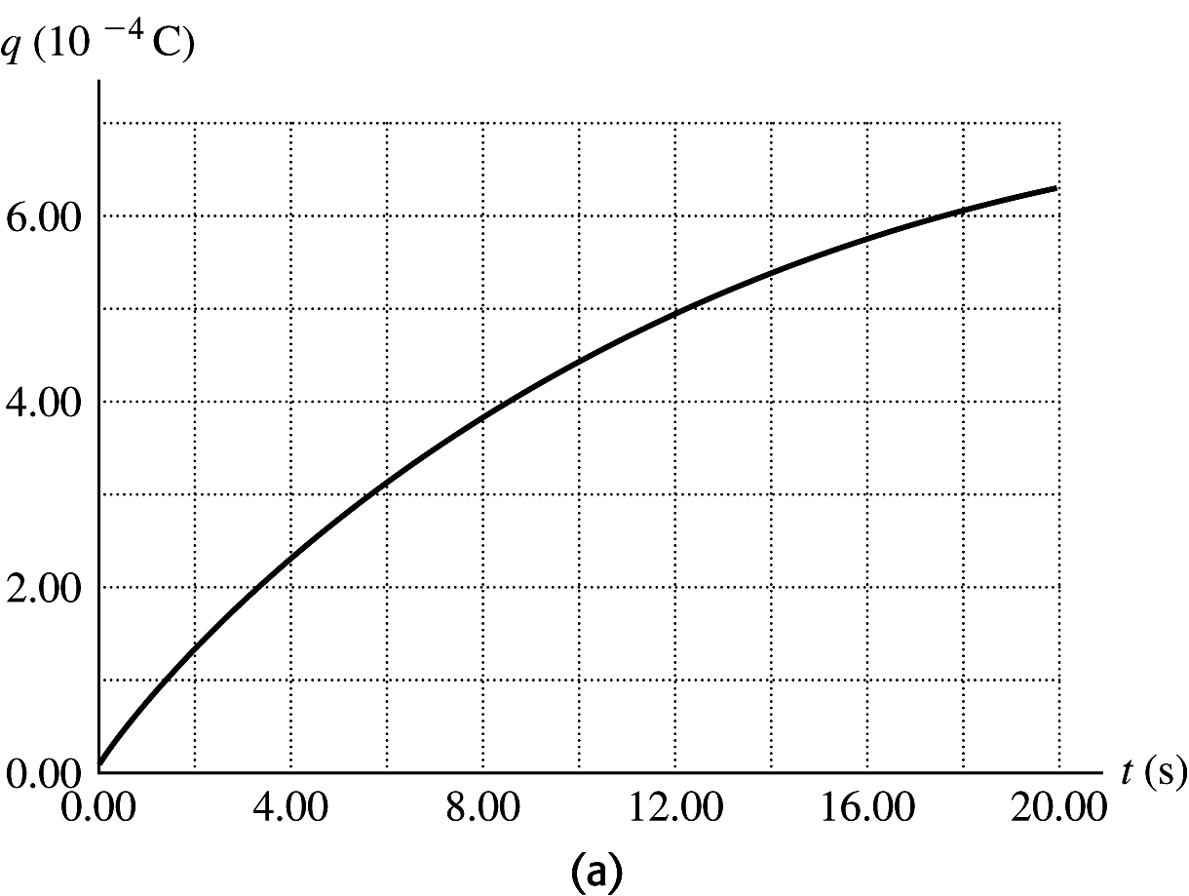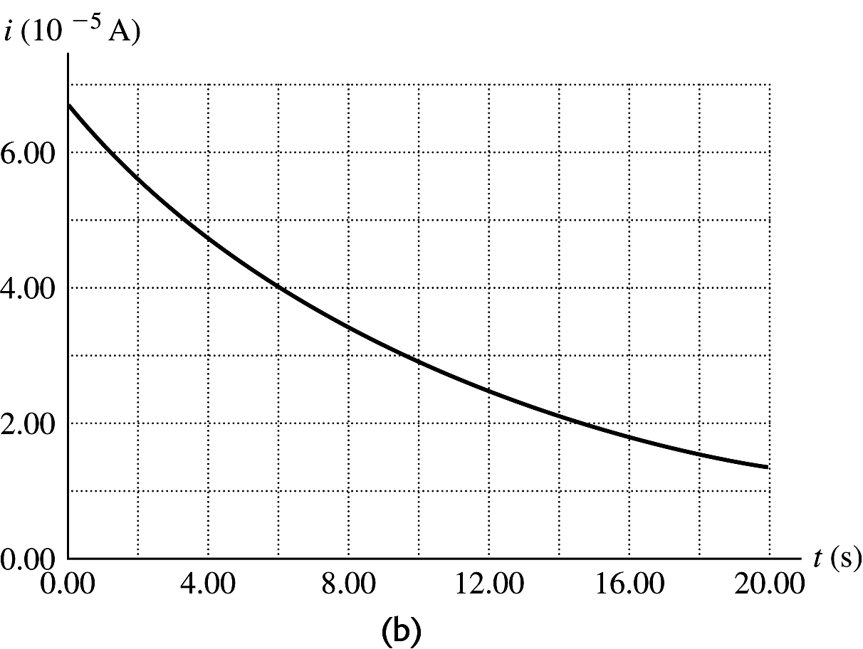
Figure 26.42

26.43. Identify: The capacitors, which are in parallel, will discharge exponentially through the resistors.
Set Up: Since V is proportional to Q, V must obey the same exponential equation as Q,
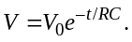 The current is 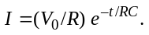
Execute: (a) Solve for time when the potential across each capacitor is 10.0 V:
(b) 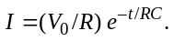 Using the above values, with 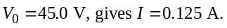
Evaluate: Since the current and the potential both obey the same exponential equation, they are both reduced by the same factor (0.222) in 4.21 ms.

26.60. Identify: Half the current flows through each parallel resistor and the full current flows through the third resistor, that is in series with the parallel combination. Therefore, only the series resistor will be at its maximum power.
Set Up: 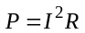
Execute: The maximum allowed power is when the total current is the maximum allowed value of 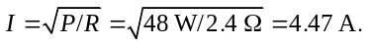 Then half the current flows through the parallel resistors and the maximum power is
Evaluate: If all three resistors were in series or all three were in parallel, then the maximum power would be 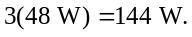 For the network in this problem, the maximum power is half this value.

26.65. Identify and Set Up: The circuit is sketched in Figure 26.65.

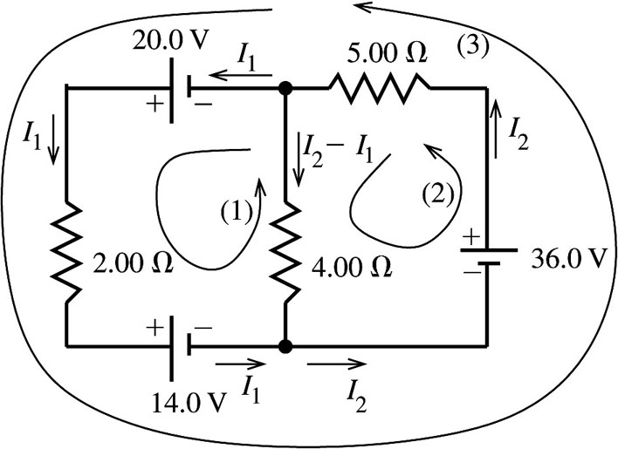 |  | Two unknown currents (through the 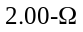 resistor) and (through the 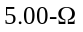 resistor) are labeled on the circuit diagram. The current through the resistor has been written as 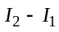 using the junction rule.
Figure 26.65

Apply the loop rule to loops (1) and (2) to get two equations for the unknown currents, 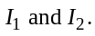 Loop (3) can then be used to check the results.
Execute: 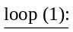
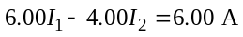
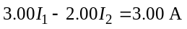 eq. (1)
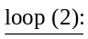
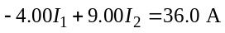 eq. (2)
Solving eq. (1) for 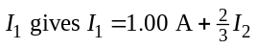
Using this in eq. (2) gives 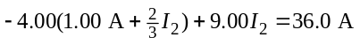
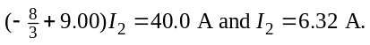
Then 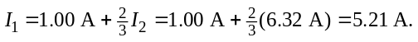
In summary then
Current through the resistor: 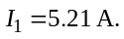
Current through the resistor: 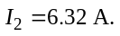
Current through the resistor: 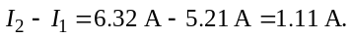
Evaluate: Use loop (3) to check.
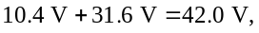 so the loop rule is satisfied for this loop.

