Homework Solution
Chapter 28
Young and Freedman 13 th Edition

28.2. Identify: A moving charge creates a magnetic field as well as an electric field.
Set Up: The magnetic field caused by a moving charge is and its electric field is since
Execute: Substitute the appropriate numbers into the above equations.
out of the page.
toward the electron.
Evaluate: There are enormous fields within the atom!
28.3. Identify: A moving charge creates a magnetic field.
Set Up: The magnetic field due to a moving charge is
Execute: Substituting numbers into the above equation gives
(a)
(b)
out of the page.
(c)
Evaluate: Even at high speeds, these charges produce magnetic fields much less than the earth’s magnetic field.

28.14. Identify: A current segment creates a magnetic field.
Set Up: The law of Biot and Savart gives
Both fields are into the page, so their magnitudes add.
Execute: Applying the law of Biot and Savart for the 12.0-A current gives
The field from the 24.0-A segment is twice this value, so the total field is into the page.
Evaluate: The rest of each wire also produces field at P. We have calculated just the field from the two segments that are indicated in the problem.

28.26. Identify: Each segment of the rectangular loop creates a magnetic field at the center of the loop, and all these fields are in the same direction.
Set Up: The field due to each segment is is into paper so I is clockwise around the loop.
Execute: Long sides: For the two long sides,
Short sides: For the two short sides,
Using the known field, we have which gives
Evaluate: This is a typical household current, yet it produces a magnetic field which is about the same as the earth’s magnetic field.

28.27. Identify: The net magnetic field at the center of the square is the vector sum of the fields due to each wire.
Set Up: For each wire, and the direction of is given by the right-hand rule that is illustrated in Figure 28.6 in the textbook.
Execute: (a) and (b) since the magnetic fields due to currents at opposite corners of the square cancel.
(c) The fields due to each wire are sketched in Figure 28.27.
so
Evaluate: In part (c), if all four currents are reversed in direction, the net field at the center of the square would be to the right.

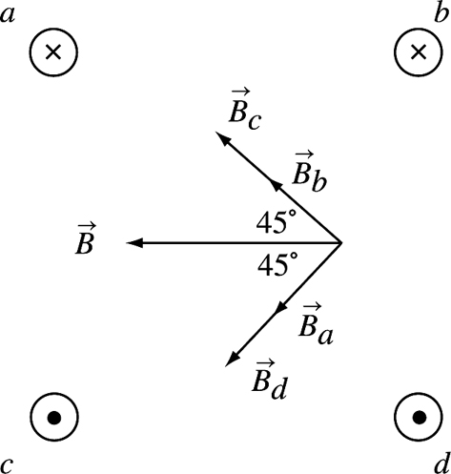
Figure 28.27

28.30. Identify: Apply Eq. (28.11) for the force from each wire.
Set Up: Two parallel conductors carrying current in the same direction attract each other. Parallel conductors carrying currents in opposite directions repel each other.
Execute: On the top wire upward. On the middle wire, the magnetic forces cancel so the net force is zero. On the bottom wire downward.
Evaluate: The net force on the middle wire is zero because at the location of the middle wire the net magnetic field due to the other two wires is zero.

28.36. Identify: The magnetic field at the center of a circular loop is By symmetry each segment of the loop that has length contributes equally to the field, so the field at the center of a semicircle is that of a full loop.
Set Up: Since the straight sections produce no field at P, the field at P is
Execute: The direction of is given by the right-hand rule: is directed into the page.
Evaluate: For a quarter-circle section of wire the magnetic field at its center of curvature is

28.39. Identify: Apply Eq. (28.16).
Set Up: At the center of the coil, a is the radius of the coil, 0.020 m.
Execute: (a)
(b)
Evaluate: As shown in Figure 28.14 in the textbook, the field has its largest magnitude at the center of the coil and decreases with distance along the axis from the center.

28.74. Identify: Apply
Set Up: The two straight segments produce zero field at P. The field at the center of a circular loop of radius R is so the field at the center of curvature of a semicircular loop is
Execute: The semicircular loop of radius a produces field out of the page at P and the semicircular loop of radius b produces field into the page. Therefore, out of page.
Evaluate: If

