Physics 50 Workshop

Week 1.

Topic: Chapter 1: Unit conversions and adding vectors

\*Please note that the workshop problems are designed to give you practice on the most essential topics from each chapter. Your lecture instructor will probably cover more topics in class. For the unit conversions, I realize that you can just look it up, but try to work through the math so that you know how it’s done.

Some useful background info:

The textbook uses the standard mathematical convention that an angle is measured counterclockwise from the +x axis. For example, the +y axis is +90o.

North, south, east and west can also be expressed as angles but the convention is different (probably because mathematicians do not make maps). North is defined as 0o and the angles are measured *clockwise* from there, so that east is 90o, south is 180o and west is 270o. Northeast, or NE, is exactly halfway between north and east. North northeast (NNE) is exactly halfway between NE and N. Likewise for all the other points on the compass:

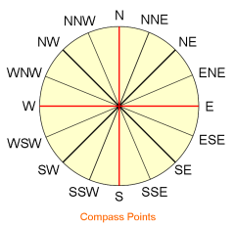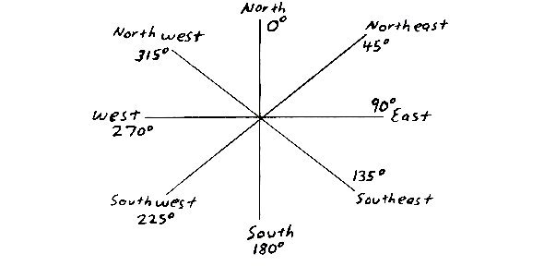

For instance, if you are heading in the direction ESE then your direction is 112.5o. For any problems that deal with directions on a map, first figure out what the angle is, relative to north (0o). A problem may specify that you are traveling in a direction that is 15o north of west: that means you’re roughly heading west, except slightly toward the north, so your exact direction is 270o + 15o = 285o. If you are traveling 10o east of south, then your direction is 180o – 10o = 170o. Look at the figures above to figure out if you add or subtract the angle. I recommend first converting the NSEW directions into the usual mathematical convention, then converting your answer back into NSEW values at the end. That is how I write my solutions.

1. While exploring a cave, a spelunker starts at the entrance and goes 75.0 m north, 250 m east, 125 m at an angle of 30o north of east, and 150 m south. Find the resultant (total) displacement from the starting position (give a distance and angle).
2. A particle undergoes the following displacements: 3.50 m south, 8.20 m northeast, and 15.0 m west. What is the resultant displacement?
3. A man pushing a mop across the floor causes it to undergo two displacements: the first has a displacement of 150 cm at an angle of 120o from the x axis, the second one is unknown. The resultant displacement is 140 cm from the origin at an angle of 35o from the x axis. Find the magnitude and direction of the second displacement.
4. Consider the two vectors  and  . Calculate (a) , (b) , (c) , (d)  , and the directions of  and  .
5. Given the displacement vectors  and  (where m is for meters), find the magnitudes of the vectors (a)  and (b) , also expressing each vector in terms of its rectangular (x,y,z) components.
6. A typical rock has a density of about 3 g/cm3. What is the mass of a cubic meter of rock, in kg?
7. How many square meters are in 15,000 square km?
8. The mks (meter kilogram second) unit for energy is the joule (J). A joule is defined as a . The cgs (centimeter gram second) unit for energy is the erg, which is defined as . How many ergs are in one joule?
9. Convert  m3 into cubic micrometers (micro = 10-6) .

Answers:

1. Distance is 360 m (rounded to 2 significant digits) and the direction is 2.0o south of east
2. The total distance is 9.48 m and the direction is 14o north of west (or 166o from the +x axis)
3. The length (magnitude) of vector B is 196 m and the angle is 345o or -14.5o (14.5o below the x axis)
4. (a)  (b)  (c) 6.32 (d) 4.47 (e) the direction of vector  is 289o (or -71o) and the direction of  is 26.6o.
5. (a) the x,y,z components are (+5,-1,-3) and the magnitude is 5.9 m (b) the components are (+4,-11,+15) and the length is 19 m.
6. 3000 kg
7. 1.5 x 1010 m2
8. 107 ergs per joule
9.  cubic micrometers