Physics 50 Workshop
Chapter 4: Newton’s Laws

A reminder about force problems: always keep the forces ΣF separate from the mass that is accelerating (ma). Use free-body diagrams, where each arrow represents the force due to some object other than the mass m in F = ma. Then just add the forces like vectors (same as always) and the acceleration is that of mass m.

Draw free-body diagrams for the following scenarios:

a) A sky diver in free fall.

b) A feather slowly wafting to the ground

c) Two blocks attached by a string (draw two separate diagrams, one for each object). There is no air resistance and the blocks move at constant velocity.

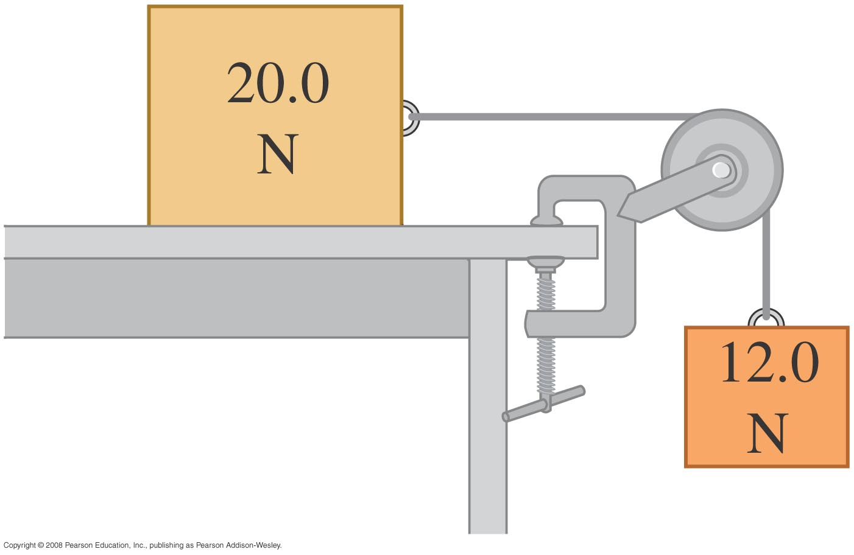

d) A small rock sinking at a constant speed in a pool.

e) A skier, speeding up as she skis down a slope (include friction)

f) A pendulum (a 1kg mass swinging back and forth at the end of a long string)

g) The Earth orbiting the Sun.

h) a ball that was tossed vertically in the air, at the instant when it is at the top of its path (where its velocity is zero)

1. A space traveler whose mass is 75.0 kg leaves the Earth on a space ship. Find his mass and weight a) on earth, b) on Mars, where the acceleration due to gravity is 3.8 m/s², and c) in space, very far from either planet, while the ship is moving at a constant velocity.

2. A car moving at an intial speed of 80 km/hour weighs 13,000 N. It requires 61 meters to stop, assuming constant acceleration. Find a) the braking force required to stop the car, b) the time required to stop. If the car was moving at 40 km/hour initially, and has the same braking force, find c) the distance required to stop and d) the time required to stop.

B
A
C
T₂
T₁

3. An elevator consists of an elevator car (A, in diagram), counterweight B, and a driving mechanism C, connected over two pulleys with a strong cable. A and B move, C does not. Find the tension in cable 1 and the tension cable 2 (the tension force is shown in diagram with the letter T). the Car, A has a mass of 1100 kg and the counterweight B has a mass of 1000 kg. The car accelerates upward at a constant rate of 2.0 m/s² .

4. An electron travels in a straight line from the cathode of a vacuum tube to its anode (negative and positive ends, respectively) due to the electric field between the two ends of the tube. It travels a distance of 1.0 cm. The electron starts at rest and reaches the anode at a speed of 6.0 x 10⁶ m/s. Its acceleration is constant, and the mass of the electron is 9.1 x 10⁻³¹ kg. Find the electrical force on the electron. How many times greater is this than the gravitational force (i.e. the electron’s weight)?

5. Three blocks are connected as shown. Someone pulls them toward the right with a force of 60 N on string #3. The table on which the blocks slide is frictionless and horizontal. Find T₁ and T₂ (the tensions in string 1 and 2).

10 kg
20 kg
30 kg
T₁
T₂
T₃

Answers to this week’s problems:

1. mass is always the same. Weight on earth is 735 N, weight on Mars is 285 N. In space, weight is zero because there is no gravitational force when you are far from a source of gravity (i.e. a planet)

2. a) 5400 N, b) 5.5 seconds, c) 15 m, d) 2.7 sec.

3. T₁ = 13000 N and T₂ = 7800 N

4. 1.6 x 10⁻¹⁵, which is about 10¹⁴ times greater than the gravitational force, mg.

5. T₁ = 10 N and T₂ = 30 N.

