Physics 50 workshop problem set.
Review of Chapters 1, 2, and 3.

1. The figure to the right shows the velocity of a car moving in a straight line.
a) Find the average acceleration in each segment (I, II, and III).
b) Find the total distance that the car travelled from 0 to 24 seconds.
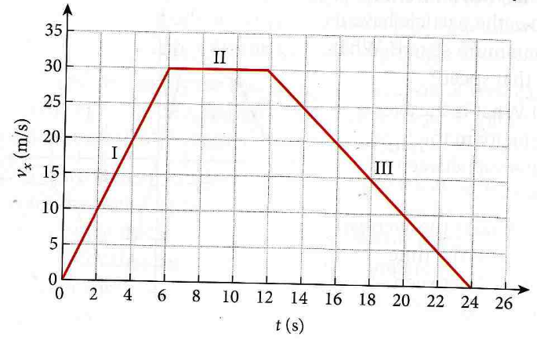

2. The orcs are storming the castle at Helms Deep, which looms 200.0 meters over the battlefield below. The elves, being expert marksmen, never miss their targets when they shoot their arrows at orcs. They shoot their arrows at an angle of 45.0 degrees (above the horizontal) at a speed of 50.0 m/s. Being elvish arrows, they of course experience no drag forces as they fly through the air.

How far from the base of the castle do the arrows slay the orcs? (You may neglect the height of the orc because it is small compared to the height of the castle.)

3. One of the orcs in problem 2 manages to survive the initial volley of arrows and is charging toward the castle at a constant speed of 5.00 m/s. Legolas sees him and instantly fires his arrow when the orc is 120.0 meters from the base of the castle. At what velocity (speed and angle) must Legolas fire the arrow such that the orc is slain at a distance of 102.5 m from the castle wall? (Again, neglect the height of the orc.)

4. A ferris wheel of 25.0 meters in diameter is turning at 3.00 revolutions per minute. What is the centripetal acceleration (magnitude and direction) for a point at the top of the wheel?

5. The area of California is 164,000 square miles. How many square km is this? Conversion: 10 km = 6.2 miles.

6. A car is driving around a circular track. The radius of the track is 700.0 meters. The car starts from rest at the eastern-most part of the track and starts speeding up in the counter-clockwise direction. After 20.0 seconds, it is going 60.0 mph in the counter-clockwise direction. Draw a picture, it will help.
- what is the tangential component of the car’s acceleration? (Hint: its magnitude is constant, and its direction is in the direction the car is going.)
- what is the radial component of the car’s acceleration at t = 15.0 seconds?
- What is the acceleration vector (magnitude and direction) at t = 15.0 seconds? (Hint: you need to know where on the track the car is located at this instant.)

7. Two forces act on an object that is at rest at the origin. Force 1 has a magnitude of 10.0 N and makes a +30.0 degree angle with the x axis. Force 2 has a magnitude of 5.00 N and makes an angle of – 45.0 with the x axis. What force would be required to oppose these two forces, so that the object stays at the origin? Give the magnitude and direction of this force.

8. A rabbit runs in a garden such that the x and y components of his displacement are
x(t) = – 0.45 t² – 6.5 t + 25 and y(t) = 0.35 t² + 8.3 t + 34.
x and y are in meters and t is in seconds.
a) Calculate the rabbit’s position vector (its magnitude and direction, from the origin) at 10 seconds.
b) Calculate the rabbit’s velocity vector at 10 seconds (magnitude and direction).
c) Calculate the rabbit’s acceleration vector at 10 seconds (magnitude and direction).

9. Gold has a density of 19.3 grams per cubic centimeter. What is the density of gold in SI (mks: meter, kg, second) units?

Answers:

1. The figure shows the velocity vs. time of a car moving in a straight line.
a) Find the average acceleration in each segment (I, II, and III).
For segment I: 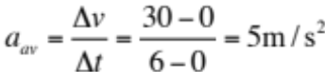

For segment II: 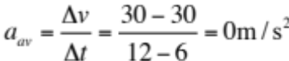

For segment III: 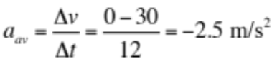

b) Find the total distance that the car travelled from 0 to 24 seconds.
add up the total distance covered in each segment. Use the equation
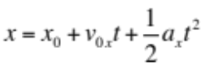three times, once for each segment.
Solve for x-x₀ for each segment. This is the distance for the segment.
The three distances are 90 m, 180 m, and 180 m, for a total of 450 m.

2. First break the velocity into its x and y components. Next use the y component to find the time in the air. Plug these values into 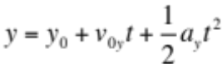where a = -9.8 m/s² and solve for the time, which comes out to be 10.94 seconds. You will have to solve the quadratic equation for t.
Then use that time in 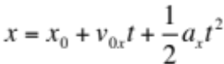to solve for x (where a = 0), and x comes out to be 387 m.

3. At a speed of 5 m/s, the orc covers 120-102.5 = 17.5 meters in 3.5 seconds. This is the time that the arrows spend in the air. Use and where you substitute 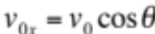 and 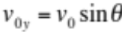, where is the angle that the initial velocity vector makes with the ground. The arrow hits the orc at x =102.5 m from the castle. When you substitute those velocity components in, then you have two equations and two unknowns, 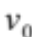 and . Solve for each of those: = 53.78 degrees below horizontal, and =49.1 m/s.

4. 3.00 revolutions per minute is 3.972 m/s at the edge of the ferris wheel. 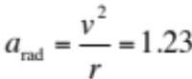 m/s² and is directed toward the center of the wheel (downward, when you are at the top of the wheel).

5. The area of California is 164,000 square miles. How many square km is this? Conversion: 10 km = 6.2 miles. This comes out to be 427,000 square km.

6. Convert units to find that 60 mph is 26.88 m/s.
a) what is the tangential component of the car’s acceleration? (Hint: its magnitude is constant, and its direction is in the direction the car is going.) the tangential component of acceleration is found the usual way that you find acceleration: v = v₀ + at.
Here, a = 1.34 m/s².
b) what is the radial component of the car’s acceleration at t = 15.0 seconds?
Use v = v₀ + at to find the velocity at 15 seconds, which is 20.16 m/s. Then use 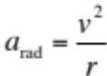 which gives 0.58 m/s².
c) you will need to find the position at 15 seconds: which is about 150 m. the radial component of acceleration is toward the center as always. Now you have the components of the acceleration vector (1.34, 0.58), and you can find the direction the usual way. Just sketching it is fine.

7. Add the two given vectors the usual way. The opposing force is exactly opposite of that: 12 N at an angle of 187 degrees from the +x axis.

8. A rabbit runs in a garden such that the x and y components of his displacement are
x(t) = – 0.45 t² – 6.5 t + 25 and y(t) = 0.35 t² + 8.3 t + 34.
x and y are in meters and t is in seconds.
a) Calculate the rabbit’s position vector (its magnitude and direction, from the origin) at 10 seconds. (Just plug in 10 seconds, which gives you the x and y components of the position vector: <85,152>. The distance is 174 meters at an angle of 119 degrees from the +x axis.
b) Calculate the rabbit’s velocity vector at 10 seconds (magnitude and direction).
Take the derivative and then evaluate at t = 10 sec. components are (-15.5, 15.3) m/s, and the speed is 21.8 m/s at an angle of 135 degrees from x axis.
c) Calculate the rabbit’s acceleration vector at 10 seconds (magnitude and direction). Components are (-0.9, 0.7) magnitude is 1.14 m/s² at an angle of 142 degrees from the x axis.

9. Gold has a density of 19.3 grams per cubic centimeter. What is the density of gold in SI (mks, or meter, kg, second) units? 19,300 kg/m³

