Tech/ME 140 Dr. Samuel C. Obi

Design Project 2: Mold/Die Design or Modular Concept Green Car Design
(60 Points or 60/4 = 15% of Course Grade)

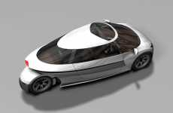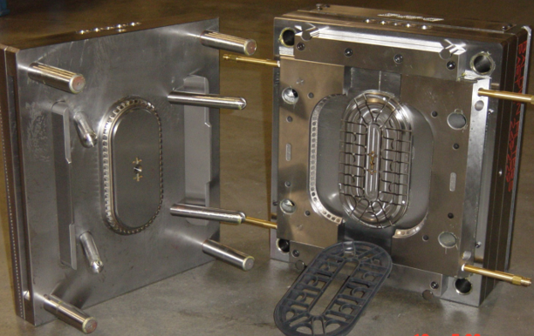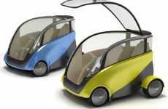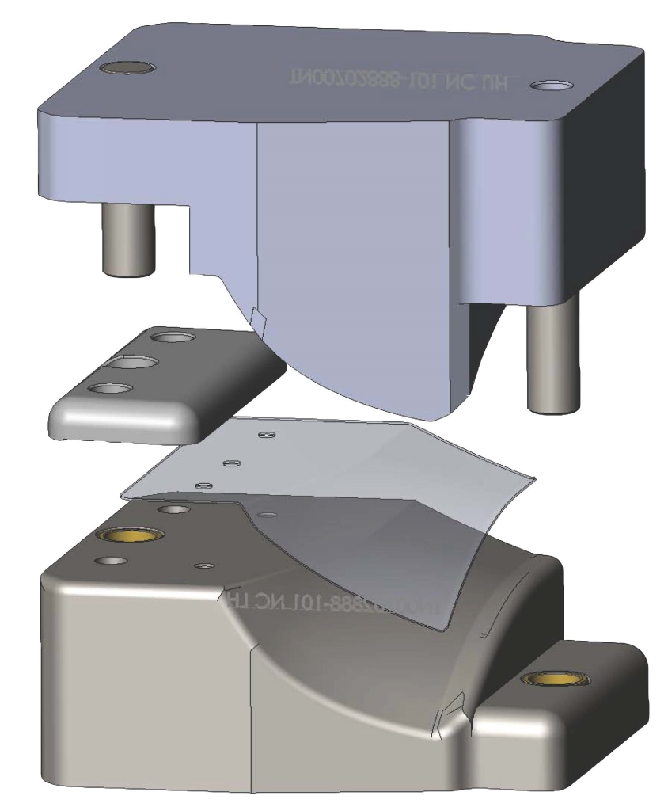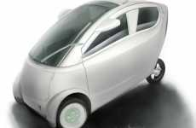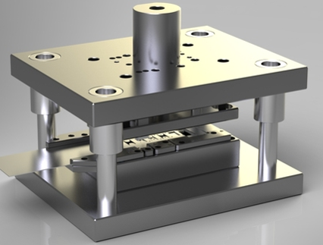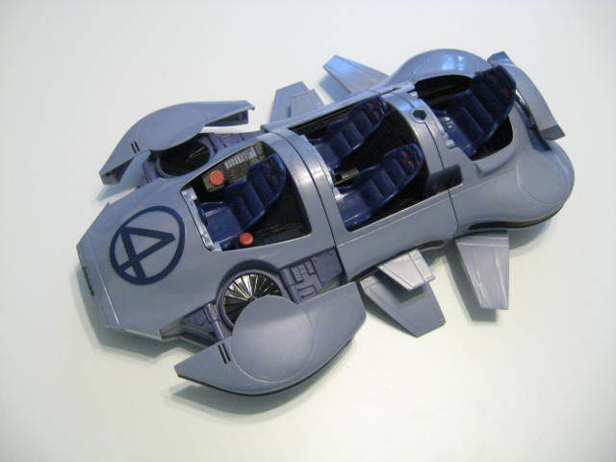

This mold/die (tooling) or Modular Concept Green Car Design Project is worth 15% of the course grade. Details regarding the project (project proposal, drawings, fabricated parts, written reports, oral presentations, etc.) are contained in the following sections.

Mold/Die Design or Miniature Modular Concept Green Car Design Project
The project will be done in groups of 3 students each, as much as possible from different majors. It has both team aspects and individual aspects. Each individual team member has distinct responsibility to design, document, and produce the assigned parts.

This project requires that a 90-100% green mold/die or miniature (1/8 the size of a normal compact small car) 2-person car be designed using the following criteria:
- If mold/die option is selected, its mold halves have to be of sizes that can be made with the 3-D printer, unless the group has access to a bigger resource. Consult the instructor for 3-D printer size specifications. The other parts can be made of any material except wood.
- If mold/die option is selected, the group must design a top plate, top plate shank, bottom plate, upper mold/die half, lower mold/die half, and a product template that is at least 1/8” thick. (See the samples provided by the instructor). These components should be “owned” as follows:

  - Top plate and upper mold/die half
  - Top plate shank and 1/8” thick product template
  - Bottom plate and lower mold/die half

These components must be built to match and function as needed. All hardware like screws, nuts, pins, dowels and nuts may be purchased or obtained from the instructor.
Some parts can be made with the 3-D printer, but not all parts can be so made.

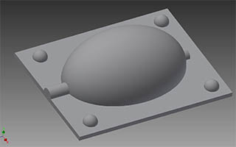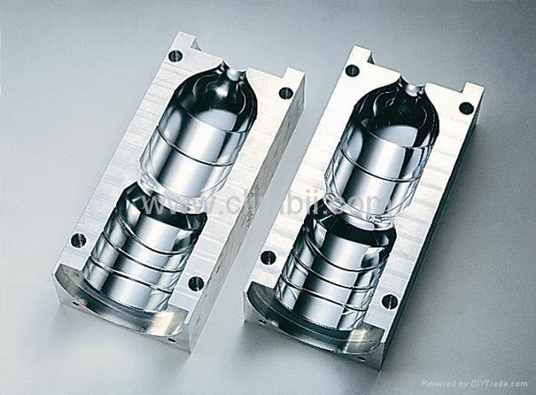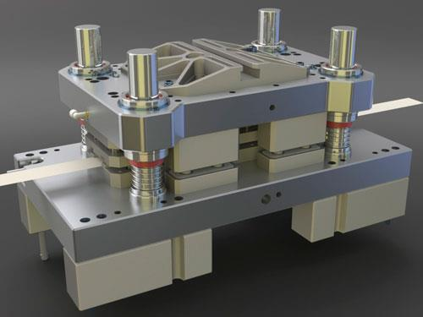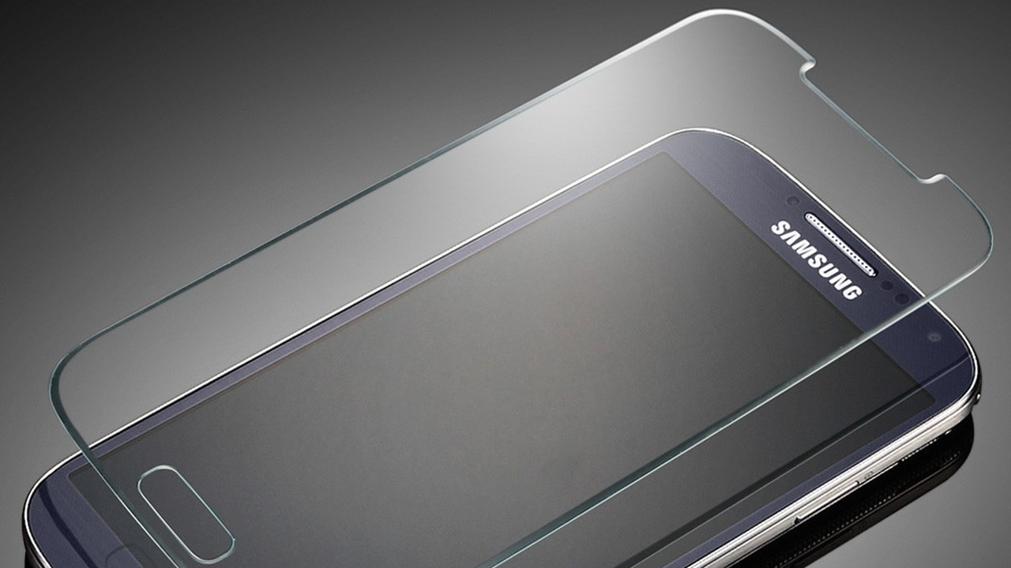
- If the modular green car option is selected, the car should be designed in modular sub-assemblies to include:
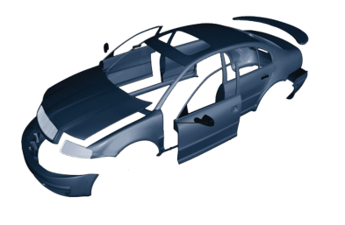
  - A body: 2 doors and body shell.
  - A chassis (platform) and Fenders: platform, 2 front fenders and front bumper.
  - Wheels and Bumper: 4 Wheels/tires, 2 axles, and rear bumper.

Interior contents like steering wheel, front seats, dashboard/console units, engine or battery, belt system, etc. should not be included in this design. The hood, boot and rear fenders should be designed into the body shell. Some parts can be made with the 3-D printer, but not all parts should be so made.

- For any selected option, each student will “own” (design and fabricate) the components listed in each category grouping. Off-the-shelf fasteners, pins, springs, etc. should not be designed.
- Each student must design and fabricate their parts. Each part must be sized/scaled to match with other components for proper fit using simple lab tools.
- When a 2-person team is used, they should share all the components for the selected option equally.
- Most energy must come from solar, hydro-electricity, wind, rechargeable batteries etc.
- It is assumed that there is a battery storage located somewhere in the chassis of the green car.
- The materials for the tooling option can be steel, aluminum and plastics. The materials for the car should be mostly foam, plastic or metal dowels or rods, car body bondo or putty, dough, wax and/or other suitable and easy-to-work material, wood glue and spray paint. Most of the materials will be supplied, but students are free to bring in their own materials at their own expense.
- All students in each group should jointly put their parts together to create the assembled model. Finishing can be done by sanding, scraping, polishing etc.
- Proper safety procedures should be followed, including protection from breathing material dust and fumes, avoiding getting any cuts and wearing safety goggles. Work areas should be properly ventilated, cleaned and all tools and materials returned to their proper places at the end.

This assignment exercises the design, planning, and fabrication of prototyping of a custom assembly. It is an opportunity to directly apply classroom knowledge and laboratory experience in a more active, integrated, and comprehensive way. Accordingly, each project is expected to be an original work this.

Project Proposal
Consultation before submitting the proposal is essential. The project scope must be discussed in advance with the instructor before submitting the proposal. A project analysis and evaluation sheet (attached or to be provided) must be used to brainstorm and evaluate the project before any design work is done. A completed project analysis and evaluation sheet should be turned in to the instructor. Parts that are too trivial will be rejected at the proposal stage, and overly ambitious ideas or those that require unavailable resources will fail to reach completion.

Class/Lab Schedule
Work is to be done within the scheduled lab sessions only. Working during a lab session other than your primary section is discouraged, and acceptable only with explicit permission from the lab instructor in charge. Work outside of the fixed lab sessions and facilities is also discouraged since staff can not provide training, supervision, or helpful input. All lab work must be done in our facilities. Special permission may be granted on rare occasions when it is not possible to adhere to this rule.

Materials
All materials used should be green materials or close (90%-100%) to green. You may contact the instructor for what constitutes acceptable green material. In cases where material is not available, the group members will share the cost of purchasing the materials used in their project.

Fabricated Parts/Prototypes
Generally, should be completed according to proposal as is (for tooling) or as scaled model or prototype (for the modular car). Timely completion, attention to surface finish, key details, sharp edges, dents, aesthetics, warps, and functionality are expected to be within acceptable quality of work performed during the time period allotted.

Assembly Drawing
A volunteer group member, or all the members should jointly, develop a 3-D assembly CAD model drawing of your tooling or green car design. When a volunteer group member does an assembly drawing, other group members should be given a chance to see and approve it before inclusion into your group report. This drawing should be titled, completely labeled and placed as the third page of your report after the table of content.

Detailed Part Drawings
Each member should design, title, dimension, and note all required details of each part. Title block with part name, drawing number, owner name, date, material, units, projection, appropriate set of views showing all required dimensions with no redundancy, tolerancing with reasonable values for each dimension should normally be included.

Individual Report
- A 1 ½ - 2-page, double-spaced typed report is required. It should bear your name on the top right hand corner of the first page. The report should include detailed descriptions of what made your design to be green and sustainable in the following subtitle areas:

  - Design
  - Material
  - Processing
  - Life cycle

Oral Presentation
Each group will be required to make a 10-15-minute oral presentation of their project to the class. This presentation should also include sufficient explanation/demonstration of your project, using effective visual aid to explain how your project works and how you made your design to be green and sustainable. Plan your presentation as if you will be presenting it to your company’s product review board seeking their approval for the proposed design. Coming to class late on that day may result in lost points, so try and be in class at least five minutes before class begins.

Portfolio Content and Submission
All materials generated should be placed in a portfolio and their pages noted before submission. The Design Project portfolio is due on the scheduled date (see class schedule). Most contents should be printed on standard letter-size paper. The only exception would be larger sheets if needed for readability in part drawings. However, larger sheets should still be folded such that they are nearly letter-size (no larger than 9"x 12" after folding). All photographs should normally be incorporated directly into the document as digital images printed on ordinary paper. The contents of each portfolio should be ordered as follows.

- Cover Page that includes a title for the group, the course name, and the names of everyone in the group.
- Project Proposal (graded cover page only, not the whole proposal)
- Assembly Drawing (Complete, titled and clearly labeled)
- Individual Cover Sheet for first team member
  - 1 ½ - 2-page report for the first team member
  - Fully dimensioned and titled Part Drawing(s) for which first team member had primary responsibility
- Individual Cover Sheet and work for second team member
  - 1 ½ - 2-page report for the second team member
  - Fully dimensioned and titled Part Drawing(s) for which second team member had primary responsibility
- Individual Cover Sheet and work for third team member
  - 1 ½ - 2-page report for the third team member
  - Fully dimensioned and titled Part Drawing(s) for which third team member had primary responsibility

Grading Criteria: This is a 60-point project and is worth 15% of the overall course grade. Below is the weighted distribution. Specific expectations for each item are detailed in the attached grade sheet.

Criterion Points
1) Project Proposal, evaluated on a TEAM basis 10
2) Project report, evaluated on INDIVIDUAL basis 10
3) Assembly Drawing evaluated on a TEAM basis 10
4) Detailed Part Drawing(s), evaluated on an
INDIVIDUAL basis 10
5) Fabricated model or prototyped part(s),
evaluated on an INDIVIDUAL basis 10
6) Oral presentation, evaluated on INDIVIDUAL basis 10
Total Points Possible 60

Tech/ME 140 Dr. Samuel C. Obi

GRADING CRITERIA FOR SECOND DESIGN PROJECT (60 POINTS)

CRITERIA POSSIBLE POINTS POINTS EARNED
STUDENT 1 STUDENT 2 STUDENT 3

__________ _________ __________

1. Project proposal (Refer to requirements) 10 ___________ __________ ___________

2. Written report (1 ½ - 2 pages):
(Completeness, format, grammar,
spelling, clarity etc.) 10 ___________ __________ ___________
3. Detailed Part Drawing(s) and analysis
(Title block with part name, drawing
number, owner name, date, material,
units, projection, appropriate set of views
showing all required dimensions with no
redundancy, tolerancing with reasonable
values for each dimension, meaningful and
detailed product/parts analysis as evidenced in
the completed title block). 10 ___________ __________ ___________

4. Assembly Drawings (Complete and clear
graphics, clear titles and labels, proper format,
easy to read etc.). 10 ___________ __________ ___________

5. Fabricated Parts/Prototypes (General
completion according to proposal either as scaled
or full-sized model or prototype. Timely completion,
attention to surface finish, key details, sharp
edges, dents, aesthetics, warps, functionality, etc.). 10 ___________ __________ ___________

6. Oral presentation: (Time, completeness,
preparedness, content, visual aids, clarity, outline,
audibility, appearance, etc.). 10 ___________ __________ ___________

TOTAL POINTS RECEIVED OUT OF 100 _________ ________ _________

Comments: ________________________________________________________________________________________
________________________________________________________________________________________________________________________________________________________________________________

Design Project Proposal for Project 2
The design project proposal is due by the second week of introducing your project, before any work can begin. This cover sheet must be attached as the front page of your proposal. Please read carefully, understand fully, and ask for clarification as soon as possible.

Each team is encouraged to discuss its proposal with the instructor BEFORE submitting for approval. Asking instructors about scope and especially about needed resources will be tremendously valuable in choosing a project that is feasible, meaningful, eligible for full credit, and hopefully rewarding!

Your proposal should accompany the form below. Attach all required information to the completed form before submitting for approval. All work should be typed.

Title or Name of Product (1 Point):

___________________________________________________ Score: _____
Team Members (1 Point) Responsibilities (Assigned Parts)

1.____________________________________________ _____________________________

2.____________________________________________ _____________________________

3.____________________________________________ _____________________________

Score: _____
Requirements (should be attached) | Instructor’s Feedback/Comments
Draft CAD drawings for the overall assembly and for EACH part in the assembly. Only rough outer dimensions are required. (2 Points) | Score: _____
Description of the purpose/use and nature of project, including number of parts, brief manufacturing processes and machines to be used (~ 50-70 words, typed). (2 Points) | Score: _____
List of machine stations and specific tools required, including cutter/bit sizes, instruments and needed hardware. (2 Points) | Score: _____
Complete bill of materials (BOM) including estimated size/quantity for each. (2 Points) | Score: _____

Total Score out of 10 = _____
Project Analysis and Evaluation Sheet for Design Project 2
Your Name: ___________________________________________
Project 2 | Parts | Strengths | Weaknesses | Decision | Comments
Section A: Generating Initial Ideas
First Idea (Name and sketch in the attached sheets) | 1. 2. 3. 4. 5. 6.
Second Idea (Name and sketch in the attached sheets) | 1. 2. 3. 4. 5. 6.
Third Idea (Name and sketch in the attached sheets) | 1. 2. 3. 4. 5. 6.
Section B: (Selected Product From A _____________________________)
Materials | 1. 2. 3. 4. 5. 6.
Sizes | 1. 2. 3. 4. 5. 6.
Cost | 1. 2. 3. 4. 5. 6.
Availability | 1. 2. 3. 4. 5. 6.
Green Content (in %) | 1. 2. 3. 4. 5. 6.
Manufacturing Processes | 1. 2. 3. 4. 5. 6.
Manufacturability (DFM) | 1. 2. 3. 4. 5. 6.
Assembly (DFA) | 1. 2. 3. 4. 5. 6.
Section C
Discuss the strengths of your selected product here:

