Ecological Economics 102 (2014) 94–104

Contents lists available at ScienceDirect

Ecological Economics

journal hom epage: w ww.elsevier.com/locate/ecole co n

Methodological and Ideological Options

Using a coupled behavior-economic model to reduce uncertainty and assess ﬁshery management in a data-limited, small-scale ﬁshery
Liam M. Carr ⁎, William D. Heyman 1

LGL Ecological Research Associates, Inc., 4103 S. Texas Ave., Suite 211, Bryan, TX 77802, United States

a r t i c l e i n f o

Article history:
Received 12 October 2013
Received in revised form 17 February 2014
Accepted 19 March 2014
Available online 22 April 2014

Keywords:
Fisher ecological knowledge Social–ecological systems Fishery modeling
U.S. Virgin Islands
a b s t r a c t

This paper examines how ﬁshers' ecological knowledge (FEK) and the analysis of their decision-making process can be used to help managers anticipate ﬁsher behavior and thus be able to efﬁciently allocate scarce resources for monitoring and enforcement. To examine determinants of ﬁsher behaviors, this study develops a coupled behavior-economic model examining how physical, market, and regulatory forces affect commercial ﬁshers' choice of ﬁshing grounds in a small-scale ﬁshery (SSF) in St. Croix, U.S. Virgin Islands. The model estimates that ﬁshing operations land $396 ± 110 per trip (mean ± 1 SD; n = 427 trips), with the highest value in landings arriving from Lang Bank. The model explains 62% of the variation in ﬁshers' choice to ﬁsh at Lang Bank, the most
productive, yet farthest ﬁshing grounds. The coupled behavioral–economic model is focused on the small tempo-
ral and spatial scales of ﬁshing effort and FEK in an SSF. Therefore the model can be used to predict how a range of physical and regulatory conditions and changes in demand will drive overall (ﬂeet) ﬁshing effort allocation in space and time. By illustrating and quantifying these social–ecological causes and effects, the model can assist
managers to efﬁciently allocate limited monitoring and enforcement resources.
© 2014 Elsevier B.V. All rights reserved.

1. Introduction

1.1. Social–Ecological Systems and Uncertainty in Small-scale Fisheries

Fisheries have long been described as poorly understood systems from both socioeconomic (Gordon, 1954; Ross, 1896) and ecological (Hilborn and Walters, 1992; Hobday et al., 2011) perspectives. In re- sponse, the management of ﬁsheries has historically focused on reduc- ing risk of overﬁshing and succeeding despite uncertainty in how a
ﬁshery responds to ﬁshing effort (Hilborn, 1987; Peterson and Smith,
1982) through a coordinated quantitative scientiﬁc approach (Hilborn and Walters, 1992). This was attempted by developing intense studies that monitored ﬁshery functions and responses to environmental and
ﬁshing-related pressures (Sissenwine and Shepherd, 1987), data collec- tion on ﬁshing effort and catch (Walters, 1975), modeling and predic- tion efforts (Bockstael and Opaluch, 1983; Mangel and Clark, 1983), and reﬁnement of ﬁsheries policies to respond to concerns of over- exploitation (Hilborn, 1979).
Despite these best efforts, successful management of ﬁsheries, as deﬁned by sustainability indicators, remains a hard-to-achieve objective (Hilborn et al., 2003; Worm et al., 2009). There is the

⁎ Corresponding author. Tel.: + 1 843 819 8169.
E-mail addresses: liam.carr@aya.yale.edu (L.M. Carr), wheyman@lgl.com
(W.D. Heyman).
1 Tel.: + 1 301 335 3230.
recognition that “the key to successful ﬁsheries management is not better science, better reference points, or more precautionary ap- proaches but rather implementing systems of marine governance that provide incentives for individual ﬁshermen, scientists, and managers to make decisions in their own interest that contribute to societal
goals” (Hilborn, 2002, 403). This is not to say that high-quality, long-
term quantitative data is not important in ﬁshery management. Instead, it is the recognition that management must move toward societally- shared sustainability goals despite data limitations, without robust quantitative methods and models, and while juggling the oftentimes competing short-term economic motivations of the ﬁshery with the
long-term ecological needs of the resource. In short, a lack of “suitable”
data cannot be an excuse for the mismanagement of the ﬁshery resource.
Today, an alternative approach views ﬁshery management not as working with predictable systems that can be reduced via rich data
sets into simple components or curves, but as complex social–ecological
systems (Holling et al., 1998; Mahon et al., 2008) built upon the often- hidden interactions of ecological, social, and economic drivers (Rice,
2011). Successful ﬁshery management requires balancing these drivers and developing scale-appropriate tools and policies that work in concert with these drivers to support sustainable outcomes within the ﬁshery. And rather than using separate methods and criteria to examine the ecology and socioeconomic faces of the ﬁshery in isolation, this ap- proach encourages a common framework (Ostrom, 2009) where avail- able ecological and socioeconomic information is brought in and

http://dx.doi.org/10.1016/j.ecolecon.2014.03.011
0921-8009/© 2014 Elsevier B.V. All rights reserved.

considered together in the development of management tools and policies. In doing so, potential data limitations in one area are offset by the information gleaned in other areas, leading to a greater sum accumulation of knowledge, reduction in uncertainty, and strength- ened ability to successfully pursue management goals.
While a certain level of uncertainty can be expected in ﬁsheries of all sizes, the problem may be most pronounced in small-scale ﬁsheries (SSFs). Owing to limited size, economic value, and management re- sources, SSFs are often data-limited (Berkes et al., 2001a). They are characterized by ﬁshing effort that is highly opportunistic, employing a variety of gears in targeting multiple stocks on any given trip, making SSFs problematic for quantitative scientiﬁc efforts like single-stock assessments and monitoring (Johannes, 1998). Management of SSFs
may beneﬁt from an approach that focuses on “facilitating socio-
ecological processes rather than primarily promoting a high level of quantitative science and implementing ﬁndings” (McClanahan et al.,
2009, 33). Socio-economic information can be used to begin making linkages with the missing or insufﬁcient ecological data (Cinner et al.,
2009). And perhaps the most readily available data source in SSFs is human behavior (Fulton et al., 2011). Where, how, and what a ﬁsher chooses to ﬁsh, and what the market chooses to buy, have important ecological and socioeconomic implications for SSFs. As a result, ﬁshing behavior may be the crucial link between the ecology and socioeco- nomics of a SSF, and, once understood, may provide insights for man- agement that might not be attained in any other way (Bundy et al.,
2008).

1.2. Reducing Uncertainty through Modeling Fishing Behavior

This paper uses ﬁeld-collected data from a tropical nearshore reef
ﬁsh SSF in the United States Virgin Islands to examine relationships between FEK, ﬁshery economics, and regulations. To examine physical, market, and regulatory forces in concert, this study uses a probability model to predict ﬁsher behavior, measured as a choice in ﬁshing grounds. To evaluate the economic consequences of those choices, the study develops an economic model to estimate the value of ﬁshing (or not ﬁshing) those grounds. The models are then coupled into a behavior-economic model that can then be used to evaluate relation- ships between behaviors, economics, and the consequences of vari- ous regulations on those relationships. Finally, the coupled model's utility in managing ﬁshing effort and maintaining sustainable stocks is evaluated.
Successful ﬁshery management depends on understanding risk (Hobday et al., 2011) and developing suitable tools despite uncer- tainty concerns, be they physical or biological (Ludwig et al., 1993), socioeconomic or political (Rosenberg, 2007). In situations with suf-
ﬁcient data quantifying relevant components of a ﬁshery's dynamics, robust stock assessment methods and modeling efforts may be ap- plied (Hilborn and Walters, 1992). For ﬁsheries with data limita- tions, which include many SSFs (Berkes et al., 2001b), the need for a precautionary, risk-averse approach remains (Johannes, 1998). And while quantitative data may be absent or insufﬁcient, ﬁsheries of all scales have their own basic characteristics that can begin to, at least qualitatively, describe the ﬁshery in terms useful for manage- ment. Chief among these characteristics is ﬁshing behavior.
In data-limited SSFs, ﬁsher behavior represents a valuable source of information that can be used to reduce uncertainty and foster sus- tainable practices (Armitage et al., 2009; Johannes, 1998; Johannes et al., 2000). Ecological information like habitat health, water condi- tions and quality, and community composition can be qualitatively described by ﬁshers or gleaned from detailed ﬁsheries dependent data, e.g. monitoring where and how they ﬁsh, as well as what they land and sell. Furthermore, monitoring changes in ﬁshing behavior can help reveal the underlying knowledge of a ﬁsher who relies on their experience in responding to the same set of basic information available to them to make a successful ﬁshing trip. Expanded to the
scale of the ﬁshery, ﬁshing behavior offers a more complete and pre- dictable understanding of how data-limited SSFs work. By introduc- ing a level of predictability in ﬁshing ground selection and resulting catch composition and size, basic models can be developed to begin describing SSFs, providing managers with an improved ability to manage proactively and adaptively.

1.3. From Knowledge to Behavior to Improved Management of SSFs

SSFs are characterized by small ﬁshing ﬂeets and small numbers of ﬁshers, low capital investments, opportunistic targeting of multi- ple species with multiple gears each trip (Béné and Tewﬁk, 2001; Berkes, 2003; Berkes et al., 2001a), and small spatial concentration of directed effort (Salas et al., 2007). And while individual SSF opera- tions may have a limited impact on the marine resource, together, the scope and size of ﬁshing effort has led to difﬁculties in ﬁshery manage- ment. Collectively, SSFs represent about 90% of the world's 34 million active ﬁshers (Béné and Tewﬁk, 2001; FAO, 2010), responsible for
landing contribution 25–33% of the annual global marine catch
(Chuenpagdee et al., 2006). SSFs are tremendously important, and their successful management is critical for the long-term health and productivity of marine resources and the communities depen- dent upon them for food, employment, and other ecological goods and services.
A reason that ﬁsher behavior can serve as a starting point for managing SSFs stems from the nature of the ﬁshery itself. Fishers in SSFs often retain several characteristics of the artisanal ﬁsher, de-
scribed by Johannes et al. (2000) as “ﬁshers' ecological knowledge”
or FEK. In SSFs, where gathering ecological information, routine data collection, or quantitative stock assessments may not be possi- ble, political will fractured or non-existent, and the economic alter- natives for food and employment stark (Béné, 2009; Bentley and Stokes, 2009; Cochrane et al., 2011), ﬁshing behavior and landings may represent the sum descriptive total of the ﬁshery both ecologi- cally and economically.
Examining behavior and landings data offers a glimpse into the knowledge and experience – their FEK – that allows a ﬁsher to be economically successful. Monitoring landings over time allows man-
agers to identify effort and market trends. By coupling landings to
ﬁsher behavior, managers can track changes in relative productivity and preference of selected ﬁshing grounds, identify how existing regulations affect ﬁshing behavior, effort, and landings composition.
In short, examining the measurable outcomes of FEK – behavior and
market trends – provides a greater ability to understand and de-
scribe SSFs. For ﬁsheries with little or no other information to guide managers, anticipating how FEK will be expressed is important for meeting management objectives. Taken further, management deci- sions based in an understanding of FEK can help bridge the gap cre- ated by the numerous areas of uncertainty, allowing managers to understand local perspectives of the ﬁshery's ecology and socioeco- nomics, and developing behavioral-based regulations that reﬂect
this reality. In doing so, management would answer the call to “man-
age people, not ﬁsh” (Berkes et al., 2001a, 12).

2. Site Description

The study was conducted in St. Croix, United States Virgin Islands (17°45′N 61°45′W), the largest of the three major U.S. Virgin Islands. St. Croix is 215 km2 in size and lies 60 km to the south of St. Thomas
and St. John, separated by the 4,685-m deep Virgin Islands Trench (Fig. 1). Territorial ﬁsheries (0–3 nautical miles) are managed by the Virgin Islands Department of Planning and Natural Resources (DPNR), while United States Caribbean ﬁsheries (3–200 nautical miles) are managed federally through the National Oceanic and At-
mospheric Administration (NOAA) by the Caribbean Fishery Man- agement Council (CFMC).

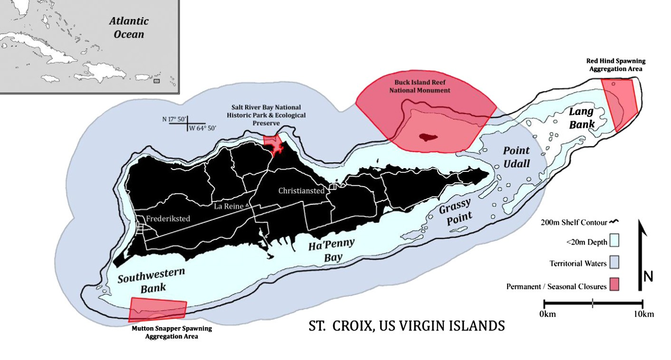Fig. 1. St. Croix, U.S. Virgin Islands, including identiﬁed ﬁshing grounds.

St. Croix ﬁsheries share several characteristics with SSFs in less- developed parts of the Caribbean region. The scale of ﬁshing effort and capital investment into the ﬁshery are relatively small and the
ﬁshing community is readily identiﬁable (Carr and Heyman, 2012), The island's population views the local reef ﬁsh ﬁshery as a food source, employment opportunity, and cultural tie that binds the larg- er island community together (NOAA, 2009a). The ﬁshery is also comparatively data-limited (CFMC, 2011). There have been no full stock assessments completed for Caribbean ﬁnﬁsh (NRC, 2013), ren- dering it very difﬁcult to assess species' status (NOAA, 2009b).

2.1. Physical Factors Affecting St. Croix Fisheries

For St. Croix's commercial ﬁshers, weather is an ever-present consideration on if, where, and how much to ﬁsh. Severe weather impacts ﬁshing effort spatially (i.e. grounds targeted) as well as the composition and amount of landed catch. Fishers are also aware that poor weather also dampens market activity, with fewer shoppers turning out on rainy days. More importantly, severe weather presents safety concerns. There is precious little free deck space on ﬁshing boats preferred by St. Croix's ﬁshers. Coolers, extra dive tanks, ﬁshing gear, and containers of gas and water all take up space. Strong swells present ﬁshers with the difﬁcult task of keeping balance and preventing equipment from rolling around. Vessel captains rely on small trailing surface buoys or scuba bubbles to track their divers, a task made more difﬁcult and dangerous when strong winds, heavy seas, or rain squalls reduce visibility. Fishers are required to land conch whole and in shell (DPNR, 2009), resulting in vessels laden with hundreds of pounds of sharp-edged conch shells, made more dangerous amongst all the other equipment and gear when seas pick up. Finally, under the most extreme conditions, ﬁsh- ers have reported losing steerage and engine power, had the cockpit swamped, or suffered some other critical mechanical failure. Fortu- nately St. Croix's ﬁshing community has had relatively few fatalities or ﬁshers lost at sea (USCG, 2010).
2.2. Fishery Market Forces Affecting St. Croix Fisheries

Overriding regulatory instruments, market forces play a large role in dictating ﬁshing effort and targeted stocks by St. Croix's ﬁshers.
Crucian ﬁshers consider their “high season” to coincide with the
opening of the queen conch ﬁshery season on November 1, marked by an uptick in demand generated by both the local population and tourism industry's American Thanksgiving (late November) to Easter
(late March to mid-April) “high season”. During the winter months, in
addition to an increased demand for locally-popular parrotﬁsh (Family Scaridae), a relative increase in demand for high-value stocks like conch ($7 per pound), spiny lobster ($8 per pound), mahi mahi (Coryphaena hippurus) and other pelagics ($6 per pound), and snappers (Family
Lutjanidae) and hinds ($6 per pound) can be seen. The “low season”,
generally considered to be the summer and early autumn months, is identiﬁed by both the closing of conch season and the slowdown in tourist arrivals. Low season is characterized by the unsettled tropical weather of hurricane season, less frequent, shorter ﬁshing trips by com- mercial ﬁshers, smaller landings by weight, decreased demand for ﬁsh
generally and a transition to inexpensive “potﬁsh”— parrotﬁsh, grunt
(Family Haemulidae), doctorﬁsh (Family Acanthuridae), and other small reef ﬁsh that sell for $4 per pound. Annually, parrotﬁsh represent nearly 33%, by landed weight, of the 550,000 kg ﬁshery (NOAA, 2010).
St. Croix has 143 registered full-time commercial ﬁshers.2 They use
small (6.3 ± 1.6 m) open-cockpit ﬁshing vessels and launch primarily from three locations. The selection of where to launch is determined each morning depending on where the ﬁsher intends to ﬁsh, what stocks they are targeting that day, weather conditions, and regulatory forces. The ﬁshers are opportunistic, targeting multiple species on any particular day. Unique in the U.S. Caribbean, the majority of St. Croix
ﬁshers employ spearguns and scuba-aided hand collection as their pri- mary means of ﬁshing, although other gear types, particularly weighted

2 Unpublished data from a 2010 census update for the commercial ﬁshing communities of the U.S. Virgin Islands. This value updates a 2004 census report of 220 licensed ﬁshers working from St. Croix (Kojis, 2004).

traps and hand lines, are also employed (Kojis, 2004). Catch is sold at well-known road-side stands across the island, as well as a larger, open-air market in the center of the island at Estate Villa La Reine. Nearly all ﬁsh caught locally is consumed locally (NOAA, 2009a), re- inforcing the economic and cultural importance of SSF-style ﬁshing to St. Croix. The La Reine market is open Monday through Saturday, beginning at 6 am. Demand typically increases through the week. Saturdays are the island's market day, with many bustling roadside stands appearing only for that day. On Saturdays, the La Reine mar- ket shares space with a government-sponsored farmer's market, drawing in additional customers.

2.3. Regulatory Structure of Fishery Management in St. Croix, USVI

St. Croix's ﬁsheries are managed by a mix of territorial and federal regulations. While the majority of St. Croix's nearshore and shelf- edge reef habitat occur in territorial waters, two areas that stretch into federal waters are particularly important for St. Croix's commer- cial ﬁshery: Lang Bank to the east and a small shelf-edge elbow along the Southwestern Bank, both sites for seasonal no-take closed areas. The Red Hind Spawning Aggregation Area (RHSAA) is located entire- ly in federal waters at the eastern terminus of Lang Bank (Fig. 1). All
ﬁshing activity is prohibited there each year from 1 December to 28
February, coinciding with the red hind's (Epinephelus guttatus) peak spawning period (Nemeth et al., 2007). The Mutton Snapper Spawning Aggregation Area (MSSAA) (Fig. 1), protects a known mutton snapper (Lutjanus analis) spawning aggregation site (Kojis and Quinn, 2011) from 1 March to 30 June. From 1 April to 30 June, a no possession rule for mutton snapper is in place in all territorial and federal waters (DPNR, 2009). Additionally, there are two perma- nent no-take closures: Buck Island National Marine Refuge and Salt River Bay National Historic Park and Ecological Preserve (Fig. 1). Al- though both fall completely inside territorial waters, they are feder- ally protected and managed by the National Park Service. Other territorial and federal ﬁshery regulations include seasonal and per- manent no-possession regulations for a number of stocks, minimum size limits for Caribbean spiny lobster (Panulirus argus) and queen conch (Strombus gigas), and daily and seasonal quotas for a number of reef ﬁshes (DPNR, 2009; NOAA, 2011). The regulatory framework for queen conch is highly germane to this study.
Queen conch is managed via a series of daily and seasonal quotas that begins in both territorial and federal waters on November 1. Each commercial ﬁshing vessel can collect 200 conch per day in territorial waters, while the federal bag limit for commercial ﬁshers is 150 conch per day per ﬁsher, rather than vessel. For St. Croix, reaching the territory's 50,000 lb (22,680 kg) annual quota sets off a no-possession regulation and closes the season both commercially and for recreational
ﬁshers in federal waters (DPNR, 2009). The no-possession regulation does not apply to conch caught, cleaned, and stored during the open season, meaning that conch can be sold throughout the closed season (12 VIC § 316). In 2013, the CFMC passed a motion that would harmo- nize federal commercial regulations with the territorial regulation of
200 conch per day per vessel (CFMC, 2013).

3. Methodology

This research examines how physical, market and regulatory forces affect ﬁshers' choice of ﬁshing grounds and their gross landings. Physi-
cal forces are represented by daily weather information — wind direc-
tion and strength, sea conditions, and rainfall. Market forces are based on customer demand over multiple time frames – day to day, week to week, and season to season – and represented by the relative portion of ﬁsh, conch, and lobster in each ﬁsher's landed catch. Regulatory forces
include seasonal and area closures. We developed a coupled behavior- economic model to reﬂect the underlying FEK, and predicts where a
ﬁsher decides to ﬁsh, and how much they can be expected to catch.
More broadly, the model's results also provide a qualitative assessment of the SSF productivity, health, and management effectiveness at rele- vant spatial and temporal scales, which is more than what is possible from landings or economic data alone.

3.1. Analyses of Physical Forces

Wind direction, speed, sea direction, and sea height data were compiled from 21 January to 3 September 2010, from NOAA's National Data Buoy at Salt River (Station SRBV3). The original data
ﬁles included wind speed and direction measured every six minutes and a wave height every thirty minutes, barring instrument or data transfer failure, and then hourly means were calculated. Daily weather conditions were deﬁned from statistical summaries of wind and wave records during the period from six hours prior to local sunrise to 13:00 local time, each day. Wind speed, direction, and frequency of direction was plotted in wind compass plots using MatLab software (MatLab, v7.0), grouped into ten 36° wind direction bins, beginning at true north (0º) and proceeding clockwise. Mean and standard deviation for wind speed and wave height were calcu- lated and used to test model parameters. Measurable rainfall was also reported.
Taken together, these physical parameters describe the weather conditions under which ﬁshers must decide if and where to ﬁsh. For
purposes of this study, weather data was aggregated into ‘severe’ or
‘calm’ conditions. Severe weather was deﬁned to be any day where at
least two of the three factors existed (Table 1): daily mean wind speed exceeding 8 m/s, daily mean wave height above 1.1 m, and mea- surable rainfall. Above 8 m/s (F5 on the Beaufort Scale), white caps and wind-driven waves build, and conditions begin to deteriorate, making
ﬁshing increasingly difﬁcult, if not unsafe. High winds and rain can ob- scure divers' bubbles and also pushes ﬁshing boats off station and downwind. Higher waves and rough seas increase ﬁshers' risk of injury, temporary loss of divers, and vessel damage.
Finally, weather conditions were correlated with choice of ﬁshing grounds under four scenarios: 1) ﬁshing grounds selected during ex- tended periods of calm weather; 2) ﬁshing grounds selected one or two days before severe weather arrived; 3) ﬁshing grounds selected during severe weather conditions, and; 4) ﬁshing grounds selected one or two days after severe weather, as calm conditions returned. The model examines how weather impacts SSF productivity by compar- ing landings from these scenarios. These scenarios also provide an opportunity to more directly measure behavior as the observable ex- pression of FEK as a ﬁsher draws on their own experiences, knowledge, and understanding of how changing weather impacts preferred grounds as they go through their decision-making routine.

3.2. Analyses of Market Landings

Landings and market sampling was conducted for a period of
225 days between 21 January and 3 September 2010 (n = 427 market stall samples). Prior to being included into the sample population,

Table 1
Weather conditions matrix.
Wind speed | Wave height | Rainfall | Condition
0–8 m/s | 0–1.1 m | None | Calm
N 8 m/s | 0–1.1 m | None | Calm
0–8 m/s | N 1.1 m | None | Calm
0–8 m/s | 0–1.1 m | Rain | Calm
N 8 m/s | N 1.1 m | None | Severe
N 8 m/s | 0–1.1 m | Rain | Severe
0–8 m/s | N 1.1 m | Rain | Severe
N 8 m/s | N 1.1 m | Rain | Severe

each ﬁshing operation was approached and research aims explained. Participating operations, their owners, captains, sellers, boat hands, and other associated ﬁshers gave verbal and written approvals of their anonymous participation in the study, following established institution- al standards. For each ﬁshing operation on each day of observation, the weight of total landings was estimated, grouped by demersal ﬁshes, conch, and lobster. When and where possible, estimations were validat- ed by direct reporting of weights of ﬁsh and lobster sold. Value of landed catch was then calculated based on established market prices: $4 per
3.3. Regression Model of Predicted Ground Selection by Conditions

With St. Croix ﬁshers identifying Lang Bank as the most produc- tive and proﬁtable ﬁshing grounds, a multiple variable regression model was proposed that would evaluate the relative effects of vari- ous conditions on the choice of ﬁshing there. Following preliminary tests of model ﬁt with statistical software (SPSS) a logistic binomial linear regression model was selected, following the form:

pound of demersal ﬁsh, $7 per pound for knocked and cleaned conch f z 1 1

meat (in $20 bags), and $8 per pound for spiny lobster. Values calculat- ed for demersal ﬁsh represent low-end estimations, as commercial
ﬁshers sell both $4 ‘potﬁsh’ and $6 ‘reef ﬁsh’ throughout the year,
with some even selling ‘mixed bags’ at $5 per pound. Researchers
interviewed ﬁshers on any direct sales and added them to the market sample when they provided ﬁgures. If none were provided or ﬁshers de- clined to respond to the question, it was assumed that the operation had no direct sales that day. Pelagic ﬁshes were only observed sporadically so were dropped from the dataset.
Fourteen landings censuses were conducted opportunistically, to verify landings estimations. These censuses calculated the upper range for daily, scuba-assisted catch per ﬁshing operation to be 122 ± 26 de- mersal ﬁshes, weighing 49 ± 8.2 kg (106 ± 18 lb). Lobsters were indi- vidually weighed when possible. Otherwise, total lobster weight was estimated by multiplying the number of landed, un-weighed, live lob- sters by 2.4 ± .4 lb (1.1 ± 0.2 kg), the mean wet weight from all mea- sured individuals. This weight is similar to a reported mean weight of
2.58 lb (1.2 kg) by Castillo-Barahona (1981), and near the sampled mean length-weight ratio reported from 1986 through 2003 (NOAA,
2005). Simultaneous records were kept detailing running sales totals, and were incorporated into the ﬁnal value determination for observed operations as a correcting factor, particularly when higher-value ﬁshes were the primary sale.
Fishing ground selection data was collected by interviewing ﬁshers either as they departed a particular launch site in the morning, returned to the launch site, or at the market. Fishing grounds were loosely demar- cated from existing maps (DPNR, 2005; Valiulis and Messineo, 2005), and conﬁrmed through interviews. Five major grounds were identiﬁed (from east to west): Lang Bank, Point Udall and northeast St. Croix, Grassy Point, Ha'Penny Bay, and the Southwestern Bank (Fig. 1). During interviews, ﬁshers described Lang Bank as being the most productive St. Croix ﬁshing ground. Fishing ground selections were aggregated by site and date for frequency analysis to examine changes in site selection be- havior as functions of daily physical conditions on one hand and regula- tory conditions on the other. For each of the ﬁve identiﬁed grounds, recorded landings data were separated and presented as a function of seasonal regulatory conditions (Table 2). A two-tailed, two-sample t- test (p ≤ 0.05) was completed to compare landings from each of the four sites to the landings from Lang Bank.
ð Þ ¼ 1 þ e−z ð Þ

where f(z) is the logistic probability that a ﬁsher will either not select (f(z) ≈ 0) or select (f(z) ≈ 1) to ﬁsh at Lang Bank on any given day, given a set of physical (e.g. wind speed, wind direction, wave height, rainfall), behavioral (e.g. ﬁshing ground selection), and regulatory (e.g. closed areas and/or seasons) conditions. This probability is built on a summation of the log-odds independent variable z, which is com- posed of odds ratio coefﬁcients αi and explanatory dummy variables xi, such that:

z ¼ a1 x1 þ a2 xx þ K ak xk ð2Þ

where xk represent those physical, behavioral, and regulatory condi- tions identiﬁed as signiﬁcant for strengthening the predictive abili- ties of the model through a step-wise process. The model was run for all combinations of all records. For each model iteration, the step-wise addition of a variable resulted in a percent change in predic- tive ability. Coefﬁcients with signiﬁcant values (p ≤ 0.05) were kept
and the ﬁnal model was tested for goodness-of-ﬁt (Hosmer–Lemeshow
Test; HL ≥ 0.05). The ﬁnal model is reported, including Nagelkerke's pseudo-r2, Hosmer–Lemeshow value, and predictive strength values along the continuum from zero (no predictive power) to one (perfect
correlation).

3.4. Economic Model of Expected Landings Value by Grounds

Fishing ground selection data and market value calculations were used to develop an economic model predicting daily gross landed value by ﬁshing operation, based on physical, behavioral, and regulatory conditions. Records were identiﬁed by operation, ﬁshing grounds se- lected, and recorded market landings and then assembled into a larger dataset for model development using the software SPSS. Variables were tested for normality, covariance, and heteroskedasticity. The basic regression model takes the form:

V ¼ f ðv; w; xÞ ð3Þ

Table 2
Total ﬁshing trips recorded for targeted grounds, by season and regulations.
(Two-tailed t-test in parentheses comparing other ground selection to Lang Bank, at p ≤ 0.05).

 |  | Lang Bank | Pt. Udall | Grassy Pt. | Ha'Penny | Southwest
Conch season open | 1 Jan–28 Feb | 44 | 17 | 5 | 0 | 10
 | (RHSAA closure) |  | (0.005)* | (0.000)* | – | (0.000)*
 | n = 19 days sampled
 | 1 Mar–30 Apr | 24 | 16 | 10 | 1 | 22
 | (MSSAA closure) |  | (0.22) | (0.026)* | – | (0.81)
 | n = 22 days sampled
Conch season closed | 1 May–30 June | 56 | 32 | 30 | 5 | 4
 | (MSSAA closure) |  | (0.016)* | (0.005)* | (0.000)* | (0.000)*
 | n = 24 days sampled
 | 1 July–10 Sep | 49 | 26 | 16 | 10 | 50
 | n = 30 days sampled |  | (0.029)* | (0.002)* | (0.000)* | (0.93)
Asterisk indicates two-tailed t-test that are statistically signiﬁcant at p≤0.05.

where predicted gross value, in dollars, of landed catch (V) isa function of physical, behavioral, and regulatory conditions made observable as weather (v), ﬁshing ground selection (w), and relevant regulations (x). Following tests of model ﬁt, a standard linear model using dummy variables {v, w, x} was selected, taking the form:

i j k
V ¼ X βi vi þ X β j v j þ X βk xk : ð4Þ
gross landed value per trip to the Southwestern Bank, in the relative- ly protected lee of the island, are statistically similar with Lang Bank (Fig. 3c and d).

4.2. Regression Model of Predicted Ground Selection by Conditions

The ﬁnal model for predicting if a ﬁsher would opt to ﬁsh Lang
Bank is:

i¼1
j¼1
k¼1

1

The linear model is forced through the origin (β0 = 0), representing the condition that gross landings value cannot be generated with-
f ðzÞ ¼ 1
þ e−z

ð5Þ

out ﬁshing. Regression coefﬁcients (β), in units of dollars, were calculated for each of the model's conditional variables. Two- tailed t-tests (p ≤ 0.05) were reported for each coefﬁcient.

4. Results

4.1. Analyses of Physical Forces

The wind dataset had 4,715 data points, collected inclusively be- tween 0:00 AST (− 4:00 GMT) 21 January 2010 and 23:00 AST on 3
September 2010. During this period, wind direction was generally east-southeasterly, with a mean of 118 ± 41°. Mean wind speed was 5.7 ± 2.5 m/s (11.1 ± 4.9 knots). Daily wave heights had a mean of 0.81 ± 0.29 m. These data support Caselle and Warner's (1996) description of the southeastern shelf and coastline of St. Croix as the windward side of the island. Fully 55% of wind records
fell within the east-southeasterly 72–144° bin, and when incorporat-
ing all ‘windward’ bins between 72 and 180°, this frequency rises to
nearly 70% (Fig. 2).
Fig. 3a–d presents gross landed value, by targeted ﬁshing grounds, for the range of weather conditions: calm, pre-severe, severe, and
post-severe weather conditions, as deﬁned in the methodology. Under all weather condition categories, Lang Bank yielded the greatest daily landed value of the ﬁshing grounds considered. In good weather
(i.e. ‘calm’ and ‘pre-severe’ conditions), landings from Lang Bank were
signiﬁcantly higher (p ≤ 0.05) than from any other grounds, regardless of weather conditions (Fig. 3a–d). Southwestern Bank, was the only grounds nearly as productive as Lang Bank. During and after bad weather (i.e. ‘severe’ and ‘post-severe’ conditions), daily mean

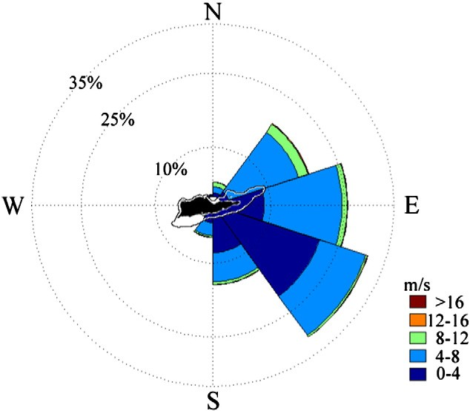

Fig. 2. Mean wind speed (m/s), by direction and frequency, from 21 January to 10
September 2010.
(Source: NOAA National Data Buoy Center — Station SRBV3)
z ¼ 2:834xw þ 0:202xr þ 0:561xm þ 1:642xc

where xw = 1 on days with calm wind speeds (wind speed ≤ 8 m/s), xr = 1 during the RHSAA closure, xm = 1 during the MSSAA closure, and xc = 1 during the open conch season (Table 3). All coefﬁcients were signiﬁcant (p ≤ 0.05).
The parameterized model (Eq. (5) above) correctly predicted
ﬁshers' choice to target Lang Bank 61.6% of the time (Table 3), a
52% improvement over the initial, term-less model, whose predic- tions were correct only 40.5% of the time. The reported coefﬁcients suggest that the likelihood of choosing to ﬁsh at Lang Bank increases during days with calm winds and throughout the open conch season, and decreases when either the RHSAA or MSSAA are closed. Of these conditions, the strongest positive inﬂuence for a ﬁsher choosing to
ﬁsh at Lang Bank is calm wind days (αw = 2.834), while the strongest negative inﬂuence is the RHSAA closure at Lang Bank (αr = 0.202) each December 1 through February 28.

4.3. Economic Model of Expected Landings Value by Grounds

The linear regression model (r2 = 0.85, F = 402.7) takes the form:

V ¼ 29:12vw þ 144:54vv þ 224:42wl −141:50xr −18:08xm þ 294:10xc
ð6Þ

where the explanatory dummy variables are vw = 1 for calm wind speeds (wind speed ≤ 8 m/s), vv = 1 for calm sea conditions (wave height ≤ 1.1 m), wl = 1 when a ﬁsher chose to ﬁsh Lang Bank, xr =
1 during the RHSAA closure (1 December–28 February), xm = 1 dur-
ing the MSSAA closure (1 March–30 June), and xc = 1 during the
open conch season (1 November 2009–30 April 2010). All variables
were signiﬁcant (p ≤ 0.05). The ﬁnal linear model predicts a gross daily landed value, in dollars ± 1 σ, per ﬁshing operation to be:

V ¼ 396:63 ± 110:25 ð7Þ

with a range of $286–$507. The signs reﬂect the relative effect of each variable, in dollars, on expected value of landings. Eq. (6) shows that the conch ﬁshery (βc = $294.10) and the ability to ﬁsh at Lang Bank (βl = $224.42) are the strongest positive economic forces for St. Croix ﬁshers, with calm winds and seas also improving
the value of their daily gross landings (Fig. 3a–d). Conversely, the
RHSAA (βr = − $141.50) and MSSAA (βm = − $18.08) closures have a negative economic inﬂuence. Fig. 4a–d presents daily gross landed value per trip throughout the various regulatory periods of
2010. Finally, gross landed value per trip is compared for the ‘high’
open season (Fig. 5a) for conch during the study's sampling period (21 January–30 April 2010), and the ‘low’ season (Fig. 5b), once the conch season is closed (1 May–3 September 2010), further revealing the importance of conch as an economically important stock to St.
Croix's commercial ﬁshers. The predicted value of landings per

1200

1000

800

600

400

200

a b
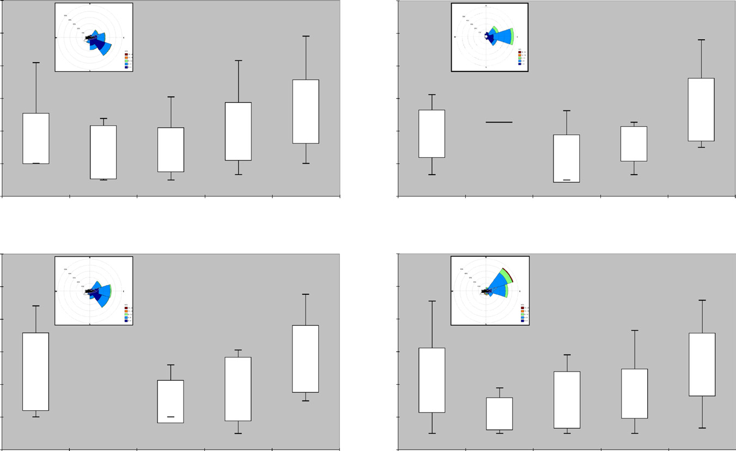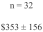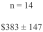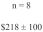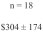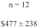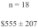1200

1000

800

600

400

200

0

1200

1000

800

600

400

200

0
0
Southwestern Bank Ha’Penny Bay Grassy Pt. Pt. Udall Lang Bank Southwestern Bank Ha’Penny Bay Grassy Pt. Pt. Udall Lang Bank

c d
1200

1000

800

600

400

200

0
Southwestern Bank Ha’Penny Bay Grassy Pt. Pt. Udall Lang Bank Southwestern Bank Ha’Penny Bay Grassy Pt. Pt. Udall Lang Bank

Fig. 3. Daily per trip gross landed value, by grounds and weather conditions, 21 January to 3 September 2010. Stars reﬂect two-tailed t-test comparing daily landings from each ground to Lang Bank, signiﬁcant at p ≤ 0.05; box plot represents ± 1 standard deviation from mean per trip gross landed value, with number of trips (n) and mean included inside box. Tails represent maximum and minimum recorded gross landed values for each ground.

ﬁshing operation, $397 ± 110, is similar to the average recorded values recorded from market observations, $422 ± 216.

5. Discussion

This study developed and used behavioral and economic models showing that ﬁsher behavior is predictable by examining how the inter- play of physical, market, and regulatory forces inﬂuence decisions in SSFs on where and what to ﬁsh. These observable outcomes, aggregated and considered together, reﬂect the FEK of the ﬁshing community of St. Croix. The model provides managers with an improved ability to assess regulatory effectiveness and better describe the ﬁshery's trends in effort and productivity, thereby incrementally reducing management uncer- tainty in how the ﬁshery system responds to changes in effort dictated by those physical, market, and regulatory forces. Through its coupled
behavioral–economic foundation, the model's functionality in examin-
ing how and to where seasonal area closures at the RHSAA and MSSAA redirect ﬁshing effort supports the idea that ﬁshery manage- ment is fundamentally about managing people (Berkes et al., 2001a; Hilborn, 2007).
5.1. Coupling Fisher Behavior to Economic Outcomes

The daily decisions made by ﬁshers, informed by FEK and physi- cal and regulatory forces, lead to economic outcomes. The ﬁnal model shows that the RHSAA closure is a strong deterrent (xr =
0.202, p = 0.000) from ﬁshing at Lang Bank, despite the fact that
of 76 reported trips taken during the RHSAA closed season, 44 were made to Lang Bank (Table 2). Examining a breakdown of landing data collected during this period, 36 of these trips returned with conch, totaling 415 kg (915 lb), with a market value of $6405, or $178 per trip average. Total landings from all other grounds reported for
the same period (21 January–28 February 2010) totaled 250 kg
(552 lb) pounds of conch, an average of $156 per trip (n = 24 trips reporting conch).
Once the RHSAA is re-opened but before conch season is closed (1
March–30 April 2010), Lang Bank produced mean daily landings per
ﬁshing operation of $746 ± 163 (n = 24 ﬁshing trips), signiﬁcantly different than all other grounds and the highest mean landings re- ported for any site throughout the study period. Once conch season closed, however, Lang Bank mean landings decreased considerably,

Table 3
Binary logistic model for predicting likelihood of ﬁshing Lang Bank.
(Two-tailed t-test statistic in parentheses at p ≤ 0.05 unless otherwise noted).

% Predicted | Pseudo-r2 | Wind speed | RHSAA | MSSAA | Conch season
(% improvement) | (Hosmer–Lemeshow) | v ≤ 8 m/s | xr = 1 | xm = 1 | xc = 1
61.6 | 0.126 | 2.834 | 0.202 | 0.561 | 1.642
(21.1) | (0.538) | (0.000) | (0.000) | (0.004) | (0.05)

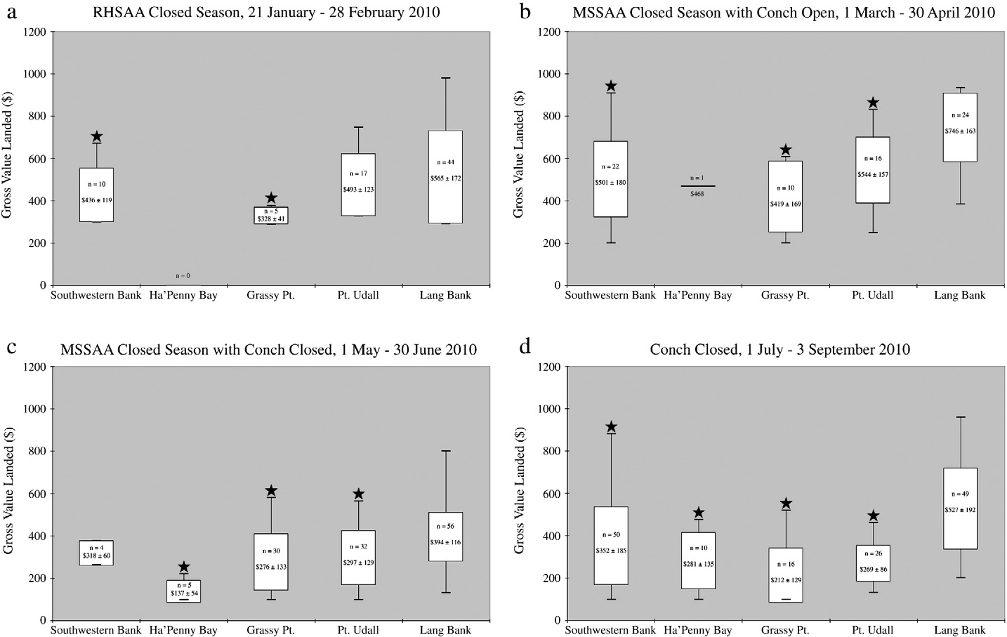

Fig. 4. Daily per trip gross landed value, by grounds and regulations — 21 January–3 September 2010. Stars reﬂect two-tailed t-test comparing daily landings from each ground to Lang Bank, signiﬁcant at p ≤ 0.05; box plot represents ± 1 standard deviation from mean per trip gross landed value, with number of trips (n) and mean included inside box. Tails represent maximum and minimum recorded gross landings for each ground.

to $394 ± 116, although it remained popular, with 56 trips taken
(Fig. 4c), 44% of all trips sampled from 1 May through 30 June
2010. For St. Croix's ﬁshers, Lang Bank has the most productive and proﬁtable ﬁshing grounds.

5.2. Behavioral–Economic Models as a Means of Reducing Management
Uncertainty

More than being an aid to enforcement, behavioral and economic models can provide a rigorous assessment of regulatory tool effective- ness. Fishery regulations in the U.S. Caribbean are largely based around protecting critical life history stages and promoting spawning success for commercially important stocks (CFMC, 2005). Conch migrate from deep water in winter to shallow (harvestable) areas in advance of their summer spawning season (Appeldoorn, 1994; Béné and Tewﬁk,
2001; Stoner and Ray-Culp, 2000). Mutton snapper and red hind follow seasonal, lunar, and behavioral cues that signal when and where to ag- gregate for spawning (Cummings, 2007; Heyman and Kjerfve, 2008; Kojis and Quinn, 2011; Nemeth et al., 2007).
Fishers know exactly where, when, and often why these events occur, as exempliﬁed by ﬁshers' numbers of trips to identiﬁed ﬁshing
grounds (Fig. 4a–d). Several interviewed ﬁshers described a general
westward migration of queen conch in the early spring, from Lang Bank and Point Udall grounds, moving ultimately toward the South- western Bank. This predictable movement of conch is taken advantage of by ﬁshers, who chose Lang Bank or Point Udall for 80% of all reported trips from 21 January through 28 February 2010, a point made clearer when comparing the clear economic beneﬁt of those grounds (Fig. 4a). As conch moved west (Fig. 4b), ﬁshers continued to ﬁnd the greatest economic success at Lang Bank, but effort began redirecting
to other grounds, with noticeable increases in gross value landed at each. Once the conch season closed and with the Southwestern Bank still under the MSSAA closure (Fig. 4c), effort redirected eastward once again. The ending of the MSSAA closure (Fig. 4d) saw a return of a more even distribution of effort. And while gross landings fell, largely due to the closing of the conch season, the predictable shifting of effort shows that ﬁshers do rely upon their FEK and understanding of physical, market, and regulatory forces to make ﬁshing economically worthwhile through the slow summer months.
More importantly, these shifts in effort, and the resultant changes in gross landed value help assess the success of existing regulations. The model presented here gives a quantitative estimate of the eco- nomic impact that regulations have on commercial ﬁshers in St. Croix, and how they respond to those regulations to minimize that impact. This response is informed by their FEK, limitations caused by inclement weather, and a keen understanding of market de- mands. The model shows that the seasonal area closures are effective in redirecting effort to other areas and targeted stocks, suggesting that their purpose of protecting spawning aggregations of red hind and mutton snapper is being met. Less well-identiﬁed is how effec- tive conch regulations are in preventing overexploitation. It is clear that conch are a valuable stock (Fig. 4a and b), and in interviews,
ﬁshers noted that they always would attempt to land their full daily quota. This model cannot, as constructed, identify if conch ef- fort is sustainable over the long-term, given the relative short sam- pling period and federal requirements for determining overﬁshing and overﬁshed status (NOAA, 2009b). Given a longer time period, inter-seasonal comparisons can be completed, and new shifts in ef- fort or market value may be identiﬁed as potential causes for further
investigation. Having a coupled behavioral–economic model allows

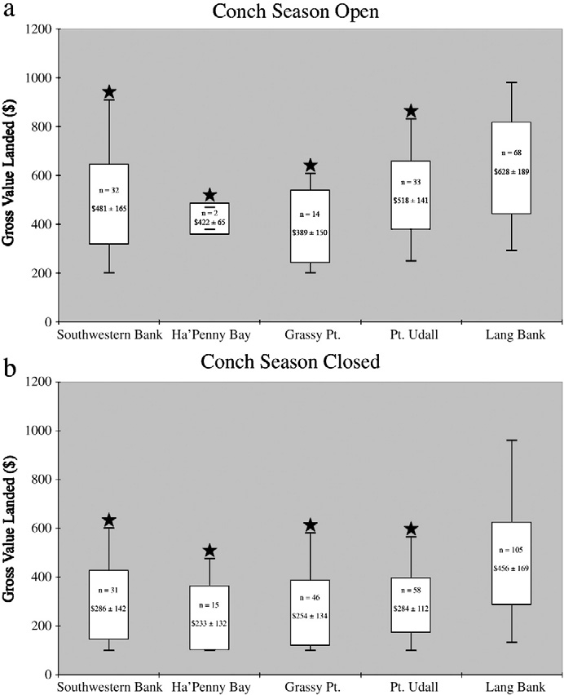

Fig. 5. Daily per trip gross landed value — open vs. closed conch season. Stars reﬂect two-tailed t-test comparing daily landings from each ground to Lang Bank, signiﬁcant at p ≤ 0.05; box plot represents ± 1 standard deviation from mean per trip gross landed value, with number of trips (n) and mean included inside box. Tails represent maximum and minimum recorded gross landings for each ground. Open conch sea- son: 21 January–30 April 2010; closed conch season: 1 May–3 September 2010.

managers in SSFs to direct their often limited resources proactively, rather than having to wait until waiting sufﬁcient biological informa- tion is collected to conduct traditional stock assessments and then develop new regulations. Such a time-consuming process is ill- suited for SSFs that change, often rapidly, on daily to seasonal scales.
It is therefore a worthwhile endeavor to understand that the be- haviors of ﬁshers are tied to decisions made over small temporal and spatial scales, and that any effective ﬁshery regulation must be not only effective over the ecological time scales dictated by the length of conch or ﬁsh spawning seasons but also within the day-
to-day world of the ﬁsher. In this manner, at least the ‘when’ portion
of the management uncertainty equation can be reduced. As rela- tionships and trust between practicing ﬁsher and observing scientist
are improved so might the opportunity to better unravel the ‘where’
and ‘why’ of ﬁshing. From such an equitable position, where ﬁshers
are sought for their opinions and FEK, the seeds of decentralized, locally-relevant management can take root. Once ﬁshers and managers truly form a working partnership, co-management initiatives can be de- veloped and tested (Berkes, 2009).

5.3. Sources of Error

Researchers were acutely aware at the outset that three difﬁculties would emerge with regards to data collection and reporting as follows:
1) deﬁning daily targeted grounds accurately; 2) properly identifying and quantifying daily landings; and 3) performing data collection in an unobtrusive manner that didn't overly impact the ﬁshing operation's primary concern of selling their catch. The ﬁrst issue represents the
greatest potential source of error. As a guide, grounds were best deﬁned by a series of corroborating data being collected, namely grounds de- scribed by the interviewed ﬁsher, contemporaneous launch site data re- ports collected by the researchers based on observed departures, arrivals, and boat trailers of ﬁshers. When this was not possible, re- searchers relied on whichever piece of information they had more con-
ﬁdence in reporting.
More vexing from the point of ‘deﬁning’ a targeted ﬁshing ground, many ﬁshers actually ﬁsh across several grounds, particularly during
conch season. For example, ﬁshers may opt to conduct two or three dives at Lang Bank and stop in Point Udall's conch grounds on the way home. This routine is highly predictable, suggesting it may be valuable from a behavior-based analysis to combine Lang Bank with Point Udall, while from an ecosystem perspective, the two grounds are dis- similar (NOAA, 2008). Fishers stated in interviews that, due to the conch quota and specter of an approaching end to the season, they al- most always landed their daily limit, regardless of that particular day's market demand. Most ﬁshers have deep freezers that allow them to store unsold catch for a period. In the case of queen conch, there are no prohibitions against possession or sale of conch outside of the season, provided that the conch was caught in-season. This provides difﬁculties to both sampling work and regulatory effectiveness. Unless it was clear
that a bag of conch sold during the open season (21 January–30 April
2010) was previously frozen, researchers included the weight and sale into the dataset. Conch sold after 30 April 2010 were excluded from the analysis, as verifying the behavioral side of the model on where the conch was originally caught was not possible or had been previously sampled at an early market date.
Successfully completing a ﬁsheries study that focuses largely on the daily income of ﬁshers requires tremendous amounts of trust and communication between participating ﬁshers and researchers (Conway and Pomeroy, 2006; Johannes et al., 2000; Johnson and van Densen, 2007). While this study reports on ﬁshing behavior and market trends over 225 days in 2010, researchers began building relationships with several key ﬁshing community leaders as far back as 2004. Even so, ﬁshers consider their favorite ﬁshing grounds and techniques to be privileged information, and they are naturally pro- tective of their knowledge. Great care was taken by researchers to validate all information obtained through interviews and market ob- servations by follow-on conversations. Ultimately, however, trust between ﬁsher and researcher cannot be tested or veriﬁed. That is the nature of highly cooperative ﬁsheries research (Kaplan and McCay, 2004). The datasets relied upon here, the researchers trust, are an accurate a reﬂection of St. Croix's commercial reef ﬁsh ﬁshery. The researchers further recognize that there exists some level of ille- gal and unreported ﬁshing effort, with interviewed ﬁshers sharing their own reports and experiences of seeing illegal activity near their own boat or market stall (Carr and Heyman, 2012). The scope of work is not designed to include illegal ﬁshing, but given the be- havioral responses of licensed commercial ﬁshers included in the study, there is a level of compliance that positively supports the value and appropriateness of seasonal area closures for managing St. Croix's nearshore ﬁsheries.
The sample population includes nine ﬁshing operations representing
42 individual licensed ﬁshers, or 32% of the entire full-time com- mercial ﬁshing community in St. Croix. The population size is sufﬁ- ciently large enough to be modeled within a behavioral study (Eden et al., 2005), and the results can be used to describe St. Croix's com- mercial ﬁshing community. Previous work in St. Croix has shown that the commercial ﬁshing community is readily identiﬁable through a set of shared characteristics, and the sample pool is rep- resentative of the larger commercial ﬁshing community (Carr and Heyman, 2012). The methodology is robust enough to be tested in other similarly sized commercial Caribbean ﬁshing communities, recognizing that a different coupled behavior-economic model will result.

6. Conclusion

This research presents a novel, cooperative approach for assessing the effectiveness of SSFs management through the daily decisions and behavior of ﬁshers, and the economic outcomes of those decisions. For data-limited ﬁsheries where management resources may be scarce, as many SSFs are, behavioral data of ﬁshers, shared cooperatively by ﬁsh- ers, can be used to describe the ﬁshery and reduce areas of uncertainty
that hinder successful management. With careful social–ecological sys-
tems analysis, behavioral data can reveal important ecological and so- cioeconomic patterns, identifying productive grounds, at the scale of the ﬁsher and their ﬁshery, and how productivity shifts over time. For protected areas like ﬁsh spawning aggregations, behavioral and eco- nomic data can be used to model the impact of regulations on the ﬁsh- ery, as well as how the ﬁshing community responds to management. Anticipating ﬁshing behavior can help managers direct limited re- sources efﬁciently. In short, examining and modeling ﬁsher behavior begin to reveal their FEK, which provides a greatly underutilized infor- mation source for describing and managing data-limited SSFs, and assessing the effectiveness of those regulations established to achieve
ﬁshery goals. Fisher behavior is the key.

References

Appeldoorn, R.S., 1994. Queen Conch Management and Research: Status, Needs and Pri- orities. Queen Conch Biology, Fisheries and Mariculture. Fundacíon Cientiﬁca Los Roques, Caracas, Venezuela.
Armitage, D.R., Plummer, R., Berkes, F., Arthur, R.I., Charles, A.T., Davidson-Hunt, I.J., Diduck, A.P., Doubleday, N.C., Johnson, D.S., Marschke, M., McConney, P., Pinkerton, E.W., Wollenberg, E.K., 2009. Adaptive co-management for social–ecological com-
plexity. Front. Ecol. Evol. 7, 95–102.
Béné, C., 2009. Are ﬁshers poor or vulnerable? Assessing economic vulnerability in small- scale ﬁshing communities. J. Dev. Stud. 45, 911–933.
Béné, C., Tewﬁk, A., 2001. Fishing effort allocation and ﬁshermen's decision making pro- cess in a multi-species small-scale ﬁshery: analysis of the conch and lobster ﬁshery
in Turks and Caicos Islands. Hum. Ecol. 29, 157–186.
Bentley, N., Stokes, K., 2009. Contrasting paradigms for ﬁsheries management decision making: how well do they serve data-poor ﬁsheries? Mar. Coast. Fish. 1, 391–401.
Berkes, F., 2003. Alternatives to conventional management: lessons from small-scale ﬁsh- eries. Environments 31, 5–19.
Berkes, F., 2009. Evolution of co-management: role of knowledge generation, bridging or- ganizations and social learning. J. Environ. Manag. 90, 1692–1702.
Berkes, F., Mahon, R., McConney, P., Pollnac, R., Pomeroy, R., 2001a. Managing Small-scale Fisheries: Alternative Directions and Methods. International Development Research Centre, Ottawa, Canada.
Berkes, F., Mahon, R., McConney, P., Pollnac, R., Pomeroy, R., 2001b. New Directions: A Vi- sion for Small-scale Fisheries. Managing Small-scale Fisheries: Alternative Directions and Methods. Ottawa, Canada, International Development Research Centre.
Bockstael, N.E., Opaluch, J.J., 1983. Discrete modelling of supply response under uncertain- ty: the case of the ﬁshery. J. Environ. Econ. Manag. 10, 125–137.
Bundy, A., Chuenpagdee, R., Jentoft, S., Mahon, R., 2008. If science is not the answer, what is? An alternative governance model for the world's ﬁsheries. Front. Ecol. Evol. 6,
152–155.
Carr, L.M., Heyman, W.D., 2012. “It's about seeing what's actually out there”: quantifying
ﬁshers' ecological knowledge and biases in a small-scale commercial ﬁshery as a path toward co-management. Ocean Coast. Manag. 69, 118–132.
Caselle, J.E., Warner, R.R., 1996. Variability in recruitment of coral reef ﬁshes: the impor- tance of habitat at two spatial scales. Ecology 77, 2488–2504.
Castillo-Barahona, F., 1981. Composition of the commercial catch of spiny lobster in
Puerto Rico and the U.S. Virgin Islands. Proc. Gulf Caribb. Fish. Inst. 33, 267–270. CFMC, 2005. Comprehensive Amendment to the Fishery Management Plans (FMPs) of
the U.S. Caribbean to Address Required Provisions of the Magnuson-Stevens Fishery Conservation and Management Act. San Juan. Caribbean Fishery Management Coun- cil, Puerto Rico.
CFMC, 2011. Report of the CFMC Science and Statistical Committee. Caribbean Fishery
Management Council, San Juan, PR.
CFMC, 2013. Regulatory Amendment 2 to the Fishery Management Plan for Queen Conch Resources of Puerto Rico and the U.S. Virgin Islands. Caribbean Fishery Management Council, San Juan, PR.
Chuenpagdee, R., Liguori, L., Palomares, M.L.D., Pauly, D., 2006. Bottom-up, Global Esti- mates of Small-scale Marine Fisheries Catches. Fisheries Centre Research Reports. University of British Columbia, Vancouver, BC.
Cinner, J.E., McClanahan, T.R., Daw, T.M., Graham, N.A.J., Maina, J., Wilson, S.K., Hughes, T.P.,
2009. Linking social and ecological systems to sustain coral reef ﬁsheries. Curr. Biol. 19,
206–212.
Cochrane, K.L., Andrew, N.L., Parma, A.M., 2011. Primary ﬁsheries management: a mini- mum requirement for provision of sustainable human beneﬁts in small-scale ﬁsher-
ies. Fish Fish. 12, 275–288.
Conway, F.D.L., Pomeroy, C., 2006. Evaluating the human – as well as the biological –
objectives of cooperative ﬁsheries research. Fisheries 31, 447–454.
Cummings, N.J., 2007. Important Aspects of the Life History of Mutton Snapper, Lutjanus analis, with Emphasis on Populations in the Caribbean. NOAA, Silver Spring, MD.
DPNR, 2005. United States Virgin Islands Marine Resource and Fisheries Strategic and Comprehensive Conservation Plan. Department of Planning and Natural Resources, Division of Fish and Wildlife, Charlotte Amalie, USVI.
DPNR, 2009. United States Virgin Islands Commercial and Recreational Fisher's Informa- tion Booklet. Department of Planning and Natural Resources, Division of Fish and Wildlife, Charlotte Amalie, USVI.
Eden, S., Donaldson, A., Walker, G., 2005. Structuring subjectivities? Using Q methodology in human geography. Area 37, 413–422.
FAO, 2010. The State of World Fisheries and Aquaculture - 2010. Food and Agriculture Or- ganization of the United Nations, Rome, Italy.
Fulton, E.A., Smith, A.D.M., Smith, D.C., van Putten, I.E., 2011. Human behaviour: the key source of uncertainty in ﬁsheries management. Fish Fish. 12, 2–17.
Gordon, H.S., 1954. The economic theory of a common-property resource: the ﬁshery.
J. Polit. Econ. 62, 124–142.
Heyman, W.D., Kjerfve, B., 2008. Characterization of transient multi-species reef ﬁsh spawning aggregations at Gladden Spit, Belize. Bull. Mar. Sci. 83, 531–551.
Hilborn, R., 1979. Comparison of ﬁsheries control systems that utilize catch and effort data. J. Fish. Board Can. 36, 1477–1489.
Hilborn, R., 1987. Living with uncertainty in resource management. N. Am. J. Fish Manag.
7, 1–5.
Hilborn, R., 2002. The dark side of reference points. Bull. Mar. Sci. 70, 403–408.
Hilborn, R., 2007. Managing ﬁsheries is managing people: what has been learned? Fish
Fish. 8, 285–296.
Hilborn, R., Branch, T.A., Ernst, B., Magnusson, A., Minte-Vera, C.V., Scheuerell, M.D., Valero, J.L., 2003. State of the world's ﬁsheries. Annu. Rev. Environ. Resour. 28,
359–399.
Hilborn, R., Walters, C.J., 1992. Quantitative Fisheries Stock Assessment: Choice, Dynamics and Uncertainty. Chapman & Hall, London, UK.
Hobday, A.J., Smith, A.D.M., Stobutzki, I.C., Bulman, C., Daley, R., Dambacher, J.M.,
Deng, R.A., Dowdney, J., Fuller, M., Furlani, D., Grifﬁths, S.P., Johnson, D., Kenyon, R., Knuckey, I.A., Ling, S.D., Pitcher, R., Sainsbury, K.J., Sporcic, M., Smith, T., Turnbull, C., Walker, T.I., Wayte, S.E., Webb, H., Williams, A., Wise, B.S., Zhou, S., 2011. Ecological risk assessment for the effects of ﬁshing. Fish.
Res. 108, 372–384.
Holling, C.S., Berkes, F., Folke, C., 1998. Science, sustainability and resource management.
In: Berkes, F., Folke, C. (Eds.), Linking Social and Ecological Systems: Management Practices and Social Mechanisms for Building Resilience. Cambridge University Press, Cambridge, UK.
Johannes, R.E., 1998. The case for data-less marine resource management: examples from tropical nearshore ﬁnﬁsheries. Trends Ecol. Evol. 13, 243–246.
Johannes, R.E., Freeman, M.M.R., Hamilton, R.J., 2000. Ignore ﬁshers' knowledge and miss the boat. Fish Fish. 1, 257–271.
Johnson, T.R., van Densen, W.L.T., 2007. Beneﬁts and organization of cooperative research for ﬁsheries management. ICES J. Mar. Sci. 64, 834–840.
Kaplan, I.M., McCay, B.J., 2004. Cooperative research, co-management and the social di- mension of ﬁsheries science and management. Mar. Policy 28, 257–258.
Kojis, B., 2004. Census of the Marine Commercial Fishers of the U.S. Virgin Islands. Carib- bean Fisheries Management Council, San Juan, PR.
Kojis, B., Quinn, N.J., 2011. Validation of a Spawning Aggregation of Mutton Snapper and Characterization of the Benthic Habitats and Fish in the Mutton Snapper Seasonal Closed Area, St. Croix, U.S. Virgin Islands. Caribbean Fisheries Management Council, San Juan, PR.
Ludwig, D., Hilborn, R., Walters, C., 1993. Uncertainty, Resource Exploitation, and Conser- vation: Lessons from History. Science 260, 17.
Mahon, R., McConney, P., Roy, R.N., 2008. Governing ﬁsheries as complex adaptive sys- tems. Mar. Policy 32, 104–112.
Mangel, M., Clark, C.W., 1983. Uncertainty, search, and information in ﬁsheries. J. Conseil.
41, 93–103.
MatLab. v7.0. Natick, MA: The MathWorks, Inc.
McClanahan, T.R., Castilla, J.C., White, A.T., Defeo, O., 2009. Healing small-scale ﬁsheries by facilitating complex socio-ecological systems. Rev. Fish Biol. Fish. 19, 33–47.
Nemeth, R.S., Blondeau, J., Herzlieb, S., Kadison, E., 2007. Spatial and temporal patterns of movement and migration at spawning aggregations of red hind, Epinephelus guttatus, in the U.S. Virgin Islands. Environ. Biol. Fish 78, 365–381.
NOAA, 2005. Preliminary Application of a State-space Age-structured Production Model to the Spiny Lobster (Panulirus argus) Fishery of the U.S. Caribbean. NOAA, Miami, FL.
NOAA, 2008. Benthic Habitats of Puerto Rico and the U.S. Virgin Islands. Center for Coastal
Monitoring and Assessment, Silver Spring, MD.
NOAA, 2009a. In: NOAA (Ed.), Can an Island be a Fishing Community: An Examination of
St. Croix and its Fisheries (Miami, FL).
NOAA, 2009b. Magnuson–Stevens Act — National Standard 1. National Oceanic and At- mospheric Administration, Washington, DC.
NOAA, 2010. In: National Oceanic and Atmospheric Administration (Ed.), Commercial
Fishery Landings — St. Croix, U.S. Virgin Islands, 2000–2009 (Miami, FL).
NOAA, 2011. Fisheries of the Caribbean, Gulf, and South Atlantic. National Marine Fisher- ies Service, Silver Spring, MD.
NRC, 2013. Evaluating the Effectiveness of Fish Stock Rebuilding Plans in the United
States. National Research Council, Washington, DC.
Ostrom, E., 2009. A general framework for analyzing sustainability of social–ecological systems. Science 325, 419–422.

Peterson, S., Smith, L.J., 1982. Risk reduction in ﬁsheries management. Ocean Man- age. 8, 65–79.
Rice, J., 2011. Managing ﬁsheries well: delivering the promise of an ecosystem approach.
Fish Fish. 12, 209–231.
Rosenberg, A.A., 2007. Fishing for certainty. Nature 449, 989.
Ross, E.A., 1896. Uncertainty as a factor in production. Am. Acad. Political Soc. Sci. 183,
304–331.
Salas, S., Chuenpagdee, R., Seijo, J.C., Charles, A., 2007. Challenges in the assessment and management of small-scale ﬁsheries in Latin America and the Caribbean. Fish. Res.
87, 5–16.
Sissenwine, M.P., Shepherd, J.G., 1987. An alternative perspective on recruitment overﬁshing and biological reference points. Can. J. Fish. Aquat. Sci. 44, 913–918.
SPSS. v17.0. Armonk, NY: IBM.
Stoner, A.W., Ray-Culp, M., 2000. Evidence for Allee effects in an over-harvested marine gastropod: density-dependent mating and egg production. Mar. Ecol. Prog. Ser. 202,
297–302.
USCG, 2010. Coast Guard Recovers Missing Diver in St. Croix, U.S. Virgin Islands. United
States Coast Guard, San Juan, PR.
Valiulis, J., Messineo, J., 2005. Compilation of Fishing Area Maps Used in Commer- cial Catch Reporting in the U.S. Virgin Islands (1974/75 to 2004/05) Including Subarea Conversion Factors Between Maps. DPNR, Charlotte Amalie, St. Thomas USVI.
Walters, C.J., 1975. Optimal harvest strategies for salmon in relation to environ- mental variability and uncertain production parameters. J. Fish. Board Can.
32, 1777–1784.
Worm, B., Hilborn, R., Baum, J.K., Branch, T.A., Collie, J.S., Costello, C., Fogarty, M.J., Fulton, E.A., Hutchings, J.A., Jennings, S., Jensen, O.P., Lotze, H.K., Mace, P.M., McClanahan, T.R., Minto, C., Palumbi, S.R., Parma, A.M., Ricard, D., Rosenberg, A.A., Watson, R., Zeller, D.,
2009. Rebuilding global ﬁsheries. Science 325, 578–585.

