Phil. 106, The Philosophy of Art
Fall 2013
Professor Tom Leddy
Thurs. 7:00-9:45 BBC 223

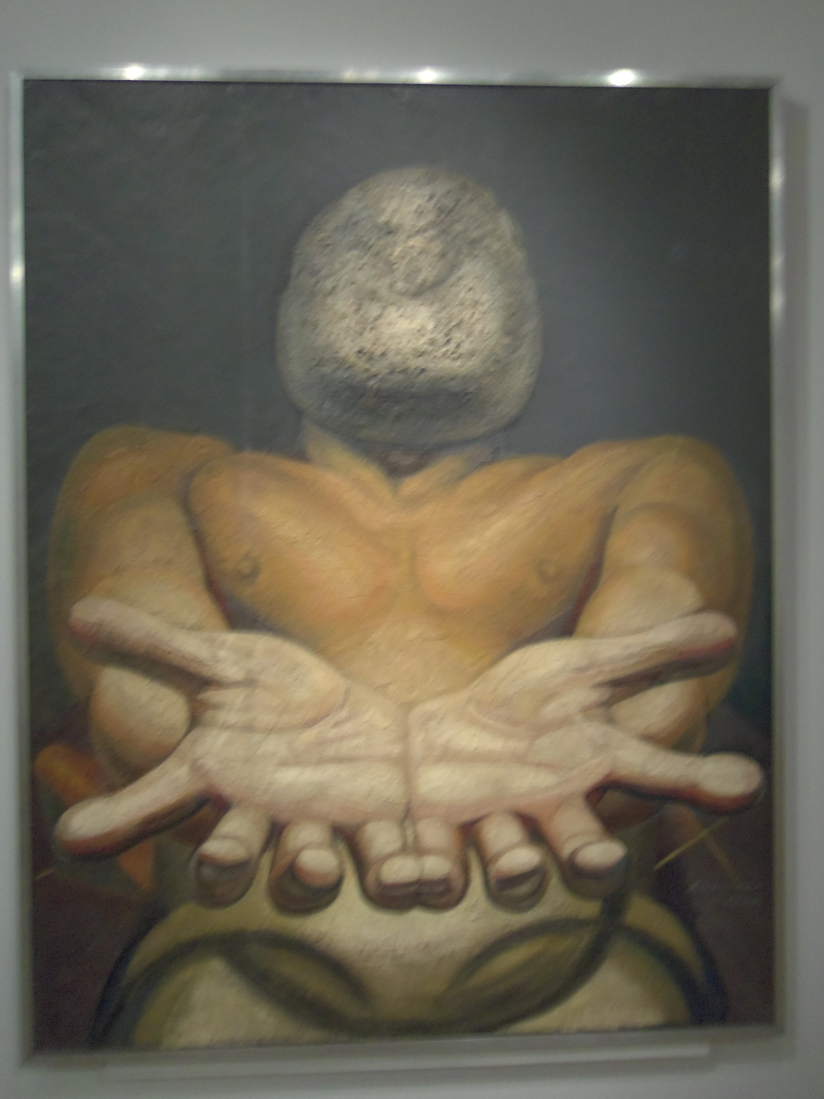
David Siqueiros, Our Present Image, 1947

Philosophy of art covers philosophical issues related to the various arts. It is closely related to aesthetics, which deals with such concepts as “the beautiful” and “the sublime.” In this class we will discuss such questions as: What is art? What is the function of art? What is the creative process? What is beauty? What is aesthetic experience? What role does aesthetics play in art? What role does expression play in art? What is the relation between art and morality? Can art give us knowledge? Are there any principles of taste? What is the meaning of a work of art?

Some more specific debates will include Can food be art? What makes a musical work authentic? What is wrong with forgery? What role does music play in culture? Are there correct ways to appreciate nature? Why should we care about fictional characters? Is there a difference between pornography and erotica? Are there societies without art? We will also look into the relationship between art and everyday life through Scruton’s book on beauty and my own work on everyday aesthetics.

The class will be a mixture of lecture, class discussion and student presentations and will be illustrated with slides and other media.

Alex Niell and Aaron Ridley ed. Arguing About Art: Contemporary Philosophical Debates (2007)

Theodore Gracyk. Philosophy of Art: An Introduction (Polity, 2011)

Roger Scruton. Beauty: A Very Short Introduction (Oxford University Press, 2011)

Cynthia Freeland. But is it Art? An Introduction to Art Theory (Oxford University Press, 2002)

Thomas Leddy. The Extraordinary in the Ordinary: The Aesthetics of Everyday Life (Broadview Press, 2012).

