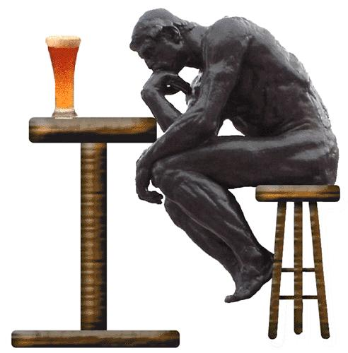

Philosophy 113: Existentialism and Phenomenology
Fall, 2013, Department of Philosophy

Prof. P. Hadreas

Wednesday evenings, 7-9:45pm, BBC 203

Attempts to supply an overview of existentialism and phenomenology in one semester cannot help but leave out major figures and texts. We’ll nonetheless attempt a synoptic approach this semester, touching upon some of the highly influential literary expressions of existentialism as well as the primary philosophical figures. Husserl, Heidegger, and Merleau-Ponty and commentary on these main philosophers will take up most of the time. But we’ll also discuss selections from Kierkegaard, Dostoyevsky, Sartre, De Beauvoir, Camus and Ellison.

Required Books:
Solomon, Robert C., Phenomenology and Existentialism, New York: Roman & Littlefield, 2001. ISBN: 0-7425-1240-1.
Marino, Gordon, Basic Writings of Existentialism, New York: The Modern Library, 2004. ISBN: 0-375-75989-1.

Assignments:
There will be a midterm written in class and three papers. Two relatively short, four to five pages, ands one longer seven to eight pages due at the time of the final exam.

