TechEdSat Program Commendation by the City Council of San Jose
By recommendation of the Councilmember Raul Peralez of the city council of San Jose the Mayor, Sam Liccardo, presented a commendation to the Technology Educational Satellite team for their achievements and the most recent launch of TechEdSat-8. Council member Peralez recognized the efforts and importance of this accomplishment and invited Dr. Periklis Papadopoulos to accept the commendation on behalf of the TechEdSat program at San Jose State University. The commendation ceremony took place on Tuesday Feb 26th at the Council Chambers at City Hall. The award was received by Dr. Papadopoulos, and Dr. Marcus Murbach, in the presence of Jaye Bailey, Vice President for Organizational Development & Strategic Initiatives at SJSU. Present at the award ceremony were all members of the TechEdSat-8 team: Ali Guarneros Luna, Elias T. Reyes, Austin Tanner, Alejandro Salas, Cedric Priscal, Nicolas S. Williams, Reine Dominque Ntone, Bernardo Soriano-Gama, Khoa Ngo, Jesus Ramiro Rosila Mares, Roberto Rosila, Nanci Solomon, Robert Bruce and Zachary M. Hughes.
The commendation was then presented to Dr. Papadopoulos on behalf of the TechEdSat-8 team by the councilmember Peralez and Mayor Liccardo that outlined the following acknowledgements:

WHEREAS: The Technology Education Satellite program founded by San José State engineering professors Marcus Murbach and Dr. Periklis Papadopoulos, allows students to perform satellite experiments with NASA Ames engineers; and
WHEREAS: The Technology Education Satellite program launched their first satellite into orbit in October 2012 and reentered the atmosphere in May 2013, this experiment was a grand success that spurred a series of satellite experiments; and
WHEREAS: On January 31st 2018 the 8th satellite was launched into orbit with the purpose of improving the Small Payload Quick Return concept; and
WHEREAS: The San José State University College of Engineering, has made great strides to the Aerospace curriculum by allowing students and NASA Ames staff to improve satellite technologies;

Dr. Papadopoulos addressed the council and thanked the Mayor and councilmember Peralez and stated that
“The TechEdSat nano-sat series is a decadal / multi-year collaborative effort between the San Jose State University College of Engineering and NASA Ames. The program originated from NASA’s Chief Technologist officer, Dr. John Hines and was materialized and program managed by Dr. Marcus Murbach in close collaboration with us at the Aerospace Engineering Department. It has involved several generations of students and young professionals that make up the workforce of tomorrow in this rapidly developing and exciting field. We are honored to accept this commendation on behalf of San Jose State University, the Davidson College of Engineering, the Aerospace Engineering Department – our colleagues from the NASA’s Ames Research Center in Silicon Valley – as well as the many students and alumni who participated.”

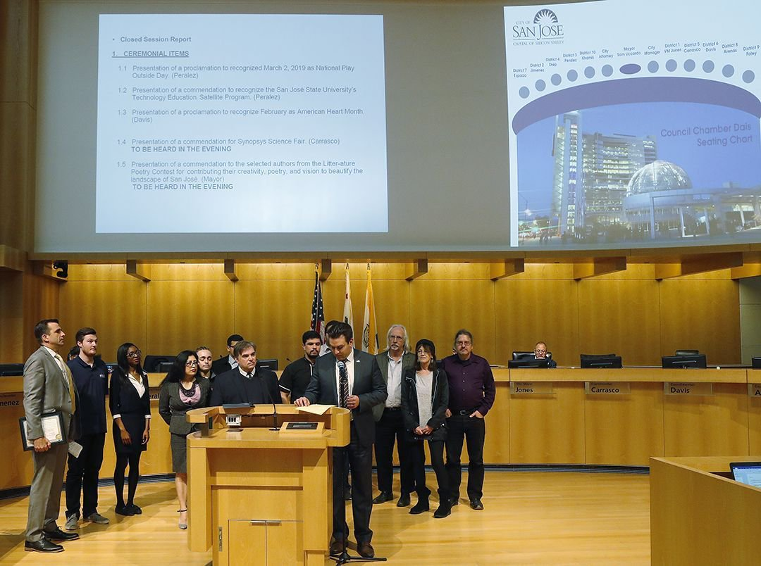
Councilmember Peralez commending the TechEdSat team at the City Council of San Jose in the presence of Mayor Sam Liccardo

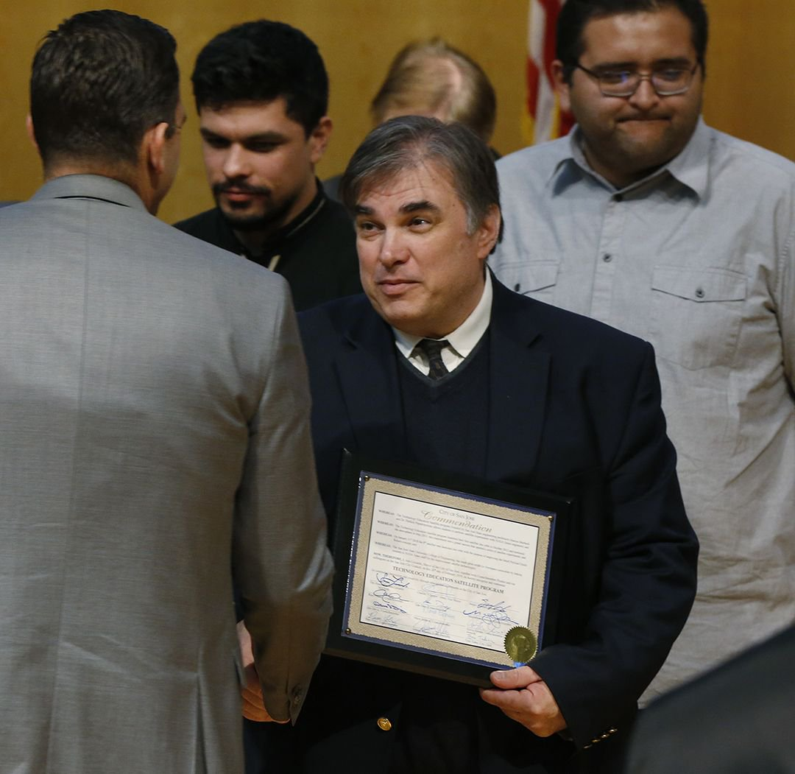
Mayor, Sam Liccardo, Congratulating Dr. Papadopoulos on behalf of the TechEdSat Team

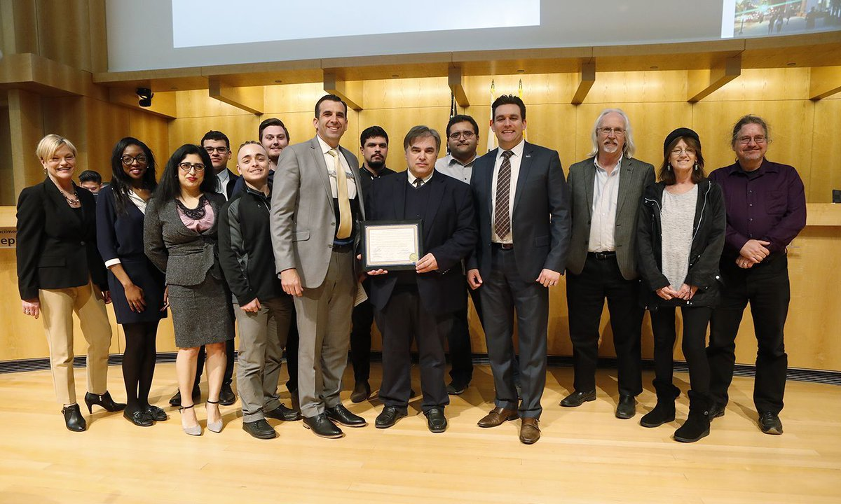
TechEdSat Program Commendation Ceremony at the City Council of San Jose
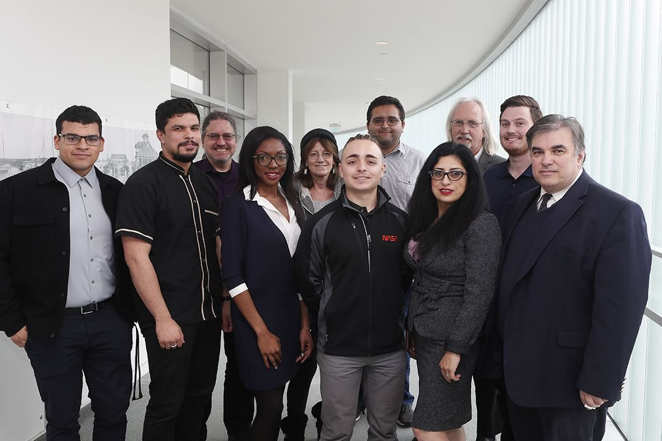
TechEdSat-8 Team at the City Council of San Jose

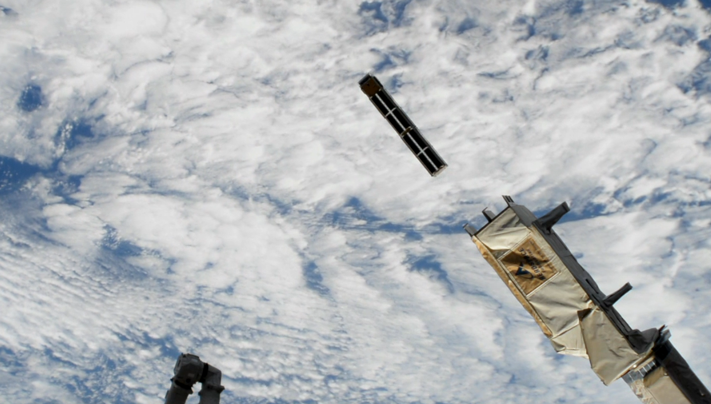TechEdSat-8 Deployment from the International Space Station on January 31st 2019
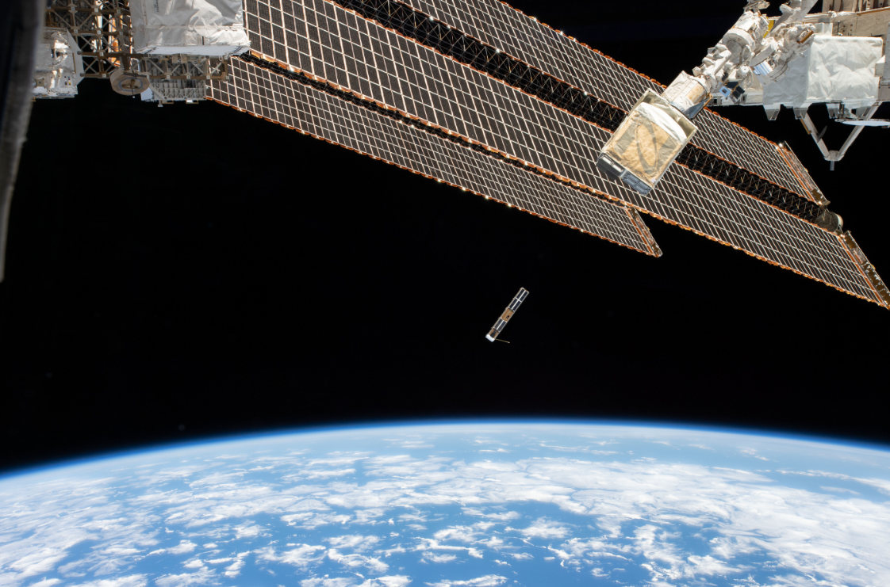TechEdSat-8 Deployment from the International Space Station on January 31st 2019
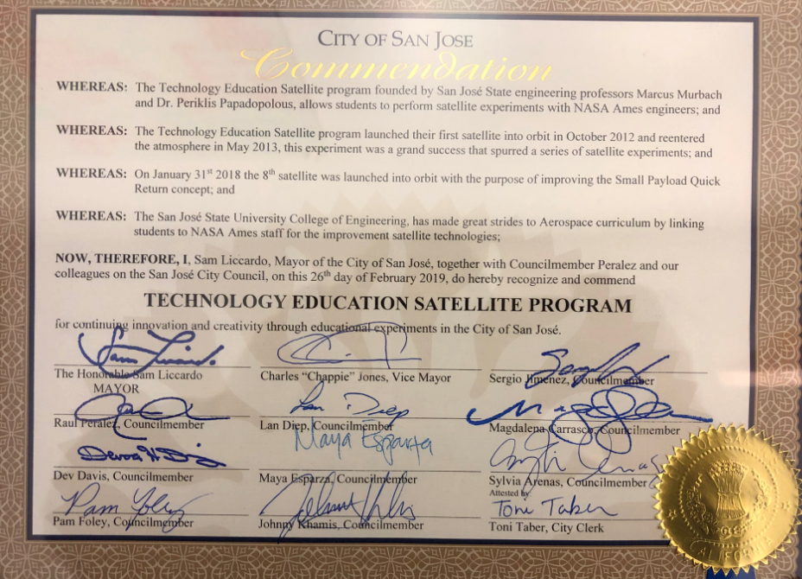TechEdSat Program Commendation by the City Council of San Jose
More details on the Technology Educational Satellite (TES-8) program can be found at the official NASA website:
https://www.nasa.gov/mission_pages/station/research/experiments/2804.html

