Design of a Short to Medium Range
Hybrid Transport Aircraft
A Project Presented to
The Faculty of the Department of Aerospace Engineering
San José State University

In Partial Fulfillment of the Requirements for the Degree
Master of Science in Aerospace Engineering

by
Sarah M. Ortega

approved by
Dr. Nikos J. Mourtos
Faculty Advisor



Nomenclature
A = aspect ratio
A/C = aircraft
AEP = airplane estimated price
A_{h} = horizontal tail aspect ratio
$A_{inl}$ = capture area per inlet in square feet
A_{v} = vertical tail aspect ratio
ac = aerodynamic center
AH_{j} = number of flight hours per year for crew member j
ASP = avionics systems price
b = wingspan
B.L. = wing buttock lines
C_{L} = lift coefficient
C_{D} = drag coefficient
Cr = cruise
c = chord
c_{r} ₌ root chord
c_{t} = tip chord
CGR = climb gradient
cg = center of gravity
$C_{n_{δ_{r}}}$ = control power derivative
$C_{lab/ap}$ = labor cost of airframe and system maintenance
$C_{lab/eng}$ = labor cost of engine maintenance
$C_{mat/ap}$ = cost of maintenance materials for the airframe and systems
$C_{mat/eng}$ = cost of maintenance materials for the engines
$C_{amb}$ = applied maintenance burden
$C_{dap}$ = cost of airplane depreciation
$C_{deng}$ = cost of engine depreciation
$C_{dav}$ = cost of avionics system depreciation
$C_{dapsp}$ = cost of airplane spare parts depreciation
$C_{dengsp}$ = cost of engine spare parts depreciation
C_{lf} = direct operating cost due to landing fees
C_{aplf} = airplane landing fee per landing
C_{nf} = navigation fee
C_{apnf} = navigation fee charged per airplane per flight
C_{rt} = direct cost of registry taxes
DOC = direct operating cost
DOC_{lnr} = direct operating cost of landing fees
DOC_{fin} = direct operating cost of financing the airplane
DP_{ap} = airplane depreciation period
DP_{av} = airplane avionics system depreciation period
DP_{engsp} = depreciation period for engine spare parts
e = battery specific energy, Oswald constant
E_{bat} = energy of batteries
$E_{τ}$ = propulsive energy required
EP = engine price
ESPPF = engine spare parts price factor
F_{dap} = airframe depreciation factor
F_{dav} = airplane avionics system depreciation factor
f = equivalent parasite area
F.S. = fuselage stations
FAA = Federal Aviation Administration
FAR = Federal Aviation Regulations
FT = Fischer-Tropsch
F_{engsp} = engine spare parts factor
f_{rt} = factor depending on airplane size
g = gravitational acceleration
h = height
$h_{fus}$ = height of fuselage in feet
HTA = Hybrid Transport Aircraft
i_{w} ₌ incidence angle
j = crew member type
K = drag due to lift polar coefficient
K_{g} = gust alleviation factor
k_{j} = factor accounting for crew vacation pay, cost of training crew insurance, etc.
LE = leading edge
LG = landing gear
Ltr = loiter
$l_{fus}$ = length of fuselage in feet
$l_{h}$ = distance from wing root quarter cord to horizontal tail quarter cord in ft
$l_{n}$ = nacelle length
n = load factor
$n_{c_{j}}$ = number of crew members of type j
N_{D} = drag induced yawing moment
$N_{e}$ = number of engines
$n_{\lim_{pos}}$ = positive limit naneuvering load factor
$n_{\lim_{neg}}$ = negative limit naneuvering load factor
$N_{inl}$ = number of inlets
$N_{pax}$ = number of passengers
$N_{pil}$ = number of pilots
mgc = mean geometric chord
M_{H} = maximum Mach number at sea level
M_{ff} = mission fuel fraction
M_{res} = reserve fuel fraction
M_{tfo} = trapped fuel fraction
MEA = More Electric Aircraft
p = battery specific power
P_{r} = power required (propulsive)
$P_{2}$ = maximum static pressure at engine compressor face in psi
q = dynamic pressure in psf
$\overline{q}$ = design dive dynamic pressure in psf
RC = rate of climb
Re_{r} = Reynold’s number at root chord
Re_{t} = Reynold’s number at chord tip
$R_{bl}$ = block distance
$R_{cl}$ = climb distance
$R_{de}$ = descent distance
$R_{man}$ = maneuvering distance
S = wing reference surface area
S_{h} = horizontal tail area
S_{v} = vertical tail area
S = gross wing area
SAL_{j} = yearly salary per crew member
S_{TOFL} = takeoff field length
T = time of flight
T_{phase} = time of flight for a certain phase
TBW = Truss Braced Wing
t/c = thickness ratio
T_{cl} = time to climb
T/W = thrust loading (or thrust to weight ratio)
$t_{r_{h}}$ = horizontal tail maximum root thickness
$t_{r_{v}}$ = vertical tail maximum root thickness
TEF_{j} = travel expense factor per crew member j
W/S = Wing loading
$W_{ai}$ = air induction system weight
$W_{api}$ = weight of air-conditioning, pressurization, anti-icing and de-icing system
$W_{apu}$ = weight of auxiliary power unit (APU)
W_{bat} = weight of batteries
$W_{bc}$ = weight of baggage and cargo handling equipment
W_{e} = empty weight
$W_{els}$ = weight of electrical system
$W_{eng}$ = weight of engine
W_{f} = fuel weight
$W_{fc}$ = weight of flight control system
$W_{fur}$ = weight of furnishings
$W_{hs}$ = weight of hydraulic and pneumatic system
$W_{i}$ = weight of instruments
$W_{iae}$ = weight of the instrumentation, avionics, and electronics
W_{oe} = operating empty weight
$W_{ops}$ = weight of operational items
$W_{ox}$ = weight of oxygen system
W_{pl} = payload weight
$W_{pt}$ = weight of paint
W_{tfo} = trapped fuel weight
W_{to} = take off weight
W_{L} = landing weight
$W_{fs}$ = fuel system weight
$W_{fus}$ = weight of fuselage in lbs
$w_{fus}$ = width of fuselage
$W_{p}$ = propulsion system
$W_{pwr}$ = powerplant weight
$W_{struct}$ = weight of structure
$U_{ann_{bl}}$ = annual utilization in block hours
V = velocity
V_{B} = design speed for maximum gust intensity
V_{A} = approach speed
V_{C} = design cruise speed
V_{cr} = cruise velocity
V_{D} = design diving speed
V_{M} = design maneuvering speed
$V_{pax}$ = passenger cabin volume
V_{S} = +1g stall speed or minimum speed at which airplane is controllable
$x_{v}, x_{h, }x_{c}$ = distance from center of gravity to aerodynamic center of the surface
y_{t} = lateral thrust moment arm of most critical engine
z_{h} = distance from vertical tail to root, where horizontal tail is mounted on vertical tail
η_{p} = propeller efficiency
$ρ$ = air density
Λ = quarter chord sweep angle
λ = taper ratio
ε_{w} = twist angle
Γ_{w} = dihedral angle

Table of Contents
Nomenclature ii
List of Figures xv
List of Tables xx
1. Introduction 1
1.1. Exploring Hybrid Possibilities for the Next Generation of Transport Aircraft 3
1.1.1. Environmental Factors 3
1.2 Alternate Fuel Sources 6
1.2.1. Synthetic Fuel 6
1.2.2. Hydrocarbon Feedstock 6
1.2.3. Alternative Fuel Comparisons 7
1.2.4. Lithium Ion Batteries 8
1.3. Battery Sizing 11
1.4. Project Objective 16
1.5. Mission Specifications 16
1.5.1. Mission Specifications 16
1.5.2. Mission Profile 17
1.6. Methodology 17
1.7. Comparative Study of Airplanes with Similar Mission Performance 18
1.7.1. Comparison of Weights, Performance, and Geometries of Similar Airplanes 18
1.7.2. Configuration Comparison of Similar Airplanes 21
1.8. Discussion 26
2. Configuration Selection 29
2.1. Overall Configuration 29
2.1.1. Fuselage Configuration 29
2.1.2. Engine Configuration 30
2.1.3. Wing Configuration 30
2.1.4. Empennage Configuration 31
2.1.5. Landing Gear Configuration 31
3. Weight Sizing and Weight Sensitivities 32
3.1 Data Base for Takeoff Weights and Empty Weights of Similar Airplanes 32
3.2. Determination of Mission Weights 34
3.3. Manual Calculation of Mission Weights 35
3.3.1. Payload Weight 35
3.3.2. Estimated Takeoff Weight Method 1 35
3.3.3. Determination of Mission Fuel Weight 36
3.3.4. Estimating Takeoff Weight Method 2 39
3.3.5. Determining Allowable Value for Empty Weight 40
3.3.6. Determination of Mission Battery Weight 42
3.4. AAA Calculation of Mission Weights 43
3.5.Takeoff Weight Sensitivities 45
3.5.1. Manual Calculations of Takeoff Weight Sensitivities 45
3.5.2. AAA Calculation of Takeoff Weight Sensitivities 48
3.6. Trade Studies 49
3.7. Takeoff Weight vs. Critical Mission Parameters 50
3.7.1. Takeoff Weight vs. L/D 50
3.7.2. Takeoff Weight vs. Payload 51
3.7.3. Takeoff Weight vs. Range 51
3.7.4. Takeoff Weight vs. Specific Fuel Consumption 52
3.8. AAA Calculation of Range vs. Payload 53
3.9. Trade Study Conclusions 53
4. Determination of Performance Constraints 54
4.1. Manual Calculation of Performance Constraints 55
4.1.1. Stall Speed Sizing 55
4.1.2. Takeoff Distance Sizing 55
4.1.3. Landing Distance Sizing 58
4.1.4. Climb Requirement Sizing 60
4.1.5. Maneuvering Requirement Sizing 63
4.1.6. Cruise Speed Requirement Sizing 63
4.2. AAA Calculation of Performance Constraints 64
4.2.1. Stall Speed Sizing 64
4.2.2. Takeoff Distance Sizing 64
4.2.3. Landing Distance Sizing 64
4.2.4. Climb Requirement Sizing 65
4.2.5. Cruise Speed Requirement Sizing 65
4.2.6. Matching Plot 65
5. Fuselage and Cockpit Design 66
5.1. Cockpit Design 66
5.1.1. Cockpit Layout Design 69
5.2. Fuselage Design 70
5.2.1. Fuselage Layout Design 70
5.3. Recommendations and Conclusions 74
5.3.1. Recommendations 74
5.3.2. Conclusions 74
6. Wing, High-Lift System and Lateral Control Design 75
6.1. Wing Planform Design 75
6.1.1. Sweep Angle-Thickness Ratio Combination 75
6.2. Airfoil Selection 77
6.3. Design of the High-Lift Devices 78
6.3.1. AAA Calculation of Lift Coefficient 81
6.4. Design of the Lateral Control Surfaces 82
6.5. Drawings 84
6.6. Discussion 84
6.7. Recommendations and Conclusions 85
6.7.1. Recommendations 85
6.7.2. Conclusions 85
7. Design of the Empennage and the Longitudinal and Directional Controls 86
7.1. Overall Empennage Design 86
7.2. Design of the Horizontal Stabilizer 87
7.3. Design of the Vertical Stabilizer 87
7.4. Empennage Configuration Drawings 88
7.5. Empennage Design Evaluation 89
7.6. Discussion 90
7.7. Recommendations and Conclusions 90
7.7.1. Recommendations 90
7.7.2. Conclusions 90
8. Design of the Landing Gear and Weight and Balance Analysis 92
8.1. Introduction 92
8.2. Estimation of the Center of Gravity 92
8.3. Landing Gear Design 101
8.4. Weight and Balance 104
8.5. Conclusion 104
9. Stability and Control Analysis 104
9.1. Introduction 104
9.2. Static Longitudinal Stability 105
9.3. Static Directional Stability 107
9.4. Minimum Control Speed with One Engine Inoperative 108
9.5. Empennage Design-Weight and Balance- Landing Gear Design- Longitudinal Static Stability and Control Check 109
9.7. Conclusion 110
10. Drag Polar Estimation 110
10.1. Introduction 110
10.2. Airplane Zero Lift Drag 110
10.3. Low Speed Drag Increments and Compressibility Drag 113
10.3.1. High Lift Device Drag Increments for Takeoff and Landing Gear Drag 114
10.5. Airplane Drag Polars 115
10.6. Discussion 115
10.7. Conclusion 116
11. Environmental and Economic Tradeoffs 116
11.1. Important Design Parameters 116
11.2. Recommendations 117
11.2.2. Einvironmental/Economic Tradeoffs 117
12. Preliminary Design Sequence II 117
13. V-n Diagram 118
13.1. Calculation of V_{S} 119
13.2. Calculation of V_{C} 119
13.3. Calculation of V_{D} 120
13.4. Calculation of V_{M} 120
13.5. V-n Maneuver Diagram and V-n Gust Diagram 122
14. Class II Weight and Balance 123
14.1. Class I Weights 123
14.2. Weight Estimate Calculations 124
14.2.1. Structural Weight 124
14.2.2. Powerplant Weight 129
14.2.3. Fixed Equipment Weight 130
14.2.4. Empty Weight Discussion 141
14.3. Component Centers of Gravity 142
14.4. Airplane Inertias 145
15. Cost Analysis 145
15.1. Direct Operating Cost 147
15.1.1. Direct Operating Cost of Flying 148
15.1.2. Direct Operating Cost of Maintenance 149
15.1.3. Direct Operating Cost of Depreciation 151
15.1.4. Direct Operating Cost of Landing Fees, Navigation Fees, and Registry Taxes 153
15.1.5. Direct Operating Cost of Financing 153
15.1.5. Direct Operating Cost Discussion 153
15.2. Indirect Operating Cost 156
15.3. Program Operating Cost 156
15.3. Hybrid Power Cost Analysis 157
15.3.1. Sample Battery Specifications 157
16. Conclusion 158
References 160

List of Figures
Figure 1. World Carbon Dioxide Emissions 3
Figure 2. Direct CO₂ emissions from 1 gallon of fuel (lbs/gal) 4
Figure 3. Number of General Aviation Aircraft from 1970 to 2014 5
Figure 4. Alternative Biofuels 6
Figure 5. Comparison of different types 8
Figure 6. Performance Comparison of Li-ion Batteries 9
Figure 7. Mission Profile Comparison of Sample Aircraft 14
Figure 8. Current and expected battery technology 16
Figure 9. Mission Profile 17
Figure 10. Boeing 737-100 aircraft configurations (Boeing Commercial Airplanes, 2013) 21
Figure 11. Boeing 737-200 aircraft configuration. (Boeing Commercial Airplanes, 2013) 22
Figure 12. Airbus A320NEO aircraft configuration (Airbus Commerial Aircraft, n.d.) 23
Figure 13. Embraer ERJ-170-100 aircraft configuration (Jane's All the World's Aircraft, 2013) 24
Figure 14. CRJ200-ER aircraft configuration (Canadair Regional Jet, 2016) 25
Figure 15. SUGAR Volt 765-096 RevA aircraft configuration (Bradley & Droney, Subsonic Ultra Green Aircraft Research: Phase II- Volume II- Hybrid Electric Design Exploration, 2015) 26
Figure 16. Log-Log Plot of Takeoff Weight vs. Empty Weight with included trendline and linear regression equation 33
Figure 17. Regression Line Constants for Aircraft 34
Figure 18. Weight Trends for Transport Jets 42
Figure 19. AAA output with all fuel aircraft with 2 turbojet engines 44
Figure 20. W_{e} vs. W_{to} of 2 turbojet engine fuel-powered aircraft with ideal design point of W_{to}=71,635.9 lbs and W_{e}=39,775.9 lbs 44
Figure 21. Takeoff weight sensitivities calculated by AAA for fuel-powered aircraft 49
Figure 22. Takeoff weight sensitivities calculated by AAA for electric aircraft 49
Figure 23. Takeoff Weight vs. L/D for Cruise 50
Figure 24. Takeoff Weight vs. L/D for Loiter 50
Figure 25. Takeoff Weight vs. Payload Weight (ranges from 80 passengers to 124 passengers) 51
Figure 26. Takeoff Weight vs. Range 51
Figure 27. Takeoff Weight vs. Specific Fuel Consumption during Cruise 52
Figure 28. Takeoff Weight vs. Specific Fuel Consumption during Loiter 52
Figure 29. Range vs. Payload 53
Figure 30. Range vs. Payload with design point W_{pl}=19,630.6 lb and R_{cr}=1,638.7 nm for fuel-powered aircraft 53
Figure 31. AAA results of stall speed sizing 64
Figure 32. AAA results of takeoff distance sizing 64
Figure 33. AAA results of landing distance sizing 64
Figure 34. AAA results of climb requirement sizing 65
Figure 35. AAA results of cruise speed requirement sizing 65
Figure 36. AAA results of the performance sizing plot 65
Figure 37. Dimensions of sitting male crew member in cockpit (Roskam, 2011). 67
Figure 38. Radial eye vectors emanating from C. (Roskam, 2011) 68
Figure 39. Ideal minimum visibility pattern for transport aircraft. (Roskam, 2011) 68
Figure 40. Side and top-down view of cockpit. Dimensions in meters (Boeing Commercial Airplanes, 2013) 69
Figure 41. Front and side 3-D view of cockpit. Dimensions in meters (Boeing Commercial Airplanes, 2013) 69
Figure 42. Rear view of cockpit. (Aircraft Technical Data and Specifications: Boeing 737-100/200, 2017) 70
Figure 43. Top down view of the fuselage (Boeing Commercial Airplanes, 2013) 70
Figure 44. Front view of the fuselage (Boeing Commercial Airplanes, 2013) 71
Figure 45. Front 3-D view of the 6 abreast passenger seating in the fuselage (Creative Aviation Photography, 2017) 71
Figure 46. Rear 3-D view of the 6 abreast passenger seating in the fuselage (Creative Aviation Photography, 2017) 72
Figure 47. Side view of fuselage with cargo compartment visible (Boeing Commercial Airplanes, 2013) 73
Figure 48. Side view of fuselage with cargo placement (Boeing Commercial Airplanes, 2013) 74
Figure 49. Jet Transports Wing Geometric Data (Roskam, Airplane Design Part II: Preliminary Configuration Design and Integration of the Propulsion System, 2011) 75
Figure 50. Plots of t/c and W_{w} vs. Λ 76
Figure 51. Boeing 737 Airfoil selections schematic (Aircraft Technical Data and Specifications: Boeing 737-100/200, 2017) 77
Figure 52. C_{l} vs. angle of attack for maximum lift coefficient at root and midspan 79
Figure 53. Effect of Flap Chord Ratio and Flap Type on K 80
Figure 54. AAA Estimate of clean Lift Coefficient of the Wing 81
Figure 55. Wing Planform: flap and lateral control layout 84
Figure 56. Empennage Configuration (units in feet) 88
Figure 57. Horizontal Tail Geometry Calculations by AAA 89
Figure 58. Vertical Tail Geometry Calculations by AAA 89
Figure 59. Vertical tail configuration in HTA 91
Figure 60. Horizontal tail configuration in HTA 91
Figure 61. c.g. for various aircraft components 94
Figure 62. c.g. location for each component on the aircraft 95
Figure 63. c.g. excursion plot produced using Microsoft Excel 96
Figure 64. Weight fractions referenced from the 737-200 from AAA 96
Figure 65. c.g. locations produced using AAA 97
Figure 66. c.g. location for MTOW aircraft 97
Figure 67. Loading Table from AAA for x-direction c.g. excursion diagram 98
Figure 68. c.g. excursion diagram (x-direction) 99
Figure 69. Loading Table from AAA for z-direction c.g. excursion diagram 100
Figure 70. c.g. excursion diagram (z-direction) 100
Figure 71. Landing gear and strut placement 102
Figure 72. Nose gear retraction 102
Figure 73. Stick Diagram for main gear retraction 103
Figure 74. Illustration of the two nose tires and four main tires for the landing gear. 103
Figure 75. Landing Gear retracted into fuselage 103
Figure 76. Geometric quantities for aircraft calculations 106
Figure 77. Longitudinal X-Plot for the HTA 106
Figure 78. HTA Directional X-Plot 107
Figure 79. Geometry for one engine out V_{mc} calculations 108
Figure 80. Maximum takeoff weight vs. wetted area for jet transports 112
Figure 81. Wetted area vs. equivalent parasite area 113
Figure 82. Typical Compressibility Drag Behavior 114
Figure 83. Low speed polars for transport 115
Figure 84. L/D Ratios 115
Figure 85. 3-view of HTA 116
Figure 86. Ghost View of Aircraft 118
Figure 87. V-n Maneuver Diagram 122
Figure 88. V-n Gust Diagram 122
Figure 89. hFan engine overview 130
Figure 90. Class II c.g. Excursion Diagram 144
Figure 91. DOC for a Jet Transport 154
Figure 92.HTA DOC with batteries and fuel 154
Figure 93. HTA DOC for all fuel 155
Figure 94. Effect of variable depreciation period on DOC 155

List of Tables
Table 1. Preliminary database of Electric Aircraft 10
Table 2. Mission Overview of Sample Aircraft 14
Table 3. Summary of Theoretical Specific Energy 15
Table 4. Comparison of Aircraft Weights 18
Table 5.Comparison of Aircraft Performance (Assuming standard conditions at sea level) 19
Table 6. Comparison of Aircraft Geometries 20
Table 7. Aircraft Takeoff and Empty Weights 32
Table 8. Data for W_{to} Comparison 36
Table 9. Suggested Fuel-Fractions for Mission Phases 37
Table 10. Breguet Partials for Propeller and Jet Airplanes 47
Table 11. Stall Speed Sizing 55
Table 12. Takeoff Distance Sizing for S_{TOFL} =5000 ft at 0 ft altitude 56
Table 13. Takeoff Distance Sizing for S_{TOFL} =6000 ft at 0 ft altitude 57
Table 14. Takeoff Distance Sizing for S_{TOFL} =9468 ft at 5000 ft altitude 57
Table 15. Takeoff Distance Sizing for S_{TOFL} =10800 ft at 8000 ft altitude 57
Table 16. W/S_{to} with W_{L}/W_{to}=0.85 59
Table 17. W/S_{to} with W_{L}/W_{to}=0.9 59
Table 18. W/S_{to} with W_{L}/W_{to}=0.93 59
Table 19. W/S_{to} with W_{L}/W_{to}=0.96 60
Table 20. Configuration Parameters and Drag Polars 60
Table 21. FAR 25.111 (gears down, TO flaps, with additional T/W calculated for 50ºC increase) 61
Table 22. FAR 25.121 (gears down, TO flaps, with additional T/W calculated for 50ºC increase) 61
Table 23. FAR 25.111 (gears down, TO flaps, with additional T/W calculated for 50ºC increase) 62
Table 24. FAR 25.121 (gears up, flaps up, with additional T/W calculated for 50ºC increase and maximum thrust at 0.94) 62
Table 25. FAR 25.119 (AEO) (balked landing, gears down, flaps down) 62
Table 26. FAR 25.121 (OEI) (balked landing, gears down, flaps down) 62
Table 27. Sizing to Time to Climb Requirements 63
Table 28. Thickness Ratio and Wing Weight vs. sweep angle 76
Table 29. $∆CLmax TO$ and $∆CLmax L$ using various S_{wf}/S 80
Table 30. Calculated$∆cl$ for takeoff and landing 81
Table 31. Jet Transport Lateral Control Surface Information 82
Table 32. Additional Jet Transport Lateral Control Surface Information 83
Table 33. Summary of Comparable Volume Coefficients and Control Surface Data 86
Table 34. HTA Component Weight and Coordinate Data 93
Table 35. Wetted Area Summary 111
Table 36. $CD0$ summary 114
Table 37. First Estimates for Drag with flaps and gear down 114
Table 38. Class I Weights 124
Table 39. Constants in Landing Gear Weight Equation 128
Table 40. Class II Estimation of Structure Weight 129
Table 41. SUGAR Flight Control System Weight Data 131
Table 42. SUGAR Hydraulic System Weight Data 133
Table 43. SUGAR Electrical System Weight Data 134
Table 44. SUGAR Data for Instrumentation, Avionics, and Electronics Weight 135
Table 45. SUGAR API Weight Data 136
Table 46. SUGAR APU Weight Data 137
Table 47. SUGAR Aircraft Furnishings Weight Data 138
Table 48. SUGAR Data for Operational Items Weight 140

1. Introduction
The allure of the skies has long since driven many to explore the possibilities of flight. From the early studies of George Cayley, an eighteenth century pioneer of aircraft design, to the Wright brothers, and their historic 1902 glider flight, to today’s commercial jet airliners and small electric airplanes, advancements in aircraft have come a long way over the past two hundred years. Achievements in electric aircraft are only just beginning, with the ultimate goal of eliminating the use of fossil fuels and converting to an eco-friendly, form of propulsion for all aircraft.
The early pioneers of flight paved the way for aeronautical infrastructure and eventually the jet airliners. These commercial aircraft revolutionized flight, making world travel a reality for nearly half the global population (Federal Aviation Administration, 2015). In order to accommodate a large number of passengers, jet aircraft required changes in their airframe design, structure, and support. These changes included a larger, pressurized fuselage to accommodate more passengers and the changes in altitude; reduced drag by sweeping the wings; improved ground-handling equipment for servicing, fueling, loading, and unloading; and air traffic control changes involving navigation and flight surveillance to monitor increased air traffic. (An Encyclopedia of the History of Technology, 2002) Companies like Boeing responded to the demand and produced the Boeing 720, then the three-engined Boeing 727, and later the twin-engined Boeing 737. As the demand for more passengers increased, the designs changed yet again with Boeing introducing the 747 with four turbofan engines that provided better fuel and overall propulsive efficiency. (An Encyclopedia of the History of Technology, 2002)
The 737 family of aircraft was designed to operate for short to medium range flights from runways shorter than 6,000 ft. Other significant features of the aircraft include overwing gravity fueling and single-station pressure fueling, available airstairs for airports that lack passenger loading bridges or stairs, system maintenance performance at eye level, and servicing with standard ground equipment. (Boeing Commercial Airplanes, 2013) The first of the family of 737’s was the 737-100, which was the short body version, measuring 94 ft in length. The later versions increased in length, experienced improvements in range, payload, runway requirements, and interior layout. The 737-100 model will be the foundation for the design of the hybrid 737. The 737-100 model has specific design characteristics. These include a maximum design takeoff weight of 97,000 lbs, a maximum design landing weight of 89,700 lbs, maximum structural payload of 23,100 lbs with a seating capacity of 96 at 6 abreast and FAA exit limit of 124 passengers, maximum cargo volume of 650 ft³, and 3,540 gallons of usable fuel. (Boeing Commercial Airplanes, 2013) Similar features will be present in the proposed aircraft.
While electric power is the way to cleaner, greener aircraft, current battery capabilities are still limited, having just enough power to sustain small airplanes. A 2011 NASA Green Flight Challenge yielded a 2 seater electric aircraft that could fly at more than 100 mph for 200 miles using less than 1 gallon of fuel or energy equivalent per passenger. This engineering feat demonstrated the limiting capabilities of current battery power, making a fully-functional electric transport aircraft the size of the 737 seem like it might be more than a few decades out.
As a result, this project will explore the design tradeoffs of a hybrid 737 with the specifications of the 737-100 model powered with a combination of fuel and lithium ion batteries. This aircraft will result in lowering carbon dioxide emissions, lessening reliance on fossil fuels, using renewable energy sources, and providing an alternative means of power with current technology.

1.1. Exploring Hybrid Possibilities for the Next Generation of Transport Aircraft

1.1.1. Environmental Factors
With transportation innovations and the widespread availability of aviation to nearly half the global population, environmental protection and stability are motivating factors for exploring hybrid and electric aircraft. This has resulted in imposed constraints monitoring air and water cleanliness, noise impacts, and climate change. The Federal Aviation Administration (FAA) published the “Aviation Environmental and Energy Policy Statement” in 2012, emphasizing the commitment to both aviation growth and environmental protection. (Federal Aviation Administration, 2015) To achieve this commitment, the FAA’s Next Generation Air Transportation System will be responsible for establishing programs to develop new technologies, operations, and systems, while minimizing aviation’s environmental impact.
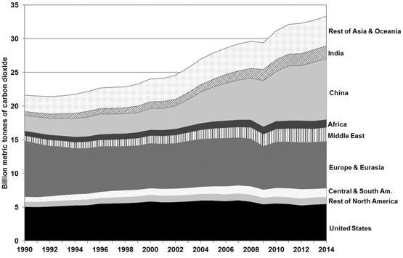
Conventional propulsion systems thermally decompose oil in piston engines or gas turbines. This in turn produces mechanical power which runs either a turbofan or turbo-propeller. Gearboxes can increase efficiency when they decouple the fan from the turbine or turbofan engine. Despite the ability to increase efficiency, these propulsion systems emit
exhaust into the atmosphere (Hepperle).

Figure 1. World Carbon Dioxide Emissions
Both aircraft and aviation infrastructure contribute to emissions of pollutants. Aircraft emissions consist of carbon dioxide (CO₂), water vapor (H₂O), nitrogen oxides (NO_{x}), sulfur oxides (SO_{x}), carbon monoxide (CO), partially burned or unburned hydrocarbons (HC), particulate matter (PM), and other trace compounds. CO₂ and H₂O emissions constitute about
70% and 30%, respectively, with the remainder of pollutants comprising less than 1%. The majority of emissions range in elevations with 90% released at altitudes above 3000 ft and the remainder close to the ground, with HC and CO having different emission properties. HC and CO discharge 70% above 3000 ft and the remaining 30% on the ground. (Federal Aviation Administration, 2015) Additionally, airport transportation vehicles such as buses, shuttles, construction vehicles, and cars emit similar pollutants. In turn, these pollutants enter the atmosphere, and join storm water runoff. In summary, the production of these chemicals impacts climate change, air, and water quality.
Figure 1, illustrates the billions of metric tons of CO₂ that are emitted annually by each country world-wide. CO₂ has a lifetime of up to 200 years and has a global warming potential direct effect of 100 years, so its annual contribution effects are present for decades to come. Transportation produces approximately 31.8% of these emissions, contributing to green
Direct CO₂ Emissions From 1 Gallon of Fuel (measured in pounds per gallon)
house gases. (Davis, Williams, & Boundy, 2016) Figure 2 summarizes the types
Figure 2. Direct CO₂ emissions from 1 gallon of fuel (lbs/gal)
of fuel emissions in pounds per gallon that contribute to direct CO₂ emissions. Aviation gasoline, or Av-gas, contributes 11% and jet fuel contributes 12%. (Davis, Williams, & Boundy, 2016) With an increase in the number of general aviation aircraft in use, these emissions will not decrease without changes to aircraft or fuel. General aviation consist of aircraft following general operating and flight rules, aircraft with a minimum seating capacity of 20 or maximum payload of 6,000 lbs that are not for hire, agricultural aircraft, rotorcraft external load operators, and commuter or on-demand aircraft not covered under FAR regulations part 121. From 1970-2014, the number of general aviation aircraft increased by around 1% per year, as summarized in Fig. 3. As a result in the number of increased aircraft, the energy used has increased by about 2% per year and 2.3% from 2004-2014. (Davis, Williams, & Boundy, 2016)
Besides producing a high volume of pollutants, aircraft also contribute to the use of fossil fuels. The United States imported 564,000,000 tons of oil in 2008 and has since increased oil importation. Transportation used a significant portion of
Figure 3. Number of General Aviation Aircraft from 1970 to 2014
the oil at 61.4%. Unpredictable oil prices have caused budget concerns with dependence on foreign oil. (Xue, 2014) Until 1989, the U.S. was able to sustain their petroleum needs for transportation. Now, the U.S. relies on foreign import for fuel. By the year 2040, the U.S. is expected to require the use of 7.8-8.9 million barrels of petroleum per day for all sectors, including transportation. (Davis, Williams, & Boundy, 2016). In 2001, North American Airlines dedicated 13.4% of their operating costs to fuel. By 2008, fuel comprised 34.2% of their costs. (Xue, 2014). Emissions from aviation activity and fossil fuel usage are projected to increase due to the increase in number of aircraft and demand for air transportation. Electric aircraft would remove that dependence and hybrid vehicles would alleviate oil dependence.
In response to the rise in pollution and fossil fuel usage, improvements in aircraft operational efficiency, usage of alternative, sustainable fuels, and electric or hybrid aircraft are being developed. Changes in aircraft construction could focus on using light-weight, aerodynamic materials. On the operations side, airplanes could spend less time idling and taxiing and fly more direct routes in better weather and less congested air traffic. (Federal Aviation Administration, 2015). Each of these would decrease emissions.

1.2 Alternate Fuel Sources

1.2.1. Synthetic Fuel
Although fuel efficiency has been increasing, with current jet aircraft being 70% more fuel efficient per seat-kilometer than the original 1960s jets, alternate fuel could additionally support fuel efficiency and reduce CO₂ emissions. (Federal Aviation Administration, 2015) Synthetic fuels are created from coal, natural gas, or other hydrocarbon feedstock using the Fischer-Tropsch (FT) process. These fuels yield less PM, sulfur, and, possibly, CO₂. When being manufactured, synthetic fuels produce CO₂ and emit 1.8 times the amount originally produced during flight. (Daggett, Hendricks, Rainer, & Corporan, 2008) As a result, in order to be a viable option for reducing CO₂, steps would need to be implemented to capture and store all emissions.

1.2.2. Hydrocarbon Feedstock
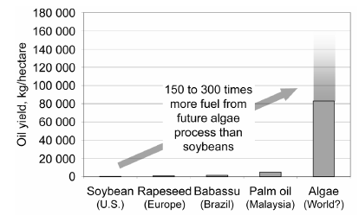
Another consideration is the candidate for hydrocarbon feedstock. If some form of plants were used, there would need to be adequate farmland to sustain the fuel. This farmland would need to be acquired without deforestation techniques, where the smoke from fires would contribute to green house gases and increase pollution. Algae holds promise as a future option due to its oil production. A comparison of algae to other feedstocks is present in Figure 4 and depicts the significantly higher oil production as compared to other biofuels. It is estimated to produce 10,000-20,000 gallons per acre per year of oil, a dramatic increase from the use of soybean oil.

Figure 4. Alternative Biofuels
Logistically, 8.5 million acres would be used to farm the algae that would then yield 85 billion gallons of processed biofuels. This quantity of fuel woul both globally provide and potentially sustain the world’s aviation fuel needs. (Daggett, Hendricks, Rainer, & Corporan, 2008) Researchers are also exploring renewable sources for a combination of synthetic and biofuel, such as fuel produced by the algae, which could support turbofan engines, refurbished engines, and future, redesigned engines.

Alternative Fuel Comparisons
Since 2004, researchers have been conducting studies and have compared fifteen alternative aircraft fuels and their emissions on a NASA Douglas DC-8 with CFM56-2-C1engines. Some examples of these fuels were base JP-8 fuel, alternative fuel manufactured using the FT method, alternative fuel derived from coal, and blends of 50% base JP-8 fuel with 50% FT fuel, synthesized from various sources. The first of these experiments was the Aircraft Particle Emissions Experiment (APEX), conducted in 2004. Probes measured emissions of five different fuels at 1 m, 10 m, and 30 m downstream of the exhaust. The First Alternative Aviation Fuel Experiment (AAFEX-I) was performed in 2009. In this experiment, probes measured emissions of five different fuels at three different locations, 1 m, 30 m, and 145 m, downstream of the flow. AAFEX-II similarly tested five more fuel emissions, and Alternate Fuel Effects on Contrails and Cruise Emissions (ACCESS-I) conducted studies on two different fuels. (Moore, et al., 2015) Their findings concluded that reducing sulfur in JP-8 fuel from the U.S. Department of Defense Petroleum Quality Information System (PQIS) average value of 673 ppmm S to 0 ppmm S lowers the aerosol number emission index by a factor of 4. Additionally, reducing fuel naphthalenes from 1.27% volume to 0% volume generates a similar result for reducing black carbon mass emission index. Hence, one option for aviation changes could involve transitioning to low sulfur FT fuel, with the goal of capturing CO₂ generated during the FT process.

Lithium Ion Batteries
Other alternatives to conventionally fueled aircraft include electric powered aircraft and hybrid aircraft. Electric aircraft depend heavily on the limits of batteries and energy storage. These limits include additional weight, which requires additional energy to provide lift, and low energy-to-mass and energy-to-volume densities, which lowers battery performance. Thus, battery weight and power plays a significant role in electric power selection.
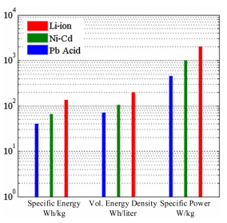
Lithium ion batteries have been utilized in many applications, including electric vehicles and electronics. These batteries are considered the most commercially available, power-dense batteries. Graphite carbon composes the anode of the batteries; while lithiated metal oxides like LiMO₂ and LiCoO₂ are used as cathodes. With charging, the cathode transforms into lithium ions, which then move towards the anode through lithium salts combining with external electrons. (Farhadi & Mohammed, 2016) Battery measurements consist of specific energy densities, measured in Wh/kg, volumetric energy densities, measured in Wh/liter, and specific power, measured in W/kg. Although Li-ion batteries are more costly, priced at $0.82 per Wh, compared to Ni-Cd and Pb-acid, at $0.42 and $0.28, respectively, they have the highest energy density offered, which means they are the smallest in both volume and weight for the amount of energy stored. Figure 5 illustrates the capabilities of Li-ion batteries’ specific energy, volumetric energy density, and specific power, and compares them against
Figure 5. Comparison of different types
of battery chemistries
Ni-Cd and Pb-acid batteries. (Tariq, Maswood, Gajanayake, & Gupta, 2017). Studies have stated that Li-ion battery energy densities are increasing 8-10% per year, with power doubling every 10 years. The maximum specific energy density value potentially being 5200 Wh/kg (Ullman). Figure 6 illustrates a summary of efficiency, discharge time, operating temperature, and lifespan of Li-ion batteries compared to other energy storage technologies.
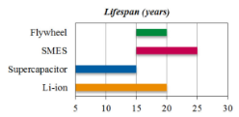
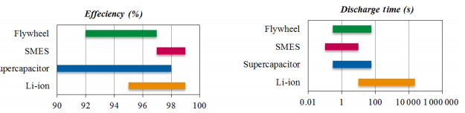
Lithium ion batteries are 95-99% efficient. They have lifespans of 5-20 years with long discharge times and a wide range of temperatures in which they can operate. Seal level temperatures are usually around 15ºC and flight temperatures range from -44 ºC to -56 ºC at cruise altitude. Considerations could be made to protect the batteries in the cool atmosphere. The long discharge time makes these batteries ideal for transportation applications. High energy storage batteries with long discharge time lead to maximum system efficiency combined with minimal cost, weight, and volume. (Farhadi & Mohammed, 2016) With cost, weight, and volume being critical factors in aircraft design, lithium ion batteries demonstrate good promise statistically and have illustrated their capabilities through their use in small aircraft.
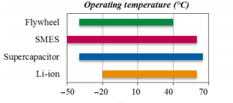
Figure 6. Performance Comparison of Li-ion Batteries
Batteries have been used in aircraft operations, and the FAA imposed regulations on minimum emergency power requirements. Aircraft such as the Boeing 737 stored 80kVA, and although electricity storage and generation was not a focus, power demands in aircraft increased, with the Boeing 787 having 1450 kVA powered by Li-ion batteries. (Tariq, Maswood, Gajanayake, & Gupta, 2017) This push towards electrical architectures is spurring aircraft industry to incorporate more batteries in to their designs, with Li-ion batteries being the prime choice. More Electric Aircraft (MEA) is a design concept that involves using only electric power for all non-propulsive systems, while using fuel to power the aircraft. MEA can be used for both large aircraft with seating for 240-850 passengers and for small aircraft with capacities of 100 passengers.
A sizing of a 100 passenger aircraft was performed with MEA requirements, powered with Li-ion batteries. The following results demonstrated that using Li-ion batteries reduced the aircraft weight and cost. 154.5 kg of weight were saved compared to using Ni-Cd batteries. This produces a savings of $96,780 per aircraft. Five Li-ion batteries were connected in series to produce 128 V and 400 A. (Tariq, Maswood, Gajanayake, & Gupta, 2017) In summary, these results demonstrate a reduction in the size of the battery system, which improves aircraft efficiency.
With the increased level of technology for batteries, designing and building light and general aviation aircraft is becoming a reality. Although initially costly in production, these aircraft will not rely on fuel and will therefore have immense savings in the future. Prices will also dwindle with increasing availability of technology and scale economy effects. Table 1 lists electric aircraft that have flown as of 2016. (Riboldi & Gualdoni, 2016) These aircraft were referenced to perform an electric aircraft sizing for a light or general aviation aircraft.
Table 1. Preliminary database of Electric Aircraft
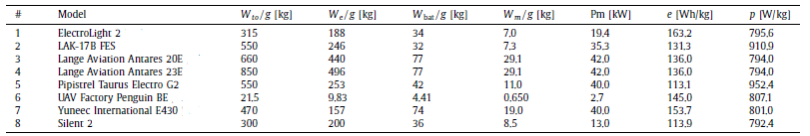

1.3. Battery Sizing
To perform the sizing of the battery of a small airplane designed for cross country flying or training, the weight was first considered. For an electric aircraft, the weight is a combination of the weight of the payload, batteries, electric motor, and the empty weight of the vehicle itself, as illustrated in Eq. (1).
$W_{to}=W_{e}+W_{pl}+W_{bat}+W_{m}$ (1)
The mission profile consisted of the usual phases of take-off, climb, cruise, loiter, and land. Typical flight sizing, relies on fuel fractions to define the fuel necessary for each portion of the flight. (Roskam, Airplane Design Part 1: Preliminary Sizing of Airplanes, 2017) Since the fuel would not change, and the weight would stay constant, this method of sizing would not be appropriate. Instead, a relationship between the weights and the mission requirements was examined. In electric aircraft, the most significant phases that affect the power are climbing, cruising, and loitering. The power required for climb can be calculated through Eq. (2) relating air density during the climb, constant airspeed, wing reference surface, the value of the drag coefficient, and the rate of climb.
$P_{r}^{climb}=W_{to}RC+\frac{1}{2}ρ^{climb}{V^{climb}}^{3}SC_{D}^{climb}$ (2)
Using Roskam’s procedure to calculate the drag coefficient involves estimating the aspect ratio from similar aircraft, and then applying
$C_{D}=C_{D, 0}+KC_{L}^{2}$ (3)
where K is found through estimations using
$K=\frac{1}{π∙AR∙e}$ (4)
and the Oswald coefficient, e. With clean values of K and C_{D}, the lift coefficient can be calculated using Eq. (3).
$C_{L}=\frac{2W_{to}}{ρV^{2}S}$ (3)
The next factor for sizing is the energy required. This involves energy required to climb, cruise, loiter, and land. To estimate the energy required to climb, the time to climb and the power required for the climb are taken into consideration, where the time to climb is defined in Eq. (4)
$TTC=\frac{h^{cruise}}{RC}$ (4)
and the energy required for climb is defined in the following equation. (Riboldi & Gualdoni, 2016)
$E^{climb}=P_{r}^{climb}TTC$ (5)
The energy required for cruise and loiter can be assumed to be the same. Different values will be calculated because the densities, velocities, and drag coefficients differ for the phases. (Riboldi & Gualdoni, 2016)
$P_{r}=\frac{1}{2}ρV^{3}SC_{D}$ (6)

From there, the energy required for each phase can be calculated using $E^{phase}=P_{r}^{phase}T^{phase }$ (7)
where the time of each phase relies on the range of the phase and the cruise speed at that phase. (Riboldi & Gualdoni, 2016) Finally, the battery weight can be determined. With this calculation, the propulsive efficiency is assumed to be less than 100%, providing the batteries and motor with a higher requirement. The mission profile battery weight can be calculated using the following equation. (Riboldi & Gualdoni, 2016)
$W_{bat, MP}=\frac{g}{η_{p}}\max\left\{\frac{E^{climb}+E^{cruise}+E^{loiter}}{e}, \frac{\max\left\{P_{r}^{climb},{ P}_{r}^{cruise}, P_{r}^{loiter}\right\}}{p}\right\}$ (8)
This sizing examination is limited in that it applies to current technology and small aircraft. Sizing aircraft in other weight categories could prove to be more challenging, especially with relying on current battery technology. A solution to transferring this process to a larger aircraft, and utilizing current technology, could be to size a hybrid aircraft that could rely both on the reusable power of batteries and on fuel to compensate for the additional size and weight strain.
Hybrid aircraft are defined as aircraft where the propulsion is powered by more than one type of energy source (Thauvin, et al., 2016). Different fuel sources provide the ability to improve the aircraft’s performance, reduce fossil fuel reliance, reduce noise levels, and emit fewer pollutants. Forms of Electrical Energy Storage (EES) would benefit hybrid vehicles in their ability to store and use electric power, as needed.
Research was performed on an aircraft with twin-turbo propeller engines with 3500 thermal horsepower per engine, with the capabilities of traveling 400 nautical miles, at a ceiling of 20,000 ft. The aircraft was also designed using technology for 2035, which would provide batteries with higher energy densities (Thauvin, et al., 2016). This aircraft’s mission overview can be viewed in Table 2. Its mission profile with the comparison of down-sized gas powered turbine and standard conditions can be viewed in Fig. 7. The mission profile illustrates the capabilities of added power provided by an energy storage unit combined with a reduced engine. Also visible in the mission profile is added power sent to the storage unit during descent.
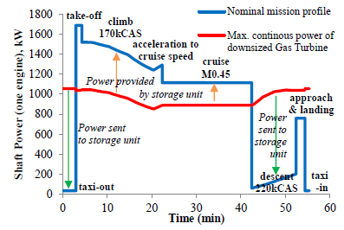
Energy recovering through the use of EES can be achieved through a few different mechanisms. The research on this specific aircraft and the energy recovery examined the energy gained through braking and through gravitational potential energy. The amount of energy recovered and stored through braking is fairly minimal. For the research aircraft, the equivalent amount of fuel saved is 2 kg, which is less than the amoung of fuel needed to taxi. These results stemmed from assuming a gas turbine efficiency of 40%, and the braking system consisting of disc brakes, thrust reversers, and airbrakes. (Thauvin, et al., 2016) Producing the equivalent of 2 kg of fuel or 0.19% of total energy used during this mission seems insubstantial.
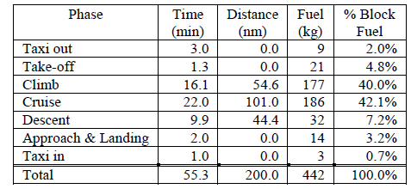
Table 2. Mission Overview of Sample Aircraft

Figure 7. Mission Profile Comparison of Sample Aircraft
Utilizing gravitational potential energy during descent by windmilling propellers produces energy that can be stored in the EES. On the experimental aircraft, four different propeller modes were tested: folded, feathered, transparency, and wind turbine. Folded propeller blades ideally produce zero drag during descent. Feathered blades rotate parallel to the direction of the airflow. These add to the drag of the aircraft. Transparency blades result in rotating propellers that don’t generate thrust or drag. Wind turbine blades add drag and energy to the EES. Results from these trade studies demonstrated that propellers should be folded during descent, and with a hybrid power generation system, transparency mode is most beneficial during normal operations. (Thauvin, et al., 2016)
Other results regarding power efficiency provided additional improvements in operation. The propeller efficiency could be increased by 49% if a hybrid electric system is utilized during taxi, removing the minimum speed constraint. Energy during taxi could be decreased by 90% if the taxi and descent phase could operate on purely electric power. Another consideration coud be to use a single larger engine that has two times the power. This improves efficiency by 10.5%, but removes redundancies in the event of engine failure. Finally, the engine could be sized to perform the climbing phase, with that phase being the most energy demanding. (Thauvin, et al., 2016) Each of these considerations could be used to analyze and design future aircraft of various sizes and explore the balance of the two power sources.
Other considerations for different types of batteries that could prove more energy dense in future years have also been studied. Lithium ion batteries currently have a mass specific energy content of Wh/kg, with a potential of 250 Wh/kg. Other variations of lithium batteries could produce higher specific energies. Research is being conducted on Lithium-Sulfur (Li-S) and Lithium-Oxygen (Li-O) batteries. Additionally, Zinc-Air (Zn-air) also have higher theoretical specific densities. Their specific densities are summarized in Table 3, and an
illustration of their performance is present in Fig. 8. (Hepperle) These batteries could potentially provide an AV-gas fuel equivalent of 3800 Wh/kg, and power an electric aircraft. However, current technology is still limited. Hence, the hybrid aircraft could provide an alternative aircraft which combines current battery technology with reduced fuel and emissions.
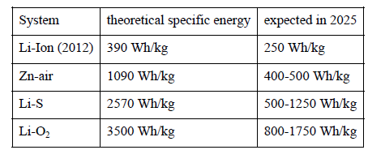
Table 3. Summary of Theoretical Specific Energy

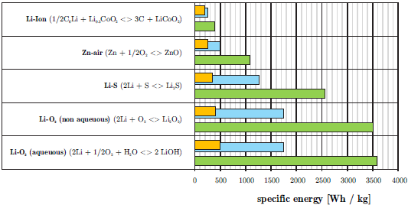
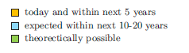

Figure 8. Current and expected battery technology

Project Objective
The purpose and objective of this project is to design a hybrid powered aircraft with the following mission specifications. The payload will consist of a FAA maximum of 124 passengers and 2 crew members along with their luggage. The aircraft will have a maximum range of 1720 nautical miles at maximum payload and a cruise speed of 500 kts. The required takeoff field length will be 5,500 ft, and the required landing distance is 3,960 ft. The maximum cruise altitude will be 40,000 ft. With the use of alternative power, provided by both Lithium ion batteries and fuel, the project will focus on design trade-offs to power the short-range, narrow-body aircraft that will reduce fuel usage, and provide a cheaper, cleaner, more energy-efficient hybrid commercial vehicle.

1.5. Mission Specifications

1.5.1. Mission Specifications
The following consist of mission requirements for the HTA:
- Payload capacity: All Economy with 96 at 6 abreast; FAA limit: 124
- Number of crew members required: 2 pilots, 2 cabin attendants
- Range: 1720 nm
- Cruise speed and Mach number: 500 kts (M=0.75)
- Cruise altitutde: 40,000 ft
- Take-off field length: 5,500 ft
- Landing field length: 3,960 ft
- Approach speed: 128 knots
- Noise requirements: $≤$97.5 EPNdb

1.5.2. Mission Profile
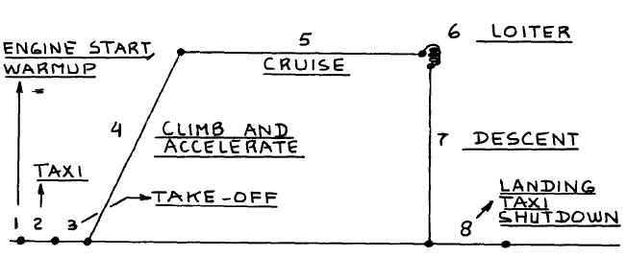
Figure 9. Mission Profile

1.6. Methodology
This hybrid aircraft will be designed and sized through a combination of techniques that will account for both the fuel and batteries. Initially, Roskam’s approach using an estimated take-off weight and fuel fractions will be used to address the changing fuel weight during the various phases of the flight. The battery weight will be constant and will be sized using the work of Riboldi and Gualdoni. Trade studies will be performed to assess the best usage of fuel and batteries during each flight phase.
Once the weight has been sized, performance sizing and verification will be performed, using the smallest size engine with the lowest weight. Then the design of the fuselage will take place. This will be based on the 737-100 series aircraft, but modifications may be made to suit the payload and change in power supply. From there, the wing will be sized. Again, this will be based on the 737-100 aircraft, but changes may be made if parametric studies support changes in sweep angle, wing thickness, or taper ratio. High lift systems will be applied if they are beneficial. Analysis on the empinage design will be similar to the analysis of the wing. The last feature of the aircraft to design will be the landing gear that promotes stability and control and maintains the appropriate weight.
Drag analysis will additionally be performed to estimate the drag of the entire aircraft and calculate a L:D ratio. If the aircraft, after all additions and design changes, is within 0.5% of its initial weight, small changes will be made to reduce or resize. However, if the weight is not within 0.5%, the aircraft sizing will need to be iterated until it is within 0.5% of the initial weight.

1.7. Comparative Study of Airplanes with Similar Mission Performance

1.7.1. Comparison of Weights, Performance, and Geometries of Similar Airplanes
Table 4. Comparison of Aircraft Weights
 | Boeing 737-100 | Boeing 737-200 | Airbus A320NEO | Embraer ERJ-170-100 | ARJ21-700STD | Bombardier  CRJ200- ER | SUGAR Volt 765-096-RevA
Max Design Takeoff Weight (lbs) | 97,000 | 100,000 | 174,165 | 79,344 | 89,287 | 51,000 | 150,000
Max Design Landing Weight (lbs) | 89,700 | 95,000 | 146,165 | 72,311 | 83,037 | 47,000 | 143,300
Max Design Zero Fuel Weight (lbs) | 81,700 | 85,000 | 138,450 | 66,447 | 77,062 | 44,000 | 135,300
Operating Empty Weight (lbs) | 58,600 | 59,900 | 92,814 | 48,733 | 55,016 | 30,500 | 88,800
Max Structural Payload (lbs) | 23,100 | 25,100 | 44,974 | 19,918 | 19,698 | 13,500 | 30,800
Seating Capacity | 96 (FAA: 124)  (2 class) | 124 (FAA:136)  (2 class) | 150 (FAA: 180)  (2 class) | 70  (single class) | 90 | 50 | 154
Usable Fuel (gallons) | 3,540 | 3,460 | 6,268 | 3,071 | 3,417 | 2,052 | 2,196
Max Fuel Capacity (gallons) | 4,720 | 4,780 | 6289.6 | 3,093 | 3,196 | 2,135 | 5,416
Source(s) | (Boeing Commercial Airplanes, 2013) | (Boeing Commercial Airplanes, 2013) | (Airbus Commerial Aircraft, n.d.) | (Jane's All the World's Aircraft, 2013) | (Jane's All the World's Aircraft, 2013) | (Jane's All the World's Aircraft, 2013) | (Bradley & Droney, Subsonic Ultra Green Aircraft Research: Phase II- Volume II- Hybrid Electric Design Exploration, 2015)

Table 5.Comparison of Aircraft Performance (Assuming standard conditions at sea level)
 | Boeing 737-100 | Boeing 737-200 | Airbus A320NEO | Embraer ERJ-170-100 | ARJ21-700STD | CRJ200-ER | SUGAR Volt 765-096-RevA
Max Cruise Speed (Mach number) | 0.82 | 0.82 | 0.82 | 0.82 | 0.82 | 0.85 | 0.7
Cruise Speed (mph) | 580 | 580 | 598 | 529 | 518 | 534 | 537
Takeoff Field Length (MTOW) (ft) | 5,499 | 5,499 | 6,857 | 4,866 | 5,578 | 5,800 | 8,180
Landing Field Length (ft) | 3,960 | 3,960 | 5,020 | 4,029 | 5,086 | 4,850 | --------
Service Ceiling (ft) | 35,000 | 37,000 | 19,500 | 41,000 | 20,340 | 41,000 | ---------
Cruising Altitude (ft) | 23,500 | 23,500 | 37,000 | 41,000 | 35,000 | 37,000 | 42,000
Range (nm) | 1,720 | 2,645 | 3,078 (3,700 with sharklets) | 1,800 | 1,200 | 1,893 | 3,500
Source(s) | (Boeing Commercial Airplanes, 2013) | (Boeing Commercial Airplanes, 2013) | (Airbus Commerial Aircraft, n.d.) (Jane's All the World's Aircraft, 2013) | (Jane's All the World's Aircraft, 2013) | (Jane's All the World's Aircraft, 2013) | (Jane's All the World's Aircraft, 2013) | (Bradley & Droney, Subsonic Ultra Green Aircraft Research: Phase II- Volume II- Hybrid Electric Design Exploration, 2015) (Bradley & Droney, Subsonic Ultra Green Aircraft Research: Phase I Final Report, 2011)

Table 6. Comparison of Aircraft Geometries
 | Boeing 737-100 | Boeing 737-200 | Airbus A320NEO | Embraer ERJ-170-100 | ARJ21-700STD | CRJ200-ER | SUGAR Volt 765-096-RevA
Overall length (ft) | 94 ft | 100 ft 2 in | 123 ft 3.25 in | 98 ft 1.25 in | 109 ft 9.5 in | 87 ft 10 in | 139.7
Height (ft)  (at max W_{oe}) | 37 ft 2 in | 37 ft 3 in | 38 ft 7 in | 31 ft 11.25 in | 27 ft 8.25 in | 20 ft 5 in | 35
Wing Area (ft²) | 1098 | 1098 | 1317.5 | 782.8 | 859.6 | 587.1 | 1477.11
Wing span | 93 ft | 93 ft | 117 ft 5.5 (including sharkets) | 85 ft 3.5 in | 89 ft 6.5 in | 69 ft 7 in | 169.3
Cabin width | 12 ft 4 in | 12 ft 4in | 12 ft 1.75 in | 8 ft 11.75 in | 10 ft 3.75 in | 8 ft 5 in | ----------
Fuselage width | 12 ft 4 in | 12 ft 4 in | 12 ft 11.5 in | 9 ft 11 in |  | 8 ft 10 in | 148.7
Fuselage length | 90 ft 7 in | 96 ft 11 in | 123 ft 3 in | 98 ft 1 in | 99 ft 10 in | 80 ft | 124.8
Total Bulk Cargo (ft³) | 650 | 875 | 403 | 515 | 711.4 | 318 | ----------
Source(s) | (Boeing Commercial Airplanes, 2013) | (Boeing Commercial Airplanes, 2013) | (Airbus Commerial Aircraft, n.d.) (Jane's All the World's Aircraft, 2013) | (Jane's All the World's Aircraft, 2013) | (Jane's All the World's Aircraft, 2013) | (Jane's All the World's Aircraft, 2013) | (Bradley & Droney, Subsonic Ultra Green Aircraft Research: Phase II- Volume II- Hybrid Electric Design Exploration, 2015)

1.7.2. Configuration Comparison of Similar Airplanes
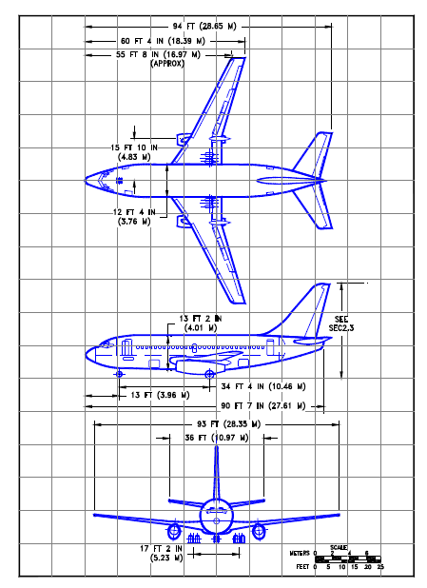
Figure 10. Boeing 737-100 aircraft configurations (Boeing Commercial Airplanes, 2013)
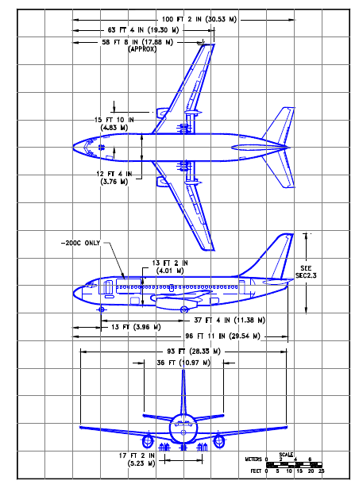
Figure 11. Boeing 737-200 aircraft configuration. (Boeing Commercial Airplanes, 2013)

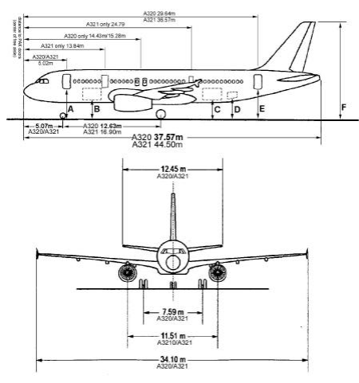
Figure 12. Airbus A320NEO aircraft configuration (Airbus Commerial Aircraft, n.d.)
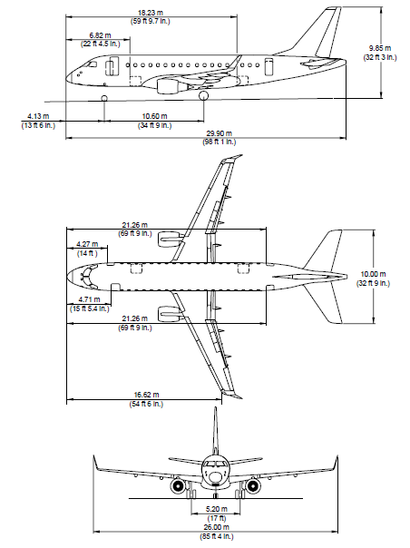
Figure 13. Embraer ERJ-170-100 aircraft configuration (Jane's All the World's Aircraft, 2013)

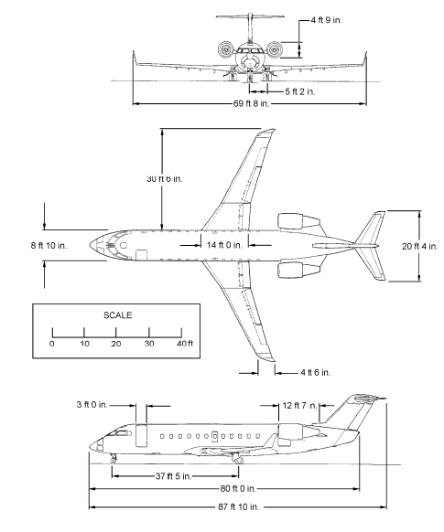
Figure 14. CRJ200-ER aircraft configuration (Canadair Regional Jet, 2016)

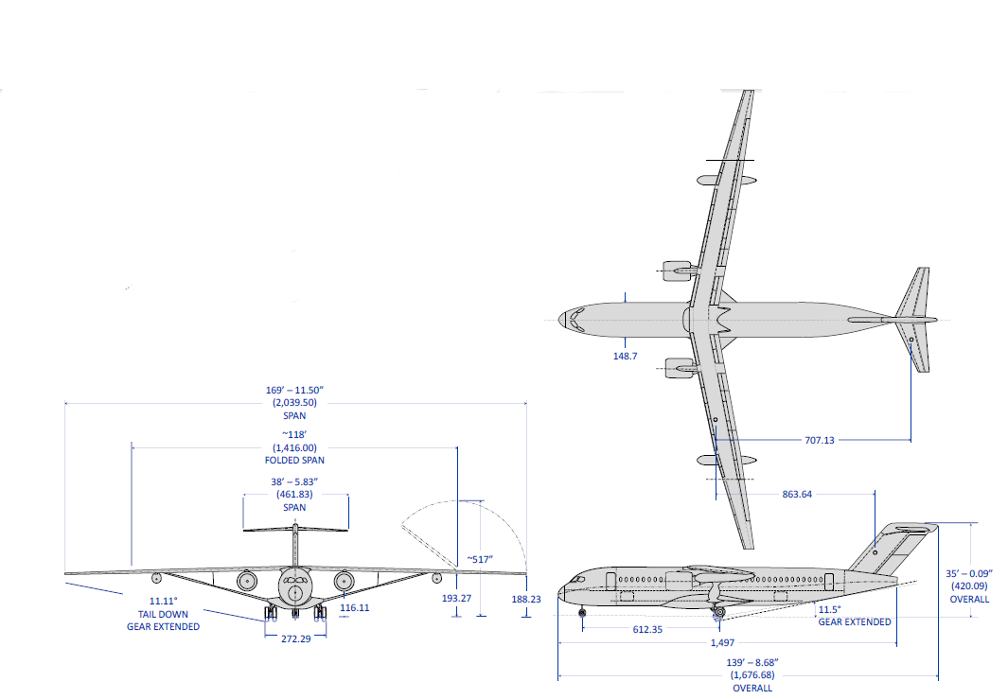
Figure 15. SUGAR Volt 765-096 RevA aircraft configuration (Bradley & Droney, Subsonic Ultra Green Aircraft Research: Phase II- Volume II- Hybrid Electric Design Exploration, 2015)

1.8. Discussion
The configuration designs of the 737-100, 737-200, A320NEO, ERJ-170-100, CRJ200-ER, and SUGAR Volt 765-096 RevA demonstrate common characteristics of transport aircraft, as observed by Figures 10-15. Aircraft configurations allow for many architectural options. Among these options are the wing sweep, wing style, wing position, propulsion system integration, and other added aerodynamic features. Each of these features contributes to the aircraft’s ideal design for performance, design for handling qualities, and meeting FAA requirements on safety, ability, and noise.
The aircraft configurations display wings that have been aft swept. The sweep angle depends on the speed of the aircraft. Subsonic speeds allow for small sweep angles. Transonic speeds delay increase in drag, due to higher Mach numbers, by sweeping the wings 30 º -35º. Supersonic aircraft have sweep angles of 45º -70º. (Mason, 2006) The sampled aircraft have small sweep angles, with the Boeing 737-100 having a sweep angle of 25 º and the SUGAR Volt 765-096 RevA having sweep angle of 12.52º. (Bradley & Droney, Subsonic Ultra Green Aircraft Research: Phase II- Volume II- Hybrid Electric Design Exploration, 2015)
Each of the aircraft also features a low wing, excluding the SUGAR Volt 765-096 RevA. This typically provides efficient use of the fuselage cargo space and easy retraction of landing gear. This characteristic also allows for better maneuverability and smooth landing. The SUGAR Volt aircraft had additional systems to integrate involving batteries, which changed the wing configuration. It features a high wing Truss Braced Wing (TBW), which is predicted to save fuel consumption by 5-10% compared with conventional low wings. (NASA, 2014)
For the propulsion integration, the 737-100, 737-200, A320NEO, and ERJ-170-100 have two pod mounted engines suspended below the wings. This meets civil aircraft requirements of having more than one engine in the event that one becomes inoperable. The airplane must be able to complete take-off in the event of one engine failure or only 50% power with 2 engines. (Obert, 2009) The CRJ200-ER has two pod mounted engines fitted to the rear of the fuselage. These two locations, below the wings and on the aft of the fuselage, are common configurations for jet transport engines. Boeing has demonstrated that suspended engines don’t incur a drag penalty. (Obert, 2009) This structural design of placing engines in nacelles suspended below the wings has several advantages. Among these are load relief, with the engines opposing the lift force; easy engine access for maintenance and repairs; and safety since the engines are further from the passengers. (Obert, 2009) The SUGAR Volt 765-096 RevA has two engines suspended below the wings along with two battery pods suspended below the wings. This configuration allows for easy charge or exchange of batteries for quick transitions between flights. Additionally, it balances the load of the battery pod weight. (Bradley & Droney, Subsonic Ultra Green Aircraft Research: Phase II- Volume II- Hybrid Electric Design Exploration, 2015)
The tail and fin configurations also differ for the CRJ200-ER and SUGAR Volt 765-096 RevA aircraft compared to the 737-100, 737-200, A230NEO, and ERJ-170-100. The CRJ200-ER and SUGAR Volt 765-096 RevA feature a T-tail; while the other aircraft feature fuselage mounted conventional tails. Along with the fuselage mounted tails, the aircraft also have tail plane mounted fins. These different configurations provide different aircraft control. A T-tail, which is an empennage configuration where the tailplane is attached to the top of the fin, typically accompanies fuselage mounted engines. With a T-tail arrangement, there is a risk for the horizontal tail becoming engrossed by the wake of the wing at high angles of attack. (Mason, 2006) This is likely why the more common configuration is the conventional fuselage mounted tail.
The Airbus A320NEO also has added sharklets to their wings. The Sharklet wingtip devices are 7.9 feet wingtips that are standard on all NEO aircraft. They reduce fuel burn by approximately 4%, and reduce annual CO₂ emissions by approximately 9,000 tons per aircraft. (Airbus Commerial Aircraft, n.d.) This added feature could be added to other A320 aircraft as well as other aircraft models.
In summary, choosing various configurations can improve safety, increase performance, and, with added features, reduce fuel consumption. The four common aircraft configurations illustrate that the low swept wing, with two pod mounted engines suspended from the wing and tail plane mounted fins meets the requirements of short to mid-range flights by providing greater structural efficiency, less weight, and satisfactory stall characteristics. New advances in design also demonstrate the benefits of the high wing TBW, as well as integration of batteries for hybrid and electric vehicles.

Configuration Selection

2.1. Overall Configuration
The HTA will have a conventional configuration due to the expansive database of conventional aircraft and design modeled after the Boeing 737 aircraft. From here, the configurations of the fuselage, engine, wing, empennage, and landing gear will be presented with short discussions on the rationale for selections.

2.1.1. Fuselage Configuration
The conventional fuselage will be designed to hold two cockpit crew members, 96 passengers at 6 abreast, and 2 flight attendants. Since it is designed for a short to medium range flight, an approximate value of 175 lbs per person and 30 lbs of luggage per person will be chosen for both the crew and the passengers. This totals 20,500 lbs, with 3,000 lbs being designated for cargo. This cargo will be stored below the cabin floor in cargo containers that have a capacity of 80 ft³. According to Roskam, typical luggage density is 12.5 lb/ft³ (Roskam, Airplane Design Part 1: Preliminary Sizing of Airplanes, 2017). Therefore, 240 ft³ of baggage volume will be required for bagge storage in 3 containers.
With 6 abreast seating, there will be 16 rows, which maintains a shorter fuselage. Although 5 abreast seating may be more comfortable for passengers, this would add an additional 4 rows of seating, which increases the fuselage length and the aircraft weight. The seat pitch for tourist/economy/coach passengers ranges from 34-36 inches, and could be 30-32 inches for high density seating arrangements. (Roskam, Airplane Design Part 1: Preliminary Sizing of Airplanes, 2017) The hybrid aircraft will have a 34 in. seat pitch, and 18 in. aisles to provide a comfortable mode of transportation. Further design layouts of the fuselage will be presented in the fuselage design section.

2.1.2. Engine Configuration
The hybrid aircraft will have two engines suspended below the wings. Two engines provides for redundancy in the event of a single engine failure or 50% failure of both engines. The engines will be stored in nacelles, and two battery pods will also be stored in nacelles attached under the wing. Having the batteries outside of the aircraft allows for easier access when charging and easier exchange of the batteries for quick transitions between flights. 737-100 model airplanes used JT8D turbofan engines. For the hybrid airplane, the design could include two hFan engines with 1,380 hp and thrust equivalent to 21,000 lbf of Boeing thrust.
Although buried engines produce less drag, having the engines stored in pods outside the fuselage also provides the ability to easily repair or exchange as technology improves. This configuration also provides optimal engine operation, in-flight wing bending relief, and engine stability. Mounting the engines above the wings also has advantages, including less debris ingestion and lower noise levels. However, this is not beneficial aerodynamically, and will not be considered.

2.1.3. Wing Configuration
For the wing configuration, the airplane will have a low Cantilever wing. Low wings are ideal for transport vehicles due to the increased safety of the aircraft, increased cargo volume, and ease of maneuverability. High wings are generally best for short take-offs and landings, but offer very little cargo space. Mid wings provide the least drag during flight due to their design, with the wings being continuous with the fuselage. This design would not be ideal for the hybrid transport due to the fact that the fuselage volume is reduced to accommodate the wings.
The wings will be swept aft with the characteristics of the wings, including sweep angle, aspect ratio, thickness ratio, and other features, being discussed and explored in detail later.

2.1.4. Empennage Configuration
The empennage consists of the stabilizing tail and added features on the aircraft. The configuration for the hybrid transport aircraft will be a single verticle tail mounted to the fuselage. Mounting to the fuselage provides adequate support. Since the tails are designed to help recover from stalling and spinning, the vertical configuration is more reliable than the T-tail configuration, which may be affected by the air flow, potentially causing deep stall.

2.1.5. Landing Gear Configuration
Since the hybrid vehicle is a narrow-body vehicle, the bicycle landing gear can easily be used. This does limit the takeoff and landing locations to level ground since the landing gear will not be able to rotate. With retractable landing gear mounted on the fuselage, the drag during flight will not be increased, and the gears are well-supported. Having the landing gear mounted to the nose of the fuselage provides more stability than aft wheel mounted landing gear. However, this position increases the weight. Since weight is such a large factor in the design, due to the already heavy batteries, mounting the retractable landing gear to the aft of the wheel would be beneficial.
The remaining aspects of the configuration, including number of main fear struts, number of tires, and the retraction kinematics will be discussed in detail when the landing gear is sized.
In summary the overall configuration of the aircraft will be a conventional fuselage designed to comfortably hold 96 passengers and their luggage, The aircraft will be supported by conventional low wings with 2 engines mounted below the wings and 2 batteries mounted below the wings. The vertical tail will provide the stability during flight, and the tricycle aft wheel retractable landing gear will provide adequate support with minimal weight for landing.

Weight Sizing and Weight Sensitivities
Using data for takeoff weights and empty weights of similar aircraft, a plot of gross takeoff weight vs. empty weight will be analyzed. The axes will be scaled logarithmically to create a log-log plot of the weight data.. The regression coefficients will be calculated to determine the weight required for takeoff and for the overall mission. A sensitivity study will be performed using the AAA Program.

3.1 Data Base for Takeoff Weights and Empty Weights of Similar Airplanes
The following data in Table 7 provide takeoff weights and empty weights for comparison to the HTA. Roskam additionally provides transport jet weights for comparison. The takeoff weights and empty weights can be related linearly when graphing the log of the takeoff weight and the log of the empty weight. The plot of this relationship is illustrated in Figure 15.
Table 7. Aircraft Takeoff and Empty Weights
Aircraft | Takeoff Weight (lbs) | Empty Weight (lbs) | Source
765-093 FREE | 182,600 | 94,400 | (Bradley & Droney, Subsonic Ultra Green Aircraft Research: Phase II- Volume II- Hybrid Electric Design Exploration, 2015)
765-095 SUGAR High | 138,300 | 81,700 | (Bradley & Droney, Subsonic Ultra Green Aircraft Research: Phase II- Volume II- Hybrid Electric Design Exploration, 2015)
Balanced 765-095 (1,380 Hp) | 140,700 | 84,300 | (Bradley & Droney, Subsonic Ultra Green Aircraft Research: Phase II- Volume II- Hybrid Electric Design Exploration, 2015)
Balanced 765-095 (1,750 Hp) | 139,700 | 83,800 | (Bradley & Droney, Subsonic Ultra Green Aircraft Research: Phase II- Volume II- Hybrid Electric Design Exploration, 2015)
Core Shutdown 765-095 (7,150 Hp) | 190,000 | 102,600 | (Bradley & Droney, Subsonic Ultra Green Aircraft Research: Phase II- Volume II- Hybrid Electric Design Exploration, 2015)
Boeing 737-100 | 97,000 | 58,600 | (Boeing Commercial Airplanes, 2013)
Boeing 737-200 | 100,000 | 59,900 | (Boeing Commercial Airplanes, 2013)
Airbus A320NEO | 174,165 | 92,814 | (Jane's All the World's Aircraft, 2013)
Embraer ERJ-170-100 | 79,344 | 48,733 | (Jane's All the World's Aircraft, 2013)
ARJ21-700STD | 89,287 | 55,016 | (Jane's All the World's Aircraft, 2013)
CRJ200- ER | 51,000 | 30,500 | (Jane's All the World's Aircraft, 2013)
SUGAR Volt 765-096 RevA | 150,000 | 88,800 | (Bradley & Droney, Subsonic Ultra Green Aircraft Research: Phase II- Volume II- Hybrid Electric Design Exploration, 2015)

Figure 16. Log-Log Plot of Takeoff Weight vs. Empty Weight with included trendline and linear regression equation

From the plot, the regression line constants A and B can be determined, since the log of the weights has the following relationship:
log(W_{to})= A+B*log(W_{e}) (9)
Thus, A=0.1776 and B= 0.9195, as demonstrated by the regression equation in the plot. In Part 1 of Roskam’s Airplane Design Volumes, Roskam lists the regression line constants for various airplane types. These are included in Figure 16. The B values obtained in this analysis are similar, with B having an 11.44% margin of error. However, the A values are very different. This could be due to the type of aircraft in the database. 5 of the 12 aircraft included are hybrid vehicles. The remaining 7 are conventional fuel-powered aircraft. The A value for this database differs by -113.2%, with the transport jet A coefficient calculated as 0.0833 and the B value as 1.0383.
The other factor that could impact the weights could be the materials used for the primary and secondary structures, which would affect the takeoff weight and empty weight. Roskam’s database consists of Boeing 727, 737, 747, 757 and 767 aircraft, McDonnell Douglas DC 8, 9, and 10 aircraft, Airbus A300 and A310 aircraft, and several others. The Boeing aircraft were constructed from aluminum alloy, aluminum, and graphite composites. (Jane's All the World's Aircraft, 2013) The Airbus aircraft were constructed from aluminum alloy, steel, and titanium. The SUGAR aircraft have incorporated metal-matrix composites, ceramics, high temperature polymer composites, thermoplastic composites, carbon, and nanocomposites. These will lighten the weight of the structure, landing gear, and engine nacelles. (Bradley, Droney, & Allen, 2015)
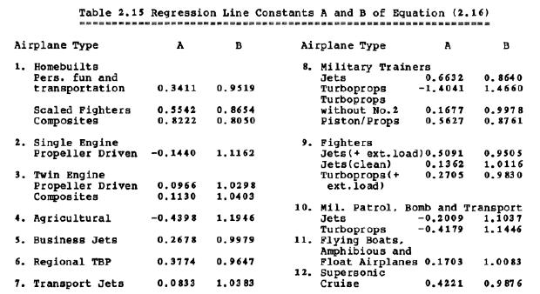
Figure 17. Regression Line Constants for Aircraft
For future calculations, both Roskam’s constants and the calculated constants will initially be used and comparisons in results will be made before determining the constant that will be used in the end.

3.2. Determination of Mission Weights
The following mission weights will be estimated: ${W_{pl},W}_{to}, W_{f}, W_{e}, and W_{bat}$using comparisons to similar aircraft, calculations from Roskam and Riboldi, and iterating through the AAA program to verify and refine estimations.
Takeoff weight, W_{to,} consists of the sum of the operating empty weight of the aircraft, W_{oe,} with the weight of the fuel, W_{f,} weight of the payload, W_{pl} and the added weight of the batteries, W_{bat}. Therefore, takeoff weight can be calculated using equation 10.
$W_{to}=W_{oe}+W_{f}+W_{pl}+W_{bat}$ (10)
Note that the operating empty weight consists of the sum of the empty weight, weight of the trapped fuel and oil, and the weight of the crew, as summarized in equation 11.
$W_{oe}=W_{e}+W_{tfo}+W_{crew}$ (11)
For equation 10, the weights of each of the parts will need to be calculated. Although the payload weight is known, the remaining values will need to be calculated. The process for this will be conducted as follows. Initially, a takeoff weight will be estimated using data from similar aircraft. From there, the weights of the fuel, and batteries will be calculated. Roskam’s fuel fraction method will be used to calculate the mission fuel weight; while Riboldi’s battery sizing method will be employed to estimate mission battery weight. Then, the operating empty weight will be calculated to find an allowable value of the empty weight. AAA will be used to iterate and find an empty weight within 0.5% of the tentative empty weight.

3.3. Manual Calculation of Mission Weights

3.3.1. Payload Weight
The payload weight consists of the passengers and their luggage. Based on the desired configuration of the cabin, 96 passengers will be assumed to weigh 175 lbs each and carry 30 lbs of luggage. Thus the total payload weight is 19,680 lbs.

3.3.2. Estimated Takeoff Weight Method 1
To estimate the takeoff weight, there are two methods. The first consists of examining a database of aircraft and comparing W_{to} to W_{pl.} The database, displayed in Table 8, consists of turbojet transport aircraft and conceptual hybrid aircraft. Using the data, an average ratio of W_{pl} to W_{to} was calculated as 0.237. Since the payload weight is a known value, the takeoff weight can be estimated using the ratio. Using a 96 passenger payload yields a takeoff weight value of 83,006.38 lbs. If the payload is increased to hold 100 passengers, the takeoff weight increases to 86,464.98 lbs. Finally, if the payload is increased to 108 passengers, the takeoff weight estimate is 93,382.18 lbs.
Table 8. Data for W_{to} Comparison
 | 737-100 | 737-200 | A320NEO | ERJ-170-100 | ARJ21-700STD | CRJ200- ER | SUGAR Volt 765-096-RevA | 737-300 | McDD DC9-80 | A320
W_{to} | 97,000 | 100,000 | 174,165 | 79,344 | 89,287 | 51,000 | 150,000 | 135,000 | 140,000 | 145,000
W_{pl} | 23,100 | 25,100 | 44,974 | 19,918 | 19,698 | 13,500 | 30,800 | 35,000 | 38,000 | 42,000

The second method to calculate takeoff weight involves knowledge of more values. Therefore, it will be discussed later. With an estimation of takeoff weight from the database, calculating the fuel weight will be the next step.

3.3.3. Determination of Mission Fuel Weight
To determine the mission fuel weight, W_{f}, the weight of the fuel used during the mission and the weight of the reserve fuel will need to be known. To calculate the weight of the fuel for the mission, Roskam’s fuel fraction method will be employed. This consists of breaking down the mission into phases and estimating the fuel for each phase. The phases for the mission are: Phase 1: Engine start and warm-up, Phase 2: Taxi, Phase 3: Takeoff, Phase 4: Climb, Phase 5 Cruise, Phase 6: Loiter, Phase 7: Descent, and Phase 8: Land, taxi, and shut-down. This process will be presented for the 96 passenger payload and considered for a fuel powered flight. From there, fuel can be reduced by using batteries to power various phases of flight and eliminating parts of the fuell fraction process. AAA will then be used to calculate weights for the aircraft if it had used all fuel, to compare, as well as using fuel for stages 1-4 vs. fuel for stages 1-3, and 5.
To calculate the mission fuel weight, the sum of the fuel used and the fuel in reserves will need to be known.
$W_{f}={W_{f}}_{used}+{W_{f}}_{res}$ (12)
${W_{f}}_{used}$ is the fuel used during the mission; while ${W_{f}}_{res}$ is the fuel reserves required for the mission.These reserves are specified by FAR regulations. For a fully fuel-powered aircraft, the reserves will be 25% of the fuel used. The reserve quanitities will change depending on the fuel used during different mission phases. The fuel used will be calculated using the fuel fraction method. Each phase will have an estimated or calculated fuel fraction, which is the ratio of the ending weight of the phase to the beginning weight of the phase.
Table 9. Suggested Fuel-Fractions for Mission Phases
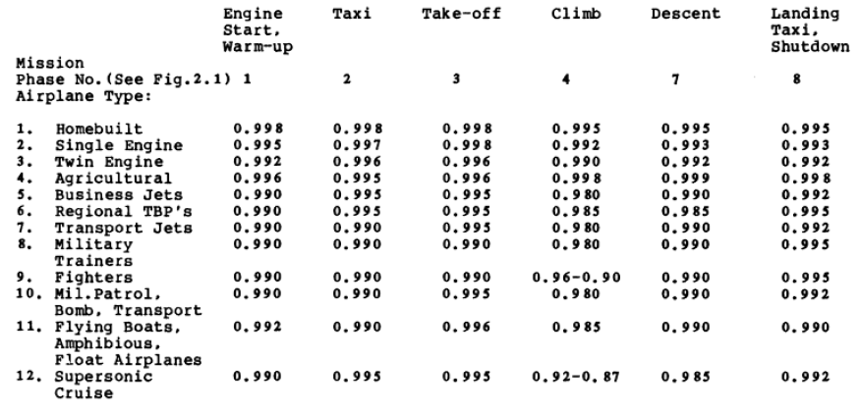
As seen in Table 9, the fuel fractions for phases 1, 2, 3, 4, 7, and 8, have been estimated and published by Roskam. (Roskam, Airplane Design Part 1: Preliminary Sizing of Airplanes, 2017) These values for transport jets will be used in the calculation of the fuel-powered aircraft. The phase 1 fuel fraction of 0.990 is the ratio of $W_{1}/W_{to}$. The phase 2 fuel fraction of 0.990 is the ratio of $W_{2}/W_{1}$. 0.995 is the ratio of $W_{3}/W_{2}$, which is the phase 3 fuel fraction. 0.980 is the ratio of $W_{4}/W_{3}$; 0.990 is the ratio of $W_{7}/W_{8}$, and 0.992 is the ratio of $W_{8}/W_{9}$. The fuel fractions, $W_{5}/W_{4}$ and $W_{6}/W_{5}$, for phases 5 and 6, respectively, will be calculated.
For a jet airplane, Breguet’s equation, equation 13 below, can be used to calculate the fuel fraction $W_{5}/W_{4}.$ $R_{cr}$ is range of cruise measured in nautical miles and $c_{j}$ is the specific fuel consumption in lbs/lbs/hr.
$R_{cr}={\left(\frac{V}{c_{j}}\right)}_{cr}{\left(\frac{L}{D}\right)}_{cr}\ln\left(\frac{W_{4}}{W_{5}}\right)$ (13)
The velocity for cruise is known, along with the range. The lift to drag ratio and specific fuel consumption values can be found in Roskam’s part 1. For transport jets in cruise, L/D ranges from 15-24s and $c_{j}$ ranges from 0.5-0.9. The following values will be used to estimate $W_{5}/W_{4}:$ $V=500 kts, c_{j}=0.5,\frac{L}{D}=22, and R_{cr}=1656 nm.$ This yields $W_{5}/W_{4}=0.928$.
For the loiter phase, Breguet’s endurance equation, equation (14) below, for jet airplanes can be used (Roskam, Airplane Design Part 1: Preliminary Sizing of Airplanes, 2017).
$E_{ltr}=\left(\frac{1}{{c_{j}}_{ltr}}\right){\left(\frac{L}{D}\right)}_{ltr}\ln\left(\frac{W_{5}}{W_{6}}\right)$ (14)
$E_{ltr}$ is the loiter time in hours. According to Roskam, ${c_{j}}_{ltr}$ ranges from 0.4-0.6, and L/D for the loiter phase ranges from 14-18. Using $E_{ltr}=0.75 hours, {c_{j}}_{lrt}=0.4, and \frac{L}{D}=18,$ $W_{5}/W_{6}=$0.981.
Now that the fuel fractions for each phase are known, the mission fuel fraction, $M_{ff}$, can be calculated using equation 15. (Roskam, Airplane Design Part 1: Preliminary Sizing of Airplanes, 2017).
$M_{ff}=\left(\frac{W_{1}}{W_{to}}\right)\prod_{i=1}^{7}{\frac{W_{i+1}}{W_{i }} }$ (15)
Therefore, $M_{ff}=0.99∙0.99∙0.995∙0.98∙0.928∙0.981∙0.99∙0.992=0.854$. Using the mission fuel fraction, the weight of the fuel used during the mission can be calculated, using equation 16 and thus the weight of the total fuel, which is the mission fuel and reserves.
$W_{f_{used}}=\left(1-M_{ff}\right)W_{to}$ (16)
From equation 16, $W_{f_{used}}$=12,089.3 lbs. Adding 25% for the fuel reserves gives a fuel weight of 15,111.6 lbs.

3.3.4. Estimating Takeoff Weight Method 2
A second method to calculate W_{to} is to use equation 10, from Appendix A in Roskam’s Part I of Airplane Design (Roskam, Airplane Design Part 1: Preliminary Sizing of Airplanes, 2017). This is a direct way to calculate the takeoff weight, provided that the regression coefficients A and B are known, along with the fuel reserve fraction coefficient C, and the sum of the crew and passenger payload weight, D.
$\log_{10}{W_{to}=A+B∙\log_{10}\left(C∙W_{to}-D\right) }$ (17)
Roskam’s A and B values will be used since the calculated B value will not yield a real solution for the equation and hence not provide an estimated takeoff weight. D is the sum of the crew and passenger weight along with their cargo. Assuming 96 passengers and 4 cabin and crew members with their luggage, D=20,500. To calculate C, equation 11 can be used. (Roskam, Airplane Design Part 1: Preliminary Sizing of Airplanes, 2017)
$C=\left\{1-\left(1+M_{res}\right)\left(1-M_{ff}\right)-M_{tfo}\right\}$ (18)
$M_{res}$ is the reserve fuel fraction; $M_{ff}$is the mission fuel fraction; and $M_{tfo}$ is the trapped fuel and oil fraction. $M_{tfo}$ is assumed to be 0.005, and M_{res} is assumed to be 0.25. (Roskam, Airplane Design Part 1: Preliminary Sizing of Airplanes, 2017) $M_{ff}$ varies based on the amount of fuel required. This calculation will be reviewed in the following section. For 100% fuel use, $M_{ff}=$0.854. With fuel use during stages 1-4, $M_{ff}=$0.956. With fuel use during stages 1-3 and 5, $M_{ff}=$0.905. Three different values of C were calculated based on the three different fuel options. C_{all fuel}=0.813, C₁₋₄=0.9396, and C_{1-3,5}=0.876. These three different values provided three different takeoff weights based on using different quantities of fuel. Solving equation 17, if the aircraft relied only on fuel, then W_{to}=77,602 lbs, whch is close to the 83,006.38 lbs estimated from similar aircraft. When using fuel in stages 1-4, W_{to}=53,489 lbs, and when using fuel in stages 1-3, and 5, W_{to}=77,003 lbs. Considering these weights, the difference from an all fuel aircraft to a hybrid aircraft using fuel in stages 1-4 and a hybrid aircraft using fuel in stages 1-3 and 5 is 24,113 lbs and 598 lbs, respectively. This difference could be the weight of the battery to power the aircraft during the remaining stages, as it has not yet been accounted for.

3.3.5. Determining Allowable Value for Empty Weight
To determine an allowable value for empty weight, for a fuel-powered aircraft, first a tentative value for the operating empty weight is calculated, using the following equation:
${W_{oe}}_{tent}={W_{to}}_{guess}-W_{f}-W_{pl}$ (19)
Since the ${W_{to}}_{guess}, W_{f}, and W_{pl}$ are known, where ${W_{to}}_{guess}=83,006.38 lbs, W_{f}=15,111.6 lbs, and W_{pl}=19,680 lbs$, then ${W_{oe}}_{tent}=48,214.8$lbs. Then, a tentative value for the empty weight is calculated, using the following equation
$W_{e_{tent}}=W_{oe_{tent}}-W_{tfo}-W_{crew}$ (20)
Since this is a tentative estimate, $W_{tfo}$ will not be subtracted at this time. It can add as much as 0.5% of the takeoff weight, but can initially be neglected. (Roskam, Airplane Design Part 1: Preliminary Sizing of Airplanes, 2017) With the weight of the crew and the tentative operating empty weight, $W_{e_{tent}}=48,214.8-820=47,394.8$lbs. This tentative weight is then compared to a calculated weight. If these values are not within 0.5%, adjustments are made to the takeoff weight guess and the process is iterated.
Figure 18 illustrates the trend of takeoff weights and empty weights for transport jets. The regression line for the data has the following equation:
$W_{e}=invlog_{10}((\log_{10}{W_{to}-A)/B)) }$ (21)
Since A and B are known, along with the guessed takeoff weight, $W_{e}$ is calculated as 47,394.8 lbs. Since these two weights are close, but not within 0.5% of each other, adjustments will be made to the takeoff weight guess and the empty weight will be recalculated. This process will be completed using AAA.

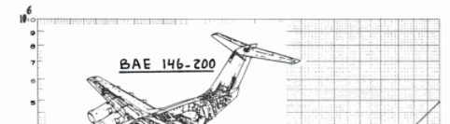
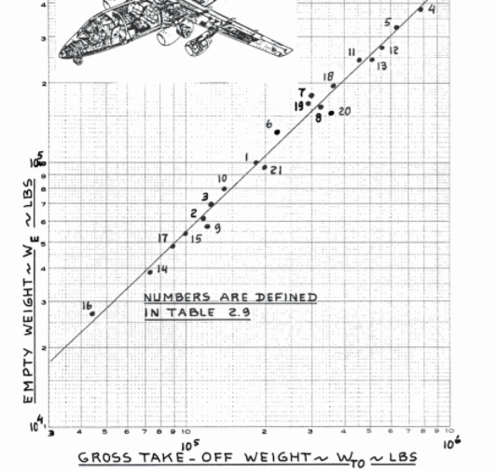
Figure 18. Weight Trends for Transport Jets

3.3.6. Determination of Mission Battery Weight
To determine mission battery weight, the method of Riboldi and Gualdoni will be used. (Riboldi & Gualdoni, 2016) To calculate the battery weight, equation 8 will be used. Therefore, the energy and power required for mission phases will be calculated first. The following assumptions will be made in order to proceed with calculations: the efficiency will be 85%; the takeoff weight will be 53,489 lbs, fuel will be used in phases 1-4, the battery specific power will be 320 W/kg; the battery specific energy will be 250 Wh/kg; the aircraft will have a clean configuration; and flight conditions will be standard. The battery specific power and specific energy values are values for lithium ion batteries by the year 2025, and will likely increase further with advancements in batteries. (Hepperle)
Since the climb, cruise, and loiter phases are the longest phases of the flight, the power and energy required for these phases will be taken into account. To calculate the power and energy for these phases, the drag polar will be calculated. Use Roskam’s method, equations 3 and 4, and the following values: AR=8.83, $e$=0.75, S_{wet}=5,763 ft², f=17.286, the drag polar was found to be 0.12.
From there, the power for each phase can be calculated, using S=1,341 ft² and the velocity at cruise to be 575 mph. The power at loiter is 405.34 watts, and the power at cruise is 736.42 watts. The energy required for loiter is 1,094,411.5 joules, and the energy required for cruise is 8,779,440.79 joules.
Using equation 8 and the calculated power and energy values, the battery should weigh 289.38 lbs for a 1 hour loiter. This calculated fuel weight is less than the allotted 598 lbs that is the difference between the takeoff weight of the fuel-powered aircraft and the HTA.

3.4. AAA Calculation of Mission Weights
The following figures summarize the output parameters generated by AAA given the input parameters of the mission. The summary of data in the first two figures is for a twin turbojet engine fuel-powered aircraft. The manual calculations and AAA calculations proved to be very similar for the fuel-powered aircraft, with the AAA output weights being lower. AAA calculated the design point takeoff weight to be 71,947.6 lbs and the empty weight to be 39,775.9 lbs. The manual calculation produced an estimate of 77,602.6 lbs for the takeoff weight and 45,439.32 lbs for the empty weight. For an all fuel-aircraft, AAA calculated 11,554 lbs of fuel, including 25% reserves; while manual calculations found 15,111.6 lbs of fuel necessary, including the 25% reserve fuel.
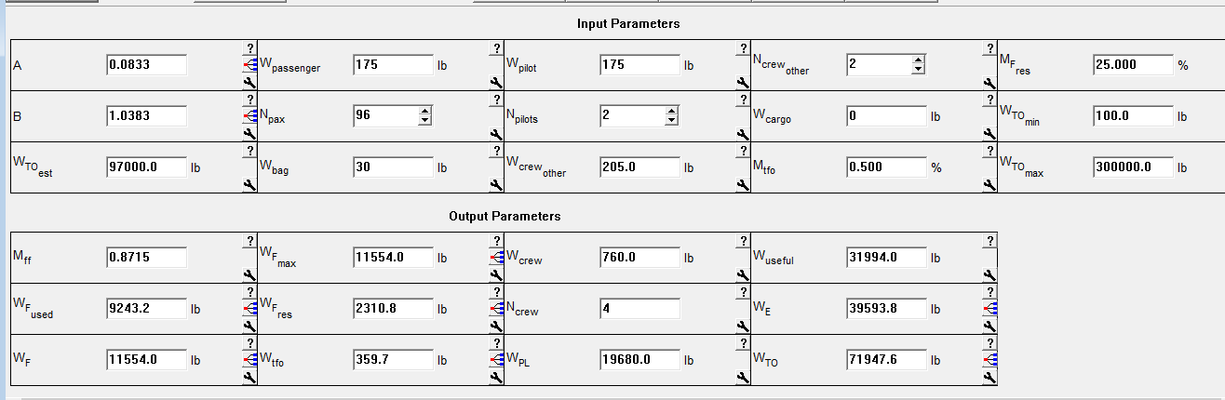
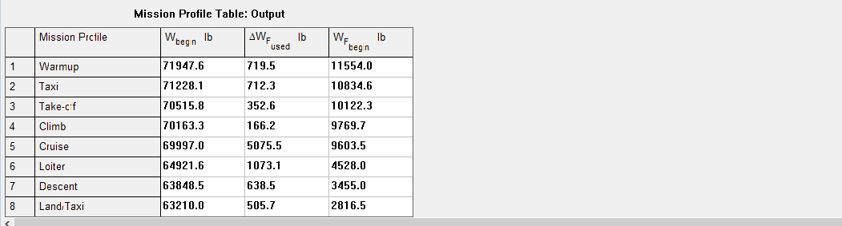
Figure 19. AAA output with all fuel aircraft with 2 turbojet engines
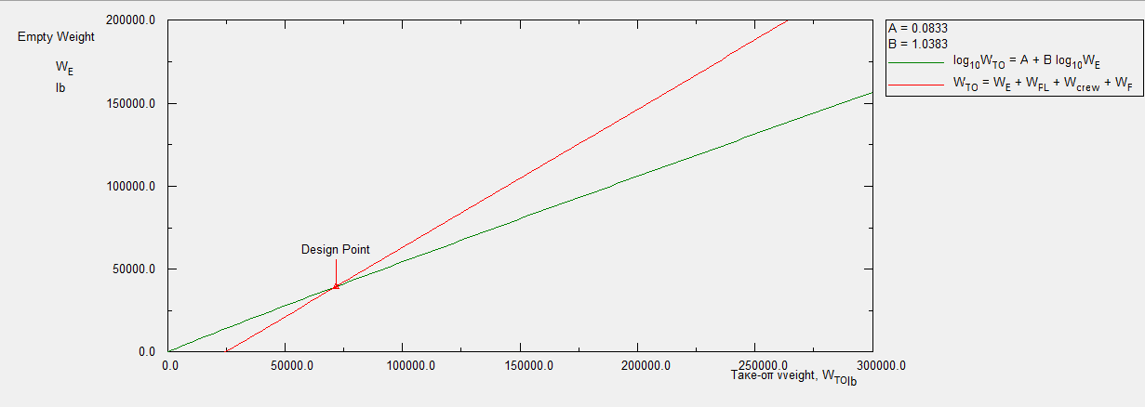
Figure 20. W_{e} vs. W_{to} of 2 turbojet engine fuel-powered aircraft with ideal design point of W_{to}=71,635.9 lbs and W_{e}=39,775.9 lbs

3.5.Takeoff Weight Sensitivities

3.5.1. Manual Calculations of Takeoff Weight Sensitivities
Aircraft takeoff weight depends on many factors. These include the payload weight, empty weight, range, endurance, lift to drag ratio, and specific fuel consumption. (Roskam, Airplane Design Part 1: Preliminary Sizing of Airplanes, 2017) Sensitivity studies will be performed on these to determine which parameters impact the design. Using Roskam’s correlation coefficients of A=0.083 and B=1.038, the calculated C values, the combined crew and passenger payload weight, D=20,500 lbs, and the force, F=250,337.6 lbs, sensitivities for the takeoff weight to: payload, empty weight, range, endurance, cruise speed, L/D, and specific fuel consumption will be calculated for the HTA. Additionally, the airplane growth factor due to payload will be calculated. To illustrate the concept, calculations will be completed for the fuel-powered aircraft, initially, with sensitivities also being calculated for various amounts of fuel use. This includes using fuel in stages 1-4, 1-3 and 5, and sensitivities for an electric aircraft.
In order to calculate the sensitivities, the takeoff weight needs to be established. For the purposes of these sensitivities, the takeoff weight used will be the manually calculated takeoff weight of 77,602.6 lbs. Using equation 9, and taking the partial derivative of the takeoff weight with respect to the empty weight produces:
$\frac{∂W_{to}}{∂W_{e}}=BW_{to}{\left[invlog\left(\frac{\log\left(W_{to}\right)-A}{B}\right)\right]}^{-1}$ (22)
Substituting the values gives: $\frac{∂W_{to}}{∂W_{e}}=(1.038)(77,602.6){\left[invlog\left(\frac{\log\left(77,602.6\right)-0.083}{1.038}\right)\right]}^{-1}$ =1.89. As a result, for a fuel-powered aircraft, the takeoff weight must be increased by 1.89 lbs for each pound of increase in the empty weight. 1.89 is the growth factor due to empty weight for the fuel-powered aircraft. If the aircraft used fuel during phases 1-4, the growth factor would be 1.866, and it would remain the same for fuel use in phases 1-3 and 5. If the aircraft were all electric, the growth factor would be 2.22.
To compute the sensitivities of the takeoff weight to the payload weight, the partial derivative of equation 17 will be taken, and reduced. Since $\frac{∂A}{∂W_{pl}}=0, \frac{∂B}{∂W_{pl}}=0,$ $\frac{∂D}{∂W_{pl}}=1$, and $\frac{∂C}{∂W_{pl}}=0$, this results in:
$\frac{∂W_{to}}{∂W_{pl}}=B{(W}_{to}){ \left\{D-C\left(1-B\right)W_{to}\right\}}^{-1}$ (23)
Substituting the remaining values produces $\frac{∂W_{to}}{∂W_{pl}}=1.038(77,602.6){\left\{20,500-0.813\left(1-1.038\right)77,602.6\right\}}^{-1}=3.5$. Therefore, if the payload increases by 1 lb, the takeoff weight increases by 3.5 lbs for the fuel powered aircraft. When fuel is used in stages 1-4, the airplane growth factor due to payload is 2.5; with fuel use in stages 1-3, and 5, it’s 3.5; and for an electric airplane, the airplane growth factor due to payload is 2.2.
In order to calculate the sensitivity of takeoff weight to range, endurance, speed, specific fuel consumption, and lift to drag ratio, a generic case will be considered. The variable $y$ will represent any parameter, excluding payload. Thus, the following equation represents the takeoff weight sensitivity to a parameter $y:$
$\frac{∂W_{to}}{∂y}={\left\{CW_{to}\left(1-B\right)-D\right)}^{-1}BW_{to}^{2}\left(\frac{∂C}{∂y}\right)$ (24)
Using Breguet’s equations and
$F=-BW_{to}^{2}{\left\{CW_{to}\left(1-B\right)-D\right\}}^{-1}\left(1+M_{res}\right)M_{ff}$ (25)
Breguet’s partials can be derived. They are available in Table 10, below. Using the manually calculated values, F=250,337.6 lbs.

Table 10. Breguet Partials for Propeller and Jet Airplanes
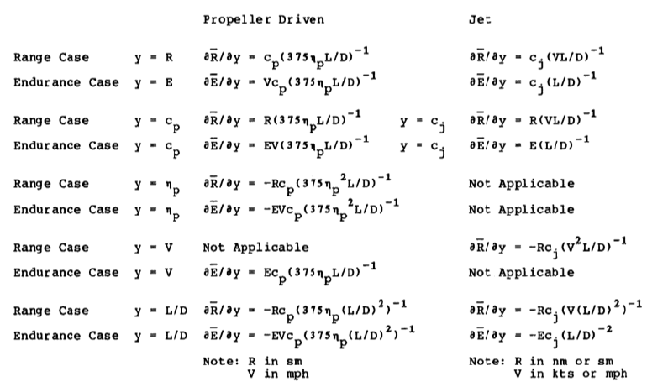
Substituting in range and endurance for y, respectively, yields
$\frac{∂W_{to}}{∂R}=Fc_{j}{\left(V\left(\frac{L}{D}\right)\right)}^{-1}=16.7$lbs/nm and $\frac{∂W_{to}}{∂E}=Fc_{j}{\left(\frac{L}{D}\right)}^{-1}=7,699.7$ lbs/hr. In summary, if the range of the fuel aircraft is decreased by 1 nm, the takeoff weight decreases by $16.7$ lbs. If the endurance is increased by 1 hour, the takeoff weight is increased by 5,563 lbs.
Continuing to use Breguet’s partials in Table 10, the sensitivities of takeoff weight to cruise speed will be calculated. Assuming a cruise speed of 500 kts or M=0.75, L/D=22, cruise range of 1656 nm, and specific fuel consumption of 0.5, $\frac{∂W_{to}}{∂V}=-37.7$ lbs/kt. Therefore, if the cruise speed could be increased without changing any parameters, the gross takeoff weight would decrease. Despite these results, this sensitivity result is not practical. An increase in cruise speed results in a decrease in the lift coefficient and thus a decrease in the lift to drag ratio. The specific fuel consumption will also change. (Roskam, Airplane Design Part 1: Preliminary Sizing of Airplanes, 2017) All of these factors change the sensitivity of takeoff weight to cruise speed.
Finally, sensitivities of takeoff weight to L/D and to specific fuel consumption will be calculated during cruise and loiter. For the cruise phase, a cruise speed of 500 kts will be assumed, along with L/D ratio of 22, $c_{j}$=0.5, and a force of 250,337.6 lbs. For the loiter phase, the lift to drag ratio will be 18, $c_{j}$=0.4, and F=250,337.6 lbs. Using Breguet’s partials, the sensitivity of takeoff weight to L/D for range is -856.3; the sensitivity of takeoff weight to L/D for endurance is -154.5; the sensitivity of takeoff weight to $c_{j}$ for range is 37,679.3; and the sensitivity of takeoff weight to $c_{j}$ for endurance is 6,953.8. If L/D were increased, for both cruise and loiter, the takeoff weight would decrease. For cruise, if L/D were increased by 1, the takeoff weight would decrease by 856.3 lbs. Similarly. For loiter, if L/D were increased by 1, the takeoff weight would decrease by 154.5 lbs. For the specific fuel consumption, if $c_{j}$ increases, the takeoff weight increases. For example, for the cruise phase, if $c_{j}$ was incorrectly assumed to be 0.5 instead of 0.9, the takeoff weight would increase by 0.4*37,679.3 or 15,071.7 lbs. Similarly, if if $c_{j}$ was incorrectly assumed to be 0.4 instead of 0.6, during loiter, the takeoff weight would increase by 0.2*6,953.8 or 1,390.8 lbs.

3.5.2. AAA Calculation of Takeoff Weight Sensitivities
The following data, displayed in Figure 21, summarizes AAA’s calculations of takeoff weight sensitivities for a fuel-powered aircraft with a takeoff weight of 71,947.6 lbs. According to AAA, if the payload were to increase by 1 lb, the takeoff weight would increase by 3.29 lbs. If the crew weight were to increase by 1 lbs, the takeoff weight would increase by 3.29 lbs. Finally, if the empty weight were to increase by 1 lb, the takeoff weight would increase by 2.04 lbs. For an electric aircraft, the takeoff weight increases by 2.17 lbs per pound increase of payload. The takeoff weight increases by 2.17 lbs for every 1 pound increase in crew, and the if the empty weight increases by 1 pound, the takeoff weight increases by 1.86 lbs.
The sensitivities for the hybrid aircraft with fuel use in phases 1-4 or 1-3 and 5 have similar values with their values being between the fuel-powered aircraft and the electric aircraft. This holds true for both the manual calculations and the AAA calculations.
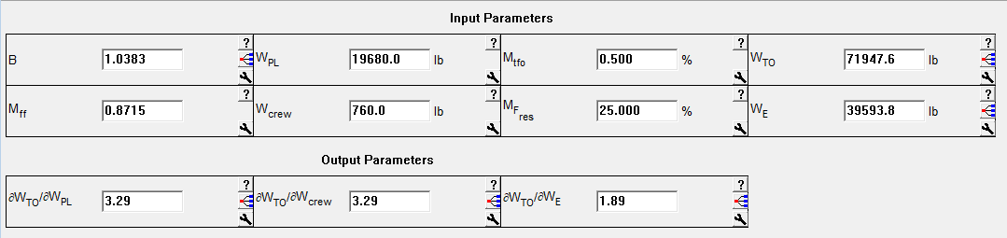
Figure 21. Takeoff weight sensitivities calculated by AAA for fuel-powered aircraft
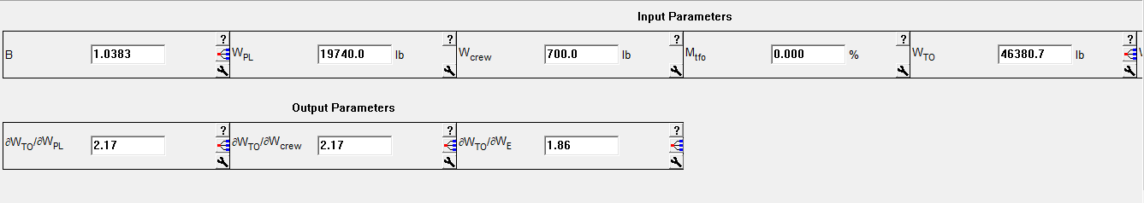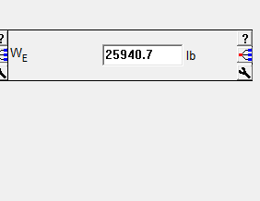
Figure 22. Takeoff weight sensitivities calculated by AAA for electric aircraft

3.6. Trade Studies
Trade studies of takeoff weight versus L/D, payload, range, and specific fuel consumption will be performed. These trade studies are being performed on the HTA which will use fuel in stages 1-4. Additionally, a trade study of range vs. payload will be performed by AAA for the fuel-powered aircraft to compare.

3.7. Takeoff Weight vs. Critical Mission Parameters

3.7.1. Takeoff Weight vs. L/D

Figure 23. Takeoff Weight vs. L/D for Cruise

Figure 24. Takeoff Weight vs. L/D for Loiter

3.7.2. Takeoff Weight vs. Payload

Figure 25. Takeoff Weight vs. Payload Weight (ranges from 80 passengers to 124 passengers)

3.7.3. Takeoff Weight vs. Range

Figure 26. Takeoff Weight vs. Range

3.7.4. Takeoff Weight vs. Specific Fuel Consumption

Figure 27. Takeoff Weight vs. Specific Fuel Consumption during Cruise

Figure 28. Takeoff Weight vs. Specific Fuel Consumption during Loiter

Figure 29. Range vs. Payload

3.8. AAA Calculation of Range vs. Payload
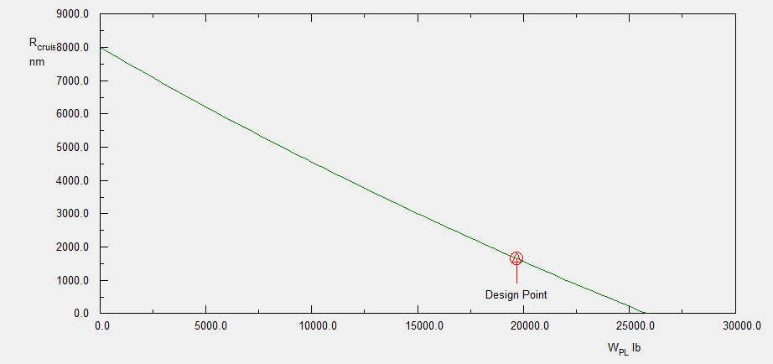
Figure 30. Range vs. Payload with design point W_{pl}=19,630.6 lb and R_{cr}=1,638.7 nm for fuel-powered aircraft

3.9. Trade Study Conclusions
The estimated takeoff weight of 53,778.38 lbs, which is the sum of the manually calculated takeoff weight for the HTA and the batteries, assuming fuel is used during phases 1-4 of flight and lithium ion batteries supply the power for phases 5-8. This weight is represented in the trade study graphs and lies between the design points for the electric aircraft the the fuel-powered model.
The sensitivity studies demonstrated that the takeoff weight is strongly affected by the empty weight, the payload, specific fuel consumption, and lift to drag ratio. The aircraft is able to meet its mission specifications, based on the trade studies. From here constraint analyses will be performed, and the remaining systems will be designed.

Determination of Performance Constraints
Using FAR 25 requirements, data presented in Roskam’s Airplane Design volumes, and the HTA mission requirements, the performance constraints to which the HTA will be sized will be calculated and discussed. Calculations will be performed manually and with AAA. Then the results will be compared and analyzed. The performance constraints of stall speed, takeoff field length, landing field length, cruise speed, climb rate, time to climb to cruise, and maneuvering have an impact on the performance of the aircraft. Aircraft wing area, takeoff thrust (or takeoff power), maximum required lift coefficient for takeoff, and maximum required lift coefficient for landing include stall speed compose the airplane design parameters that are affected by the stall speed, takeoff field length, landing field length, cruise speed, climb rate, time to climb to cruise, and maneuvering.
Together, the results will determine a range of values for wing loading, W/S, thrust loading, T/W, and maximum lift coefficient, C_{L}max. These values will be the result of meeting performance requirements, and specific values will be chose that allow for the lowest takeoff weight and minimize cost.

4.1. Manual Calculation of Performance Constraints

4.1.1. Stall Speed Sizing
The HTA will be designed to meet stall speed requirements, which, in turn, will define an allowable W/S for a given maximum lift coefficient. ${C_{L}}_{max}$ is influenced by the wing and airfoil design, flap type and size, and the center of gravity location (Roskam, Airplane Design Part 1: Preliminary Sizing of Airplanes, 2017). Using equation 26, below,
$V_{S}={\left(\frac{2\left(W/S\right)}{ρ{C_{L}}_{max}}\right)}^{1/2}$ ( 26)
stall speeds during takeoff, cruise, and landing at different M will be calculated. The 737-100 aircraft has a wing loading value of 433.33 kg/m². Assuming standard conditions on the ground and at altitude, $ρ=1.225\frac{kg}{m^{3}} and ρ=0.4135\frac{kg}{m^{3}}$, respectively, $S=102m^{2}$ and varying ${C_{L}}_{max}$values of 0.45, 03.5, and 0.3 at $M=0.75, 0.74, and 0.78$, respectively, the stall speed during cruise with M=0.74, ${C_{L}}_{max}=0.5$ at 40,000 ft is calculated as follows:
$$V_{S}={\left(\frac{2\left(433.33kg/m^{2}\right)}{0.4135kg/m^{3}(0.5)}\right)}^{1/2}=125.8 kts$$
The table below summarizes the stall speeds at various stages based on varying mach and lift coefficient values.
Table 11. Stall Speed Sizing
Parameter | Stage | Cruise | Cruise | Cruise | Cruise | Takeoff | Landing
$$C_{L}$$ |  | 0.45 | 0.5 | 0.3 | 0.58 | 1.75 | 2.73
V_{s} (kts) |  | 116.9 | 162.5 | 125.9 | 132.7 | 39.1 | 53.9

4.1.2. Takeoff Distance Sizing
According to Roskam, takeoff weight, takeoff speed, thrust to weight ratio at takeoff, the aerodynamic drag coefficient, and pilot technique all play a role in takeoff distance sizing (Roskam, Airplane Design Part 1: Preliminary Sizing of Airplanes, 2017). As a result, some parameters will be assumed to be fixed; while others will be changed to determine the thrust loading, T/W, for a given maximum lift coefficient and wing loading.
Since the field length required for takeoff, S_{TOFL,} is proportional to the wing loading, thrust to weight ratio, and the maximum lift coefficient at takeoff, the following equation is true:
$S_{TOFL}∝\frac{{\left(W/S\right)}_{to}}{σ{C_{L}}_{max}{\left(T/W\right)}_{to}}=Top_{25}$ (27)
Note that Top₂₅ is the takeoff parameterin lbs/ft², that meets FAR 25 requirements. Substituting in values for the density ratio, varying ${C_{L}}_{max}$ values, and varying wing loading values, various thrust loadings are calculated. As sample calculation with $σ=0.861$ at 5000 ft elevation with standard conditions and ${C_{L}}_{max}=1.2$ and ${\left(W/S\right)}_{to}=40 lbs/ft^{2}$ produces:
$$\frac{40 lbs/ft^{2}}{0.861(1.2)(217.3969 lbs/ft^{2})}=0.1533 lb/lbf=W/S_{to}$$
The following tables summarize varying lift coefficient values and wing loading values at various altitudes of takeoff and at various field lengths.
Table 12. Takeoff Distance Sizing for S_{TOFL} =5000 ft at 0 ft altitude
$${{C_{L}}_{max}}_{to}$$ | 1.200 | 1.600 | 1.750 | 2.000 | 2.400
W/S_{to}
40.000 | 0.250 | 0.188 | 0.171 | 0.150 | 0.125
60.000 | 0.375 | 0.281 | 0.257 | 0.225 | 0.188
80.000 | 0.500 | 0.375 | 0.343 | 0.300 | 0.250
100.000 | 0.625 | 0.469 | 0.429 | 0.375 | 0.313
120.000 | 0.750 | 0.563 | 0.514 | 0.450 | 0.375
140.000 | 0.875 | 0.656 | 0.600 | 0.525 | 0.438
160.000 | 1.000 | 0.750 | 0.686 | 0.600 | 0.500

Table 13. Takeoff Distance Sizing for S_{TOFL} =6000 ft at 0 ft altitude
$${{C_{L}}_{max}}_{to}$$ | 1.200 | 1.600 | 1.750 | 2.000 | 2.400
W/S_{to}
40.000 | 0.208 | 0.156 | 0.143 | 0.125 | 0.104
60.000 | 0.313 | 0.234 | 0.214 | 0.188 | 0.156
80.000 | 0.417 | 0.313 | 0.286 | 0.250 | 0.208
100.000 | 0.521 | 0.391 | 0.357 | 0.313 | 0.260
120.000 | 0.625 | 0.469 | 0.429 | 0.375 | 0.313
140.000 | 0.729 | 0.547 | 0.500 | 0.438 | 0.365
160.000 | 0.833 | 0.625 | 0.571 | 0.500 | 0.417

Table 14. Takeoff Distance Sizing for S_{TOFL} =9468 ft at 5000 ft altitude
$${{C_{L}}_{max}}_{to}$$ | 1.200 | 1.600 | 1.750 | 2.000 | 2.400
W/S_{to}
40.000 | 0.153 | 0.115 | 0.105 | 0.092 | 0.077
60.000 | 0.230 | 0.172 | 0.158 | 0.138 | 0.115
80.000 | 0.307 | 0.230 | 0.210 | 0.184 | 0.153
100.000 | 0.383 | 0.287 | 0.263 | 0.230 | 0.192
120.000 | 0.460 | 0.345 | 0.315 | 0.276 | 0.230
140.000 | 0.537 | 0.402 | 0.368 | 0.322 | 0.268
160.000 | 0.613 | 0.460 | 0.421 | 0.368 | 0.307

Table 15. Takeoff Distance Sizing for S_{TOFL} =10800 ft at 8000 ft altitude
$${{C_{L}}_{max}}_{to}$$ | 1.200 | 1.600 | 1.750 | 2.000 | 2.400
W/S_{to}
40.000 | 0.147 | 0.110 | 0.101 | 0.088 | 0.074
60.000 | 0.221 | 0.166 | 0.151 | 0.133 | 0.110
80.000 | 0.295 | 0.221 | 0.202 | 0.177 | 0.147
100.000 | 0.368 | 0.276 | 0.252 | 0.221 | 0.184
120.000 | 0.442 | 0.331 | 0.303 | 0.265 | 0.221
140.000 | 0.515 | 0.387 | 0.353 | 0.309 | 0.258
160.000 | 0.589 | 0.442 | 0.404 | 0.353 | 0.295

4.1.3. Landing Distance Sizing
Parameters affecting the landing distance include the landing weight, approach speed, method to decelerate, the pilot’s landing technique, and the quality of the aircraft (Roskam, Airplane Design Part 1: Preliminary Sizing of Airplanes, 2017). Considering that the aircraft is a hybrid, the landing weight will be heavier than conventional transport aircraft. Comparing the conceptual SUGAR aircraft weight ratio of maximum landing weight to takeoff weight, or $W_{L}/W_{to}$ , provides a strong estimate for hybrid transport weight ratios. Although the fuel depreciates during the stages of the flight, the battery weight does not change, and therefore, the plane will be heavier at landing than an identical fuel-powered aircraft.
The following assumptions will be made for the landing distance sizing: standard conditions, applied brakes to stop the aircraft, and a takeoff weight of 77, 602 lbs. Various approach speeds, field lengths, weight ratios, and lift coefficients at landing will determine the possible wing loading values for the HTA.
Using the desired approach speed, the field length can be found.
$S_{FL}=0.3V_{A}^{2}$ (28)
From there, the stall speed at landing can be found using:
$V_{A}=1.3V_{S_{L}}$ (29)
Then, the ${\left(W/S\right)}_{L}$results from
${\left(W/S\right)}_{L}=\frac{V_{S_{L}}^{2}\left(0.002378\right)}{2}*C_{L_{\max_{L}}}$ (30)
Thus, for an approach speed of 128 kts, the field length is 4915 ft. The landing stall speed is 98.46 kts. Using a $C_{L_{\max_{L}}}$value of 1.7, the wing loading at landing is 55.8. Then the takeoff wing loading value can be calculated with $W/S_{to}=\frac{W/S_{L}}{0.96}=$ 58.2.

The $W_{L}/W_{to}$ values considered include 0.85, 0.9, 0.93, and 0.96. Together with the varying maximum landing C_{L} values of 1.7, 2, 2.3, 2.6, and 2.73, and the range of approach speeds from 114 kts to 129 kts, the field length and the wing loading at takeoff were calculated. The summary of the manual calculations is pesented in the tables below.
Table 16. W/S_{to} with W_{L}/W_{to}=0.85
 |  | $$C_{L_{\max_{L}}}$$
V_{A} (kts) | S_{FL} (ft) | 1.700 | 2.000 | 2.300 | 2.600 | 2.730 | 3.000 | 3.400
128.000 | 4915.200 | 65.689 | 77.281 | 88.873 | 100.465 | 105.488 | 115.921 | 131.377
114.900 | 3960.603 | 52.931 | 62.272 | 71.613 | 80.953 | 85.001 | 93.408 | 105.862
115.470 | 4000.000 | 53.458 | 62.891 | 72.325 | 81.759 | 85.846 | 94.337 | 106.915
122.474 | 4500.000 | 60.140 | 70.753 | 81.365 | 91.978 | 96.577 | 106.129 | 120.279
129.099 | 5000.000 | 66.822 | 78.614 | 90.406 | 102.198 | 107.308 | 117.921 | 133.644

Table 17. W/S_{to} with W_{L}/W_{to}=0.9
 |  | $$C_{L_{\max_{L}}}$$
V_{A} (kts) | S_{FL} (ft) | 1.700 | 2.000 | 2.300 | 2.600 | 2.730 | 3.000 | 3.400
128.000 | 4915.200 | 62.039 | 72.987 | 83.935 | 94.884 | 99.628 | 109.481 | 124.078
114.900 | 3960.603 | 49.990 | 58.812 | 67.634 | 76.456 | 80.279 | 88.218 | 99.981
115.470 | 4000.000 | 50.488 | 59.397 | 68.307 | 77.216 | 81.077 | 89.096 | 100.975
122.474 | 4500.000 | 56.799 | 66.822 | 76.845 | 86.868 | 91.212 | 100.233 | 113.597
129.099 | 5000.000 | 63.110 | 74.247 | 85.384 | 96.521 | 101.347 | 111.370 | 126.219

Table 18. W/S_{to} with W_{L}/W_{to}=0.93
 |  | $$C_{L_{\max_{L}}}$$
V_{A} (kts) | S_{FL} (ft) | 1.700 | 2.000 | 2.300 | 2.600 | 2.730 | 3.000 | 3.400
128.000 | 4915.200 | 60.038 | 70.633 | 81.228 | 91.823 | 96.414 | 105.949 | 120.076
114.900 | 3960.603 | 48.378 | 56.915 | 65.452 | 73.990 | 77.689 | 85.373 | 96.756
115.470 | 4000.000 | 48.859 | 57.481 | 66.103 | 74.726 | 78.462 | 86.222 | 97.718
122.474 | 4500.000 | 54.966 | 64.666 | 74.366 | 84.066 | 88.270 | 97.000 | 109.933
129.099 | 5000.000 | 61.074 | 71.851 | 82.629 | 93.407 | 98.077 | 107.777 | 122.148

Table 19. W/S_{to} with W_{L}/W_{to}=0.96
 |  | $$C_{L_{\max_{L}}}$$
V_{A} (kts) | S_{FL} (ft) | 1.700 | 2.000 | 2.300 | 2.600 | 2.730 | 3.000 | 3.400
128.000 | 4915.200 | 58.162 | 68.426 | 78.689 | 88.953 | 93.401 | 102.638 | 116.324
114.900 | 3960.603 | 46.866 | 55.136 | 63.407 | 71.677 | 75.261 | 82.705 | 93.732
115.470 | 4000.000 | 47.332 | 55.685 | 64.038 | 72.390 | 76.010 | 83.527 | 94.664
122.474 | 4500.000 | 53.249 | 62.646 | 72.042 | 81.439 | 85.511 | 93.968 | 106.497
129.099 | 5000.000 | 59.165 | 69.606 | 80.047 | 90.488 | 95.012 | 104.409 | 118.330

4.1.4. Climb Requirement Sizing
In order to size to the climb requirement, the drag polar is necessary to find. The drag coefficient can be summarized as:
$C_{D}=C_{D_{0}}+\frac{C_{L}^{2}}{πAe}$ (31)
$C_{D_{0}}=f/S$ (32)
Since the HTA is modeled after the Boeing 737-100 aircraft, Roskam’s correlation coefficients for parasite area vs. wetted area will be used along with the regression line coefficients for takeoff weight vs. wetted area. These regression coefficients are a= -2.5229, b=1, c=0.0199, and d=0.7531. These coefficients are used in the following equations:
$\log_{10}\left(f\right)=a+b*\log_{10}{(S_{wet})}$ (33)
$\log_{10}\left(S_{wet}\right)=c+d*\log_{10}{(W_{to})}$ (34)
Using A=8.83, from the Boeing 737-100 model and the e values from Roskam, the drag polars can be calculated using equations 31 and 32. The results are summarized in Table 20.35
Table 20. Configuration Parameters and Drag Polars
Configuration | $$C_{D_{0}}$$ | A | e | $$C_{D_{i}}$$ | $$C_{L_{max}}$$ | $$C_{D}$$
Clean | 0.013772 | 8.83 | 0.85 | 0.205265 | 2.2 | 0.219037
Takeoff flaps | 0.0334 | 8.83 | 0.8 | 0.137999 | 1.75 | 0.171399
landing flaps | 0.0784 | 8.83 | 0.75 | 0.358223 | 2.73 | 0.436623
gear down | 0.015 | 8.83 | ------ | ------- | ------ | ------
These values can be used to calculate the thrust loading at takeoff that meets FAR 25 specifications. The following FAR specifications are for a takeoff climb. For FAR 25.111 (OEI), the configuration consists of gears up, takeoff flaps, ground effects, CGR>0.012 and $1.2V_{S_{to}}$. For FAR 25.121 (OEI), the configuration consists of gears down, takeoff flaps, ground effects, CGR>0, and the speed ranging between $V_{LOF}$ and $1.2V_{S_{to}}$. For FAR 25.121 (OEI), the configuration consists of gear up, takeoff flaps, no ground effects, and speed at $1.2V_{S_{to}}$. For FAR 121 (OEI), the configuration consists of gears up, flaps up, maximum continuous thrust on remaining engines, CGR>0.012, and speed at $1.2{5V}_{S}$ (Roskam, Airplane Design Part 1: Preliminary Sizing of Airplanes, 2017).
In the event of a necessary landing climb from a balked landing, there are two FAR specifications to meet. FAR 25.119 (AEO) requires CGR>0.032, and a configuration of gears down, landing flaps, takeoff thrust on all engines, maximum design landing weight, and $1.3V_{S_{L}}.$FAR 25.121 (OEI) requires CGR>0.021, and a configuration of gears down, approach flaps, takeoff thrust on remaining engines, and $1.5V_{S_{A} .}$ (Roskam, Airplane Design Part 1: Preliminary Sizing of Airplanes, 2017) A summary of these results is presented in the tables below.
Table 21. FAR 25.111 (gears down, TO flaps, with additional T/W calculated for 50ºC increase)
$C_{L}$ modified | 1.215278
$$C_{D}$$ | 0.09995
L/D | 17.50869
T/W_{to} | 0.138229
T/W_{to} (Modified for +50ºC) | 0.172786

Table 22. FAR 25.121 (gears down, TO flaps, with additional T/W calculated for 50ºC increase)
${C_{L}}_{LOF}$ (V=1.1$V_{S_{TO}}$) | 1.446281
$$C_{D}$$ | 0.127655
L/D | 11.3296
T/W_{to} | 0.176529
$C_{L}$ (for $V_{2}=1.2V_{S_{TO}})$ | 1.215278
$$C_{D}$$ | 0.11495
L/D | 10.57219
T/W_{to} | 0.189175
*Since $V_{2}$ is the more critical value, we will calculate T/W_to modified temperature
T/W_{to} (Modified for +50ºC) | 0.220661

Table 23. FAR 25.111 (gears down, TO flaps, with additional T/W calculated for 50ºC increase)
$C_{L}$ modified | 1.215278
$$C_{D}$$ | 0.09995
L/D | 12.15881
T/W_{to} | 0.21249
T/W_{to} (Modified for +50ºC) | 0.265612

Table 24. FAR 25.121 (gears up, flaps up, with additional T/W calculated for 50ºC increase and maximum thrust at 0.94)
$C_{L}$ modified | 1.408
$$C_{D}$$ | 0.102477
L/D | 13.7397
T/W_{to} | 0.145437
T/W_{to} (Modified for +50ºC and 94% thrust) | 0.1934

Table 25. FAR 25.119 (AEO) (balked landing, gears down, flaps down)
$C_{L}$ modified | 1.615385
$$C_{D}$$ | 0.218824
L/D | 7.382124
T/W_{to} | 0.167462
$$W_{L}$$ | 72946.44
T/W_{to} (Modified for +50ºC) | 0.222689

Table 26. FAR 25.121 (OEI) (balked landing, gears down, flaps down)
$C_{L}$ modified | 1.035556
$$C_{D}$$ | 0.122444
L/D | 8.457407
T/W_{to} | 0.278479
$$W_{L}$$ | 72946.44
T/W_{to} (Modified for +50ºC) | 0.327213
From the data presented in the tables, the rate of climb at altitude and sea level, along with the altitude, absolute ceiling, and other parameters can be found. This information is summarized in Table 27.
Table 27. Sizing to Time to Climb Requirements
Sizing to Time to Climb Requirements
rate of climb at altitude h (ft/min) | $$RC_{h}$$ | 366.2041
rate of climb at sea level (ft/min) | $$RC_{0}$$ | 3295.837
Height (ft) | h | 40000
absolute ceiling (ft) | $$h_{abs}$$ | 45000
time to climb (min) | $$t_{Cl}$$ | 30
rate of climb (ft/min) | RC | 3158.786
 | V | 957.3788
 | T/W (english) | 3.377
 | L/D | 12.88834
 | W/S | 291.184
 | density | 0.000738

4.1.5. Maneuvering Requirement Sizing
Maneuvering requirements are generally listed in mission specifications for military aircraft, agrigultural aircraft, or acrobatic aircraft. Since the HTA’s mission specifications do not include maneuvering capabilities, the aircraft will not be sized to meet these capabilities.

4.1.6. Cruise Speed Requirement Sizing
In order to size to cruise speed requirements, the following equations will be used (Roskam, Airplane Design Part 1: Preliminary Sizing of Airplanes, 2017).
$T_{reqd}=C_{D}\overline{q}S=C_{D_{0}}\overline{q}S+\frac{C_{L}^{2}\overline{q}S}{πAe}$ (36)
$W=C_{L}\overline{q}S$ (37)
Combining the two equations by dividing by the weight yields:
$\frac{T}{W_{reqd}}=\frac{C_{D_{0}}\overline{q}S}{W}+\frac{C_{L}^{2}\overline{q}S}{WπAe}$ (38)

4.2. AAA Calculation of Performance Constraints

4.2.1. Stall Speed Sizing
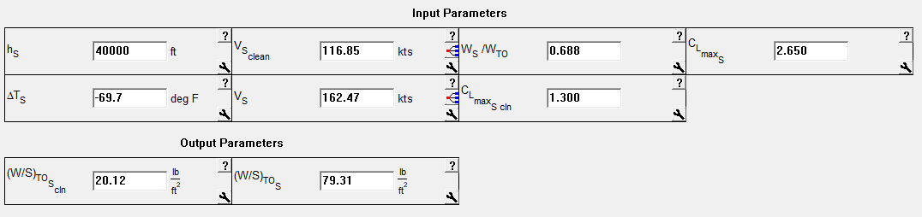
Figure 31. AAA results of stall speed sizing

4.2.2. Takeoff Distance Sizing
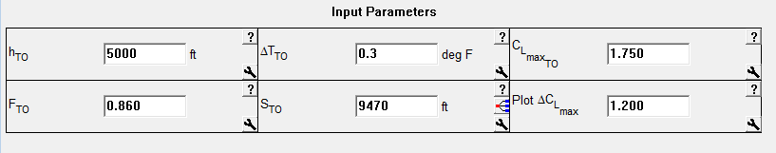
Figure 32. AAA results of takeoff distance sizing

4.2.3. Landing Distance Sizing
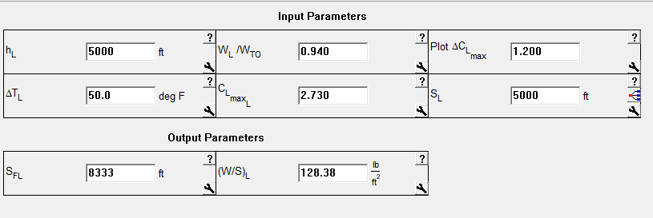
Figure 33. AAA results of landing distance sizing

4.2.4. Climb Requirement Sizing
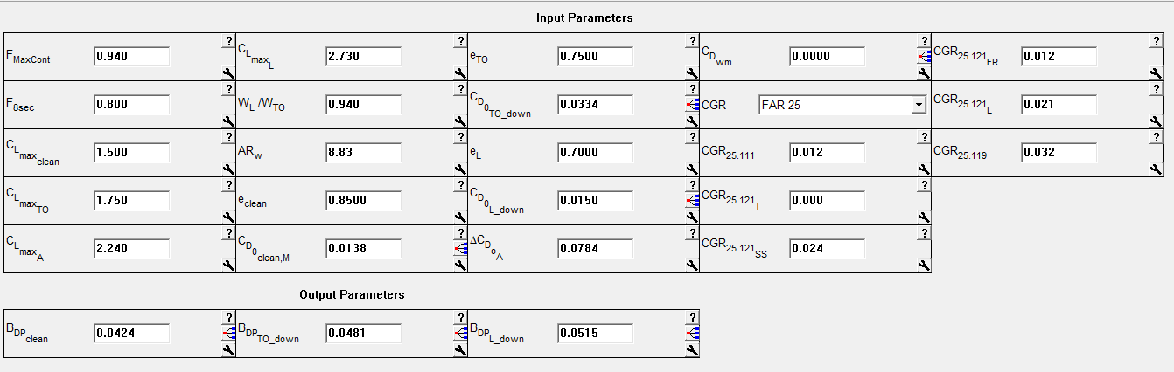
Figure 34. AAA results of climb requirement sizing

4.2.5. Cruise Speed Requirement Sizing
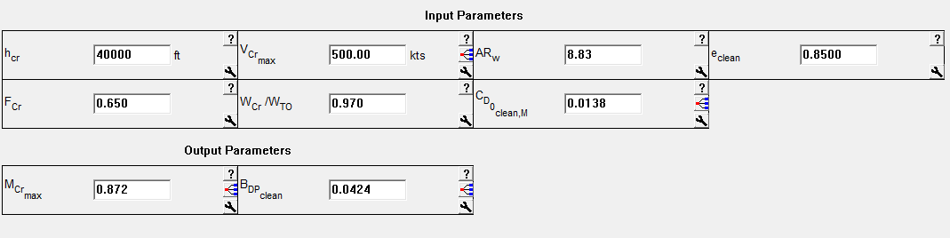
Figure 35. AAA results of cruise speed requirement sizing

4.2.6. Matching Plot
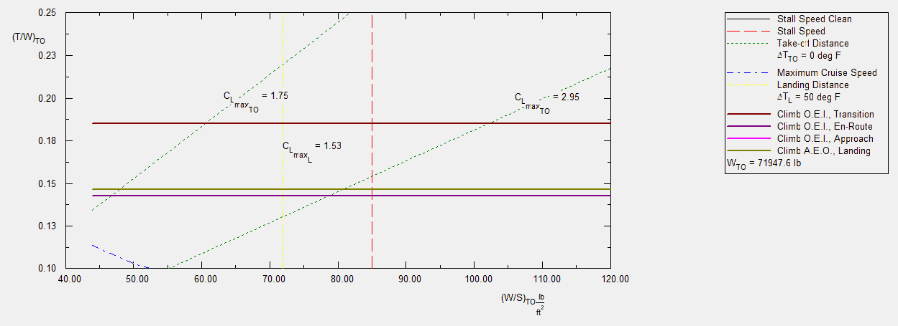
Figure 36. AAA results of the performance sizing plot

From the performance sizing plot, a design point with a wing loading of 128.34 lb/ft² and a thrust to weight ratio of 0.31 has been chosen. This yelds a $C_{L_{\max_{L}}}$=2.73 , $C_{L_{\max_{TO}}}$=2.25, ${ S}_{w}=560.61 ft^{2},$ and a thrust of $21,766 lbs$.

5. Fuselage and Cockpit Design
The cockpit and fuselage design will be modeled after the Boeing 737-100 model aircraft. Utilizing Roskam’s Airplane Design Part 3, each of these sections will be designed with using typical arrangements that take into account human factors.

5.1. Cockpit Design
The cockpit will be designed for two pilots with standard heights and weight. The cockpit will be initially sized to hold two male crew members, as female crew members are typically smaller. The pilots will be assumed to weigh 175 lbs, based on body component weights and the fact that they will not be wearing a helmet. For dimensions, the body width consists of the shoulder width, which will be estimated at 21 in. across, the width at the elbows, estimated at 22 in. across, and the hip width at 18 in. across. The weights and dimensions include flight clothing. The remaining dimension assumptions are illustrated in Figure 1, below.
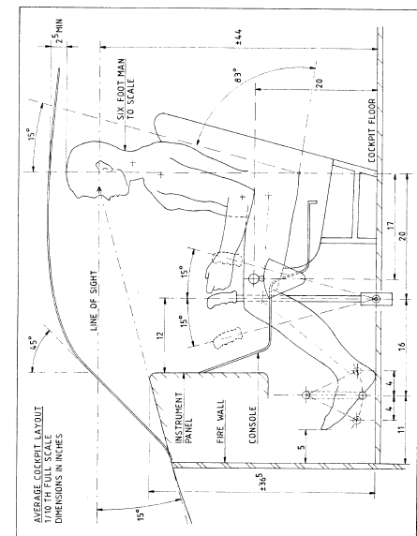
Figure 37. Dimensions of sitting male crew member in cockpit (Roskam, 2011).
The cockpit design must also take into account the visibility during takeoff, cruise, and landing. Figure 1 also illustrates the angles for line of sight. Roskam defines cockpit visibility as “the angular area obtained by intersecting the airplane cockpit with radial vectors emanating from the eyes of the pilot” (Roskam, 2011). The point C, in Figure 2, lies on the eyes of the pilot. Figure 3 demonstrates the minimum visbility pattern for transport aircraft, per FAR 25 specifications.
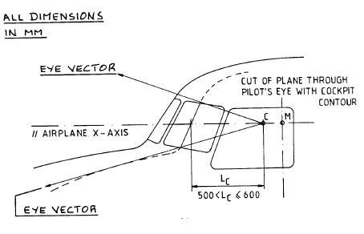
Figure 38. Radial eye vectors emanating from C. (Roskam, 2011)
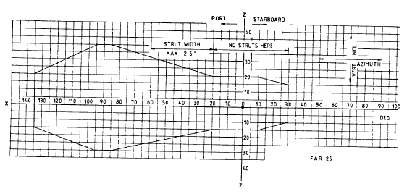
Figure 39. Ideal minimum visibility pattern for transport aircraft. (Roskam, 2011)
The cockpit layouts in section 5.1.1. meet the visibility requirements and height, width, and weight requirements for the pilots. They are from the Boeing 737-100 model since the exchange of the hybrid engine, and battery nacelles will not change the fuselage nor cockpit design.

5.1.1. Cockpit Layout Design
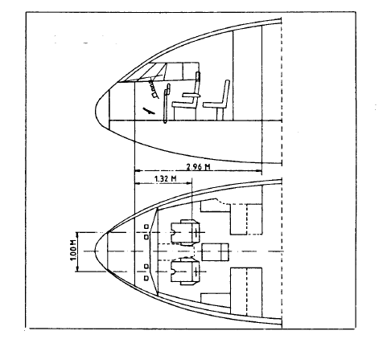
Figure 40. Side and top-down view of cockpit. Dimensions in meters (Boeing Commercial Airplanes, 2013)

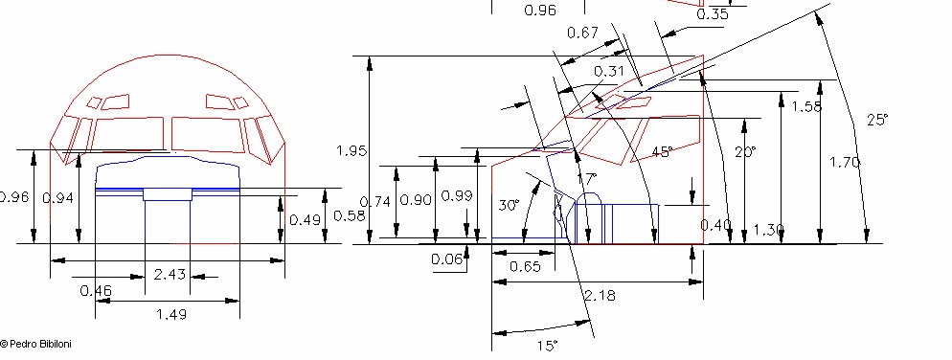

Figure 41. Front and side 3-D view of cockpit. Dimensions in meters (Boeing Commercial Airplanes, 2013)
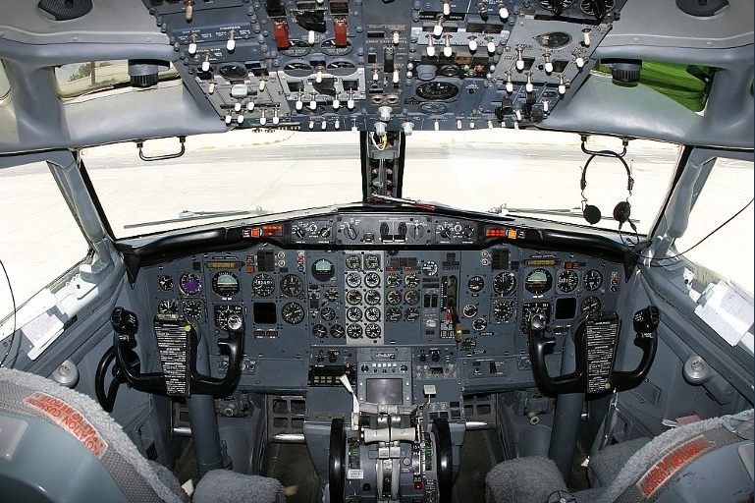
Figure 42. Rear view of cockpit. (Aircraft Technical Data and Specifications: Boeing 737-100/200, 2017)

5.2. Fuselage Design

5.2.1. Fuselage Layout Design
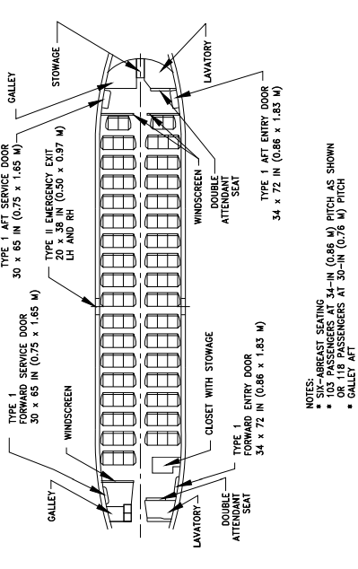
Figure 43. Top down view of the fuselage (Boeing Commercial Airplanes, 2013)
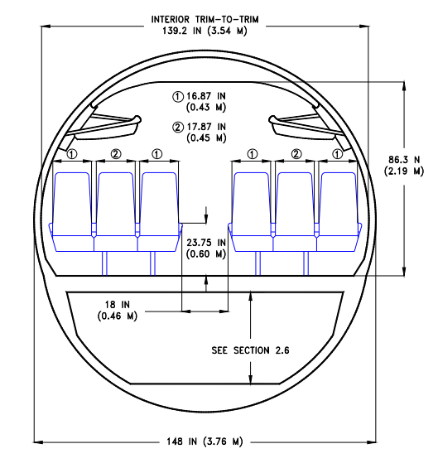
Figure 44. Front view of the fuselage (Boeing Commercial Airplanes, 2013)
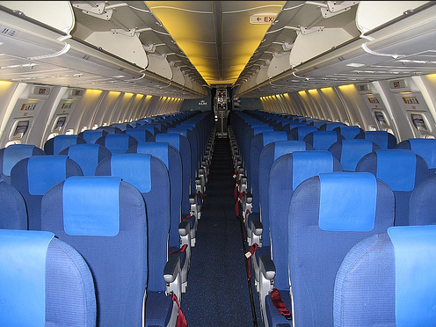
Figure 45. Front 3-D view of the 6 abreast passenger seating in the fuselage (Creative Aviation Photography, 2017)

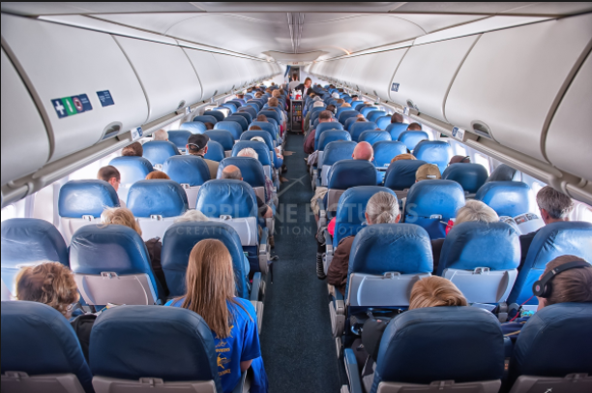
Figure 46. Rear 3-D view of the 6 abreast passenger seating in the fuselage (Creative Aviation Photography, 2017)

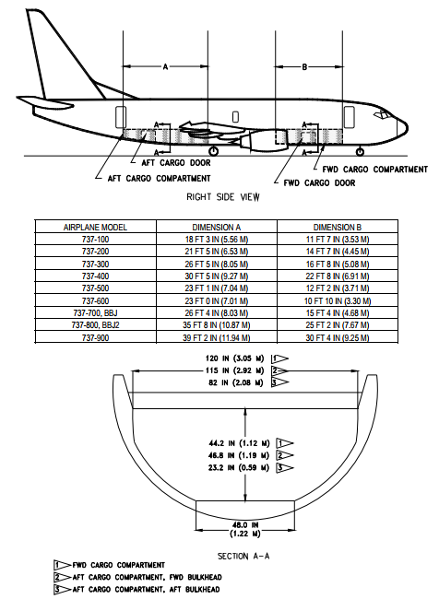
Figure 47. Side view of fuselage with cargo compartment visible (Boeing Commercial Airplanes, 2013)
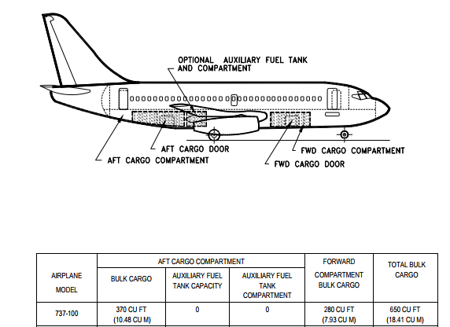
Figure 48. Side view of fuselage with cargo placement (Boeing Commercial Airplanes, 2013)

5.3. Recommendations and Conclusions

5.3.1. Recommendations
In general, the HTA is a hybrid version of the Boeing 737-100. Considering the 96 passenger payload, the 6 abreast seating allows for a smaller fuselage and lower takeoff weight. The standard cockpit design will work with two pilots, whether male or female. The fuselage design allows for flight attendant seating.

5.3.2. Conclusions
The current model of the 737-100 fuselage and cockpit meets FAR 25 requirements, visibility requirements, and provides the opportunity to exchange the engine and add batteries. To keep the takeoff weight a minimum, the minimum number of passengers will be considered, and the plane can be expanded length-wise in a future design.

6. Wing, High-Lift System and Lateral Control Design

6.1. Wing Planform Design
Using the known gross wing area, S, and aspect ratio, A, the remaining planform design characteristics of the wing will be chosen. These characteristics include the sweep angle, Λ, thickness ratio, t/c, airfoil type, taper ratio, λ, incidence angle i_{w}, twist angle, ε_{w}, dihedral angle, Γ_{w}, and the lateral control surface size and layout. Some of these will be calculated, and others will be chosen based on reference data. The HTA will feature conventional, cantilever low wing.

6.1.1. Sweep Angle-Thickness Ratio Combination
The 737-100 has a wing quarter chord sweep angle of 25º and is, therefore, aft swept. The HTA will feature the same 25 º sweep angle. This angle also matches well with other jet transport sweep angles, visble in the Figure 1 below.
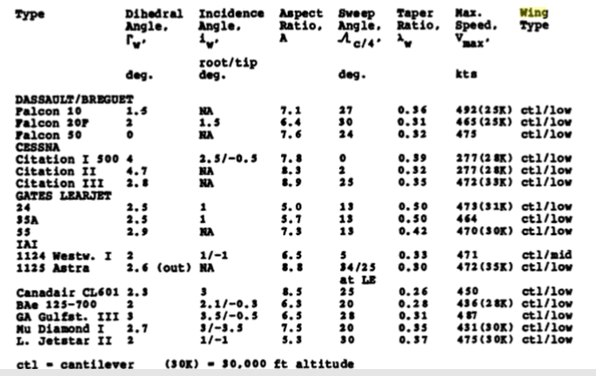
Figure 49. Jet Transports Wing Geometric Data (Roskam, Airplane Design Part II: Preliminary Configuration Design and Integration of the Propulsion System, 2011)
The next values to select for the wing parameters are the taper ratio and the dihedral angle. The taper ratio consists of the ratio of the tip chord to root chord. The dihedral angel is the upward angle from the horizontal to the tailplane of the fixed-wing aircraft. These values will be modeled after the Boeing 737-100. λ=0.339 and Γ_{w}=6.
Since the airplane will be flying at high subsonic speeds, a trade study will be performed varying the sweep angle and the thickness ratio. This will facilitate the choice of the sweep angle and thickness ratio that allows for the minimum weight of the wing. The following equation:
$\frac{M_{cc}^{2}\cos^{2}{Λ}}{\sqrt{1-M_{cc}^{2}\cos^{2}{Λ}}}\left[\left(\frac{γ+1}{2}\right)\left(\frac{2.64\left(\frac{t}{c}\right)}{\cos{Λ}}\right)+\left(\frac{γ+1}{2}\right)\left(\frac{2.64\left(\frac{t}{c}\right)\left(0.34C_{l}\right)}{\cos^{3}{Λ}}\right)\right]+\frac{M_{cc}^{2}\cos^{2}{Λ}}{1-M_{cc}^{2}\cos^{2}{Λ}}\left[\left(\frac{γ+1}{2}\right){\left(\frac{1.32\left(\frac{t}{c}\right)}{\cos{Λ}}\right)}^{2}\right]+M_{cc}^{2}\cos^{2}{Λ}\left[1+\left(\frac{γ+1}{2}\right)\frac{\left(0.68c_{l}\right)}{\cos^{2}{Λ}}+\left(\frac{γ+1}{2}\right)\frac{\left(0.34c_{l}\right)}{\cos^{2}{Λ}}\right]-1=0$ (39)
can be used to solve for the thickness ratio for varying sweep angles. The table and plot below demonstrate these results.
Table 28. Thickness Ratio and Wing Weight vs. sweep angle
Λ (deg) | t/c | W_{w} (lbs)
0 | 0.079 | ----------
5 | 0.081 | 436448.0332
10 | 0.086 | 81961.74273
15 | 0.095 | 44021.92291
20 | 0.108 | 29471.24401
25 | 0.124 | 21783.48296
30 | 0.145 | 17064.19453
35 | 0.169 | 13911.36935
40 | 0.197 | 11691.97308
45 | 0.227 | 10076.63814
50 | 0.259 | 8877.443908
55 | 0.291 | 7981.378457
60 | 0.319 | 7320.729094
65 | 0.338 | 6862.089862
70 | 0.337 | 6614.330935
75 | 0.295 | 6700.319668
80 | 0.142 | 8184.063457
85 | -0.454 | ----------
Figure 50. Plots of t/c and W_{w} vs. Λ
Using the wing weight as the figure of merit, the minimum wing weight occurs at a sweep angle of 70º. This is not a reasonaible sweep angle, and therefore, the wing weight may not be an appropriate figure of merit.
Besides using the weight of the wing as a figure of merit, there are other considerations for selecting the thickness ratio. The thickness ratio should be greater than 0.1 to accommodate the wing structure, fuel, batteries, and main landing gear when retracted. Additionally the thickness ratio should not exceed 0.2 in order to prevent the drag profile from being too high. Additionally, large sweep angles result in lower performance of the wing during low speed. As a result, high lift systems may be necessary to improve this performance. Using these values for the thickness ratio, a sweep angle between 20 and 40º would be appropriate. Thus, the 25º angle will be selected and this results in a thickness ratio of 0.124.

6.2. Airfoil Selection
Selecting the airfoil involves considering the aircraft mission, along with properties of the drag coefficient at the design lift coefficition, section critical Mach number, and section pitching moment. The Boeing 737-100 used the Wing root- BAC 449/450/451 airfoil with Wing tip- BAC 442 airfoil . This will be selected as well for the HTA. The schematic, below, illustrates the various airfoils for the root airfoil, two midspan airfoils, and outbard airfoil.
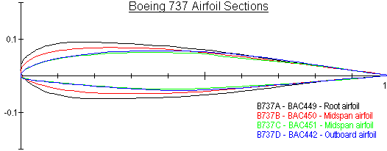
Figure 51. Boeing 737 Airfoil selections schematic (Aircraft Technical Data and Specifications: Boeing 737-100/200, 2017)
Based on Roskam’s wing geometric data for transport aircraft, the incidence angle will be 1º (Aircraft Technical Data and Specifications: Boeing 737-100/200, 2017). Using the Boeing 737-100 model, the dihedral angle used will be 6º. Most aircraft have negative wash-out twist angles. Based on Roskam’s discussion of designing wings for transport aircraft, a twist angle of -2º will be assumed.

6.3. Design of the High-Lift Devices
High lift devices are useful to help the aircraft meet its requirements for ${C_{L}}_{max⁡TO}$and ${C_{L}}_{\max{L}}$. High lift devices include leading-edge devices and trailing-edge devices. Leading edge devices include VC Krueger flap, two-position slat, three-position slat, fixed slot, variable camber (VC) leading edge, hinged leading edge (or droop nose), folding bull-nose Krueger flap (Rudolph, 1996). Trailing edge devices include split flap, plain flap, simple slotted flap, single-slotted Fowler flap, fized vain/main slotted flap, articulating vane/main double slopped flap, main/aft double slotted flap, triple-slotted flap (Rudolph, 1996).
The following sizing will determine which high lift devices would provide the HTA with enough lift to meet the takeoff and landing mission requirements. The HTA has $C_{L_{\max_{L}}}$=2.73 and $C_{L_{\max_{TO}}}$=2.25. These values were determined from the performance sizing in discussed in Chapter 4. According to Roskam, sizing the high lift devices involves determining the maximum lift coefficient capability of the wing, estimating $∆C_{L_{\max_{TO}}}$ and ${∆C}_{L_{\max_{L}}}$, accounting for the sweep of the wing, and then sizing the device using the desired ${∆C}_{L}$. Using the planform design characteristics of Λ=25º, t/c= 0.124, λ=0.339, i_{w} =2º , ε_{w}=, Γ=6º, S=1098 ft², b=93 ft, c_{r}=24.02 ft , and c_{t}= 5.2 ft, the high lift devices will be sized.
The $C_{L_{max }}$ can be obtained from the $C_{L_{max W}}$. To calculate the maximum lift coefficient of the wing, the following equation will be used:

$C_{L_{max W}}=\frac{k_{λ}\left(C_{L_{\max{r}}}+C_{L_{\max{t}}}\right)}{2}$ (40)
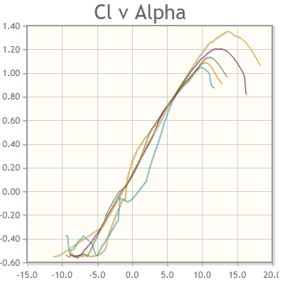
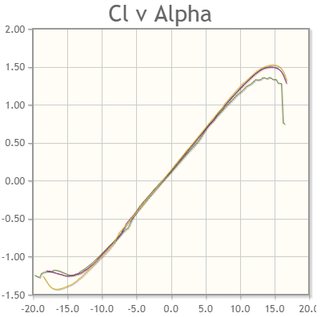
Thus, using $k_{λ}=0.957$ and obtaining the root and tip maximum lift coefficients for the airfoil, $C_{L_{max W}}$ can be calculated, with $C_{L_{max W}}=\frac{0.957\left(1.9+1.6\right)}{2}=1.67$.

Figure 52. C_{l} vs. angle of attack for maximum lift coefficient at root and midspan
$C_{L_{max W}}=1.1$, and taking into account the quarter chord sweep angle, $C_{L_{max W}}=1.8$. Since the original 737-100 is a short-coupled airplane, the HTA will be assumed to be a short-coupled airplane. Therefore,
$C_{L_{max W}}=1.1C_{L_{max }}$ (41)
and $C_{L_{max}}=1.6$.
Using $C_{L_{max}}=1.6$, the ${∆C}_{L_{max W}}$ and ${∆C}_{L_{max L}}$ can be calculated using the following two equations.
${∆C}_{L_{max TO}}=1.05(C_{L_{\max_{TO}}}-$ $C_{L_{max}}$ ) (42)
${∆C}_{L_{max L}}=1.05(C_{L_{\max_{L}}}-$ $C_{L_{max}}$ ) (43)
Therefore, ${∆C}_{L_{max TO}}=1.05(2.25-$ $1.1)=1.2$ and ${∆C}_{L_{max L}}=1.05(2.73-$ $1.1)=1.7$. The factor of 1.05 takes into account the trip penalties incurred when using flaps. To calculate the ${∆C}_{L_{max }}$values, with the sweep correction factor taken into consideration, the following table illustrates the various ${∆C}_{L_{max }}$with three arbitrary flapped wing area to wing area ratios.
Table 29. ${∆C}_{L_{max TO}}$ and ${∆C}_{L_{max L}}$ using various S_{wf}/S
 | Takeoff | Landing
S_{wf}/S | $${∆c}_{l_{max TO}}$$ | $${∆c}_{l_{max L}}$$
0.60 | 0.83 | 1.18
0.80 | 1.11 | 1.57
0.90 | 1.25 | 1.77

In order to achieve the required flap lift increments, Fowler flaps will be used. The Fowler flaps have the following geometry: $\frac{c_{f}}{c}=0.3, δ_{f_{t0}}=35°, δ_{f_{L}}=40°.$ (Roskam, Airplane Design Part II: Preliminary Configuration Design and Integration of the Propulsion System, 2011). The required incremental section lift coefficient, ${∆c}_{l}$ will be calculated. This is the value that the trailing edge flaps must generate. The${∆c}_{l_{max}}$ values have been estimated at takeoff and landing based on the S_{wf}/S ratio. ${∆c}_{l}$ is related to ${∆c}_{l_{max}}$ through the following equation
${∆c}_{l}=\left(\frac{1}{K}\right){∆c}_{l_{max}}$ (44)
K=0.94 is determined using , below, with $c_{f}/c=0.3$ Thus the needed ${∆c}_{l}$values can be summarized in Table 3.
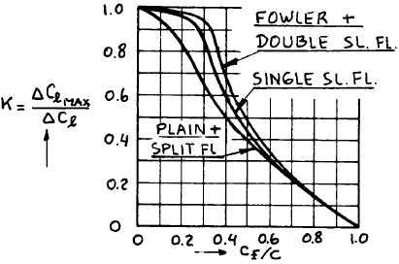

Figure 53. Effect of Flap Chord Ratio and Flap Type on K

Table 30. Calculated${ ∆c}_{l}$ for takeoff and landing
 | Takeoff | Landing
S_{wf}/S | $${{∆c}_{l}}_{to}$$ | $${{∆c}_{l}}_{l}$$
0.60 | 0.88 | 1.26
0.80 | 1.18 | 1.67
0.90 | 1.33 | 1.88
For Fowler flaps, the following equations hold:
${∆c}_{l}=c_{l_{∝}{∝_{δ}}_{f} δ_{f}}$ (45)
$c_{l_{α_{f}}}=c_{l_{∝}(c^{'}/c)}$ (46)
$\frac{c^{'}}{c}=1+2\left(\frac{z_{fh}}{c}\right)\tan\left(\frac{δ_{f}}{2}\right)$ (47)
Therefore, ${∆c}_{l}=2π\left(0.53\right)\left(\frac{35}{57.29}\right)=2.03$. Finally, using
$\frac{S_{wf}}{S}=\left(η_{0}-η_{i}\right)\left\{2-\left(1-λ\right)\left(η_{i}+η_{0}\right)\right\}/(1+λ)$ (48)
the following is a summary of the flap geometry: $\frac{S_{wf}}{S}=0.83$, $\frac{c_{f}}{c}=0.3, δ_{f_{t0}}=35°, δ_{f_{L}}=40°$. The ${∆c}_{l}$ supplied by the Fowler flaps satisfies the required ${∆c}_{l}$for both takeoff and landing. Thus, the Fowler flaps will be sufficient in providing additional lift.

6.3.1. AAA Calculation of Lift Coefficient
Using AAA, the clean maximum lift coefficient was found to be 1.541. Although this value is lower than the original manual calculations, the increase in lift provided by the Fowler Flaps is still substantial to provide the aircraft with lift.
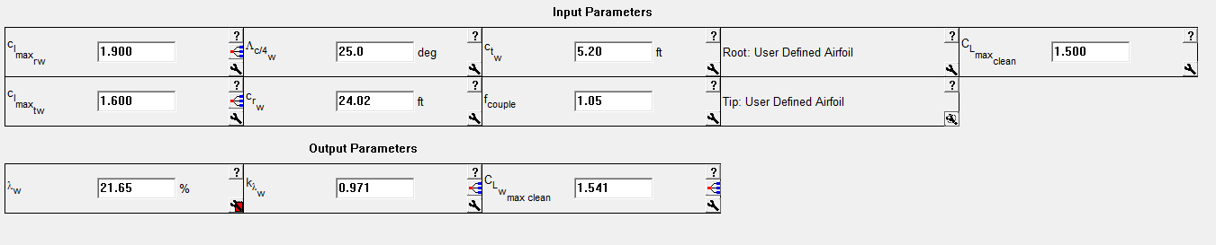
Figure 54. AAA Estimate of clean Lift Coefficient of the Wing

6.4. Design of the Lateral Control Surfaces
Roskam provides reference data for the lateral control surfaces. The data for jet transports is summarized in the table below. The aircraft will have a rudder area of 56.2 ft², a fin height of 20.2 ft, and a fin area of 224 ft² . The HTA will also have ailerons and spoilers with the ailerons composing 2.4% of the wing area.
In summary, the HTA will have the following wing parameters: b=93 ft, c_{r}=24 ft, c_{t}=5.2 ft, mac=12.5 ft, mgc=12.5 ft, Λ_{LE}=27.8º , Λ_{TE}= 16.625º, and (40.7, 43.8)= coordinates of the aerodynamic center measured in feet from the center of gravity.
The following figures will illustrate the wing planform and show these parameters.
Table 31. Jet Transport Lateral Control Surface Information
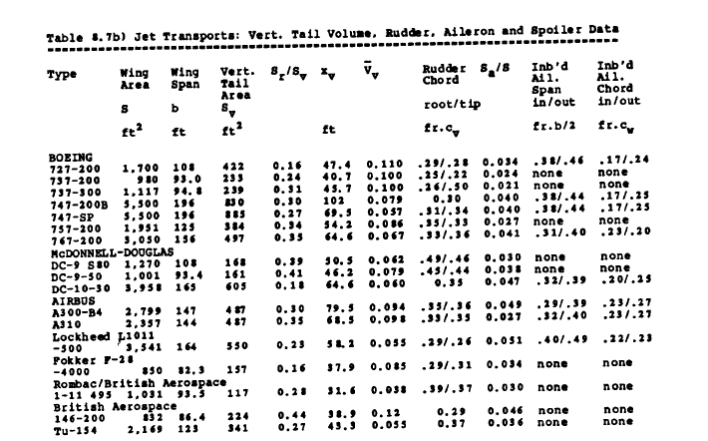

Table 32. Additional Jet Transport Lateral Control Surface Information
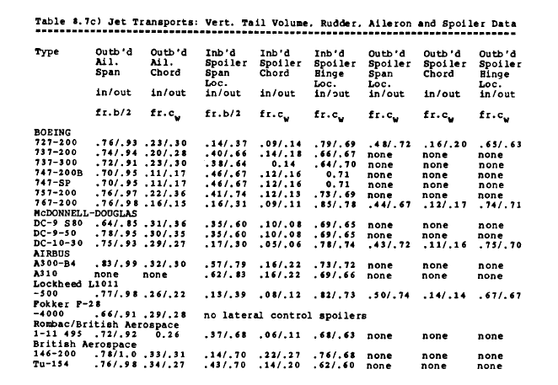

6.5. Drawings
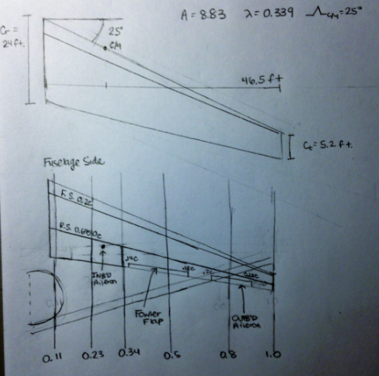
Figure 55. Wing Planform: flap and lateral control layout

6.6. Discussion
The HTA planform and lateral control layout illustrate the wing parameters. The Fowler flaps will be full span, and the spoilers will be used for lateral control. The spoilers will run from 0.4($\frac{b}{2})$to 0.66$\left(\frac{b}{2}\right)$ with 0.14c to 0.18c. The outboard ailerons will run from 0.74$\left(\frac{b}{2}\right)$ to 0.94$\left(\frac{b}{2}\right)$ with 0.20c to 0.28c. Additionally, the drawings demonstrate the span of 93 feet, and the root and tip chord.

6.7. Recommendations and Conclusions

6.7.1. Recommendations
Based on the geometry of the wing and the flight parameters chosen, Fowler flaps are the recommended high lift device that will provide substantial lift. Additionally, the fuel can be stored in the wing without the risk of fire due to lightning strikes since the fuel in the HTA is less than the fuel in the 737-100. The batteries will additionally be suspended below the wing in nacelles, and this may change the aerodynamics surrounding the flaps and the nacelles.

6.7.2. Conclusions
The data in both tables from Roskam, along with pre-existing Boeing 737-100 specifications, provides benchmarks with which to compare the wing parameters. Although wing weight is usually a figure of merit for the thickness ratio, it proved to be a poor basis for the thickness ratio. Using a thickness ratio greater than 0.1 and less than 0.2 proved to provide optimal sweep angles of 25º at the quarter chord, along with a reasonable thickness ratio of 0.124. Additionally. The 25º sweep angle, which is the same as the original 737-100, yielded Λ_{LE}=27.8º , Λ_{TE}= 16.625º, from linear interpolation.
Through the analysis of the Boeing airfoil data, the ${∆C}_{L_{max }}$ was calculated, and the Fowler flaps were found to provide substantial lift, without any leading edge devices. The HTA has requirements for $C_{L_{\max{to} }}=2.25$ and $C_{L_{\max{L} }}=2.73$. The calculations demonstrated that an additional ${∆C}_{L_{max }}$ of 1.25 is needed for takeoff and ${∆C}_{L_{max }}$of 1.77 is needed for landing. Since the Fowler flaps provide an additional ${∆C}_{L_{max }}=2.03$, they are substantial in providing lift.
Other high lift devices could be considered for the HTA. Given the geometry of the wing and the parameters chosen, the Fowler flaps provide adequate lift, and the wing geometry provides adequate storeage for the fuel.

7. Design of the Empennage and the Longitudinal and Directional Controls

7.1. Overall Empennage Design
The empennage design, which was initially introduced in the configuration design chapter is composed of the tail and stabilizing features organized in a tail aft arrangement. The HTA will feature a single vertical tail mounted to the fuselage along with a horizontal stabilizer.
For conventional configurations, the center of mass is generally near wing’s aerodynamic center. This is the point at which the wing’s pitching moment coefficient doesn’t vary with changes in angle of attack. The empennage moment arms, $x_{h}, x_{v}, x_{c}$, will be located so as to create a maximum moment arm relative to the center of gravity (Roskam, Airplane Design Part III: Layout Design of Cockpit, Fuselage, Wing, and Empennage: Cutaways and Inboard Profiles, 2011). Besides creating a large moment arm, the placement of these locations minimizes the area of the empennage. This helps minimize the weight of the aircraft and the drag during flight.
For the HTA, $x_{h}=43.8 ft and x_{v}=40.7 ft.$ The in the table below summarizes the volume coefficients and control surface data.
Table 33. Summary of Comparable Volume Coefficients and Control Surface Data
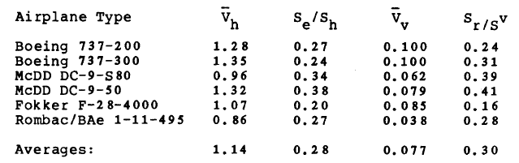
Using comparable data and 737-100 data, the tail areas will be computed using equations 1 and 2) below (Roskam, Airplane Design Part II: Preliminary Configuration Design and Integration of the Propulsion System, 2011).
$S_{h}=\overline{V_{h}}S\overline{c}/x_{h}$ (49)
$S_{V}=\overline{V_{V}}Sb/x_{V}$ (50)
Together, these will compose the horizontal stabilizer and the vertical stabilizer.

7.2. Design of the Horizontal Stabilizer
The horizontal stabilizer area is 401 ft², and was calculated using equation 1:
$S_{h}=\frac{\overline{V_{h}}S\overline{c}}{x_{h}}=\frac{\left(1.28\right)\left(1098\right)\left(12.5\right)}{43.8}=401 ft^{2}.$ Additional parameters of the horizontal stabilizer include the aspect ratio, quarter chord sweep angle, taper ratio, thickness ratio, airfoil, dihedral angle, and incidence angle. The 737-100 model will be used as a reference for these parameters. Therefore, the horizontal stabilizer aspect ratio will be 4.15. The thickness ratio will be 0.12. The horizontal stabilizer will have a 7º dihedral angle, a taper ratio of 0.26, a quarter chord sweep angle of 30º and a variable incidence angle (Aircraft Technical Data and Specifications: Boeing 737-100/200, 2017).
The horizontal stabilizer will span 36 feet and will have a tailplan area of 312 ft² and an elevator area of 70.5 ft². The elevator is 0.3 of the chord at the root and 0.32 of the chord at the tip. The airfoil used is the BAC airfoil by Boeing (Aircraft Technical Data and Specifications: Boeing 737-100/200, 2017).

7.3. Design of the Vertical Stabilizer
The vertical stabilizer, or fin, provides directional stability, and will have an area of $S_{V}=\frac{\overline{V_{V}}Sb}{x_{V}}=\frac{\left(0.1\right)\left(1098\right)\left(93.011\right)}{40.7}=250.9 {ft}^{2}.$ Additionally, using the 737-100 for reference, the design parameters of the vertical stabilizer will be chosen. These include the aspect ratio of 1.64, the quarter chord sweep angle of 35º, a taper ratio of 0.288, a thickness ratio of 0.15, and a 0º incidence angle. Additionally, the fin height of 20 feet and a rudder area of 56 ft². The airfoil used is the BAC airfoil by Boeing (Aircraft Technical Data and Specifications: Boeing 737-100/200, 2017).

7.4. Empennage Configuration Drawings
The figure below consists of the drawings of the empennage arrangement for the HTA. Included in this drawing are the elevator and rudder outlines. All dimensions are in feet and are illustrated below.
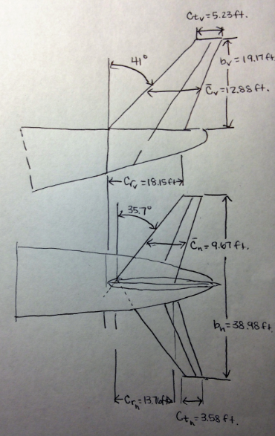
Figure 56. Empennage Configuration (units in feet)

7.5. Empennage Design Evaluation
AAA will be used to analyze the performance of the empennage horizontal and vertical stabilizers. Using the inputs of AP, λ, S, Λ_{c/4}, and the x, y, and z offset values, the output parameters were calculated. This provided the root and tip dimensions, span, mean geometric chord, leading edge and trailing edge sweep angle, and the positions for the mean geometric chord for both the vertical and horizontal tail. The outputs and inputs are presented below.
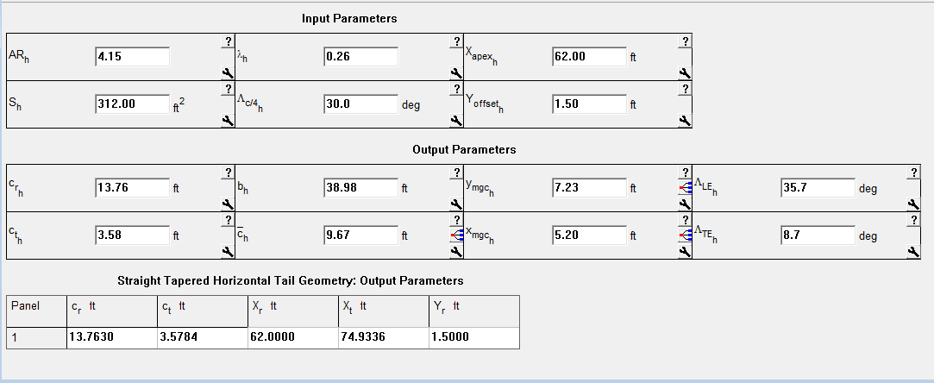
Figure 57. Horizontal Tail Geometry Calculations by AAA
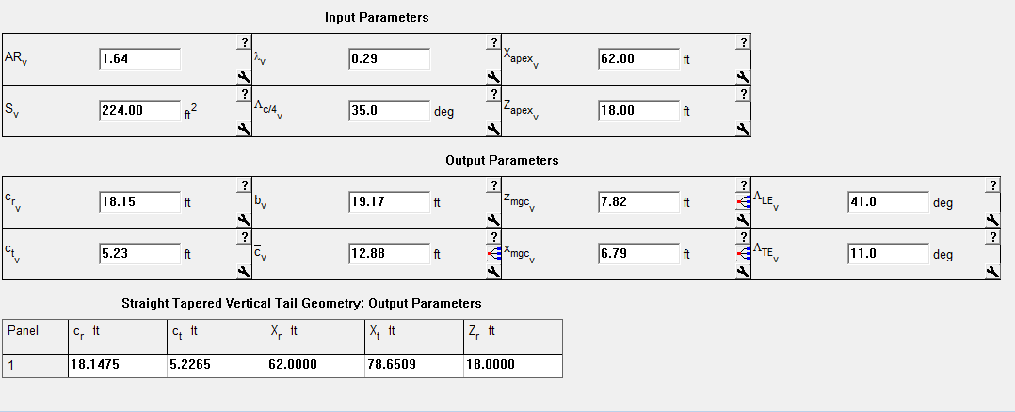
Figure 58. Vertical Tail Geometry Calculations by AAA

7.6. Discussion
Since the use of batteries during various stage of flight will not change the empennage, the 737-100 model was used as a reference for the HTA. This data, along with similar data provided by Roskam, provided the foundation for initial selections for the parameters. Additionally, the parameters chosen are consistent with the control surface ratios provided by Roskam. Thus, $S_{e}/S_{h}=0.27$ for a 737-200 and $S_{e}/S_{h}=0.24$ for a 737-300. Using the 737-100 parameters, $\frac{S_{e}}{S_{h}}=\frac{70.5}{401}=0.18$. This value is lower, but comparable. For the rudder area to vertical stabilizer area, $\frac{S_{r}}{S_{v}}=0.31 and 0.39$ for 737-200 and 737-300, respectively. For the HTA, $\frac{S_{r}}{S_{v}}=\frac{56}{250.9}=0.22$. Again, although this is lower, it is comparable.
AAA additionally calculated very similar values to the original 737-100 aircraft. The tail geometry is consistent with previous aircraft, and will provide adequate stability for the HTA.

7.7. Recommendations and Conclusions

7.7.1. Recommendations
The HTA empennage will be modeled after the 737-100 airplane with slight changes. The moment arms have been estimated at $x_{h}=43.8 ft and x_{v}=40.7 ft$. These locations will be iterated to determine the aerodynamic center that provides the best stability and control.

7.7.2. Conclusions
The tail aft empennage arrangement provides a suitable conventional configuration design for the HTA. With the hybrid plane being modeled after the 737-100, the parameters have been chosen based on the fuel powered model. The distance from the cg to the ac will be established further when exploring the stability and control of the landing gear and may be adjusted, if necessary, after an iterative process. The figures below illustrate how the empennage fits in the aircraft.
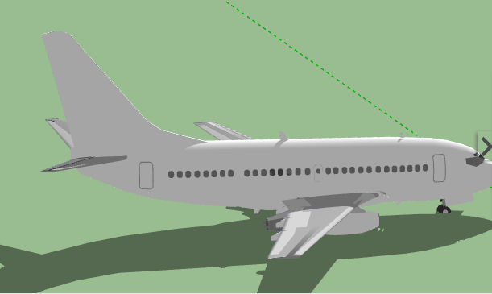
Figure 59. Vertical tail configuration in HTA
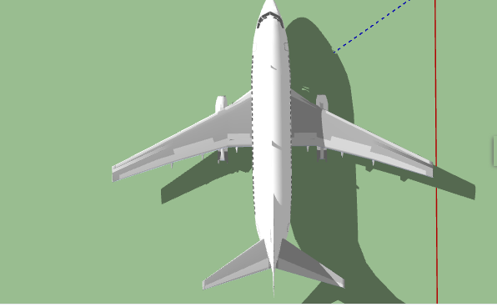
Figure 60. Horizontal tail configuration in HTA

8. Design of the Landing Gear and Weight and Balance Analysis

8.1. Introduction
The landing gear arrangement, previously introduced in the configuration chapter, will consist of retractable conventional tricycle landing gear. The main landing gear will retract into the fuselage, and the nose landing gear will retract into the nose. In order to size the landing gear, the center of gravity will need to be determined. From there, a weight and balance iteration will be performed to determine whether the cg of the proposed design is in the correct location. The cg excursion diagram will be used to illustrate the possible locations of the cg.

8.2. Estimation of the Center of Gravity
The following data consists of the component weight and coordinate data for the Class I component weight estimation Assuming a takeoff weight of 83,000 lbs and the weight fractions from Roskam’s Part V. Component Weight Estimation, the weights and positions are summarized in the table below (Roskam, Airplane Design Part II: Preliminary Configuration Design and Integration of the Propulsion System, 2011).
The zero reference point will be located a distance well to the left and below the airplane. This allows the airplane to change size without changing the reference point. The x-axis will refer to x-coordinates called the fuselage stations (F.S.) and the y-axis coordinates will be referred to as the wing buttock lines (B.L.). For the HTA, the first F.S. point will be at 151 inches, and the first B. L. point will be at 78 inches.
The comcomponent weight and coordinate data for the HTA are summarized in Table 34, below. Note that the aircraft is symmetric, so the y coordinates will all be 0 inches.

Table 34. HTA Component Weight and Coordinate Data
No. | Type of Component | W_{i} (lbs) | x_{i} (in.) | W_{i}x_{i}  (in lbs) | y_{i} (in.) | W_{i}y_{i} (in lbs) | z_{i} (in.) | W_{i}z_{i} (in lbs)
1 | Fuselage Group | 8,549 | 641 | 5,479,909 | 0 | 0 | 248 | 2,120,152
2 | Wing Group | 7,636 | 680 | 5,192,480 | 0 | 0 | 350 | 2,672,600
3 | Empennage Group | 1,992 | 1190 | 2,374,480 | 0 | 0 | 300 | 597,600
4 | Engine Group | 20,950 | 590 | 12,360,500 | 0 | 0 | 140 | 2,933,000
5a | Landing Gear Group:Nose Gear | 500 | 390 | 195,000 | 0 | 0 | 130 | 74,750
5b | Landing Gear Group: Main Gear | 2654 | 710 | 1,884,340 | 0 | 0 | 130 | 345,020
6 | Fixed Equipment Group | 10,707 | 680 | 7,280,760 | 0 | 0 | 200 | 2,141,400
7 | Trapped Fuel and Oil | 142.8 | 690 | 98,532 | 0 | 0 | 215 | 30,702
8 | Crew | 700 | 300 | 210,000 | 0 | 0 | 240 | 168,000
9 | Fuel | 4,500 | 690 | 3,105,000 | 0 | 0 | 430 | 1,935,000
10 | Batteries | 18,000 | 733 | 13,194,000 | 0 | 0 | 120 | 2,160,000
11 | Passengers | 16,800 | 680 | 11,424,000 | 0 | 0 | 200 | 3,360,000
12 | Luggage | 3,000 | 680 | 2,040,000 | 0 | 0 | 200 | 600,000

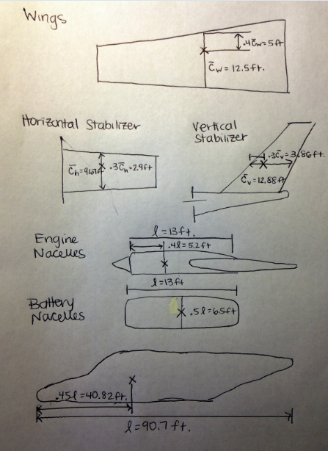
Figure 61. c.g. for various aircraft components
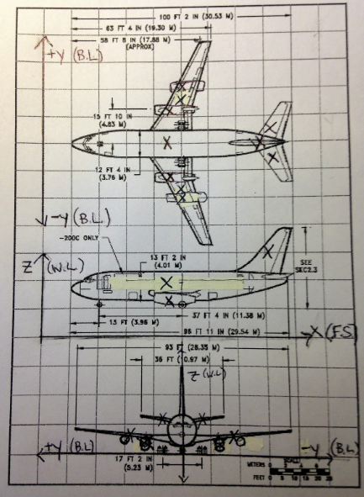
Figure 62. c.g. location for each component on the aircraft
Using the listed c.g. locations for the various components and their individual weights, the c.g. excursion diagram was produced using Excel. The most forward c.g. is located at 46.91 ft. and the most aft c.g. is located at 66.08 ft. Although they have a very wide spread, AAA will be used to check these calculations, and then after the landing gear placement, the weight and balance will be performed again.

Figure 63. c.g. excursion plot produced using Microsoft Excel
Using the 737-200 airplane for comparison, the weight fractions were calculated for the various components. The figure below illustrates the results from AAA.
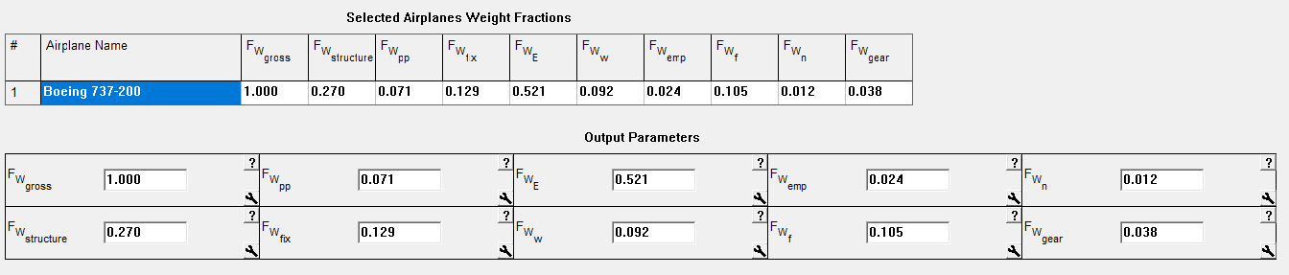
Figure 64. Weight fractions referenced from the 737-200 from AAA
Using the empty weights, the c.g. positions for each of the empty weight components can be determined, as well as the c.g. of the structure as a whole. These results, from AAA, are summarized as follows.
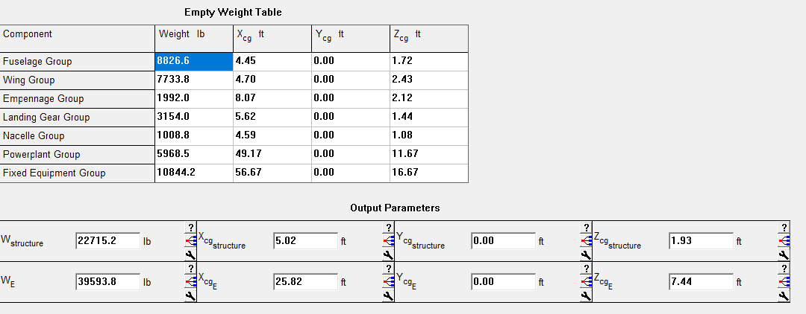
Figure 65. c.g. locations produced using AAA
Using the outputted parameters as inputs, the c.g. of the HTA along with the c.g. locations for each component.

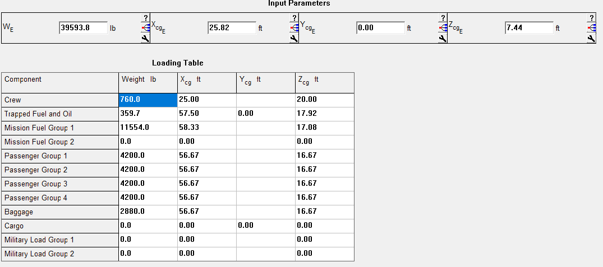
Figure 66. c.g. location for MTOW aircraft
From here, the c.g. excursion diagram for the x and z directions can be plotted. The following information was used to plot the c.g. excursion diagram.
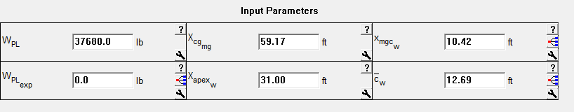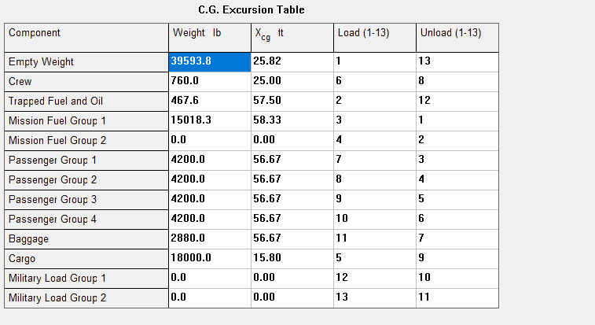
Batteries

Figure 67. Loading Table from AAA for x-direction c.g. excursion diagram
Using the loading table and the valculated c.g. values, the x c.g. excursion plot illustrates the possible c.g. locations depending on the loading scenario.
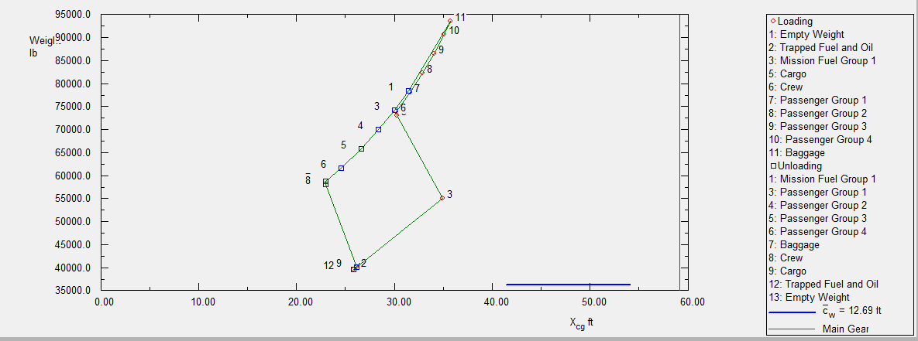
Figure 68. c.g. excursion diagram (x-direction)
The plot illustrates a variation in c.g. with the most forward c.g. being located at 22.9 ft and the most aft c.g. being located at 35.7 ft. Note that the c.g. is left of the main landing gear, which indicates that the HTA will not tip over with the current loading and unloading scenarios. For reference, the z-direction c.g. excursion diagram has also been plotted. Note that for the loading and unloading scenarios, the cargo represents the batteries.


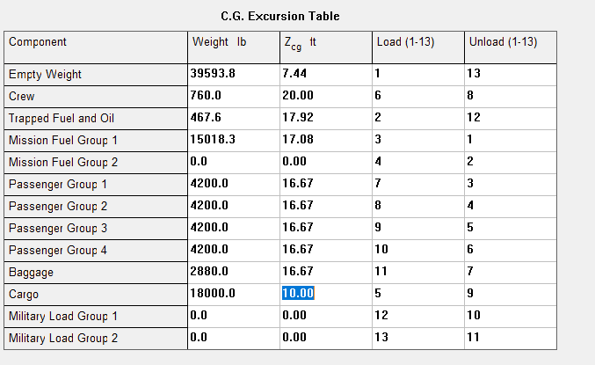
Batteries
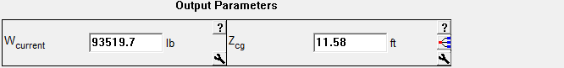
Figure 69. Loading Table from AAA for z-direction c.g. excursion diagram
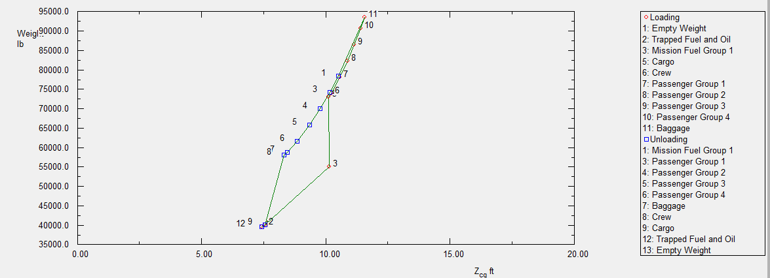
Figure 70. c.g. excursion diagram (z-direction)

8.3. Landing Gear Design
For the landing gear design, the following characteristics will be determined: number and size of tires, length and diameter of struts, preliminary disposition, and retraction feasibility. The HTA will have retractable tricycle landing gear. Preliminary decisions on placement of the wheels and struts will be made, and the placements will be checked to see that they meet the tip over criteria and ground clearance criteria.
The main landing gear must be behind the aft most c.g. Based on the c.g. excursion diagram, the most aft c.g. is located at 39.63 ft. By constructing a line parallel ot the sweep of the fuselage and a 7-15 degree angle to find the optimal ground clearance, the intersection of these two is the location of the main landing gear. This location, at 47.33 ft, which is the same as the location of the Boeing 737-100 model, is aft of the c.g. Thus, it meets the tip-over criteria.
To meet the ground clearance criteria, the main gear struts will be placed under the fuselage. The selection of the strut length will impact the weight of the landing gear, ground clearance of the aircraft, the tip-over characteristics, and stability during ground operation.
To determine the maximum static load per strut, the following equations will be used:
$P_{n}=\frac{W_{TO}l_{m}}{l_{m}+l_{n}}$ (51)
$P_{m}=(W_{TO}l_{n})/n_{s}(l_{m}+l_{n})$ (52)
Note that $P_{n} and P_{m},$ are the maximum nose wheel strut loading and main gear strut loading, and $l_{m} and l_{n}$, are the distance from the c.g. to the main landing gear and nose gear, respectively. For the HTA, the maximum load per strut for the main landing gear is 32,833 lbs, and the maximum load per strut for the nose gear is 27,852 lbs.
There will be two nose wheels and four main wheels. The nose wheel tires have a diamer of 24 inches and a wheel tread width of 7.75 inches. The main wheel tires have a diameter of 40 inches and a wheel tread width of 14.5 inches (Brady, 1999). Boeing oleo pneumatic shock aborbers provide shock absorption. One main gear strut and one nose gear strut dampen the vertical oscillations felt upon landing.
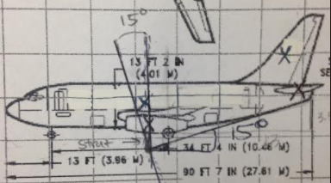
Figure 71. Landing gear and strut placement
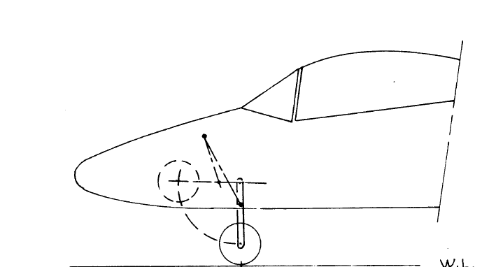
Figure 72. Nose gear retraction
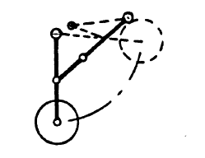
Figure 73. Stick Diagram for main gear retraction
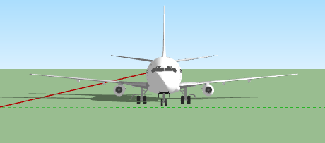
Figure 74. Illustration of the two nose tires and four main tires for the landing gear.


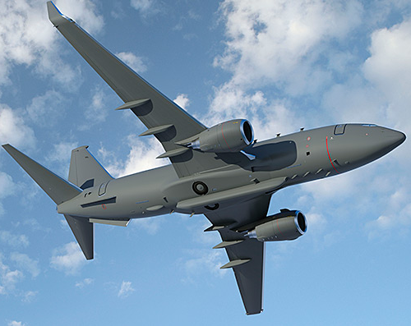
Figure 75. Landing Gear retracted into fuselage

8.4. Weight and Balance
Since the landing gear placement, at 47 feet from the nose, is aft of the most aft c.g., the weight and balance does not need to be repeated. The location of the main landing gear correlates with the location of the main landing gear in the 737-100 model.

8.5. Conclusion
Compared to the 737-100 model, the c.g. excursion diagram demonstrated the change in c.g. location due to the addition of the batteries. The location of the batteries did not change the location of the main landing gear, and, as a result, the HTA will not tip over in any loading scenario. The landing gear can support the weight of the plane, with the added weight due to the batteries, and the landing gear retracts directly into the fuselage.

9. Stability and Control Analysis

9.1. Introduction
The stability and control analysis will be performed by following Roskam’s steps in Airplane Design Part II. This will allow the determination of the stability and control characteristics of the HTA. These characteristics include the static longitudinal stability, static directional stability, and minimum control speed with one engine out (Roskam, Airplane Design Part II: Preliminary Configuration Design and Integration of the Propulsion System, 2011)
Stability is the tendency of an object to return to equilibrium when displaced (Crawford, 2009). Static stability involves an object’s initial tendency to return to equilibrium upon initial displacement. For aircraft, this requires a balance because the greater an aircraft’s static stability, the greater its resistance in maneuvering. The center of gravity, or c.g., strongly determines the longitudinal static stability. Moving the c.g. aft reduces static stability and increases maneuverability.
Aircraft can have inherent stability, in which the stability is built into the aircraft’s design, or de facto stability, where control systems provide feedback and provide stability requirements. Some aircraft have relaxed stability. This type of stability involves the aircraft changing its attitude and bank angle on its own. This, along with stability augmentation devices, allows for better cruise performance and better maneuverability at high altitudes. Many jet transport aircraft have relaxed stability. The HTA will also feature relaxed stability.

9.2. Static Longitudinal Stability
The longitudinal X-plot illustrates the rate at which the c.g. moves aft as a function of the horizontal tail area and the rate at which the aerodynamic center, or a.c., moves aft as a function of the horizontal tail area. This will be plotted for the HTA, which features a conventional configuration.
The a.c. leg of the plot will be calculated using the following equations:
${{\overline{x}}_{ac}}_{A}=\frac{\left[{\overline{x}}_{ac_{wf}}+\frac{\left\{{C_{L_{α}}}_{h}\left(1-\frac{dε_{h}}{dα}\right)\left(\frac{S_{h}}{S}\right){{\overline{x}}_{ac}}_{h}-{C_{L}}_{α_{c}}\left(1+\frac{dε_{c}}{dα}\right){{\overline{x}}_{ac}}_{c}\left(\frac{S_{c}}{S}\right)\right\}}{C}+C_{L_{α_{wf}}}\right]}{F}$ (53)
$F=\frac{\left[1+{( C}_{L_{α_{h}}}\left(1-\frac{dε_{h}}{dα}\right)\left(\frac{S_{h}}{S}\right)+C_{L_{α_{c}}}\left(1+\frac{dε_{c}}{dα}\right)\left(\frac{S_{c}}{S}\right)\right)] }{C_{L_{α_{wf}}}}$ (54)
The figure below illustrates how to find the geometric quantities to perform these calculations. (Roskam, Airplane Design Part II: Preliminary Configuration Design and Integration of the Propulsion System, 2011)
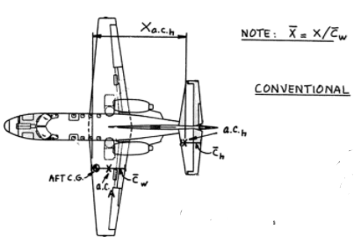
Figure 76. Geometric quantities for aircraft calculations

Figure 77. Longitudinal X-Plot for the HTA
The longitudinal x plot illustrates that as the tail plane area is increased, the c.g. moves aft, and the a.c. also moves aft, but more slowly. The 10% difference between the a.c. and c.g. location is the optimal area of the horizontal stabilizer.
The 10% static margin yields a horizontal stabilizer area of 380-401 ft². These results match the results from the wing design, where the horizontal stabilizer area was sized to 401 ft². This yields a slightly larger wing area than the 737-100, but this is likely due to the extra battery weight being suspended below the wings.
The HTA has a level of instability of $0.085{\overline{c}}_{w}$, which has been chosen based on the instability levels of comparable jet transport. Using the aft c.g. leg of the longitudinal X-plot, the longitudinal stability augmentation system must generate a change in static margin of $∆SM=0.085+0.05=0.135$, where the minimum static margin of ${\overline{X}}_{cg}-{\overline{X}}_{ac}=0.05$ or 5%. The empennage area follows from these calculations. The original horizontal tail area of 401 ft² will be compared with the horizontal tail area obtained from the longitudinal X-plot. Since they are the same, 401 ft² will remain the design size.

9.3. Static Directional Stability
The directional X-plot illustrates the change in directional stability for various vertical tail areas.

Figure 78. HTA Directional X-Plot
The desired de facto level of directional instability is $C_{n_{β}}=0.0010$. From the plot, $C_{n_{β}}=-0.001$ and there is a difference of 0.002. The sideslip feedback system must support this difference. To compute the required sideslip to rudder feedback gain, the following equations will be used.
$k_{β}=\frac{∆C_{n_{β}}}{C_{n_{δ_{r}}}}$, with $k_{β}<5 deg/deg$ (55)
$∆C_{n_{β}}=0.0010-C_{n_{β}}$ (56)
As a result, $k_{β}=\frac{∆C_{n_{β}}}{C_{n_{δ_{r}}}}=\frac{0.0010-0.002}{-0.0012 }=0.833 deg/deg$. This is acceptable, and the vertical tail is not critical for the HTA.

9.4. Minimum Control Speed with One Engine Inoperative
The critical one engine out yawing moment can be determined from the following equation.
$N_{t_{crit}}=T_{TO_{e}}Y_{t}$ (57)
In this equation $Y_{t}$is the lateral thrust moment arm of the most critical engine, which equals 17.5 ft. $T_{TO_{e}}$ is the thrust required by the engine at takeoff. The geometry for these calculations is illustrated in the figure below.
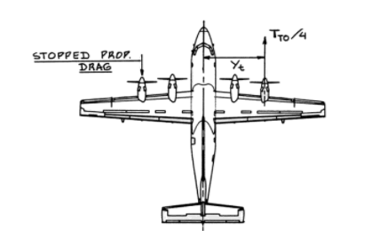

Figure 79. Geometry for one engine out V_{mc} calculations
Using the geometry and the thrust at takeoff, $N_{t_{crit}}=T_{TO_{e}}Y_{t}=21,000lb ∙17.5 ft=367,500 ftlbs$. For a jet transport with a low bypass ratio, $N_{D}=0.15N_{t_{crit}}$, and thus $N_{D}=55,125 ft lbs$. Therefore, the critical engine out yawing moment is 55,125 ft lbs.
The following equations can be used to calculate the maximum allowable $V_{mc}$ and the rudder deflection required to hold the engine out condition at $V_{mc}$. The rudder deflection angle should not exceed 25 degrees. If it does, the vertical tail needs to be resized or the rudder needs to be resized.
$V_{mc}=1.2 V_{s}$ (58)
$δ_{r}=(N_{D}+N_{t_{crit}})/{\overline{q}}_{mc}SbC_{n_{δ_{r}}}$ (59)
Using the lowest stall speed, which is the stall speed at landing, $V_{mc}$is calculated to be $1.2 V_{s_{L}}=1.2\left(54\right)=64.8 kts.$ From the vertical tail and rudder geometry, the control power derivative is equal to $C_{n_{δ_{r}}}=-0.245 rad^{-1}$. Thus, at $V_{mc}=64.8 kts$, the rudder deflection angle is calculated to be $δ_{r}=\frac{T_{TO_{e}}Y_{t}}{-\overline{q}SbC_{n_{δ_{r}}}}$.
$δ_{r}=(N_{D}+N_{t_{crit}})/{\overline{q}}_{mc}SbC_{n_{δ_{r}}}=(55,125 ft lbs+367,500 ft lbs)(.5{\left(7.38*{10}^{-4}\right)(109.37ft/s)}^{2}\left(250 ft^{2}\right)\left(93.011 ft\right)\left(-\frac{0.0012}{deg}\right)=43.6º$. This is a large angle, and the size of the vertical tail should be increased and the calculation performed again.

9.5. Empennage Design-Weight and Balance- Landing Gear Design- Longitudinal Static Stability and Control Check
The horizontal stabilizer area meets the 10% static margin difference, and the horizontal stabilizer does not need to be resized. The vertical stabilizer needs to increase in order to provide a smaller rudder deflection angle.

9.7. Conclusion
Overall, the sizing of the HTA is still comparable to the 737-100 model. The horizontal stabilizer was increased to 401 ft², as determined in the wing sizing chapter, and this sizing will be maintained based on the longitudinal X-plot.
The critical one engine out yawing moment has been determined to be 55,125 ft lbs, with a minimum control speed of 64.8 kts.
Rudder deflection should not exceed 25 degrees, but was calculated to be 43.6$°$, whichi necessitates an increase in size of the vertical stabilizer. This will be explored further during the Class II sizing.

10. Drag Polar Estimation

10.1. Introduction
A drag polar is the relationship between the airplane’s lift and its drag, where the lift coefficient depends on the drag coefficient. The results of the HTA’s comparison of its lift and drag coefficients will be examined and displayed in a plot.
To perform the drag polar estimation, Roskam’s method will be utilized. This involves eight steps. Initially, the wetted area of the airplane components will be estimated. The airraft’s components will be analyzed individually. These include the fuselage, wings, empennage, and engine and battery nacelles. Once these have been computed, the equivalent parasite area will be calculated. From there, the compressibility drag increment will be found along with the flap drag increment, and landing gear drag increment. The drag polars for cruise, takeoff, and landing will be constructed, and the L/D critical values will be determined from the drag polars.

10.2. Airplane Zero Lift Drag
The following equations will be used to compute the wetted areas for each component.
${S_{wet}}_{plf}=2S_{exp.plf}\{1+0.25{\left(\frac{t}{c}\right)}_{r}(1+τλ)/(1+λ) .$ (60)
$τ={\left(\frac{t}{c}\right)}_{r}/{\left(\frac{t}{c}\right)}_{t}$ (61)
$λ=c_{t}/c_{R}$ (62)
${S_{wet}}_{fus}=πD_{f}l_{f}{\left(1-\frac{2}{λ_{f}}\right)}^{\frac{2}{3}}(1+1/λ_{f}^{2})$ (63)
$λ_{f}=l_{f}/D_{f}$ (64)
${S_{wet}}_{fan}=l_{n}D_{n}\{2+\frac{0.35l_{1}}{l_{n}}+\frac{0.8l_{1}D_{h1}}{l_{n}D_{n}}+\frac{1.15\left(1-\frac{l_{1}}{l_{n}}\right)D_{ef}}{D_{n}}\}$ (65)
$S_{wet_{gen}}=πl_{g}D_{g}{\left[1-\left(\frac{1}{3}\right)\left(1-\frac{D_{eg}}{D_{g}}\right)\left\{1-0.18\right)(\frac{D_{g}}{l_{g}}\right)}^{5/3}\}]$ (66)
${S_{wet}}_{plug}=0.7πl_{p}D_{p}$ (67)
It’s important to note that the wings, empennage, and nacelles usually intersect the fuselage or a nacelle, so the intersection of the wetted area will be subtract. In order to estimate the wetted area of the batteries, the calculated wetted area of the engine nacelles will be multipled by a factor of 1.5.
The wetted areas are as follows:
Table 35. Wetted Area Summary
Component | Wetted Area (ft²)
Wing | 2,367
Intersection of wing and fuselage | -200
Vertical Tail | 463
Horizontal Tail | 642
Engine Nacelles | 455
Battery Nacelles | 455
Fuselage | 4,000
TOTAL WETTED AREA | 8,182

The wetted area compares fairly with the wetted area of a jet transport that weights approximately 90,000 lbs and has a wetted area of $6,000ft^{2}$, as illustrated in the graph below (Roskam, Airplane Design Part II: Preliminary Configuration Design and Integration of the Propulsion System, 2011). The HTA has a larger wetted area due to the battery nacelles. This added area may impact the cruise L/D and the corresponding fuel consumption.
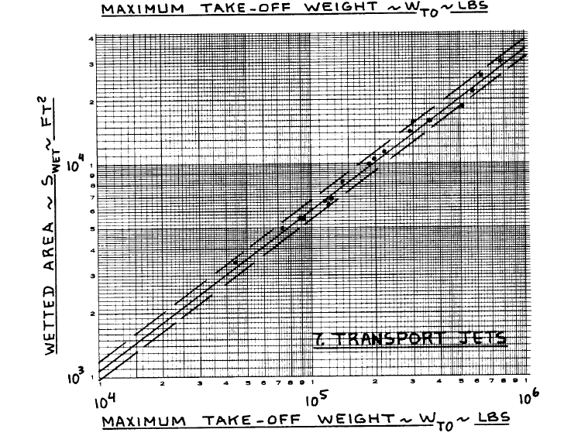
Figure 80. Maximum takeoff weight vs. wetted area for jet transports
Using the plot below, the equivalent parasite area of the HTA is approximately 22 ft².
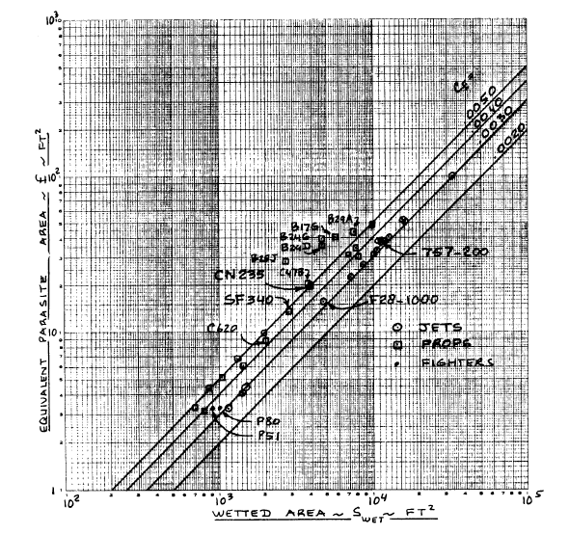
Figure 81. Wetted area vs. equivalent parasite area

10.3. Low Speed Drag Increments and Compressibility Drag
The clean zero lift drag coefficient at low speed is $C_{D_{0}}=\frac{f}{s}=\frac{22}{1098}=0.02$. Using the figure below, the compressibility drag increment is about 0.0005. Due to this low value the cruise drag does not need to be re-evaluated. The cruise value of the zero lift drag coefficient can be summarized as $C_{D_{0}}=0.0005+ 0.02=0.0205$ . The minimum lift to drag ratio can be calculated and then compared to the previously determined L/D.
Originally, $C_{D_{0}}$ was estimated to be:
Table 36. ${C_{D}}_{0}$ summary
Configuration | $$C_{D_{0}}$$
Clean | 0.014
Takeoff flaps | 0.03
landing flaps | 0.08
gear down | 0.02

Using the clean $C_{D_{0}}$value and the newly calculated $C_{D_{0}}=0.0205$, the (L/D)_{max} values are equal to 18.27 and 18.05, respectively. Based on the sensitivity calculation, for each increase in L/D, there is a decrease of 856 lbs. Thus, for a change of 0.224, the weight will increase 192 lbs, which is not substantial enough to change the structure.
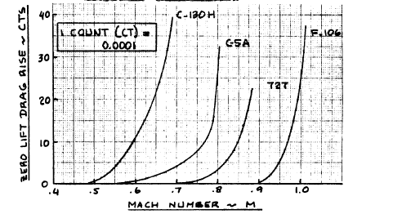
Figure 82. Typical Compressibility Drag Behavior

10.3.1. High Lift Device Drag Increments for Takeoff and Landing Gear Drag
Table 37. First Estimates for Drag with flaps and gear down
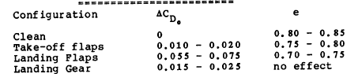
The values in table 2 will be used to produce the drag polar plot based on the change in $C_{D_{0}}$ for various configurations, including clean, takeoff flaps, landing flaps, and landing gear.

10.5. Airplane Drag Polars
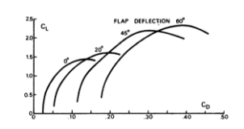
Figure 83. Low speed polars for transport
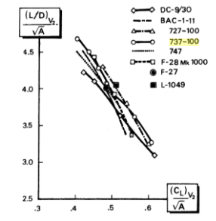
Figure 84. L/D Ratios

10.6. Discussion
The HTA will not be resized. Although it is heavier than anticipated, it is within 10%, and was expected, due to the battery weight. A more thorough estimation would probably include subtracting more overlapping wetted areas, as well as more accurately sizing the battery nacelles.

10.7. Conclusion
The HTA is ready to commence Class II sizing following an analysis of the economic, safety, and environmental tradeoffs.

11. Environmental and Economic Tradeoffs

11.1. Important Design Parameters
The HTA three view drawing that reflections the iterations of the design is illustrated in
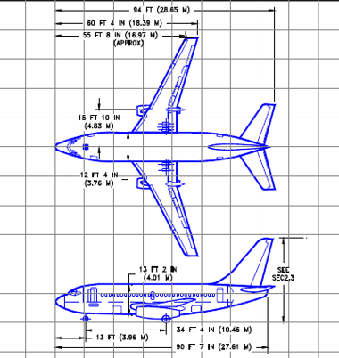
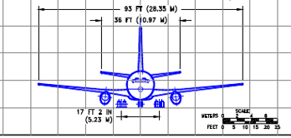
Figure 85. 3-view of HTA
The most important feature of this aircraft is the implementation of lithium ion batteries for battery powered cruise, loiter, descent, and landing. These batteries changed the weight analysis and overall sizing of the aircraft, but many of the features, such as the fuselage design, remained the same as the original 737-100. The following will summarize economic and environmental tradeoffs, as well as safety tradeoffs for the HTA.

11.2. Recommendations
To further support this design concept, more research needs to be done for the overall battery weight and volume sizing. The sizing summarized in the reports reflected conceptual designs and sizings that have been done for both similar sized aircraft, such as Boeing’s conceptual SUGAR designs, and small aircraft, through the work of Riboldi. Additionally, more research could be done with lithium ion batteries to determine if the battery specific energy could be increased further. In terms of design, the vertical stabilizer size needs to increase as well. This is to support a lower rudder deflection angle.

11.2.2. Einvironmental/Economic Tradeoffs

12. Preliminary Design Sequence II
This chapter commences the Class II sizing of the HTA. The systems that have the largest impact on the HTA include the propulsion system, specifically engines and the fuel and battery power to support the system; aerodynamic control systems, including the ailerons, elevator, and rudder; and aircraft structural system, which include the wings, fuselage, horizontal tail, and vertical tail. These systems have a significant impact on the empty weight of the aircraft, and will be thoroughly analyzed during the weight and balance analysis. Additionally, a ghost view of the aircraft, presented in Figure 80, illustrates the aircraft systems and their current locations.

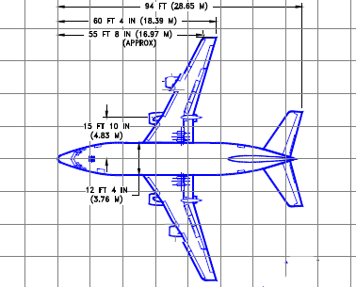
Figure 86. Ghost View of Aircraft
Initially, a V-n diagram will be constructed, and then the Class II weight and balance analysis will be performed. From there, the Classs II stability and control analysis will be conducted, followed y the Class II drag polar analysis. The power computation and installation will follow, analyzing power for the aircraft along with factors that change the power output, such as altitude. Finally, a cost analysis will be performed to predict the acquisition cost of the airplane. This will be performed based on statistical data and equations for cost.

13. V-n Diagram
A V-n diagram is a graph of the velocity vs. load factor, which illustrates the aircraft performance limits. These limits include the design ultimage load factors and the speed to which each of the airplane’s parts have been designed (Roskam, Airplane Design Part V: Component Weight Estimation, 2003). This will be used with the Class II weight estimation and will be considering the case where flaps are up.
For the calculations, the following nomenclature will be used: V_{C} =design cruise speed, V_{D}=design diving speed, V_{M} =design maneuvering speed, V_{S}=+1g stall speed or minimum speed at which airplane is controllable, and V_{B}= design speed for maimum gust intensity.

13.1. Calculation of V_{S}
To determine the minimum controllable speed of the FAR 25 aircraft, the following equation will be used: (Roskam, Airplane Design Part V: Component Weight Estimation, 2003)
$V_{S}={\left\{\frac{2\left(\frac{GW}{S}\right)}{ρC_{N_{max}}}\right\}}^{1/2}$ (68)
Note that GW is the flight design gross weight, measured in lbs; S is the wing area in square feet; the air density is measured in slugs/cubic feet; and $C_{N_{max}}$ is defined as:
$C_{N_{max}}$=${\left\{{\left(C_{L_{max}}\right)}^{2}+{\left(C_{D_{at {C_{L}}_{max}}}\right)}^{2}\right\}}^{1/2}$ (69)
Another way to calculate $C_{N_{max}}$ is using the following:
$C_{N_{max}}=1.1C_{L_{max}}$ (70)

Solving these equations gives $C_{N_{max}}=1.56$ and $V_{S}=129.8$ kts.

13.2. Calculation of V_{C}
The design cruise speed must be greater than the design speed for maximum gust intensity in the event that there are severe atmospheric turbulences that could cause speed increases. To determine V_{B}, consider the intersection of the $C_{N_{max}}$ line and the V_{B} gust line. The value of V_{B} may not be less than the value at the intersection. From there, using the equation below, V_{C}=290 kts.
V_{C}$≥V_{B}+43 kts$ (71)

13.3. Calculation of V_{D}
To calculate the design driving speed, the following equation will be used:
$V_{D}≥1.25V_{C}$ (72)
As a result, V_{D}$≥$368.75 kts.

13.4. Calculation of V_{M}
The design maneuvering speed is given by the following condition:
$V_{M}≥V_{S_{1}}{{(n}_{lim})}^{\frac{1}{2}}$ (73)
Therefore, $V_{M}=205.23 kts$. The limit maneuvering load factor at V_{C} depends on the more critical requirement of either the positive limit maneuvering load factor or the gust load factor lines. The positive maneuvering load factor, $n_{\lim_{pos}}.$Where the following equation determines the positive limit maneuvering load factor.
$n_{\lim_{pos}}≥2.1+\left\{\frac{24,000}{W+10,000}\right\}$ (74)
The only exception to this is that the limit maneuvering load factor must be greater than or equal to 2.5 at all times, but not greater than 3.8 at the takeoff weight. Thus, although $n_{\lim_{pos}}$ is equal to 2.4, following the exception, $n_{\lim_{pos}}$=2.5. The negative maneuvering load factor has two specifications. This value is greater than or equal to -1 up to the design cruise velocity and from the cruise speed design to the the design diving speed, the negative maneuvering load varies linearly.
To determine the negative stall speed line, the following equations will be used:
$V_{S_{neg}}={\left\{\frac{2\left(\frac{GW}{S}\right)}{ρC_{N_{\max_{neg}}}}\right\}}^{1/2}$ (75)
$C_{N_{\max_{neg}}}$=${\left\{{\left(C_{{L_{max}}_{neg}}\right)}^{2}+{\left(C_{D_{at {{C_{L}}_{max}}_{neg}}}\right)}^{2}\right\}}^{1/2}$ (76)
$C_{N_{\max_{neg}}}=1.1C_{{L_{max}}_{neg}}$ (77)
It will be assumed that $C_{{L_{max}}_{neg}}=-1.0$, from similar transport aircraft. As a result, $C_{{L_{max}}_{neg}}=-1.1$ and ${V_{S}}_{neg}=$154 kts.
The design maneuvering speed depends on the construction of the gust load factor lines if they are more critical. Thus the derived gust velocities will be determined. To plot the gust lines, the following equations will be used (Roskam, Airplane Design Part V: Component Weight Estimation, 2003).
$n_{lim}=1+\left(K_{g}U_{de}VC_{l_{α}}\right)/(498GW/S)$ (78)
$K_{g}=0.88μ_{g}/(5.3+μ_{g})$ (79)
$μ_{g}=2(\frac{GW}{S})/(ρ\left(mgc\right)gC_{l_{α}})$ (80)
In these equations, $K_{g}$ is the gust alleviation factor, and the gust load factor for the lines is defined using $n_{lim}$. Note that V is the true airspeed, and that is the variable. Since $n_{lim}$ also depends on $U_{de}$, those values, for each of the gust lines, for $V_{B}, V_{C},$and $V_{D}$, can be determined using the equations below (Roskam, Airplane Design Part V: Component Weight Estimation, 2003).
$V_{B_{U_{de}}}=\left\{\begin{aligned}66 fps for 0≤h≤20,000 ft \\ 84.67-0.000933h for 20,000≤h≤50,000 ft \end{aligned} \right.$ (81)
$V_{C_{U_{de}}}=\left\{\begin{aligned}50 fps for 0≤h≤20,000 ft \\ 66.67-0.000833h for 20,000≤h≤50,000 ft \end{aligned} \right.$ (82)
$V_{D_{U_{de}}}=\left\{\begin{aligned}25 fps for 0≤h≤20,000 ft \\ 33.34-0.000417h for 20,000≤h≤50,000 ft \end{aligned} \right.$ (83)
Assuming a cruise height of 35,000 feet, the gust lines in Figure 82, below, were graphed based on the equations:
$V_{B}=1+0.004835V$ (84)
$V_{C}=1+0.003487V$ (85)
$V_{D}$=1+0.001742V (86)
The negative gust lines had negative slopes, but still started at 1.

13.5. V-n Maneuver Diagram and V-n Gust Diagram
The following graphs summarize the design limits, by illustrating the V-n Maneuver Diagram and the V-n Gust Diagram for the HTA.

Figure 87. V-n Maneuver Diagram

Figure 88. V-n Gust Diagram
According to the diagrams in Figure 81 and Figure 82, the positive load factor that can be safely achieved at varying airspeeds ranges from 0 to 2.5, while the negative load factor cannot go below -1. Any velocity and load factor combination that lies outside of the line would result in a stall; whereas, any point inside the lines is within the flight envelope, and is possible. These diagrams were constructed assuming symmetrical loading. This chart has been plotted for 35,000 feet, but can be plotted at various altitudes to illustrate the loading factor achieveable. The gust lines fall within the maneuvering V-n diagram.

14. Class II Weight and Balance
From the Class I analysis, the following weights are already known: payload, crew, fuel, batteries, trapped fuel and oil, and engine weight. The remaining weights will need to be estimated. The weight of the structure consists of the wing, fowler flaps, empennage, fuselage, nacelles, and landing gear. The weight of the powerplant consists of the engines, fuel system, propulsion system, accessory drives, and thrust reversers. The fixed equipment weight consists of flight controls, electrical system, instrumentation, avionics, electronics, airconditioning, pressurization syste, de-icing system, oxygen, APU, furnishings, baggage and cargo handling, operational items, and paint. Equations used in Roskam’s fifth volume will be used to compute the weights of the structure, power, and fixed equipment. From there, the Class II empty weight will be compared to the Class I empty weight. Iterations will be performed if there is a discrepancy between the two weights.

14.1. Class I Weights
The following table summarizes the known weight values from the Class I sizing.

Table 38. Class I Weights
Item | Nomenclature | Weight (lbs)
payload | W_{pl} | 19,680
Crew | W_{crew} | 820
Fuel | W_{F} | 4,140
Trapped Fuel and Oil | W_{tfo} | 150
Batteries | W_{bat} | 10,300

14.2. Weight Estimate Calculations

14.2.1. Structural Weight
The structural weight, $W_{struct}$, consists of the wing, W_{w}, fowler flaps, empennage, W_{emp}, fuselage, W_{fus}, nacelles, W_{n}, and landing gear, W_{g.} Both the GD Method and the Torenbeck method will be used to compute the weight of the wing. Both methods, which can be used for transport aircraft, consider the weight of normal high lift devices and ailerons.

14.2.1.1. Wing Weight
The GD method will use the equation, below, where the maximum Mach number at sealevel should be between 0.4 to 0.8 and the maximum wing thickness ratio should range from 0.08 to 0.15 (Roskam, Airplane Design Part V: Component Weight Estimation, 2003). The HTA cruises at Mach 0.75 and has a thickness ratio fo 0.124. As a result, the GD Method can be applied for estimation and the equation can be used.
$W_{w}=\left\{0.00428\left(S^{0.48}\right)\left(A\right){\left(M_{H}\right)}^{0.43}{\left(W_{to}n_{ult}\right)}^{0.84}λ^{0.14}\right\}/\left[{\left\{100{\left(\frac{t}{c}\right)}_{m}\right\}}^{0.76}{\left\{cosΛ_{\frac{1}{2}}\right\}}^{1.54}\right]$ (87)
Additionally, the aircraft meets specifications for the Torenbeek sizing, as it is a transport with a take-off weight greater than 12,500 lbs. The following equation presents Torenbeek’s method (Roskam, Airplane Design Part V: Component Weight Estimation, 2003).
$W_{w}=00017W_{MZF}(b/{\cos\left(Λ_{\frac{1}{2}}\right)}^{0.75}(1+{\left(\frac{6.3\cos\left(Λ_{\frac{1}{2}}\right)}{b}\right)}^{0.5}\left(n_{ult}^{0.055}\right){\left(\frac{bs}{t_{r}W_{MZFcos}Λ_{\frac{1}{2}}}\right)}^{0.3}$ (88)
The GD Method gives an estimation of 4,872 lbs, and the Torenbeek Method gives an estimation of 8,038. The Class I sizing provided an estimate of 7,636 lbs. Averaging the three weights gives 6,849 lbs. However, considerations must be made for the number of engines and Fowler flaps. With 2 suspended engines and 2 suspended battery nacelles, the weight will initially be reduced by 10%, and with the Fowler flaps, the weight is increased by 2%. The resulting Class II estimate of the wing weight is 6,287 lbs.

14.2.1.2. Empennage Weight
The Empennage consists of the sum of the horizontal tail and vertical tail. For commercial transport jets, like the HTA, the GD Method and the Torenbeek Method will be applied to estimate. From there, comparisons will be made to the Class I estimate and a final Class II estimate will be established.
Using the GD Method, the horizontal tail and vertical tail can be estimated using the following two equations (Roskam, Airplane Design Part V: Component Weight Estimation, 2003).
$W_{h}=0.0034{{(\left(W_{to}n_{ult}\right)}^{0.813}{\left(s_{h}\right)}^{0.584}{\left(\frac{b_{h}}{t_{r_{h}}}\right)}^{0.033}{\left(\frac{mgc}{l_{h}}\right)}^{0.28} )}^{0.915 }$ (89)
$W_{v}=0.19{{(\left(1+\frac{z_{h}}{b_{v}}\right)}^{0.5}{\left(W_{to}n_{ult}\right)}^{0.363}{\left(S_{v}\right)}^{1.089}{\left(M_{H}\right)}^{0.601}{\left(l_{v}\right)}^{-0.726}{\left(1+\frac{S_{r}}{S_{v}}\right)}^{0.217}{\left(A_{v}\right)}^{0.337}{ \left(1+λ_{v}\right)}^{0.363}{\left(cosΛ_{\frac{1}{4}}\right)}^{-0.484})}^{1.014}$ (90)
Torenbeek’s Method involves the following equations (Roskam, Airplane Design Part V: Component Weight Estimation, 2003).
$W_{h}=K_{h}S_{h}(3.81{\left(S_{h}\right)}^{0.2}V_{D})/{(1000\cos{Λ_{{\frac{1}{2}}_{h}})}}^{\frac{1}{2}})-0.287$ (91)
$W_{v}=K_{v}S_{v}\left(3.81{\left(S_{v}\right)}^{0.2}V_{D}\right)/{(1000\cos{Λ_{{\frac{1}{2}}_{v}})}}^{\frac{1}{2}})-0.287$ (92)
For fixed incidence stabilizers, $K_{h}=1$, and for fuselage mounted horizontal tails, $K_{v}=1$.
The GD Method yields a horizontal tail weight of 831.649 lbs; while the Torenbeek Method produces a horizontal tail weight of 1,169 lbs. The GD Method provides a vertical tail area of 2,797 lbs, and the Torenbeek Method calculated 1,093 lbs. The total empennage weight from GD is 3,628 lbs, and the total empennage weight from Torenbeek is 2,263 lbs. The Class I estimate had an empennage weight of 1,992 lbs. Taking the average of the three yields 2,627 lbs for the Class II estimate of the empennage.

14.2.1.3. Fuselage Weight
For commercial transport aircraft, the fuselage weight can be calculated using the GD Method and the Torenbeek Method. Again, both calculations will be performed to assess the best estimate for Class II fuselage weight.
The GD Method provides the following equation (Roskam, Airplane Design Part V: Component Weight Estimation, 2003).
$W_{fus}=10.43{\left(K_{inl}\right)}^{1.42}{\left(\frac{\overline{q}}{100}\right)}^{0.283}{\left(\frac{W_{TO}}{1000}\right)}^{0.95}{\left(\frac{l_{fus}}{h_{f}us}\right)}^{0.71}$ (93)
In the above quation, $K_{inl}$ is the factor that takes into account whether there are inlets on the fuselage for buried engines. Since the engines are suspended and not buried, $K_{inl}=1,$and $\overline{q}$ is the design dive dynamic pressure in psf.
The Torenbeek Method, which applies to jet transport aircraft with dive speeds above 250 kts, provides the following equation (Roskam, Airplane Design Part V: Component Weight Estimation, 2003).
$W_{fus}=0.021 K_{f}\{{\left(\frac{V_{D}l_{h}}{w_{fus}+h_{fus}}\right\}}^{\frac{1}{2}}{\left(S_{fgs}\right)}^{1.2}$ (94)
$S_{fgs}$ is the fuselage gross shell area in feet. $K_{f}=1.08$ for a pressurized fuselage. The weight of the fuselage is a function of the dive speed, width and height of the fuselage, and the distance from the wing root quarter cord to the the tail root quarter cord in feet.
Using the GD Method, the fuselage weight is 4024 lbs. The Torenbeek Method calculates the fuselage weight to be 7425 lbs, and the Class I estimated 8,549 lbs. Since the GD Method is significantly different, I will use the average of the Torenbeek Method and the Class I estimate. The Class II fuselage weight estimate is 7,987 lbs.

14.2.1.4. Nacelle Weight
The nacelle weight consists of the podded engines and the structural weight associated with engine external ducts. The pylon weight is included. The nacelle weight also consists of the battery nacelles. The GD Method and the Torenbeek Method will be used to calculate the nacelle weight.
The GD Method for turbojet engines gives the nacelle weight as a function of the capture area per inlet in square feet, the number of inlets, the nacelle length, and the maximum static pressure at engine compressor face in psi (Roskam, Airplane Design Part V: Component Weight Estimation, 2003).
$W_{n}=7.435\left(N_{inl}\right){\left\{{\left(A_{inl}\right)}^{0.5}\left(l_{n}\right)\left(P_{2}\right)\right\}}^{0.731}$ (95)
Using the hFan geometry, the fan diameter is 89 inches and the length is 156 inches (Bradley & Droney, Subsonic Ultra Green Aircraft Research: Phase I Final Report, 2011). I will assume that the maximum static pressure at the engine compressor face is 20 psi based on similar jet transport data. The GD Method estimates the nacelles to weigh 3,495 lbs.
The Torenbeek Method, which estimates the nacelle weight based on the turbofan engine thrust at takeoff estimates a nacelle weight of 1,564 lbs using the following equation (Roskam, Airplane Design Part V: Component Weight Estimation, 2003).
$W_{n}=0.065T_{TO}$ (96)
Taking into consideration the two estimation, along with the Class I estimation of 2,082 lbs, the Class II estimation of the nacelle weight is 2,381 lbs.

14.2.1.5. Landing Gear Weight
The landing gear weight for commercial transport aircraft is a function of the takeoff weight, for the GD Method calculation. For the Torenbeek Method, the landing gear is calculated considering constants in the landing gear weight equation. These constants are summarized in Table 39, below (Roskam, Airplane Design Part V: Component Weight Estimation, 2003). The GD Method equations and Torenbeek Method equations are:
$W_{g}=62.21{\left(\frac{W_{TO}}{1000}\right)}^{0.84}$ (97)
$W_{g}=K_{g_{r}}(A_{g}+B_{g}{\left(W_{TO}\right)}^{\frac{3}{4}}+C_{g}W_{TO}+D_{g}{\left(W_{TO}\right)}^{3/2}$ (98)
Table 39. Constants in Landing Gear Weight Equation
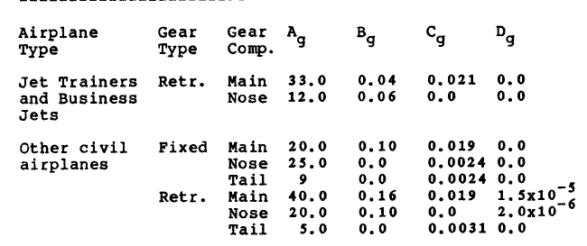
The GD Method calculates the landing gear weight to be 2,406 lbs. Using the constants for retractable landing gear for a jet transport, the Torenbeek Method calculates the landing gear to be 3,111 lbs. From the Class I estimate, landing gear was 2,654 lbs. The average results in 2,724 lbs for the Class II estimate.

14.2.1.6. Structure Weight Summary
The total structure weight is summarized by the following table:
Table 40. Class II Estimation of Structure Weight
Component | GD Method Estimate (lbs) | Torenbeek Method Estimate (lbs) | Class I Estimate (lbs) | Class II Estimate (lbs)
Wing | 4,872 | 8,038 | 7,636 | 6,287
Empennage | 3,628 | 2,263 | 1,192 | 2,627
Fuselage | 4,024 | 7,424 | 8,549 | 7,987
Nacelle | 3,495 | 1,564 | 2,082 | 2,381
Landing Gear | 2,406 | 3,111 | 2,654 | 2,724
TOTAL | 18,425 | 22,400 | 22,113 | 22,006

14.2.2. Powerplant Weight
The powerplant weight, $W_{pwr}$, of the HTA consists of the following: weight of the engines, including the exhaust, cooling, supercharger, and lubrication systems; air induction system, which includes the inlet ducts, ramps, spikes, and controls; fuel system; and the propulsion system, which includes engine controls, starting systems, and provisions for engine installation (Roskam, Airplane Design Part V: Component Weight Estimation, 2003). Since the HTA will be using the hFan engine, which is a hybrid electric system, allowing the HTA to be able to use a gas turbine for some stages of the mission and batteries for other stages of the mission, while providing sufficient thrust for the aircraft with the added battery weight, the specifications of the propulsion system are available. A schematic of the hFan propulsion system is illustrated in the figure below (Bradley & Droney, Subsonic Ultra Green Aircraft Research: Phase I Final Report, 2011).
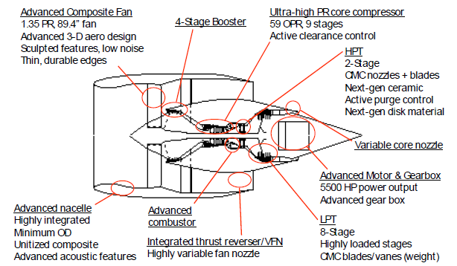
Figure 89. hFan engine overview
The HTA will require 2 suspended engines. Thus, from the manufacturers of the propulsion system, the weight of the propulsion system, which includes the advanced composite fan, 4-stage booster, ultra-high PR core compressor, combustor, thrust reverser, variable core nozzle, low and high pressure turbo, air induction system, fuel system, nacelles, and pylons, is 21,778 lbs (Bradley & Droney, Subsonic Ultra Green Aircraft Research: Phase I Final Report, 2011).

14.2.3. Fixed Equipment Weight
The fixed equipment weight, $W_{feq}$, consists of the weights of the flight control system, $W_{fc}$, hydraulic system, $W_{hs}$, the electric system, $W_{els}$, instrumentation, avionics, and electronics, $W_{iae}$, air-conditioning, pressurization, anti- and de-icing system, $W_{api}$, oxygen system, $W_{ox}$, auxiliary power unit (APU), $W_{apu}$, furnishings, $W_{fur}$, baggage and cargo handling equipment, $W_{bc}$, operational items, $W_{ops}$, and paint, $W_{pt}$ (Roskam, Airplane Design Part V: Component Weight Estimation, 2003). Therefore, $W_{feq}=W_{fc}+W_{hps}+W_{els}+W_{iae}+W_{api}+W_{ox}+W_{apu}+W_{fur}+W_{bc}+W_{ops}+W_{pt}$. The Torenbeek Method and GD Methods can be used to estimate the subsystem weights for the transport aircraft. The weights for each method will be compared to the weight estimated from similar data, and a Class II estimate will be formed.

14.2.3.1. Flight Control System Weight
The GD Method to estimate commercial transport aircraft flight control system weight involves the following equation (Roskam, Airplane Design Part V: Component Weight Estimation, 2003).
$W_{fc}=56.01{\left\{\frac{\left(W_{TO}\right)\left(\overline{q}\right)}{100000}\right\}}^{0.576}$ (99)
For the GD Method, the flight control system weight is a function of the design dive dynamic pressure in psf, $\overline{q}$ and the takeoff weight. Using this method, $W_{fc}=56.01{\left\{\frac{\left(77602.6\right)\left(450\right)}{100000}\right\}}^{0.576}=1633.4$ lbs.
The Torenbeek Method estimates the flight control system weight for a jet transport with powered flight controls using the following equation (Roskam, Airplane Design Part V: Component Weight Estimation, 2003).
$W_{fc}=0.64{\left(W_{TO}\right)}^{2/3}$ (100)
Thus, the Tornbeek Method estimate is $W_{fc}=1164.4$ lbs.
The SUGAR aircraft 765-093, 765-094, 765-095, and 765-096, which range from fully fuel-powered to hybrid powered aircraft, provide a database of additional weight data, including the flight control system data with which to compare the HTA flight control system weights (Bradley & Droney, Subsonic Ultra Green Aircraft Research: Phase I Final Report, 2011). The average flight control system weight is 2,932.5 lbs, which is about 1.8% of the takeoff weight. Using this ratio, the HTA is estimated to have a flight control system weight of 1,432 lbs.
Table 41. SUGAR Flight Control System Weight Data
SUGAR A/C | A/C number | $W_{TO}$(lbs) | $W_{fc}$ (lbs) | $$\frac{W_{fc}}{W_{TO}}$$
SUGAR Free | 765-093 | 175,635.000 | 3,084.000 | 0.018
Refined SUGAR | 765-094 | 136,412.000 | 2,900.000 | 0.021
SUGAR High | 765-095 | 163,853.000 | 2,873.000 | 0.018
SUGAR Volt | 765-096 | 164,375.000 | 2,873.000 | 0.017
 |  | Average | 2,932.500 | 0.018

Thus, combining the three methods of estimation, the Class II estimate of the flight control system weight is the average, 1,410 lbs.

14.2.3.2. Hydraulic System Weight
The hydraulic system weight can be estimated by using Roskam’s recommended range of $0.0060W_{TO}-0.120W_{TO}$, giving a range of 466-931 lbs for the HTA (Roskam, Airplane Design Part V: Component Weight Estimation, 2003). Additional comparisons can be performed, comparing the HTA to similar aircraft. When comparing to similar size aircraft, such as the 737-200, the Hydraulic system weight is 873 lbs, and using the ratio $\frac{W_{hs}}{W_{TO}}$=0.0076, an estimate for the HTA’s $W_{hs}$ is 587 lbs.
. When comparing to similarly powered aircraft, such as the SUGAR aircraft, the average for the SUGAR 765-093, 765-094, and 765-095 is 846 lbs (Bradley & Droney, Subsonic Ultra Green Aircraft Research: Phase I Final Report, 2011). For the SUGAR aircraft, the ratio of the hydraulic system weight to the takeoff weight is approximately 0.0053. Using this ratio and the takeoff weight of the HTA, an additional estimate for the HTA’s hydraulic system weight is 413 lbs.

Table 42. SUGAR Hydraulic System Weight Data
SUGAR A/C | A/C number | $W_{TO}$(lbs) | $W_{hs}$ (lbs) | $$\frac{W_{hs}}{W_{TO}}$$
SUGAR Free | 765-093 | 175,635.000 | 894.000 | 0.005
Refined SUGAR | 765-094 | 136,412.000 | 836.000 | 0.006
SUGAR High | 765-095 | 163,853.000 | 827.000 | 0.005
SUGAR Volt | 765-096 | 164,375.000 | 827.000 | 0.005
 |  | Average | 846.000 | 0.005

Combining the estimates of 466 lbs, 931 lbs, 413 lbs, and 587 lbs, gives a Class II estimate of 600 lbs for the weight of the hydraulic system.

14.2.3.3. Electrical System Weight
The Torenbeek Method to estimate the electrical system weight uses an equation that is a function of the passenger cabin volume in cubic feet, $V_{pax}$. This equation is as follows (Roskam, Airplane Design Part V: Component Weight Estimation, 2003).
$W_{els}=10.8{\left(V_{pax}\right)}^{0.7}\{1-0.018{\left(V_{pax}\right)}^{0.35}\}$ (101)
The Torenbeek Method gives an estimate of 831 lbs.
The weight of the electrical system can be estimated from weights of similar electrical systems, as well (Bradley & Droney, Subsonic Ultra Green Aircraft Research: Phase I Final Report, 2011). The SUGAR aircraft electrical systems average 2362 lbs. Compared to their takeoff weight, the ratio of electrical system weight to takeoff weight is 0.015. Using this ratio, an estimate, from the SUGAR aircraft, for the electrical system weight of the HTA is 1152 lbs.
Using the 737-200 data from Roskam, the ratio of electrical system weight to takeoff weight is 0.009, and the resulting weight for the HTA’s electrical system is 716 lbs.

Table 43. SUGAR Electrical System Weight Data
SUGAR A/C | A/C number | $W_{TO}$(lbs) | $W_{es}$ (lbs) | $$\frac{W_{es}}{W_{TO}}$$
SUGAR Free | 765-093 | 175,635.000 | 2,557.000 | 0.015
Refined SUGAR | 765-094 | 136,412.000 | 2,297.000 | 0.017
SUGAR High | 765-095 | 163,853.000 | 2,297.000 | 0.014
SUGAR Volt | 765-096 | 164,375.000 | 2,297.000 | 0.014
 |  | Average | 2,362.000 | 0.015

Averaging the resulting estimates from Torenbeek, SUGAR aircraft, and the 737-200, $W_{es}=900$ lbs for the Class II estimate.

14.2.3.4. Instrumentation, Avionics, and Electronics Weight
The GD Method calculates the weight of the instruments as the sum of the flight instruments, engine instruments, and other instruments as a function of the number of engines and the number of pilots (Roskam, Airplane Design Part V: Component Weight Estimation, 2003).
$W_{i}=N_{pil}\left\{15+0.032\left(\frac{W_{TO}}{1000}\right)\right\}+N_{e}\left\{5+0.006\left(\frac{W_{To}}{1000}\right)\right\}+0.15\left(\frac{W_{TO}}{1000}\right)+0.012W_{TO}$ (102)
This method resulst in an estimate of 989 lbs.
The Torenbeek Method for jet transports is a function of the empty weight and the maximum range in nautical miles (Roskam, Airplane Design Part V: Component Weight Estimation, 2003).
$W_{iae}=0.575W_{e}^{0.556}R^{0.25}$ (103)
The Torenbeek Method estimates $W_{iae}$ to be 1,475 lbs.
These two methods can now be compared to the data gathered from the SUGAR aircraft (Bradley & Droney, Subsonic Ultra Green Aircraft Research: Phase I Final Report, 2011). The SUGAR aircraft, have a ratio of $\frac{W_{iae}}{W_{TO}}=$0.014, and therefore provide the HTA estimate for $W_{iae}$ to be 1,107 lbs. The Class II estimate for $W_{iae}$ is 1,050 lbs.
Table 44. SUGAR Data for Instrumentation, Avionics, and Electronics Weight
SUGAR A/C | A/C number | $W_{TO}$(lbs) | $W_{iae}$ (lbs) | $$\frac{W_{iae}}{W_{TO}}$$
SUGAR Free | 765-093 | 175,635.000 | 2,219.000 | 0.013
Refined SUGAR | 765-094 | 136,412.000 | 2,277.000 | 0.017
SUGAR High | 765-095 | 163,853.000 | 2,277.000 | 0.014
SUGAR Volt | 765-096 | 164,375.000 | 2,277.000 | 0.014
 |  | Average | 2,262.500 | 0.014

14.2.3.5. Air-Conditioning, Pressurization, and Anti- and Deicing Systems Weight
For pressurized commercial jet airplanes, the air-conditioning, pressurization system, and the anti- and deicing systems weight, $W_{api}$ can be estimated using the GD method. The GD Method is a function of the passenger cabin volume in cubic feet, $V_{pax}$, the number of crew members, $N_{cr}$, and the number of passengers, $N_{pax}$. The equation below provides the estimate (Roskam, Airplane Design Part V: Component Weight Estimation, 2003).
$W_{api}=469{\left\{\frac{V_{pax}\left(N_{cr}+N_{pax}\right)}{10,000}\right\}}^{0.419}$ (104)
The resulting GD Method estimate for $W_{api}$ is 1,019 lbs.
The Torenbeek Method is a function of the length of the passenger cabin in feet, and is summarized by the following equation (Roskam, Airplane Design Part V: Component Weight Estimation, 2003).
$W_{api}=6.75{\left(l_{pax}\right)}^{1.28}$ (105)
The Torenbeek Method estimate is 1,496 lbs.
Compared to similar aircraft, such as the 737-200, with $W_{api}=1,416$ lbs, and SUGAR aircraft, which would give a ratio $\frac{W_{api}}{W_{TO}}=0.01$, provides a low estimate of 792 lbs (Bradley & Droney, Subsonic Ultra Green Aircraft Research: Phase I Final Report, 2011). For the Class II estimate, the SUGAR aircraft data will be neglected, and $W_{api}$is estimated as the average of the GD and Torenbeek Methods along with the 737-200 data and SUGAR A/C data as 1,181 lbs.
Table 45. SUGAR API Weight Data
SUGAR A/C | A/C number | $W_{TO}$(lbs) | $W_{api}$ (lbs) | $$\frac{W_{api}}{W_{TO}}$$
SUGAR Free | 765-093 | 175,635.000 | 1,796.000 | 0.010
Refined SUGAR | 765-094 | 136,412.000 | 1,549.000 | 0.011
SUGAR High | 765-095 | 163,853.000 | 1,582.000 | 0.010
SUGAR Volt | 765-096 | 164,375.000 | 1,582.000 | 0.010
 |  | Average | 1,627.250 | 0.010

14.2.3.6. Oxygen System Weight
The weight of the oxygen system can also be estimated using both the GD Method and Torenbeek Methods. The two equations, from Roskam are:
$W_{ox}=7{\left(N_{cr}+N_{pax}\right)}^{0.702}$ (106)
$W_{ox}=30+1.2N_{pax}$ (107)
As a result, the GD Method gives an estimate of $W_{ox}=175 lbs$, while the Torenbeek Method gives an estimate of $W_{ox}=145 lbs$ for short flights above 25,000 ft, and $W_{ox}=270 lbs$ for extended flights overwater. Since the HTA is a short to medium range transport aircraft, to determine a Class II estimate, $W_{ox}=160$ lbs.

14.2.3.7. Auxiliary Power Unit Weight
The Auliary Power Unit (APU) weight will be taken into account, since the jet transport requires one. Although a specific APU has not been determined, the weight will be estimated using Roskam’s estimate of the takeoff weight, along with comparisons for the 737-200 and the SUGAR aircraft APU weights (Bradley & Droney, Subsonic Ultra Green Aircraft Research: Phase I Final Report, 2011).
According to Roskam, $W_{apu}=0.004W_{TO}-0.013W_{TO}$ (Roskam, Airplane Design Part V: Component Weight Estimation, 2003). This range is 310-1008 lbs, with an average of 660 lbs. The SUGAR aircraft data gives an average APU weight of 1018.5 lbs, which is 0.6% of the takeoff weight. Using this data gives a low estimate of $W_{apu}=498$ lbs. Taking the average of these values gives a Class II estimate of 450 lbs.
Table 46. SUGAR APU Weight Data
SUGAR A/C | A/C number | $W_{TO}$(lbs) | $W_{apu}$ (lbs) | $$\frac{W_{apu}}{W_{TO}}$$
SUGAR Free | 765-093 | 175,635 | 1,032 | 0.006
Refined SUGAR | 765-094 | 136,412 | 1,014 | 0.007
SUGAR High | 765-095 | 163,853 | 1,014 | 0.006
SUGAR Volt | 765-096 | 164,375 | 1,014 | 0.006
 |  | Average | 1,018.5 | 0.006

14.2.3.8. Furnishings Weight
Furnishings include cabin furniture and accessory items, like seats, insulation, trim panels, sound-proofing, instrument panels, control stands, lighting, and wiring. Furnishings also include galley provisions and the structure, the lavatory system, overhead luggage containers, escape provisions, and fire-fighting equipment (Roskam, Airplane Design Part V: Component Weight Estimation, 2003). The Torenbeek Method and GD Method will provide initial estimates, with the SUGAR data and the 737-200 data providing additional support for the Class II Estimate.
The GD Method and Torenbeek Method provide the following equations, respectively to calculate $W_{fur}$.
$W_{fur}=55N_{fdc}+32N_{pax}+15N_{cc}+k_{lav}{\left(N_{pax}\right)}^{1.33}+k_{buf}{\left(N_{pax}\right)}^{1.12}+109{\left\{\frac{N_{pax}\left(1+P_{c}\right)}{100}\right\}}^{0.505}+0.771\left(\frac{W_{TO}}{1000}\right)$ (108)
$W_{fur}=0.211{\left(W_{TO}-W_{F}\right)}^{0.91}$ (109)
These two equations yield $W_{fur}=3,918$ and $5,655$ lbs, respectively. The 737-200 aircraft gives an estimate of $W_{fur}=4,463$lbs, and using the ratio provided by the Sugar aircraft data, below, $W_{fur}=4,651$ lbs.
Table 47. SUGAR Aircraft Furnishings Weight Data
SUGAR A/C | A/C number | $W_{TO}$(lbs) | $W_{fur}$ (lbs) | $$\frac{W_{fur}}{W_{TO}}$$
SUGAR Free | 765-093 | 175,635.000 | 10,866.000 | 0.062
Refined SUGAR | 765-094 | 136,412.000 | 9,115.000 | 0.067
SUGAR High | 765-095 | 163,853.000 | 9,115.000 | 0.056
SUGAR Volt | 765-096 | 164,375.000 | 9,115.000 | 0.055
 |  | Average | 9,552.750 | 0.060

Nikolai also provides a method to determine the weight of the furnishings. It is the sum of the crew seats, passenger seats, miscellaneous furniture, and the cabin windows. The equations that provide these, respectively are as follows (Nikolai, 1984).
$W_{cs}=34.5\left(N_{cr}\right)q^{0.25}$ (110)
$W_{ps}=32.03(N_{pax})$ (111)
$W_{m}=0.771\left(W_{TO}*{10}^{-3}\right)$ (112)
$W_{cw}=109.33{\left(N_{pax}\left(1+P_{c}\right)*{10}^{-2}\right)}^{0.505}$ (113)
$W_{cs}, N_cr, q, W_{ps}, N_{pax}, W_{m}, W_{cw}, P_{c}$ are the weight of the crew’s seats, the number of crew, the dynamic pressure, weight of the passenger’s seats, number of passengers, weight of miscellaneous furnishings, weight of the cabin windows, and th ultimate fabin pressure in Psi, respectively. Using these equations, results in the following weights: $W_{cs}=318 lbs, W_{ps}=3,075 lbs, W_{m}=60 lbs, and W_{cw}=539$lbs, with a total of 3991 lbs.
The Class II weight estimate for furnishings weight will be 3,991 lbs.

14.2.3.9. Baggage and Cargo Handling Equipment Weight
According to Roskam, the baggage and cargo containers’ weight can be estimated using
$W_{bc}=1.6*lbs/ft^{3}$ (114)
There will be 3 containers at 80 ft³ each, for a total of 240 ft³, which gives the total weight to be 384 lbs, as the Class II estimate for $W_{bc}$.

14.2.3.10. Operational Items Weight
The operational items include food, water, drinks, china, and lavatory supplies. Using the SUGAR aircraft database, below, the Class II estimate of the HTA’s operational items weight will be calculated (Bradley & Droney, Subsonic Ultra Green Aircraft Research: Phase I Final Report, 2011). Assuming the operational items weight as 4.6% the takeoff weight, the HTA’s estimate for operational items weight from SUGAR A/C data is $W_{ops}=3,540$ lbs.

Table 48. SUGAR Data for Operational Items Weight
SUGAR A/C | A/C number | $W_{TO}$(lbs) | $W_{ops}$ (lbs) | $$\frac{W_{ops}}{W_{TO}}$$
SUGAR Free | 765-093 | 175,635.000 | 7,342.000 | 0.042
Refined SUGAR | 765-094 | 136,412.000 | 7,207.000 | 0.053
SUGAR High | 765-095 | 163,853.000 | 7,207.000 | 0.044
SUGAR Volt | 765-096 | 164,375.000 | 7,207.000 | 0.044
 |  | Average | 7,240.750 | 0.046

According to Nikolai’s Fundamental’s of Aircraft Design,
$W_{lav}=1.11*N_{pax}^{1.33}$ (115)
$W_{food}=K_{BUF}*N_{pax}^{1.12}$ (116)
where $W_{lav}$ is the weight of the lavatories and water provisions, $W_{food}$ is the weight of the food provisions, and $K_{BUF}=5.68 or 1.02$ for long range flights and short range flights, respectively (Nikolai, 1984). Combining these weights for 96 passengers give an estimate for the operational weight of 650 lbs. This is significantly less than the data from the SUGAR A/C. Differences include the number of passengers, and the length of the flight.
The calculated value of 650 lbs will be used as the estimate for the Class II operational weight.

14.2.3.11. Weight of Paint
Roskam provides the following equation to estimate the weight of paint for a well painted airplane to be:
$W_{pt}=0.003W_{TO}-0.006W_{TO}$ (117)
This gives a range of 233-466 lbs and an average of 349 lbs. The 737-700 uses approximately 350 lbs of paint (Hansen, n.d.). The Class II estimate will use an equivalent ratio of paint equal to 260 lbs.

14.2.3.12. Fixed Equipment Weight Summary
Table 49. Fixed Equipment Weight Summary
Component | GD Method (lbs) | Torenbeek Method (lbs) | Roskam Method (lbs) | Estimate from 737 A/C (lbs) | Estimate from SUGAR A/C (lbs) | Estimate from Nikolai (lbs) | Class II Estimate (lbs)
Flight Control System | 1633.4 | 1164.4 | ---------- | ---------- | 1432 | -------- | 1,410
Hydraulic System | --------- | ------------ | 466-931 | 873 | 413 | -------- | 600
Electrical System | ---------- | 831 | --------- | 716 | 1,152 | -------- | 900
Instrumetation, Avionics, and Electronics | 989 | 1,475 | --------- | ---------- | 1,107 | -------- | 1,050
Air-Conditioning, Pressurization, Anti and De-icing | 1,019 | 1,496 | -------- | 1,416 | 793 | -------- | 1,181
Oxygen System | 175 | 145-208 | ------ | ------- | ----------- | -------- | 160
APU | ---------- | --------- | 310-1008 | ------------ | 498 | -------- | 450
Furnishings | 3,919 | 5,655 | --------- | 4,463 | 4,652 | 3,991 | 3,991
Baggage and Cargo | --------- | ---------- | 384 | ----------- | ------------- | -------- | 384
Operational Items | --------- | ---------- | ----------- | ----------- | 3,540 | 650 | 650
Paint |  |  | 233-466 | 350 |  | ------- | 260
TOTAL |  |  |  |  |  |  | 11,036

14.2.4. Empty Weight Discussion
The empty weight is the sum of the structural weight, powerplant weight, and fixed equipment weight. $W_{e}=W_{struct}+W_{pwr}+W_{feq}$. Combining the totals from each of these sections gives a total estimate of 52,439 lbs for the empty weight. Note that the nacelle weights were accounted for in the powerplant weight calculations, and the structural nacelle weight estimate will be neglected, since the manufacturer’s data is available for the powerplant.
For the HTA, which uses fuel only in stages 1-4, and is battery powered for the remaining stages, the Class I estimate for the empty weight is 48,379 lbs. This difference of 4,060 lbs is fairly close to the Class I estimate, and gives a 7.7% difference.
The Class II weight sizing will need to be iterated if the weight savings criteria that follows does not provide a convergence. The weight savings criteria involve manufacturing the fuselage from composites, which would save 15% of the weight, manufacturing parts of the wing and fuselage under low stress from composites, which would save about 5%, and using a quadruplex digital flight control system and fly-by-wire as opposed to mechanical flight controls, which would save 15%, and replacing the primary wing and fuselage structure with lithium aluminum, which would give a 6% weight savings (Roskam, Airplane Design Part II: Preliminary Configuration Design and Integration of the Propulsion System, 2011). Thus, the empennage weight could be reduced by 394 lbs; the wing and fuselage low-stress composite replacement could be reduced by 713 lbs; the flight controls system could be reduced by 212 lbs; and the lithium aluminum would reduce the wing and fuselage structure by 857 lbs. Thus, the estimated empty weight has been lowered to 50,263 lbs, now only a 3.7% difference. Considering the percent difference is small, and the Class I weight sizing will continue to be used.

14.3. Component Centers of Gravity
The c.g. locations for the structural components, powerplant, and fixed equipment components will be presented using Roskam’s guidelines. The table below illustrates the c.g. location of the structural components, powerplant, and fixed equipment (Roskam, Airplane Design Part V: Component Weight Estimation, 2003).
Using the revised Class II weights and the c.g. locations for both the x and z direction gives the following weights summary.
Table 50. Class II Weights and CG locations
No. | Type of Component | Wi (lbs) | xi (in.) | Wixi (in lbs) | yi (in.) | Wiyi (in lbs) | zi (in.) | Wizi (in lbs)
1 | Fuselage Group | 7,130 | 641 | 4,570,330 | 0 | 0 | 248 | 1,768,240
2 | Wing Group | 5,568 | 680 | 3,786,240 | 0 | 0 | 350 | 1,948,800
3 | Empennage Group | 2,233 | 1190 | 2,657,270 | 0 | 0 | 300 | 669,900
4 | Engine Group | 21,778 | 590 | 12,849,020 | 0 | 0 | 140 | 3,048,920
5a | Landing Gear Group:Nose Gear | 500 | 390 | 195,000 | 0 | 0 | 130 | 65,000
5b | Landing Gear Group: Main Gear | 2224 | 710 | 1,579,040 | 0 | 0 | 130 | 289,120
6 | Fixed Equipment Group | 10,824 | 680 | 7,360,320 | 0 | 0 | 200 | 2,164,800
7 | Trapped Fuel and Oil | 34.4 | 690 | 23,736 | 0 | 0 | 215 | 7,396
8 | Crew | 700 | 300 | 210,000 | 0 | 0 | 240 | 168,000
9 | Fuel | 3,440 | 690 | 2,373,600 | 0 | 0 | 430 | 1,479,200
10 | Batteries | 12,000 | 733 | 8,796,000 | 0 | 0 | 120 | 1,440,000
11 | Passengers | 16,800 | 680 | 11,424,000 | 0 | 0 | 200 | 3,360,000
12 | Luggage | 3,000 | 680 | 2,040,000 | 0 | 0 | 200 | 600,000

The x c.g. location is located at 55.9 ft, and the z c.g. location is located at 16.4 ft based on the equations from Roskam (Roskam, Airplane Design Part V: Component Weight Estimation, 2003).
$x_{cg}=\sum_{i=1}^{n}{\frac{W_{i}x_{i}}{W}}$ (118)
$z_{cg}=\sum_{i=1}^{n}{\frac{W_{i}z_{i}}{W}}$ (119)
If any of the components are moved, then the c.g. location moves according to the following equation (Roskam, Airplane Design Part V: Component Weight Estimation, 2003).
$∆x_{cg}=\frac{∆x_{i}\left(W_{i}\right)}{\sum_{i=1}^{n}{W_{i}}}$ (120)
The most likely movement could be the batteries, but since they are suspended below the wings, they do not have a wide range of movement available.
The c.g. excursion plot, based on the Class II data, is illustrated in the figure below. The plot illustrates that the most forward c.g. location is at 57.33 ft and the most aft c.g. location is at 72.11 ft. This was plotted by varying the number of passengers, luggage, and fuel. The conditions included a fully loaded aircraft, an aircraft with half passenger and full fuel, all passengers and half the luggage, zero passengers and full luggage, no passengers and no cargo, zero fuel, passengers only, and cargo only.

Figure 90. Class II cg excursion diagram

14.4. Airplane Inertias
To estimate the moments and products of inertia for the HTA, the weights from the Class II sizing and the c.g. locations in feet will be used. The engine group will be one weight and c.g. location, and will therefore be a ‘lumped mass’ assumption. This is also true for the passengers and fuel systems. The structural components will also be assumed to have uniform mass distributions. The following table summarizes the moments and products of inertia.
Table 51. Moments and products of Inertia
$$I_{xx}$$ | $$I_{yy}$$ | $$I_{zz}$$ | $$I_{xy}$$ | $$I_{yz}$$ | $$I_{zz}$$
111,166.12 | 314,123.14 | 202,957.02 | 0 | 0 | -52,406.14

The table was computed using the following equations (Roskam, Airplane Design Part V: Component Weight Estimation, 2003).
$I_{xx}=\sum_{i=1}^{n}{m_{i}\left\{{\left(y_{i}-y_{cg}\right)}^{2}+{\left(z_{i}-z_{cg}\right)}^{2}\right\}}$ (121)

$I_{yy}=\sum_{i=1}^{n}{m_{i}\left\{{\left(z_{i}-z_{cg}\right)}^{2}+{\left(x_{i}-x_{cg}\right)}^{2}\right\}}$ (122)
$I_{zz}=\sum_{i=1}^{n}{m_{i}\left\{{\left(x_{i}-x_{cg}\right)}^{2}+{\left(y_{i}-y_{cg}\right)}^{2}\right\}}$ (123)
$I_{xy}=\sum_{i=1}^{n}{m_{i}\left\{(x_{i}-x_{cg})(y_{i}-y_{cg})\right\}}$ (124)
$I_{yz}=\sum_{i=1}^{n}{m_{i}\left\{(y_{i}-y)(z_{i}-z_{cg})\right\}}$ (125)
$I_{zx}=\sum_{i=1}^{n}{m_{i}\left\{(z_{i}-z_{cg})(x_{i}-x_{cg})\right\}}$ (126)

15. Cost Analysis
The life cycle cost consists of the research and development costs, production and construction costos, operations and maintenance costs, and retirement and disposal costs. For typical aircraft, the operating costs composes nearly 94% of the life cycle cost (Ploetner, Schmidt, Baranowski, Isikveren, & Hornung, 2013). Thus, the preliminary cost analysis for the HTA will consider the operating cost (Roskam, Airplane Design Part II: Preliminary Configuration Design and Integration of the Propulsion System, 2011).
In order to estimate the program operating cost, $C_{ops}$, direct operating cost, DOC, and indirect operating cost, IOC, mission data will be reviewed. These calculations will require the block distance, $R_{bl}$, block time, $T_{bl}$, block speed, $V_{bl}$, and annual utilization in block hours, $U_{ann_{bl}}$. The block distance can be considered the door to door distance. This distance will be the 1,720 nm established for the HTA. The block time is the door to door time from the departure gate to the parking spot. The block time is calculated through the following equations (Roskam, Airplane Design Part VIII: Airplane Cost Estimation: Design, Development, Manufacturing, and Operating, 2015).
$T_{bl}=T_{gm}+T_{cl}+T_{cr}+T_{de}$ (127)
$T_{gm}=0.51{\left(10\right)}^{-6}\left(W_{TO}\right)+0.125$ (128)
$T_{cr}=(1.06R_{bl}-R_{cl}-R_{de}+R_{man})/V_{Cr}$ (129)
$R_{cl}=(V_{cl})(T_{cl})$ (130)
$R_{man}=(V_{man})(T_{man})$ (130)
$T_{man}=0.25\left({10}^{-6}\right)W_{TO}+0.0625$ (130)
The times consisting of the time spent on ground maneuvers, $T_{gm},$ such as leaving the gate, taxiing to the runway, time on the takeoff run, on the landing ground run, and taxiing to the destination, time spent in climb, $T_{cl}$, time spent in cruise, $T_{cr}$, and time spent in descent, $T_{de}$. The ground maneuver time dependso n the takeoff weight, and the time for cruise depends on the block distance, $R_{bl}$, distance for climb, $R_{cl}$, distance for descent, $R_{de}$, maneuvering distance, $R_{man}$, and the cruise velocity, $V_{cr}.$ The distance for climb depends on the climb velocity and the time to climb. The distance for maneuvering depends on the maneuvering velocity, which will be 250 kts, and time spent doing the maneuver. The results of the calculations are as follows:
Table 52. Block Time Results
Time segment | $$T_{bl}$$ | $$T_{gm}$$ | $$T_{cr}$$ | $$T_{de}$$ | $$T_{cl}$$ | $$T_{man}$$
Time (hrs) | 4.485 | 0.165 | 3.554 | 0.267 | 0.5 | 0.082

Table 53. Block Speed Results
 | $$V_{bl}$$ | $$V_{de}$$ | $$V_{man}$$ | $$V_{cr}$$ | $$V_{de}$$
Speed (kts) | 383.478 | 250 | 250 | 500 | 250
Table 54. Block Distance Results
 | $$R_{bl}$$ | $$R_{de}$$ | $$R_{man}$$
Distance (nm) | 1720 | 66.667 | 20.475

Thus, the annual utilization in block hours can be calculated using the following equation (Roskam, Airplane Design Part VIII: Airplane Cost Estimation: Design, Development, Manufacturing, and Operating, 2015).
$U_{ann_{bl}}={10}^{3}\left[3.4546∙T_{bl}+2.994-{\left(12.289{\left(T_{bl}\right)}^{2}-5.6626\left(T_{bl}\right)+8.964\right)}^{\frac{1}{2}}\right]$ (133)
The annual utilization is approximately 3,297 hours, which is equivalent to about 9 hours of daily utilization. These results are comparable to other aircraft, including 727-200, 737, 757, and DC-8. For these medium range aircraft, with $2<T_{bl}<5$, the annual utilization numbers in block hours ranges from 2,100-3,300 block hours. The HTA falls in this range. Now that these parameters have been calculated, the direct operating cost can be calculated.

15.1. Direct Operating Cost
The direct operating cost is the sum of the direct operating cost of flying, maintenance, depreciation, landing fees, and financing, abbreviated as $DOC, DOC_{flt}, DOC_{maint}, DOC_{depr},$ $DOC_{lnr}$, and $DOC_{fin}$, respectively. Each of these direct operating costs will be measured in USD/nm. Each of these will be calculated and summed to find the total direct operating cost.

15.1.1. Direct Operating Cost of Flying
The direct operating cost of flying consists of the sum of the cost of the crew, $C_{crew}$, cost of the fuel and oil, cost of the batteries, and cost of the airframe insurance.

15.1.1.1. Cost of the Crew
The cost of the crew depends on the number of crew members, $n_{c_{j}},$the type of crew member, with $n_{c_{1}}$being the captain and $n_{c_{2}}$ being the co-pilot, the factor, $k_{j}$, which accounts for vacation pay, cost of training, crew insurance and premiums, and payroll tax, the block speed, $V_{bl}$, the annual salaries of the crew members, $SAL_{j}$, the number of flight hours per year for a crew member, $AH_{j}$, and the travel expense factor, $TEF_{j}$.
$C_{crew}=\sum_{i=1}^{j}{\left[n_{c_{j}}\left\{\frac{1+k_{j}}{V_{bl}}\right\}\left(\frac{SAL_{j}}{AH_{j}}\right)+\left(\frac{TEF_{j}}{V_{bl}}\right)\right]}$ (134)
All the of the costs are for 2018. They have been scaled using the cost escalation factor, CEF, which is
$CEF_{year}=6.008930+0.10280(year-2014)$ (135)
There will be two crew members for the HTA, a captain and co-pilot. The salaries of each fo the respective crew members will be assumed to be $158,686 and $102,679. Flight crew will be assumed to fly an average of 800 flight hours per year. The travel expense factor for each of the crew is 13.06 per block hour. Thus, the total cost of the crew is 1.14 USD/nm.

15.1.1.2. Cost of the Fuel and Oil
The cost of fuel and oil, $C_{pol}$, depends on the mission fuel weight, the price of the fuel, FP, and the density of the fuel, FD.
$C_{pol}=1.05\left(\frac{W_{f_{bl}}}{R_{bl}}\right)\left(\frac{FP}{FD}\right)$ (136)
The current fuel price is $2.20 per gallon (Jet Fuel Daily Price, 2018). The fuel density is 6.74 lbs/gallon (Roskam, Airplane Design Part VIII: Airplane Cost Estimation: Design, Development, Manufacturing, and Operating, 2015). Using a mass fuel fraction of 0.955696, the weight of the fuel, and thus the weight of the block fuel is 3,438 lbs. The total cost of fuel and oil in USD per nautical mile is 0.69 USD/nm.

15.1.1.3. Cost of the Batteries
To determine the direct operating cost fo the batteries, $DOC_{bat}$, measured in USD/nm, the following assumptions will be made. The flight will require 35,314 kWh for the flight. Generally, the cost per charge per kWh is $0.0085. Thus the rate in USD/nm for the batteries charge is 0.17 USD/nm. Note that the initial cost of the battery is not included in this.

15.1.1.4. Summary of Direct Operating Cost of Flying
The direct operating cost of flying, $DOC_{flt}$, can be calculated using the following equation (Roskam, Airplane Design Part VII: Determination of Stability, Control and Performance Characteristics: FAR and Military Requirements, 2006).
$DOC_{flt}=C_{crew}+C_{pol}+C_{ins}+C_{bat}$ (136)
Since the cost of insurance is 2% of the direct operating cost, the direct operating cost of flying if a function of the direct operating cost. $DOC_{flt}=2.10+0.02(DOC)$ USD/nm.

15.1.2. Direct Operating Cost of Maintenance
The direct operating cost of maintenance is calculated using the following equation, from Roskam. The direct operating cost of maintenance is the sum of the labor cost of the airframe and systems maintenance, labor cost of the engine maintenance, cost of maintenance materials for the airframe and system, cost of maintenance materials for the engines, and applied maintenance burden, all measured in USD/nm. The following equations summarize the calculations necessary to determine the direct operating cost of maintenance (Roskam, Airplane Design Part VIII: Airplane Cost Estimation: Design, Development, Manufacturing, and Operating, 2015).
$DOC_{maint}=C_{lab/ap}+C_{lab/eng}+C_{mat/ap}+C_{mat/eng}+C_{amb}$ (138)
$C_{lab/ap}=1.03(MHR_{map_{bl}})(R_{l_{ap}})/(V_{bl})$ (139)
$C_{lab/eng}=1.03\left(1.3\right)N_{e}(MHR_{meng_{bl}})(R_{l_{eng}})/(V_{bl})$ (140)
$C_{mat/ap}=1.03\left(C_{mat/apblhr}\right)V_{bl}$ (141)
$C_{mat/eng}=1.03*1.3*N_{e}*C_{mat/engblhr}/V_{bl}$ (142)
$C_{amb}=1.03\left\{\left(f_{amb/lab}\right)\left[\left(MHR_{map_{bl}}\right)\left(R_{l_{ap}}\right)+\left(N_{e}\right)\left(MHR_{eng_{bl}}\right)\left(R_{l_{eng}}\right)\right]+\left(f_{amb/lab}\right)\left[C_{mat/apblhr}+\left(N_{e}\right)C_{mat/engblhr}\right]\right\}/V_{bl}$ (143)
The maintenance labor cost for the airframe and system depends on the number of maintenance manhours per blockhour for airframe systems, which is 6.35 hours, the weight of the airframe, which is 26,601 lbs, and the airplane maintenance labor rate per manhour, of 16 USd/nm. These inputs produce $C_{lab/ap}=0.3142$USD/nm.
The cost of the maintenance labor for the engines depends on the number of engines, the number of engine maintenance hours per engine, which will be assumed to be 5 hours, the hourly labor rate for engine maintenance, at $18.40, and the block speed of 383.5 kts. This produces $C_{lab/eng}=0.64$ USD/nm.
The cost of maintenance materials for the airframe and systems, other than the engines, depends on the airframe price, and the cost of the maintenance materials per blockhour, at 100 USD/nm. Thus, $C_{mat/ap}=0.27$ USD/nm.
The cost of maintenance materials for the engines depends on the number of engines, the cost of the maintenance materials per blockhour, which is 90.34 USD/blockhour, and the block speed of 383.5 kts. $C_{mat/eng}=0.63$ USD/nm.
Finally, the cost of the applied maintenance burden per nm is a function of overhead distribution factors for labor and material cost, the time of flight, the block time, and the cost of the maintenance man hours per flight for the materials. This amounts to 1.053 USD/nm.
Taking the sum of these costs gives the direct operating cost of maintenance to be 2.91 USD/nm.

15.1.3. Direct Operating Cost of Depreciation
The direct operating cost of depreciation is composed of the cost of the airplane depreciation without engines, avionics systems, the cost of the engine depreciation, the cost of the avionics system depreciation, the cost of the depreciation of the spare parts, and the cost of the depreciation of the engine spare parts (Roskam, Airplane Design Part VIII: Airplane Cost Estimation: Design, Development, Manufacturing, and Operating, 2015).
$DOC_{depr}=C_{dap}+C_{deng}+C_{dav}+C_{dapsp}+C_{dengsp}$ (144)
The airframe depreciation per nautical mile is calculated using the following equation.
$C_{dap}=\frac{\left(F_{dap}\right)[\left(AEP\right)-\left(N_{e}\right)\left(EP\right)-\left(N_{p}\right)\left(PP\right)-\left(ASP\right)]}{(DP_{ap})(U_{ann_{bl}})(V_{bl})}$ (145)
This cost depends on the airframe depreciation factor, which is 0.85, the airplane estimated price of $33,354,004 for 2018, the number of engines, 2, the engine price, which will be assumed to be $1,558,607, since the price of the hFan engine is not available, but this price is comparable to other engines, the avionics system price of $2,670,000, the depreciation period off the airplane of 10 years, the annual utilization in block hours, calculated as 3,297 hours, and the block speed, 383.5 kts. This gives $C_{dap}=1.85$ USD/nn.
The cost of engine depreciation per nautical mile is calculated using:
$C_{deng}=\frac{\left(F_{deng}\right)N_{e}(EP)}{(DP_{eng})(U_{ann_{bl}})(V_{bl})}$ (146)
This equation depends on the engine depreciation factor of 0.85, the engine depreciation period of 7 years, which may change when using the new hybrid engines, and other previously established factors of engine price, annual utilization in block hours, and block speed. The result is that $C_{deng}=0.299$USD/nm.
The cost of the depreciation of the avionics sytem in USD per nautical mile is calculated using:
$C_{dav}=\frac{\left(F_{dav}\right)ASP}{(DP_{av})(U_{ann_{bl}})(V_{bl})}$ (147)
Thus, $C_{dav}=0.42$ USD/nm with an avionics system depreciation factor of 1 and the depreciation time to be 5 years.
The cost of the depreciation of airplane spare parts in USD/nm is calculated using:
$C_{dapsp}=\frac{\left(F_{dapsp}\right)\left(F_{apsp}\right)\left(AEP-\left(N_{e}\right)\left(EP\right)\right)}{(DP_{apsp})(U_{ann_{bl}})(V_{bl})}$ (148)
Thus $C_{dapsp}$ is a function of the airplane spare parts depreciation factor of 0.85, the airplane spare parts factor of 1, the airplane spare parts depreciation period of 10 years, and other previously calculated values. $C_{dapsp}=0.20$ USD/nm.
The cost of the depreciation of engine spare parts is given by:
$C_{dapsp}=\frac{(_{F_{dengsp}})\left(F_{engsp}\right)\left(N_e)(EP\right)(ESPPF)}{(DP_{engsp})(U_{ann_{bl}})(V_{bl})}$ (149)
$C_{dapsp}=0.23$ USD/nm, and is based on the engine spare parts depreiciation factor of 0.85, the engine spare parts factor of 0.5, the engine spare parts price factor of 1.50, the depreciation period for the engine spare parts, which is 7 years, and the block speed and annual utilization.
Summarizing, $DOC_{depr}=C_{dap}+C_{deng}+C_{dav}+C_{dapsp}+C_{dengsp}=1.85+0.299+0.42+0.20+0.23=3.01$ USD/nm.

15.1.4. Direct Operating Cost of Landing Fees, Navigation Fees, and Registry Taxes
The direct operating cost of landing fees, navigation fees, and registry taxes is given by the following equations (Roskam, Airplane Design Part VIII: Airplane Cost Estimation: Design, Development, Manufacturing, and Operating, 2015).
$DOC_{lnr}=C_{lf}+C_{nf}+C_{rt}$ (150)
$C_{lf}=(C_{aplf})/(V_{bl}T_{bl})$ (151)
$C_{nf}=(C_{apnf})/(V_{bl}T_{bl})$ (152)
$C_{rt}=f_{rt}(DOC)$ (153)
The landing fee cost is 0.09 USD/nm, with the airplane landing fee per landing being 155.21 USD/nm. The cost of navigation fee will be assumed to be $0 USD/nm as the plane will not fly internationally. The cost of financing will be assumed to be 0.58 USD/nm, and the cost of registry taes is 0.01 USD/nm. Thus, the resulting sum is 0.099 USD/nm.

15.1.5. Direct Operating Cost of Financing
The direct operatinc cost of financing, $DOC_{fin}$ is 7% of the DOC. Thus, this amounts to approximately 0.34 USD/nm.

15.1.5. Direct Operating Cost Discussion
The direct operating cost, totals 8.45 USD/nm. The following chart illustrates the breakdown of the DOC for a jet transport aircraft.
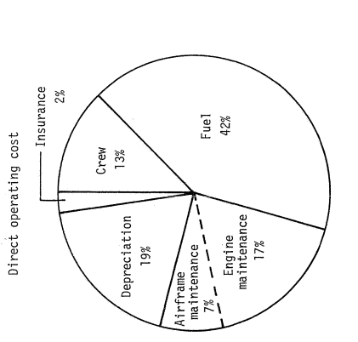
Figure 91. DOC for a Jet Transport
Based off of the calculations for the direct operating cost for the HTA, the figures below illustrates the breakdown of the DOC for both the HTA and a fuel version of the HTA. There is a significant decrease in fuel usage, but higher maintenance due to the batteries. Additionally, there is an increase in the depreciation with batteries due to the life cycles.

Figure 92.HTA DOC with batteries and fuel

Figure 93. HTA DOC for all fuel
Additionally, the figure below illustrates the decrease in the direct operating cost over the years of the flight (Maddalon, Molloy, & Neubauer, Jr., 1980). This figure is a a jet transport. For a hybrid aircraft, the DOC should decrease more quickly as there will be less fuel to purchase. Note that this chart extends for 15 years. Many of these calculations were performed assuming a 10 year life of the airplane. However, many aircraft last longer than 10 years, which only increases the profit over the years.
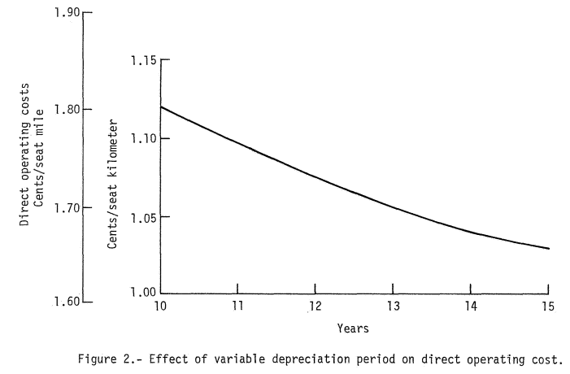
Figure 94. Effect of variable depreciation period on DOC
Sensitivity studies on a fully electric jet transport demonstrate that fuel price and electricity price have the strongest impact of the DOC. The study shows that with a 10% increase in fuel costs, there is a 3% increase in DOC. Additionally, a reduction in the number of cycles of battery use, less than the typical 2000 cycles, combined with battery installation costs also produces higher DOCs (Ploetner, Schmidt, Baranowski, Isikveren, & Hornung, 2013).

15.2. Indirect Operating Cost
The indirect operating cost, $IOC,$is composed of the indirect operating cost for passenger services, maintaining depreciating ground equipment and facilitiesm airplane and traffic servicing, promotions sales, and entertainment, and general administrative expenses. Its units are in USD/nm. The costs for these services can be estimated through the equation:
$IOC=F_{ioc}(D0C)$ (154)
$F_{ioc}$ is the factor extrapolated from the 737 data from Roskam. This factor is 0.5. Thus, the indirect operating cost is 4.14 USD/nm.

15.3. Program Operating Cost
The program operating cost depends on the indirect program operating costs, the direct program operating costs, and the number of aircraft acquired. Due to the fact that operating costs vary between customers, the program operating costs depends on the number of customers. For the purposes of these calculations, 1,200 aircraft will be assumed to be in acquisition (Sales, 2018). As of January 1, 2018, Boeing has orders for more than 4,300 737- MAX aircraft. Since the HTA has similar mission specifications, a high volume will be assumed for acquisition. Then the program operating cost can be estimated using the following equations (Roskam, Airplane Design Part VIII: Airplane Cost Estimation: Design, Development, Manufacturing, and Operating, 2015).
$C_{ops}=\sum_{i=1}^{i=n}{\left[{\left(C_{ops_{dir}}\right)}_{i}{\left(N_{acq}\right)}_{i}+{\left(C_{ops_{ind}}\right)}_{i}{\left(N_{acq}\right)}_{i}\right]}$ (155)
${\left(C_{ops_{dir}}\right)}_{i}={\left(DOC\right)}_{i}{\left({R_{bl}}_{ann}\right)}_{i}{\left(N_{yr}\right)}_{i}$ (156)
${\left(C_{ops_{ind}}\right)}_{i}={\left(IOC\right)}_{i}{\left({R_{bl}}_{ann}\right)}_{i}{\left(N_{yr}\right)}_{i}$ (157)
Assuming the aircraft are in use for 10 years, the operating cost is $190,835,543,254.38. The early design has a significant impact on the ultimate cost of the aircraft. In the future, trade studies can be performed on the number of years in service and the number of aircraft acquired per year to determine the effect on the operating cost.

15.3. Hybrid Power Cost Analysis
Although the price of jet fuel fluctuates per gallon, the general trend illustrates an increase in fuel costs and an increase in the number of general aviation aircraft, as discussed in the introduction. The price of electricity to recharge the batteries is significantly cheaper than jet fuel and has the added benefit of drastically reducing carbon dioxide and other harmful emittants. Electricity costs approximately 8.5 cents per kilowatt hour. For a fully-fuel powered version of the HTA, which requires 17,888 lbs or 2,670 gallons of jet fuel, this would reduce the cost of the total fuel per flight from $5,874 to $1,129.

15.3.1. Sample Battery Specifications
Although battery technology is not yet at its peak in power, companies are selling advanced lithium ion batteries for aviation power. True Blue Power is one such company.
For aviation, True Blue has a 46 amp hour battery, which at an output voltage of 26.4 Volts, and weight of approximately 23.4 kg, gives approximately 51.7 Wh/kg of energy. The low specific energy density would result in more batteries and higher weight, further illustrating the need for increased battery energy density. However, with the promise of better battery technology and the capabilities of lithium ion batteries, these batteries may provide future capabilities.
This battery has a life expectancy of 8 years with a 2 year maintenance interval. It weighs 51.7 lbs and has superior performance at extreme temperatures, including -40ºF to 158ºF and at pressures up to 35 Psi. Its dimensions are 10.9 in by 10.5 in by 10.1 in, making it easily fit in small spaces and configure with other batteries (True Blue Power, 2018). Each battery costs approximately $16,400 (True Blue Power, 2018). Though the batteries may initially be expensive, this one time cost for the life of the aircraft will drastically decreasethe cost to power the aircraft over time.

16. Conclusion
The preliminary design of the narrow-body, short to medium range hybrid transport vehicle demonstrates the feasibility of a hybrid powered aircraft fueld by both lithium ion batteries and jet fuel. Through a series of Class I estimates, including configuration design, weight sizing and sensitivities, determination of performance constraints, fuselage and cockpit design, wing design, empennage design, landing gear design, weight and balance analysis, stability and control analysis, and drag polar estimation, and Class II estimates of the V-n maneuver diagram, and weight and balance, and cost analysis, the early design calculations carefully layout the conversion of a jet aircraft to a hybrid powered aircraft.
This vehicle provides an environmentally friendly form of flight, reducing emissions and dependence on oil. As the number of general aviation aircraft increase and FAA standards call for reduced emissions, designing aircraft with less dependence on oil and fuel is becoming necessary. With battery technology developing, a hybrid aircraft is the perfect transition to greener aircraft for the near future.
Compared to the Boeing 737-100 model, the HTA has comparable weights, with the possibility of a lower takeoff weight. Additionally, with the research behind the SUGAR aircraft, the availability of hybrid engines would make the transition of power between fuel and electricity much more simple to integrate.
In regards to future work, the battery technology will continue to develop, and, as a result the weight may decrease and the specific energy densities may increase. Additionally, more studies could be performed on the benefits of using fuel and battery power during different phases of the flight. Trade studies could show the advantages and disadvantages of each power source during the phase of flight. The direct operating cost, although preliminary, demonstrates that the batteries, as a power source, are competitive from a cost perspective.
Overall, the hybrid transport aircraft demonstrates strong potential as a preliminary design to meet FAA standards, reduce emissions, and utilize future battery technology to pave the way toward new-age transport jets.

References
Airbus Commerial Aircraft. (n.d.). Retrieved July 5, 2017, from http://www.aircraft.airbus.com/aircraftfamilies/passengeraircraft/a320family/a320neo/
Aircraft Technical Data and Specifications: Boeing 737-100/200. (2017). Retrieved from Airliners: http://www.airliners.net/aircraft-data/boeing-737-100200/91
An Encyclopedia of the History of Technology. (2002). In I. McNeil (Ed.). Routledge.
Boeing Commercial Airplanes. (2013). 737 Airplane Characteristics for Airport Planning.
Bradley, M. K., & Droney, C. K. (2011). Subsonic Ultra Green Aircraft Research: Phase I Final Report. Huntington Beach: Boeing Research and Technology.
Bradley, M. K., & Droney, C. K. (2015). Subsonic Ultra Green Aircraft Research: Phase II- Volume II- Hybrid Electric Design Exploration. NASA. Huntington Beach: Boeing Research and Technology.
Bradley, M. K., & Droney, K. C. (2011). Subsonic Ultra Green Aircraft Research: Phase I Final Report. Langley Research Center. Hampton: National Aeronautics and Space Administration.
Bradley, M. K., Droney, C. K., & Allen, T. J. (2015). Subsonic Ultra Green Aircraft Research: Phase II Volume I Truss Braced Wing Design Exploration. NASA.
Brady, C. (1999). Detailed Technical Data. Retrieved from The 737 Technical Site: http://www.b737.org.uk/techspecsdetailed.htm
Canadair Regional Jet. (2016). Canadair Regional Jet Airport Planning Manual. Toronto: Bombardier Inc.
Crawford, B. (2009). Flightlab Ground School. Flight Emergency and Advanced Maneuvers Training Inc.
Creative Aviation Photography. (2017). Retrieved from Airplane Pictures: http://www.airplane-pictures.net
Daggett, D. L., Hendricks, R. C., Rainer, W., & Corporan, E. (2008). Alternate Fuels for Use in Commercial Aircraft. National Aeronautics and Space Administration, Glenn Research Center, Cleveland.
Davis, S. C., Williams, S. E., & Boundy, R. G. (2016). Transportation Energy Data Book (35 ed.). Oak Ridge, Tennessee: Oak Ridge National Laboratory.
Farhadi, M., & Mohammed, O. (2016). Energy Storage Technologies for High-Powered Applications. IEEE Transaction on Industry Applications, 52(3), 1953-1961.
Federal Aviation Administration. (2015). Aviation Emissions, Impacts, and Mitigation: A Primer. Office of Environment and Energy.
Fuel Price Analysis. (2017). Retrieved from IATA: http://www.iata.org/publications/economics/fuel-monitor/Pages/price-analysis.aspx
Hansen, D. (n.d.). Airframe Design. Retrieved from The Boeing Company: http://www.boeing.com/commercial/aeromagazine/aero_05/textonly/fo01txt.html
Hepperle, M. (n.d.). Electric Flight- Potential and Limitations. NATO OTAN.
Jane's All the World's Aircraft. (2013). IHS Markit.
Jet Fuel Daily Price. (2018, May 14). Retrieved from index mundi: https://www.indexmundi.com/commodities/?commodity=jet-fuel
Maddalon, D. V., Molloy, J. K., & Neubauer, Jr., M. J. (1980). NASA Technical Memorandum 80196: Computer Programs for Estimating Civil Aircraft Economics. Hampton: NASA Langley Research Center.
Mason, W. H. (2006). Aerodynamic Configuration Design Options. In Configuration Aerodynamics.
Matsushita, T., Yabuta, K., Tsujikawa, T., Matsushima, T., Arakawa, M., & Kurita, K. (2008). Construction of Three-Dimensional Thermal Simulation Model of Lithium Ion Secondary Battery. IEEE, 1-6.
Moore, R. H., Shook, M., Beyersdorf, A., Corr, C., Hendon, S., Knighton, W. B., . . . Anderson, B. E. (2015). Influence of Jet Fuel Composition on Aircraft Engine Emissions: A Synthesis of Aerosol Emissions Data from the NASA APEX, AAFEX, and ACCESS Missions. Energy & Fuels, 29, 2591-2600.
NASA. (2014, January 24). In Future Aircraft Designs We "Truss". (L. Gipson, Editor) Retrieved 2017, from https://www.nasa.gov/aero/boeing_sugar_wind_tunnel.html
Nikolai, L. M. (1984). Fundamentals of Aircraft Design. San Jose: METS, Inc.
Obert, E. (2009). Aerodynamic Design of Transport Aircraft. Delft University of Technology .
Ploetner, K. O., Schmidt, M., Baranowski, D., Isikveren, A. T., & Hornung, M. (2013). Operating Cost Estimation for Electric-Powered Transport Aircraft. American Institute of Aeronautics and Astronautics.
Riboldi, C., & Gualdoni, F. (2016). An integrated approach to the preliminary weight sizing of small aircraft. Aerospace Science and Technology, 58, 134-149.
Roskam, J. (2003). Airplane Design Part V: Component Weight Estimation. Lawrence: DARcorporation.
Roskam, J. (2006). Airplane Design Part VII: Determination of Stability, Control and Performance Characteristics: FAR and Military Requirements. Lawrence : DARcorporation.
Roskam, J. (2011). Airplane Design Part 3: Layout Design of Cockpit, Fuselage, Wing, and Empennage: Cutaways and Inboard Profiles. Lawrence: DARcorporation.
Roskam, J. (2011). Airplane Design Part II: Preliminary Configuration Design and Integration of the Propulsion System. Lawrence: DARcorporation .
Roskam, J. (2011). Airplane Design Part III: Layout Design of Cockpit, Fuselage, Wing, and Empennage: Cutaways and Inboard Profiles. Lawrence: DARcorporation.
Roskam, J. (2015). Airplane Design Part VIII: Airplane Cost Estimation: Design, Development, Manufacturing, and Operating. Lawrence: DARcorporation.
Roskam, J. (2017). Airplane Design Part 1: Preliminary Sizing of Airplanes. DARcorporation.
Rudolph, P. C. (1996). High-Lift Systems on Commercial Subsonic Airliners. Moffett Field: NASA Ames Research Center.
Sales. (2018, Feb. 10). Retrieved from The Boeing 737 Technical Site: http://www.b737.org.uk/sales.htm
Tariq, M., Maswood, A. I., Gajanayake, C. J., & Gupta, A. K. (2017). Aircraft batteries: current trend towards more electric aircraft. The Institute of Engineering and Technology, 7(2), 93-103.
Thauvin, J., Barraud, G., Roboam, X., Sareni, B., Budinger, M., & Leray, D. (2016). Hybrid Propulsion for Regional Aircraft: a Comparative Analysis Based on Energy Efficiency. IEEE.
True Blue Power. (2018). TB46. Retrieved from True Blue Power: https://www.truebluepowerusa.com/aviation-products/advanced-lithium-ion-batteries/tb46/
Ullman, D. (n.d.). The Electric Powered Aircraft: Technical Challenges.
Xue, N. (2014). Design and Optimization of Lithium-Ion Batteries For Electric Vehicle Applications .
Zayat, K. A., Dray, L., & Schafer, A. (2017). A First Order Analysis of Direct Operating Costs of Battery Electric Aircraft. Antwerp: Engineering and Physical Sciences Research Council.

