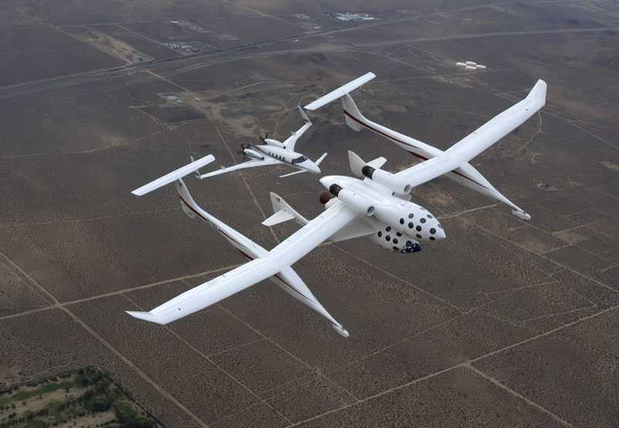

Instructor Dr. Nikos J. Mourtos
nikos.mourtos@sjsu.edu
ae.sjsu.edu/nikos/

Class Days / Time TR 18:00 – 19:15
Final Project Presentations 6, 8, & 19 December
Final Exam 19 December 2016, 14:45 – 17:00
Classroom Engr.164
Prerequisite Graduate standing in AE or instructor consent
Credit 3 units
GWAR This course satisfies the Graduation Writing Assessment Requirement (GWAR)

Textbook J. Roskam: Airplane Design, Parts I-VIII
Roskam Aviation and Engineering Corp.
Route 4, Box 274, Ottawa, Kansas, 66067.

Description This is a project course in which students complete the preliminary design of an airplane of their choice. The design process involves defining the mission requirements, weight sizing, performance sizing, fuselage design, wing, high-lift system and lateral controls design, landing gear design, weight and balance, stability and control, drag polars, final drawings. In their final report students will also discuss any environmental, economic and safety considerations for their airplane.

Goals 1. To provide graduate level experience in airplane design.
2. To develop students' creative abilities in solving open-ended, airplane design problems.
3. To develop an appreciation of the interrelationships between aerodynamics, propulsion, structures, flight mechanics, stability & control, manufacturing, maintenance, and cost in an integrated airplane design.
4. To develop students' engineering judgment as well as their confidence in making and accepting responsibility for design decisions.

Learning
Objectives Each student completing AE271 will be able to:

- Describe the pros and cons of unconventional aircraft configurations such as canards, 3-surface, swept-forward wings, flying wings, tailless, V/STOL, stealth, etc.
- Perform weight and performance sizing of an airplane, including pertinent Title 14 of the U.S. Code of Federal Regulations (14 CFR Parts 23/25) and European standards (EASA CS23/25)
- Design the fuselage, the wing, the empennage, and the landing gear of an airplane.
- Perform weight and balance analysis of an airplane.
- Perform a stability and control analysis of an airplane.
- Compute the drag polars of an airplane.
- Construct the V-n diagram of an airplane.

Grading Design reports* = 60%
2 oral progress reports & examinations @ 10% each = 20%
Final oral presentation & examination = 10%
Final exam (written) = 10%

850 points < A-, A, A+
700 points < B-, B, B+
650 points < C
*A minimum of 70% score is required in both components of this assignment (see below) to approve the course and meet minimum writing proficiency requirements.
**Written reports not meeting minimum writing proficiency standards will be returned without a grade. Revised reports may be re-submitted (once each) with a penalty of 20 points in the scale of 1 to 100.

Reports Reports will be graded for English (grammar, spelling, punctuation, etc.) as well as for technical content. Please see general guidelines for professional reports below.

Exams A brief written exam to cover basic concepts and definitions will be given on the 19th December 2016.

Approximate Weekly Schedule

Week Lecture Topic(s)
25 August Aircraft design overview.
29 August Mission requirements. Figures of merit.
Weight sizing,
06 September Weight sensitivities, trade studies.
12 September Performance sizing.
19 September Configuration design – conventional configurations.
26 September Configuration design – unconventional configurations.
03 October 1st Briefing – Mission, configuration, weight sizing,
Performance sizing.
10 October Fuselage, wing & empennage design.
17 October Landing gear design. Weight & balance.
24 October Longitudinal stability & control.
31 October Lateral stability & control.
07 November 2nd Briefing – Fuselage, wing & empennage design.
14 November Directional stability & control.
21 November Green Aviation (No Class On 24 November - Thanksgiving)
28 November Possibilities for green aviation
05 December 6 & 8 December – Final Design Briefings
19 December Final Exam & Final Design Review: 14:45 – 17:00
GENERAL COMMENTS ON PROFESSIONAL REPORT WRITING

Each report must meet minimum standards of professionalism. Unprofessional reports will be
severely downgraded even if the technical content is correct. The following items explain some of the features of a professional report.

- All reports must be prepared with a word processor.
- Organize reports using a decimal numbering system. The chapters, Sections, Sub-Sections should be indicated as follows:
4. TITLE OF CHAPTER
4.1 TITLE OF SECTION
4.1.1 Title of Sub-Section
4.1.1.1 Title of sub-sub-section
- Many reports require calculations. At least one “hand” calculation must be performed and documented for each case in a separate sub-section. These hand-calculations do not have to be typed but should be clearly written and well organized. If they are lengthy (i.e. more than 2 pages), they should be placed in a separate appendix but the results should be discussed in the main body of the report.
- All pages must be numbered. Start the introduction at page 1. Pages in the main body of the report are numbered: 1, 2, 3, etc. Preliminary pages such as Table of Contents, List of Symbols etc. are numbered sequentially : i, ii, iii, iv, etc.
- A minimum margin of one inch must be observed on all pages including graphs, figures, tables, computer print-outs, etc.
- The report must be written in good English. All words must be properly spelled. You are expected to proofread your reports before handing them in.
- Avoid using sentences longer than 2 lines. If you do not, your report will have a high "Fog Index" (i.e. it will be difficult to read).
- Do not use I, You, We, They, etc. in a technical report. Also, do not treat an airplane nor airplane components as persons, i.e., DO NOT write: the airplane's landing gear is of the retractable type. Instead, write: the landing gear of the Cessna 182 is of the retractable type or the airplane has a retractable landing gear.
- Never use the words: 'in order to ...'. Remember, the words 'in order' are nearly always out of order!
10. Make use of the technique called "bulletizing".
Instead of: in this chapter, the results of calculations of wing-loading, maximum lift
coefficients, thrust-to weight ratio, lift-to-drag ratio and cruise lift coefficients are presented.
Write: In this chapter the following characteristics of the Spartan Jet are presented:
• Wing Loading
• Maximum Lift Coefficients
• Thrust-to-Weight Ratio
• Lift-to-Drag Ratio
• Cruise Lift Coefficient
11. Make sure that no symbols are omitted from your equations. Again, it is important to
proofread your reports before handing them in!
12. All equations must be numbered and numbered sequentially. Within a chapter use a decimal
numbering system. For example:
X = Y + Z (4.17)
13. All references must be numbered sequentially as they appear in your report. See examples
below (1 is a book, 2 is a technical report, 3 is a journal article, 4 is a conference paper, 5 is
an internet reference). In your report refer to each of them with a number in a bracket.
For example: The vortex increases the lift of the flat plate [2] or Mourtos [2] found that the
existence of the vortex increased the lift on the flat plate at any given angle-of-attack.

1. Nickel, K., Wohlfahrt, M., Tailless Aircraft in Theory and Practice, AIAA Education Series, 1994.
2. Mourtos, N.J., Couillaud, S., Carter, D., Hange, C., Wardwell, D., Margason, R.J., Flow
Visualization Studies of Jet VTOL models during Hover in Ground Effect, NASA TM
108860, Jan. 1995.

3. Mourtos, N.J., Flow past a Flat Plate with a Vortex / Sink Combination, ASME Journal of
Applied Mechanics, Jun. 1996.
4. Papadopoulos, P., Subrahmanyam, P., Airbreathing Engine Analysis and Simulation Tool
for Space Vehicle Design, Proc., AIAA/CIRA 13th International Space Planes and
Hypersonics Systems and Technologies Conf., Centro Italiano Ricerche Aerospaziali
(CIRA), Capua, Italy, 16-20 May 2005.
5. UAV, Wikipedia, URL: <http://en.wikipedia.org/wiki/Unmanned_aerial_vehicle>, retrieved
Dec. 5, 2007.

14. All figures and graphs must be numbered and numbered sequentially. They must also
have descriptive titles. Titles must appear below the figure. All axes must have scale and
descriptive labels including units whenever appropriate. Curves must also have descriptive
labels. All lettering must be at least 3 mm high to be legible! For example:
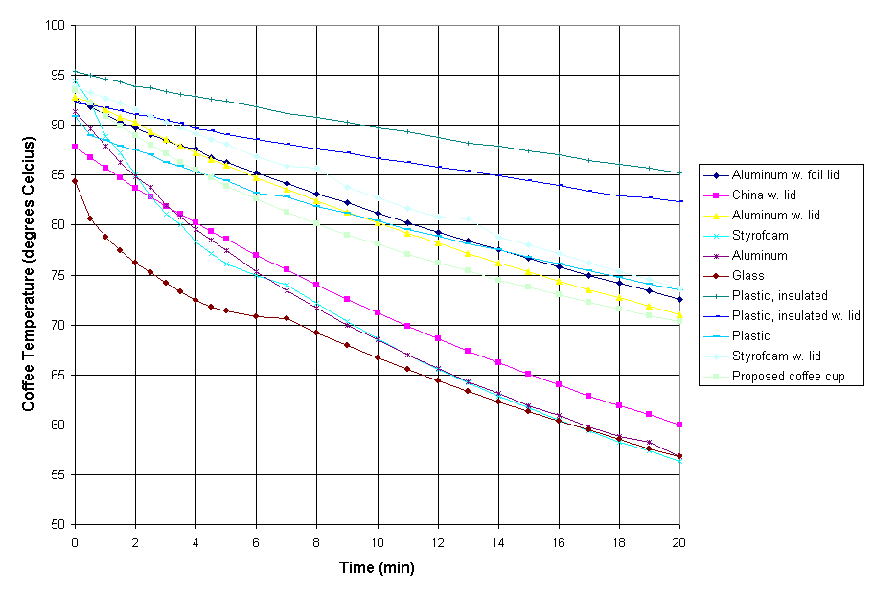
Figure 3.1 – Coffee temperature decline in various cups.

15. All tables must be numbered and numbered sequentially. They must also have descriptive
titles. Titles must appear above the table. Again, all lettering must be at least 3 mm high to
be legible!

Table 5.1 - The heaviest ten airplanes. MTOW = Maximum take-off weight, MLW = Maximum
landing weight, TOR = Take-off run (SL, ISA+15°, MTOW), LR = Landing run (SL, ISA+15°, MLW)
Type | MTOW [tons] | MLW [tons] | TOR [m] | LR [m]
Antonov An-225 | 640
Airbus A380-800F | 590 | 427
Boeing 747-8I | 439.985 | 306.175
Antonov An-124 | 405
Airbus A340-500 | 368 | 240 | 3050 | 2010
Boeing 777-300ER | 351.535 | 251.29
MD-11 | 273.314 | 195.04 | 3115 | 2118
Ilyushin IL-96M | 270 | 175
Boeing 787-9 | 244.94
L-1011-500 | 231.54 | 166.92 | 2636

16. When presenting aerodynamic data in a table, graph or figure it is mandatory that you
include the following information:
• Reference geometries: S, c and b in ft (or inches) and m (or cm).
• Moment center information in fractions of the m.g.c.
• Airplane weight consistent with the presentation of the data.
• Airplane configuration information, such as:
- Clean
- Flaps down, gear up
- Flaps down, gear down
- Thrust or power setting
- Speed brake deployment
- Flight condition
- C.g. location in fractions of m.g.c.
17. Remember: tables, graphs and figures are much easier to understand than prose so use
them as much as possible.
18. Do not put lengthy derivations in the main body of the report. Put such material in an
appendix (or appendices) and summarize the result in the main part of the report.
19. Plagiarism will result in total loss of credit for the entire report! If you decide to use
material, which was not generated by you, clearly identify the source of such material. Give
credit where credit is due!
20. A list of symbols must be included in your report. This list must define all symbols used
anywhere in the report (including figures, appendices, etc.). Do not include symbols which
are not used in your report! Do not copy a list of symbols from another reference! The list of
symbols must be presented in the following manner:

Symbol | Definition | Units (SI)
W | Weight | lbs (N)
Greek Symbols
α | Angle of attack | deg or rad
Subscripts
( )_{TO} | Takeoff | -------
Acronyms
APU | Auxiliary Power Unit | -------

21. Never make an unsubstantiated claim! Example: if you claim that you have optimized
airplane weight, you are expected to prove it. If you cannot, do not make the claim!
22. Avoid the use of superlatives, (e.g. this is the best airplane ever designed or the wing area
selected is the smallest possible for this type of airplane).
23. If you extrapolate data or if you extrapolate existing technology, discuss the consequences
to your design of not being able to achieve the extrapolated characteristics.
24. Include units (both systems) with all your results.
25. Appendices must be sequenced using capital letters and must have specific titles. For example: Appendix A - Hand Calculations
Appendix B - Design Parameters of Comparable Aircraft

