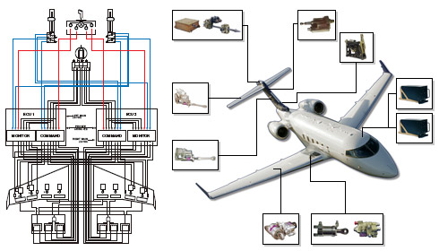
Instructor Info Prof. Gonzalo Mendoza
gonzalo.mendoza@sjsu.edu

Prerequisite Graduate standing or instructor consent.

Textbook Roskam, Jan, Airplane Design III - IV
Part III: Layout Design of Cockpit, Fuselage, Wing and Empennage
Part IV: Layout Design of Landing Gear and Systems

Description

Aircraft subsystem analysis and design: flight controls; avionics and electrical systems; cabin systems; landing gear and other mechanical systems; systems safety analysis.

Goals

Develop an understanding of aircraft subsystems operation, analysis, design, and safety as well as how the various systems interact with each other.

Student Learning Objectives
Students completing AE273 should be able to analyze and design the following subsystems for various types of aircraft:

- Flight control systems.
- Avionics and electrical systems.
- Cabin systems.
- Landing gear systems.
- Mechanical systems.
…as well as…
6. Analyze system safety for the above subsystems.

Grading: Design Reports 60%
Two Oral Reports 40%

100 – 97% A+; 96 – 93% A; 92 – 90% A-; 89 – 85% B+; 84 – 80% B; 79 – 76% B-; 75 – 72% C+; 71 – 68% C; 67 – 64% C-; 63 – 53% D; 52% and below below F.
Approximate Weekly Schedule

Week Topics
01 Flight controls, design of mechanical systems for the generation of required vehicle level aerodynamic forces
02 Flight controls: human powered systems: control surface forces, system mechanical
advantage and energy methods; control surface feel.
03 Flight controls: hydraulically or electrically powered systems: hydraulic actuator design,
function, and behavior; hydraulic and electrical actuator response models; design
issues
04 Flight controls: trim systems, drag, and high lift devices
05. Avionics and electrical systems: flight sensors; air data; inertial reference systems; health
monitoring; navigation.
06 Avionics and electrical systems: propulsion control mechanisms; EICAS
07 Avionics and electrical systems: Complex hardware, flight control computers and remote electronic units; autoflight systems
08 Avionics and electrical systems: EWIS; other service items (weather radar, radio altimeters, etc).
09. Cabin systems: environmental control systems; pressure, temperature, special needs, etc.
10. Landing gear and mechanical systems: landing gear design principles; loading
11. Landing gear and mechanical systems: dynamic characteristics; design requirements
12. Other mechanical systems: thrust reversing systems; brakes; doors; miscellaneous controls
13. Systems safety analysis: system safety concepts
14. Systems safety analysis: functional hazard assessments
15. Systems safety analysis: fault tree analyses
16. Systems safety analysis: interaction of systems and structures

