San José State University
Aerospace Engineering

AE 297 – Special Topics in

Aerospace Engineering

Spring 2021

Human Factors Engineering for Aerospace Systems Design

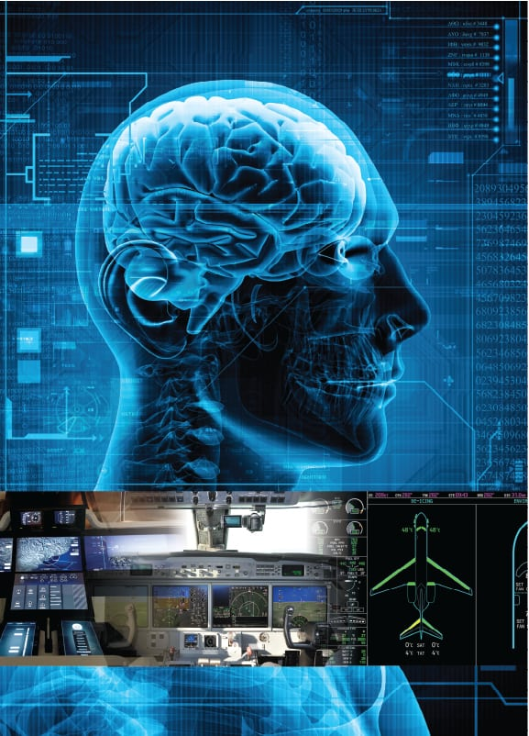

Contact Information: Gerasimos Kontos, PhD
Mob:+30 694 477 1968
Gerasimos.Kontos@sjsu.edu
Office Hours: TBA

Class Days / Time: Monday to Wednesday (Times: TBA)

Classroom: Zoom
Prerequisites: None
Co-requisites: None
Credit: 3 units

Rationale

Aerospace Engineers and Aviation Professionals design, build, operate and maintain the aviation ecosystem. It is no wonder that the majority of aviation accidents and incidents have roots in human factors. With this realization, this course is designed to provide both undergraduate and graduate aerospace engineering students with a fundamental understanding and a practical approach of human factors that must be taken into account in the design and engineering of complex aviation systems

Emphasis is placed in the derivation of human engineering design criteria from human performance and cognitive sources to include design principles of displays, control and ergonomics, manual control, the nature of human error and human limitations as well as human computer interaction and human to human interaction in complex sociotechnical systems (i.e. Flight deck and maintenance hangar)

Students will demonstrate proficiency through aviation accidents case analysis and presentation, homework assignments and practical exercises that require students to work effectively as a team and create synergy

Insights gained from attending this course will support students to better understand how people interact with technology and this knowledge can be used to assist in the design of more efficient aerospace systems in the future.

Module Description

This course will cover the scope of regulations concerning aviation and how they impact human performance and limitations for aviation professionals. The course will provide the fundamental understanding of the human factor concepts including psychological and physiological limitations of humans operating in complex sociotechnical systems. In addition, the course will include an in-depth study of Crew Resource Management, which involves an understanding of the flight deck environment and the proper utilization of available resources to human operator

Throughout the lectures, discussion topics will refer to the interactions between human and machines, including human intervention in automation processes and trade offs between human control and human monitoring. The overall aim is focused on improving the safety, efficiency and awareness of people using machines including the designers and engineers of aerospace systems. Failure to integrate Human Factor principles early in the design and development of aerospace systems will inevitably mean that additional training, procedures and checklists will have to compensate for the shortcomings

Ultimately, special focus will be provided to the paramount importance of Non-Technical Skills (i.e. Crew Resource Management) for aviation safety and students will be able to understand how human performance is positively reinforced from communication, situational awareness and team synergy and negatively affected from stress and automation complacency (i.e. Deskilling).

Measurable Learning Outcomes

Upon successful completion of this course, students will be able to:

- Critically apply knowledge of the principles of Human Factors to create safe and efficient solutions in the aerospace / aviation ecosystem;
- Understand Human performance issues, including why well-trained humans make errors and violate procedures as well as ways to minimize the consequences of these errors;
- Identify strengths and weaknesses in aerospace systems design from displays, control columns to automation the new challenges regarding information processing and automation as well as means of ensuring situational awareness to ensure safety throughout all phases of flight;
- Discuss the concepts of crew resource management, team dynamics and the role they play in flight deck operation;
- Describe the fundamentals of human factors models used in aviation. Define judgement, decision making and situational awareness. Describe and understand how stress and fatigue affect performance. Analyze the relationship between stress and judgement and decision making; and
- Engage in team synergy to enhance time management, coordination and collaborative learning.

Course Resources

Course Web Site: TBA

Textbook: Practical Human Factors for Pilots, Elsevier Publishing, Eds: 1st/ 2015, ISBN: 9780124202443

Note for Textbook: Students are not required to purchase the suggested textbook. The syllabus, office hours, course slides, homework assignments and additional course information and resources will be posted at the course folder on Canvas.

Materials for Learning:

- Internet access (broadband recommended)
- Computer with basic audio / video
- Canvas learning platform

Course Requirements:

- Adherence to SJSU AE departmental policies and procedures
- Regular course attendance according to SJSU AE departmental policies and procedures
- Complete and turn in quizzes and assignments by due deadline

Course Assignments

Critical Analysis Paper

Individual student or student teams will be assigned an NTSB aircraft accident investigation report, and students are expected to provide a 2-3 page critical analysis of the report, highlighting critical decisions and actions that lead to the accident as well as presenting recommendations and major lessons learned.

Quizzes

Students will complete one quiz at the end of each section which summarizes the main topics of each section. All quizzes will be open-book / open-notes and contain multiple choice and true/false questions. Quizzes will be provided through an online platform.

Course Grading

 |  |  | Grade Scale
A+ | A | B+ | B | C+ | C | D+ | D | Fail
950 – 1000 | 900 - 949 | 850 – 899 | 800 - 849 | 750 – 799 | 700 – 749 | 650  - 699 | 600 – 649 | Below –  600

The course will not have a final exam. One mid term assignment and one final assignment will be provided. Final assignment refers to the analysis of an accident investigation report. Mid-term assignment will worth 30% of the final grade. Critical analysis of an accident report will worth 40% of the final grade. The remaining 30 % will be determined from quizzes and overall participation in the course.

Tentative Schedule

Week | Module | Book Chapter / Study Material | Assignment
1 | Introduction to Human Factors and Human Information Processing for Aerospace Engineers | Chapters 1 & 2 | Quiz
2 | Systems Approach to Safety | Instructor Notes and Web Sources | Quiz
3 | Error Management & Human Limitations for Flight crew and Maintenance Personnel | Chapters  3 & 4 | Case Study Analysis
4 | Mid Term Project | Official Accident Investigation Report | Analysis and Review of lessons learned
5 | Human Computer Interface and Interaction | Instructor Notes and Web Sources | Quiz
6 | Communication,  Teamwork and Stress Management | Chapters  5 & 6 | Case Study Analysis
7 | Automation, Deskilling and Situational Awareness | Chapters 8 & 9 | Case Study Analysis
8 | Critical Analysis Paper | Official Accident Investigation Report | Analysis and Review of lessons learned
9 | Final Thoughts, Human Factor Models and Course Closure | Instructor Notes and Web Sources | In Class Quiz

