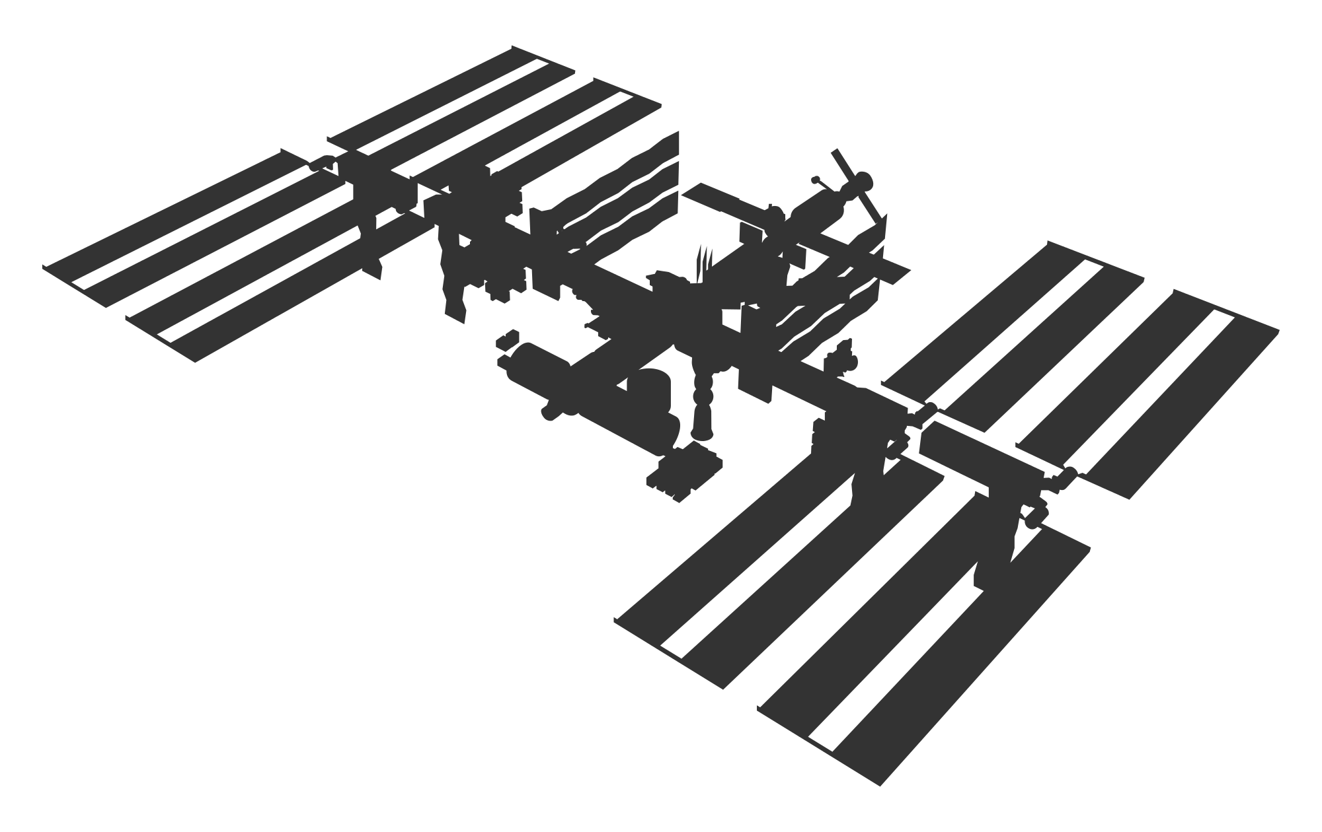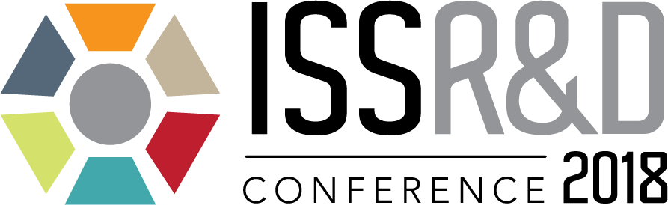

Attend the University Outreach Day at the International Space Station Research and Development Conference in San Francisco!

Get involved with research and engineering on the International Space Station

Engage with industry leaders at NASA, CASIS, Boeing, Bigelow Aerospace, SpaceX, Orbital ATK, Sierra Nevada Corporation & others!

Event to include a presentation by an Astronaut, career panel, student space research panel, access to exhibit hall, and a networking reception with scientists and engineers, academic researchers, entrepreneurs, policy makers, business development professionals, and other students.

FREE for undergraduate and graduate students

Date: Thursday, July 26, 2018
Time: Noon-4:30pm (free admission valid only during these hours)
Location: San Francisco Marriot Marquis, 780 Mission St, San Francisco
Please RSVP to attend: https://www.eventbrite.com/e/issrdc-university-outreach-day-tickets-45912200628
-or email- RSVP@iss-casis.org

www.issconference.org
