PROVIDING DESIGNERS INSIGHT INTO
VISITOR EXPERIENCE AND VALUES WITH APPLIED ANTHROPOLOGY

A Project Report
Presented to
The Faculty of the Department of Anthropology
San José State University

In Partial Fulfillment
Of the Requirements for the Degree
Master of Arts
In Applied Anthropology

By
Jasmine Low
May 2020

© 2020
Jasmine Low
ALL RIGHTS RESERVED
The Designated Committee Approves the Project Report Titled

PROVIDING DESIGNERS INSIGHT INTO
VISITOR EXPERIENCE AND VALUES WITH APPLIED ANTHROPOLOGY
By

Jasmine Low

APPROVED FOR THE DEPARTMENT OF ANTHROPOLOGY

SAN JOSÉ STATE UNIVERSITY

May 2020

Jan English-Lueck, Ph.D. Department of Anthropology

A. J. Faas, Ph.D. Department of Anthropology

Charlotte Sunseri, Ph.D. Department of Anthropology

ABSTRACT

PROVIDING DESIGNERS INSIGHT INTO
VISITOR EXPERIENCE AND VALUES WITH APPLIED ANTHROPOLOGY

By Jasmine Low

The gender gap in STEM is often described as a pipeline problem, as different cultural and societal agents shape children’s choices so that girls are subtly steered away from science and technology. Reducing the gap is a distributed effort that involves employers, educators, politicians, and even museums. Designers at the Tech Interactive, a science center in San Jose, California, sought to better understand how girls experience hands-on, engineering challenges in their makerspace area called the Tech Studio. In this work, I surveyed and interviewed both designers and young visitors to understand the alignment of their values in the context of the Tech Interactive’s mission to “inspire the innovator in everyone.” In order to include context for these values I carried out observations of visitors during their engagement with the Tech Studio using audio and video recording, photography, and field notes. My sample included 4 designers, and 23 youths aged 4 to 15 years old, of which there were 16 girls and 7 boys. While boys and girls both exhibited STEM identified behaviors, unsurprisingly, boy’s STEM-related preferences and activities appeared to relate more to the theme of high-tech industry, and girl’s STEM-related preferences and activities appeared to relate more to themes of empathy and care. This reflects the general trend that motivates the Tech Studio’s inquiry into how girls interact with their STEM programs, to better understand and possibly address this gap in the spirit of their mission to help build civil society and support self-actualization. The most significant insight about the designers’ guiding values was the central importance of appealing to people with low-STEM confidence. My research indicates they are succeeding, as the majority of visitors had a positive experience, except in the few cases of family member interference. Nevertheless, I argue that designers’ focus on inclusion of people, thought as a collection of genders, ethnic groups and ages, should be adjusted to encompass the distinctive values carried by female visitors, rather than focusing on girls per se. In fact, using a comparative analysis of boys’ and girls’ interviews, I point out how girls, even in the context of STEM-oriented activities, appeared to value empathy and care more than boys, while boys appeared to value conventional themes of high-tech industry, such as functionality and performance. Therefore, this research implies that designing for inclusion means designing to be more inclusive of values. With this in mind, rather than trying to “make girls more like boys” I suggest that designers consider how they might acknowledge feminine values that girls bring to the Tech. These insights were delivered to the Tech Interactive in the form of a presentation, slide deck, case studies and short films.

ACKNOWLEDGEMENTS
My deepest thanks go to the scholars, designers, young people, and their families whose words and ideas have contributed to this project. Lauren Cage at the Tech Interactive helped me develop the initial ideas for this project and provided essential coordination and access to my research site. The Experience Development and Prototyping team at the Tech Interactive welcomed me into their workspaces as a colleague, offering me a base to conduct fieldwork and a glimpse into the dynamic and exciting world of design. I thank them for their insight, collaboration, and friendship. I was inspired by the ways they went about their work and am humbled to see first-hand how big-hearted people like them work every day to build a more civil and resilient community. I am grateful to scholars near and far, whose writing provided vision and framework. Thank you especially to Toni Dancstep, Emily Dawson, and Emily MacLeod who responded to my emails and supported this project by sharing articles, instruments, and words of encouragement. I thank the girls and boys, and their families, in the Tech Studio who graciously welcomed me into a portion of their day out together. I am better off for the chance I had to appreciate life from their perspectives, as well as the chance to observe their enthusiasm for learning and the trusting ways they depend on family and community caregivers.
A constellation of mentors, colleagues, and friends supported and enriched this project throughout its development. The MA Program in Applied Anthropology at San Jose State University provided me with an opportunity to associate and mentor with a marvelous group of anthropologists including A.J. Faas, Jan English-Lueck, Charlotte Sunseri, Marko Meniketti, John Marlovits, and Chuck Darrah. They each shared inspiration and critical ethnographic and analytical tools that allowed me to carry out and complete this project. They hosted me during their office hours, after hours, and extended their professional networks to support my ongoing professional development. I am especially grateful to my project chair and advisor Jan English-Lueck, for her wisdom, mentorship, and continual guidance through the pleasures and difficulties of research and writing. Her skill and passion for research inspired me to join the MA program and encourages me still. My committee members A.J. Faas and Charlotte Sunseri have my gratitude for the skill with which they sharpened my ideas and raised expectations, while never failing to remind me of their support and confidence in my abilities. I thank them for their generous engagement with the completed drafts of this project. I had the good fortune of joining the 2018 cohort of peers who provided valuable insights and exchanges in our hallways, classrooms, homes, and cafes. I thank Melanie Bailey, Kevin Kochever, Kristen Constanza, Brett Witteck, Ashley Estrada, Andrea Vinke, and Jeff Greger for their support, direction, and companionship. I look forward to many more conversations together.
Friends and family outside of my academic circle were a vital source of energy and perspective. A heart-felt thanks goes to Sahar El Abbadi who shared her experience and support as I refined my approach to research. My immediate and extended family cheered me and provided me with a place for love and renewal. My nieces and nephews taught me to respect and to listen intently to the experiences and perspectives of young people. My dear husband Fausto D’Apuzzo accompanied me along the course of this project, during which many evenings, weekends, and outings were passed by, rerouted, or otherwise compromised. I thank him for his caring patience, for clearing my way, and showing me how to dig deep, wonder more, and work hard for my goals.

TABLE OF CONTENTS

ACKNOWLEDGEMENTS
INTRODUCTION……..………………………………………………………………………….1
Networks and Theoretical Footholds……..……………………………………………….1
Problem Statement and Research Questions……..………………………..………….......6
Format of this Report……..…………………………………………………………….....9
SECTION ONE: VISITOR EXPERIENCE DESIGN……..……….………..………………….11
Defining Experience……...……...……….……………………………………………...11
Co-Productive Relationships……….…………………………………………………....12
Defining Design……..…………………………………………………………………...13
Design Friction……..…………………………………………….………………………14
From Design Anthropology into a Science Center……..……………………………......17

SECTION TWO: RESEARCH DESIGN AND METHODS……..……………………………..18
Preparations……..………………………………………………..………..…………......20
Creating Space……..………………………..……………………………….......20
Finding People and Documents……..………………...…………..…...…….......21
Sampling Strategy and Characteristics……..………………...…………..….......21
Instrument Formulation……..……………………...……………..…………......23
Data Collection……..……………………………………………………..…………......24
Recruitment and Informed Consent……..………………………..………….......25
Continuous Observation and Video Recording……..……………………….......26
Semi-Structured Interview and Questionnaire……..………………………….....27
Jottings, Fieldnotes, and Photos……..…………...………………..………..........29
Analysis……..……………………………………………………………..…………......30
Sorting……..………………………………………………..……..…………......30
Coding and Comparison……..……………………………..……..………..........30

SECTION THREE: CONTEXTUAL INFORMATION……..………………………..…...........33
Service Worlds……..………………………………………….…………..…………......33
The Tech Interactive: From Museum to Interactive……..………………..………..........36
Tech Studio: Designing for Inclusion and Access to STEM……..………………….......41
Four Tech Studio Designers……..………………………………………..…………......42
Michelle: Designing Access to Embodied Learning……..………………...........42
Roseren: Designing Access to Alternatives and Connection……..……………..45
Julia: Designing Access to Intuition to Bolster Confidence……..……………....46
Molly: Designing Access to Safe Spaces and Shared Information…………….. 48
Designing Access to Embodied Ways-of-Knowing..……..………….…………...…......50
Tech Studio Space……..……………………………………………...……………….....51
Tech Studio Programs……..……………………………………………….………….....53

SECTION FOUR: INSIGHTS ABOUT VISITOR EXPERIENCE AND VALUES………......56
Insights about Tech Studio Visitor Research…………………………….…………........56
Discussion: Language of Tech Studio Visitor Research……………………………........61
Insights About Youths: Gendered Differences in STEM Identity………………...…......62
Boys: High-Tech STEM Identity…………………………….…………..........................63
Girls: Empathic, Social, and Expressive Identity…………………………......................65
Discussion: Disrupting Gendered STEM Identity with Design…………………….........68
Curated Materials and Design Cues…………………………….…………..........69
Language of Simile and Metaphor…………………………….…………............71
Conclusion…………………………….…………............................................................73
Next Steps…………………………….………….............................................................76

SECTION FIVE: DELIVERABLE DESIGN…………………………….…………………......77
Slide Deck…………………………….…………………………………………….........77
Case Studies …………………………….………….........................................................78
Short Films…………………………….……………………………………………........80

SECTION SIX: REFLECTIONS…………………………….…………………………….........81
Restless Texture…………………………….…………………………………………....81
Inviting Politics Back In…………………………….……………………………….......84

REFERENCES…………………………….……………………………………………..….......86
APPENDIX A: GUARDIAN QUESTIONNAIRE ……………………………………..…........89
APPENDIX B: INTERVIEW GUIDELINE FOR DESIGNERS………………………..….......91
APPENDIX C: INTERVIEW GUIDELINE FOR YOUTH……………………………..….......97
APPENDIX D: DEMOGRAPHIC INFORMATION FOR YOUTH………………..…..….......99
APPENDIX E: FOUR MATRICIES COMPARING GENDER AND STEM………………..101
APPENDIX F: DELIVERABLE: SLIDE DECK………………..…..…...................................106
APPENDIX G: DELIVERABLE: CASE STUDIES………………..…..…..............................119
APPENDIX H: DELIVERABLE: VIDEO CLIPS ………………..…..….................................141
APPENDIX I: PHOTO GALLERY………..…..…....................................................................142
APPENDIX J: DESIGN INTERVETION PROPOSAL………………..…..….........................157

INTRODUCTION

Networks and Theoretical Footholds

I have created this report to document the process I used to address the research interests of the Experience Development and Prototyping (ExD&P) team at The Tech Interactive, a science center in downtown San Jose, California, a key city in the region known as Silicon Valley. ExD&P designers sought to better understand how girls experience their hands-on, engineering activities in a makerspace area of The Tech Interactive called the Tech Studio. Their concern can be placed within a larger national and international discussion regarding gender equity in STEM activities and careers. The Tech Interactive has a technologically optimistic and social mission: “to inspire the innovator in everyone” (The Tech Interactive 2020). Their vision is to directly and indirectly help build “a civil society that enables everyone, especially low-income young people, to succeed in a world driven by technology” (The Tech Interactive 2020). My research which informs this report, centers on the Tech Studio, an area in the Tech Interactive dedicated to helping people explore the process of hands-on problem-solving through open design construction activities and guided engineering design challenges.
Prior to starting this project, I was studying how anthropologists understand design, which takes into account aesthetic, material, creative, and socio-political aspects (see Murphy 2016). Murphy explains that design is often understood as aesthetic features like shapes, geometries, patterns, and relationships between these elements. Design is also a domain of dynamic, multifaceted, creative practice. Design begins to take on a more political tone however, when we acknowledge that it is a means of putting order and intention into the world, a practice whereby people intervene in the lives of others, “provisioning for one another the conditions of life in innumerable forms and at almost every scale.” (Murphy 2016, 435). In this report, I recognize these three meanings and focus primarily on design as a social force whereby people, inclusive of their values and assumptions about what is, what they deem to be good, to be incompatible, and what they imaging could be better, provision the built world for other people (Tsing 2005; Fassin 2008; Murphy 2015; 2016).
I imagined conducting research alongside designers, observing the process of form taking, as they used intuition and correspondence with the materials at hand, producing the material conditions of life and tracing how cultural identity and morality become embedded in the material world (see Ingold 2012; Murphy 2013; 2015). As I completed coursework throughout my first semester in the MA Program in Applied Anthropology at San Jose State University, I was encouraged to apply my interests and skills to address the needs of a community partner. This helped me adjust my attention to the local community, to consider what real-world design projects were taking place around me. I visited ‘The Tech’ to scope out whether I thought I’d like to pursue a partnership with The Institute for the Future. That visit to The Tech, through a casual conversation with a gallery staff member and manager, connected me to my partners in the Tech Studio. After an initial email introduction, two members of the Experience Development and Prototyping Team (ExD&P), who design and oversee the Tech Studio, invited me to meet them on-site.
Our first meetings in December 2018 were productive and engaging. I had come to them looking for collaboration and their team was looking for help to better understand their visitors’ experiences. They felt I had a lot to offer them and we were both interested in seeing what directions the project could go. At one of our meetings in February 2019, they explained that their Tech Studio programs were about shifting decision-making power to the guest. Therefore, they wanted to understand whether their guests value the design process which is at the heart of the Tech Studio visitor experience rather than simply the feelings of fun or success. How could they show evidence of this? How could they do this better? As part of the broad maker movement and community, they explained their goals were to help children develop their own identities by facilitating and modeling design thinking behavior and maker mindsets. We continued to refine our research interests together and we settled on having me help them understand girl’s experience in the Tech Studio, because they said girls were generally considered to have low-STEM identity. STEM identity is a form of cultural identity in which a person asserts an affiliation with science and technology and uses language and behavior to reinforce that association. I determined to create space in my research design to first conduct in-depth interviews with my partners in order to better understand their work and perspectives before answering their question about girl’s visitor experience in the Tech Studio. I needed to understand their service world to be able to deliver insights that speak to their values, frameworks, and processes.
As a newcomer intellectually to the fields of STEM education and museum visitor studies, and geographically to the Bay Area region, my first task in becoming a partner was to gather and survey literature from those fields to understand what conversations were happening.
While preparing my proposal, I discovered the Exploratorium, a science center in San Francisco, which hosted their Visitor Research & Evaluation (VRE) repository online and reached out to one of their senior researchers, Toni Dancstep. I also read papers authored by Louise Archer, a professor of Sociology of Education and Emily Dawson, a professor of Science and Technology Studies, both at University College London, and whose research articles helped form my initial ideas about science identity, informal science education, and inclusion/exclusion in science centers. My approach to using video methodology and the idea to create video clips as a deliverable comes from Toni and her team at the Exploratorium. The semi-structured interview instrument I developed to use with young visitors was largely informed by the instruments the ASPIRES research team created (Archer et al. 2013). Archer and colleagues (2010) assertion that young people’s lack of engagement with science is related to displays of identity, encouraged me to focus on designers and young visitor’s self-identities, preferences, and aspirations. My research aligns with Dawson and colleagues’ conclusion that girls are better able to learn science when their identities are valued in learning environments (Dawson et al. 2019), by proposing that girls’ may be better able to learn science when they can identify their values in learning environments.
In April 2019, I drew up a memorandum of understanding that outlined what the ExD&P staff at the Tech could expect from our partnership. It explained that the main goal of this project was to provide insights to ExD&P staff about visitors’ behaviors and perceptions of their Tech Studio experience, with a specific interest in understanding girls’ visitor experience. It was also designed as an educational opportunity, to allow me to practice designing and conducting formative research and to exchange qualitative research methodology with Tech Studio researchers. Our tentative objective was that this research might be used to compare visitor experience, in the words of young people, to Tech Studio designer’s ideals and directives, in order to trace out relationships, similarities, or discrepancies between design processes and youth outcomes that can support grant applications and inform future Tech Studio experience design. I agreed to prepare a research report and supply video clips that could support on-going Tech Studio visitor research purposes and professional development. We had originally imagined a more collaborative project, where an ExD&P staff member would work alongside me. However, as we came closer to beginning the project, they became unavailable for research purposes but maintained a supportive role.
I frame this endeavor as an ethnographic contribution for design, rather than of design (Murphy 2016). My research activities supported my partner’s human-centered goals and utilized my training in the humanistic traditions of applied anthropology. My focus and findings centered on the values and perceptions of two groups of people: designers who create Tech Studio programs, and young visitors with accompanying adults, who come as paying visitors to explore their programs. I used ethnographic methods to establish a better understanding of designer’s service worlds (Blomberg and Darrah 2015) and young people’s perceptions of self in the context of a Tech Studio visit and in their everyday lives. The documents I produced for ExD&P staff were created, with their language and world views in mind, to support their work by providing contextually rich insights about visitor experience and how to incorporate a more holistic, ethnographic approach for understanding the people that interact with and benefit or otherwise, from their designs.
This report and the research that supports it are based on the learning that took place as I progressed through the MA Program in Applied Anthropology at San Jose State University (SJSU). From September 2018 to June 2019, I attended graduate level classes where my professors provided us with materials and support to develop our own research projects. From June through August 2019, I conducted ethnographic-style fieldwork in the Tech Studio, taking a two-phase approach where I documented the perspectives and values of Tech Studio staff. In the second phase of research I sat alongside young visitors as they explored the Tech Studio activity of the day. This report takes into account 23 young visitor’s observations and interview data. Because of the preliminary and exploratory nature of this research project, the sample of youth was not intended to be generalizable but to be a starting place to begin to document and better understand values and ideas of young people, and to trace how they differ along lines of gender. It is not easy to appropriately or accurately represent context. I chose multiple research tools, like fieldnotes, audio recording, video recording, and photography, that allowed me to document and their observable actions and individual explanations and keep them intact after their visit had finished. In my analysis of this data, I reviewed these documents, listening for the many ways they talked about themselves as they presently are and they imagined they could-be (Bezaitis and Robinson 2018, 65). By documenting, locating, and presenting visitor’s perspectives and values in context, designers too can develop a “knowledge-supported imagination of what could-be” (Bezaitis and Robinson 2018, 65) as they work toward their goals to design for inclusion and equity in STEM activities, thereby helping young visitor’s develop as persons and prepare them to be capable citizens and problem-solvers of the future.
Problem Statement and Research questions
Toni Dancstep and Lisa Sindorf (2018) brought me into the conversations happening at the intersection of gender, STEM, and science museums, showing me how it is a concern that stretches from bodies of federal government to visitor experience designers at local museums. Over the last half-century, national and international discourse has revealed a growing concern about gender inequity in STEM programs and fields (OSTP 2013, 2018; Dancstep and Sindorf 2018). Although there have been improvements, imbalances remain, especially in females’ interest and engagement in STEM-related activities (Dancstep and Sindorf 2018, 2). National surveys show fewer girls than boys report liking math and science, fewer females take AP exams in math and science, and women are underrepresented in STEM careers (Dancstep and Sindorf 2018, 2). Museums such as The Tech and Exploratorium have taken notice, conducting their own studies on this topic. In their review of literature, Exploratorium visitor researchers found that females have fewer opportunities to participate in engaging STEM activities and that girls are less likely than boys to visit science museums (Dancstep and Sindorf 2018, 2). They confirmed in their own visitor data a similar discrepancy, noting that return visitors were often family groups with only boys (Dancstep and Sindorf 2018, 2).
Gender is becoming a significant issue for visitor engagement and learning in science museums (Dawson et al. 2019, 2). Scholars have studied whether science learning leads to science careers via young people’s aspirations, or otherwise and how differences fall along social axes, such as race, class, and gender (Archer et al. 2010; Dawson 2018; Dawson et al. 2019). In the US and the UK, researchers argue that when it comes learning science, identity, that is “who you are matters” (Dawson et al. 2019, 2). When it comes to women and girls’ lived experience, we cannot ignore the ways subjectivity, including but not limited to gender, ‘race’/ethnicity and class, intersect and trouble science learning many times over (Dawson et al. 2019, 2).
Researchers of science learning suggest that all people, including girls, are engaged in science learning when their “identities, knowledges and behaviours are valued and reflected in a given space” (Dawson et al. 2019, 2). Increasingly, however, studies document how women and girls must put in extra work to pursue science and be themselves (Dawson et al. 2019, 2). Dawson calls for urgent attention to better understand “how girls enact the identity performances they are invested in while learning science” (Dawson et al. 2019, 2). My task would be to operationalize the identity performances within the varying social contexts of the Tech Studio.
Dawson and colleagues remind us it is crucial to recognize how studies of gender, identity, and science are framed (Dawson et al. 2019, 2). Positioning girls as individually responsible for the positions available to them minimizes or obscures the limiting effects of structural inequalities like gender, ‘race’/ethnicity, and class (Dawson et al. 2019, 2). Science education is especially problematic, where these types of biases “have been repeatedly found to penalize women and girls within and beyond school” (Dawson et al. 2019, 2).
In a similar current, Tech Studio staff have initiated evaluations of their hands-on, STEM learning programs to better understand how girls engage with and experience them. Initially they used institution-wide visitor reports and anecdotal knowledge from working face-to-face with visitors when prototyping or facilitating a program. In January 2019, Tech Studio researchers completed a study that gathered and analyzed data from 8,408 family visitors on how children use and perceive of the Tech Studio makerspace. Tech Studio researchers learned about visitor’s activity paths, the number of iterations they completed during design, and helped them uncover pertinent themes like “family participation,” “perseverance,” and “iteration by children.” They reported that integrating a story into design challenges led to “greater empathy and persistence in visitors, especially for girls.” Motivated by these forays into visitor experience and program evaluations, the Tech Studio team requested that I help them understand how children, specifically girls, experience programs in the Tech Studio. The following questions guided my research activities:
1. What values guide the design of a Tech Studio visitor experience?
2. How do girls experience STEM in the Tech Studio?
3. How do youth visitor’s values compare along lines of gender and STEM?

Format of this Report
This report contains six sections and an appendix. The first section, “Background Information,” is comprised of information about my partnering organization and design anthropology. The information about the Tech highlights its place and history in Silicon Valley. The information about design anthropology outlines why I focus on morals and values in design. This material is important for understanding designers, visitor experiences, and the project in their respective contexts.
The second section “Research Design and Methodology” describes the methods I used to structure and carry out my research project. I also describe the analytical strategy I used to identify salient insights and their implications. I discuss how my Tech partner’s needs influenced my analytical processes and outcomes and how I applied ethnographic research methods to a dynamic, interdisciplinary design setting.
The third section “Contextual Information” contains information about the service worlds and physical environment where I carried out this research on how girls experience STEM in the Tech Studio. I also provide historical and present context about the Tech Interactive and Tech Studio that help situate this research design and its findings. Fieldnotes and photos of the space help readers gain a deeper sense of this dynamic and engaging place.
The fourth section “Insights about Visitor Experience and Values” provides an overview of the insights that led to the creation of my deliverables. The insights in this section respond to the research questions that guided my research activities throughout this project. This section is the heart of this project, providing ExD&P staff understanding about youth visitors’ experience and insights regarding female visitors’ values and identity with the Tech Studio’s STEM-based activities. I have included how I will deliver the findings from this applied project to my partners.
The fifth section “Deliverable Design” describes how I prepared to deliver the insights from this research project to my partners at the Tech Interactive. I explain how I sought out a variety of lengths and communication styles that would appeal to the language of design. I detail how I created 5-minute films, a brochure-like slide deck, and longer, context rich case studies. This section provides an approach for presenting anthropological findings to a design team and the lessons I learned along the way.
The sixth, and final section, “Reflections” is a contemplation on how applying anthropological approaches to a civic, social justice driven design team at a Silicon Valley science center provided me with a remarkable opportunity and some constraints. In this section I describe how being a newcomer to the area forced me to think about the work of inclusion in the context of a Silicon Valley high-tech milieu in new ways. I have included them because I felt they may be relevant to readers, particularly applied anthropologists.
The appendices include: (a) the guardian questionnaire; (b) the interview guideline used with ExD&P staff; (c) the interview guideline used with youth; (d) demographic summaries of youth participants; (e) matrices that led to insights about girls and boys values in relation to STEM; (f) a project deliverable: PowerPoint slide deck (g) a project deliverable: case studies; (h) a project deliverable: video clips; (i) a photo gallery of images taken during fieldwork; (j) a design intervention proposal
SECTION ONE: VISITOR EXPERIENCE DESIGN
In this section I introduce my working definitions of experience, co-production, and design. I introduce the critical approach taken up by design anthropologists which explains why I chose to focus on designers’ and visitors’ values in this project. This material is important for understanding my framing of this research, designers, and visitors in the Tech Studio in their respective contexts.
Defining Experience
The idea that museums can be designed as environments for a visitor experience rather than simply a place to store and display objects reflects a broad shift in the way museum-like spaces have been organized, arranged, and managed (Roppola 2012). Over time, the focus has moved from “space making to holistic experience making from the design of ‘static architectural spaces towards dynamic mediated experiences,’ blending artefacts, architecture, and new technologies for increasingly media-literate audiences” (Greenberg 2005, 227 in Roppola 2012, 38). Museums have not only become a place for encounters between people and “materiality, the stuff of nature and culture” but to be understood as intentionally enabling a “dialogic relationship between the thinking, feeling visitor and the knowledge-orchestrating museum” (Roppola 2012, 38). To view the museum as “a dynamic knowledge structure” and myself as “a dynamic cognitive structure” acknowledges that visitor experiences are an exchange between visitor and museum (Roppola 2012, 38), that are negotiated and result in transforming both entities, albeit with varying degrees and permissions. The visitor experience is at the heart of a transformational service a museum, or science center like the Tech Interactive, provides.
While the word experience is commonly used, it is a rather “slippery” notion without a definition (Roppola 2012, 38). Tiina Roppola identified four broad ways that the notion of experience is commonly used in museum and museum-like contexts: 1. “to reflect the multidimensionality of museum visiting,” 2. to “suggest alliance with particular views of learning,” 3. “to acknowledge the coproduced relationship between visitor and museum,” and 4. To emphasize “the importance of maximizing emergent experience” (Roppola 2012, 39). In these findings, I use the third idea, that visitor’s experience is a co-produced relationship between visitor and museum.
Co-productive Relationships
The concept of co-production inspires me to think practically about how design practices can facilitate positive change for underrepresented publics in a museum. joni m. palmer explains that public art becomes ‘public’ through people's engagement with it (palmer 2018, 70) and that engagement is important for building relationships between individuals, public art installations, communities, and public art programs (palmer 2018, 71). Some artists request or require public involvement, giving artwork “social potential.” People interact with a piece because it positively or negatively resonates with them, motivating them to express that meaning or importance to others. Thus, members of the public participate in the on-going production of that piece, long after the designers have finished their work. Co-productive acts include many people acknowledging, interacting with, reflecting, and sharing with one another a work of art. Through these social sequences, art becomes a memorable and meaningful part of individuals and of the community, and this, palmer argues, is what ultimately benefits public arts programs. In this sense, the concept of public art shifts from a product to a process, “a social medium instead of a mere aesthetic form” (Guinard 2018, 131). Guinard (2018) points out that limited recruitment of participants in a public art project may reinforce socio-spatial cohesion and division between spaces and social groups. Despite this outcome, she argues the artists’ approach may be an effective tool for reimagining our cities today to produce them differently tomorrow (Guinard 2018, 132).
Defining Design
When I started inquiring about graduate studies in applied anthropology at San Jose State University in 2018, my academic interests focused on understanding how anthropologists were adapting their methods to contribute to design practices. I use anthropologist Keith Murphy’s (2016) framing of design as a basis for my approach to this research project. Murphy’s work draws together, details, and evaluates anthropologists’ decades-long contributions to the design field and is recognized for offering scholars a critical framework for examining “design and designing things” (Murphy 2016, 433).
When the word design first entered the English language, as early as the fourteenth century, its usage was closer to that of the contemporary word designate. In the sixteenth century, “to design” was used in two senses, “to plan or intend something; and to draw or trace out forms” (Murphy 2016, 434). By the eighteenth century, the meaning of design was used in a more restricted sense, “to draw for the purposes of construction” (Murphy 2016, 434). Then, by the late nineteenth century the verb to design became simply an activity that was linked with architecture and other creative professions. Today, English-speakers use the word across a wide-range of contexts, but prominent usage tends toward “the technical, the professional, the modern, and the aesthetic” (Murphy 2016, 435). By considering the nuanced and various characterizations of design made by historians, designers, and anthropologists, Murphy (2016, 435) points out they all take into account four features, "form, order, planning, and intention.”
In anthropology, the study and usage of the word design has persisted in two broad and largely distinct senses. The first is design as aesthetic features like shapes, geometries, patterns, and relationships between these elements, which emphasizes form and order form and order while disregarding the role of human actors (Murphy 2016, 435). In a second sense, design as a complex domain of creative practice, like the work of urban designers, architects, and advertisers, emphasizes design features like “planning, practice, and intention” but deprioritizes form (Murphy 2016, 435). Murphy argues that neither branch of this bifurcation is wrong, but separately, they are incomplete. What these definitions of design are missing, he argues, is design’s inseparable connection to politics and the ways some people exercise control over others. When we examine these characteristics of design together, design as purposeful human action, done with intention to put form and order into the world, we see that design is also an attempt to produce a “push,” to nudge people’s behavior in a direction (Murphy 2016, 435). Murphy’s research and analysis reveals a critical aspect of design in social scientific and other critical studies: design as “humans provisioning for one another the conditions of life in innumerable forms and at almost every scale” (Murphy 2016, 435). He brings politics to the foreground, making it clear how design is a common way people intervene in the lives of others by furnishing the objects, technology, and built world that enable and constrain how we conceive of and put our life projects into practice (Murphy 2016; Manzini 2015).
Design Friction
If we accept Murphy’s definition of design as an intentional attempt to order, sort, and produce some effect, then Anna Tsing’s (2005) writing illuminates the social processes of design, the process of embedding particular meanings in things (Murphy 2013). Tsing writes that we should not assume collaborations simply share information, that collaborators share common goals, nor that everyone benefits (Tsing 2005, 13). Collaboration are a social process that work to highlight and extend certain aspects of life, while simultaneously “ignoring, suppressing, or stripping away what is deemed incompatible” (Tsing 2005, 13). Tsing calls this process friction. As new knowledge is produced, new gaps are created via collaborative friction (Tsing 2005, 13). The smoothing action of friction alters trajectories, “enabling, excluding, and particularizing” (Tsing 2005, 6). In the networks that support design and designing things, a similar semiotic process shapes how things are made—and “made to mean” demonstrating how design is never politically neutral (Murphy 2013, 128).
In his detailed ethnographic research on design in Sweden, Murphy (2015) traces how material form is embedded with meaning, including through the designer’s actions, the design world, exhibitions sites, and the language of social democracy. He traces how actors in these domains relate to each other, documenting their reciprocal effects clarifying another facet of design, “design as a social force” (Murphy 2015, 7). Designers give form to materials by “refining, deliberating, changing, and preserving them” (Murphy 2015, 133). He argues that even if hand gestures and things designers say in the course of making a design don’t touch the material, they “do leave marks” on those objects (Murphy 2015, 147). When a designer shakes her head, draws a line across a sketch, and turns a page, the possibilities of that design contract. Whereas, when a designer uses a phrase like “It could be…” or “let’s try” the possibilities for that design expand (Murphy 2015, 147). Murphy argues that designers do not simply choose which qualities they like over others but that their choices are conditioned by patterns of interaction over time that result in reintroducing dominant “cultural geometry” into their designs.
In Sweden’s design networks and across exhibition sites, actors reproduce the conditions by which objects affiliate or disaffiliate with dominant, normative Swedish design. Governments, corporations, and individuals can promote their ideologies by enabling and limiting which objects are on display in fairs, museums, libraries, showrooms, and window displays, magazines, and websites. Exhibiting designs to the public selectively constructs and reproduces Swedish design. These microcosms of a better social world are powerful because they manipulate viewer’s sense of time, relying on embodied, sensory experience, and they manipulate space and scale to create new boundaries of what is considered Swedish design. Actors with financial power can back designers and design projects that align with their ideas of “good” design and designers navigate these structures of recognition and funding to be able to both support themselves and achieve artistic freedom (Murphy 2015, 121).
With Murphy’s work in mind, I focused on design as a social force whereby people, inclusive of their values and assumptions about what is, what they deem to be good, to be incompatible, and what they imaging could be better, provision the built world for other people (Tsing 2005; Fassin 2008; Murphy 2015; 2016). Design is not only a practice of manipulating materials into aesthetic or functional forms, but simultaneously and regardless of intention, a means for rearranging and (re)producing interests and identities, sometimes standardizing knowledge and meaning. Design spaces can be imagined as foundries of friction—melding, reworking, and maintaining semiotic relationships between people, power, and things. The critical and expansive approach put forward by these thinkers aligns with Didier Fassin’s (2008) appeal for a moral anthropology that does not propose what is good, guide toward what is better, nor evaluate in terms of a moral position the anthropologist might have. Rather, Fassin’s approach to research aims to reveal the principles and practices people use to guide, measure, steer their actions, and justify how they interpret differences between what exists and what could be (Fassin 2008).

From Design Anthropology into a Science Center
With this literature in mind, I framed my project as an exploration into the burgeoning field of design anthropology and a contribution for design, rather than of design (Murphy 2016). As a result, I designed this research in two phases: an initial phase to discover how values and identity guide the Tech Studio experience design and a second phase to discover how a sample of youth identify with and relate to those values during a visit to the Tech Studio, with particular attention to the female youth experience, in all its variety. In my analysis, I compared and contrasted male and female visitor experiences, their preferences, aspirations, and perspectives of self to see whether and where they diverged in relation to STEM in order to examine identity in relation to STEM fields. These two phases together take up design anthropologists’ call to contribute a more comprehensive understanding of the conditions of those who design experiences and physical things, and of how the conditions of design translate to social effects (Suchman 2011; Murphy 2016), in this case, as experienced by female youth visitors.
The social effects in this case can include both the short term and long term the emotional and cognitive outcomes, that is, the experience of fun, success, engagement, and the development of affinity, identity, and mindsets that result from a single visit and interaction with the Tech Studio and the cumulative effect of returning many times. While the scope of this research cannot tell us whether the designers’ efforts had their long-term, intended social effects, documentation of visitor’s behavior and perceptions of their Tech Studio visit, coupled with documentation of the ways their visitors talk about themselves and their interests (affinities) can give us clues as to whether the designers’ intention for certain social effects are taking place. This discussion is revisited in more detail in Section Four “Insights About Visitor Experience and Values.”
SECTION TWO: RESEARCH DESIGN AND METHODS
In order to answer my guiding research questions, I recruited 29 participants, including 4 designers and 25 youths to participate in my study. My research methods included observation, interviews, and surveys. My observations were exploratory using fieldnotes, photography, audio, and video recording. I conducted Interviews that were open-ended but guided by the interview instruments. I designed two surveys that were completed by ExD&P designers and young visitor’s parents/legal guardians. In this section I will discuss the process by which I developed my research process, including my sampling strategy, my instrument design and how I prepared to immerse myself in the world of informal science and technology education and Tech Studio culture.
Ethnography is both a fieldwork practice between an anthropologist and a group of people, and a visual and written document where anthropologists communicate “experiences, findings, and analysis to our students, academics, and the broader public” (Lamphere 2018, 65).
As a fieldwork practice, ethnography is a systematic, scientific, and investigative approach to studying the social and cultural life of communities and institutions (Schensul, Schensul, and LeCompte 2010, 1). Ethnography is a research methodology that emphasizes people as “social beings inhabiting rich cultural worlds” (Murphy 2016, 440). Ethnographers enrich participant observations with in-depth, semi-structured interviews so that people can provide background and meaning.
Today, applied anthropologists adopt a collaborative and often activist approach to research, focusing on social justice issues like social discrimination, human rights, and poverty in a variety of places including workplaces, health clinics, city streets, public parks, and governments offices, locally and abroad (Lamphere 2018). Applied anthropologists view the people they study as “partners and collaborators,” striving to apply their knowledge to not only solve problems but to use their research findings as advocates when intervention or activism can serve the pursuit of social justice and protect their partners’ interests (Lamphere 2018, 64).
Applied anthropologists’ methods and approaches have carried over into for-profit domains through advertising since at least the 1950s (Graffam 2010; Murphy 2016) and through computer-supported collaborative work (CSCW) for systems engineering and software usability since at least the early 1980s (Suchman 2011; Murphy 2016). Anthropologists drew inspiration from the Scandinavian tradition of participatory design (Greenbaum and Kyng 1991), working alongside designers, and helping to usher in what is now a standard practice in design anthropology (Murphy 2016). In the 1990s, the term “design ethnography” emerged in interdisciplinary contexts as a methodology for accessing “what people do, what they say, and what they think” (Salvador et al. 1999, 36) beyond what researchers can learn from surveys and focus groups (Murphy 2016). Applied anthropologists who collaborate with designers on interdisciplinary teams to develop new products and services has come to be called design anthropology, a burgeoning field that has gained some prominence in academic and corporate circles since the early 2000s (Wasson 2000; Murphy 2016). In addition to bringing a more holistic perspective to the study of people in for-profit and non-profit contexts, design anthropology brings new understandings of the design process itself. Anthropologists reflexively examine relationships between “skills, practices, and materials in design” and collaborate with designers throughout the design process to contribute observation and critical analysis that can be appropriately fed back into the design cycle (Murphy 2016, 440).

Preparations

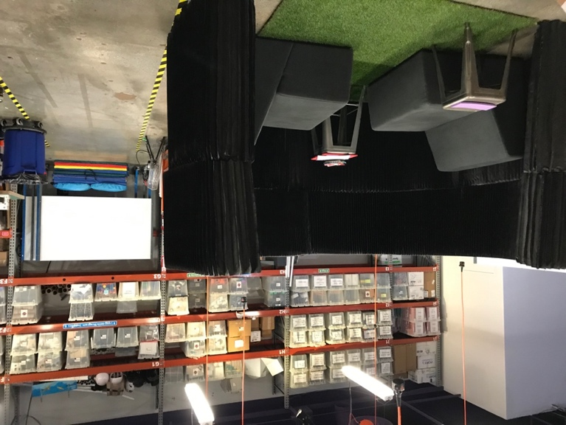
Creating Space. In the days leading up to data collection, the ExD&P team cleared space at a desk for me to keep my belongings during the days I collected data. This allowed me to spend time behind the scenes in the morning, during lunch break, and at the end of data collection while I uploaded and organized files. It was a wonderful opportunity to develop more personal relationships with my partners at the Tech. I created a half-page introduction to my research along with a headshot that the ExD&P team used to introduce me to staff. I printed off a copy of this introduction, along with a document that described in my more depth, the purpose of my study, and the methods I would be using. I covered it in colorful post-it notes to fit in with the feel of the office and left it up for the team to browse if desired. Tech Studio staff helped me create my own interview booth. I designed the space to be private enough to capture clear audio, but public enough to allow parents and youths to stay in line of sight. The result was a space I created with accordion-like “molo” walls, two couches from the Tech Studio B area, a piece of fake grass, two stools for end tables, some colorful red and purple foam to bring some color in, a pile of white 8x11 papers, and a basket of colored markers in a plastic basket. It felt official, whimsical, and provided both a degree of privacy and publicity. The molo walls provided sound dampening for clear audio recording the interview studio’s lack of door and proximity to the public area allowed parents and young people to maintain a degree of visual and auditory contact to each other.
Adapting space for an interview studio
Finding People and Documents. As a female who does not identify strongly with STEM fields, I was unfamiliar with efforts in the past decade to involve girls and minorities in STEM and had no formal understanding of discussions around girls' access and inclusion in science museums and STEM education. To remedy this, I sought out three documentation resources: people, online databases, and review articles (Bernard 2006, 96). Those people included my research partners at the Tech and directly emailing authors of papers I was reading, like Toni Dancstep at the Exploratorium, and Emily Dawson with the ASPIRES project in London. I used the following academic databases: AnthroSource, Google Scholar, and SJSU’s Martin Luther King Jr. Library. These databases provided me with access to the literature in the fields of science museum visitor studies and science communication. In order to first understand Tech Studio identity as it is officially portrayed, I requested paper and digital copies of documents. The primary way I received digital documents from the Tech Studio team was through their Slack Channel. I reviewed each of these documents and referred back to them often to orient myself to the team and to summarize passages that describe the Tech Studio’s public-facing goals, interests, and values, what I refer to as their identity.
Sampling Strategy and Characteristics
Phase I: My sampling strategy was purposive. In purposive sampling, you decide what subpopulations you would like to learn from, and then go out and find them. Purposive sampling is appropriate for in-depth studies that require knowledge from informed participants, rather than randomly selected respondents (Bernard 2006). I chose this non-probability sampling method because I was interested in obtaining personal narratives from ExD&P designers about how they understood their design work and the people they design for, rather seeking to understand attributes about designers generally. In our first meetings we established that our study would be limited to the Tech Studio, so I relied on my partners to identify and provide me with emails of members of the staff members who help shape Tech Studio programs. This led to seven ExD&P staff interviews, which during analysis I narrowed my sample to four ExD&P staff whose decisions and daily tasks most directly shape Tech Studio programs. While it could have been useful to also speak with administrators who oversee the ExD&P team, or exhibits, engineering, and gallery staff who help the ExD&P team carry out their tasks, I limited my attention to this subset of the ExD&P team to be able to also collect data about young visitors during the summer. To request their participation, I created a cover letter email with a link to an online scheduling tool, Doodle, where participants could choose a date and time. This tool allowed me to limit the days I had available to stay within my research timeline and provided my partners with a variety of times to fit my interview into their dynamic schedules. I created a spreadsheet to keep track of my interviewee’s name, email, whether I’d sent them a recruitment email, and the date they chosen for their interview.
Phase II: My study population later shifted to visitors. I used quota sampling to select participants. In quota sampling a researcher decides on a population and subpopulations that they are interested in based on variables that are of interest to their study (Bernard 2006). For example, because I was interested in female youth visitors, I made my main variables gender and age. As my data collection period was necessarily limited to the months of June through August, when the period of public school field trips to the museum had finished, my research partners and I chose to focus our study on youth visiting in family groups. Limiting my focus to family groups allowed me to obtain parental consent and the youth participants’ assent. In consultation with my advisor Dr. Jan English-Lueck, we determined my population should include youth visitors between 8-19 years old. This age range includes the transition period when youth become aware of gender roles and career paths (Wang and Dengol 2017). In quota sampling, the proportions of each variable are determined before beginning research and then filled as you seek informants. I used family group visitors who enter the Tech Studio area as an initial place to select otherwise unlisted youth visitors. The following table shows the demographic variables and number of participants I proposed and actually sampled:
Proposed Sample | Youth Visitors 8-19 years
 | 15-20 Female | 15-20 Male | 0-5 non-binary, gender diverse | 0-5 Prefer not to answer
Actual Sample | Youth Visitors 4-15 years
 | 15 Female  (4-15 years old) | 10 Male  (6-13 years old) | 0 | 0
Table 1: Quota Sample of Youth Visitors in Tech Studio
I conducted formal observations of 23 youth and recorded interviews with 22. From the beginning, this project was designed to be exploratory and did not seek generalizability. While there were very busy days and moments, like the Teacher Appreciation Day, I found it difficult most days to recruit, either because of low visitation, some preferring not to participate in the research, or in an effort to increase diversity in my sample by age, gender, and ethnicity.
Instrument Formulation. I created a simple verbal screener, a script for obtaining legal guardian consent, a script for obtaining minor’s assent, an observation guideline, a guideline for key-informant interviews, and another for youth visitor interviews. I relied on the experience of other researchers to design my instruments. I patterned my observation guideline and key-informant interview guideline after the instruments Jan English-Lueck created for the Reengineering Nature research project (English-Lueck, J.A., Email message to the author, March 13, 2019), a study based in the Silicon Valley region that I have participated in since 2019. The Reengineering Nature guideline was designed to be used with Silicon Valley cultural and technological innovators. To create the young visitor interview guideline, I used questions from the ASPIRES Year 6 research interview guideline (Emily MacLeod, email message to the author, May 7, 2019). ASPIRES is a longitudinal study based in the UK at University College London studying young people’s science and career aspirations. The Year 6 guideline was designed to be used with youths aged 10-11. I created the parent survey using a selection of questions taken directly from the Tech’s 2018 Annual Visitor Survey Report. I created the survey on Qualtrics and provided parents access to it on an Apple iPad that I had access to through my partners in the Tech Studio. Parents also read and signed their consent to participate using the iPad.
Data Collection
In order to document designers and young visitor’s experiences, I used a number of tools. I carried a notebook and pens for fieldnotes, a smartphone for photos, an iPad tablet for consent forms and surveys, a voice recorder and lapel mic for voice recording, and a Go-Pro Hero 3 camera fitted on a chest mount for video recording. I was trained in using all of these tools for ethnographic research, except for video recording. To familiarize myself with ethnographic and visitor research methods, I relied on recent publications where ethnographers and visitor researchers explained their use of video for research (Jordan and Wasson 2015; Gutwill, Hido, and Sindorf 2015; Burbank, McGregor, and Wild 2018; Scull and Agafonoff 2019).

Recruitment and Informed Consent
Phase I: Designers. Prior to meeting, I sent Tech Studio staff the consent form ahead of time so that they would have time to read the consent form. The form was designed to make information easy to find, with clear headings and clear designation where sensitive information, like video and audio would be used.
Phase II: Youth and legal guardians. Each day I conducted observations, I set out a large sign to let people know we were filming in that area. Notably, like most other signage in the Tech, it was in English, which might have posed a problem for visitors with low English literacy. All visitors passed an additional large sign near the entrance, notifying visitors that they may be recorded while in the Tech Interactive. I became familiar with staff members and made a point to wear my Tech branded nametag.
When a family with children approached the Tech Studio, I would wait until they were greeted by staff, invited into the space, and showed interest in staying there. I then introduced myself to one of the parents. If they accepted, I provided them with the consent form I had loaded on an iPad. While they reviewed it, I introduced myself to the youth participant. Where a family group had more than one child, I invited all youth to participate and used my sampling matrix to determine which gender and age to focus my observation on.
When speaking with youth participants, I introduced myself as a researcher who helps the people who design this space, to learn how young people like them use and think about the activity. What we learned would help the designers build new activities with these youths specifically in mind. I made a point to introduce my camera and asked if they would mind if I used a camera. I encountered a variety of preferences regarding visitor’s comfort with data collection. While most people I approached were pleasant and welcoming about joining the research, some would participate but only if there was no video and no identifying photos, or only with audio, or only with me taking notes in my notebook. In two instances, mothers were visibly uncomfortable with me collecting data about their families and I assured them it was not obligatory in any way and wished them a good day. Because I had multiple methods for collecting data, I could be flexible with visitors’ preferences, always prioritizing visitor comfort and ethics. The challenge of having data in various formats meant comparing observations were less straightforward as if they had all been in say, survey results or interview transcripts. Data formats ranged from an informal discussion with one girl, just the audio and photos (no faces!) with another, simply fieldnote jottings with another, and the full suite of video observation, fieldnote observation, photos, and follow up interview with another. I maintained an attitude of appreciation that these families were willing to give me any amount of their time on their day off together.
Kylie 9, helped document her Tech Studio experience by wearing a video camera
Continuous Observation and Video Recording
In order to collect data about visitors, staff, and exhibit engagement in a dynamic environment, I used continuous monitoring (Bernard 2006, 413) and audio/video recording (Bernard 2006, 423). Visitor experience researchers at the Exploratorium used video to observe visitors in their Tinkering Studio makerspace (Gutwill, Hido, and Sindorf 2015). Jordan and Wasson (2015) found time-stamped video data formed the backbone for communicating insights between scholars from different disciplines and that this more "objective" data stream allowed for counting, measuring and could create a large digitized database for analyzing activity patterns. Dr. English-Lueck and I worked with our IRB to determine how to use video recording ethically with children in a public space which involved informed consent from the accompanying parent and assent from the child being filmed or wearing the camera. I always asked the youth participants if they would like to wear the camera or if they preferred that I wear it. I conducted continuous observation, sometimes wearing the camera, and sometimes beside the participant wearing the camera. When I wore the camera, I sat across from them, moving with them when they moved from their table, to collect building materials, back to their table, and to the testing rig. Some participants moved often, others spent a lot of time at the table creating and testing only occasionally. I needed to be quite mobile to keep the subject in focus and to capture their audio. When youth visitors were willing, I filmed the experience with help from the participant wearing the camera and/or voice recorder which allowed me to put my focus into observing and taking jottings.
Semi-Structured Interview and Questionnaire
I conducted seven interviews with four staff experts and twenty-two young visitors (15 girls, 7 boys). The semi-structured format of the interviews with staff, reserved for an hour and a half in the middle of their work day, allowed us to time to speak casually and candidly about their work, their life outside of work, the people and places that influence how they think about their approaches, and their optimistic and pessimistic take on the future of their programs in the Tech studio. In contrast, the interviews with youth came in the middle of a day with their family, and as such, I was mindful to keep our time to around 10 minutes. Youth interviews ranged from 3.5 minutes (6-year-old Casey whose mom was hurrying us along) to 17 minutes (13-year-old KJ who shared a seemingly never-ending list of interests and activities). The average interview was about 8 minutes.
When a participant or parent indicated they were finished, I invited them to join me in my “interview studio” for a short interview. At this time, I provided a survey questionnaire for the legal guardian to complete, which served a couple purposes. It allowed the legal guardian to provide me with demographic data about their child and the family they come from. The open-ended, text-entry questions allowed the parents to use their own words to describe their child and thoughts about raising their child. It also helped me avoid a potential third-party effect, that children would respond to questions to please their parent nearby, also known as a social desirability effect (Bernard 2006, 242). I did not mitigate a social desirability effect that the children might have had toward me. I sensed in one interview in particular, KJ, that perhaps he had a lot of practice talking about himself to adults, in a way that impressed them. For tools, I used a voice recorder and a stack of paper and markers. Based on literature about working with children, I initially thought that children might find it easier to communicate about themselves if they could draw a picture. This appeared to be the case with three participants and a younger sibling who each showed eagerness for and used the markers and paper (ABear, Daphne, Gemma, and the little sister of Casey). No other participants appeared to pay much attention to them. Instead, I found that most kids were comfortable simply having a conversation with me.
These piloted, semi-structured questions were guided but open-ended (Bernard 2006, 210). The flow of the interviews was guided by the interview instrument to ensure I addressed themes and questions related to the research. The open-ended nature of interviewing allowed youth participants to use their own terms to introduce themselves, their interests, affinities, and aspirations. Open-ended questions also allowed for unexplored topics to emerge. To finish our engagement, I thanked the youth participant for their help and walked them to their parents, thanking them also for their participation. Due to precedence with other research projects in the Tech Studio, the team was not willing to provide compensation for visitor’s time.
Jottings, Fieldnotes, and Photos
In the times when visitor traffic was slow or I was unable to recruit, I would take jottings in my notebook that I always had on hand. I used three types of fieldnotes: jottings, field notes, and photos to capture detail about the day’s events as I observed them and to reflect on my journey as a researcher. I carried a small, wire coiled notebook to jot down observations, phrases, and questions that came up. I wrote over 200 pages of handwritten jottings. As I rode public transportation home each day, I would re-read my notes into my microphone and record this unedited stream of words on my Evernote app. When I got home, I would take a couple hours to flesh out and edit the notes into a Word document, generating hundreds of pages of text. I then saved these digital fieldnotes using a standard format to organize and locate the file by date. Photos were an important form of jottings for me, for capturing context and for following the movements of participants in a busy makerspace. I used an iPhone 7 to take the photos and organized them using participant’s pseudonyms. Over the course of the project, I collected 500 pictures documenting the Tech Studio space as it changed from day to day, the materials set out, participants’ design challenge experiences, the larger environment of the Tech Interactive and the streets adjacent to its location

Analysis
Sorting. Analysis is a process of constantly winnowing the data you accumulate. Analysis is continuous, from the beginning to the end. It involves deciding what data is worth acquiring in the first place, sorting the data and discovering the essence, or themes, that respond to your research questions. It involves sorting data into inductive categories, comparing with negative cases, and getting rid of the rest (Bernard 2006, 492; Wolcott, 2009, 39). The critical task of the researcher is not to impress readers with how much they have observed but to demonstrate how well they have observed (Wolcott 2009, 40).
Wolcott (2009) advises researchers to begin with data sorting, by identifying a few broad categories that you can sort all of your data into. One way to organize any study that focuses on the effects of one group of status trying to produce an effect on those in another group is to use to sort all your data into 1. Target Group; 2. Innovating Organization; 3. Interaction Setting (Foster 1969 in Walcott 2009). In the case of my research, I was interested in ways the Tech and its staff work to effect change on their visitors and society. Therefore, the largest categories that organized my analysis, findings, and deliverables included data about 1. Tech Studio Staff; 2. Youth Visitors; and 3. Interaction Setting: The Tech Studio.
Coding and Comparison. Comparitive methods, such as coding, pile sorts, and matrices were indispensable to my analytical process. My process involved preparing transcripts, careful reading and re-reading, coding, memo-writing, and textual analysis, to develop matrices whereby I compared gender to visitor experience and involvement in STEM-related activities. Carrying out these steps allowed me to spend many weeks and months with my research participants words and images.
The first step in analysis is to create transcripts, verify they match the audio, and anonymize any identifying information. In phase I, I used voice-to-text software from OTranscribe to generate transcripts for four key expert interviews. These interviews were rich in detail and I first identified expert staff’s answers to my interview questions, placing them in a matrix to compare answers between the four staff interviewees. As I made subsequent passes over the text, I created new matrices to extract what values and assumptions made up the Tech Studio team culture and identity. I organized bits of interviewees’ verbatim text in matrices titled: Values, Insights, and Assumptions, gathering and comparing the four interviewees responses with one another and generating my own memos. Focusing on the matrix “Values”, I printed and cut these snippets of text or key words, and performed a pile sort, whereby I looked for how these elements hung together under an umbrella of larger themes. This exercise allowed me to create a summary of the values that the four staff experts emphasized in their interview. That summary is discussed in the following section titled “Findings.”
I found this approach to transcription and analysis useful, but a bit unwieldly and time consuming. For phase II data, I looked for digital alternatives to coding and analyzing data, including full-service transcription and qualitative data analysis software. I fielded the possibility of obtaining funding transcription to my research partners. I submitted a budget to my partners at their request, and they offered to pay for phase II transcriptions. After a first pass, changing names to pseudonyms and anonymizing other identifiers, I uploaded the “clean” key-expert and youth interviews to Dedoose, an online qualitative data analysis software. As I made subsequent passes over these youth interviews, I identified their answers to my questions and coded inductively, starting with the codes: “Tech Studio Visitor Experience” and “Identity” with subthemes -self, -as a social subject, -gendered, -as a learner, -in relation to science, -in relation to engineering. My purpose in using these codes was to discover, in young peoples’ own words, what emotions and insights they might share about their visit to the Tech Studio, and generally, how they perceive themselves, what interest and emotions they express in terms of learning interests, extra-curricular activities, and their future career aspirations. These themes informed the construction of the matrices 1, 2, and 3 in Appendix E.
By comparing snippets of participants STEM-related interests, activities, and aspirations from their interview transcripts, insights about gender and STEM-identity began to emerge. I applied a provisional STEM-identity to each participant, using a simple 3-point scale of high (green), medium (yellow), low (red). Next, I created a simpler matrix comparing age, gender, and provisional STEM-identity. Microsoft Excel’s “Sort & Filter” function allowed me to separate the data by gender, and then by STEM-identity. This sorting function allowed me to see an obvious difference in my sample of girls and boys along lines of gender and STEM identity (See matrix 4 in Appendix E). Insights from these analytical activities are discussed in Section Four, “Insights About Visitor Experience and Values.”
SECTION THREE: CONTEXTUAL INFORMATION

In this section, I provide information about why I took time to first study the service worlds of my partner organizations, the Tech Interactive and the Tech Studio area, before launching into answering their research question about how girls experience their STEM-related programs. I also provide historical and contemporary context about the Tech Interactive and Tech Studio that help situate this research design and its findings. Included are moments in history that highlight its place in Silicon Valley and the transitional moment in which I conducted this research. I also use fieldnotes and photos to help readers sense a deeper connection this dynamic and engaging place.
I framed this research in response to design anthropologists’ call to learn about the conditions of design and of how those conditions translate to social effects (Suchman 2011); that is, to discover “how things are made and made to mean” (Murphy 2016). The direction of this research was also strongly influenced by my partners’ interest in girls experience with their STEM-related programs (See “Introduction”) With that framing in mind, the first research question I used to guide my research was, “What values guide Tech Studio design?”
As an anthropologist contributing to design, my aim was to use my training to make explicit what values and meanings my partners, designers in the Tech Studio, used to guide, measure, and steer their actions. My aim was to learn how they interpret and justify differences between what exists and what could-be (Fassin 2008, Bezaitis and Robinson 2018). To begin, I needed to understand their service worlds. I studied ExD&P staff’s service worlds by immersing myself in their workspaces and speaking with these designers in face-to-face interviews. Throughout my desk research, observations, and interviews, I sought to understand what processes, frameworks, and values construct and maintain Tech Studio’s ways of thinking as found in official documents, in the physical space and materials found in the Tech Studio, and in designers vocalized perspectives about what they do and why. Jeanette Blomberg and Chuck Darrah’s (2015) work on conducting an anthropology of services alongside Keith Murphy’s work on cultural geometry supported my assumptions that it is possible to explore and trace the tangible material and intangible meaning and values in service design worlds.
Service Worlds
Service worlds are complex, ambiguous, changing, and evolving, places where “disjunctive and significant” activities are afoot (Blomberg and Darrah 2015, 20) and as such, service worlds are rich for research and intervention. Services have the capacity to shape everyday lives and change entire populations. Our modern economy has become predominantly a service economy, supported by service worlds (Blomberg and Darrah 2015). Service economies are less focused on producing material things, a characteristic of industrial economies, and more focused on transformations of state (Blomberg and Darrah 2015, 11). For example, janitorial services transform from dirty to clean, educational services promise the hope of change from ignorant to informed, and healthcare works to transform sick patients to healthy patients (Blomberg and Darrah 2015, 11). Services are co-produced by the providers of a service and the people consuming or receiving the service (Blomberg and Darrah 2015, 11). Importantly, “services require the social production of people who need and value them,” thereby contributing to the organization of social life and society (Blomberg and Darrah 2015, 20), with the potential to shift what people value and their relations. For example, restaurant service may affect the ways people value “home-cooked meals” or reciprocity in everyday family life (Blomberg and Darrah 2015, 20).

There is an enormous diversity of services in the world which differ in terms of whether they are delivered in-person or mediated by technology, whether their deployment is simple or complex, and whether they require education and skills training to be able to deliver or to be able to receive a service (Blomberg and Darrah 2015). Computers, digital technology, and the internet are three major changes in societies around the world, that have contributed to the growth and prominence of a service economy. Peer-to-peer and self-service are changing the way people reciprocate and connect, for example with self-check-in hotels and models like Airbnb and Lyft. Companies today adopt product-service systems, also called the servitization of products, whereby they offer their product with a service bundle that enables use of the product. Objects that we carry on us and around us send and receive information, connecting people, places, and things and opening up new data streams that change the way we exchange services (Blomberg and Darrah 2015, 15). Computers and data driven algorithms perform “digitally enabled services” (Blomberg and Darrah 2015, 18). These machine-to-machine interactions gather and aggregate frequency and geospatial data, direct users through tasks, and perform behind-the-scene calculations to make it possible for us to make online flights or concert reservations, to route the delivery of our packages, and to receive real-time notifications of events. Digital services and “smart” functions until recently, required a “skilled human workforce” (Blomberg and Darrah 2015, 18). Machine labor enables improvements and efficiencies in calculating, processing, sorting, routing, and making decisions. However, one catch is that as these new services create new divisions of labor, they displace particular workers at a growing rate, erasing particular jobs, and remove ordinary opportunities for human to human interaction (Blomberg and Darrah 2015, 19). Changes like these are not new, as humans have experienced similar shifts in economic activities with the automation of factories and farming. Services have been fundamental to human adaptation and to the organization of societies (Blomberg and Darrah 2015). Services can replace activities we once performed ourselves, like using a restaurant to provide a meal or an accountant to prepare one’s taxes, but they are increasingly tied to entirely new kinds of activities. For this reason, Blomberg and Darrah use the term service worlds, to describe not only the services that fit into society but to capture the idea that services transform society and contribute to the organization of people, processes, ideas, and things. With this in mind, I introduce the service world of the Tech Studio as it was presented to me during the summer of 2019.
Tech Interactive: From Museum to Interactive
The history of The Tech draws on the entrepreneurial and socially inclusive ideal (English-Lueck 2017, 100). In a manner reminiscent of the biblical nativity, The Tech’s website tells their origin story beginning at the birth of one of Silicon Valley’s first startups. In 1939, in a humble garage, two Stanford University graduates created Hewlett-Packard, and since that time, “many other innovators have followed in their path, and Silicon Valley has become where the world looks for the latest in technology.” It was, however, a women’s volunteer organization that envisioned building a center for hands-on science and technology learning, raised the initial seed money, and organized volunteers. That organization was the Junior League of Palo Alto (later joined by the Junior League of San Jose) whose work centered on social activism.
The Junior League started as women’s volunteer organization in 1901 under the leadership of social activist Mary Harriman as part of her work with recently immigrated people who were living in settlement houses on the Lower East Side in New York City. Harriman’s vision was to “establish a channel to promote social responsibility and an opportunity to positively impact the community at large” (The Junior League of Palo Alto 2020). Harriman’s vision was established in this region with the establishment of the San Francisco Junior League in 1911. An auxiliary unit formed in Palo Alto in 1942 during World War II due to gas rationing (The Junior League of Palo Alto 2020). From that time forward, the Palo Alto Junior League became involved in matters of children’s health in 1953, establishing an annual rummage sale in 1965, and organizing environmental volunteers to inspire a love of science and nature in 1973 (The Junior League of Palo Alto 2020). In 1978, the Palo Alto Junior League created a task force, led by Carol Schwartz, to establish a science and technology learning center, originally inspired by the Chicago Museum of Science and Industry (The Junior League of Palo Alto 2020). For 11 years, the Junior League of Palo Alto raised nearly $175,000 to promote this vision. In 1990, “The Garage” opened to offer educational resources to its visitors, young and old. In 1998, the science center moved into its current location as the Tech Museum of Innovation, a 132,000-square-foot edifice in downtown San Jose, with an eye-catching “mango and azure color scheme and domed theater” (The Tech Interactive 2020). In the decades following, The Junior League of Palo Alto has continued to carry out its mandate for social responsibility, by focusing on ending the cycle of poverty and on the health and education of children and youth. In 2014, the Palo Alto Junior League shifted their community impact model to focus on “Empowering Girls to be STEAM Leaders of Tomorrow” and in 2015, they provided a $150,000 grant to The Tech to kickstart a new program called “Girls Days @ The Tech,” to engage girls in STEAM education (The Junior League of Palo Alto 2020). That program today is called “Girls at the Tech” which exists to “build a pipeline of opportunities for girls that nurture their interest, boost their skills and solidify their confidence in STEM (The Tech Interactive 2020).
The Palo Alto Junior League’s vision to create a science center that linked education, industry, schools, and the community was “deliberately inclusive” (English-Lueck 2017, 100). This sense of inclusion in education and social responsibility is apparent in The Tech’s programs that promote these values such as The Tech Challenge, their annual team design competition for youth, and The Tech for Global Good, which credits people using technology to benefit humanity. However, rather than drawing primarily on its early beginnings as force for social responsibility, The Tech’s brand of inclusion, education, and social responsibility, as evidenced in its name since 1990, and like many institutions in Silicon Valley, revolves around the gravitational pull of technology and techno-optimism. Indeed, it is an institution that “encourages the development of innovative technology for a more promising future” (The Tech Interactive 2020). It is a manifestation of Silicon Valley’s identity with technology (English-Lueck 2017, 101) and the region’s characteristic insistence that it can produce good for society at scale, locally, nationally, and internationally.
Rebrand. At the end of May 2019, just as I was starting my research, The Tech’s social media account on Instagram put out some posts that invited followers to stay tuned for a big announcement that stirred my curiosity.
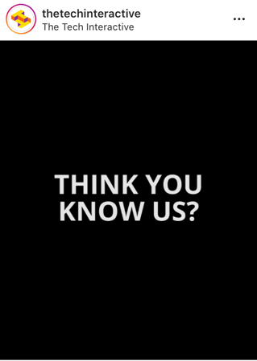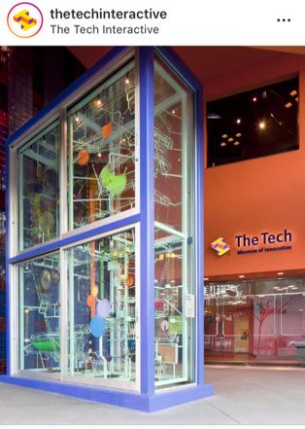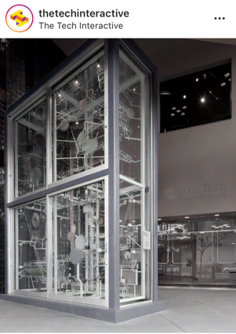
Screenshots from the Tech Interactive’s Instagram account on May 20, 2019.
Whatever was going on was being kept secret from the public until its official unveiling on May 23rd. I accepted an invitation ExD&P team to attend this special event, and sat in eager anticipation under in the glowing, cinematic dome of the Tech’s IMAX theater. Tim Ritchie, then president of the Tech, stood on a raised platform in front of us, speaking into a microphone and read his prepared papers from a podium as slides filled the exceptionally wide screen around him. After re-telling the story of The Tech Museum’s past, he explained how he has always thought their name wasn’t quite right since “we’re not a collecting institution. The Tech is not a museum.” Rather, he said, “It’s an interactive learning space” where “young people can be hands-on, minds-on, and hearts-on.” With the help of an audience drum roll at his request, he announced that they had decided on a new name: “The Tech Interactive” “Isn’t it really who we are? A place you can learn by doing.”
The day The Tech changed its name from The Tech Museum of Innovation to The Tech Interactive, a substantial rebranding campaign began. A flurry of public relations materials was unleashed, digital content and logos on the website and outside of the building changed, name tags and fleece jackets worn by volunteers and staff, previously branded “The Tech Museum of Innovation,” were officially decommissioned. Accompanying this name change was a change in scope as well. Tim Ritchie announced they were scaling up their “positive” impact, asking rhetorically, “How will the world be different in positive ways in 20 years because the Tech exists?” Ritchie announced a new institution-wide goal. In twenty years, by the year 2039, 100 million people will use their materials, a 200x increase from the half a million visitors come to The Tech Interactive each year (The Tech Interactive 2020). It was a “Silicon Valley goal” he told the audience; “R&D lab ideas we can take to the world.” They were responding, he said, to what people are asking for: to prepare kids 8-18 years old to become problem solvers locally, nationally, globally who can think, act, and be different. Ritchie drew on moonshot thinking, characteristic of the Silicon Valley region, to help propel the Tech’s ideas and designed programs to expand beyond local and national school rooms to worldwide audiences. San Jose mayor Sam Liccardo then took to the stage, celebrating Tim Ritchie’s leadership and backing up their goal, that “in true Silicon Valley” style they were “exporting” to the globe—Silicon Valley’s “great responsibility.”
Following this event, my research questions loomed even larger. If the Tech was setting its sights on transforming social life, not just locally, but everywhere, to become Tech-inspired problem solvers; to think, act, and be different, what knowledge does this institution have and what assumptions does it make about the state of young people, at the moment, specifically girls in the Tech Studio, that justifies their service “push,” to transform from what-is into what could-be? I was motivated to learn whether the same technology-centric, expansionist values guided Tech Studio designer’s frameworks? And what knowledge of and relationships to visitors did they hold and how did they obtain them? How might their values and assumptions shape a visitor’s experience in the Tech Studio? Did visitor’s experiences differ along lines of gender? In the next section, we will see different ways Tech Studio designers’ programs counterbalance this trend with a focus on inclusion, familiar household materials, and hands-on learning
Tech Studio: Designing for Inclusion and Access to STEM
“It’s an interactive learning space [where] young people can be hands-on, minds-on, and hearts-on…The Tech Interactive…Isn’t it really who we are? A place you can learn by doing.” (Tim Ritchie, former president of the Tech Interactive, May 23, 2019).

While the rebranding event asserted an identity that identified to Silicon Valley’s entrepreneurial technology industry, the ExD&P team’s approach and programs aligned significantly closer to the Tech’s legacy of women-led social activism. Through observations and interviews about the programs, exhibits and spaces they produce, and the outcomes they hope to see in visitors and in society, they regularly came back to the themes of access and inclusion. Initially, this is not surprising, as they are part of a larger institution that has makes their mission, “to inspire the innovator in everyone” and their vision “to build a civil society that enables everyone” to thrive in a technology-driven world (The Tech Interactive 2020). However, as one ExD&P staff member pointed out, in the Tech Studio, they tend to put more emphasis on the “everyone” part.
I felt the effects firsthand. When I arrived, The ExD&P team welcomed me into their workspaces, providing me with a desk in their office to work alongside them, allowing me to hang out and ask questions, and creating a dedicated messaging thread for this research on their team Slack channel, a digital workgroup messaging platform. These gestures provided ways to build personal connections with the people who became research collaborators and daily companions. Sharing office space allowed us to share life updates from day to day, enjoying and exchanging food and friendship. It was also helpful for coordinating our activities, face-to-face and asynchronously. As self-identified members of the Bay Area maker community, they shared access to their networks and events in the region.
I interviewed seven members of the ExD&P team: one male and six females in order to obtain perspectives from people who work to create the Tech Studio space and activities that take place there. Each interviewee completed a short survey, which provided me with demographic, education, and professional information, and each joined me for an interview that lasted between 45-90 minutes. The open-ended format of the interview questions allowed staff to freely associate ideas and share what was meaningful to them. In what follows, I share analytical insights from four ExD&P staff whose work is most intimately connected to the design and production of the Tech Studio visitor experience. They each relayed different perspectives about the meaning of their work but were linked by a focus on designing for inclusion and access to embodied problem-solving: hands-on learning, maker mindsets, and empathy.
ExD&P designers’ perspectives provide insight into the service worlds that they are connected to. This is not meant to be a summary of these individuals’ qualifications, personalities, or identities, nor is it meant to be a summation of all salient themes in the data. Rather, it is meant to introduce readers to the people who produced the data and informed the themes that I use to frame Section Four, “Insights about Visitor Experience and Values” and to introduce some members of the ExD&P team to whom I presented the research deliverables (see appendices F - J). Participants’ names have been replaced by a pseudonym.
Four Tech Studio Designers
Michelle: Designing access to embodied learning
Michelle enjoys the “adrenaline rush” of getting close to launching a new program, when the whole team comes together. She thrives on the satisfaction of solving problems quickly. Like other members of her team, Michelle operates as a jack-of-all-trades, helping with graphic design, thinking about educational flow, training, or facilitation, or getting into the “hands-on building of things.”
Michelle frames her design approach as a combination of user experience design and education design, integrating the learning goals and pedagogy “that we hold dear here at The Tech.” She is also involved in evaluating their programs by creating “small experiments” to figure out whether their design techniques are effective. As a service provider, Michelle thinks deeply about the educational and social outcomes they produce. Aware of declining visitor numbers, she thinks deeply about questions like, “What is the next “iteration” of the museum? Who is the audience that comes? Are we serving them effectively? Do we have the right things in place? Do we create a safe space for them? Are we a resource that they think about?” In her estimation, the ExD&P team’s efforts are having a positive effect on Tech Studio guests, because they let her know during interviews, that they “really appreciate the model that we've sort of made up.”
Michelle views hands-on working and learning as a fundamental life skill, that is likely rooted deep in our human biology. In our interview, she described the “waxing and waning” of people's interest in the importance of working with and learning with their hands. People’s decline in hands-on learning, she explained, could be related to the closure of woodshop and home economics classes. Society then reacted with a DIY movement to create bespoke, handmake crafts and the rise of making and makerspaces in schools. She sees the rise of making and makerspaces in schools as “the new woodshop and home ec. combined, plus the computer lab.” The recent bankruptcy of Maker Media, the company behind the do-it-yourself creation publication and the science and art festival Maker Faire, is an indication to her, that the cycle of interest in hands-on work and learning may be slipping into decline again.
As someone who attended middle and high school in the early 2000s, Michelle said she never got to attend woodshop and home economics classes because they were shut down just before she started. She believes many people in her generation “don't actually know how to have life skills…like, hemming your pants, like cooking your own meals.” While making and learning how to do things with our hands might have been seen by some administrators as extra-curricular and dispensable, Michelle believes hands-on learning is “core to the human experience.” For her, hands-on learning starts in childhood and becomes an embodied way-of-knowing. “You gain a sense of how the world works and how to manipulate objects through your hands, and your mouth probably” she added. “They're like the best tool for you to learn how the world works…just by using yourself to roll this orange across the table and [ask], why does it do that?” Michelle had taken ahold of the orange she had carried into our interview and rolled it against the surface of the table with her hand. Digital simulations, she said, don’t have the same type of feedback that we’re “hardwired to learn from infancy.” It’s a way-of-knowing about our environment that is important and that we lose sight of as we get older, “especially in this digital age.”
Aware of the rise and fall of societal interest in working with and learning with one’s hands, for Michelle, the Tech Studio programs exist to provide people with more access to ever-important, embodied learning and education. The Tech is a community resource for collaboration in a “digital age.” Communicating and sharing these values with the community is key to ensuring the Tech Studio receives the resources it needs to continue to provide services to its visitors.
Roseren: Designing access to alternatives and connection
Roseren’s job roles require her to be adaptable, to “wear a lot of hats” and to be flexible as her responsibilities change throughout the weeks, months, and years. To Roseren, adaptability is part of what it means to be a cultural institution these days, “at least in our case.” Similar to the way Michelle emphasized the importance of embodied knowledge, Roseren emphasized low-tech options in programs that are meant to be accessible, which translates to familiar household materials and simple testing set ups that people could easily recreate at home. Roseren said it was important for visitors to develop competence with both “high-” and “low-tech” alternatives for solving design challenges. The most important point of her work is that visitors learn the “mindset,” or process of working through a problem rather than focusing on introducing newer, bigger technologies.
With her mind on evaluations in the Tech Studio, Roseren thinks deeply about what could be considered positive visitor outcomes of Tech Studio programs. She looks for whether visitors demonstrate: “creative play,” “rapid iteration,” “whimsical fun,” “empathy toward others,” “bravery to not to think themselves out of trying,” “a desire to iterate often,” and “figuring out how to take the next step forward.” Roseren also looks for signs of happiness, an indication that visitors have learned something about themselves and have learned how they want to engage in learning and information gathering.
Roseren told me her team is always trying to find the best ways to invoke empathy. To her, designing for empathy in informal education is about being comfortable “making connections” with other people, with things, or with yourself. The ExD&P team are currently exploring how to elicit empathy in visitors by adding narrative, or a story, to engineering design challenges. For example, the ExD&P team have developed a zipline activity where the challenge is to deliver a load from one end of a zip line to the other. To explore narrative and empathy, they rebranded the zipline activity as “Unleashed,” inspired by a movie about dogs that had been showing in the Tech’s IMAX theater. When they run the zipline program with a narrative, the load is a plushie dog. “Kids will put an enormous amount of effort to make sure that dog is safe. It's pretty amazing.”
Roseren sees her job as one that inspires curiosity and enables a form of intellectual and economic self-reliance. She views the Tech as a “safe zone” for the public, in a time when people are showered with information constantly “from all sides, good and bad” while individuals try to figure out how to process all the information coming at them. She sees the Tech Studio’s maker activities as part of an inward process of connecting to oneself. She said of visitors, “I hope they value themselves. And I hope they value their individual process, whatever that may be. I hope that they have patience with themselves.” Roseren hopes the Tech Studio programs contribute to an informed and capable public who do not have to rely exclusively on consumerism. “If you are not a curious person, then you're not going to be the most informed person…if you don't know how to creatively problem-solve, then what can you do?” Tech Studio programs provide the visiting public with a form of social preparedness and self-reliance that she imagines as one way to combat the growing poverty gap and mismatch of financial and material resources needed to succeed in a “technology-driven world.”
Julia: Designing access to intuition to bolster confidence
In casual conversation, Julia describes her work as developing engineering experiences or exhibits for kids, which she admits with a laugh, is “not at all true,” but it’s an easy way to satisfy people who want a quick answer. For other people, she said, “I work to create experiences for people to intuit their way through engineering problems.” Julia imagines visitors bringing “their own experiences and their own kind of life knowledge” to the engineering problems that the Tech Studio provides. Along with “curated materials” and a “low stakes environment” visitors can “really power through some of these really complex concepts.”
Julia takes inspiration from “Maker principles and that kind of mindset” when building her programs, “a lot of thinking with your hands, interacting with the innovation design process: collaboration, brainstorming, iteration, all that good stuff.” To Julia, participation in a program is a matter of just starting to put materials together and this effort is augmented by facilitation. Visitors don’t need to know technical terms. because anyone can make. Anyone can start to solve problems by trying, iterating on it based on they think, and any visitor could “conceivably work towards a progressively better solution without needing an engineering degree.” She imagines the Tech Studio’s activities as “problem solving endeavors for all” and “opportunities to bolster people's confidence.” She explained that if the programs were to become “formulaic” or “just like anything that people who would self-select into” on their own… then we're not doing anyone any good.” She pointed out that throughout the Tech, there are “a lot of screens and a lot of technology and the Tech Studio is one of a few places in here where visitors can do “screen-less problem-solving” By “stripping away all that higher technology,” visitors can “get down to the basics, things that are more approachable, things that really are transportable back home that get at things that people are naturally inclined to do or naturally able to do without much need for help or translation or interpretation.”
Equity and inclusion are key to Julia’s approach; it’s what got her into this field in the first place “so it's definitely always on [her] mind.” At the Tech, Julia’s didn’t think they were able to solve the challenge of equity yet. “I don't know that we ever will, but we can always strive. We are definitely more focused on inclusion at this point.” She recognizes that designing for inclusion takes awareness and commitment to providing “all the little things” that can make the Tech Studio “as inclusive and welcoming as [they] can.”
To Julia, the role of the Tech Studio is to “build a new generation of problem solvers.” Notwithstanding the Tech’s 20-year plans to scale up outreach locally, nationally, and globally, Julia hopes their programs will have local impact, reaching more of San Jose in order to “equip the next generation to solve some of the problems we can't predict now or that we can't quite grapple with yet.” She sees Tech Studio programs as a way to encourage youth to be more creative and curious, more STEM literate, value science and innovation, and embody “growth mindsets.” Julia hoped that not only kids, but their parents would also share in these empowering visitor experiences. When I asked her what she might need to support that vision of the future, her first thought was money. But then she reframed her answer saying, “You know, I think, people would be surprised with how much we can do with anything. And I think constraint is a wonderful thing. I wouldn't for the world want access to everything, because it's harder to be creative [laughs] if you have everything available to you. So I think it's actually just more time for everything, for anything that we do we do on pretty short timelines considering, and with very little people power. Yeah, so time and people yeah would be really helpful [laughs].”
Molly: Designing access to safe spaces and shared information
Molly learned growing up, and especially during college, that “hands-on experience is very valuable… getting that intuition is great and can help you a lot.” Molly dedicates a lot of time figuring out how to help visitors “feel safe and comfortable” in the space and “making sure those people don't feel overwhelmed by things.” She imagines that places like the Tech Studio might be the only spaces kids have access to doing the things that happen in the Tech Studio. Providing visitors with a space where they feel comfortable experimenting with things that might be completely new to them, “like asking somebody should code for the first time, can be pretty intimidating.” Molly explained, when young visitors struggle to come up with an idea and how to execute it, the first thing you need to ask is, “What do you need? Like what are the materials you need? What are the individual components? And then how we going to put them together?” She wants to help kids figure out how to always try to move forward and make it clear what they’re trying to do.
Molly expresses empathy for visitors, especially those who are introverted, or hesitant about trying a new thing for the first time. She says this trait comes from her own experience learning hands-on problem solving, saying, “I was also very introverted. I was very good at textbook learning [laughs]. But any like, I didn’t really like labs… I didn’t like going to the machine shop for a very much, because like, even something as simple as like, I don’t know where the ‘On’ button is [laughs]…I didn’t want to like fiddle around for like ages and then have to ask somebody where the ‘On’ button was [laughs].” She assumed everybody else had more experience and knew more than she did. Now, when young visitors in the Tech Studio make mistakes, she can reassure them, “I've done this like a million times and I still do things wrong' [laughs].” She makes sure kids know that “failure is okay.” The mechanism for this, she says, is facilitation, by trained facilitators or herself when she’s “on the floor.” If something does not work out the way a young visitor thought it would, “it's not necessarily a mistake.” Molly reframes the moment as a learning opportunity, “Cool…that is what happens when you do that,” instead of treating it as failure.
Molly sees her work at the Tech is part of a democratic effort, to spread control of the production and use of knowledge and technology with a greater portion of the population. She recognizes a need to provide alternatives that can compete with technology giants in the market “if we want capitalism to work,” and to “appeal to people who don't make a lot of money.” As one way forward, she hopes that more people use and contribute to open-source platforms rather than restricting services and products behind a pay wall. In addition to open-source models, Molly cares about corporate social responsibility and meaningful implementation of technology. For example, she values, “helping the people that are not as fortunate as you” especially large companies who could help lower socio- economic areas by supporting programs and non-profit organizations. Ideally, the things they build would help people to be “better informed about and connected” to their social and physical environments, “Cause sometimes I think people can get very detached from where they're living and what's around them.” When we all do our part to help people, Molly imagines that they in turn will learn to “build a connection with the environment,” and it’s those connections that will help people “feel inclined to save it, hopefully!”
Designing access to embodied ways-of-knowing
The four ExD&P staff I presented see their work as much more than simply designing science center exhibits. They design to provide visitors with access to embodied ways-of-knowing, to contribute alternative ways of problem solving in a digital, technology-driven world. These embodied ways of knowing are hands-on learning, maker-mindsets, and empathy. They present these skills as pathways for self-realization and community resilience in a “digital age” They view the Tech as a community resource and a “safe zone” for public education and economic self-reliance in the face of an unknown future, where people will need to have competence solving problems with “high-” and “low-technology” alternatives. Tech Studio designers strive to provide access and inclusion to these ways-of-knowing by creating materials and designing engineering design challenges in a way that enable anyone to “intuit” their way through them. Tech Studio designers see their programs and area of the Tech Interactive as an important way to “equip the next generation” to be prepared for future problems that “we can't predict now or that we can't quite grapple with yet.” Their approach is steeped in a sense of activism built on empathy; they reframe “failure” as a learning opportunity and see their work as part of a movement to take care of people and the environment by sharing control of the use and production of knowledge and technology with a greater portion of the population. In the next section, I introduce readers to the Tech Studio interaction space where I carried out my observations and provide some of the Tech Studio designer’s own explanations for how the space was intended to be used.

Tech Studio Space

…you can also see through the Wave Wall and that's on purpose so that people can see us kind of futzing through the process as well and they can see us building and ideating and doing design sprints and you know, testing random weird things all the time which kind of invites them into the process behind the scenes so that we're a little bit more transparent.”

The walls of the Tech Studio are white and minimally adorned with colorful, professionally designed decals, a hand-painted mural created with “conductive paint.” Whimsical props hang from the ceiling; a mini trampoline, a curious white polyhedron. The floor is polished grey concrete laid with round cut-out pieces of bright green fake grass that brings a splash of color to the space and functions like carpets. The air temperature is cool, such that many staff members wear fleece sweaters at work, no matter the summer weather outside. The dark ceilings extend high overhead, allowing the vents, pipes and light fixtures to recede into darkness.
The Tech Studio is a space where people visit, laugh, cheer, sigh, frustrate, infuriate, discuss, and care as they explore and try to solve problems using a variety of materials in infinite new ways. Sound floats in from people doing activities in the adjacent exhibit spaces and an interactive musical exhibit that seems to play constantly. One can hear the ‘whirr’ of testing rig motors, dampened ‘thuds’ of falling objects. The varied reactions of visitors at the testing rigs stand out above the din, occasionally punctuated by a staff member ceremoniously announcing the day’s design challenge to new arrivals.
Depending on the time, day, or week the space could be filled with any combination of family groups, students and chaperones, summer camp groups in bright matching T-shirts, or attendees of a special event. At quieter times, when the testing rigs in Tech Studio B are put away, people build imaginative architecture with blocks from open-design kits, and visitors seem to find quiet refuge from interaction. Visitors are attended to by gallery staff and volunteers, ranging in age and experience, from retirees to high schoolers. This diverse workforce is there to work face-to-face with visitors. I watched as they provided a variety of services including offering welcoming invitations, introductions and instructions, facilitating learning and enjoyment, keeping an eye out for safety and crowd control, and providing care in various and unexpected moments.

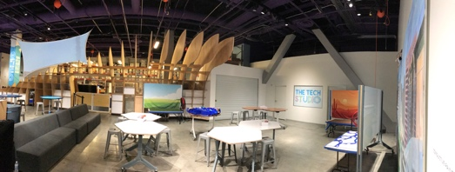

Looking into Tech Studio B from the entrance The Tech Studio’s 2018 redesign made the space “cozier”
and the addition of the “wave wall” provided the space with more transparency

Tech Studio Programs
“… at its core, the Tech Studio is really about creative problem-solving through the engineering design process. So, instilling skills and mindsets, that can be used no matter what field you're joining or what job you may have that doesn't exist now… as long as you have developed critical thinking and creative problem-solving skills, it doesn't matter what field you decide to pursue, you're going to be successful in that, in whatever you choose to do. So I see them as like foundational, like baseline skills for, you know success in life, you know?” –ExD&P staff member

At the bottom of a long escalator, tucked away in a corner on the lowest floor of the Tech Interactive, there is a 4000-square foot space called the Tech Studio (See photos in appendix I). The Tech Studio space and programs are under the direct handling of the Experience Prototyping and Design (ExD&P) team. The idea of the Tech Studio began as an activity space called “Hands-On Science Workshop”, where staff ran “maker style” programming. In 2016, The Tech made the decision to create “a more robust, long-lasting design challenge experience,” particularly one tied in with the annual Tech Challenge, and rotating nature of their makerspace programs. ExD&P staff rearranged a corner in the basement of the Tech Interactive to create their current home.
Tech Studio program design centers on engineering design challenges, which are hands-on design activities that contain a narrative to encourage a design that will accomplish a particular outcome. Design challenge outcomes can be open-ended but are constrained by intended actions that the design should be able to perform, as found in the narrative. Design Challenge Learning is an important education technique at the Tech Interactive and especially in the Tech Studio. During my research, the Tech Studio ran three engineering design challenges which Roseren describes below:
Cupcake Delivery (Wind Powered Vehicles)
“In this design challenge, guests were invited to join our cupcake delivery team as an engineer. They are tasked with building a prototype of a vehicle that can deliver one of more cupcakes just using wind for power. They must consider how to keep the cupcake safe during the ride and how to harness the wind to push the vehicle. Guests are given a variety of makerspace materials to build their vehicle. When they are ready to test their prototype, guests bring their vehicle to the testing station (a table with a fan attachment) and decide how many small 3D printed cupcakes their vehicle will deliver during the test. They must also choose between low, medium and high-powered settings on the fan. Facilitators encourage guests to vocalize what they observed during the test and encourage them to reiterate even if the test is successful.”

Beams and Bands
“Beams and Bands is an open-ended engineering activity where guests use wooden beams and rubber bands to build large structures. Guests explore how strong shapes and balance are used to create a stable structure. This experience is sometimes run with a prompt written on a whiteboard, such as “build a structure that your entire family/group can fit inside,” but guests are always welcome to build any kind of structure they wish.”

Solve the Fall
“As an updated take on the classic egg drop challenge, this program invites guests to design a device that will protect a sensor cube from the impact at the bottom of a fall. They are asked to develop a way to protect a sensor cube. They can choose to use drag, padding, suspension, or some combination to reduce the amount of impact (g-value) that is detected by the sensors. Guests will receive quantitative feedback from an onboard accelerometer in the sensor cube, which allows for a more nuanced iterative design process than the traditional binary pass/fail result (whether or not the egg cracked).”

In the minds of Tech Studio designers, the Tech Studio is conceptually and somewhat visibly divided, while remaining practically flexible and porous. On one side, Tech Studio B “makerspace” activities are designed to be “a little bit more art leaning for the STEAM side things” in order to get “other people who may be more interested in art versus an engineering space, into that space.” They ran Cupcake Delivery (Wind-Powered Vehicles) and Beams & Bands there. The other side of the Tech Studio, what ExD&P staff call Tech Studio A, is a space for “practicing that engineering or innovation design process,” which is to say, a space for visitors to move through “cycles of testing,” make “observations” of one’s test, and make “intentional decisions about how you want to change your device to succeed on the next round, and testing it again to see if succeeds or not.” The ExD&P staff ran Solve The Fall on this side. The two spaces, side-by-side, show “how art and engineering can work together” and provide visitors with “a menu of different experiences.” In one interview, I noted a sense of triviality toward activities that are “a little bit more art-based or craft-based. –Embroidery [laughs]” and then a change of seriousness toward the activities that are “classic design challenge[s]” Despite this moment, it was apparent ExD&P staff’s goal is to present a mixture of different things to appeal the different people.

SECTION FOUR: INSIGHTS ABOUT VISITOR EXPERIENCE AND VALUES

In this section, I provide an overview of the insights that led to the creation of my deliverables. These insights respond to the questions that guided my research activities throughout this project: (1). What values guide the design of a Tech Studio visitor experience? (2) How do girls experience STEM in the Tech Studio? and (3) How do youth visitor’s values compare along lines of gender and STEM? This section is the heart of this project, providing ExD&P staff understanding about youth visitors experience and insights regarding female visitors’ values and identity with the Tech Studio’s STEM-based activities. These findings are not meant to be generalizable to the broader public nor would it be appropriate to use these insights on their own, to represent the perspectives and interests of the social or demographic groups they identify with, gender, age, ethnicity, or otherwise.
When observing and visiting with ExD&P staff, I documented the types of processes, frameworks, and values they use to justify and guide their Tech Studio design work. I also documented how they approach the study of people who come to explore their design offerings in the Tech Studio. When observing and visiting with young visitors, I documented the variety of ways STEM, as “science, technology, engineering, and math,” came up in our conversations about youth identity, which included the ways they thought of themselves, their preferences, and their aspirations.
Insights about Tech Studio Visitor Research
The first significant finding about the Tech Studio was that the majority of youth participants (nineteen of twenty-two) appeared to enjoy their visit in the Tech Studio, a space of time dotted with moments of creative inspiration. I discovered this by taking into account the emic, young visitor’s assessment of their visit, and the etic, Tech Studio designer’s perspectives of success, alongside my own fieldnote observations. In addition to the ExD&P staff insights presented in section three, in order to discover what values guide the design of a Tech Studio visitor experience, I sought out what could considered a positive or negative experience and how one could measure it, using the processes, frameworks, and values I learned about in my interviews with ExD&P staff as my guide.
The first data I used came from young visitors’ responses during our interviews. I asked questions such as, “what did you think of your experience out there? Have you ever done anything like that activity before? What was the most exciting thing you did in the Tech Studio today? Was there anything about your visit you didn’t like?” Compared to my interviews with adult ExD&P staff in Phase I, young visitors’ answers were brief and limited in description. This was especially true with the youngest children, like six-year-old Dario:

Jasmine: What did you think about your activity here today?
Dario: Good.
Jasmine: Yeah? It was good? Have you ever done anything like it before?
Dario: No.
Jasmine: No? First Time?
Dario: I think so.
Jasmine: Yeah. Cool. What did you think about it?
Dario: It was pretty good.
Jasmine: Was there anything you didn't like about it?
Dario: No.
Jasmine: No? You liked everything? Would you come back again, do you think?
Dario: Think so.

To complicate the matter, I suspect English may not have been some of my young visitors’ first language. For this reason, I looked in my fieldnotes and transcripts for more clues, especially their comments and behaviors around the time they were finishing up their Tech Studio activity. I noted expressions like:

“That was hard, but fun!” – ABear 11, female
“But I don’t want to leave!” –Tessa 10, female
“It was really stressful which turns into fun” –Ezra 8, male
I also took notice of visitor’s emotional ups-and-downs during their visits and chains of events that led up to major changes in their behaviors (for example, see Ruby’s experience in appendix G “Case Studies”). The few negative experiences of Ruby, MayMay, and Luke caused me to wonder what could be done to better support these young visitors. A class assignment in Dr. Chuck Darrah’s “Creating Built Worlds” class gave me an opportunity to draft a possible intervention, based on observations and analysis from this research. I have included it in this report in case it is of interest to readers (see appendix J)
While analyzing my interviews with ExD&P staff, I noted that their program evaluations currently take notice of a combination of visitor’s positive emotions, behaviors, and words. Roseren measures success by “general signs of happiness, signs that people are enjoying the process.” She looks for indicators like smiles, laughter, jumping up and down, and showing parents what they’re doing. She also acknowledges that some kids find “the failure of their device also hilarious.” Additionally, ExD&P staff count “iterations,” or the number of times visitors use the materials in “new ways that [staff] never would come up with.”
For some time, I felt I wasn’t finding a useful strategy for making sense of young visitor’s Tech Studio experience, so I decided to efficiently package up “the messiness of people” and exchange it for “cleaner” language (Amirebrahimi 2016, 94). Although I recognize this approach can be problematic, it seemed the only useful thing I could do in the moment. I came up with a way to label visitors as having had either a “positive” or “negative” experience, using a working definition for both categories. I labeled a visitor’s experience as “negative” if during their time in the Tech Studio, and specifically in the last 5 minutes, they indicated they were feeling disinterest, frustration, exasperation, or anger. Elements in Ruby, MayMay, and Luke’s experiences guided the definition of “negative.” I labeled a visitor experience “positive” if during their visit, and specifically in the last 5 minutes, they experienced Roseren’s measures of success more often than the items listed as negative. Elements in ABear, Kylie, and Ezra’s experiences guided the definition of “positive.” For visitor’s experiences that didn’t clearly fit into the negative category, I labeled “positive.” Using these broad strokes. I labeled 19 out of 22 experiences “positive” and 3 out of 22 “negative.” Table 2 shows my thinking, and reflects ExD&P staff’s current evaluation approaches, observable aspects of visitor experience from this research, and the way I interpreted the variety of behaviors and emotions I documented, along a spectrum of “negative” to “positive.”

Negative
Emotionally broken: voice cracking, near tears, depressed, deflated | Anger: sudden, destructive movement | disinterested,  disappointed | Not manipulating materials

Positive
Actively manipulating materials | Manipulating materials toward a solution | Smiling, laughing | Showing off their creation to others | Cheering, jumping up and down

Table 2: Working Definition of Positive and Negative Visitor Experience
The continuum between negative and positive was a way to organize my thoughts and certainly could be organized in a variety of ways. It was a tool to organize my thoughts and including it here helps make explicit both my own and ExD&P researcher’s biases about what could be considered “positive” and “negative” in the context of a visitor experience in the Tech Studio.
The second significant finding about the Tech Studio was that some ExD&P staff use potentially problematic, binary language to conceptualize their visitors. While ExD&P staff do spend an admirable amount of time with their visitors, face-to-face while facilitating programs or testing prototype exhibits on the gallery floor, in our interviews their language reflected a high-level, working understanding of their visitors’ everyday lives and what is meaningful to them. The four ExD&P designers I spoke with described the people they design for in a variety of ways:

- everyone
- individuals with unique ways of thinking and learning
- students from Title I schools
- girls
- families
- the local community
- hyperlocal, repeat visitors
- weekday and weekend visitors, split by socioeconomic factors
- a very wide range of people
- people who are a little bit more introverted
- people with low-STEM confidence (because it “transcends groups”)

The variety of their answers seemed to reflect the challenges they face in attempting the enormous challenge of creating programs that are appealing to everyone. Julia was candid in her interview, responding, “How do I understand them? —Do I understand them?” She connected her concept of visitors first to The Tech’s mission to “inspire the innovator in everyone,” to explain that in the Tech Studio, that’s always how they start, but that as a team, they focus more on the “in everyone” part of that mission. She thought the Tech Studio was “a really good place to get at people who have low-STEM confidence.”
We're not in a good position to say, based on our study of certain demographic groups we think that this is the best way to reach out to X Y or Z, but we can get at people who have low STEM confidence and that's kind of what guides our work because low-STEM confidence kind of transcends groups, its present in lots of people and that's who we're really designing for, by designing for them were getting at everyone.)

Discussion: Language of Tech Studio Visitor Research
Using language that “transcends groups” can certainly be a useful place to start –my own approach in conducting research stands as a first example –however, I propose using such language with caution. Shaheen Amirebrahimi (2016) offered an insightful critique of the language of user-experience (UX) that I think helps explain the implications of using high-level, binary language when researching and designing with and for people. Amirebrahimi argued that the language of “user” and “non-user” is problematic because it ignores bodies; gendered, classed, raced, aged bodies that do particular work and have particular desires. Language like “user” and “non-user” flattens people, conceptually erasing important factors about that person’s social constraints and negotiations in everyday life. Furthermore, to think of a person in terms of being a “user” is to privilege the moments they swipe, click, enter data, or visit a site (Amirebrahimi 2016, 91). It cleanly and problematically packages up people, power, and things that the social sciences have worked for many decades to disentangle (Amirebrahimi 2016, 89). Anthropological research offers a systematic approach to understanding people that uses the practicality of high-level categories while striving to leave visitors’ gendered, classed, raced, and aged bodies in their findings. As I mentioned in the introduction to this report, it is not easy to appropriately or accurately represent context. However, keeping rich context intact has been my intention, by using direct quotes, providing context-rich video clips, and descriptive case study deliverables that correspond to the high-level insights found in report slide deck deliverable and in the body of this report.
It goes without saying, that this project is but a tiny refracted fragment of a much bigger picture of a person’s perspectives and desires. This point is not lost on ExD&P staff, who align their values with the maker movement, which emphasizes people as individuals with unique learning processes and ways of thinking. Roseren explained, “…our philosophy is that every one thinker is an individual. There is no right or wrong way to think. Everyone is going to have their own individual process and we can help, we can provide tools and situations and our programming and exhibits to help them, kind of start to develop who they are in their process and how they start developing that creative confidence.”

Insights about Youth Visitors: Gendered Differences in STEM Identity
When analyzing data from Phase II, where I observed and visited with youth in the Tech Studio, I started organizing my data according to the variety of ways STEM, as “science, technology, engineering, and math,” came up in the interview. The interview was designed to learn about young people’s sense of identity, which considered how they talked about themselves, their preferences, and their aspirations. The interview structure was open-ended, which allowed youth to speak freely about these topics and allowed me to situate STEM-related responses in the broader context of young visitor’s perceptions of everyday life. In what follows, I present the themes that fell along lines of gender in my analysis of youth visitors’ experiences in the Tech Studio.
As I mentioned in the introduction to this report, ExD&P staff’s research interests were to understand girl’s experience in the Tech Studio, because they said girls were generally considered to have low-STEM identity. I took low-STEM identity to refer to those who assert little or no affiliation with science, technology, engineering and math, nor do they use language and behavior to reinforce that association. Within my limited sample of youth visitors between 4-15 years, girls’ and boys’ preferences and interests overlapped often and when limiting our focus to STEM-related identities, there were both boys and girls who showed preference and absence of preference for STEM. However, by examining the content of visitor’s descriptions of their preferences, activities, and aspirations, I noted qualitative distinctions between the gender groups.
The most significant discovery of Phase II research was that while boys and girls both exhibited STEM identified behaviors, unsurprisingly, boy’s STEM-related preferences and activities appeared to relate more to the theme of high-tech industry, and that girl’s STEM-related preferences and activities appeared to relate more to themes of empathy and care. However, both girls and boys brought up sociality when participating in STEM-related activities. These insights appear to support the ExD&P staff’s current design approaches and offer opportunities for further research about inclusion in STEM. In what follows, I share some of the ways youths talked about their preferences and aspirations to address my partner’s research questions. The interviews and observations that support these insights could be further analyzed for additional insights (see appendices E, G, H)

Boys: High-Tech STEM Identity
There was only girl, nine-year-old Kylie, whom I considered to have high-STEM identity. Kylie told me she enjoyed coding toy robots at home for her little brother and told me “I love coding actually.” She told how she had coded a “dance party” and an “elephant flipping” that made a “bubble noise when it flipped.” She said her coding class was fun, that they got to work with partners, and she met new friends there. Kylie aspired to becoming an author of kid’s books, “like mostly about elephants. I'm already starting one.” By contrast, I labeled four boys as having high-STEM identity, Sawyer, KJ, Fern, and Casey.
When I asked thirteen-year-old Sawyer to think of ways he might be different than other people, he said “I think I know a lot more about computing than [other people]. They just know the main basics, but I think I know a little bit more.” He told me how he saved up gift money to buy computer parts and then built a computer with his father, a hardware engineer at Marvell, a semiconductor company. Sawyer and he aspired to becoming a software engineer. He enjoyed coding, saying he had coded a game on Scratch “but it was just JavaScript and you drag and drop blocks…something about it just made me excited to do it and every time I would look forward to it.”
Thirteen-year-old KJ told me he wants to become a “businessman” that can “integrate engineering and biology or chemistry.” His friend's dad, who he calls "uncle" is one entrepreneur he knows. KJ enjoys playing with science kits for “making slime” or building a robot "that could actually move based on voice command." KJ attended an engineering design summer camp where he said he created his own product that “could turn thin air into water.”
When I asked twelve-year-old Fern to tell me about himself, he introduced himself saying, "Well, my name is Fern…I like the periodic table and microbiology.” Fern told me his hobby is having “invertebrates” in his aquarium. He has “amano shrimp” and a “crayfish named Cranky” as well as two “bamboo shrimp.” I asked what he liked about his aquarium and he said he liked “how the shrimp actually cleans up everything for me.” He learned how to set up his aquarium by “search[ing] it up a lot…on Google.”
And six-year-old Casey told me how he likes telling his uncle what he wants to build. “We like building together,” he said, “Right now, we are trying to build a robot.” Casey said he had built a robot by himself, one that “had just plugs” while the next is going to be “a harder one. It’ll use soldering.” He thought he might be an engineer when he grows up, describing an engineer as “a person who build things.”

Girls: Empathic, Caring, and Expressive Identity
As I listened for the way girls talked about their everyday lives, their preferences, activities, and aspirations seemed to relate STEM less often, and when they did, they appeared to be different in type and quality compared to boys. Within my sample of girls, the oldest aged eleven to fifteen, emphasized human biology, animals, and artistic expression through activities like dance, theater, writing, and drawing, while girls seven to ten-years-old, including Kylie, talked more frequently about preferring math, science, crafting (with household materials), building with blocks, and coding, though not the same level of frequency or familiarity as the majority of boys. Rather than STEM, the girls in my study more often asserted an identity related to themes of empathy, sociality, and expression. I have included bits of my interviews with some of the girls here to compare and contrast, but more importantly, to begin to reframe girls from visitors who have “low-STEM” identity to a description that reflects their self-described identity, preferences, and aspirations. I propose girls self-described identities are assets to their own life projects as well as STEM-related activities.
Fifteen-year-old Susanne thought she was of herself as "pretty average.” She told me she likes art and French in school and does “a lot of dance…a combo between jazz and ballet…three times a week usually.” She also plays piano and likes cooking and baking. When I asked what she thought she might do when she’s older, she said she didn’t have “a clear…set plan” for what she might do, but definitely not teaching because “kids are hard.”
Twelve-year-old Carla told me she thinks of herself as someone who is “kind” and as different than others because “some people don't think girls can do boxing…and I just, I do it, you know [laughs].” She likes athletics, soccer, boxing and cheer. In school she likes studying the human body, “we studied a bunch of organs…I like animals too.” They did a frog dissection that “didn't smell that good, but it was kind of interesting.” Carla hopes to be a pediatrician when she’s older; she’s known since she was little that, “I just want to help people.”
Eleven-year-old ABear enjoys “the arts,” writing, research, and figuring out how things work, specifically how bodies, history, and social systems work. When she’s in the backyard with her mom, she asks her “a bunch of questions” about how “our bodies work and how we have knowledge of stuff we do and how someone figured out that we have to go to school. I like it. I guess being outside…just kinda triggers a question in my brain.” ABear told me she and her friends love “the arts” including drawing and theater. When ABear is older, she thought she “might wanna do some theater, act a little bit…maybe a year or something. And then I feel like if that doesn't really trigger my brain, I don't really find... that doesn't really help me then I think I'm going to be a book writer and illustrator because I like to draw and I like to write.”
Seven-year-old Fabi imagined her friends and family thought of her as “annoying” and “hyperactive”, but nonetheless, she told me “I like to take it as a compliment… It does not break my feelings one bit.” In school, Fabi likes to learn about math and chemistry, “I like division… multiplication…I'm learning about fractions…. I like chemistry… It's easy for me.” She told me about enjoying nature and interacting with creatures, "I like nature...ladybugs and butterflies… I like to catch the butterflies and I like to release them…” When she gets older, Fabi wants to be a “Veterinarian. I like to pet fluffy little animals.”
More than half of the boys (4 of 7) could be considered to have high-STEM preferences and involvement, while only Kylie, (1 of 14 girls), could be considered to have high-STEM preferences and involvement. It was notable that three of four oldest boys in the sample, Sawyer (13), KJ (13) and Fern (12) used language that emphasized their preferences, aspirations, and familiarity with high-tech industry related STEM activities. By contrast Carla (12), Kylie (9), and Fabi (7) used language that suggested more familiarity with home and school-oriented STEM activities. By broadening my gaze to include values beyond STEM, I found that the girls in my sample tended to emphasize empathy, care, and a wide range of creative expression with relatively little or no mention of conventional STEM. Boys tended to emphasize building and figuring out how things work within conventional themes of high-tech industry, such as functionality and performance, with relatively less mention of empathy, care, creative expression. Boys and girls STEM interests overlapped along themes of sociality.
Given the STEM-related gender differences I documented in this sample of visitors, especially in relation to STEM and high-tech industry, it was surprising to look back on young visitors’ time in the Tech studio and acknowledge that boys and girls enjoyment and moments of creative inspiration did not differ in significant ways. Rather, negative experiences appeared to be related to the language adult family members used with children. I found only 3 of 22 visitors experiences could be characterized as having had a “negative” experience.

Discussion: Disrupting Gendered STEM Identity with Design
The insights that this research produced raised important questions for ExD&P staff to consider as they continue to design for inclusion in STEM:
1. What do we mean when we talk about young people with low- or high- STEM-confidence or STEM identity?

2. If ExD&P staff take these values to be important to their mission of inclusion, how can they design for youth, regardless of gender, who value the empathic process of providing care and enjoying sociality, alongside conventional STEM values like functionality and performance?

3. Are the values of empathy, care, and sociality currently embedded in STEM activities and fields?

Providing answers to all of these questions are beyond the scope of this project, however, I can provide a starting place to discuss the first and second questions based on insights from my interviews with Tech Studio designers Michelle, Roseren, Julia, and Molly. I finish by highlighting some of the ways they are already designing to disrupt gendered STEM identity with curated materials, whimsical design cues, and supporting young visitor’s use of simile and metaphor.

Curated Materials and Design Cues
A moment from my interviews with Julia stands out. I had just asked her to explain what she meant by the term low-STEM identity.
“We see that there are a lot of people who say that they're not scientists are not engineers, or I think more frustratingly, their parents say that they're not engineers. We see a lot where parents will say. Oh, well go get your brother. He would love to do this and it's like well, maybe like she would love to do this too, you just didn’t give her a chance. We’re like no, this is for everyone…I was baffled. I think my first year facilitating on the floor for 4 hours a day, how often parents would see our activities and say, “Oh this has to do with cars. Let me go get your brother” and it's like well no, this is actually not, this is “Wind Powered Vehicles” sure, but it's actually “Wind Powered Contraptions” because you don't have to build a car. You can build a boat. You could build a tumbleweed, you could build whatever. It's actually about harnessing wind not about building a car. And trying to figure out all the subtle cues that can rattle somebody with low self-confidence or low-STEM confidence and also identifying ways where we can make things more accessible.”
Julia is aware that her work is not just to develop engineering exhibits for kids but is the work of understanding people. She realizes that as an experience designer, with goals and intentions for certain visitor outcomes, she needs to figure out “all the subtle cues that can rattle somebody” so that they can “intuit their way through engineering problems.” One way they are already doing this is by allowing space in their programming for visitors to introduce “their own experiences and their own kind of life knowledge.” Along with “curated materials” and a “low stakes environment” visitors can “really power through some of these really complex concepts.” To take this line of thinking one step further, Tech Studio experience designers, with goals and intentions for certain visitor outcomes, may need to first understand people’s values and everyday experiences with the themes and objects they promote, like STEM, technology, and maker culture, before they can begin to empathize with “all the subtle cues that can rattle somebody.” Then, perhaps, they will be more prepared to facilitate learning that allows people to “intuit their way through engineering problems.
Julia told me that when thinking about the narrative content of their programs and exhibits, “nothing should be too grounded.” She and Molly, at that moment, were in the process of developing a new program exhibit where they wanted visitors to build something that will move an object up (Today it is called, Climb the Cascade). Julia and Molly were grappling with the idea that their prototype exhibit was a tower that “looks like a skyscraper and if we're trying to get people to build things, skyscraper looks like construction, looks like a specific set of toys that you can find at Target that is in the section alongside other toys that are not for other people.” As a designer, her challenges are not only material but also social: “…how do you signal with the rig that this is just kind of fun and unusual or whimsical and hilarious, while also maintaining authenticity of testing, which I think is harder, because we don't want it to ring hollow. We want them to be empowered by what they're doing. We want them to see what they're doing as engineering when they leave.”
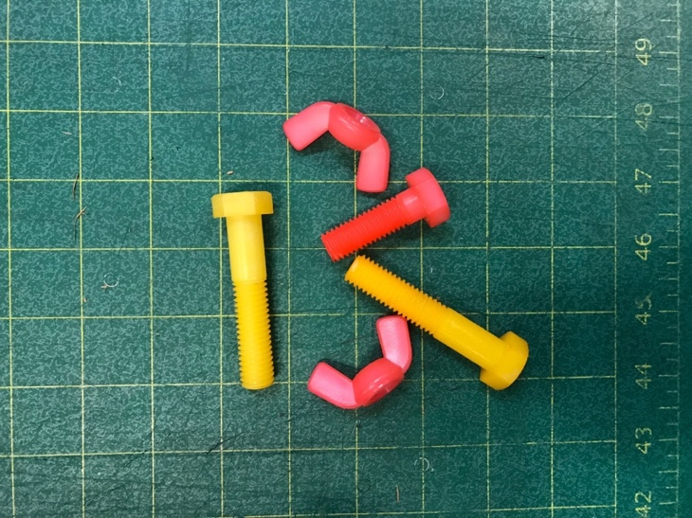
In addition to the testing rigs, ExD&P staff are thoughtful about the materials they put in the hands of guests. The building materials in Tech Studio B are thought to be “very approachable and familiar” while in Tech Studio A, building materials are sometimes “modified beyond understanding or just are funny sizes.” For example, ExD&P staff took plastic bolts and dyed them pink and yellow so that they would be “more approachable and fun…they look like strawberry lemonade.”
Dyed plastic hardware, modified by ExD&P staff
Language of Simile and Metaphor
Simile is a figure of speech that involves comparing one thing with another thing of a different kind, run fast like a rabbit, for example. Metaphors are another figure of speech where a phrase is used for an object for which it doesn’t literally relate, for example, it’s raining cats and dogs. I observed visitors, parents, and facilitators use the language of simile and metaphors to broaden definitions of STEM and to encourage connection to STEM and empathy in everyday life. I have created two case studies to illustrate these themes of connection to STEM and empathy (See ABear’s and KJ’s Videos and Case Studies). I noticed this type of language in the most pronounced way during ABear’s experience. Her visitor experience was riddled with similes and metaphors that she came up with on her own and that adults who interacted with her also used. The figures of speech ABear used on her own were marked by language of empathy, caregiving, and protection. When referring to egg-drop challenge videos she had seen, she remarked, “The poor little baby eggs.” At another point, ABear giggled and said her design looked like “a sandwich” and as she packed sponges around the accelerator cube, she said, “It’s like a little baby.” ABear’s father even joined in, talking about creating layers of protection, “like blankets” and giving her encouragement, “I get it. You’re going to stuff it like a pillow?” he said with a smile as ABear giggled in response. In contrast, gallery staff looked for metaphors related to science and engineering but translated for a younger audience. In a memorable moment at the testing rig, a gallery staff member made an extra effort to connect the activity to ABear’s everyday life: “I’m trying to think of a good way to…metaphor-ize this… Everything is made of atoms and molecules…all those pieces, they have to come together, kind of like Legos, or like Minecraft, I don’t know what you kids are into these days.”
ABear’s case study, a low-STEM identity visitor experience in the Tech Studio, seemed to indicate that Tech Studio programs are making a difference. KJ’s case study, a high-STEM identity visitor experience, seems to indicate that perhaps we have more work to do in not only teaching girls about conventional STEM values like functionality and performance, but simultaneously, finding ways to encourage boys to value the empathic process of care. KJ’s case study is an amusing interaction between KJ and his mom, as she tried to appeal to empathy to help him imagine how a customer [like her] might expect a cupcake to appear when delivered. As he wrapped a plastic 3-D printed cupcake tightly in a flattened piece of cardboard, his mother tried to get him to consider the feelings of his “customers.” But KJ was unmoved, "it's just 3-D mom." Playfully, his mom insisted, "But it is a real cupcake, come on!" Unresponsive, KJ carried on with his activity of finding a way to make his cupcake carrier “compact” while his mom offered a consolation analysis, “You don’t like frosting, but I love frosting.” KJ confirmed, “I hate frosting.” “I know”, she said, “that’s why you don’t care about the frosting. This cupcake is really sad…I’m just letting you know…would you like your food delivered like this?” KJ had no qualms, “If its cupcakes, I’m fine.” In a last-ditch attempt, she told KJ, “I don’t know, it’s your cupcake. It’s your company who’s delivering cupcakes. You might not get a second order.” (see appendices G and I for KJ’s case study and video).
Including ABear’s and KJ’s accounts, I have created seven case studies that include rich descriptions of some of the things I learned from the girls and boys who participated in this study. A careful reading of that document, the rich core of this research, will surely provide ExD&P staff with new insights about how they can design with their visitors in mind. I have organized the case studies into three topics and sub-themes: 1. Empathy and Care: toward objects and people; 2. Figuring out how things work: STEM preference and value; and 3. Sociality and other forms of facilitation: facilitating and frustrating. It is my hope that these descriptive case studies will provide ExD&P staff with even more insights into how their design for access and inclusion, can support all youth, regardless of gender, who value the empathic process of providing care, creative expression, and sociality, alongside conventional STEM values.
Conclusion
I came to this project to use ethnographic research to support the Experience Prototyping & Design team understand girls’ visitor experience. I conducted this research to address three questions: 1. What values guide the design of a Tech Studio visitor experience? 2. How do girls experience STEM in the Tech Studio? 3. How do youth visitor’s values compare along lines of gender and STEM? To begin, I explored ExD&P staff’s service world and found that Tech Studio designers value access, inclusion and embodied ways-of knowing including hands-on learning, maker mindsets, and empathy. ExD&P staff strive to design programs and spaces that appeal to “people with low-STEM confidence,” including low-income youth and girls.
I then observed and interviewed young visitors to bring insights to ExD&P staff about visitors’ experiences and values and whether there were differences along gender lines. I limited my observations to the duration of a single Tech Studio visit, and within a sample of 23 youths including 16 girls and 7 boys, between 4-15 years old. I found that while boys and girls both exhibited STEM identified behaviors, unsurprisingly, boys’ STEM-related preferences and activities appeared to relate more to functionality and performance, within a theme of high-tech industry, and that girls’ STEM-related preferences and activities appeared to relate more to themes of empathy and care. Their STEM-related preferences and activities appeared to overlap under themes of sociality. This reflects the general trend that motivated the Tech Studio’s inquiry into how girls interact with their STEM programs, to better understand and possibly address gender gaps in STEM fields in the spirit of their mission to help build civil society and support self-actualization.
My research indicates they are succeeding, as the majority of visitors had a positive experience, except in the few cases of family member interference. Nevertheless, I argue that designers’ focus on inclusion of people, thought as a collection of genders, ethnic groups and ages, should be adjusted to encompass the distinctive values carried by female visitors, and rather than focus on girls per se. Using a comparative analysis of boy’s and girl’s interviews, I pointed out how girls, even in the context of STEM-oriented activities, appeared to value empathy and care more than boys, while boys appeared to value conventional themes of high-tech industry, such as functionality and performance. The case studies and films I will provide to ExD&P staff as deliverables for this research project will illustrate with more context, how boys and girls assert an affiliation with science and technology and use language and behavior to reinforce that association to varying degrees. Further, they provide ExD&P staff with in-depth descriptions and additional insights on how the majority of girls in my sample asserted an affiliation with empathy, care, and sociality and use language and behavior to reinforce that association.
In this report, I have explored some conditions of design and designing in the Tech Studio in order to understand how design can be a social force whereby people, with their values and assumptions about what is, what they deem to be good, to be incompatible, and what they imaging could be better, provision the built world for other people (Tsing 2005; Fassin 2008; Murphy 2015; 2016). The Tech Interactive, as a landmark institution in Silicon Valley, draws heavily on the regional optimism that technology and the people behind it can produce good for society at scale, locally, nationally, and internationally. Yet, as ExD&P staff illustrate, people within the institution strive to align significantly closer to the Tech’s legacy of women-led social activism, to make it a place where they hope all people will be enabled to have access to embodied STEM knowledge, “hands-on, minds-on, hearts-on.” The ExD&P approach to design is steeped in a sense of activism built on empathy and respect for the qualities that each visitor brings with them in a visit to the Tech. This female-led team sees their work as part of a movement to take care of people and the environment by sharing embodied forms of learning, alternatives to high-tech solutions, and sharing control of the use and production of knowledge and technology with a greater portion of the population.
It seems to me, there are at least two approaches to make STEM more inclusive: 1. Institutions can invest in various means, including design, to push, inspire, or otherwise encourage people to value STEM as it is taught and promoted, and 2. Institutions can broaden the definitions of STEM they promote. The Tech Studio invests in both approaches. ExD&P staff disrupt gendered associations by curating materials and modifying design elements while they also inspire visitors to care about problems, processes, and solutions modeled after engineering design challenges and the larger world of STEM. This research implies that designing for access and inclusion in STEM means designing to be more inclusive of feminine values rather than girls per se. With this in mind, I hope that designers and design researchers might use the insights from this report and appendices to consider how they might acknowledge feminine everyday practices, values, preferences, and aspirations that youth, regardless of gender, bring to the Tech and recognize them as assets rather than deficits to STEM.
Next Steps
The presentation of the deliverables and a discussion of the insights will take place on June 3, 2020 with all ExD&P staff invited to attend. The presentation will take place during a regular ExD&P team meeting, using the Zoom conferencing platform because of current shelter-in-place orders in Santa Clara County (current as of May 2020). Jasmine will present the slides and one video clip to highlight the most important insights for the ExD&P team. All of the deliverables will be available to the ExD&P team for future Tech Studio visitor research.
SECTION FIVE: DELIVERABLE DESIGN
When my partners and I met in December 2018, they had not given me any constraints concerning deliverables, so I was free to explore delivery formats as I saw fit. I recognized that although the ExD&P team came from diverse research and training backgrounds, including engineering, art, biology, and anthropology, they came together around the work of design. As such, I sought out a communication style that would appeal to the language of design. I also recognized that this team works on fast, iterative design cycles and a lengthy academic report was unlikely to be useful to them. As such I imagined creating a variety of lengths and styles, from 5 minute “research snacks” (Vlahovic 2019) to more rounded out and filling content in the form of a slide deck, and longer, context rich case studies.
As I developed a research proposal in early 2019, I searched for literature about research methods for studying youth in a science center. Because I reached out to Toni Dancstep, senior researcher at the Exploratorium in San Francisco, she was able to connect me to the resources her team provided in their online Visitor Research & Evaluation (VRE) website. Their documentation of research methods gave me the idea for contributing short films as deliverables and gave me foothold finding meaningful ways to contribute to visitor research efforts in a science museum setting.
Slide Deck
I created multiple versions of slides before reaching the version I delivered to my partners. Creating slides was in part, an analytical activity as it served as a placeholder for significant insights and elements of my story during my analysis phase. I started by using Microsoft PowerPoint to use slides to create a simple outline of sections and key concepts. I also used the shape and design tools to draw out relationships between people, things, and ideas. Through an iterative process, going back and forth between descriptive analytical memos, matrices, and post-it notes, I continued to winnow away my findings to create the text content of my slide deck. When that was complete, I looked for ways to make the slides more enjoyable and easier to read. In one of our office hour meetings over Zoom, Dr. English-Lueck suggested I could look into using Adobe stock photos and templates. Her advice provided me with the template and a library of professional photos to choose from. Adobe Stock photos were a welcome option to my edited and blurred IRB compliant photos taken on-site throughout data collection in the Tech Studio. I kept stock photos to a minimum, and placed them on slides that didn’t display research findings, in order to help readers see the context where my data-driven insights came from.
Being able to find and purchase a beautifully designed slide template was all well-and-good but being able to adapt those templates and stock photos to my needs required additional skills. Gratefully, I had taken an introduction to graphic design course at Foothill community college prior to joining the graduate program. I learned how to use some basic tools in Adobe Illustrator and Photoshop. The skills I learned there were invaluable to my ability to produce visual assets that were enjoyable to look at and respected IRB protocols to maintain anonymity of subjects, in my slide deck deliverable.
Case Studies
The stories I documented and present as case studies were, like my slide deck and film deliverables, the product of iterative analytical activities. Throughout my analysis phase of research, I immersed myself in the data that visitors provided to me, including parent surveys, video footage, transcripts of audio from our interviews, and photos. As I organized this data in matrices, comparing and contrasting continually, I kept coming back to ponder and compare certain moments in my observations of young visitors in the Tech Studio. These moments became more significant as I outlined significant insights from the research overall. Because the slide deck format was not conducive to lengthy, context rich descriptions, I opted to include an appendix-type document to make them available to Tech Studio designers and researchers in the future.
The case studies place survey, observation, and interview data side-by-side. I designed the case studies to put readers in my shoes as a researcher, translating the world of thick description, jottings, and transcripts into a more readable format. I structured the case studies to present the information to readers in a somewhat linear sequence, as it was presented to me during the course of our time together. To begin, I included first-impression and demographic details from my fieldnotes and the legal guardian survey. I included personal details like what children were wearing and delightful off-hand comments they made, descriptions of facial expressions and ways they moved through the Tech Studio space, and descriptive sequence of events, following fieldnote and video observation data. And finally, I tried to allow visitors to present themselves in their own words, using the transcripts produced in our interviews. The case studies contain many snippets of text, transcribed from audio recordings, to give texture to the high-level insights and descriptions of young people’s experience in the Tech, attached to many threads connected to visitor’s everyday lives far from the service world of the Tech Studio.
The case study deliverable will be of interest to ExD&P staff because 1. It is likely to generate empathy and understanding about young Tech Studio visitors; 2. It shows sequences and chains of events that lead to “positive” and “negative” outcomes; and 3. It may be useful material for meetings and trainings to instruct and inspire Tech Studio designers to keep significant moments about the domains of inclusion, gender, and STEM in mind as they draw up, question, and critique future Tech Studio programs for youth.
Short Films
I was inspired by reading about the Exploratorium’s “library of exemplars” (Gutwill, Hido, and Sindorf 2015) to create films to support the Tech Studio’s nascent visitor research efforts. I hoped that by doing so I could bring youth visitor’s voices closer to Tech Studio designers, to build empathy and appreciation for young people’s experiences and perspectives. Films, I believed, had the potential to bring designers a degree closer to understanding visitors ‘as they are’ before taking steps to create design interventions based on imaginings of how they ‘could-be.’
I created four films, each around five minutes long, after I had finished analyzing my data, and had outlined and written out the content for my slide deck and case study deliverables. This ensured that the films highlighted significant moments in my other deliverables. To create the films, I used video footage recorded on the chest-mounted Go-Pro video camera that youth and I collected during observations in the Tech Studio during the summer of 2019. Having had little experience in video editing, I relied on the user-friendly iMovie software available on my Apple laptop. As I watched and re-watched these recorded episodes, I typed out the words of young visitors so text could be displayed on the screen as the viewer also hears the audio, to call-out significant moments that support my research findings. The films were limited to five minutes in order to keep the content focused for busy designers and future Tech Studio researchers.

SECTION SIX: REFLECTIONS
This section is a contemplation on how applying anthropological approaches to a civic, social justice driven design team at a Silicon Valley science center provided me with a unique opportunity and some challenges that pushed me to examine my own positionality. In this section I include reflections on how being a newcomer to the service world of museums and STEM education forced me to think about the work of inclusion in Silicon Valley’s high-tech milieu in new ways. I have included them because I felt they may be relevant to readers, particularly applied anthropologists.
Restless texture
This research project and the applied anthropology program at SJSU, have changed and improved me in significant ways. It has been a time in life, set apart to struggle through new ways of thinking and doing, to raise ourselves to new standards, to grow and adapt to new approaches to work and life beyond graduate school. It has been a welcoming place where supportive faculty members showed personal interest in my ideas and opened up their office doors and resources to support me. It has been a space where students from different countries, a range of ages, and different walks of life came together to learn, to critique, to debate, and to support one another as we moved through a demanding graduate education program together. This report represents the ways I applied what I learned in this program over the last two years to benefit designers at a partner institution in our community.
It might come as a surprise to some that I didn’t choose this project because I was passionate about science education, technology, or STEM. I came to San Jose State University’s applied anthropology program because I wanted to engage with design and designers as a participating anthropologist. At the time, design was an aesthetic and creative endeavor. Yet as I was introduced to scholars and their writing in the field of design and anthropology, I found myself in a contested, political arena that became more foreign and fascinating as time went on. Feeling out of place became more pronounced as my project eventually shifted from imagining working alongside artists to finding myself working alongside engineers in a science museum. However, I felt confident in my ability to build rapport with my partners and to begin to understand their perspectives. To my relief and happiness, I was warmly welcomed into the Experience Development and Prototyping team at the Tech Interactive, and even more, I discovered I was in the company of two anthropologists!
As I explained in the introduction to this report, our relationship started off productive and engaging. I had come to them looking for collaboration and their team was looking for help to better understand their visitor’s experiences. They felt I had a lot to offer them and we were both interested in seeing what directions the project could go. At one of our meetings in February 2019, I sat with two members of the ExD&P team on metal stools around a wood-topped table in the Prototyping Studio. They explained their goals were to help children develop their own identities by facilitating and modeling design thinking behavior and maker mindsets. And as we narrowed in on our research focus, my partners asked me to help them understand girl’s experience in the Tech Studio, because they considered them to have low-confidence, affinity, and identity with STEM.
This initial framing of girls caused an internal twinge, a brief hitch in our otherwise easily flowing conversations. Their focus on girls made me pause and take notice. I was, after all a female “visitor” to the Tech Studio and as a cultural anthropologist and musician quite apart from traditional STEM fields, I considered myself a girl with low identity with STEM. It wasn’t that I didn’t identify with STEM because couldn’t learn it; I was always a top student. I just didn’t see it as “my thing.” I had other interests for my life and support to pursue them. Yet here I was, accepting a research assignment that in a way felt like an afront to my person. Why did they view people like me as lacking, as having a deficiency in STEM that needed to be fixed? What had shaped these designer’s perspectives? What understandings of the world was I missing? This initial reaction motivated me to put extra effort into finding out where my partners were coming from.
As I learned more about design anthropology, I thought back on my reaction to my partner’s framing of the “problem” they wanted me to address. I thought about how the act of design, and especially the industry of design, must establish a deficiency, a gap, real or imagined in order to justify a design intervention. To justify their need for a job. I came to this project to collaborate and quickly found myself on the turf of activists who were looking to transform people like me into something else. I couldn’t simply adopt their framing, because from what I know about women, I wanted to stand in awe and wonder at the diversity, beauty, and power that women, girls, and their feminine values contribute to society. I was raised by a bread-baking, song-in-your-heart mother who instilled in me a deep admiration and respect for womanhood and values like empathy, care, and sociality. And so, with my background coming to the foreground, I had to stop and wonder, if not STEM, what takes its place? What do girls already identify with? What do girls already value about themselves, whether inside or outside of the Tech, and could these values provide designers with clues about girl’s engagement, confidence, affinity, and identity with STEM? This is all to say, I felt restless to bring more texture into my partner’s framework of visitors with low-STEM confidence.

Inviting politics back in
The moral implications of designing material and ideological worlds for other people was especially interesting given the context of Silicon Valley, where a deeply diverse global workforce with an optimism for developing and using new technology is coupled with capital and industrial drive has the potential to create scalable change. Designers who are plugged into the industrial complex of this region have possibilities for their work, and value-embedded programs and products, to reach far beyond the walls of their home institution.
A deep sense of humanism underlies the work of social and human science as well as the disciplines of design and development (Bezaitis and Robinson 2018, 67). Part of the work of boundary crossing being clear about what you as an individual, as a team, as a practice, and as an institution are after; to ask forcefully, “to what ends are we doing this work? with an emphasis on ‘we’” (Bezaitis and Robinson 2018, 66). Bezaitis and Robinson’s (2018) writing caused me to think deeply about my own values and my intentions for the research I would participate in. I would be involving myself in a design process that had the potential to shape the work practices of Tech Studio staff and the potential to influence the way they deliver their makerspace experience to their visitors. By partnering with the Tech Studio, I understood I was joining them in looking at ‘what is’ and using knowledge to support what ‘could-be.’ And yet, I believe this is in large part what applied anthropology exists to do, to use our power to “inject politics back into our work, back into design, back into the everyday” (Amirebrahimi 2016, 95).
In hindsight, this decision to study my partners before taking on their research question certainly added more complexity and required more effort from me as a researcher. However, guided by the designers and anthropologists I was reading in class, it became non-negotiable. Environmental-behavior design researcher John Zeisel explains that the relationship between research and design is about creating a multifaceted picture of design, collaboratively discussing design problems, and establishing a shared language about the process (Zeisel 2006, 21). Because we have individual thought processes, the practice of analyzing and externalizing the design process helps designers and researchers understand and evaluate their own behavior and design outcomes (Zeisel 2006, 21). This project has taught me that in design, much of our work is about crossing boundaries to evaluate ourselves as we evaluate our projects.

REFERENCES
Amirebrahimi, Shaheen. 2016. “The Rise of the User and the Fall of People: Ethnographic Cooptation and a New Language of Globalization.” Ethnographic Praxis in Industry Conference Proceedings 2016: 71-103.
Archer, Louise, Jennifer DeWitt, Jonathan Osborne, Justin Dillon, Beatrice Willis, and Billy Wong. 2010. “‘Doing’ science versus ‘being’ a scientist: Examining 10/11‐year‐old schoolchildren's constructions of science through the lens of identity.” Science Education 94 (4): 617-639.
Archer, Louise, Jonathan, Osbourne, Jennifer DeWitt, Justin Dillon, and Billy Wong. 2013. ASPIRES: Young People’s Science and Career Aspirations, age 10-14. London: King’s College London.
Bernard, Russell H. 2006. Research Methods in Anthropology: Qualitative and Quantitative Approaches. Oxford: AltaMira Press.
Bezaitis, Maria, and Rick E. Robinson. 2018. "Valuable to Values: How ‘User Research’ Ought to Change," In Design Anthropology: Object Cultures in Transition, edited by Alison J. Clarke, 53-68. New York: Bloomsbury.
Blomberg, Jeanette and Chuck Darrah. 2015. An Anthropology of Services: Toward a Practice Approach to Designing Services, 45-80. Morgan and Claypool
Burbank, Ben, Debra McGregor, and Mary Wild. 2018. ‘My special, my special thing, and my camera!’ Using GoPro™ as a complementary research tool to investigate young children’s museum experiences. Museum and Society, 16 (3): 311-333.
Dancstep, Toni, and Lisa Sindorf. 2018. "Creating a Female‐Responsive Design Framework for STEM Exhibits." Curator 61 (3): 469-84.
Dawson, Emily. 2019. Equity, Exclusion, And Everyday Science Learning: The Experiences of Minoritized Groups. New York: Routledge.
---2018. “Reimagining publics and (non) participation: Exploring exclusion from science communication through the experiences of low-income, minority ethnic groups.” Public Understanding of Science 27 (7): 772-786.
Dawson, Emily, Louise Archer, Amy Seakins, Spela Godec, Jennifer DeWitt, Heather King, Ada Mau, and Effrosyni Nomikou. 2019. “Selfies at the Science Museum: Exploring Girls’ Identity Performances in a Science Learning Space,” Gender and Education 1–18.
English-Lueck, Jan A. 2017. Cultures@SiliconValley. Stanford: Stanford University Press
Fassin, Didier. 2014. “Beyond Good and Evil? Questioning the Anthropological Discomfort with Morals.” In Anthropological Theory: Issues in Epistemology, edited by Henrietta L. Moore and Todd Sanders, 441-444. Malden: Wiley Blackwell
Gewertz, Deborah, and Fred Errington. 2016. “Retelling Chambri Lives: Ontological Bricolage.” The Contemporary Pacific 28 (2): 347-381.
Graffam Gray. 2010. “Design Anthropology Meets Marketing.” Anthropologica 52 (1):155–64.
Greenbaum, Joan, and Morten Kyng. 1991. “Introduction: Situated design.” In Design at Work: Cooperative Design of Computer Systems, 1–24. Hillsdale: Erlbaum.
Guinard, Pauline. 2018. “Redefining Publics, Artists, and Urban Spaces: The Case of Made in Musina, South Africa.” City & Society 30: 117-135.
Gutwill, Joshua. P., Nina Hido, and Lisa Sindorf. 2015. “Research to Practice: Observing Learning in Tinkering Activities.” Curator 58: 151-168.
Ingold, Tim. 2012. “Toward an Ecology of Materials.” Annual Review of Anthropology 41 (1): 427-442.
Jordan, Brigitte, and Christina Wasson. 2015. “Autonomous Vehicle Study Builds Bridges Between Industry and Academia.” Ethnographic Praxis in Industry Conference Proceedings 2015: 24–35.
Lamphere, Louise. 2018. “The Transformation of Ethnography: From Malinowski’s Tent to the Practice of Collaborative/Activist Anthropology.” Human Organization. 77 (1): 64-76.
Manzini, Ezio. 2015. Design, When Everybody Designs. Cambridge: MIT Press.
Murphy, Keith. M. 2016. “Design and Anthropology.” Annual Review of Anthropology 45 (1): 433-449.
---2015. Swedish Design: An Ethnography. Ithaca: Cornell University
---2013. “A cultural geometry: Designing political things in Sweden.” American Ethnologist 40: 118-131.
Office of Science and Technology Policy. 2013. “Federal Science, Technology, Engineering, and Mathematics (STEM) Education 5-Year Strategic Plan. Documents, Speeches, & Reports. Accessed May 19, 2020. https://obamawhitehouse.archives.gov/sites/default/files/microsites/ostp/stem_stratplan_2013.pdf
Office of Science and Technology Policy. 2018. “America Will Win the Global Competition for STEM Talent.” Education. Accessed May 19, 2020. https://www.whitehouse.gov/articles/america-will-win-global-competition-stem-talent/
palmer, joni. m. 2018. “The Resonances of Public Art: Thoughts on the Notion of Co‐Productive Acts and Public Art.” City & Society 30: 68-88.
Roppola, Tiina. 2012. Designing for the Museum Visitor Experience. New York: Routledge.
Salvador, Tony, Genevieve Bell, and Ken Anderson. 1999. “Design Ethnography” Design Management Journal (Former Series) 10: 35-41.
Schensul, Stephen L., Jean J. Schensul, Margaret D. LeCompte. 2013. Initiating ethnographic Research: A Mixed Methods Approach (Ethnographer’s toolkit; book 2). Lanham, MD: AltaMira.
Scull, Charley and Nick Agafonoff. 2019. “Using Video to Think Ethnographically” Accessed May 8, 2020. https://www.epicpeople.org/using-video/
Suchman, Lucy. 2011. “Anthropological Relocations and the Limits of Design.” Annual Review of Anthropology 40 (1): 1–18.
Tsing, Anna. 2005. Friction: An Ethnography of Global Connection. Princeton: Princeton University Press.
Vlahovic, Tatiana. 2019. “How to Make Your Research Consumable with Research Snacks” Accessed May 7, 2020. https://reduct.video/rca/research-snacks/
Wang, Ming-Te, and Jessica Degol L. 2017. “Gender Gap in Science, Technology, Engineering, and Mathematics (STEM): Current Knowledge, Implications for Practice, Policy, and Future Directions.” Educational Psychology Review 29, 119–140.
Wasson, Christina. 2000. “Ethnography in the field of design.” Human Organization 59 (4): 377–88.
Wolcott, Harry F. 2009. Writing Up Qualitative Research. Thousand Oaks: Sage Publications.
Zeisel, John 2006. Inquiry by Design. New York: W. W. Norton and Company.

APPENDIX A
Tech Studio - Youth Visitor Experience - Phase II
Semi-structured Guardian Questionnaire
Prepared by Jasmine Low

Introduction - Describe the questionnaire, keeping it short and casual. We’re interested in how often you visit The Tech, why you use The Tech, and the way you have observed your child’s future. Your participation is voluntary. If you are uncomfortable with a question, you don’t have to answer it

Youth Participant’s Information
- Youth’s pseudonym _______________
- Youth’s language(s) ______________
- Youth’s ‘race’/ethnicity ______________
- Youth’s gender _______________
- Youth’s age __________________
- Your relationship to the youth participant: Parent / Legal Guardian / Other____________

Parent’s Information

Type of visitor [*]
- [*1] Is this your first visit to The Tech? Y/N

- [*2] Including today, how many times have you visited the Tech? 0, 1, 2, 3, 4, 5, 6 or more

- [*5] Which of the following were reasons for your visit to the Tech? [*5 answers: Interest in Science, Interest in Technology, Sightseeing, Time with family/friends, Learn something new, Entertainment, See IMAX film, New exhibits, Existing exhibits (e.g. Earthquake, Jet pack), lecture/event/program, Downtown San Jose, Other/Describe further______________ ]
Demographics

- [*31] Which gender do you identify with? Female, Male, Prefer to self-describe________, Prefer not to respond
- [*20] Please indicate your country of residence: USA, Mexico, Canada, United Kingdom, France, Italy, Germany, Other Europe, South/Central America, Africa, Korea, China, Other Asia, Australia/New Zealand, Japan, Other _____________
- [*21] Are you a resident of San Jose Area? Y/N
- [*22] What is your residence zip code? (U.S. residents only)
- [*24] Including yourself, how many adults (18 and over) are in your party today? 1 (alone), 2, 3, 4, 5 or more
- [*26] How old are the children in your party? (Select all that apply) 0 to 2, 3 to 5, 6 to 8, 9 to 11, 12 to 14, 15 to 17, Prefer not to respond
- [*27] How old are you? 17 and under, 18-24, 25-29, 30-34, 35-39, 40-44, 45-49, 50-54, 55-59, 60-69, 70 or older, Prefer not to respond.
- [*28] What is your highest level of education? Some high school, High school graduate, Some college, College graduate, Post graduate degree, decline to respond
- [*29] What is your household’s approximate annual income? Less than 20,000; 20,000 to 39,000; 40,000 to 59,000; 60,000 to 74,999; 75,000 to 99,999; 100,000 to 199,999; 200,000 or more; Prefer not to respond
- [*30] Which ethnic group do you identify with? African-American, Asian, Caucasian, Hispanic, Native American, Middle Eastern, Pacific Islander, South Asian, Other______, Prefer not to respond
- Family religion(s) or other spiritual practice(s) ____________
- What is your job title and industry? ___________________
- What are your duties or responsibilities? ______________

APPENDIX B
Tech Studio - Youth Visitor Experience - Phase I
Key Informant In-depth Interview Guideline
Prepared by Jasmine Low

Purpose. The objectives of this interview are to:

- obtain general background information about the interviewee's employment, residence, and educational histories.
- establish how the interviewee situationally identifies his/her beliefs and attitudes about designing for youth in general and female youth in particular
- gather a work-focused life history and establish the role of critical metaphors such as STEM education, hands-on learning, social justice, gender equity.
- And discern what they see as the consequences of the designed spaces and programs with which they work and the values they consider.
Themes: Design, Youth, Identity, Values, Gender, Power, Equity, Inclusion/Exclusion, Social Justice approaches to informal science education
Place. This interview is conducted in the informant's workspace, if possible or a neutral place, such as a park or library room.

Materials
1. Pens and notebook
2. digital audio, and spare batteries
3. digital camera or smart phone
4. watch
5. large newsprint for drawing workspaces or digital pad

Preparation:
- Send recruitment email
- Send/receive consent form
- Request CV/Resumé

Before Interview:
- Interviewee has read, discussed and signed the Consent Form
- Interviewee has completed the questionnaire beforehand.
- Interviewee has provided a paper or digital copy of their CV/resumé.

Key-Informant Questionnaire
--to be completed in Qualtrics and reviewed by researcher before in-depth interview

- Choose a name other than your own as a pseudonym ______________________
- Which gender do you identify with?
- Which ‘race’/ethnicity do you identify with?

Please refer to your resumé to complete the following questions. If there are any changes or missing details from that document that you wish to include, please include them here:

- What is your current job title?
- For how long have you had this position?
- What are your duties or responsibilities?
- In a general sense, what technologies do you use and have worked on in the past?
- What jobs, including self-employed, did you hold before this one?
- Do you hold any other jobs or do any other work? If so, please describe.
- Do you perform any “volunteer” work? If so, please describe.
- Describe your educational background. Where did you go? What subjects did you study and what degrees or certificates did you receive?

In-depth Interview Guideline
--to be conducted in-person, at interviewee’s place of work
or another public place like the public library

A. WORK BACKGROUND

l. What work do you do?

2. Describe, in general terms, the kinds of projects, programs, and technologies you work on.

3. How would you characterize your job sector? How do you explain your work to people outside the industry?

4. How do you understand the people you provide service to?
Who are they?
How do you come to understand them?
Which reports do you use? What do they track? How do you respond to findings in reports?
Are these ways of knowing adequate?
What is the ideal way to understand audience, especially Youth Visitors?

B. DEFINE & QUALIFY TERMS: The Mission of The Tech

“…Our mission – to inspire the innovator in everyone – is, fundamentally, about human dignity. It assumes that each person has the ability to solve problems in innovative ways. Our job at The Tech – and your job as a volunteer – is to help people use that ability and to achieve their potential. It is a meaningful assignment, and it is one we are grateful to share with you...” Tim Ritchie, President and CEO, Volunteer Innovator Program Manual April 2019.

5. In your mind, what does it mean to “inspire the innovator in everyone?” What does that mean to you?
Probe: How does innovator or innovation relate to youth? To youth identity? To the future?

C. DEFINE & QUALIFY TERMS: The Mission of the Tech Studio

The Tech Studio is where we [] push the boundaries of making, engineering, and design learning, emphasizing empathy and community, as we help visitors discover their creative problem solver within. Experiences developed in this space support our larger work on designing open-ended engineering challenges for inclusion of girls and underserved populations in STEM, and are shared throughout the engineering education and maker education communities. (ExD&P team, Personal Communication)

6. In your mind, how would you describe the mission of the Tech Studio? What does that mean to you?
Probe: How does the Tech Studio space relate to youth?
Probe: How does a [maker mindset, growth mindset] relate to youth? Youth identity? The future?
Probe: How does [creative confidence] relate to youth? Youth identity? The future?
Probe: How does [the engineering design process, reiteration, open-ended exploration/experimentation,] relate to youth? Youth identity? The future?
Probe: How does [accessibility] relate to youth? Youth identity? The future?

D. COMMUNITIES OF INTENT/SOCIAL NETWORKS

7. Life is more than work. As you think about your day, week and year, what do you do for fun or enjoyment?
Probe: Who do you do that with?
Probe: What are some of the key events you go to?

8. Do you belong to any religious or faith-based groups or organizations?
Probe: What do you do to practice your faith or spiritual expression?
Probe: Were spiritual practices a part of your home growing up? How did your family express spirituality?

9. Take a minute to think about who you live with, the members of your family, the people you work with, and the other important people in your life, regardless of where they live. Take this sheet of paper and, with words and pictures, make a drawing of the people who have influenced you.

Probe: Identify all the people who influence your beliefs and attitudes.
Probe: Identify all the people who shape the way you approach your work in [science education programming, technology].

10. Who influences your work and the way you think about it?
At work?
Outside of work?
Probe: What does each person do that influences you?
Probe: Who were your mentors in the past?
Probe: Who are your mentors today?
Probe: Who do you want your mentors to be?

11. Select a person (on the network map) and tell me of a specific time she/he/they influenced your values–the way you thought about yourself, the larger environment or [the programs/technologies] you work with.
Probe: What happened?
Probe: What consequence did that event have for you?

12. Tell me of a specific time you influenced the way another person thought about him/herself, his/her/their place in the larger environment, and the [programs/technologies] he/she/they work with.
Probe: What happened?
Probe: What consequence did that event have for her/him/them?

D. VALUES

13. “Please recall a situation when you had to define your values for someone else.” Describe situation as fully as you can.
Probe: Who asked you to define what you believed and felt?
Probe: Why did they ask you to define yourself?
Probe: What was the situation like?
Probe: Why did you define yourself in that way?
Probe: How did you feel when you defined yourself that way?
Probe: How did the other person(s) respond to you?

14. Try to recall an occasion when you drew on that identity and those beliefs and feelings when you were at work, or when you were talking about your training/technology.
Probe: What was the occasion?
Probe: How did you feel at the time?
Probe: What happened as a consequence of that event?

15. We’ve talked about your life and how various resources within it contribute to your connection to technology. What places contribute to your sense of technology? [or some other aspect of The Tech identity like Hands-on learning, Maker movement.]
Probe: Tell of a time you went to that place. What did you do? What happened?

16 We’ve talked about your life and how various resources within it contribute to your creativity, technological and otherwise. What places contribute to your sense of creativity?
Probe: Tell of a time you went to that place. What did you do? What happened?

E. FUTURE REFLECTION
17. Take a moment and imagine your life ten years in the future.
Probe: Ideally, but plausibly what will that life be like? What will the quality of life be like?
Probe: What will your life be like, if things do not go as well? What will the quality of life be like?
Probe: What do you expect that your life will be like in ten years? Why? What happens?

18. Now take a moment and think about innovation, social justice, inclusion/accessibility [name a factor brought up in the interview] and the [programs/technologies that promote them ten years in the future. First, I would like you to imagine an optimistic or best-case scenario for the region. Describe this region in ten years in your optimistic scenario. Remember that there are no right or wrong answers, only your realistic, optimistic vision of the future.
Probe: What will the [programs/technologies] be able to do? Who will be using them?
Probe: What is the role of these [programs/technologies] in the overall ecosystem of Silicon Valley?
Probe: What do people value in this scenario?

19. Now imagine a realistic pessimistic future for these [programs/technologies], one in which things go poorly for innovation, social justice, inclusion/accessibility [name a factor brought up in the interview] and the [programs/technologies] that promote them. Again, there are no right or wrong answers.

20. What do you think is most likely to happen to these [programs/technologies] a decade from now?
Probe: What has to happen for this future to occur?
21. Is there anything else you would like to add that I have not asked?

Thank the interviewee. If the person is participating in an upcoming appropriate work event (company event, training, engineering challenge event) or community event (a maker event or meetup) and is amenable to your participant-observation, inquire about the logistical details for securing permission.

APPENDIX C
Tech Studio - Youth Visitor Experience - Phase II
Semi-structured Youth Interview guideline
Prepared by Jasmine Low

Check you are using the same preferred pseudonym as consent form and observation notes.

Show the participant the microphone, explain what will happen afterwards, ie. someone will type the interview up but all the names will be changed.

Ask youth if they would be interested in drawing a picture and telling you about it or if they’d prefer to simply answer your questions.

Make clear they know they don’t have to answer all questions and that they can stop at any time if they wish, and that they can ask questions at any time throughout the interview. Also, that if they change their mind later on about their interview being used, they can tell their parent who have my email.

Construction of self – general, as gendered, an as social subject
- Could you [draw a picture of yourself / tell me about yourself], and the things you like to do?
  - Probe: who/what is this? What do you like about it?
  - Probe: Ask for explanation of shapes, clothing, hair, accessories, or other people
  - Probe: Why did you draw this person that way?
  - Would you say you’re similar or different to other people you know?
- If similar - in what ways are you similar? (prompt: enjoy similar things?)
Are there any ways in which you’re different?
- If different - in what ways are you different? (Like different things?)
Are there any ways in which you’re similar?
  - How would you describe yourself to other people?
  - How would other people describe you? Who would describe you that way?
  - Who do you like to spend time with the most? Why?
  - Where do you make your friends? How did you become friends? What do you do together?

- Construction of self – as learner
  - What sorts of things do you like finding out about? Could you draw a picture / tell me about it?
    - At school
    - Outside of school (like when you’re at home or in your free time)?

- Tech Studio Visitor Experience
  - What was the most exciting thing you did at the Tech Studio today?
    - Probe: Have you done anything like this before?
    - Probe: I noticed [instance from observation]. Could you tell me more about that?
  - Was there anything about your visit you didn’t like?

- Aspirations and Imagined Futures

  - Have you thought about what you would like to do when you’re older? What’s that?
    - Is there anyone that you look up to or would like to be like in the future? – why? When did you first realize that?
  - Do you know anyone who does that job? Where have you seen that?
    - Probe if something seen on TV or learnt about in school or not, etc
  - Is there anything you definitely would not want to be? (why/not)

- [Science] Identities and Aspirations [or other key theme discovered in phase I]
  - Could you (draw a picture about / tell me) what is [science]
  - What does it mean to be [a scientist; an engineer; an innovator]?
  - Do you know anyone who uses [science]? What do they do?
    - Probe: Does anyone in your family use [science]? What do they do?
  - How would you feel about – becoming [a scientist]? –having a job that uses some [science]?
  - What kind of people are really into science? What are they like?
(If them) What do you and others in your class who are into science have in common?
(If not them) Are there people you know who are really into science? Can you think of anything they have in common – besides liking science...?
  - How can you get to be good at [science]? How do you know that?
  - Do you think working in science would be a good future job, or not? (Why?) How do you know? (Ever talk about it?)

APPENDIX D

Demographic information for 23 Youth Visitors

Demographic | Summary | Note
Average age | 9 years old
Age Range | 4 – 15 years
Gender | Female = 16  Male = 7 | (no other genders were described in legal guardians’ answers)
Race/ethnicity | Hispanic = 10  White, Caucasian = 6 Asian, Indian = 3 Afghan, Filipino, Polish = 1 No answer = 3 | About half (10/23) reported Hispanic or a combination (White Hispanic, Native American/Hispanic)
Household Income | $200,000 or more = 9  $100,000- 199,000 = 3 $75,000-99,000 = 1 $60,000 – 74,999 = 3  No answer = 6 | About half (9/23) reported $200,000 or more.
APPENDIX D

Youth Participants
Ordered by gender and age
Total n = 23
Female = 16
 | Pseudonym | Age  * by appearance  - range, obtained from family questionnaire | Gender | Relation to another participant, if any
1 | Susanne | 15 | F | n/a
2 | Carla | 12 | F | Marisol’s sister
3 | ABear | 11 | F | n/a
4 | Marisol | 11 | F | Carla and Ana’s sister
5 | Ruby | 10-12 | F | Sawyer’s sister
6 | Bookie | 10 | F | n/a
7 | Tessa | 10* | F | n/a
8 | Kylie | 9 | F | n/a
9 | Abby | 8 | F | n/a
10 | Daphne | 7 | F | n/a
11 | Fabi | 6-8 | F | Fern’s sister
12 | Macy | 7 | F | n/a
13 | Ana | 6 | F | Marisol’s sister
14 | Neha | 6 | F | n/a
15 | Gemma | 4 | F | n/a
16 | Lin | 4 | F | n/a
Male = 7
1 | KJ | 13 | M | n/a
2 | Sawyer | 13 | M | (Ruby’s brother)
3 | Fern | 12 | M | (Fabi’s brother)
4 | Ezra | 8 | M | n/a
5 | MayMay | 7 | M | n/a
6 | Casey | 6 | M | n/a
7 | Dario | 6 | M | n/a

APPENDIX E
Matrix 1

Youth Visitor’s STEM-related preferences and activities (total = 23)
Girls (n=16)
 | Name | Age | Gender | STEM-related preference | Other preference | Career aspiration
1 | Susanne | 15 | F | n/a | art, French, piano, dance, baking, cooking, | Not sure yet, but definitely not a teacher
2 | Carla | 12 | F | Human body, frog dissection, | Soccer, boxing, cheer | Pediatrician
3 | ABear | 11 | F | Research, social studies, human body, “how to improve something” | Writing, the arts, drawing, theater, | Actress, Author, Illustrator
4 | Marisol | 11 | F | Research about “mammals” | Boxing | Veterinarian
5 | Bookie | 10 | F | Math, Vet | Creativity, swim, tennis, travel, arts & crafts | Veterinarian
6 | Tessa | 10* | F | Making robots out of recyclable household materials | Playing outside | n/a
7 | Kylie | 9 | F | Coding, Legos, Magna-Tiles | Coloring, tv shows, playing house | Author
8 | Abby | 8 | F | Science about rocks, Legos | make-believe, gymnastics | Not sure yet, but “what’s an engineer?”
9 | Daphne | 7 | F | Math | Reading, bike rides, chalk, playing with friends, tv, drawing, | Not sure yet, but has a lemonade stand
10 | Fabi | 6-8 | F | Math (division, multiplication, fractions), Chemistry | Nature, ladybugs and butterflies, arts and crafts | veterinarian
11 | Macy | 7 | F | Math (“minuses and pluses”) | Chasing butterflies and playing make-believe with friends, playing games like ‘horsey,’, hopscotch, shoo, and ‘rock, paper, scissors’ w/ mom and dad | To “remember what I was doing when I was little”
12 | Ana | 6 | F | n/a | Going to the playground | Police
13 | Gemma | 4 | F | n/a | Draw, pretend, | n/a
14 | Lin | 4 | F | Making a kite, origami (?) | Making cookies | n/a
Boys (n=7)
 | Name | Age | Gender | STEM-related preference | Other preference | Career aspiration
1 | KJ | 13 | M | Math, engineering design, science kits, coding robots, javascript, python, playing basketball with friends on PlayStation | English, travel, business entrepreneurship summer camp, playing musical instruments, playing basketball with friends in person | A “businessman and integrate engineering and biology or chemistry”
2 | Sawyer | 13 | M | Math, video games “that type of technology,” “structure and mechanical work” Building a computer, coding a game on Scratch | History, sports, | Software Engineer
3 | Fern | 12 | M | Math (“especially algebra and geometry”), watching his aquarium of “invertebrates,” periodic table, microbiology | Playing musical instruments, bike riding | Respiratory Surgeon
4 | Ezra | 8 | M | Legos, Body parts (veins, blood vessels, the heart,” video games (“Call of Duty”) | Making up stories, watching tv, guns | Working at a burger shop
5 | MayMay | 7 | M | Cars and science experiments (like using a metal detector to find an object) | Hockey, playing with dogs, trying to trap birds | Hockey player or a musician
6 | Casey | 6 | M | Building robots, building with Legos | n/a | Engineer
7 | Dario | 6 | M | Building with blocks | Recess, “play, jump, run” with grandpa, | Not yet.

APPENDIX E
Matrix 2

Three girls with high STEM identity
Name, Age, Gender | STEM-related preference | Other preference | Career aspiration
Carla 12, F | Human body | Soccer, boxing, cheer | Pediatrician
Kylie 9, F | Coding, Legos, Magna-Tiles | Coloring, tv shows, playing house | Author
Fabi 6-8. F | Math (division, multiplication, fractions), Chemistry | Nature, ladybugs and butterflies, arts and crafts | veterinarian

Matrix 3

Three boys with high STEM identity
Name | STEM-related preference | Other preference | Career aspiration
Sawyer 13, M | Math, video games “that type of technology,” “structure and mechanical work” Building a computer, coding a game on Scratch | History, sports, | Software Engineer
Fern 12, M | Math (“especially algebra and geometry”), watching his aquarium of “invertebrates,” periodic table, microbiology | Playing musical instruments, bike riding | Respiratory Surgeon
Casey 6, M | Building robots, building with Legos | n/a | Engineer

Matrix 4
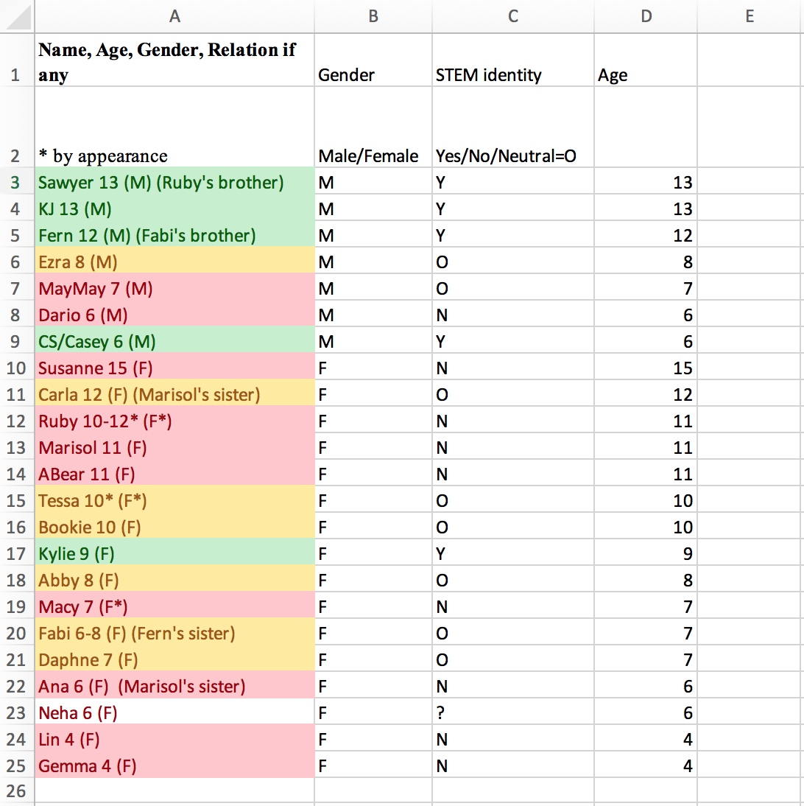
Matrix B: Participants ordered by gender and age showed higher prevalence of STEM identity among boys compared to girls in the sample
APPENDIX F 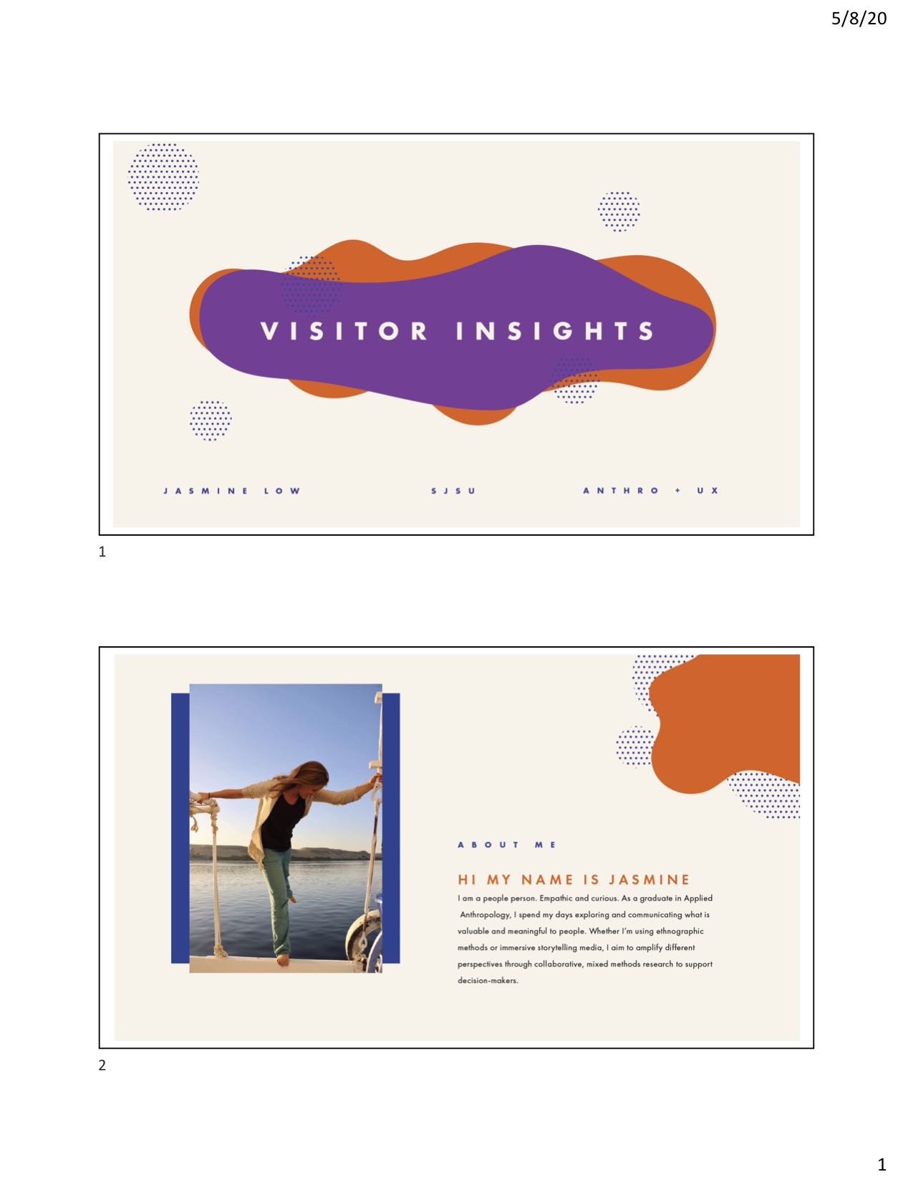
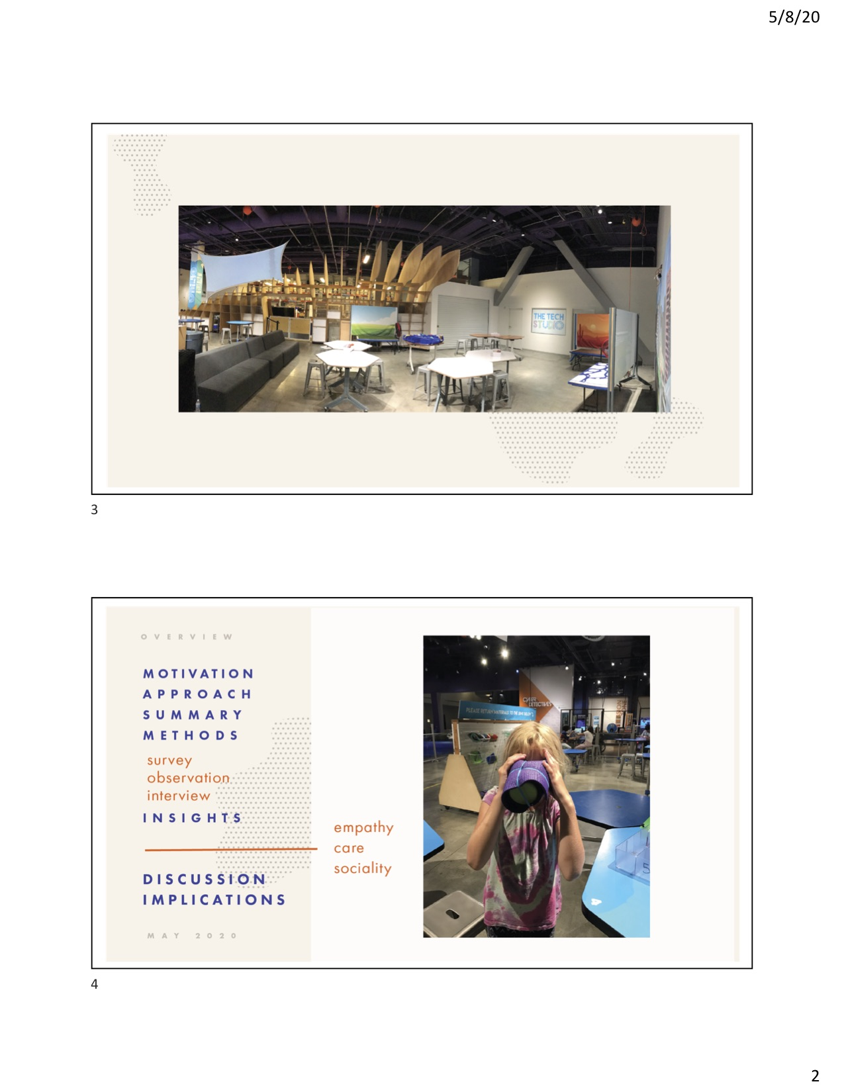
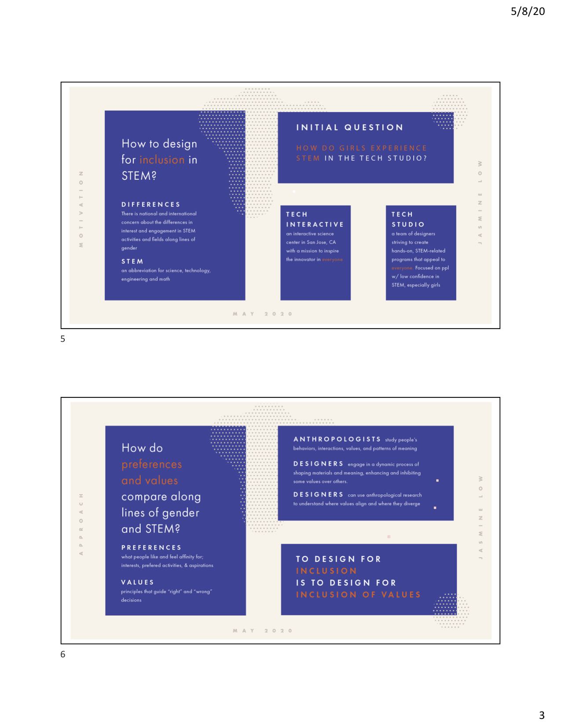

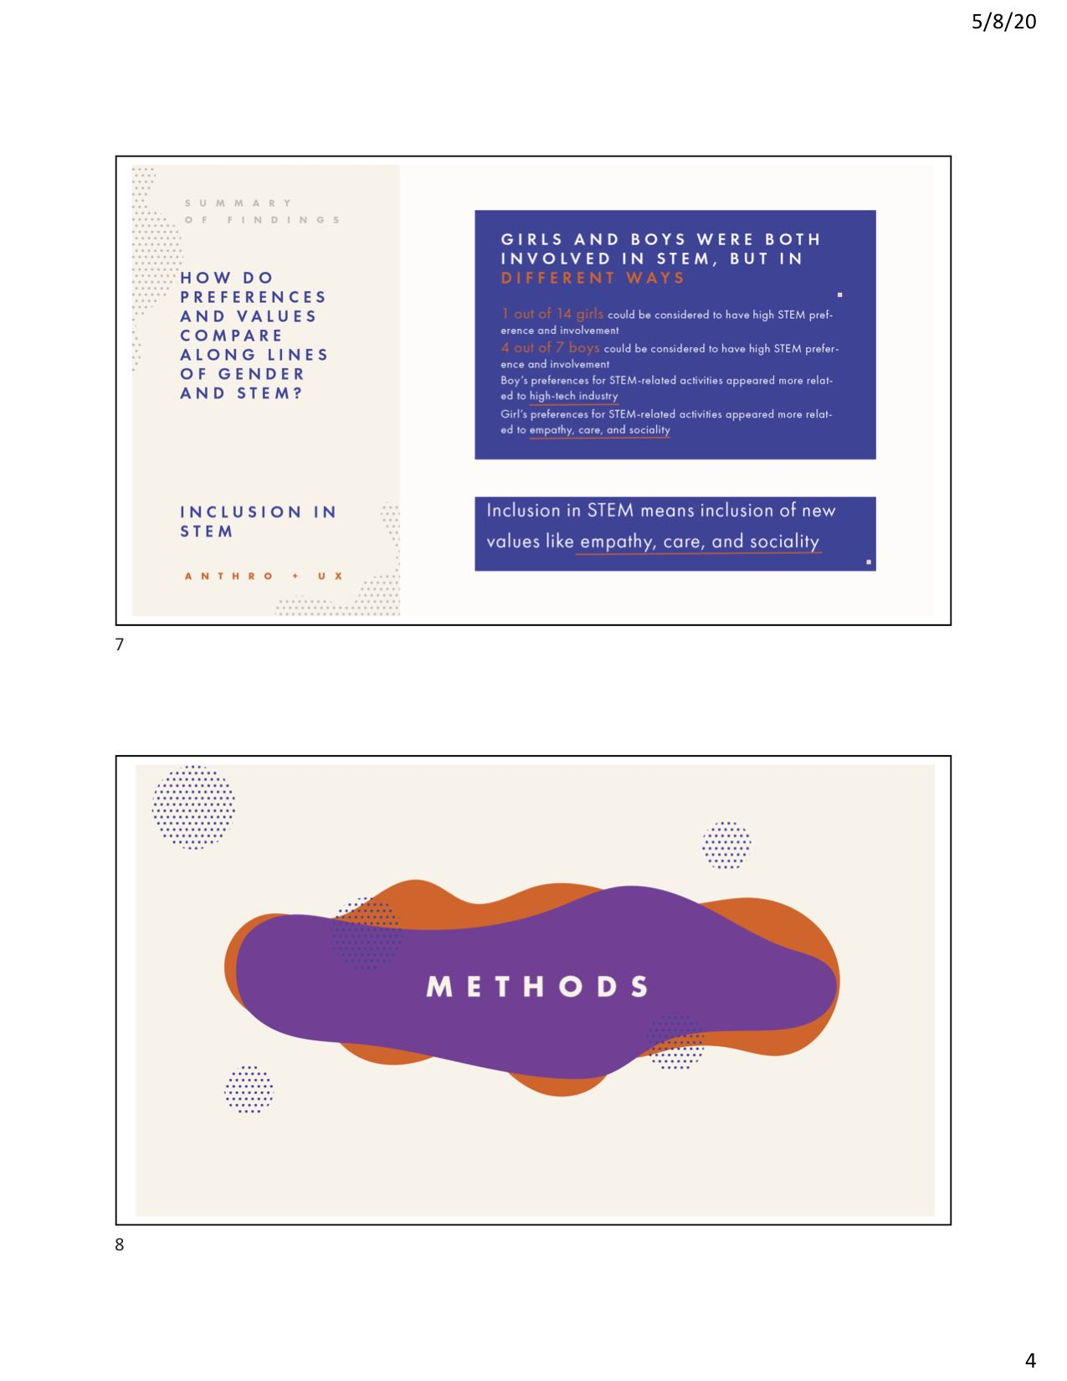
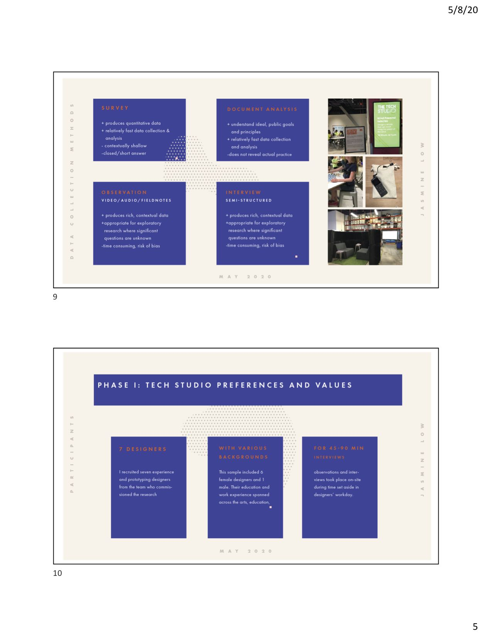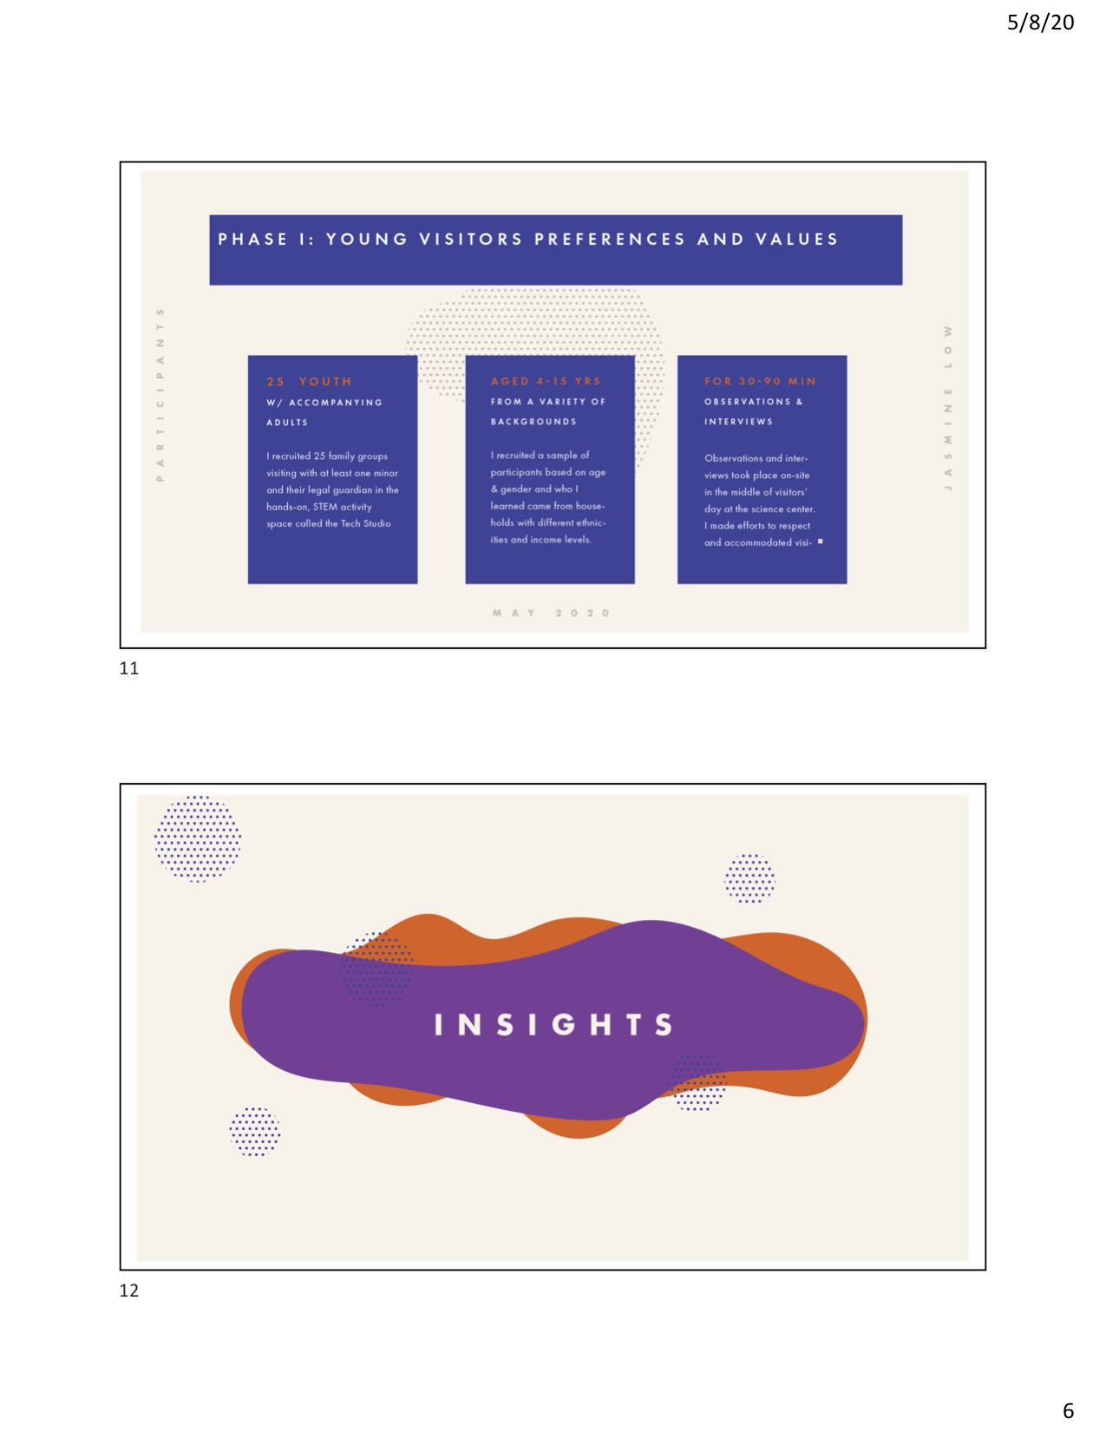
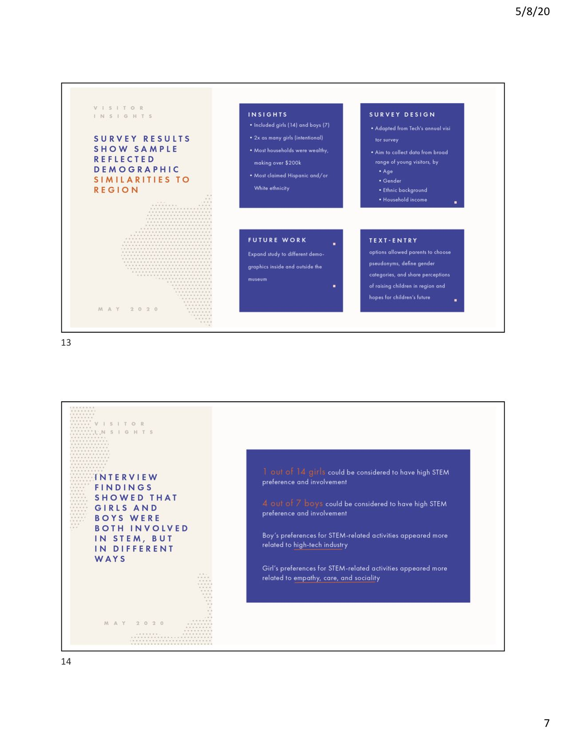
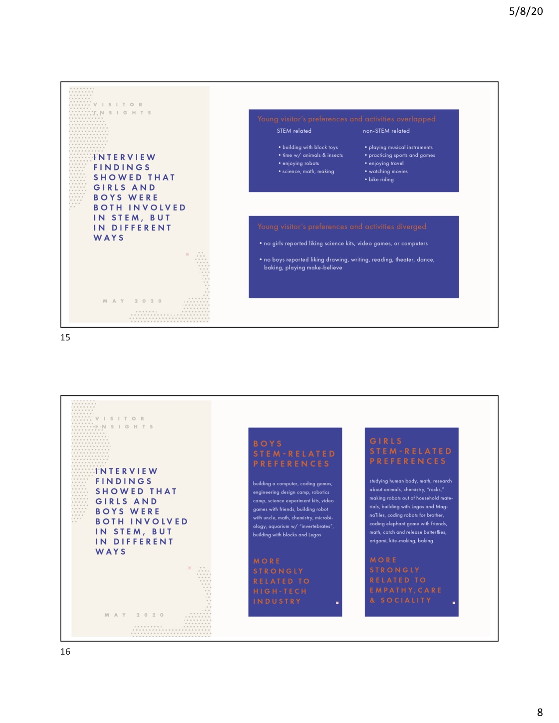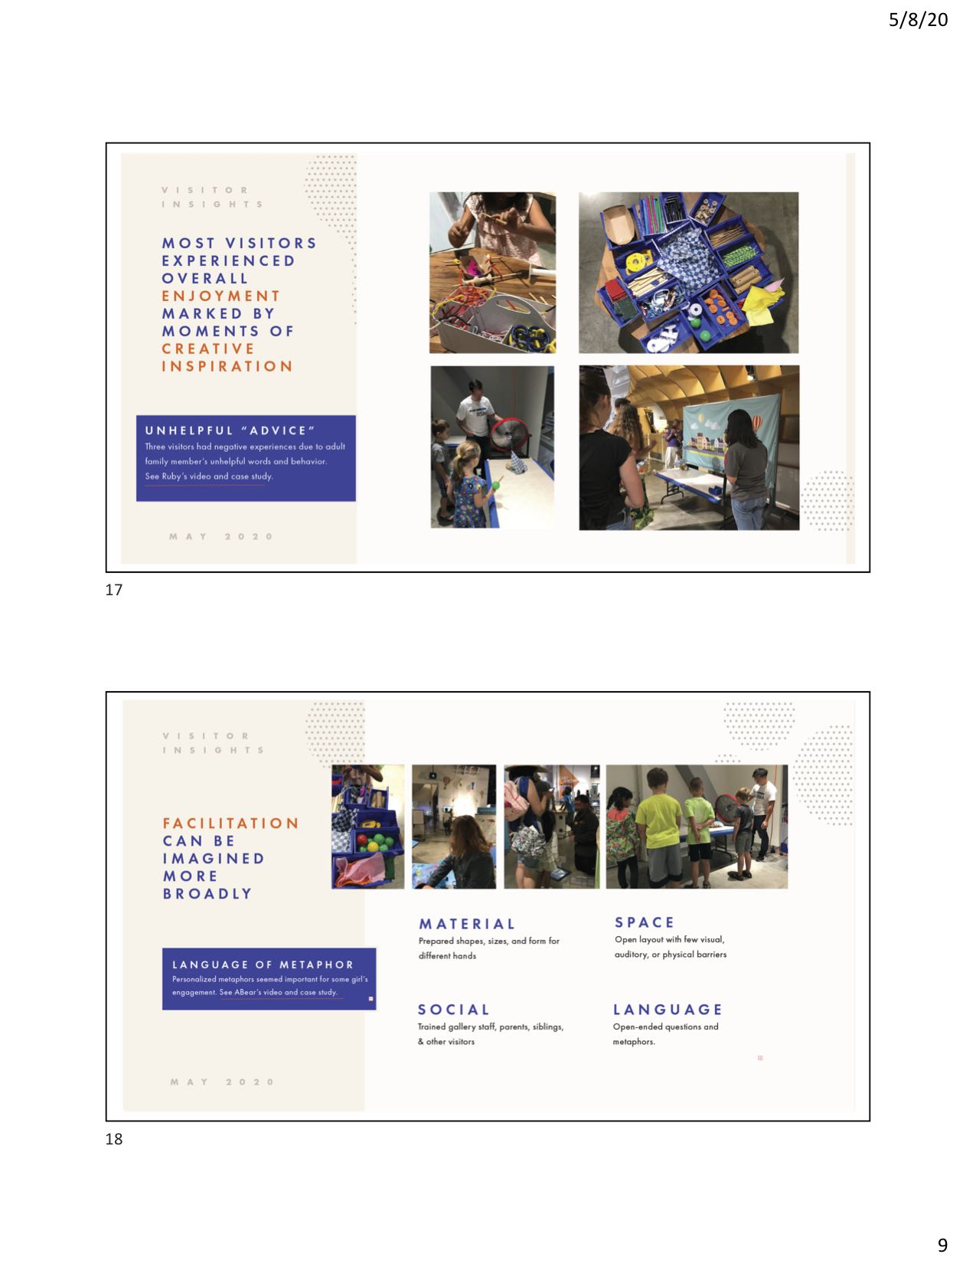

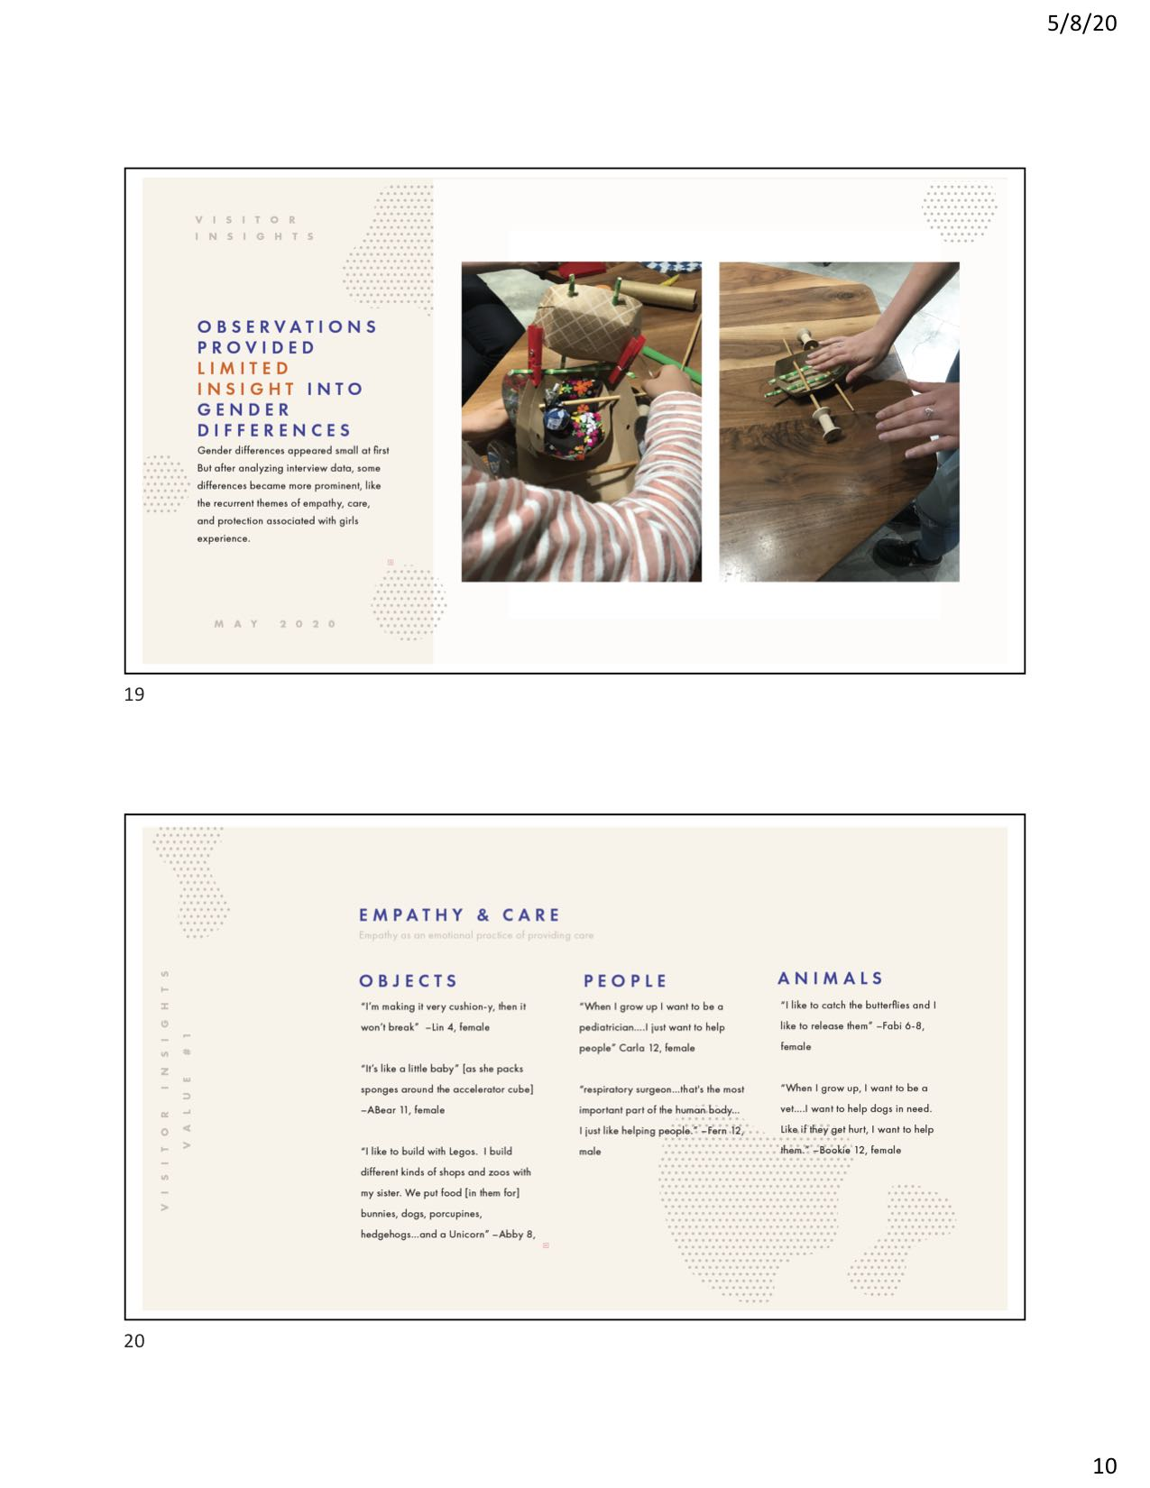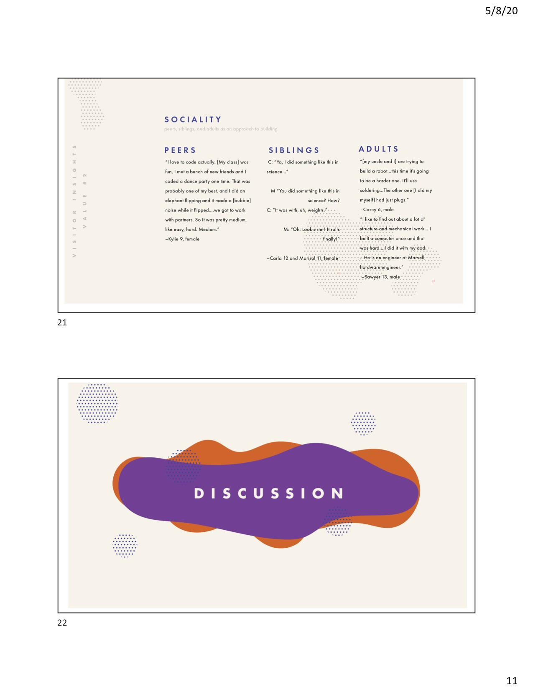
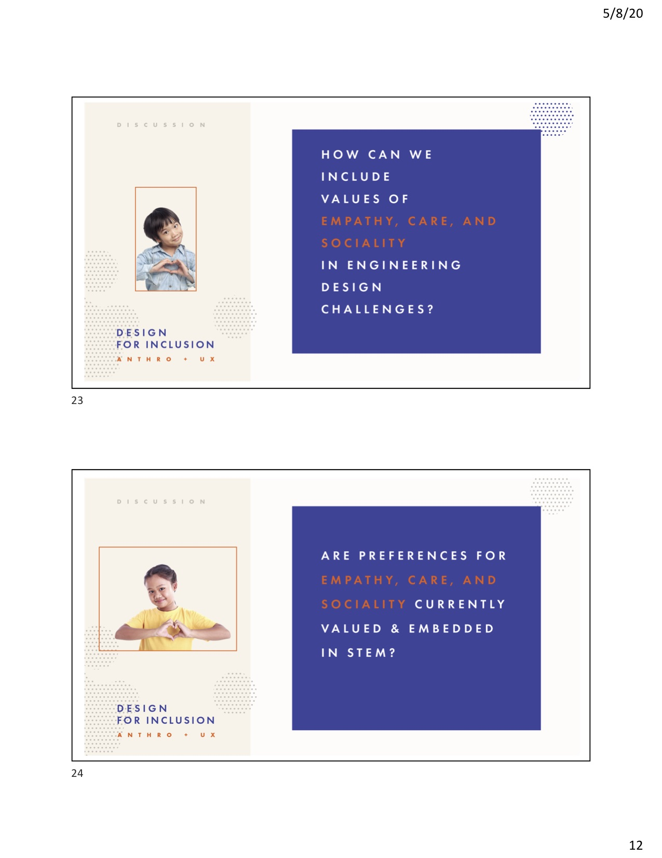

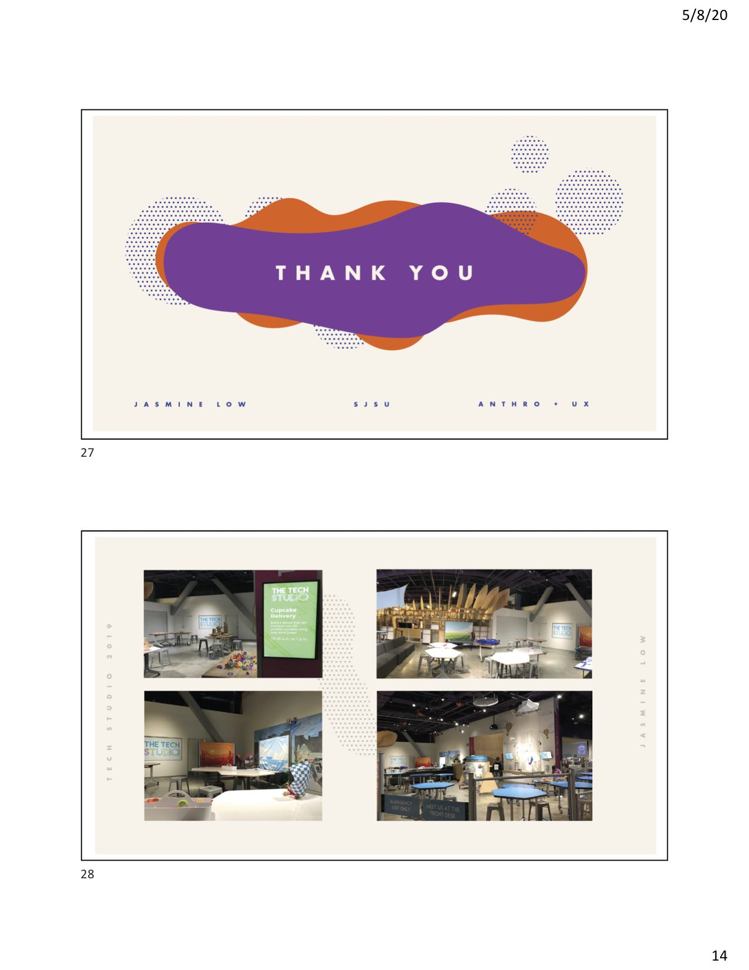

APPENDIX G

7 Case Studies

Empathy & Care
Toward objects and people

ABear

KJ

Figuring out how things work
STEM preference and value

Sawyer

Fern & Fabi

Sociality and other forms of facilitation
Facilitating and Frustrating

Kylie

Carla & Marisol

Ruby

Empathy & Care

Toward objects and people

ABear 11, female
ABear’s approach to learning gives insight into incorporating empathy and care in STEM-related activities through personalized metaphors. She expresses gendered attitudes in terms of caregiving and emotions of playful disgust.

ABear arrived in Tech Studio A with her father in the middle of July 2019 when the Solve The Fall activity was there. ABear had a chin-length bob haircut, braces on her adolescent teeth, a striped t-shirt, and overall jean shorts. She exuded a curious, bubbly, and happy demeanor. This was the first time she had tried Solve The Fall, but she had “watched videos on the ‘egg-thing’…the poor little baby eggs.” ABear’s experience was where I noticed in the most pronounced way, that culturally appropriate metaphors were significant for ways of learning. Her visitor experience was riddled with metaphors she came up with and that other adults came up with.
The metaphors ABear used on her own were marked by language of empathy, caregiving, and protection.
- Referring to egg-drop challenge videos she had seen, she remarked, “The poor little baby eggs.”
- ABear giggled, saying her design looked like “a sandwich”
- As ABear packed sponges around the accelerator cube, she said, “It’s like a little baby.”

ABear’s father even joined in, talking about creating layers of protection, “like blankets” and giving her encouragement, “I get it. You’re going to stuff it like a pillow?” he said with a smile as ABear giggled in response.
By contrast, Gallery Staff looked for metaphors related to science and engineering but translated for a younger audience:
- “That’s a good hypothesis…have you heard of Galileo?”
- “I’m trying to think of a good way to…metaphor-ize this… Everything is made of atoms and molecules…all those pieces, they have to come together, kind of like Legos, or like Minecraft, I don’t know what you kids are into these days” –Gallery staff member, female.

When asked if there was anything ABear said she didn’t think so, but perhaps the only thing was that it took so many tries for her to get it right. “But,” she added, “I feel like that wasn't too bad, I feel like that didn't really bother me too much, because it was really fun doing it.”
The most exciting part of her visit, she said, was her last test, because she had “more motivation, I went through all the stages and I figured out what the things meant, more. And that density and all that and figured out those things about it. Well, so far, so far. I have more things to do [laughs].” She had noticed the open-design kits that were set up in Tech Studio B and added, "there's those connector things over on that table, below that picture, I wanna figure out what those are.”
Trained gallery staff facilitators on the floor appeared to contribute a vital component of her experience. They used metaphors to translate STEM concepts into language that was appropriate for ABear, helping her think, smile, laugh, generating in her new ideas, fun, and motivation to make her way through “so many tries” until she felt she got it “right” –and with curiosity to spare. In just over 30 minutes, ABear created and tested 6 design iterations. As ABear finished up her last test, she turned to me and said, “That was fun! Tricky though!” [conceding with a giggle].
ABear thinks of herself as smart and creative. “I think I'm smart, my mom says I'm smart. And I think I'm creative.” Her way likes to find out about the way things work is by taking the time to wonder, ask her mom questions, and using her body, brain, and senses. She is curious about the way “our bodies work and how we have knowledge of stuff we do and how someone figured out that we have to go to school. I like it. I guess being outside reminds me how does this work and how does that work? And so I guess that just kinda triggers a question in my brain.” ABear translates her curiosity and embodied knowledge into various forms of expression, like drawing, theater, and writing. She says she shares with her friends, "the love of arts…not just the art of drawing, but the arts.”
Thinking toward the future, ABear thinks she might “wanna do some theater…maybe be an actress for a little, maybe a year or something. And then I feel like if that doesn't really trigger my brain… that doesn't really help me then I think I'm going to be a book writer and illustrator because I like to draw and I like to write and so I feel like writing books and drawing in the books would be a good idea.” She says she was inspired by the author and illustrator Grace Lin who "got me triggered on the way people write and how to express their feelings into a book.” When I asked if there was anything she definitely would not want to be, she said a farmer because she doesn’t want to work with “disgusting things, like cow poo.” She added, that her cousins, who are also in fourth grade, have a thing where they are “very obsessed with disgusting objects.” She thinks they “would really enjoy that job because they're boys and they like that stuff” but she doesn’t. She admitted, she’s met other boys who are “more emotional about things and better people than [her] cousins” and it might just be an age thing, but in her cousins’ case, she’s pretty sure “it's gonna be their lifelong thing.”
When I asked ABear about science and engineering, she told me being a scientist can mean “a bunch of different things to a bunch of different people” but for her, to be a scientist means, “not to know stuff but…to figure out stuff. I think to be a scientist it means to learn.” She said she didn’t know much about engineers but thought it was “kind of like a scientist but I feel like maybe it means get your hands dirty and really think outside the box.”

ABear is an 11-year-old girl, of “Hispanic/Irish” heritage, who speaks English. Her father is a president in the real estate industry, whose household income is $200,000 or more.

KJ 13, male
KJ values figuring out how things work to make products, help people, and make money. He only spoke in gendered terms when describing his family members’ tastes in music.

KJ arrived in Tech Studio B with his mother in the middle of July 2019 when the Cupcake Delivery activity was set up. KJ had his hair cut short above his ears, wore a cotton "Abercrombie" t-shirt showing a camouflage pattern behind a moose, blue jeans, and blue sports shoes. A thin gold chain caught the light just above the collar of his shirt. His demeanor appeared calm, thoughtful, and confident.
KJ's experience was especially memorable for a small exchange he had with his mother, where she had a different perspective on how a cupcake "should" be delivered. KJ had selected a thin brown cardboard food tray from the materials table and was flattening it. His mom sat next to him, glasses perched on her nose, arms folded in her lap. She asked if he knew his "step-by-step process" of what he was going to do. He said he was "trying to have a carrier."
A facilitator who was organizing materials came nearby and commented, “Mmm, what a unique design!” as he folded the edges of the cardboard tray around a small, plastic 3-D printed cupcake.
KJ's mom looked toward KJ, who was folding the cardboard tightly around the cupcake and asked him why he wanted the carrier smaller. His simple response was so that the cupcake is "compact." His mom reminded him, "It's a cupcake, it has frosting, remember," and she grins as KJ looks up at her, acknowledging her comment. KJ continued to fold the cardboard around the cupcake, pressing it up against himself as he folds. His mom narrowed her gaze on what he was doing and laughed saying, "I wouldn't want to eat that cupcake." KJ didn't follow, "It's just 3-D mom," so his mom tried again, smiling playfully, "But it is a real cupcake, come on!" "No it isn’t!” he retorted, smiling back at her. KJ’s mom smiled, insisting, “It is!” She tried to appeal to her own emotion of disgust, “Eww. I am not eating that cupcake, especially if it’s from Kara’s Cupcakes. You know those popular cupcakes.” However, KJ simply carried on with his activity of finding a way to make his cupcake carrier “compact.” KJ’s mom offered a consolation analysis, “You don’t like frosting, but I love frosting.” KJ confirmed, “I hate frosting.” “I know”, she said, “that’s why you don’t care about the frosting. This cupcake is really sad…I’m just letting you know…would you like your food delivered like this?” KJ had no qualms about cupcake deliveries, “If its cupcakes, I’m fine.” KJ’s mom appealed to empathy to help him imagine delivering a real cupcake and imagine how a customer [like her] might expect a cupcake to appear when delivered. In a last-ditch attempt, she told KJ, “I don’t know, it’s your cupcake. It’s your company who’s delivering cupcakes. You might not get a second order.”
When I asked KJ later in the interview, about his time in the Tech Studio he said the Cupcake Delivery activity was “kind of hard to think about, like, what to do” because he didn’t have tape, “I didn't have any things I usually use.” He said he thought the most exciting thing in the Tech Studio was Solve the Fall. He has done an “egg-drop” in fifth and sixth grade at school and said he’ll probably do it again next year in his math class.
KJ thinks other people see him as “funny” and “very persuasive,” like when he plays basketball with others, he says he looks for “loopholes to make it what I want to do.” He said his family members have a lot of things in common but have different tastes in music. For example, his dad likes “the '80s, '90s music,” while KJ likes “the Beatles but I also a lot of rap” along with his brother. He said his mom likes “those sweet songs” like the music from the “Lord of the Rings” film.
KJ had the most quantity and variety of interests and activities of all the visitors I spoke with. He told me he likes to travel and has been to over 30 countries. His favorite: the Maldives. He said his family used to live in Singapore for his dad's work, and they were there for 7 years, from the time KJ was six months old. KJ told me he liked finding out about "business" and "entrepreneurship." He spent time at a camp where he learned about business, including "SWOT analysis" and "how to start up a business, how to write an executive summary." KJ also likes to learn about "engineering design." He told me that he created a prototype of a product during camp that "could turn thin air into water." He said he had to "make up the whole thing, design it, make it look good, portable, small, and it was really fast and easy to provide water in somewhere." In another summer-long camp, KJ helped design a robot and added code to the robot; "I learned javascript. I learned python."
KJ’s list of interests and activities went on. He told me about the different sports and different musical instruments he can play. At home, KJ likes “building stuff and see[ing] if it works.” For his birthday he used to get kits for making “slime” or “building a robot that could actually move based on voice command.” He says his mom encourages him to work on these projects on his own, but if he really needed help then he’d ask. With his friends, they play basketball together or they connect over online games like, “2K19 which is a basketball game. You can play together even though you're separated… Like on the line [online].”
KJ says he's "not a fan" of "physically writing" because he says, "I'm more like, saying stuff, and me not writing." When I asked him what he definitely would not want to be when he is older, his response was a writer; a journalist. Instead, KJ wants to be an entrepreneur because of his overall interest in "business marketing." He wants to be the person at the store that "helps" by "selling it, making the product, and making money."
When I asked KJ if he could tell me what science is, he said, “There are different kinds of sciences…Biology, chemistry, there is human body system[s].” He understood science was many things, some of which “relate to life,” for example, “what's around people, what is people, what are we feeling, what do we do, and like atoms.” When I asked what it means to be a scientist, he said frankly, “I do not know.” KJ framed his understanding of engineering as “creating and designing …Because I design websites, I made actually websites and published it.”
KJ understands that "when you're becoming a businessperson, you need to have an overall aspect of all the subjects, before planning your product and see how it can help…wherever there is need." Some of the needs he thought were important were "In third-world countries. Water. More food, because some [are in] famine.”

KJ is a 13-year-old boy, of “Asian Indian” heritage, who speaks English (well), Hindi (understand), and Spanish (little). His father is a business developer in the technology industry, whose household income is $200,000 or more.

Figuring out how things work

STEM preference and value

Sawyer 13, male

Sawyer’s approach to learning gives insight into the ways he values of figuring out how things work in STEM-related activities. Of interest were the ways he confronted and navigated unhelpful advice from his grandmother.

Sawyer arrived in Tech Studio B and the Cupcake Delivery activity with his stepmother, grandmother, 10-12-year-old sister Ruby, and a younger brother who appeared 4 or 5, in the middle of July 2019. Sawyer’s hair cut was cut short above his ears, and he wore a black cotton t-shirt printed with a “Golden State Warriors” and basketball logo, dark basketball shorts, and flipflops. His demeanor was mild-mannered, thoughtful, and when he spoke or smiled at his sister, I noticed braces. When I invited the kids to participate in my research, Sawyer chose to wear a lapel mic while his sister Ruby chose to wear the Go-Pro camera. As I clipped the microphone to his t-shirt, Sawyer said he was used to lapel mics from his broadcast class. Sawyer and his family had been at the Tech for “an hour, maybe two” and had just come from “the robots” activity.

Grandma took a seat at the same table as Sawyer and Ruby, taking pictures on her cell phone, while their stepmother worked together with the youngest boy on the other side.
Sawyer worked on his own and appeared to move through the activity calmly and confidently, vocalizing his assessments and decisions with phrases like "This is gonna be perfect," "I wish there were like spacers." And after his first test, he said, “I know what I did wrong here. I didn’t use something to catch the wind." And after subsequent tests, he noticed how after he "redesigned…it went way farther." Testing allowed him to observe, assess, come up with ideas that gave him confidence. "I have an idea!" he said as he returned to the table from the testing rig, and about a minute later, "mine's for sure going to work now."
A memorable part of Sawyer’s observation was the way he warded off advice from his grandma. He started the activity in what appeared to be consultation with his grandma. However, after about twenty minutes, their conversations became moments where Sawyer pushed back against his grandma’s advice, “No, it won’t do anything grandma.” “Surface area doesn’t really matter. Air is basically a molecule grandma…” and “See grandma, that didn’t work…now it’s just making it harder for the wind to get in…it wouldn’t work like that grandma, that’s not how it works.” By the time Sawyer and Ruby’s confrontations with grandma began to escalate, Sawyer had tested and tweaked his vehicle to the point that he announced he was finished, after grandma pulled out her phone to take a picture of “what worked”.
Although he was born near San Jose, Sawyer now lives in southern California and comes back to San Jose occasionally, as his grandparents are still there. He had been to the Tech before when he was younger "like seven or something." I asked Sawyer if he’d ever done something like that activity out there, and he said last time they visited San Jose he’d done something at the Children’s Discovery Museum where you had to build “a structure” that could “get knocked down with a wind something.” He said he thinks these types of activities are “fun” but some of them seem “a little bit too complicated.” Of the Cupcake Delivery activity, he said “I liked this one. It was tough because you had to find the perfect materials to get your car to go.” He thought he tested his car six or seven times, using a process where he just “tightened [the car] differently” and other times he “added something or took away something.” He learned “bigger wheels have more traction, so they won't spin out more.” He said he wished there had “been more parts, or you should have been able to cut, or make little things” with something like “scissors, or hole punches.” But, he suspected, the materials were probably meant to be recycled.
Sawyer thinks of himself as someone who likes sports. Although he “[doesn’t] really talk to everyone” because he attends a big school, among his friends, he thinks they have a lot of similarities, “We all like video games, we all like that type of technology.” And he thinks he might be different than other people because he knows “a lot more about computing than them. They just know the main basics, but I think I know a little bit more.” He explained that when he was young, he was “around that a lot” because his dad was always showing Sawyer “what he's doing and how all of it works.”
Sawyer’s interests revolved around sports, like hockey and soccer, and engineering activities. “I like to find out about a lot of structure and mechanical work… I also like the wiring and that stuff.” He explained that’s because his dad is a hardware engineer at a large technology company “so I get to learn about it.” He got to go to a “Take Your Child to Work Day” but he didn’t remember much of that “because I was five-years-old.” Instead, Sawyer told me about how he “built a computer” with his dad at home. He was motivated to do it because he saw “all my other friends doing it, but some of them would think it's too hard and I was like, "Oh, I want to try it out." And so, he saved up his birthday and Christmas money to purchase the parts, “sometimes I would even get the parts for the computer as a gift.”
In school, Sawyer likes to learn about math, liking “how simple it is and that you don't have to memorize stuff. You just need to know the formulas and the equations.” He also likes history because “learning about our past” is “fun.” When he’s older, he wants to be “a software engineer. I don't really like the hardware, because it's too hard on my fingers." Sawyer said that he had coded a game on Scratch “but it was just JavaScript and you drag and drop blocks.” There was something about it that “just made me excited to do it and every time I would look forward to it.” His dad has mentioned that he could make his own game on his computer.
On the other hand, Sawyer "definitely, probably, wouldn't want to be a scientist or something like that" because "[scientists] go into laboratories…you have to dress up in a suit, or their coats, and then they have to put, and it takes a lot of math, but I don't like how you have to put the chemicals together or do a lot of research. I don't like that type of stuff." He told me he prefers to go outside, do math equations, or play video games inside sometimes. “I like computers and that stuff a little bit more than science.”
So, I asked Sawyer to tell me a little more. He said, “Science is basically the research and you have to find the answer to a question that people are asking. And, if you don't have a question then you look up research and you [find] out what were people asking, and then you test and you get the results. And then, you make a conclusion.” I followed up, asking how is science different than engineering? Sawyer explained, “Science takes research, which engineering takes as well, but engineering, you have the ability to do whatever you want and create something that you want.”
Of the people he knows who uses science, he said he has a cousin who is getting a degree in biochemistry. I asked if that was the type of science he was thinking about when he said he didn’t want to do science and he clarified, “No, my mom was trying to be a scientist in her college, but she dropped out to be another scholar. And, my cousin was, and it just doesn't seem interesting enough.” He’s not sure whether he knows anyone who is really into science, but he has a dad who provides him with opportunities to explore engineering. I asked Sawyer how he thought he could get to be good at engineering, and he said, for software, you can “learn the code and you have to keep memorizing the code. You have to figure out what the code could be used for. It's just another whole thing to learn and it's just fun. Who knows more languages in code? It's just...” Science on the other hand, “just doesn't excite me to memorize.

Sawyer is a 13-year-old boy, of “Caucasian” heritage, who speaks English. His mother works in a human resources department and his father is a senior architect in the engineering industry, whose household income is $200,000 or more.

Fern 12, male and Fabi 6-8, female
A binding thread in both of these visitor experiences was their mother’s involvement, in helping her daughter get comfortable getting started and looking for ways to support her son. Fern’s approach to learning gives insight into the ways he values of figuring out how things work to help people. Fern’s love of the periodic table, microbiology, and his aquarium are joined with his sense that he is a “generous” person. Similarly, his younger sister Fabi is energetic about activities at the Tech, math, and chemistry and is passionate about taking care of animals and other creatures. It may be worth noting that this family has a Tech membership, has participated in the Tech Challenge, and come from a lower income bracket than many other visitors in this study.

Fern’s observation
Fern arrived in Tech Studio B with his mother, father, and sister Fabi at the beginning of August 2019 when the Wind-Powered Vehicles activity was set up. Fern’s hair was clipped short and he wore a light blue t-shirt with colorful beetles and leaves the front and back of it, black basketball shorts, and grey sports shoes. He put forward a sincere and curious demeanor. His sister Fabi’s chin-length hair was down and set with a headband, a light purple shirt, a purple floral skirt, colorful tights with planets on them, and black sports shoes. She initially refused to participate in the observation part of the research, but she was willing to interview at the end.
Fern worked alone at a table between the testing rig and materials table, across Tech Studio B from Fabi and his mother worked at another table near his father resting and using his smartphone on the couches. Sawyer spent about ten minutes at the table, selecting materials, squeezing, sliding, and rolling materials like orange foam wheels or white plastic spools sitting on chopstick axels and felt fabric, to test their properties. Fern pushes the bundle of materials back and forth with his hands, he blows air into his cardboard sail and then carries it over to the testing rig and Fern touches the surface of the rig. I ask him what he's thinking, and he says, "I think that this [he touches the felt] will grip onto the ground." He stops to think for a moment, looks at the testing rig beside him, and says, "I think I need to use bare wheels instead" and pulls the felt off of his design at the rig. It falls slightly apart and so he makes a readjustment. He pushes it on the surface again and again while waiting for the gallery staff to come. When a gallery staff member sees him she comes over and asks what power of wind he would like. We watch as his bundle moves forward with the first level of fan power, and bumps across the uneven terrain, but flips sail-down about halfway across the surface of the rig. Fern puts his finger to his chin and says, “I need more weight in the back.” The staff member asks him where on his vehicle he would put the weight, and then Fern turned to head to the materials table where he selected two wooden spools. Fern worked energetically but calm. He made observations, like noticing the back wheel was not, and assessments like, "I think it's because the wheels are too small." He made readjustments by looking carefully at his vehicle, pulling the pieces apart a bit, and after each adjustment, over and over, testing whether the plastic spool spins until he takes it back to the testing rig. A gallery staff member at the rig encouraged him to think about another part of his design, saying, "It started moving right? You have a way to catch the wind…Think about the bottom, maybe find a way to lift it a little more. Do you want to try one more time? Okay, it's stuck in the same spot, right? So that might help you if you lift it just a little more so less stuff is touching the table." With a simple, "Ok," Fern turned to carry his vehicle back to the table.
A memorable part of this family’s visit was the ways Fern and Fabi’s mother worked alongside them. In the beginning, she sat beside Fabi, who perhaps perturbed by my intrusion or simply in a mood, did not want to get involved. She stuck close to her mom and after some time, her mother reached out to a gallery staff member on the floor to explain to them what the challenge was and how to do it. After the explanation, I overheard the mother say “Okay, she wants to do her own.” Fabi picked up materials to work with and from afar I could see a white plastic spool, a piece of pink craft felt, a red ball, and a blue plastic grid. Her mom sat beside her asking, “How do you want it?” Fabi continued to look uncomfortable, and as I meet her sad eyes, I turned my gaze away. I overheard Fabi’s mother ask, “Como lo quieres? Largo o corto?” and then switch back to English.
Fern’s mother later checked in on him, giving him advice and watching him test. She comes up to him smiling and he explains to her that he’s lifting up his design. As she watches him proceed, she advises him, “Just calm down, and you can figure it out, and think.” This surprises me because, from my point of view, he appears to be doing just that, already. His mom leaves to check on Fabi as she completes her 4th and 5th tests. When his mom comes back, she suggests, “I tell you a little trick?” and shows him that he can wind the pipe cleaner around the wooden stick to keep the wheels on, “you know, like little washers” she says. Again, his mom reminds him to go slowly and to be careful with his fingers, to “go very slowly” each time he puts on another pipe cleaner.
Shortly after, Fern was ready for a third and fourth test on the glacial landscape, where we watched as the fan pushed his vehicle straight forward and off the end of the table. Fern smiled ever so slightly and the facilitator asked if he wanted to test any other terrains. It’s at this point that I notice boys from the summer camp group have also gathered around the grassy terrain testing rig for Fern’s 6th test. As the facilitator turns on the fan, turning up the speed incrementally, “One…two…”, two boys wait at the end of the test rig, facing the fan. The gathering around the rig became more apparent at Fern’s 8th test on the grassy terrain for an 8th test. As Fern sets his vehicle on the table, three boys from camp waited around to see what would happen. Three girls from the camp sat on the couches and watched the test from there. As the facilitator turned the fan up to level 3, we all watched Fern’s vehicle roll to the end of the table where the two younger boys catch it before it crashes. As I move back, I see that Fern’s mom and younger sister Fabi have been watching also, from behind me, making a total of at least 9 spectators. Fern signals he is finished as he starts to take his vehicle apart, untwisting the pipe cleaners from each other and returning the components that made up his vehicle, back to the bins.

Fern’s interview
In our follow-up interview, I asked if he had ever done anything like that activity before, and he said he had been a part of the Tech Challenge before. He had been on a team with three other friends from the YMCA. I learned throughout our interview about Fern’s deep interest in science. He introduced himself as, “Well, my name is [Fern]…I like the periodic table and microbiology.” Fern told me his hobby is having “invertebrates” in his aquarium. He has “amano shrimp” and a “crayfish named Cranky” as well as two “bamboo shrimp.” I asked what he liked about his aquarium and he said he liked “how the shrimp actually cleans up everything for me.” He learned about how to set up his aquarium by “search[ing] it up a lot…on Google.”
At home, in his everyday life, Fern likes to watch his aquarium and ride his bike “from the gates and back. There's this long road that goes to the beginning of our house. It's like a quarter-mile.”
Fern thinks his parents would call him “generous”—he’s overheard them say it on the phone. He believes he’s similar to other people because he has friends that he plays with at recess, and perhaps different than other people because “a lot of people don’t like music” to the extent he does. At school, Fern likes playing the baritone, “and now I’m playing the tuba… I play trumpet, I play piano, I play guitar, I play recorder, And let's see. What else? I could play the harp. That's it.” He also likes math, “algebra and geometry” because he likes “variables” as “a good challenge to do” and because “geometry is almost everywhere.”
Thinking toward the future, Fern says he wants to “respiratory surgeon,” because he thinks “that's the most important part of the human body…without our respiratory system, then you cannot have oxygen for eating." He added also, because "I just like helping people."
I asked Fern if he knew what engineering is, and he said yes, that engineering is “a type of way that people use mechanics into buildings, structures, or different, kind of like, objects. And then, they use it to overcome challenges." He said, for example, a challenge could be "if you have a building, it needs to be tall. But then, the wind is too strong to support it, then they have to use engineering to fix it. Maybe they have to build the building wider? Maybe they have to have it, dig down deeper so that they can have stable rock in the bottom.”

Fabi’s interview
Although she was initially uncomfortable, Fabi and I had an engaging follow-up interview. Fabi’s attitude toward the activity was that it was “Hard” which was “not too fun.” While her first test “went smoothly” on the glacier terrain, when she tested on the rocky terrain “it didn't really work out…it flipped onto its side.” When I asked if she’d come back she surprised me by saying she would, because, “well first of all this is my 2nd favorite station in the whole museum” because she liked that you got to “build stuff.” Her favorite is “the one at the top floor with the bacteria where you get to make your own stuff…you get to put it up on this big screen.” Realizing this wasn’t her first visit, as asked how many times she’s been to the Tech. Her answer was simply, “Members.”
Fabi imagined her friends and family thought of her as “annoying” and “hyperactive”, but she had a sense of self-confidence that showed her inner strength. “A lot of my friends say that I'm annoying…but I like to take it as a compliment… It does not break my feelings one bit.”
In school, Fabi likes to learn about math because she likes the different math topics and chemistry because she finds it to be easy.
“I like division… Multiplication…I'm learning about fractions…. I like chemistry… It's easy for me.”
For extra-curricular activities, she likes things that allow her to interact with creatures. Fabi told me "I like nature" in the sense that she likes "ladybugs and butterflies… I like to catch the butterflies and I like to release them…” She spends time in nature at a summer school where there's “a huge field but someone cut down the field, which drove away most butterflies and ladybugs.” Like many of the other girls I spoke with, Fabi is interested in animals. When I asked Fabi to tell me about herself, she started off saying “Well, I love cats…my favorite is Siamese.” And when I asked if she had thought about what she wants to do when she gets older, her answer was “Veterinarian. I like to pet fluffy little animals. After cats, her next favorite animals are “2nd, bunnies, and owls. Cheetahs [she said with intrigue in her voice]…I sure do love them. Also, I love to run.”
Fabi also likes "making stuff…arts and crafts" and she is incentivized by rewards that allow her to interact with creatures, like an ant farm and butterfly net. She told me how her mom is trying to get her to work on a challenge with her brother about kindness. She is supposed to "make a box for him and decorate it then put special notes inside of it" and at the end of the week, her mom would buy them "an ant farm…also, a butterfly net…I have to work with my brother…We both want the ant farm and the butterfly net. There's a huge ant farm in one place and a box right attached to it in front of it. My brother and I are thinking that in the front part that has almost nothing inside of it, we could put the ladybugs and butterflies inside there… Maybe catch and release.”

Fabi is a 6-8-year-old girl and her brother Fern is 12. They are of “Native American/Hispanic” heritage and speak English. Their mother is an education assistant and father is an animal care technician with a household income of $60,000 - 74,999.

Sociality and other forms of facilitation

Facilitating

Kylie 9, female
Kylie’s approach gives insight into the ways she values of figuring out how things work and incorporates sociality in STEM-related activities. She expressed gendered attitudes in terms of playful destruction and preservation.

Kylie arrived in Tech Studio B with her mother and 6-year-old brother at the end of July 2019 when the Wind-Powered Vehicles activity was set up. Kylie had long hair that reached the middle of her back and she wore a t-shirt with a horse on the front, jean shorts, pink toenails decorated with polish, sticking out of pink rubber sandals. On her wrist, she wore a bracelet with a large knit pink and yellow flower on the finger-knit band. She had a happy demeanor that carried with her throughout her visit. Kylie told me she had visited the Tech once on a field trip and now comes every summer, usually with her mom. Kylie’s mom is a schoolteacher so last year, when she had a meeting, Kylie came with her grandma. The day of Kylie’s visit was a Teacher Appreciation event. She had spent time doing the Solve the Fall activity before, but this was her first time doing the Wind-Powered Vehicles activity.
Kylie’s experience was notable for how quickly she completed the activity, in 16 minutes and also for the things she shared in our follow-up interview that gives insight into values of sociality in STEM-related activities. To start, Kylie headed to the table set out with bins of materials. A female corporate volunteer talked to her about how to think about what materials to choose and showed her the caddy of connector pieces. Kylie found a stool to work out her vehicle while her little brother nearby and mom said she was just going to wander. Within the first minutes of building, Kylie had a minor frustration, “I can’t get this through” she said as she tried to put the ends of a wooden stick through two pre-punched holes in some checkered paper. After testing it on the table, Kylie announced “It’s rolling!” while her little brother announced, “Never mind, I changed my mind. I’m not going to make a turtle!” Kylie was ready to test when she carefully picked up her vehicle and carried it over to one of the testing rigs with a carpeted surface. A female corporate volunteer let her know that the rig with the smooth surface was “easier” but they could try this one first. Kylie set her vehicle on the thick grey carpet, adjusting the wooden spool wheels that slipped off as she set it down. The volunteer turned on the fan and as the airspeed picked up, the force from the fan completely blew her vehicle apart! Her face was a look of shock but she simply bent down to pick up the pieces and carried them back to her table. Her mom said, “Need to make some improvements?” to which Kylie responded, “That was funny!” and they laughed together. At the table, Kylie’s younger brother asked aloud, “How do you get the wheels to stay on?” with an adorable twisted, quizzical look on his face. His mother helped him think through some options.
The second time Kylie tested her design, she carries her vehicle over to a different testing rig with a smooth surface, where a corporate volunteer was manning the fan. He asked her if she wanted the fan speed at “one, two, or three?” She said “three” and we watched as her vehicle slid across the surface, into her little brother’s waiting hands. “It worked!” she said to her mom, “It just needed a smooth surface.”
When I asked Kylie about her time in the Tech Studio, she said, "the first experience I didn't really like because it all broke into one piece." Despite that, she found it funny when her design got blown apart, laughing with her mom, that it was "funny!" In the end, she liked her next idea. "I liked my second idea because it was like a parachute and it was moving and it made the cartwheel.”
Kylie described herself with her age, first name, that she likes elephants, that her favorite color is teal, and her birthdate; “That's pretty much it.” Kylie thinks she’s “sometimes” like other people she knows, for example, she and her cousin “like to play school all the time” and she and her brother like that too. When I asked if she thought she was different than other people, she thought “some people,” like one of her cousins who “loves destroying things.” Kylie says she likes “keeping things up for five days or something.” Kylie said she “always build[s] the biggest castle and he always destroys it, and I never like that when he does it…a little boy. So...”
In school, Kylie likes “art and writing…I like to do things that you see around the classroom…You look at something around the classroom and if you find it, you can draw a picture of it." At school, she also likes “finding out that there's going to be a new kid or something in the class…Because there's someone new that you can maybe be friends with… I just say hi to them and then we have a conversation. Then we just become friends.” She told me how she had been in a coding class once, that she “love[s] to code actually…I just like that you can go and code.” She said the class was “fun” and that she “met a bunch of new friends” and “coded a dance party one time. That was probably one of my best, and I did an elephant flipping and it made a noise while it flipped…It made like, a bubble noise.” When I asked her whether coding was a difficult thing, she said, “Well we got to work with partners. So it was pretty medium.”
Outside of school, Kylie likes to color, play with her brother and sometimes watch things on Netflix, on TV or her Kindle. A favorite show is “SpongeBob…I like his funny voice that he makes…We've seen almost every single episode”. If her brother wants to watch “Winnie-the-Pooh” and she wants to watch “Descendants” then her brother can watch his show on the TV and she can watch her show on her Kindle. She also likes to play with her cat and to “just hang around sometimes.”
When I asked Kylie what she thought she might do when she’s older, she told me, “I want to write books…Kids books…Like mostly about elephants.” She told me how she’s planning to send it to someone to make it into a hard-covered book. Her favorite book is “Little Man of Disneyland…Actually, if you go to Disneyland it's a really special book that Walt Disney actually wrote”.
Kylie understands that science is about “building stuff” and that “engineering is science too, pretty much”. Her dad has an engineering job, but she says she can’t talk about his work because “he's on a top-secret one… I don't even know [what it is]". Some "engineering things" she's done before are: "One time I helped my brother build a Lego castle for his Legos…Then one time I helped him build this robot that moves. Sometimes I code my robots at home…My brother does too…He has only one robot though, I have two.” She says her brother's robot is a Geckobot but “he doesn't get to code it. The one that he can code is the Ozobot…You draw the lines, and it follows the line.”

Kylie is a 9-year-old girl, of “Caucasian” heritage, who speaks English. Her mother is a teacher in education and her father is an engineer in the tech industry, whose household income is $200,000 or more.

Marisol 11, female (and her sister Carla 12)

Marisol and Carla’s experiences provide insight into how siblings can share life knowledge to inform the way they approach STEM-activities. They shared a fun moment was Marisol made a silly connection to a squirrel.

Marisol is an 11-year-old girl who visited the Tech Studio with her family: her mother, father, her 12-year-old sister Carla and 6-year-old sister Ana. They visited on Teacher Appreciation Day at the end of July. When I asked who would be willing to be interviewed, Marisol volunteered confidently, but their mother suggested perhaps all three of them could participate, perhaps to avoid one sister feeling left out. Marisol volunteered to wear the audio mic and I wore a Go-Pro camera. I realized too late and to my dismay, that 13 minutes into my observation, my camera wasn’t on, but the audio had been on. I drew from my fieldnotes, the audio (25 min), photos, and partial video (12 minutes) to present the following insights from their visit. Marisol and her sister each completed 3 design iterations in about 25 minutes.
Marisol spoke to her 12-year-old sister, referring to her by name but also by “Sister!” As Marisol and Carla were choosing which materials to use, they talked together about options for their vehicles. There was a memorable moment when Carla and Marisol used their life knowledge to make design decisions and to have fun with each other.

Carla: Ya, I did something like this in science but…
Marisol: Wait, sister, look. You did something like this in science? How?
Carla: It was with, uh, weights.
Marisol: Oh. Look sister! It rolls finally! Look! Sister!
…
Marisol: [She blows out a breath of air] “It actually rolls with wind! It’s cause this table’s like up, and that goes down. What if I add some stuff to it…maybe this, cause it’s like metal.
Carla: It can’t be that heavy
Marisol: I know. It’s not that heavy, do you want to feel it, or carry it, I mean?
Marisol: …Is it heavy?
Carla: No
Marisol: No for like…If you were like a squirrel, would it be heavy? [they laugh together]. Okay, well you’re not a squirrel so…I wanna make it, like, decorative or something. Maybe I can make a mini-car!...

When Marisol had picked up her vehicle, she suddenly realized it looked like a gym weight, lifting it up and down with her arm and joking it could be for a squirrel. Shortly after, Carla started to share tips with their little sister Ana who was working at the other end of the table. Marisol took over, telling Ana what she learned from Carla, “Don’t make it that heavy because you like…you need to make it not that heavy.”
In our follow up interview, Marisol said, the most exciting thing so far in the Museum that she’s seen was, “the activities” and the IMAX, which was showing Superhero Dogs that day. I asked Marisol if she’d ever done something like this activity and she recalled that last year they had a student-teacher that told them “to build a bridge out of popsicle sticks and rubber bands…to hold a phone.”
Marisol described herself by name, age, and school grade. She thought she was unlike other people because her friends “just have phones and they don't do much because they're always on their phones sometimes”. Instead, Marisol says she reads. She likes to read “Dork Diaries” and has read, “Almost all of them…Three probably. Four.” In school, Marisol said she likes “to research about animals…Like lions, or you know, mammals.” She says she takes notes about what she’s learned and last year in fifth grade she wrote an animal report about polar bears. Asked Marisol if she had ever studied science. At first, she said no, but then said in school they learned about cells of animals and plants and humans. She thought of engineering as “where you build stuff like trains or... yeah.” and said she didn’t know anyone who does engineering. Outside of school, Marisol does boxing in a community youth center “Four days a week.” She’s been boxing for four years and does it with her sister and a friend. She thinks “the stretches are fun.”
Thinking about the future, Marisol wants to be a vet, because she likes any type of animal. When I asked if there anything, she definitely wouldn’t want to be she said, nothing. “Nothing?” I probed, “You could be anything?” “Yeah,” she said.

Marisol’s interview
In my follow up interview with Carla, she said the most exciting thing so far in the Museum that she’s seen was, “the activities” and the IMAX, which was showing Superhero Dogs that day. I asked Marisol if she'd ever done something like this activity and she recalled that last year they had a student-teacher that told them "to build a bridge out of popsicle sticks and rubber bands…to hold a phone."
Marisol described herself by name, age, and school grade. She thought she was unlike other people because her friends “just have phones and they don't do much because they're always on their phones sometimes”. Instead, Marisol says she reads. She likes to read “Dork Diaries” and has read, “Almost all of them…Three probably. Four.” In school, Marisol said she likes “to research about animals…Like lions, or you know, mammals.” She says she takes notes about what she’s learned and last year in fifth grade she wrote an animal report about polar bears. Asked Marisol if she had ever studied science. At first, she said no, but then said in school they learned about cells of animals and plants and humans. She thought of engineering as “where you build stuff like trains or... yeah.” and said she didn’t know anyone who does engineering. Outside of school, Marisol does boxing in a community youth center “Four days a week.” She’s been boxing for four years and does it with her sister and a friend. She thinks “the stretches are fun.”
Thinking about the future, Marisol wants to be a vet, because she likes any type of animal. When I asked if there anything, she definitely wouldn't want to be she said, nothing. “Nothing?” I probed, “You could be anything?” “Yeah,” she said.

Carla’s interview
In our follow-up interview, Carla told me that she had been to the Tech before, “In sixth grade I went to this same place” but she thought it was a different activity. Today, she said “building the car” was the most exciting thing they’d done so far in the museum. Carla believes people who know her would describe her as “kind” and that she’s like other people she knows who are also kind. She thinks she’s different than others because “some people don't think girls can do boxing…and I just, I do it, you know [laughs].” Carla has been boxing for almost three years and she said she and her sister got into it when they were still playing soccer. “And then my parents were like, oh you guys are going to start boxing. I was like, I didn't want to. But I got my license, which is like, where I can box…Like you go to competitions.” She sees boxing as a way to "keep [her]self healthy.” She says she’s also still involved in cheer.
Carla likes to find out about how the body works and she likes animals. She told me how in school they “studied a bunch of organs.” and dissected a frog, but Carla “didn't really like it that much ‘cause there was like a smell. It didn't smell that good, but it was kind of interesting.” Thinking toward the future, Carla said, “when I grow up I want to be a pediatrician. She’s known it “since I was little…I just want to help people.” However, when I probed, she said she didn’t yet know anyone who was a pediatrician nor what you need to study to become one. She says she definitely would not want to be, “a police.”
I asked Carla if she knew what engineering was. She answered, “Where you build stuff?” She didn’t know anyone who was an engineer.

Marisol is an 11-year-old girl and her sister Carla is 12. They are of “Hispanic” heritage and speak English. Their parents did not provide information about their careers or household income.

Frustrating

Ruby 8 – 10, female

Ruby’s experience is a heart-breaking example of how “advice” as a form of facilitation can be unhelpful and frustrating. From the researcher’s point of view, it appeared to be largely due to confrontations Ruby had with her grandma who continued to push her “advice” on Ruby. It is interesting to compare Ruby’s brother’s experience, taking place at the same table, immediately next to Ruby. Two siblings started their experience with confidence and fun, but Ruby's confrontations with her grandma lasted longer, and her frustration rose to a point of perhaps anger. Ruby’s last 20 minutes, after Sawyer had finished, was marked by continual frustration, not helped by her grandma's comments. There were two poignant moments when Ruby shook apart her design and another when her voice cracked with emotion as she tried to assert control over her experience. In a crushing finish, we hear Ruby’s disappointment as she concedes, “I think that’s the best it’s gonna get gramma.”

Ruby arrived in Tech Studio B, to the Cupcake Delivery activity with her stepmother, grandmother, 13-year old brother Sawyer, and younger brother in the middle of July 2019. When I invited Ruby and her brother to participate in my research, Ruby chose to wear the Go-Pro camera. Ruby wears a skirt, black sports shoes with neon pink laces. Her fingernails are painted with cherry red polish and sparkles. In her video, we hear how she talked out loud about her thoughts and emotions while she worked. In just over an hour, Ruby completed 4 tests.
Ruby started off her visit to the Tech Studio with confidence, having fun, and a lot more silliness than her brother Sawyer. Ruby is standing at the materials table and selects a piece of pink felt fabric along with a strip of fabric that someone else has made by knotting smaller pieces together. She ties the strip around the pink fabric and makes a bow with the ends, “I think that’s a bow…-ish. Okay!” She moves onto another bin and grabs a cardboard tube, “Now, we have this…” She knocks it with her hand, “Pretty solid, okay! I guess it’s solid enough, okay.” She then reaches for a piece of paper and tries to stuff it into the end of the cardboard tube, pushing her finger through the paper, “Oh my gosh. Okay.” She stuffs the crinkling paper into the tube, announcing, “We’re just going to stuff it, this, way.” She tosses her red plastic 3-D printed cupcake into the tube and stuffs another piece of paper into the other end of the tube. Her little brother proudly holds up a bundle of materials that look like a paper sack, saying “Look at mine Ruby!” “Wow!” she says encouragingly, “good job!” Ruby knocks the tube, stuffed with paper and her plastic cupcake, against her hand a few times, and concludes, “Perfect. Perfect. Now it’s really strong.” Ruby then slides her cardboard tube under the bow she tied on the piece of pink felt, and as she does, a giggle bubbles up out of her as she shows it to her stepmom, who appears unsure of what to make of it. Ruby giggles as she carries her bundle to the table and takes a seat beside Sawyer. She has started singing a rhythmic tune, as she reaches for an elastic out of the caddy set on the table. As she finishes tying another elastic around her package she goes, “Boom!” and laughs as she lifts it and carries it back to the material table. "Now I want some wheels." Ruby selects two white plastic spools and slips the ends of the spools under the elastics, creating a sort of platform instead of wheels that will turn. Sawyer glances over and asks her about it. Ruby finds it very funny and laughs, "I don't know!" As she wraps more elastics around the spool platform arrangement, she has started singing her rhythmic songs again. When she finishes, she sets it down on the table, like two Greek pillars holding up a cardboard tube wrapped in a bow on a pink cushion of felt. She bursts out laughing, "Sawyer! Look!" She carries it over to her stepmom, giggling, “I don’t know, but it’s something.” Ruby reaches for a wooden dowel and sees that it fits inside the spool. She appears to be simply exploring how the pieces could go together without minding the design challenge, enjoying herself in any case.
Ruby’s grandma takes a seat across from Ruby and Sawyer and asks Ruby, “How’s that going to roll?” Ruby says she doesn’t know, bursting into laughter again. “This is too crazy! Okay.”
After about 8 minutes, Ruby became more serious about her endeavor and soon runs into a frustrating moment. “Now I’m back to the same spot. It doesn’t roll…Oh!...But that isn’t rolling the right way, so…” Her brother Sawyer assesses his vehicle out loud beside her saying, “Okay, I redesigned…it went way farther.” Ruby says, “This is way too much…so…I don’t think…” and then she gets an idea, “Oooh!” As Ruby is testing her design at the table, she becomes energized with ideas. “Oh, why do I have this one here. Ah, I don't need this. Why is this one here? Okay."
But then she slips back into puzzlement, “Okay, so I’m kind of in a problem. So I need something to make it roll…” Sawyer has tested 3 or 4 times now and is using the test information to re-analyze his vehicle. At 18 minutes, Ruby realizes she hasn’t “even tested [hers] once”
Ruby began to make assessments of her vehicle, but she framed it in terms of aesthetic and fashion, saying "this is definitely not the most fashionable car…I'm not focusing on how it looks, ‘cause I have a problem.” She reasoned, “These cross-over when these are straight…so I’m going to put pipe cleaners, and I’m going to try to connect them, I’m going to try to make them tight enough, so they don’t have room to move around. So I’m making this super long pipe cleaner now.”
A gallery staff member stopped by her table and reminded Ruby of the challenge. “It’s a wind-powered vehicle…Let me know when you’re ready to test it.” Ruby didn’t seem to pay much notice to the facilitator’s design prompt, as it seemed Ruby spent the bulk of her time figuring out how to make the wheels work and making sure her cupcake wouldn’t fall out the back. When a facilitator reminds her again, that the vehicle should be wind-powered, she added a cardboard tray. By this time, Sawyer and Ruby are getting frustrated with grandma’s continuous advice. Ruby felt compelled to tell grandma to “stop talking” and Sawyer felt the need to defend his decisions, that “it wouldn’t work like that grandma, that’s not how it works.”
Ruby is working on a new wheel design, testing how it rolls on the table. She realizes it’s not tight enough and abandons the pipe cleaners, finding clips will work but struggles a bit putting them on, “This is crazy, but okay” she says as she tests how it rolls on the table, to discover, “Nope, this won’t work.” In what I saw as an important moment, a gallery staff member came to Ruby’s aid, to show her how to make a simple axel and wheels with a single chopstick and two orange foam wheels. She tests them on the table in front of her.
After Sawyer completes his last test, their grandma takes a picture, and Ruby appears to become more stressed. “Hold on, it’s hard, hold on Uhg, this is not straight. Hold on.” A gallery staff member checked in on Ruby again, “How’s the design coming?” Her grandma prodded, “You want to try it Ruby?” The language of the gallery staff member was notable for the way they appeared to diffuse the pressure for Ruby:

Ruby: Ehhhssshh. [She pushes it back and forth on the table]
Gallery staff: It’s yours. You can try it many times, you don’t have to completely finish it. You can try rough-draft ideas if you want.
Grandma: Do you want to try it [Ruby]?
Ruby: Okay…Wait, wait, wait, I need to fix the wheels first. Second.
Grandma: [inaudible]
Ruby: I’m not!
Facilitator: It’s okay.
Grandma: That’s good.
Ruby: Okay
Facilitator: Why not.

After about 45 minutes of designing, Ruby took her vehicle to the testing rig for her 1st test. Ruby chose the first fan speed and then asked the staff member to turn it to two when it wouldn’t move. “I dunno about this” she hesitated. The staff member helping her pointed out to her, that “the wheels are touching,” and she carried it back to the table saying, “Ya, ya." Ruby's grandma was there at the table, ready to give advice:

Grandma: No, put a cd on there…
Ruby: No the wheels were touching grandma, I have to fix this.

After a quick adjustment, Ruby did a 2nd test, but again, the vehicle wouldn’t move. The staff member helping her asked, “What’s catching the wind? It’s supposed to be propelled by wind, even more than by wheels. It’s a wind-powered vehicle. How is the wind getting caught here?” Ruby doesn’t say anything but went back to her table to adjust her design. Again, her grandma began to offer advice that frustrated Ruby.

Grandma: Try to fit these [she holds out a plastic ball] on those orange wheels, ‘cause that’s what worked with Sawyer, really good. But you need one of Sawyer’s wheels.
Ruby: Uh, uh, hold on grandma!
Grandma: No, no, seriously Ruby!
Ruby: Hold on grandma.
Grandma: Those things are going to work better [she points to the plastic balls, then walks away]

A staff member checks in with Ruby again, “How’d your design work?” She responds with honesty, that it didn’t work that well, and with determination, “but I’m going to try something else.” Ruby added a piece of cardboard and threaded a pipe cleaner through her vehicle, and grandma offered advice:
Grandma: Those work really good [Ruby], those wheels, those balls. Oh you don’t have to push it all the way through.
Ruby: No, no, grandma, grandma, grandma, I’m going to do it all the way through, okay?

Ruby decided to take her grandma’s advice and put green plastic balls on her vehicle as wheels. But her voice turned to a tone of frustration, “Gramma, these are too bulky for my vehicle!... No gramma, just leave everything.” As Ruby adjusted her chopstick axel and plastic ball wheels, her cardboard sail kept falling, and she let out a frustrated sigh. Her grandma reached across the table to help, but Ruby sounded increasingly emotional and exasperated.
Ruby: Gramma, it didn’t help, that much!
Grandma: It will
Ruby: It doesn’t though, the stick being longer doesn’t help that much. But now they're going to touch again! And that was my problem before I started this!
Ruby then became so frustrated she shook her vehicle and allowed the materials to fall apart.
Grandma: It’s perfect
Ruby: No

Ruby said this with a very sad voice as she continued to take the axel and wheels off. She was not deterred, however, and continued working on her vehicle. Ruby tried the chopstick axel and plastic ball wheels again, but as she did, her cardboard sail fell again, and again. She exhaled with frustration and her Grandma told her something [inaudible].
Ruby: Okay, okay, okay, okay! You told me that a million times already! [her voice cracks with emotion].
Grandma: I saw you getting frustrated with it.
Ruby: Well you told me that already, stop grandma!
Grandma: Try and tie it down…put it in that hole
Ruby: I know grandma! You told me, grandma! You told me!

Ruby began securing the cardboard sail to the front of her vehicle, as her grandma suggested. And then, her grandma tells Ruby to put the plastic ball wheels on her design again.
Ruby: Wwwhhyy??
Grandma: Those work really good. They work on everyones!

Ruby ended up putting the plastic balls on and her grandma tried to reassure her, “That’s gonna work, that’s gonna work now." But grandma's attempt to reassure doesn't appear to be helping Ruby.

Ruby: But gramma the sail isn’t helping anything, it’s falling! But it’s not helping anything, but it’s not!
Grandma: Well it’s not blowing yet honey. You gotta have wind on it. You gotta have wind for a sail. It’s gonna work now, I guarantee you.
Ruby: See, these wheels, I’m telling you, they’re too bulky.
Gramma: They’re perfect. Let’s go try it now. I can’t wait to try it. I’m so excited [she says flatly]
Ruby: Gramma, but they’re going to touch anyway!
Grandma: [she leans into Ruby's face] It's okay honey because they don't roll anyway, they actually don’t roll.
Ruby: Then why do I have them!?
Grandma: Because they have really good surface area, to blow. You’ll see what I mean. For some reason they work on everybodys.
At this point, Ruby decided to pick up her design and carry it to the rig. But she continued to complain to her grandma, that there were “other kids who used those orange wheels and worked perfectly fine!...it’s not gonna...the sail’s gonna…see the sail isn’t gonna help anything.”

A gallery staff member stood behind the fan at the testing rig and Ruby’s grandma stepped in to tighten Ruby’s sail. When the staff member turned up the fan, the vehicle didn’t move.
Ruby: See it’s not working.
Grandma: It’s heavy

Ruby’s grandma sat down with her at the table to help her make some adjustments, but Ruby was losing patience.
Ruby: K gramma, stop touching it.
Grandma: I’m just trying to hold it together
Ruby: No.

Ruby’s grandma helped her adjust her sail one more time, saying “Now it’s gonna stand up!” and when she was ready, Ruby carried her vehicle to the rig again, her words trailing off, “I don’t think the balls are gonna …” At the rig, Ruby’s grandma tightened the sail before the facilitator turned on the fan. Sure enough, the sail stayed firm against the wind and started to push Ruby’s little vehicle forward. Her grandma nudged it as it crept ahead an inch at a time. The vehicle began to turn sideways, and grandma tried to correct its course until it reached about three-quarters of the track and stopped moving.
Grandma: Too far away now probably.
Gallery staff: Oh well, that’s as high as it can go, lookin’ pretty neat!
Grandma: Yeah, it looks good! It moved a lot!
Ruby: I think that’s the best it’s gonna get gramma.
Grandma: I think so, ‘cause I think that this thing is kinda heavy, but you need that, for a platform, huh?
Ruby: Yeah.
Jasmine: You all finished?
Ruby: Yeah, I think I’m done.

Based on Sawyer’s survey, we can gather that Ruby is a 10-12-year-old girl, of “Caucasian” heritage, who speaks English. Her mother works in a human resources department and her father is a senior architect in the engineering industry, whose household income is $200,000 or more.

APPENDIX H

Four Films

The have been designed for internal Tech Studio research purposes only
And have not been made public. They will be presented to the ExD&P team at our presentation on June 3, 2020.

ABEAR

KJ

KYLIE

RUBY

APPENDIX I

Photo Gallery

These pictures are a selection of photos from ethnographic fieldwork I conducted in and around the Tech Interactive, in downtown San Jose California, between May 2019 – August 2019

Official logo for the Tech Interactive

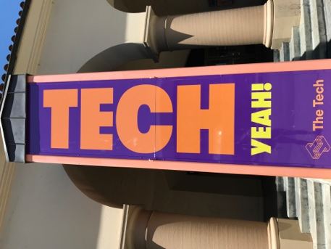
Eye-catching banner outside of Tech Interactive offices

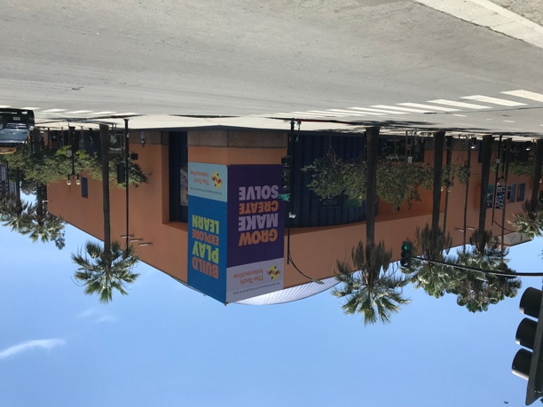
View of The Tech Interactive from Cesar Chavez Park in downtown San Jose, California
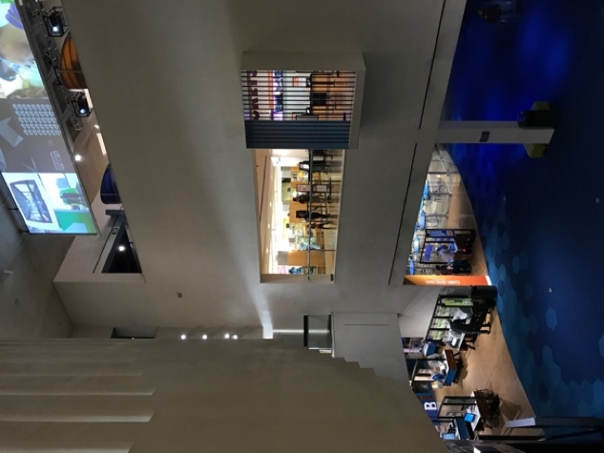
The Tech Studio is on the bottom floor of The Tech Interactive
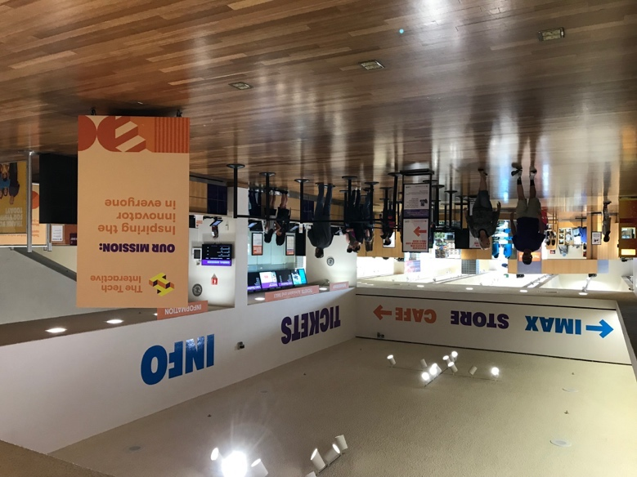
The mission of The Tech is prominent in the lobby entrance
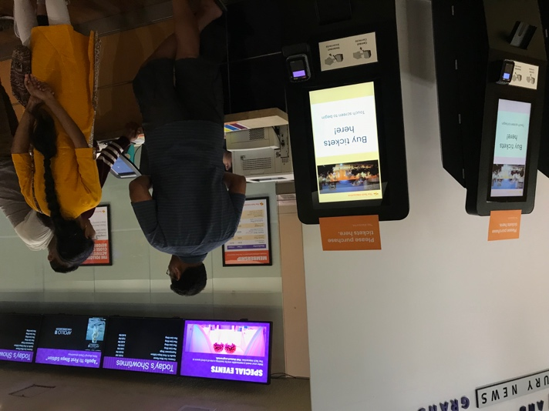
Visitors can purchase tickets in person and by using automated kiosks
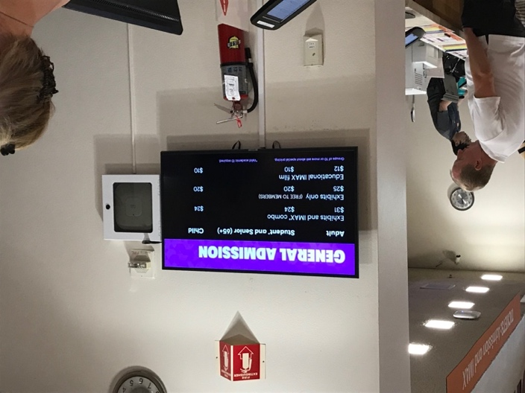
Admission prices at the Tech from July-August 2019

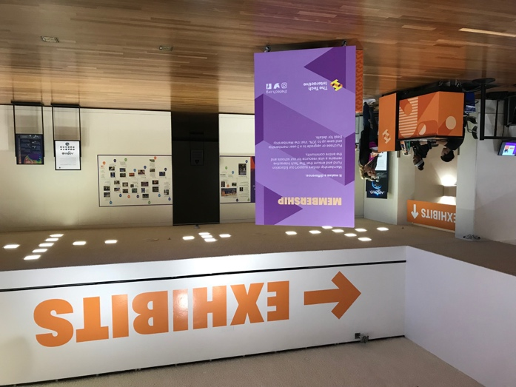
Signs encourage visitors to purchase annual memberships and celebrate philanthropic donations

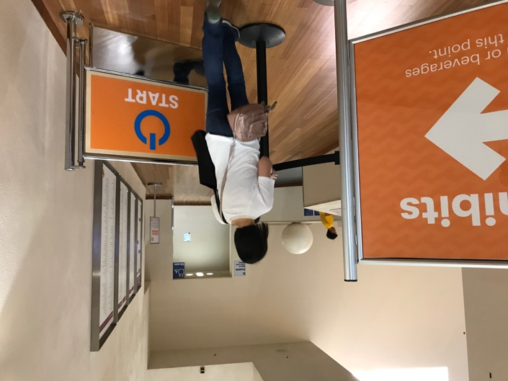
A woman trails behind an eager young visitor
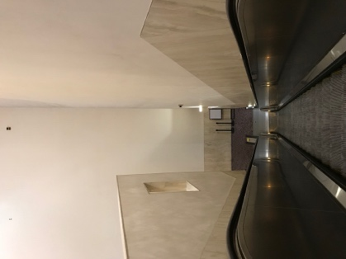
The Tech Studio is accessed by escalator, elevator, or stairs
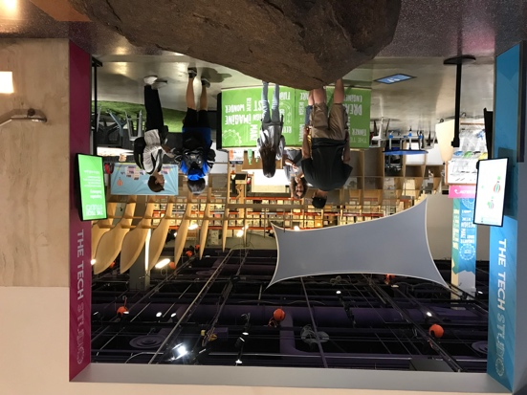
A gallery staff member greets visitors when they approach the entrance to the Tech Studio

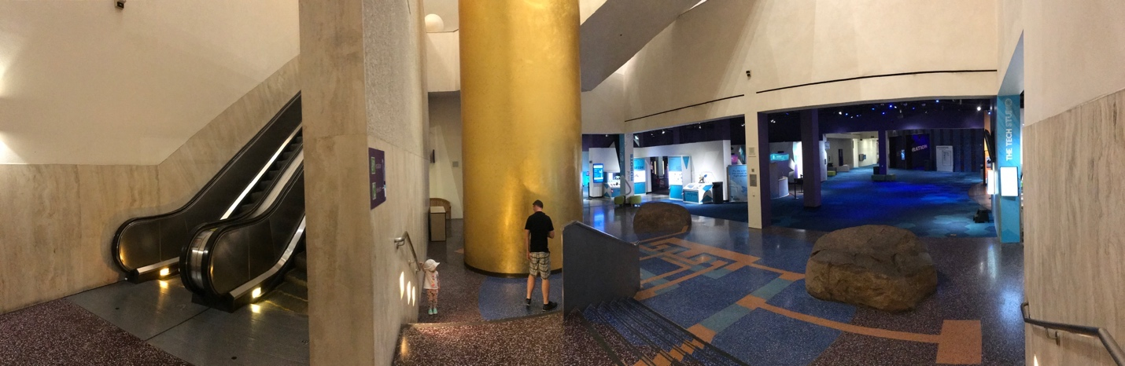
A quiet moment at opening time when visitors have not yet filled the The Tech’s galleries
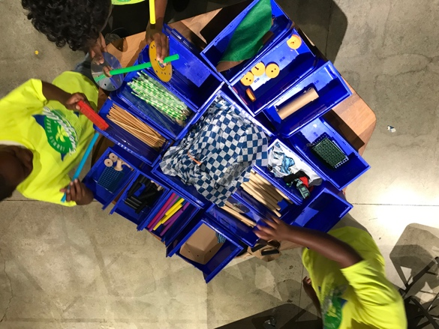
Young children select materials to use in the Tech Studio design challenge activity

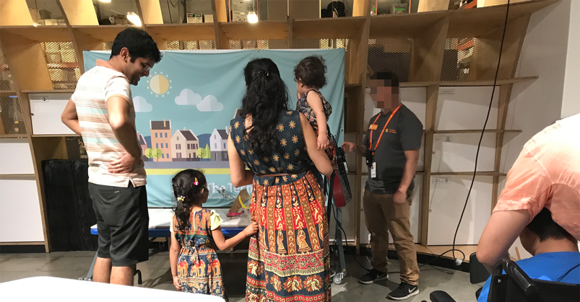
A family with two girls test a vehicle in the Tech Studio while a father helps his son in a wheelchair create their vehicle.
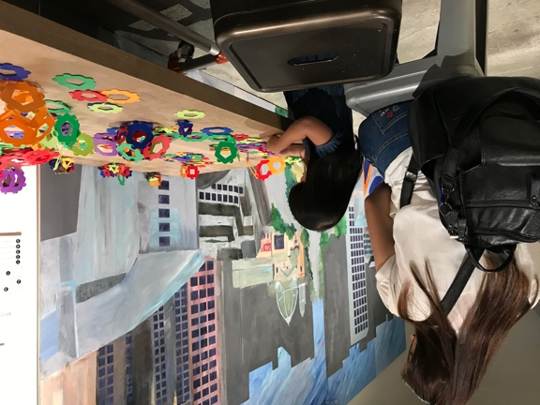
A mother looks over her young daughter as she explores an open-design kit in Tech Studio B

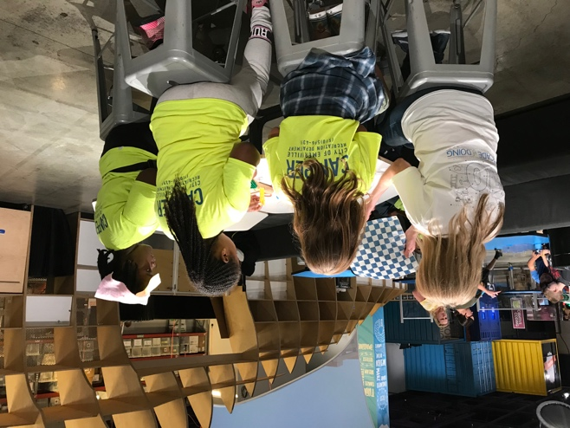
A woman sits with girls from an Emeryville recreational camp program
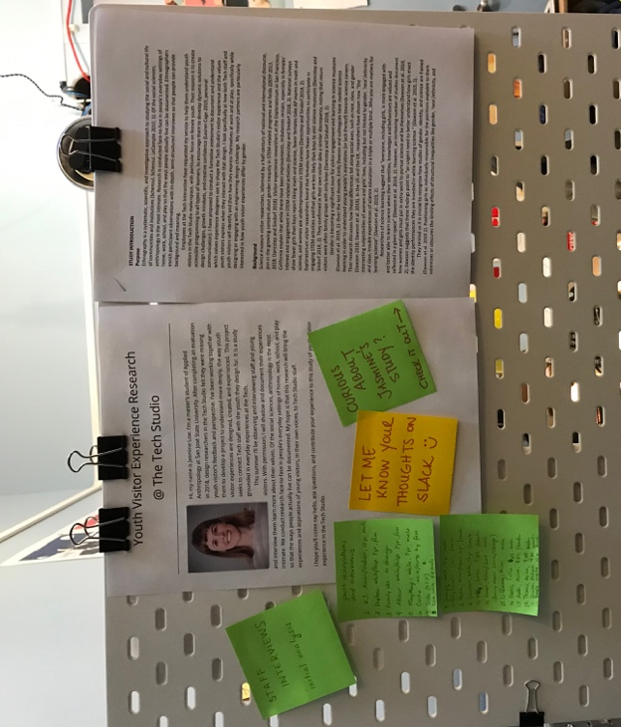
Introducing myself to build rapport and transparency

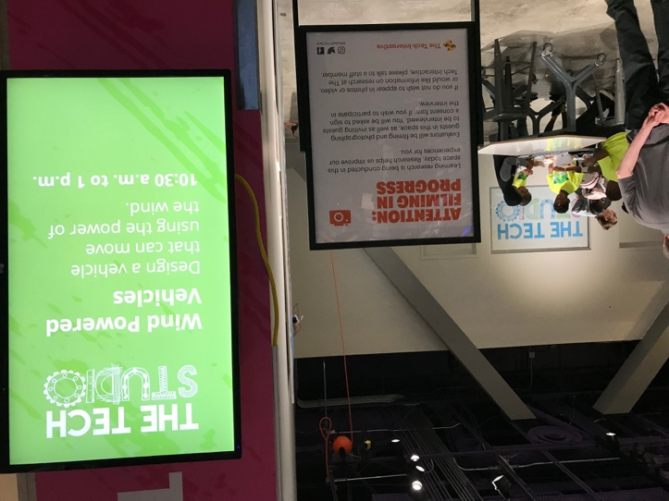
Notifying about video recording at entrance to Tech Studio

Adapting space for an interview studio

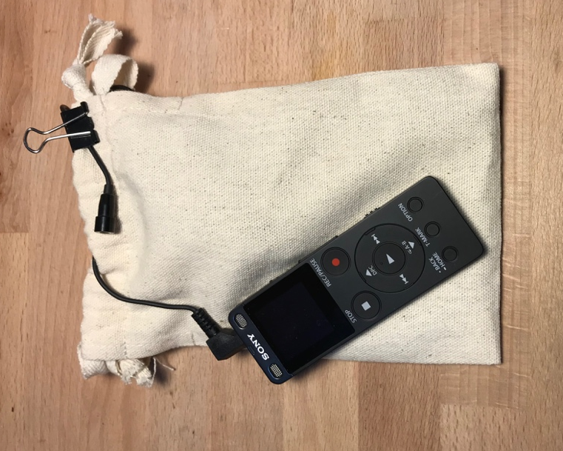
Adapting a voice recorder to be clipped on and carried inside or outside a pocket on young visitors.

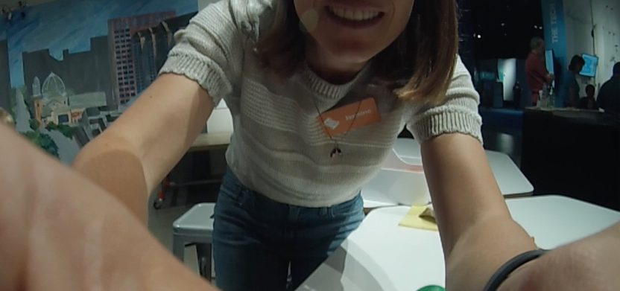
A chest-mounted camera gives researchers an alternative perspective

Kylie 9, helped document her visitor experience by wearing a Go-Pro camera

Adapting space for an interview studio
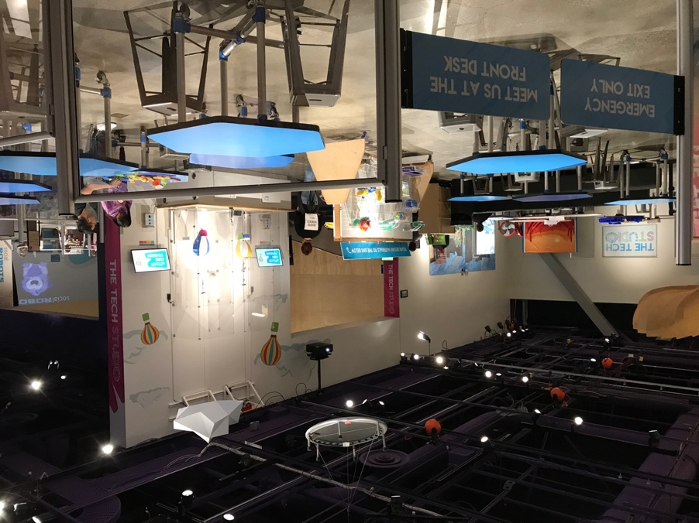
View looking across Tech Studio A (foreground) and Tech Studio B (background) from emergency exit
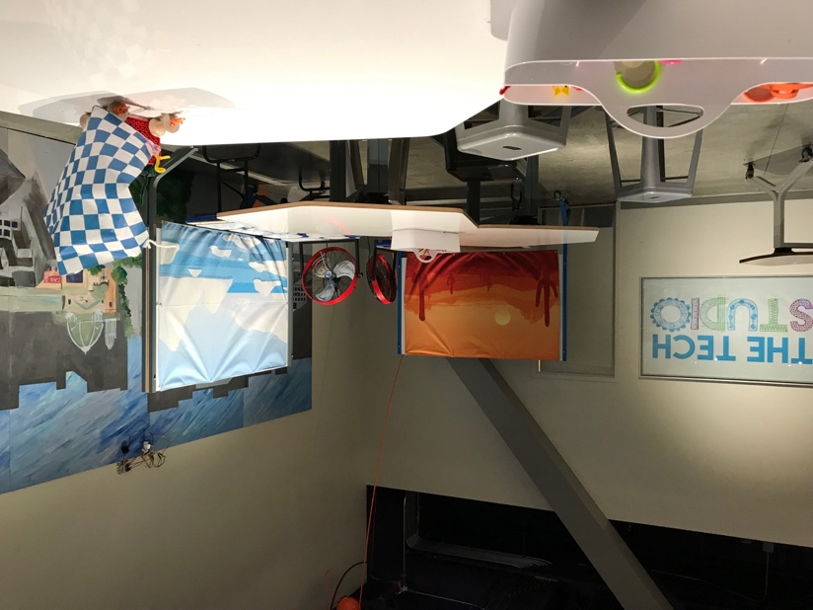
Detail of Tech Studio B

A variety of different magnets with empowering messages are intended for visitors,
and have found a home on the door in the Prototyping Office

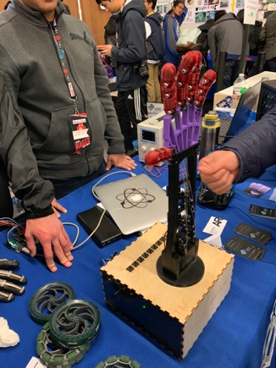
Students talk to visitors about their robotic hand at the 2019 MakerFaire in San Mateo
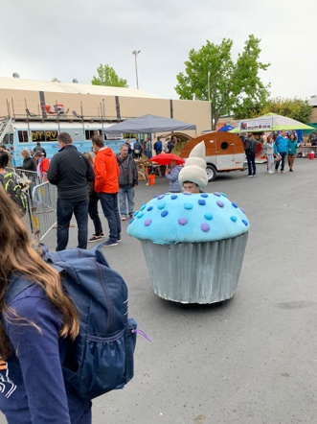
Muffin art cars “ACME Muffineering” weave between visitors at the 2019 MakerFaire in San Mateo

APPENDIX J

ANTH 132
Creating Built Worlds
April 27, 2020
Jasmine Low

Design Intervention Proposal

Observing behavior in environments can provide insights into design interventions to modify people’s behavior (Zeisel 2006). In this proposal, I will address a problem and outline a potential solution based on research conducted in Tech Studio. The observations involved over 30 family groups who visited the Tech Studio in between July and August 2019. After analyzing these observations, I recognized a problem with the language and behavior that some adults adopt when they accompany young visitors in the Tech Studio.
I learned that while most parents use language that helps young visitors feel ownership of their design decisions, in some poignant moments, adults used language and behavior that appeared unhelpful and to erode young visitor’s self-confidence and sense of accomplishment (See Appendix C). The intervention I propose is to help redirect accompanying adult’s roles, expectations, and use of language during a visit with children to the Tech Studio. The intervention would require collaboration with ExD&P designers, gallery staff, and parents. Together, we could design guidelines for parents to encourage them to interact with their children in similar ways that gallery staff are trained to interact with young visitors as skilled facilitators. I imagine the following steps taking place:
- Interview parents to grasp different ways they think about their role in the Tech Studio.
- Ask for help from staff for resources about facilitation training as well as first-hand experience in the Tech Studio, to draft the instructions for parents.
- Pilot and test the questions with parents from different backgrounds, accommodating for languages and literacy levels.
- Publish and display documents in Tech Studio
Parent facilitation cards could be based on a similar document created for training gallery staff (see Image 1). ExD&P staff have already created Quick-Reference Facilitation Cards to guide gallery staff on how to help young people through an activity as the designers intended. Similarly, ExD&P staff could create concise 1-page sheets or multiple-page booklets of principles to provide parents with principles about speaking and behaving in ways that allow children to feel ownership of the building process. The content could be initially based on the principles taught to gallery staff and informed by the observations and interviews I conducted with family groups (see Appendix C). The costs could be limited to staff member’s time, energy, and the costs of printing, laminating, and binding pages or displaying the document at each table (see Appendix A).
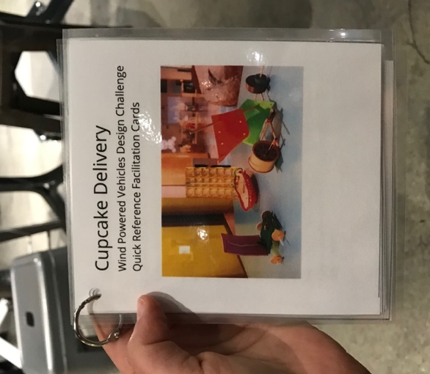
Image 1: Quick reference facilitation guide “Cupcake Delivery” for use by gallery staff

There are foreseeable benefits and drawbacks to various stakeholders using this intervention. Young visitors, like Ruby, who seem to not yet have developed hands-on problem-solving knowledge, stand to benefit emotionally from the sense of accomplishment and confidence she is likely to build by feeling in charge of design decisions. Visitors like Sawyer, who seems to have some technical knowledge of the activity would likely also be supported and further empowered. Adults may also benefit from a new approach for working alongside young people in other aspects of life. On the other hand, adults may not want to take the time to learn a new skill and may feel undue pressure to guide in a prescribed way. For this reason, the intervention should not be enforced but provided and encouraged by staff. Ultimately, using this intervention should be left to accompanying parents to negotiate and implement should they choose to do so. Gallery staff may also need to adjust their interactions with guests. Overall, it appears drawbacks would be minimal as this intervention would be patterned after the facilitation guidelines staff are likely already be familiar with.
Assessing whether this intervention is successful can be integrated into the evaluation activities that gallery staff and ExD&P staff are already involved in. Gallery staff that already circulate and check in on guests will likely observe and be able to report anecdotally, whether there is increased engagement between accompanying adults and children that appears helpful. ExD&P staff could conduct more structured observations to document the language and behavior between young visitors and adults and determine if there is an increase in moments of inspiration, in metaphors drawn from everyday life, more smiles and giggles, and longer linger times because of more iteration.
I have attached some examples of how these facilitation guides might look (see Image 1; Appendix A) and what they might say (see Appendix B). I would be willing to consult with the ExD&P staff should they be interested in carrying out this proposal.

A: Four low-cost, easily manufactured ways to display facilitation guides for parents:

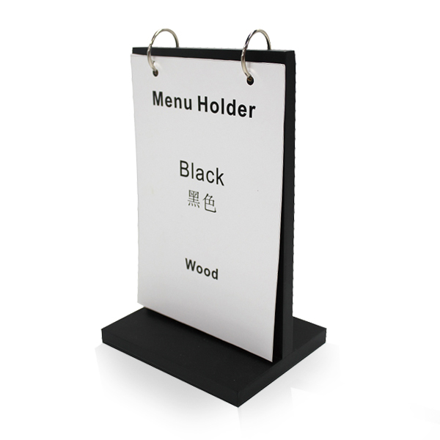 | 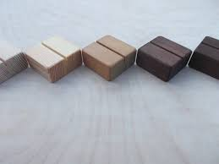
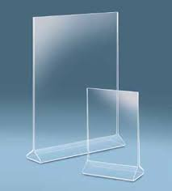 | 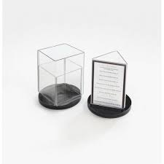

B: The following are quotes about facilitation from the Volunteer Program Handbook:

- “Facilitation is provocation, not instruction. Great facilitation should provoke curiosity, attention, and interest for the audience.”

- “Facilitation for children is not a condescension of an adult presentation; it is a fundamentally different approach.”

- Tools for Excellent Facilitation include: Starting a Conversation, Good Questions to Ask (GQAs), Your Own Stories, Discovering the Content*

- “Possibly the best way to think of an ideal visitor experience is remember the fundamentals of what we are teaching here at The Tech: Exploring, designing, failing and iterating, and asking good, open-ended questions.”

*In addition to these facilitation guides about language and behavior, some parents might benefit from a different, quick reference guide about the STEM principles that the designers would like visitors to engage with.

C: Case Study: Ruby, Sawyer, and their grandma

“…it wouldn’t work like that grandma, that’s not how it works” –Sawyer 13, male
“Well you told me that already, stop grandma!” –Ruby 10-12, female

The most poignant example was that of a 10-12-year-old girl named Ruby and her 13-year-old brother Sawyer who visited Tech Studio B for the “Cupcake Delivery” activity with their stepmother, grandmother, 6-year-old brother. Ruby and Sawyer sat at a table side-by-side while their grandma sat across from them. Ruby took a more silly and spontaneous approach to create a vehicle, seeing how a new piece might fit or slide into some other element. In the beginning, she laughed often and said things like, “This is really crazy!” and “I don’t know, but it’s something.” Sawyer laughed with her when he saw her vehicle, but generally, he didn’t laugh but took a more serious approach to the process of building, assessing, testing, and predicting what his next move should be. He showed more confidence than Ruby when he said, “This is gonna be perfect.” Sawyer and his sister Ruby both had moments of frustration when their grandma offered continuous, unsolicited advice and insisted, with words and action, that the kids follow it. Sawyer was able to use his knowledge of scientific principles to respond with a bossy sort of confidence and maintain emotional and physical control of his building process. He said things like, “Surface area doesn’t really matter. Air is basically a molecule grandma…” and later, “See grandma, that didn’t work…now it’s just making it harder for the wind to get in…it wouldn’t work like that grandma, that’s not how it works.” Ruby, on the other hand, tried, without much success, to maintain emotional and physical control of her vehicle building process. She was open to grandma’s advice but it seemed to create more frustration when it didn’t work out. She said things like, “Gramma, these are too bulky for my vehicle!...[a sulking tone]… No gramma, just leave everything…”
Sawyer was privy to grandma’s words of “advice” as well, but his understanding and way of speaking allowed him to contradict grandma’s advice and maintain a sense of ownership over his process. He also finished earlier than Ruby. The last time Sawyer tested his design, his grandma celebrated his apparently successful test clapping, laughing, and calling-out, “Woohoo!” As he came back to the table he said, “I got it” to which his grandma responded, “I should show a picture of what worked” and she snapped a picture with her cellphone. Ruby kept working for another 20 minutes, with all of grandma’s attention on her and her design decisions.

As Ruby adjusted her chopstick axel and plastic ball wheels, her cardboard sail kept falling down, and she let out a frustrated sigh. Her grandma reached across the table to help, and Ruby became more emotional and exasperated.
Ruby: Gramma, it didn’t help, that much!
Grandma: It will
Ruby: It doesn’t though, the stick being longer doesn’t help that much. But now they’re going to touch again! And that was my problem before I started this!
[Ruby then got so frustrated she shook her design and pieces of it came apart]
Grandma: It’s perfect
Ruby: No [a very sad sounding, despondent voice].
Ruby continued to take the axel and wheels off and kept working on her vehicle. However, not long after, her voice cracked with emotion as she tried to assert control again. As she tried to put together the chopstick axel and plastic ball wheels again, the cardboard sail fell down again, and again. She exhaled with frustration and her Grandma said something [inaudible] to her.
Ruby: Okay, okay, okay, okay! You told me that a million times already! [her voice cracks with emotion].
Grandma: I saw you getting frustrated with it.
Ruby: Well you told me that already, stop grandma!
Grandma: Try and tie it down…put it in that hole
Ruby: I know grandma! You told me grandma! You told me!
In contrast to her brother Sawyer, the last time Ruby tested her design it barely made it half-way down the testing rig, truly thanks to some quick adjustments from grandma, but Ruby reported to her grandma, sounding deflated, “I think that’s the best it’s gonna get gramma.”

Adapted from the questionnaire used by Morey Survey* and ASPIRES 2 Parent Interview Schedule Year 13** (Dawson and Macleod 2019)
This observation guideline is borrowed and adapted from the "Re-engineering Nature in Silicon Valley” Project, August 2018 developed by Dr. Jan English-Lueck with permission. Do not copy or use without permission.
Adapted from the ASPIRES Interview Schedule – Year 6 (Dawson and Macleod 2019)

