2022-2023
A.S. PROGRAMMING BOARD AGENDA
Location: SU Meeting Room 2A
Zoom Link (Optional): https://sjsu.zoom.us/j/84182870296
Date: October 13th, 2022
Time: 2:00 pm

- Call to Order
- Land Acknowledgement
- Roll Call
- Approval of the Agenda
- Approval of the Minutes
- Public Forum
- Action Items
  - Old Business
  - New Business
    - Discussion Item: Review Process for Midterms Energizers
      - Itinerary & Detailed Plan
    - Discussion Item: Review Resources for Social Media Awareness
      - What resources should we highlight? How can SJSU help?
    - Discussion Item: Coordinating Logistics for Student Author Book Fair
    - Discussion Item: NASO x A.S. Collaboration Event
- Announcements
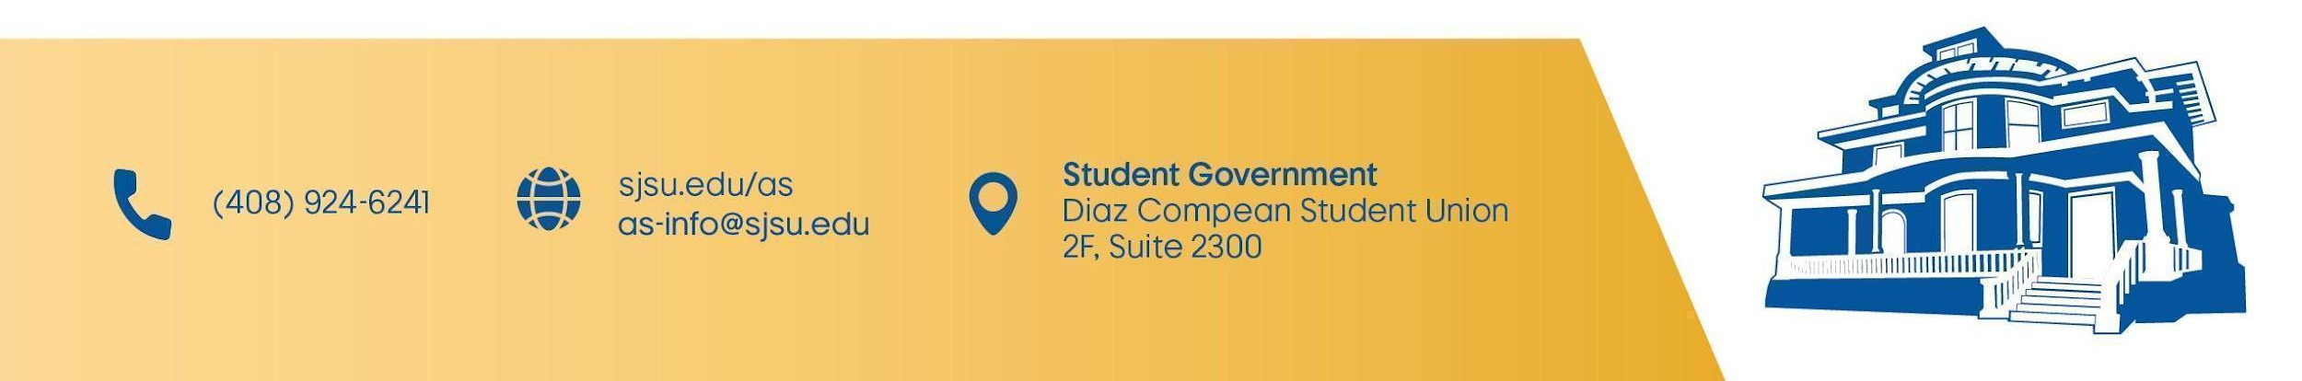
- Adjournment

