2022-2023
A.S. PROGRAMMING BOARD AGENDA
Location: SU Meeting Room 2B
Zoom Link (Optional): https://sjsu.zoom.us/j/84182870296
Date: October 27th, 2022
Time: 2:00 pm
Canceled

- Call to Order
- Land Acknowledgement
- Roll Call
- Approval of the Agenda
- Approval of the Minutes
- Public Forum
- Action Items
  - Old Business
    - Action Item: Vote to Approve Programming Board In-Service Date
  - New Business
    - Discussion Item: Academic Affairs Finals De-Stress Event (Director of Academic Affairs)
    - Action Item: Vote on Finals De-Stress Event
    - Discussion Item: Spartan Book Fair Logistics
    - Discussion Item: Native American Heritage Month Event
- Announcements
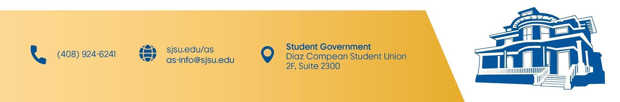
- Adjournment

