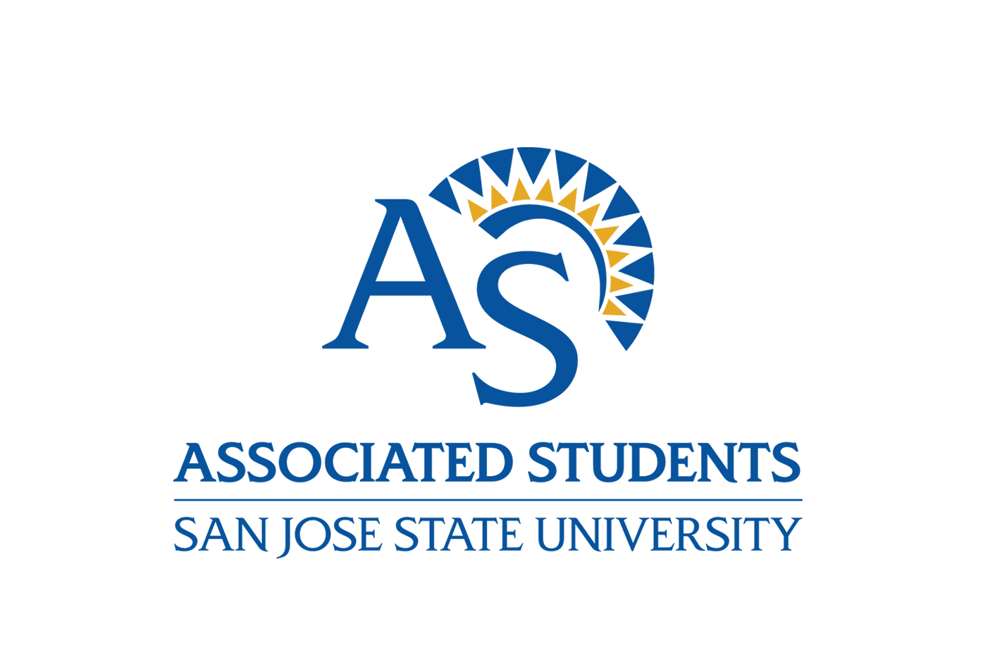

Associated Students, San Jose State University
One Washington Square
San Jose, Ca 95192-0128

Position Title: Chief Elections Officer
Position Department: Government
FLSA Status: Non-Exempt
Full/Part-Time: Part-Time, Temporary (November 2021 – May, 2022)
Compensation: $15.95 per hour
Reports To: Leadership and Government Coordinator

Click here to apply!

Associated Students Summary
Associated Students’ (A.S.) mission is to support and represent the students of San José State University by continuing the organization’s legacy of student advocacy and leadership; to enhance SJSU students’ education through high quality programs and services; and to prepare students as they move towards a thoughtful and purposeful life after graduation.

A.S. is a non-profit auxiliary corporation serving the students of San Jose State University whose primary source of funding is from mandatory student body fees. A.S. Departments include the Cesar Chavez Community Action Center, Child Development Center, General Services Center, Human Resources, Information Technology, Events, Marketing, Print & Technology Center, Student Government, and Transportation Solutions.

Position Summary
Are you a student who has leadership skills you want to further develop? Do you enjoy coordinating events with other students? The Student Elections Commission (SEC) is looking to hire a Chief Elections Officer for the 2022 SEC Elections.

Serving on the Students’ Election commission provides students with numerous benefits, which include:
- Plan and oversee the largest student body election at SJSU
- Having the opportunity to serve and create positive change for the campus
- Learning how to deal with real-world issues
- Obtaining transferable skills, especially in leadership and delegation
- Working with other talented students and having mentors within the staff/advisors

Essential Functions
- Serve as the chairperson of election meetings and events.
- Preside over all meetings and provide an agenda in accordance with the Gloria Romero Open Meeting Act of 2000 and A.S. Bylaws.
- Prepare the annual SEC budget in accordance with the A.S. Budget Policies.
- Serve as the budget authority for the SEC.
- Coordinate and delegate the design the voting materials.
- Develop instructions for poll watchers.
- Submit a written and oral report to the A.S. Board at regular Board meeting.
- Maintain office hours during the election cycle (November to May).
- Submit a written and oral report on the status and activities of the SEC to the AS Board.

Knowledge, Skills, and Abilities
- Able to work with others as a team.
- Able to handle conflicts.
- Have an understanding of Robert’s Rules of Order.
- Able to make ethical decisions when required.
- Be knowledgeable about the Elections Regulation Manual (ERM) and Student Conduct Code.
- Understand the structure of the Association Students.

Work Environment, Hours and Physical Demands
- This job operates in an office environment and routinely uses standard office equipment.
- Work hours are Monday through Friday, 8:00 AM – 5:00 PM. Occasional evening and weekend work may be required as job duties demand. Hours are decided with supervisor and are flexible.
- Must be able to operate a computer, including a keyboard and mouse, and phone.
- Must be able to occasionally lift or carry office or event products or supplies, up to 40 pounds

Required or Preferred Education and Experience
Applicants must fulfill all minimum qualifications as outlined in University Policy S05-4, Academic Qualifications for Student Office Holders, which include but are not limited to the following:

- Must be a matriculated student at SJSU.
- Must be in good standing with SJSU.
- Must not be on probation of any kind (e.g., academic, administrative, judicial, etc.).
- Must maintain a cumulative on-campus GPA of at least 2.0 while in office and the semester running for office.
- Must maintain the minimum unit load (6 units for undergraduate students and 3 units for graduate students).
- Must have no more than 150 cumulative units throughout the term being served.

Failure to obtain the required GPA or maintain the minimum unit load by the end of the semester makes the student immediately ineligible to continue to hold office or, in the case of candidates, ineligible to assume office.

Notes to Applicants
All Associated Students employees must be fully vaccinated against COVID-19 no later than September 30, 2021, unless they are exempt from this requirement because an exemption has been granted based on a medical contraindication or sincerely held religious beliefs. Fully vaccinated means that an individual has received all recommended doses of a COVID-19 vaccine that has received Emergency Use Authorization or full approval from the U.S. Food and Drug Administration (FDA) and that it has been at least two weeks since the final recommended dose.

The person holding this position is considered a mandated reporter under the California Child Abuse and Neglect Reporting Act and is required to comply with the requirements set forth in CSU Executive Order 1083 Revised July 21, 2017 as a condition of employment.

This position may be exposed to sensitive or personal information and is required to comply with the requirements set forth by the Integrated CSU Administrative Manual 8000 series and Associated Students Information Security Standards as a condition of employment.

A background check (including a criminal records check) must be completed satisfactorily after a conditional offer of employment. Failure to satisfactorily complete the background check may affect a conditional offer of employment.

Equal Employment Statement
Associated Students provides equal employment opportunities to all employees and applicants for employment and prohibits discrimination and harassment of any type without regard to race, color, religion, age, sex, national origin, disability status, genetics, protected veteran status, sexual orientation, gender identity or expression, or any other characteristic protected by federal, state or local laws. A.S. provides reasonable accommodations for applicants with disabilities who self-disclose.

Applications
Applicants must submit a complete application through the Associated Students applicant tracking system, ADP. Only complete applications will be considered.

Deadline
The deadline to apply is October 15, 2021.

Click here to apply!

