SJSU BIOL 30
Meselson-Stahl Experiment Activity
To understand the Meselson-Stahl Experiment you need to understand density centrifugation, which allows you to separate things based on their density. For this experiment density and weight are equivalent. This means that the ¹⁵N DNA is denser than the ¹⁴N DNA. (N=Nitrogen)
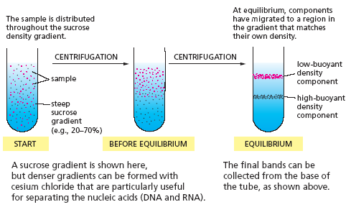
Image from: http://cellbiologyolm.stevegallik.org/node/84
Label where would you expect to see the 14N (light DNA) and ¹⁵N (heavy DNA) in the tubes below.

Here is what Meselson & Stahl’s results looked like. They could quantify how much DNA is in each band by figuring out the area under the curve. The darker the band, the more DNA in that size range.
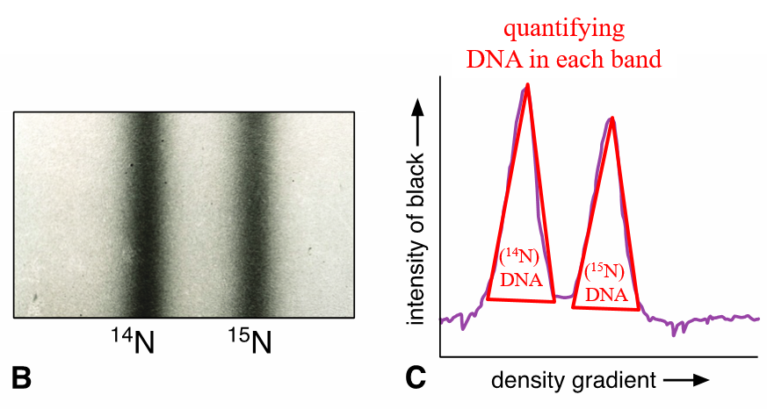
Meselson & Stahl were trying to figure out how DNA replicated. They narrowed it down to the three possibilities below. Briefly describe each of the three potential DNA mechanisms:
- Conservative:

- Semi-Conservative:

- Mosaic/Dispersive:

For their experiment, they started with E. coli grown on ¹⁵N DNA (i.e. all DNA only had the heavy N DNA). Then they switched all the cells onto ¹⁴N light DNA. When the DNA replicated all new N added was ¹⁴N light DNA. Now use the black (¹⁵N) and red (¹⁴N) pipe cleaners to mimic what would happen if DNA replication was conserved, semi-conserved or mosaic after one replication (1st Generation). Draw the resulting double strands below. You should have two double stranded DNA molecules in each group. Next, determine where these molecules will show up after density centrifugation and draw the results below. Remember, the double stranded DNA molecule will not come apart during centrifugation.
Only ¹⁴N DNA available for replication
First Generation Results
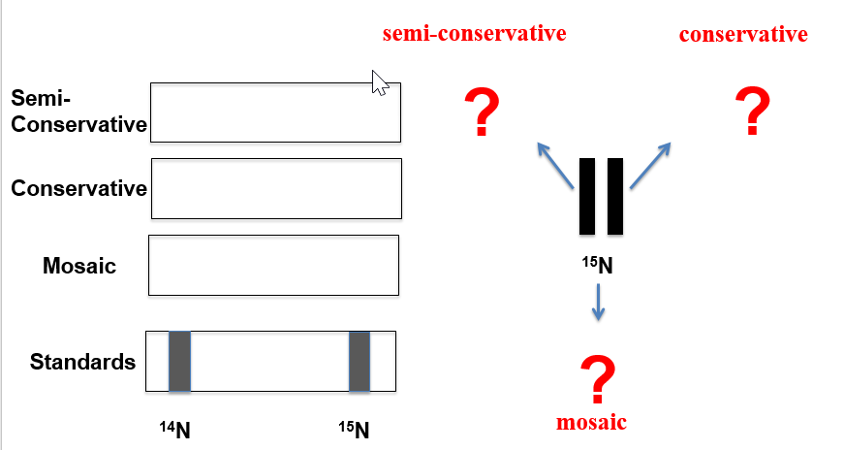
After this first replication/generation, can you tell which method of DNA replication is used in E. coli? Why or why not?
____________________________________________________________________________
___________________________________________________________________________
Now do the same thing for the second round of DNA replication. You will now have 4 double stranded DNA molecules per condition. For simplicity, you do not have to use the pipe cleaners to make the mosaic results. You should be able to figure out where the centrifugation band for the mosaic group should go.
Second Generation Results

After this second replication/generation, can you tell which method of DNA replication is used in E. coli? Why or why not?
____________________________________________________________________________
___________________________________________________________________________

Below are the real data from 0 generations (all heavy DNA), 1 generation (1 replication) and 2 generations (2 replications). From these results what type of replication does DNA use?
____________________________________________________________________________

Could you eliminate any possible mechanisms after the first generation based on your theoretical results above and the real experimental results below?

_____________________________________________________________________________

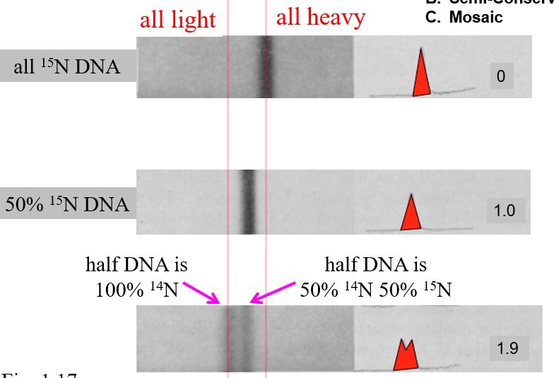
¹⁴N ¹⁵N

