 | How to View/Opt Out of the  Student Involvement and Representation Fee (SIRF)
One Washington Square, San José, CA 95192-0138

- Go to MySJSU (http://my.sjsu.edu/) and click the Login to MySJSU button. | 
- Enter your User ID and Password and click the Sign In button. | 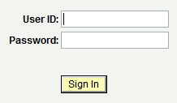
For step-by-step instructions, go to:
Pop-up Blocker Information
(http://my.sjsu.edu/technical/popup_blocker/)
- From the Student Center, scroll down to Finances.  - Click on the “other financial” drop down menu and choose option Account Activity. Click on the Go arrow. | 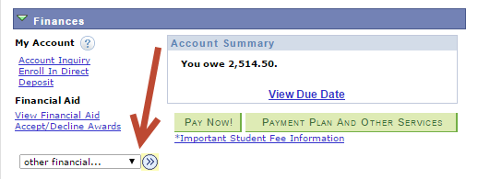
- Click View All at the top of the column to see all fees.  - Click the button to view information about SIRF.  - Screen will pop up explaining SIRF. | 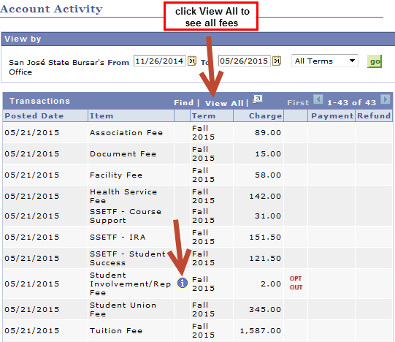  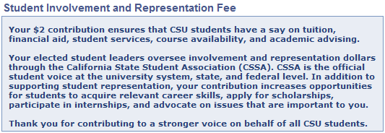
- To opt out of SIRF, click on the OPT OUT hyperlink.  Following this process will deduct SIRF from your balance.  - After clicking on the OPT OUT link, select reason from the drop down menu and click on the Opt Out button. If you do not want to opt out, click on the Go Back button.  - To view fees and verify that you have opted out of SIRF, go to Account Activity. | 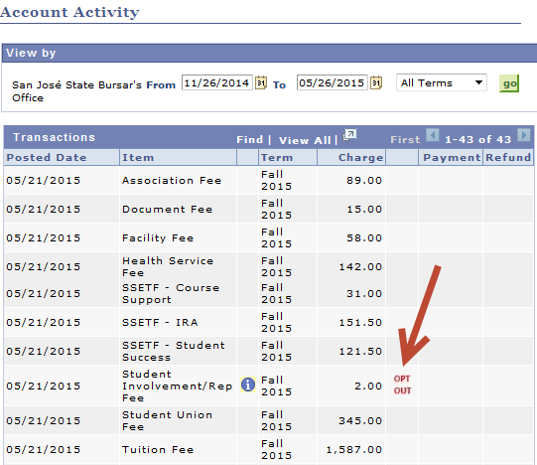  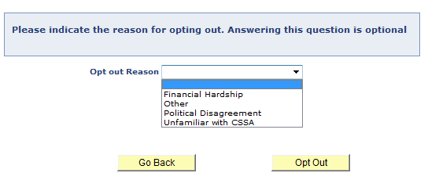  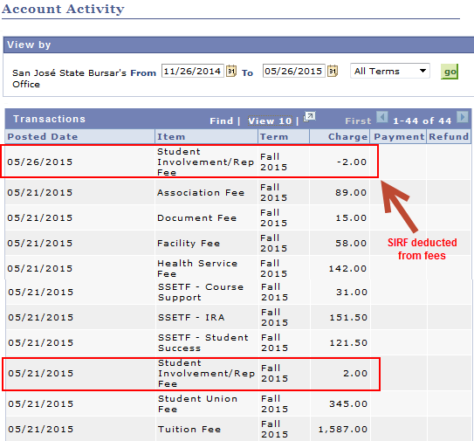
- For additional assistance, please contact….

