
How to Enroll in Direct Deposit (eRefunds)

One Washington Square, San José, CA 95192-0138

Overview
Direct Deposit (eRefunds) allow your funds to be directly deposited into your account, saves you the $20.00 refund processing fee, and prevents the possibility of your check being lost or delayed in the mail.

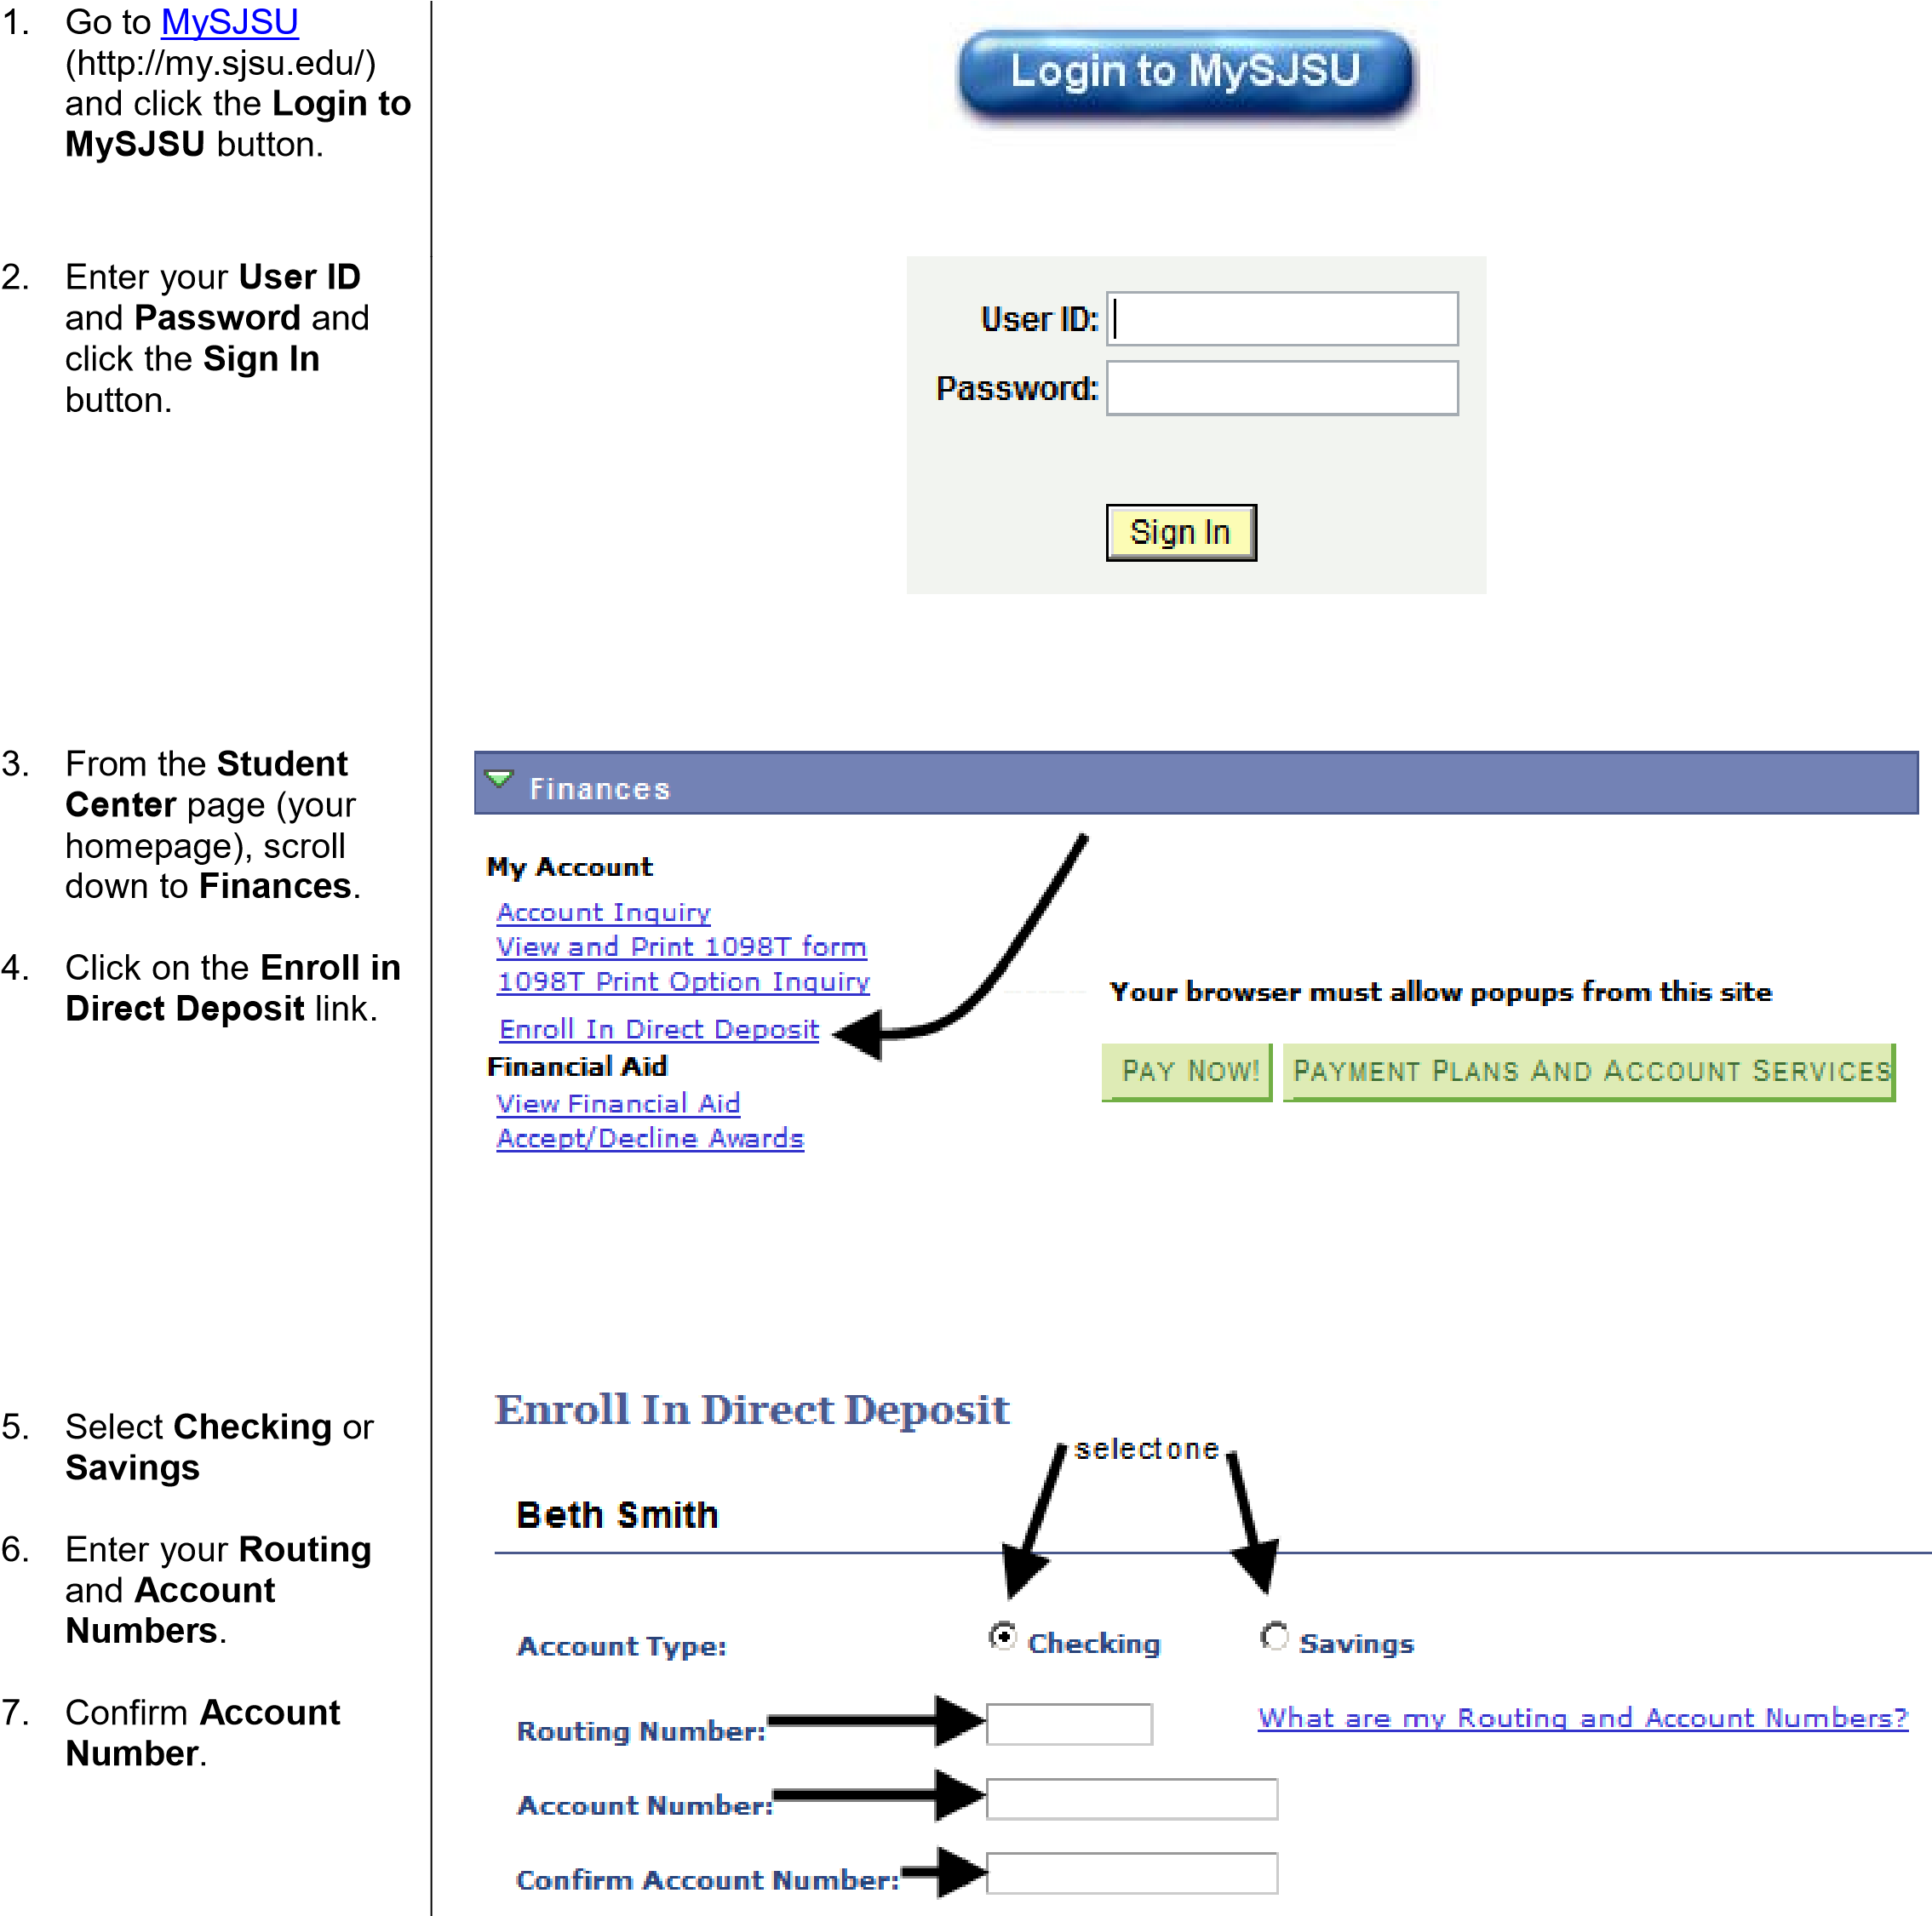

Ph: 408-924-1601 https://sjsu.edu/bursar Page 1 of 2
Fax: 408-924-1654 bursar@sjsu.edu Last Updated: 5/12/21

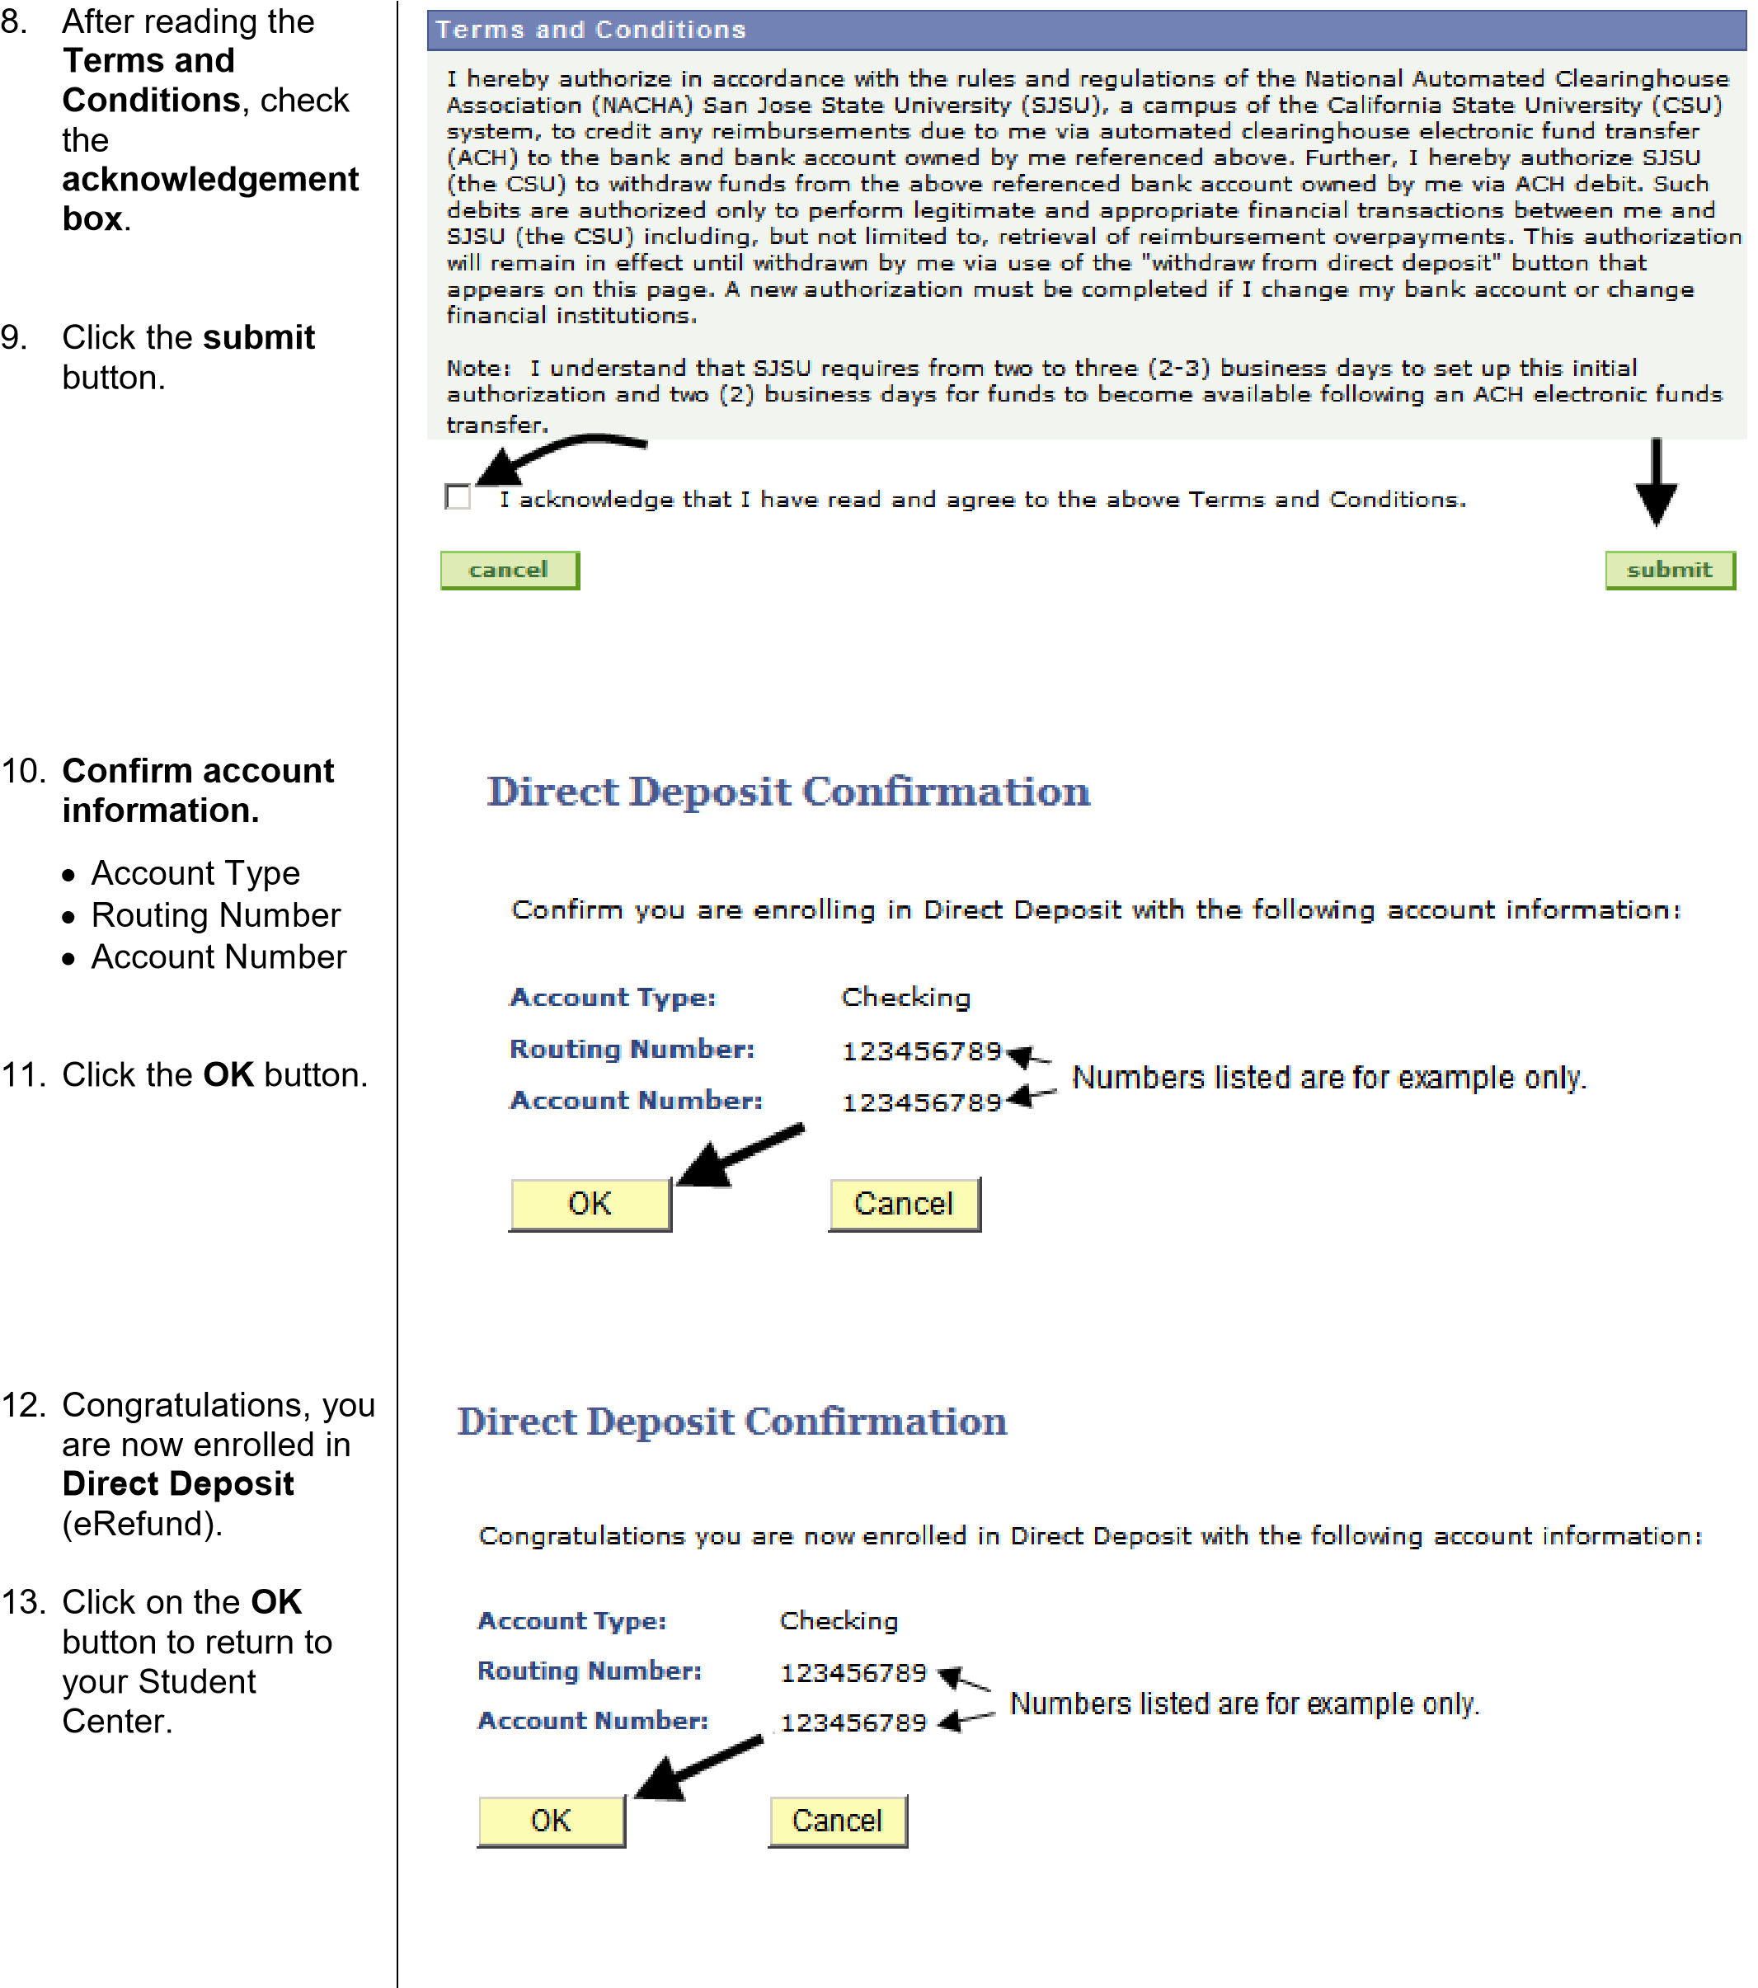

For additional assistance, visit MySJSU Financial Information (http://my.sjsu.edu/students/help/).

Ph: 408-924-1601 https://sjsu.edu/bursar Page 2 of 2
Fax: 408-924-1654 bursar@sjsu.edu Last Updated: 5/12/21

