Overview
This student guide demonstrates how to enroll in the Housing ONLY Payment Plan.

Please contact the Bursar’s Office by calling 408-924-1601 or email bursar@sjsu.edu with any questions about this process, student account, or visit them at www.sjsu.edu/bursar .

Enroll in Housing Only
Payment Plan
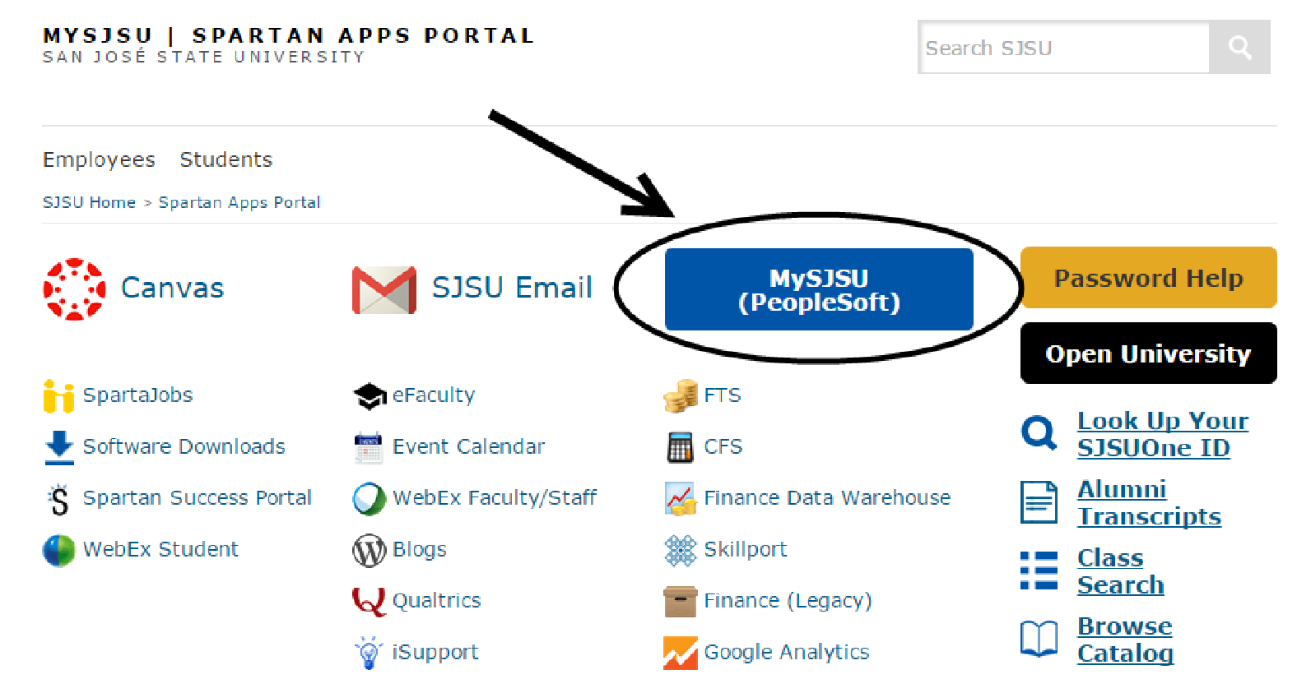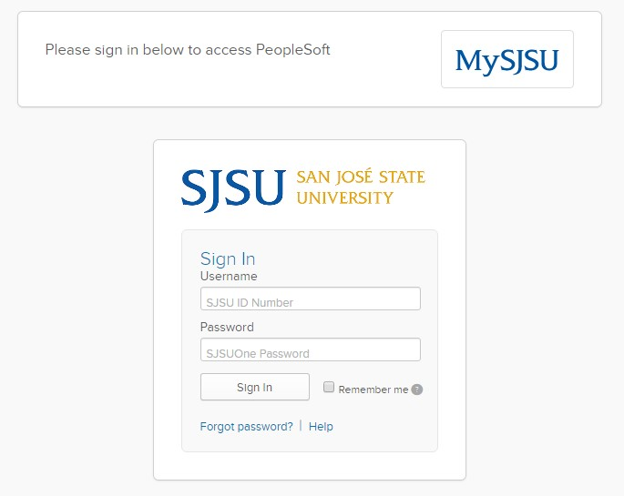
The MySJSU homepage
displays.

1.

Go to
MySJS
U

(
http://my.sjsu.edu/
).

2.

Click the

MySJSU

S
ign

I
n

button.

The Login page displays.

3.

Enter your
SJSU ID

and
Password
.

4.

Click the
Sign In

button.

Note: If you have difficulty
logging in, contact the
IT

Help
Desk

by

email
it
(
help
desk
@sjsu.edu) with
your full name and SJSU ID.

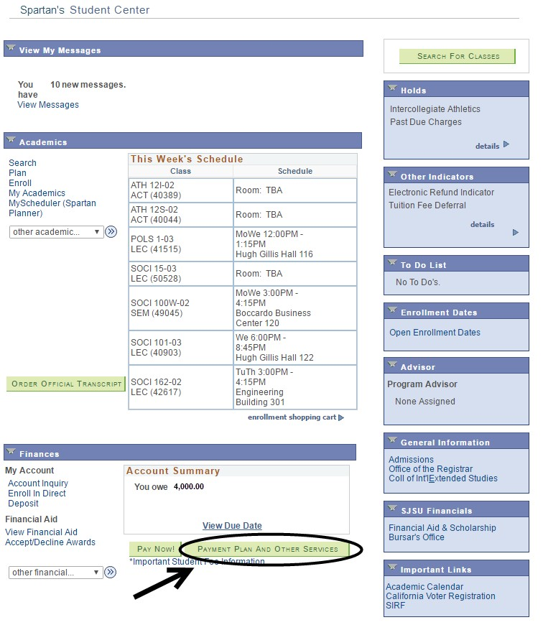
The Student
Center page
displays.

5.

Click
the

Payment Plan
and Other
Services
button
.

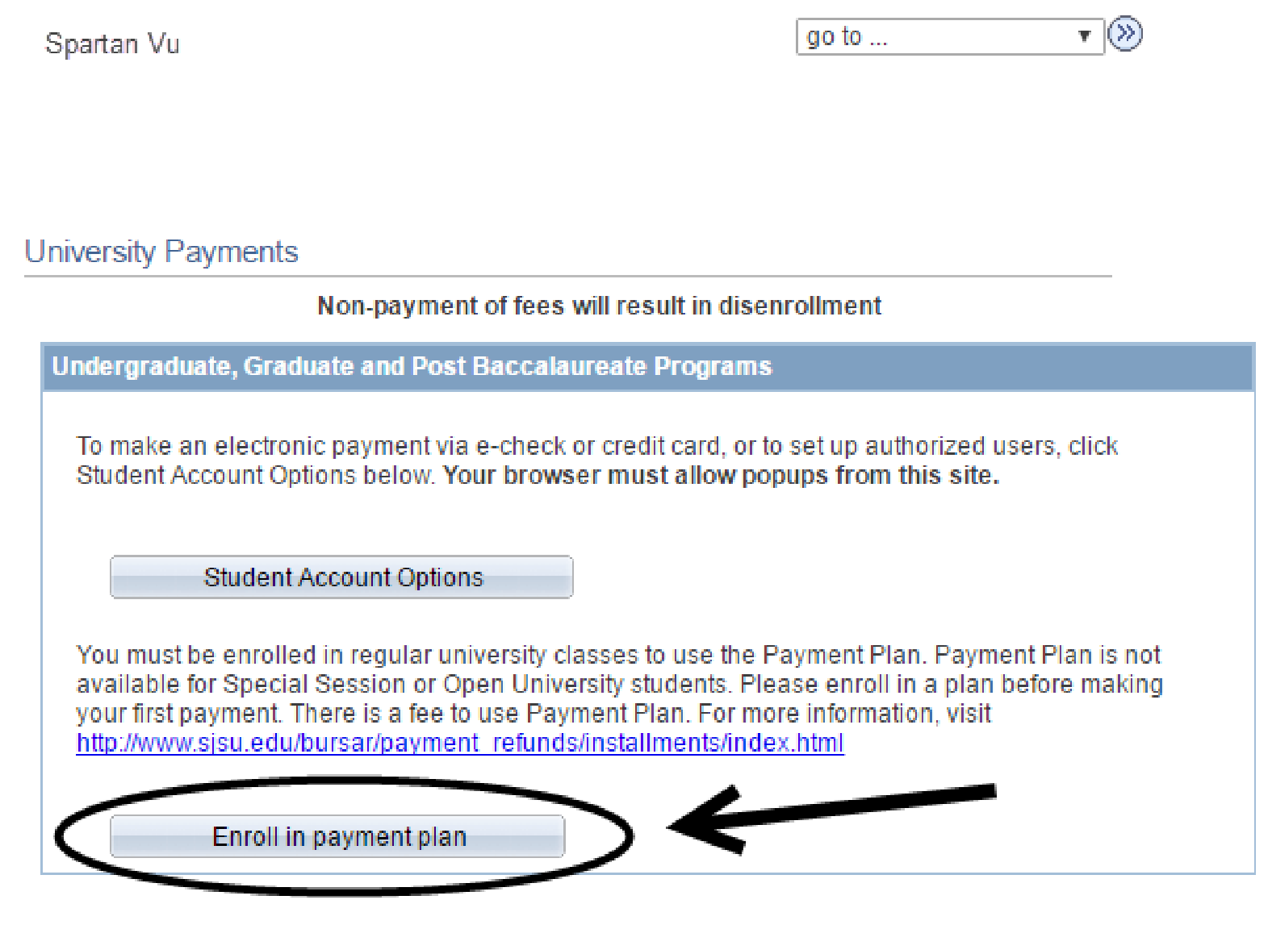
The
University Payments
page displays
.

6.

Click the
Enroll in
payment plan

button
.

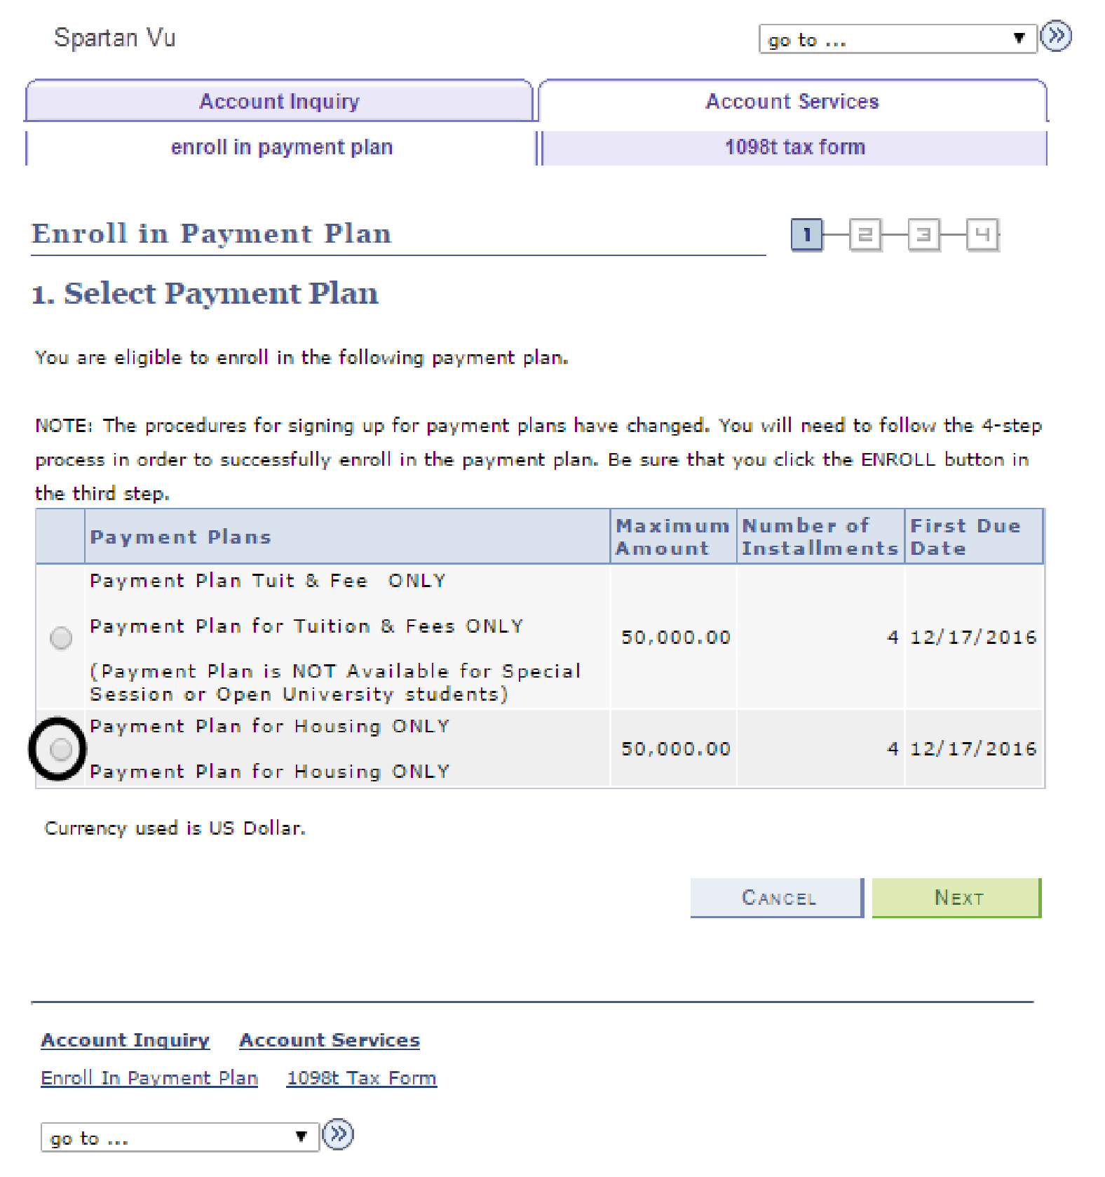
The Enroll in Payment Plan
page displays
.

7.

Select
Payment Plan

for
Housing

ONLY
.

8.

Click the
Next

button
.

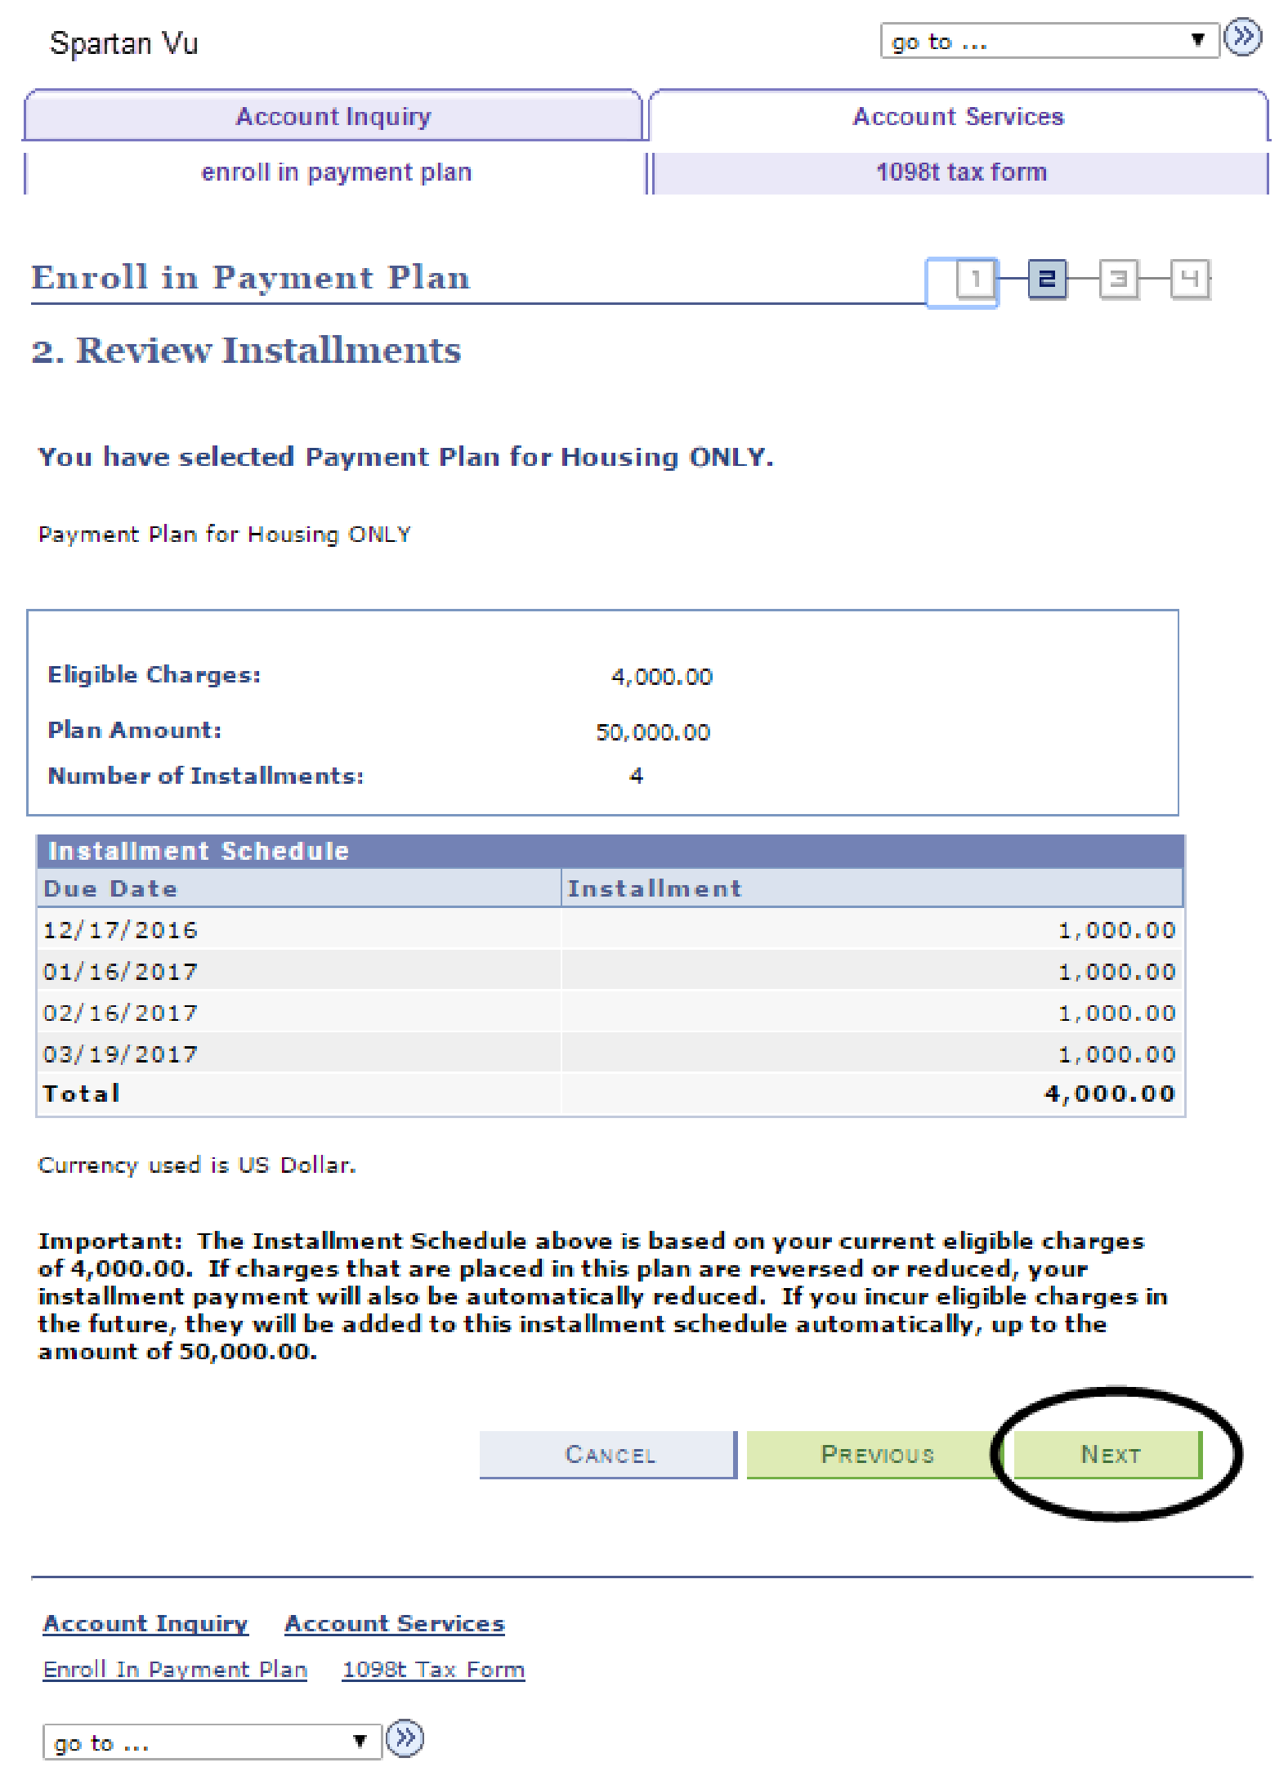
9.

Review the installment
plan you have selected.

10.

Click the
Previous
button
to make a different
selection
.

11.

Click the
Next

button to
proceed.

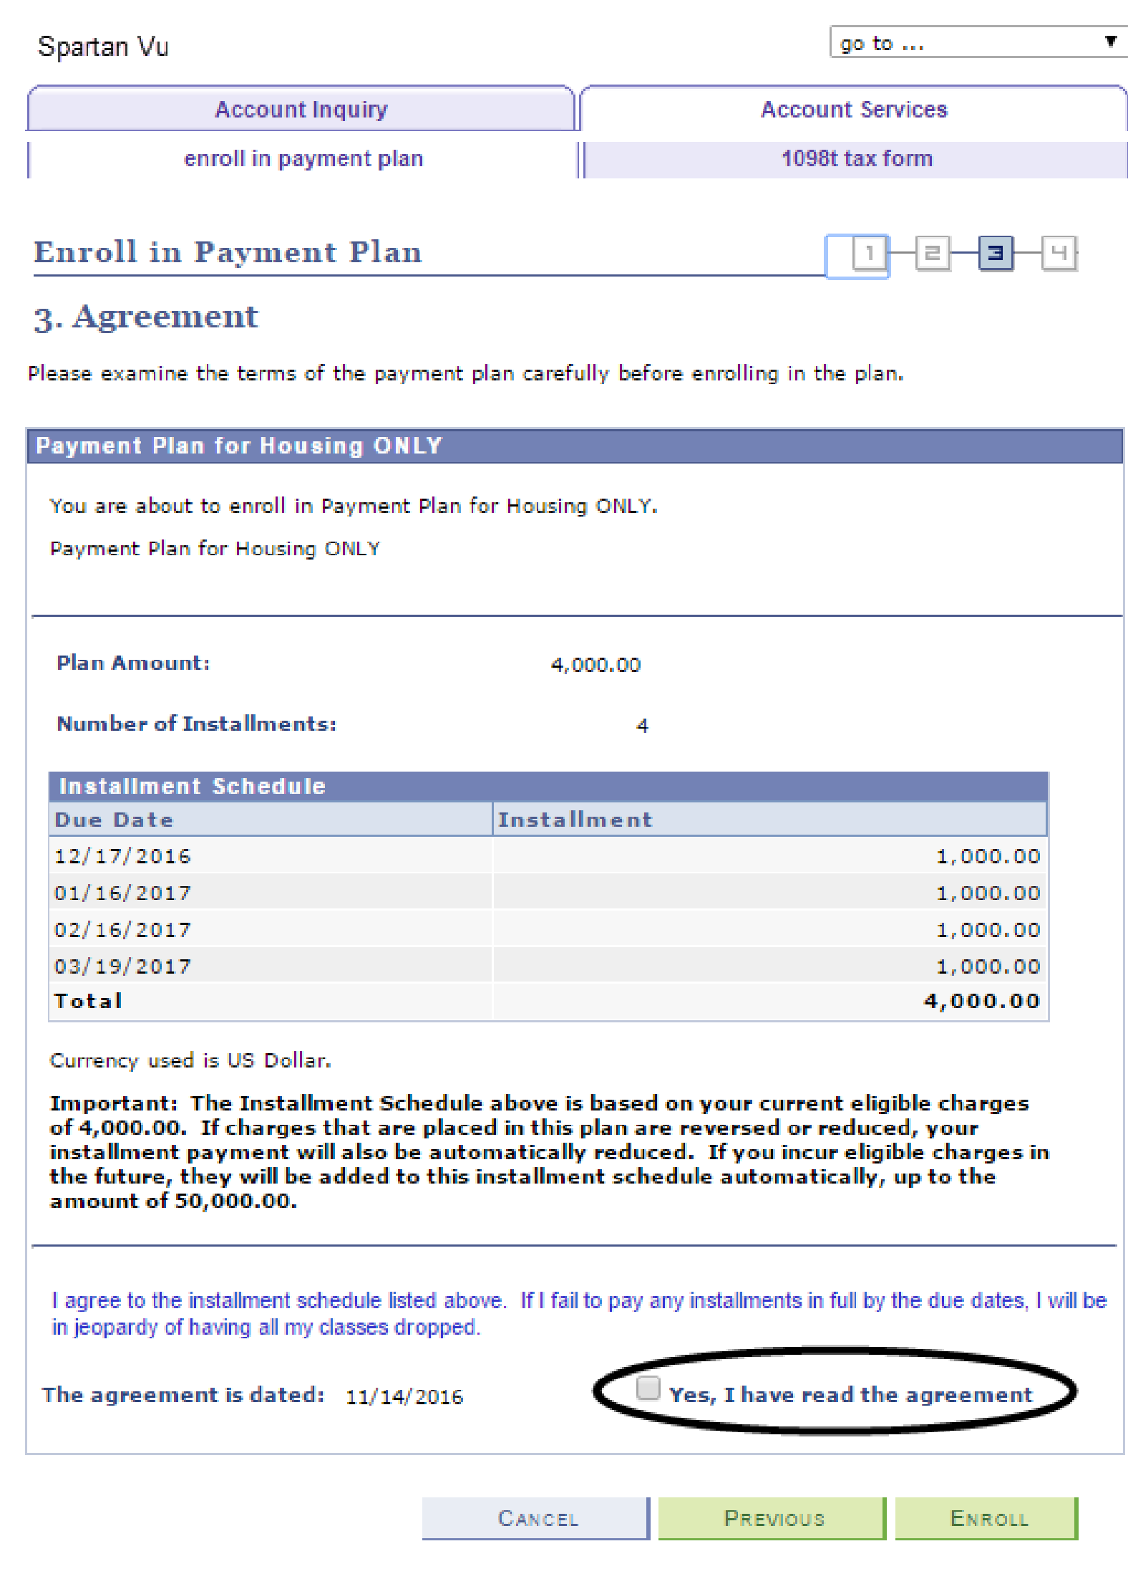
12.

Review the installment
schedule and terms of the
payment plan.

13.

Check the box indicating
that you have read the
agreement.

14.

Click the
Enroll

button or
click the
Previous

button
to select another payment
plan option.

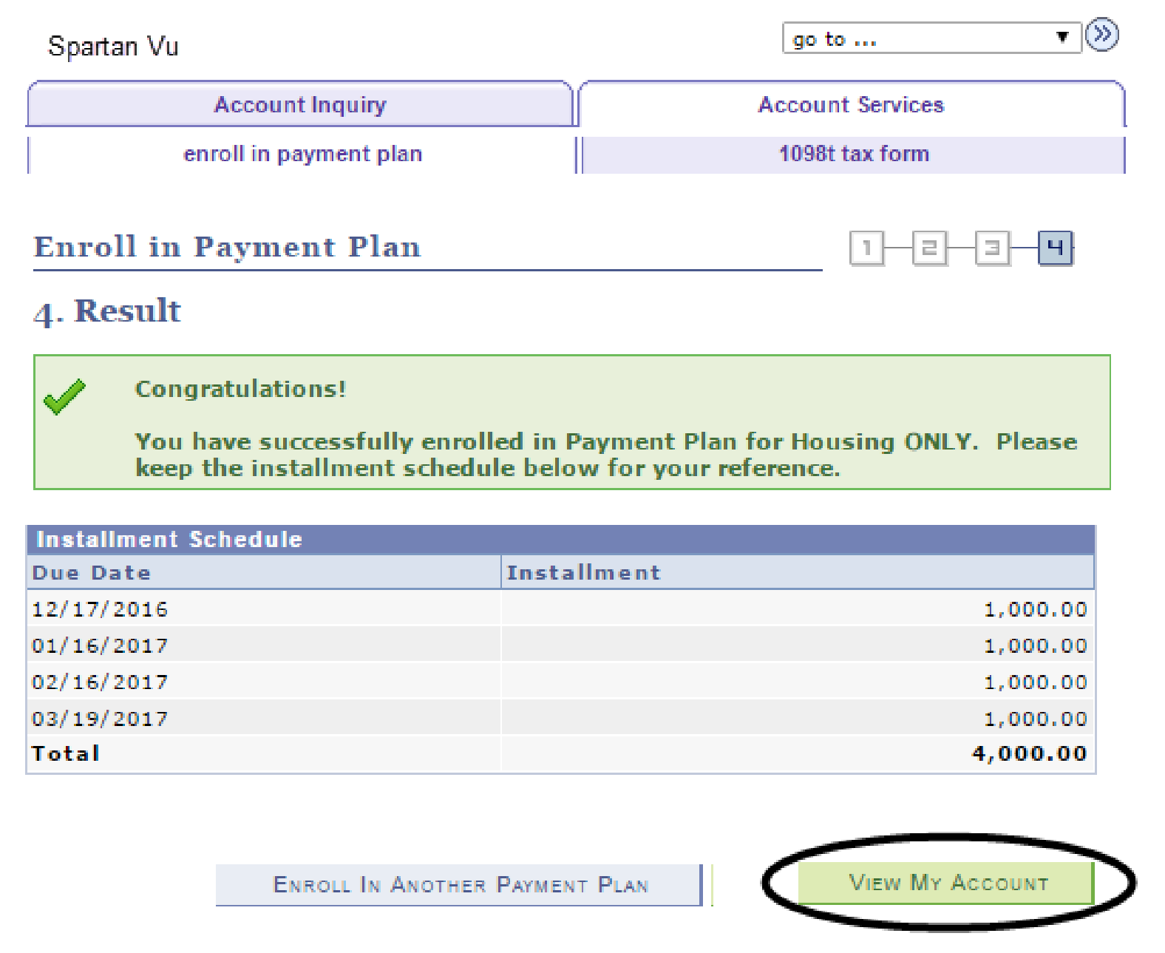
15.

Congrat
ulations! You have
enrolled in
the Housing
ONLY Payment P
lan!

16.

You can use the
View My
Account

button to see
your account.

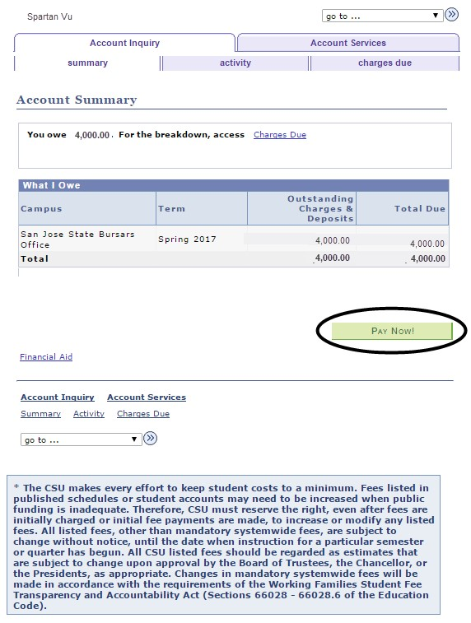
The Account Summary page
display
s.

17.

Click the
Pay Now

button
to make a payment.

