

One Washington Square, San José, CA 05192

Overview
This student guide demonstrates how to enroll in a payment plan.

Enroll in a Payment Plan

Please contact the Bursar’s Office at phone 408-924-1601 or email bursar@sjsu.edu with any questions about this process, student account, or visit them at www.sjsu.edu/bursar .

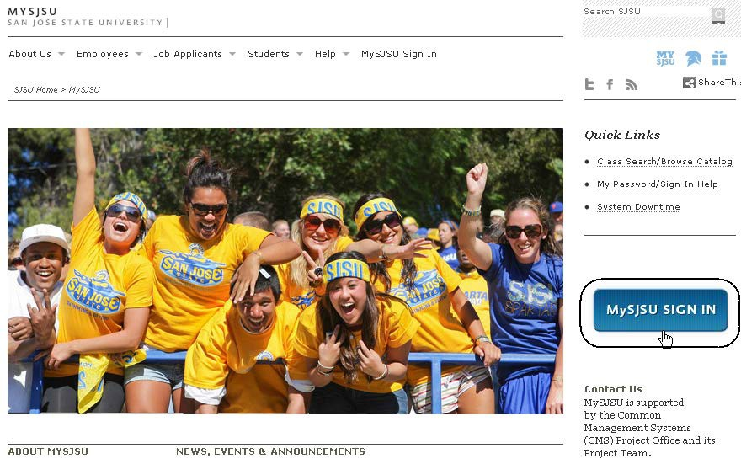
The MySJSU homepage displays.

1. Go to MySJSU
(http://my.sjsu.edu/).

2. Click the MySJSU Sign In
button.

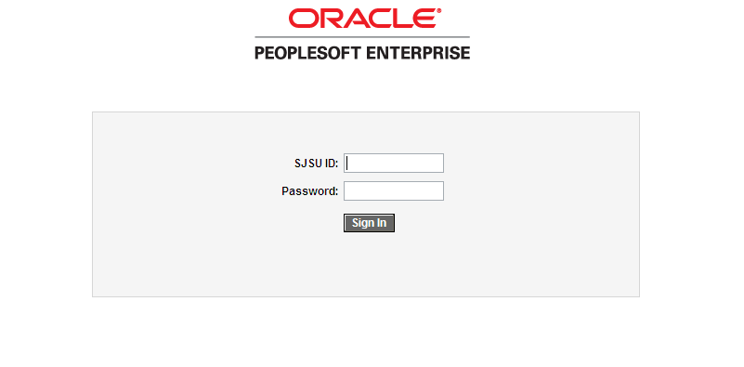
The Login page displays.

3. Enter your SJSU ID and
Password.

4. Click the Sign In button.

Note: If you have difficulty logging in, contact the IT Help Desk by email (ithelpdesk@sjsu.edu) with your full name and SJSU ID.

The Student Center page displays.

5. Click the Payment Plan and Other Services button.
Spa1·tan's Student Cente1·

• V1ew My Messages

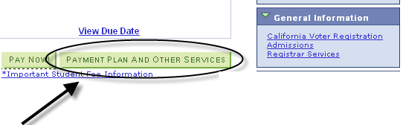
You have I new message.
View Messages

• Academ•cs
IIMYMWbt!fM{

SEARCH FOR CLASSES

• Holds

Application Fee Outstanding

details ..

Search
I Class Schedule
• Other lnd•cators

Enroll ademics

Iother academic... Iv J@
HRTM 148·01
LEC (27883)

KIN 14C·01
ACT (23520)

KIN 61A·03
ACT (23853)

LIBR 202·14
Mo 5:00PM •
7:45PM
Clark Building 324
Fr 12:30PM •
2:20PM
Spartan Complex
Central 044B
Mo 9:30AM •
11:20AM Event Center Aerobics

Electronic Re und Indicator
details ..

• To Do l•st
Copy of Green Card Residency·Graduate applicant Transcipt wldegree posted

SEM (29342) Room: TBA
We 2:30PM •
VISA·Graduate Applicants

NURS 138·04
LEC (29738)

VIET lB-01
4:20PM
IRC Richard B.
Lewis 302
Fr 4:30PM·7:15PM
Boccardo Business
Work in Progress

details ..

• F1nances
SEM (20900)
Center 125
enrollment shopping <art ..
• Enrollment Oates
Enrollment Appointment You may begin enrolling for the Spring 2012
Regular Accdemic Session session on January 25,
2012.

My Account (!)
Ao.o.uu••l l••uui1y Enroll In Direct Deposit
Financial Aid
View Fi"lancial Aid
AcceptfOecline Awards

Iother financial... Iv J@

Attount Sumnu1y (See· link below•
You owe 3,422.00.

details •

• SJSU f•nanc•als &
Extended Ed

Financial Aid
Bursar's Office
lnt'l and Extended Studies

The University Payments page displays.

6. Click the Enroll in
payment plan button.

Spartan Vu mmmmmmmm••JIvI®

University Payments


Non.payment of fees will result in disenrollment

Undergraduate,Graduate and Post Baccalaureate Programs

To maKe an electronic payment via e checK or credit card, or to set up authorized users, clicK Student Account Options below. Your browser must allow popups from this site.

Student Account Options

You must be enrolled in regular university classes to use the Payment Plan. Payment Plan is not available for Special Session or Open University students.Please enroll in a plan before maKing your first payment. There is a fee to use Payment Plan.For more information,visit
http://INvvw.s jsu.edu/bursarlfees/installments/index.htm.

Enroll in payment plan

Faculty/Staff Payments and Depos1ts

Your browser must allow popups from this site.

MaKe a paymenUdeposit

The Enroll in Payment Plan page displays.
Spartan vu Igo to . H®

Account Inquiry
1r Account Services

7. Select a Payment Plan.

8. Click the Next button.
enroll in payment plan 1098t tax form

Enroll in Payment Plan

1. Select Payment Plan

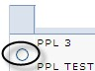
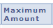
You are eligible to enroll in the following payment plans. You will need to follow the 4-step process for each payment plan you elect to enroll in.

Payment Plans
Number of First Due
Installments Date

50 ,000 .00 2 0 3/ 16/ 2 0 12

Currency used is US Dollar.

CANCEL NEXT

Account Inq ui ry Account Services Enroll In Payment Pla n l098t Ta x Form Igo to . H®

9. Review the installment plan you have selected.
Spartan vu Igo to ... H®

Account Inquiry
1r Account Services

10. Click the Previous button
to make a different selection.

11. Click the Next button to proceed
enroll in payment plan 1098t tax form

Enroll in Payment Plan

2. Review Installments

You have sel ected PPL 3.

PPL TEST

Eligi ble Charges: | 2,867.00
Pl an Amount: | 50,000.00
Number of Install ments: | 2

Due Date
!Installment !Administrative Fee !Total Installment I

0 3/ 16/ 2 0 12
04/14/2012
1,4 33 .50
1,4 33 .50
33 .00 1,4 66 s o 1
1,4 33 s o I

To ta l
2 ,867. 00 33. 00
2 ,900. 00

Currency used i s US Dollar,

Im porta nt: The Install ment Sched ule a bove is based on your current eligi ble cha rges of 2,867.00. If cha rges tha t a re placed i n this pla n a re reversed or red uced, your i nstallment payment will al so be automati cally reduced. If you i ncur eligi ble charges

i n the f uture, they will be added to this i nstall ment sched ule a utoma ticall y, up to the amount of 50,000.00.

CANCEL PREVIOUS

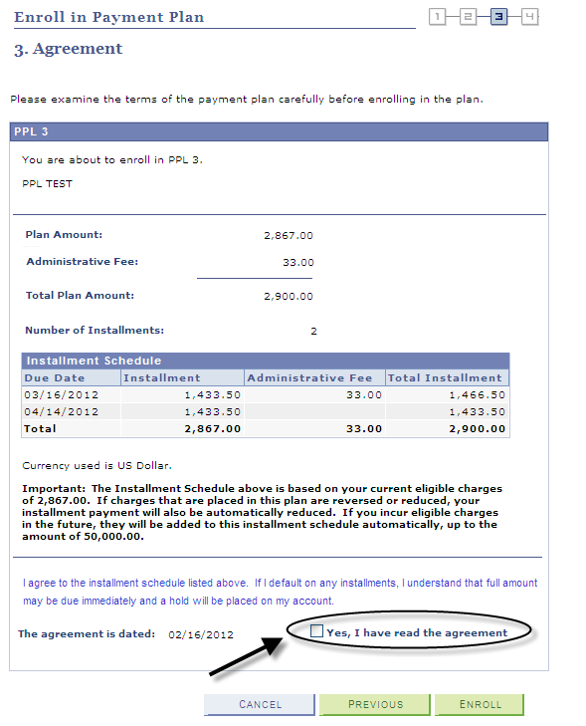
12. Review the installment schedule and terms of the payment plan.

13. Check the box indicating that you have read the agreement.

14. Click the Enroll button or click the Previous button to select another payment plan option.

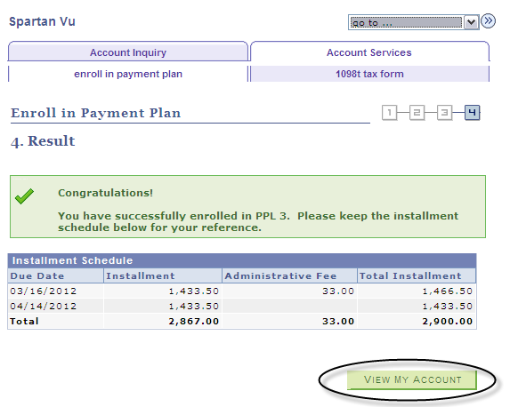
15. Congratulations! You have enrolled in a payment plan!

16. You can use the View My Account button to see your account.

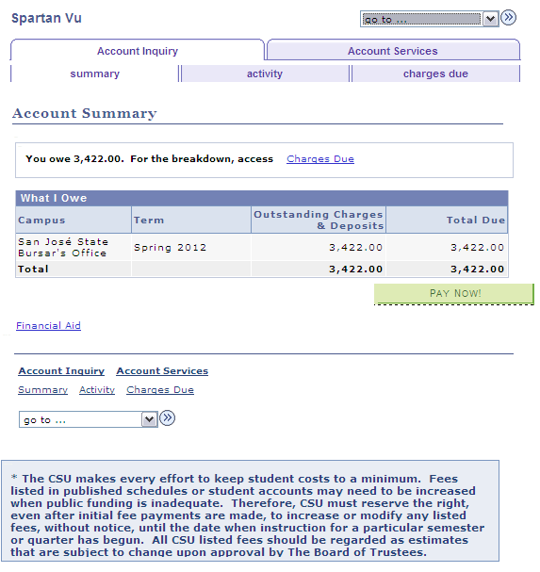
The Account Summary page displays.

17. Click the Pay Now button to make a payment.

