
Overview

Enroll in Tuition and Fees Only
Payment Plan
This student guide demonstrates how to enroll in the Tuition & Fees ONLY Payment Plan.
Please contact the Bursar’s Office by calling 408-924-1601 or email bursar@sjsu.edu with any questions about this process, student account, or visit them at www.sjsu.edu/bursar .
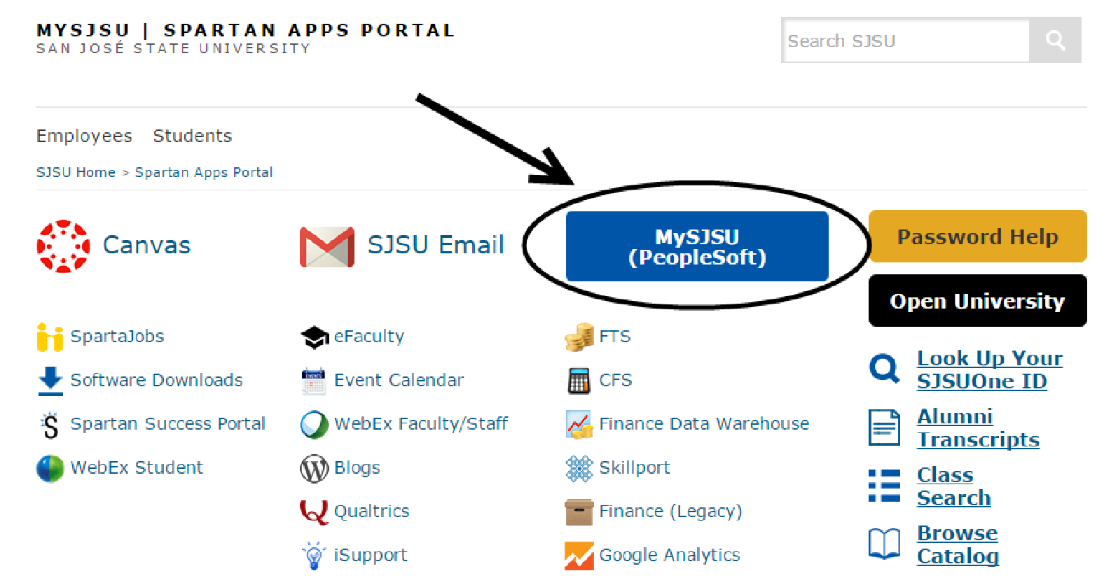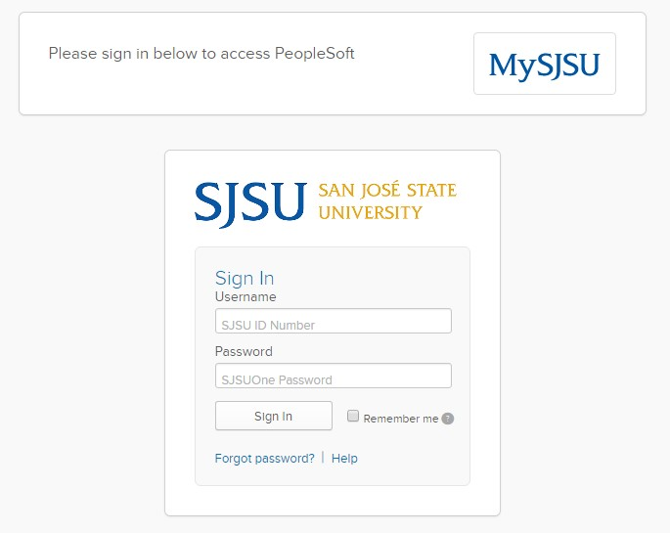
The MySJSU homepage
displays.

1
. Go to
MySJS
U

(
http://my.sjsu.edu/).
2
. Click the
MySJSU

Sign In

button.

The Login page displays.

. Enter your
3
SJSU ID
and
Password
.
4
. Click the
Sign In
button.

Note: If you have difficulty
logging in, contact the IT Help
Desk by email
(
ithelpdesk@sjsu.edu) with
your full name and SJSU ID.

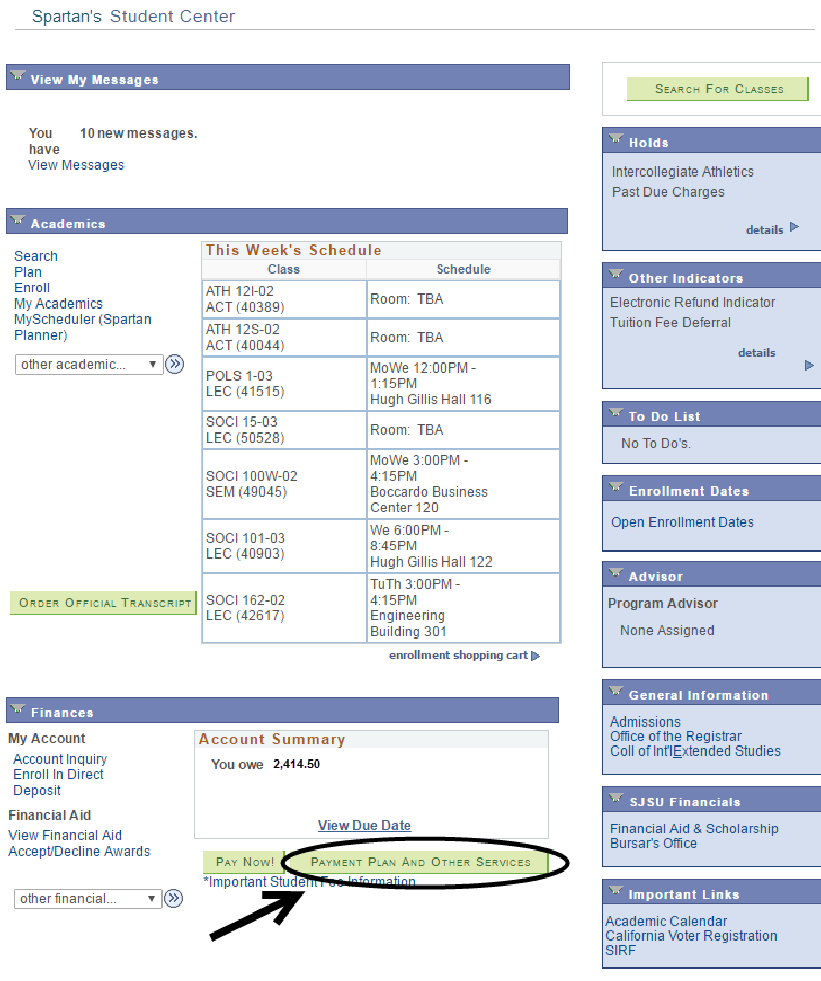
The Student Center page
displays.

5.

Click the

Payment Plan
and Other Services
button
.

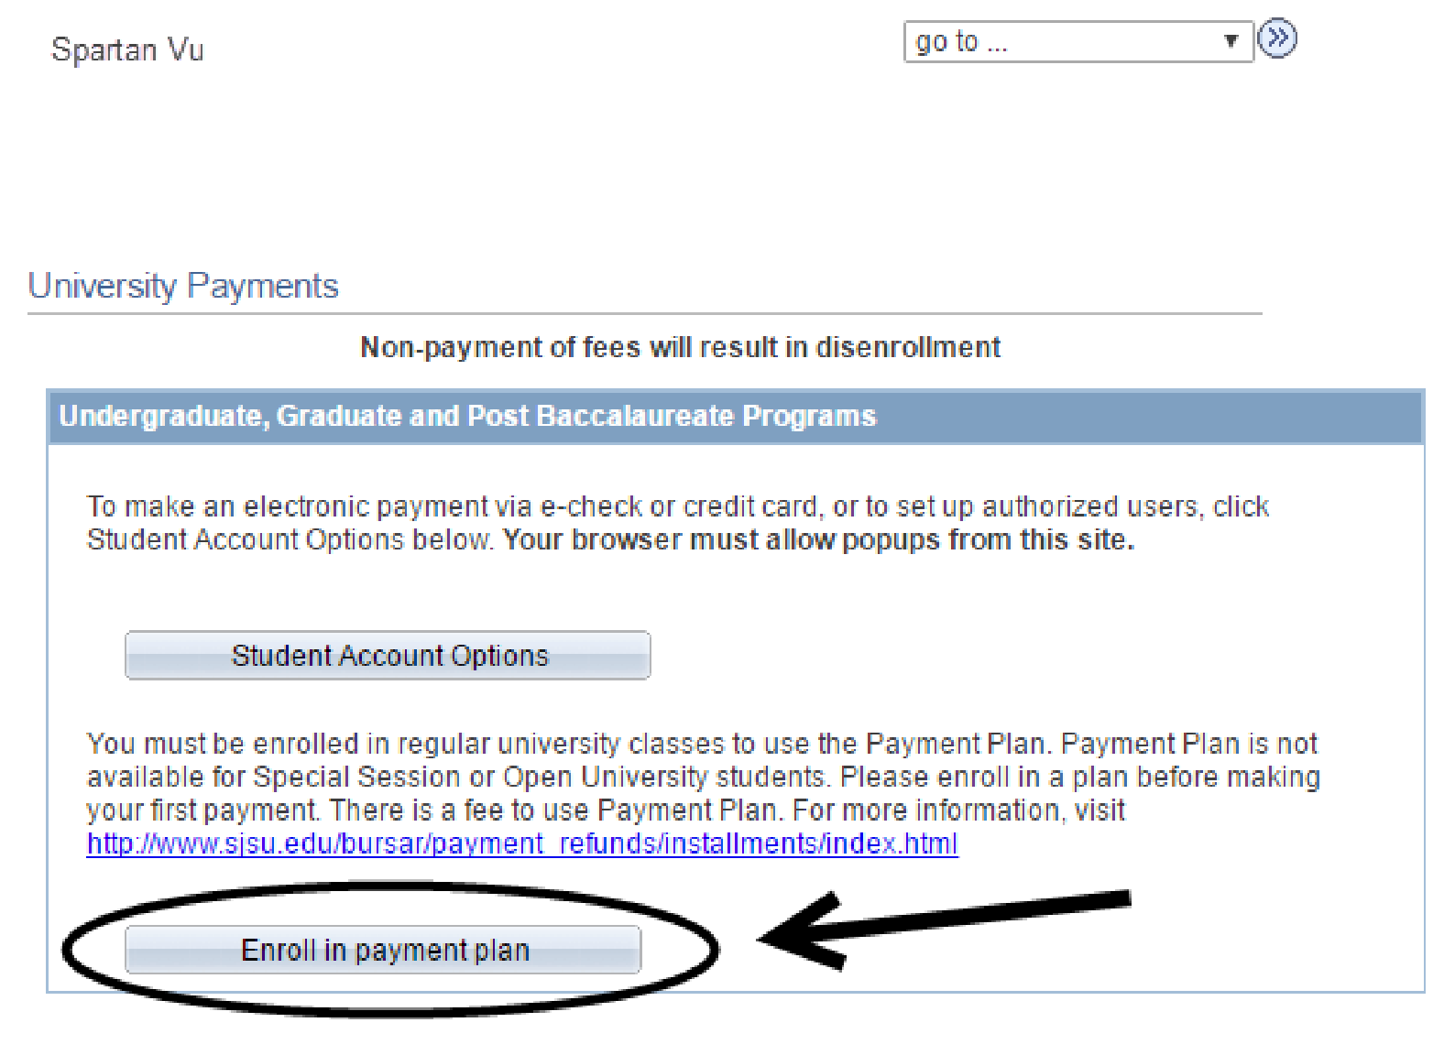
The
University Payments
page displays
.

6.

Click the
Enroll in
payment plan

button
.

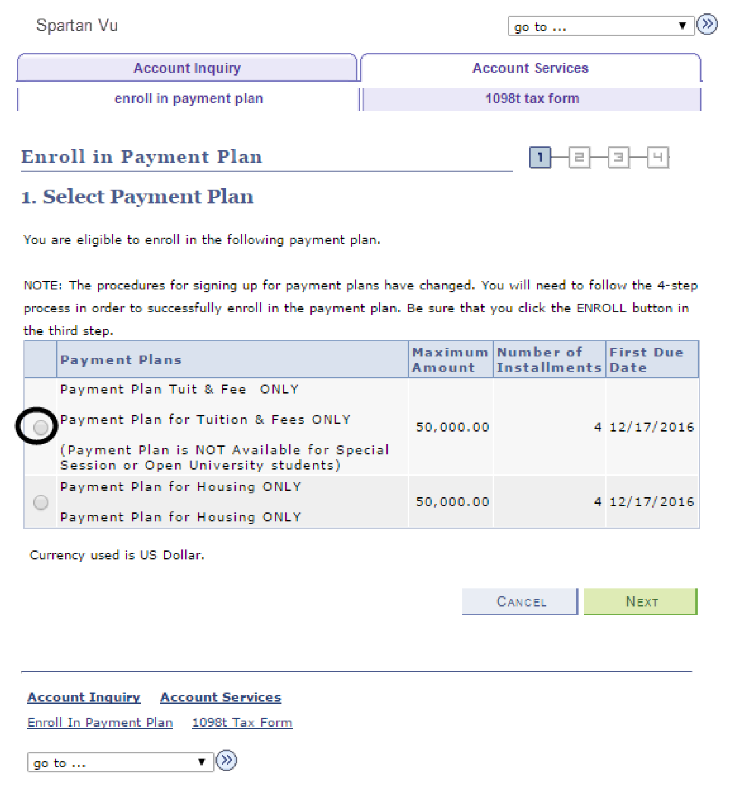
The Enroll in Payment Plan
page displays
.

7.

Select
Payment Plan

for
Tuition & Fees ONLY
.

8.

Click the
Next

button
.

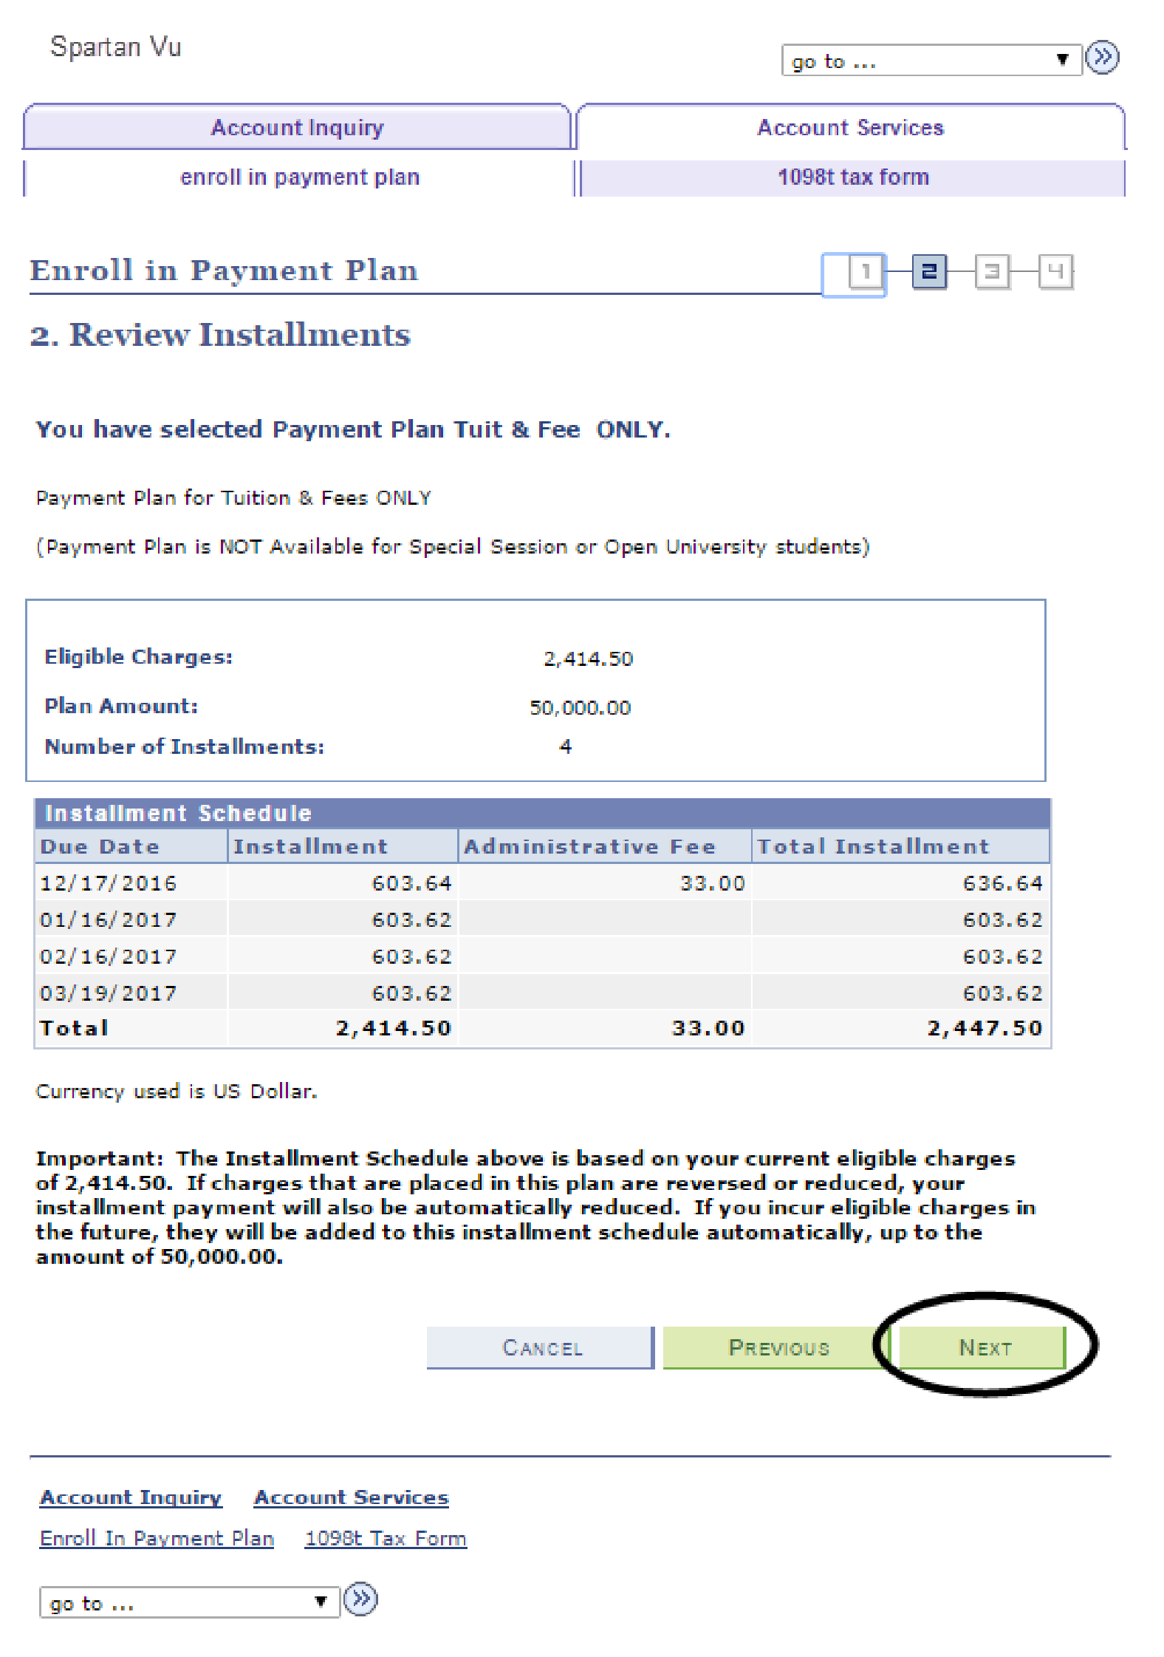
9.

Review the installment
plan you have selected.

10.

Click the
Previous
button
to make a different
selection
.

11.

Click the
Next

button to
proceed.

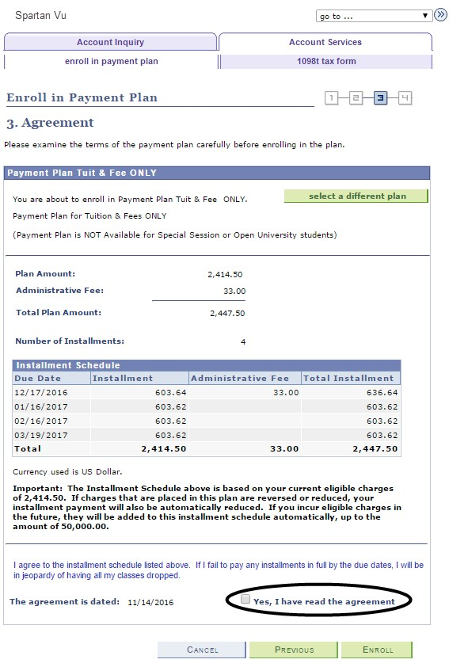
12.

Review the installment
schedule and terms of the
payment plan.

13.

Check the box indicating
that you have read the
agreement.

14.

Click the
Enroll

button or
click the
Previous

button
to select another payment
plan
option.

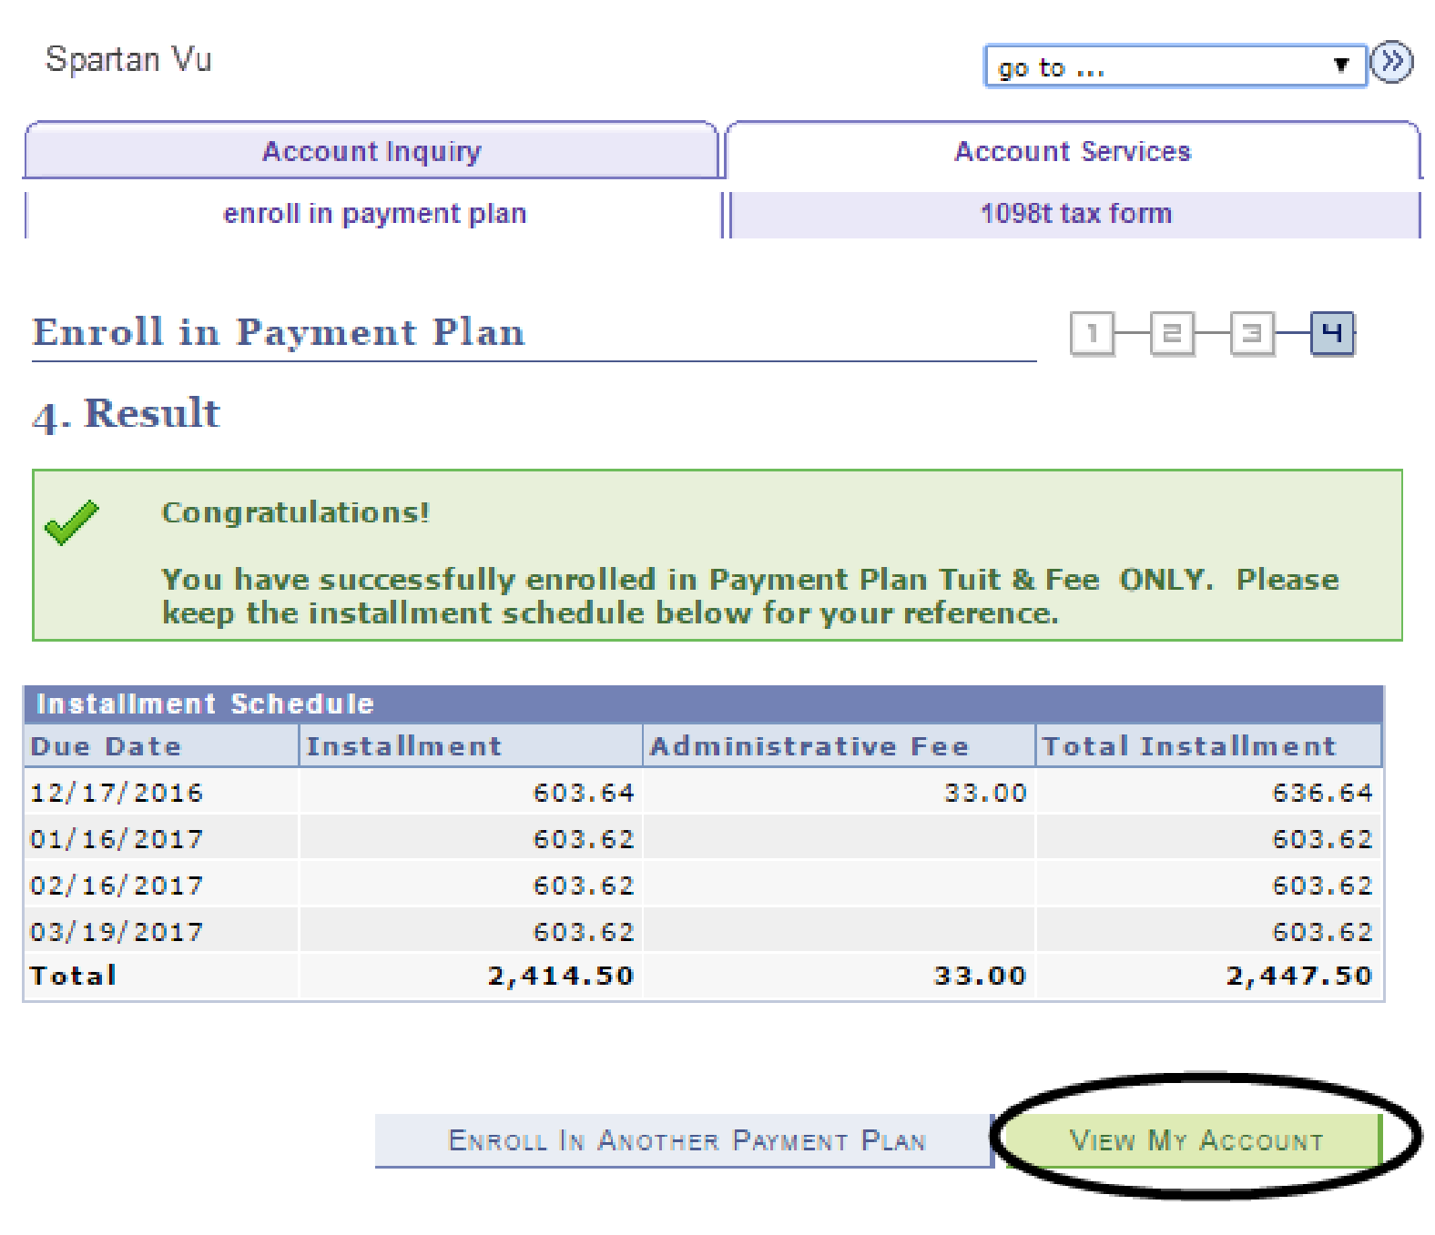
15.

Congrat
ulations! You have
enrolled in the Tuition &
Fees ONLY Payment P
lan!

16.

You can use the
View My
Account

button to see
your account.

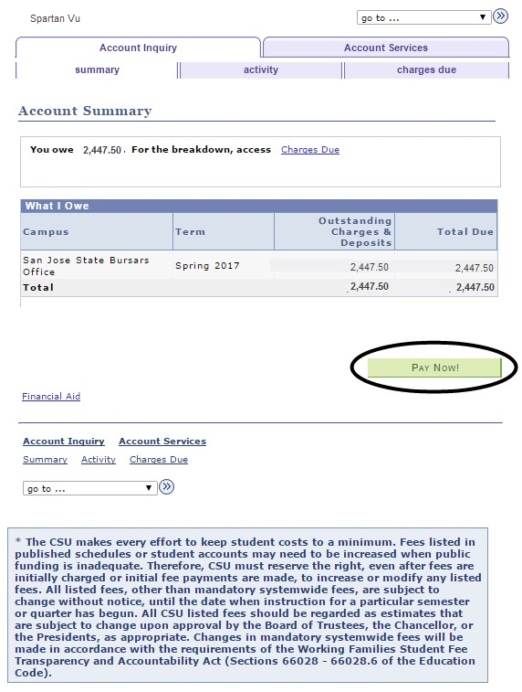
The Account Summary page
display
s.

17.

Click the
Pay Now

button
to make a payment.

