2019 FRP STUDENT COMPETITION
ACI SPRING CONVENTION
CINCINNATI OHIO

The San Jose State University’s American Concrete Institute (ACI) Student Chapter of the Department of Civil and Environmental Engineering sent a team of seven students; Meranda Hui, Sahil Vinod, Jacky Kuang, Zenab Ali, Kim Ayala, Yazan Farah, and Ahmad Abuamriah, to participate in the Fiber-Reinforced Polymer (FRP) Composites Competition against about 40 local and international university teams. The competition was hosted by the American Concrete Insititute in Cincinnati, Ohio, on October 20-24, 2019.

Each team was required to design and construct a concrete beam reinforced with fiber-reinforced polymer (FRP) reinforcement to achieve the lowest cost-load ratio. Points were also awarded for accurate predictions of the maximum load the beam would bear as well as the load value that would result in 35mm of midspan deflection. San Jose State’s entry, SPRTA, passed all preliminary weight and measurement checks, was tested to load failure, and ranked 29th place overall. The team’s predictions for maximum load ranked 10th most accurate in that category.

The student chapter gained valuable experience in the concrete mix design, design and casting of the beam, and the networking opportunities with industry professionals throughout the convention. Students who participated were also able to attend different sessions and panels presented by concrete researchers and educators; as students who have yet to fully integrate into the industry, they were greatly benefitted by the opportunity to directly ask speakers any questions and obtain continuing education units (CEU/PDH). At the end of each day of attending panels, the team was able to explore the sights and notable historical features of Cincinnati.

The ACI team and student chapter would like to thank the ACI Northern California and Western Nevada chapter, the SJSU Associated Students, Charles Davidson College of Engineering for their financial support towards this event. A special thanks to chapter advisor, Dr. Akthem Al-Manaseer for his continued support and guidance.

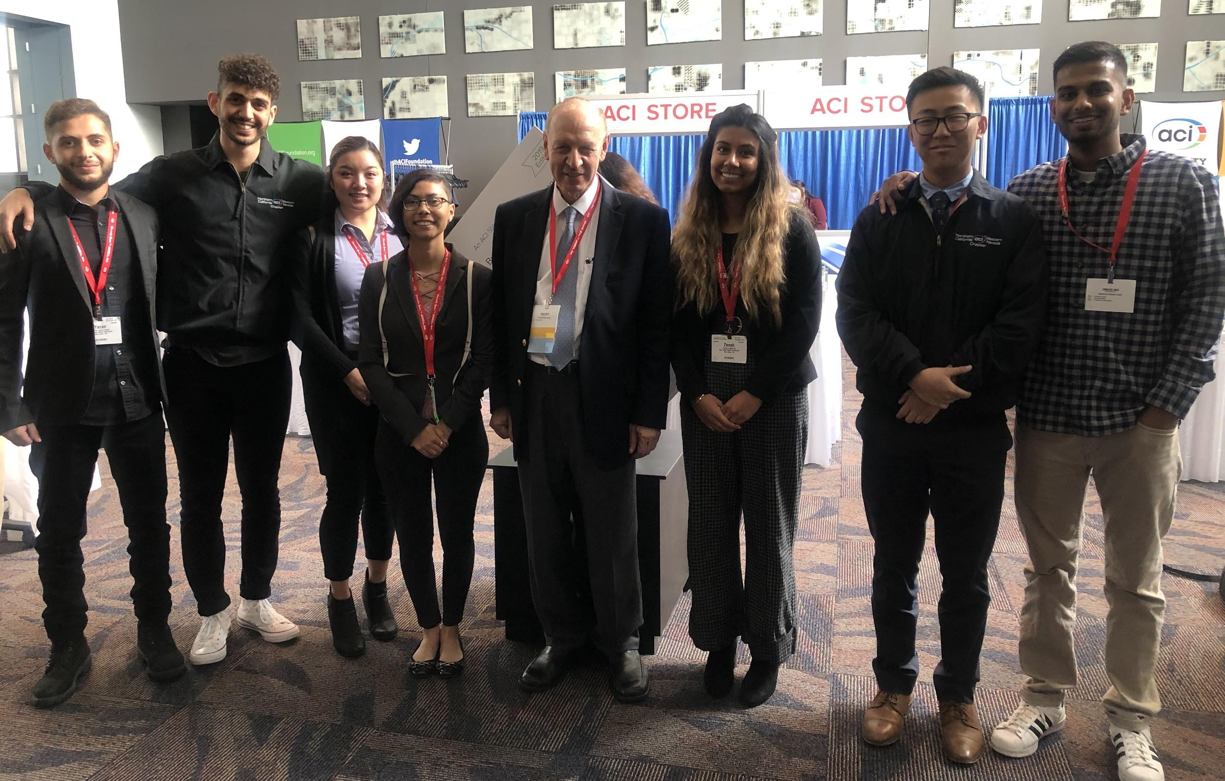
SJSU Team with Dr. Akthem Al-Manaseer at the FRP Composites Competition
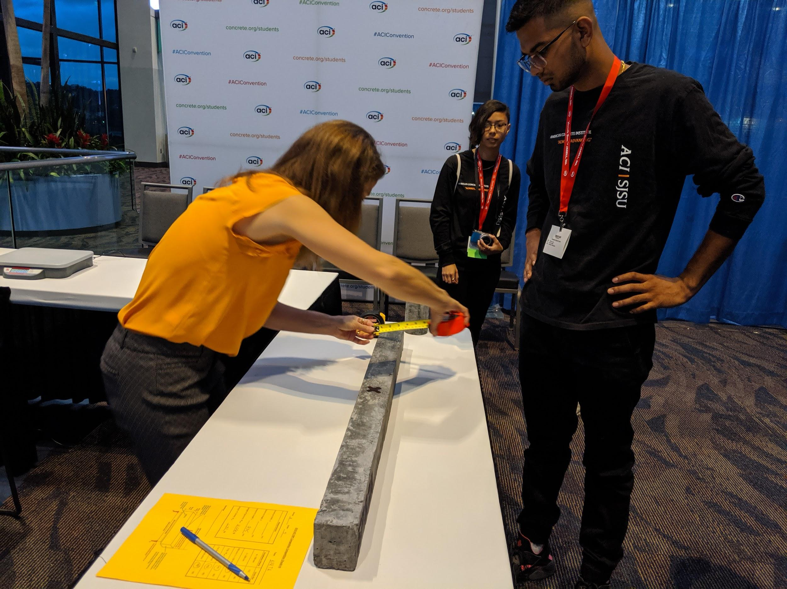
Team members Sahil Vinod and Kim Ayala looked on as SJSU’s concrete beam SPRTA underwent the preliminary measurements check.
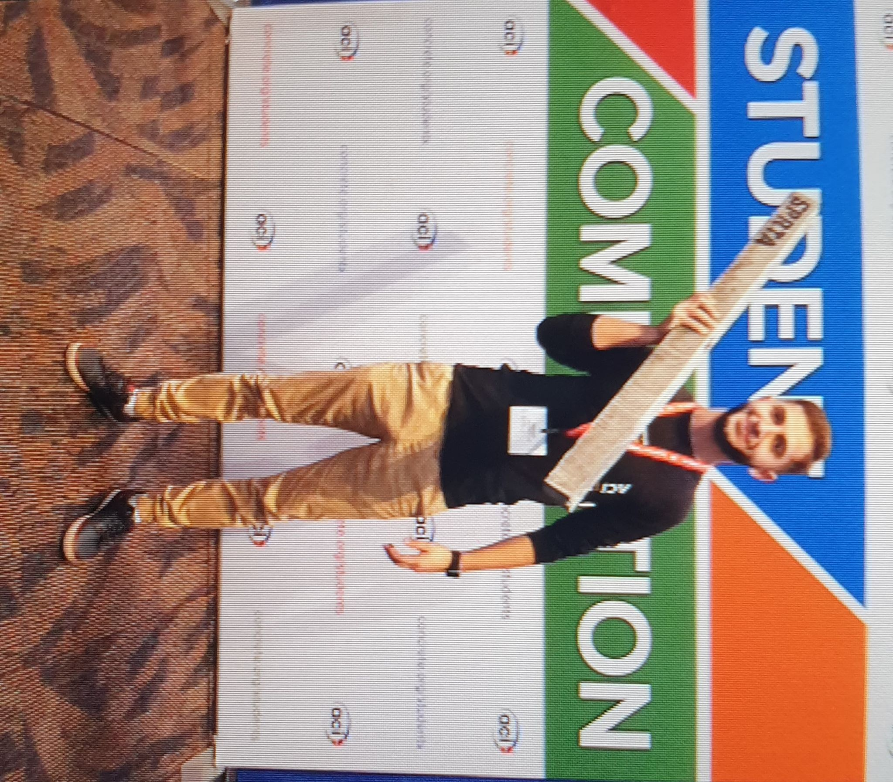
ACI SJSU Student Chapter officer Yazan Farah posing with the competition beam, SPRTA.
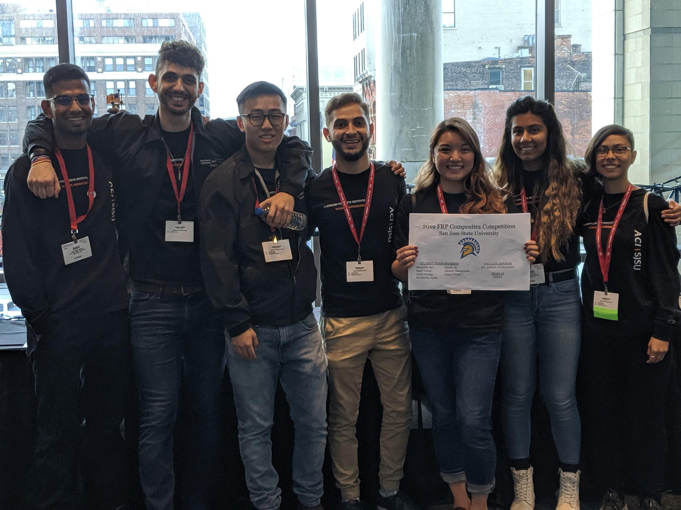
ACI SJSU Chapter’s participants in the FRP Composites Competition: Sahil Vinod, Ahmad Abuamriah, Jacky Kuang, Yazan Farah, Meranda Hui, Zenab Ali, Kim Ayala (left to right).
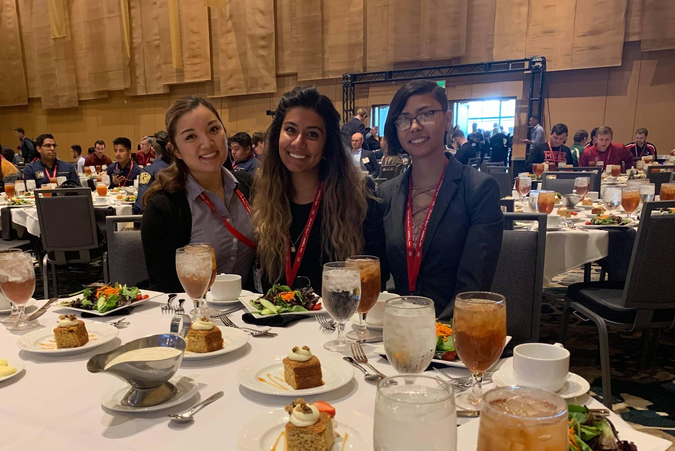
Team members Meranda Hui, Zenab Ali, and Kim Ayala (pictured left to right) at the Student Awards Lunch.

