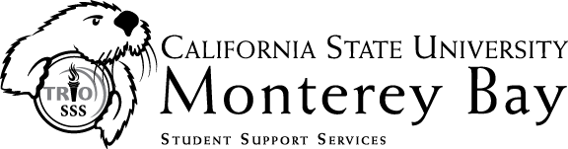
Internship Description

COUNSELING INTERN NEEDED
TRiO Student Support Services (SSS) is seeking one (1) counseling services intern for the 2013-14 academic terms. The intern will serve as a member of the professional staff and will provide general student support of project participants. Under the supervision of the Coordinator and/or Retention Specialist, the intern will undertake counseling responsibilities which may include academic and career assessment activities, workshop presentations, and/or assisting with the development of social-cultural enrichment events. A possible project may entail the development of a supplemental instruction component.

TRiO Student Support Services (SSS) is a federally funded program that offers support to first-generation, low-income students and /or individuals with a disability. TRiO SSS is designed to increase college retention and graduation rates, to foster an institutional climate supportive of the success of our students, and to improve the financial literacy and economic literacy of our participants.
Services include tutoring through the university’s certified program, advice and assistance in postsecondary course selection, information on the full range of Federal student financial aid programs and benefits, assistance in completing financial aid applications, educational services designed to improve the financial and economic literacy of students, and activities designed to assist students in applying for admission to graduate and professional programs. Additional services include grant aid, academic and personal counseling, peer mentors, exposure to cultural events and academic programs, and computer and internet access.
For more information, please visit us at http://eosp.csumb.edu/student-support-services.
Please send cover letter and resume to the following:

Jesus Clemente, Coordinator
California State University, Monterey Bay
TRiO Student Support Services (SSS)
100 Campus Center
Student Services Building (#47), Room 120
Seaside, CA 93955
Direct: (831) 582-5053
Fax: (831) 582-5181
Email: jclemente@csumb.edu

TRiO Student Support Services serves 160 students each year. TRIO SSS is 100% federally funded at $245,584.

