San Jose State University
E10 – Introduction to Engineering

Wind Turbine Project – Lab. Exercise (CAD)

For all four exercises in this assignment, print a copy of the 3D solid model (as shown) and turn it in by the start of the next lab. Include your name, lab section number, and day and time of your lab.

Exercise 1 – Reproduce the object shown below. Sketch the profile using the dimensions given, then Extrude to a depth of 3.0 inch.

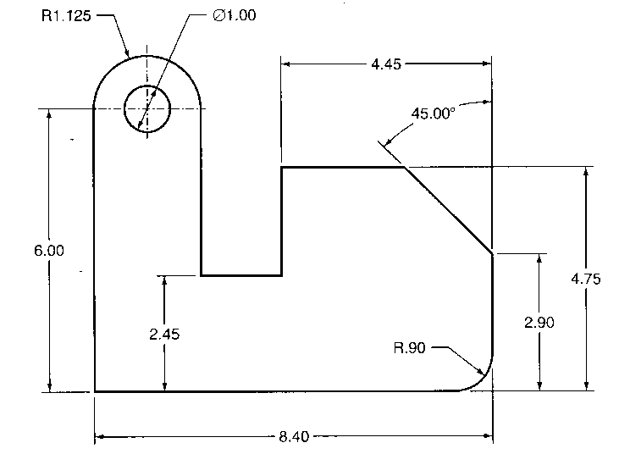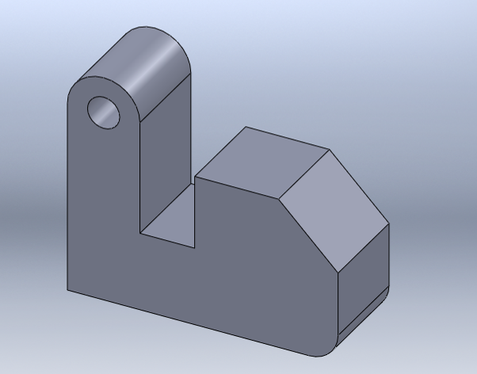
3D solid model
Profile (2D – dimensions in inches)

45º
Profile (2D – dimensions in inches)

Exercise 2 - Reproduce the object shown below. Sketch the profile using the dimensions (mm) given, then use the Revolve command (360º) to create the object.

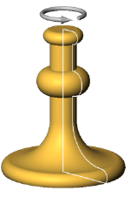
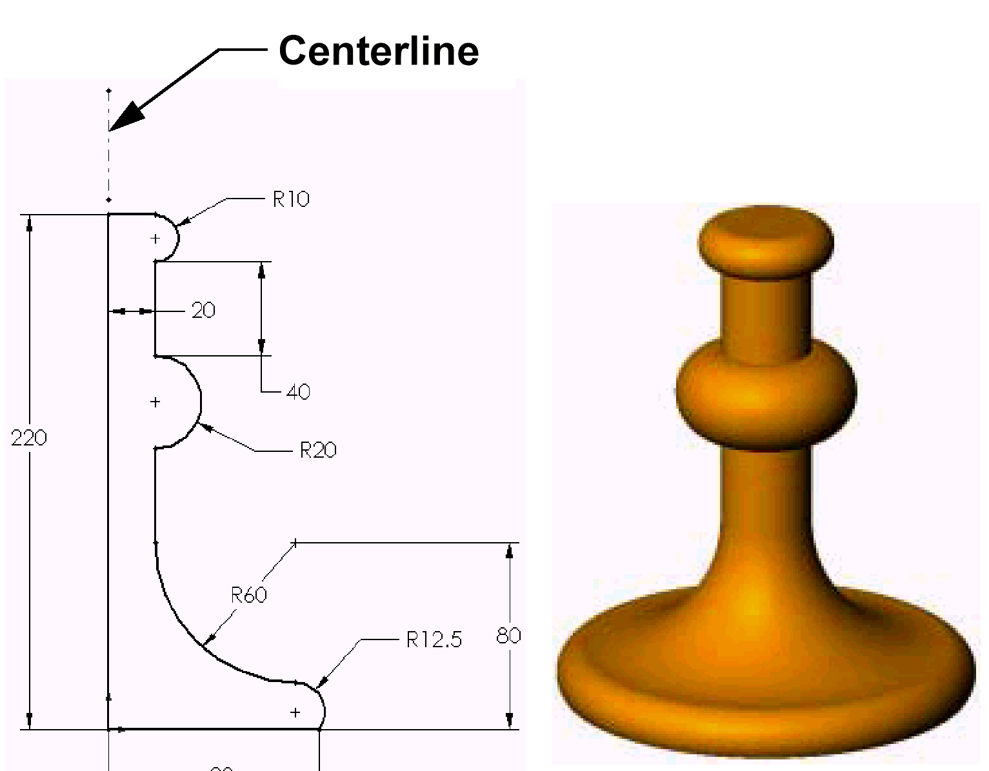

90

Profile (2D – dimensions in mm)
3D solid model

Exercise 3 – Create the 3D solid model of the paper clip shown below. The dimensions are in mm. Use
the Sweep command.

Profile (2D – dimensions in mm)

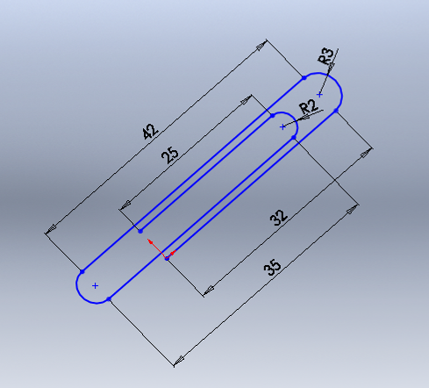
Paper clip diameter, d = 1 mm
R2 = radius of 2 mm
R3 = radius of 3 mm

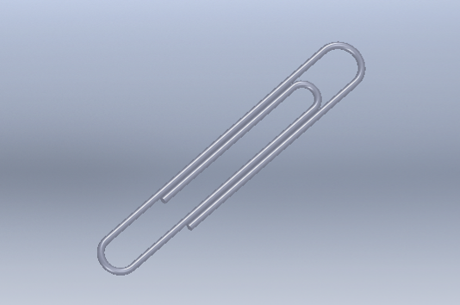

3D solid model

Exercise 4 – You are asked to design the tip of a straight screw driver. The desired shape and dimensions are provided below. Sketch the three profiles on three sketch planes, use the front plane for the tip profile (rectangle 0.5 in by 0.1 in) and create two reference planes 1.0 in. apart. Sketch the other two profiles and use the Loft command to create the front section of the screw driver.

all dimensions in inches
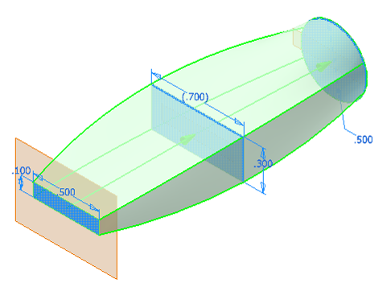
1.000
1.000

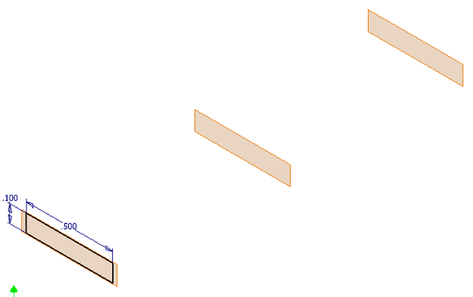
First profile
Front plane
Reference planes

Straight line passing through the centers of all profiles

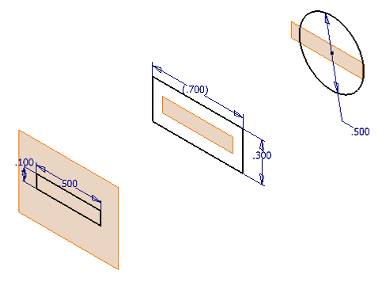
Second profile
Third profile
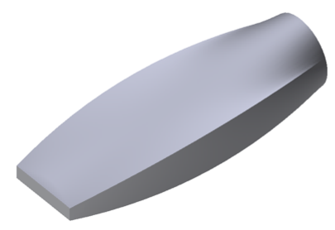
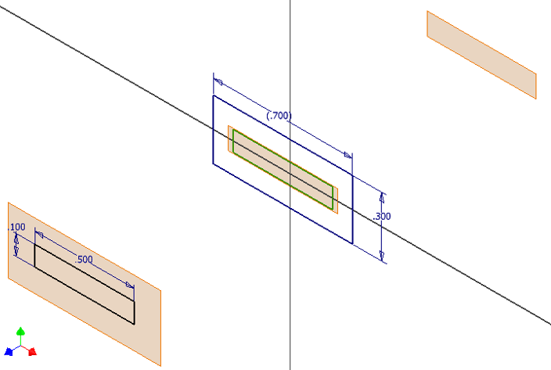
Second profile

3D model

