San Jose State University
Charles W. Davidson College of Engineering
E 10 – Introduction to Engineering

Engineering Applications Using Formulas and Charts/Graphs

- All exercises should be performed in groups of two, so find a partner.
- Ask your lab instructor how he/she prefers the solution to be turned in. Upload the Excel sheet to Canvas.
- Make sure you format the sheet properly, for example, a table should not be displayed on two pages. You should be able to fit more than one exercise per sheet.
- Make sure all exercises and answers are clearly labeled.
- Turn in one solution (Excel file) for your group of two. Include both names.

Exercise 1
An engineering student took five courses in the Spring 2020 semester. The credit hours and the grades for these courses are listed in Table 1.

Table1: Credit Hours and Grades for Spring 2012 Courses
Course | 1 | 2 | 3 | 4 | 5
Credit Hours (x_{i}) | 3 | 4 | 5 | 3 | 3
Grade | A | B+ | A | C- | A-

Calculate the student’s grade point average (formula given in Eq-1) for the semester. Table 2 provides the grade point associated with each letter grade (per each credit hour).

Table 2: Grade Points Per Credit Hour Associated with Letter Grades
Grade | A | A- | B+ | B | B- | C+ | C | C- | D+ | D | D- | F
Points (y_{i}) | 4.0 | 3.7 | 3.3 | 3.0 | 2.7 | 2.3 | 2.0 | 1.7 | 1.3 | 1.0 | 0.7 | 0.0

The equation that is used by Excel to calculate the GPA. You can check your answer by hand calculation.

Eq-1

where x_{i} is the credit hours of course i and y_{i} is the points associated with the grade for course i.

Exercise 2

Information on inventory of machine parts of a manufacturing company is displayed in Table 3. The first column displays the part identification number; the second column presents the number of units on hand available for the corresponding part; the third column gives the per-unit manufacturing cost of the corresponding part; the fourth column gives the unit sales price for the corresponding part.

The company has the following simple inventory policy.
- When the current stock level (i.e., the number of units on hand) of a part falls below a threshold, called the minimum stock level, the company will order the part from its suppliers.
- The order quantity (i.e., the number of units ordered) for the part plus the current stock level should be equal to the maximum number of units that can be held in inventory, called the maximum stock level.
- The total order cost is the sum of the order costs for all parts that must be ordered.

Table 3: Inventory of Machine Parts
Item Part Number | No. Units On Hand | Per Unit Manufacturing Cost | Per Unit Price
19165 | 10 | $1.25 | $1.65
19166 | 46 | $0.35 | $0.50
19167 | 89 | $3.15 | $4.65
19168 | 12 | $2.49 | $3.60
19169 | 53 | $2.25 | $3.00
19170 | 6 | $1.95 | $2.95
19171 | 22 | $1.55 | $2.10
19172 | 31 | $5.75 | $7.45
19173 | 95 | $3.95 | $5.35
19174 | 19 | $4.25 | $5.75
19175 | 77 | $0.75 | $0.85
19176 | 25 | $1.19 | $1.65
Minimum Stock Level |  | 30
Maximum Stock Level |  | 100

Use appropriate Excel formulas/functions to answer the following (check Excel answers by visual inspection and hand calculation:
- Use an Excel function to determine the greatest quantity on hand among all the parts stocked in the inventory.
- Use an Excel function to determine the average quantity on hand across all parts.
- Use Excel equations to calculate the total dollar amount tied up in inventory, in terms of manufacturing cost?
- Use Excel equations to determine the average manufacturing cost per unit for the total inventory on hand.
- Use an Excel formula to determine how many parts have a unit price that is greater than $2.00.
- Create a column to display an order quantity based on the following rules. If the quantity on hand is less than the minimum stock level of 30, then order 100 minus the quantity on hand (to bring the stock level up to 100 units of item). Otherwise the quantity ordered is zero. The column should contain Excel functions to automatically calculate the order.

Exercise 3

Preventing fatigue crack propagation in aircraft structures is an important element of aircraft safety. An engineering study to investigate fatigue crack in n = 9 cyclically loaded wing boxes reported the following crack lengths (mm): 2.29, 2.76, 3.22, 1.85, 1.15, 1.45, 2.14, 1.97, 2.68. Calculate by using the Eq-2 and Eq-3
- the sample mean (i.e., the average of the lengths)
- sample standard deviation (as a measure of variability of the lengths)
- verify the answers by entering Microsoft Excel statistical functions Average and Stdev, respectively

Data Observations:

Sample mean: Eq-2

Sample Variance: and Sample Standard Deviation: Eq-3

Exercise 4
Table 4 provides information on structural defects in a random sample of automobile doors:

Table 4: Structural Defects in Automobile Doors

Type of Defect | Number of Occurrences
Dents | 4
Pits | 6
Parts assembled out of sequence | 2
Parts under trimmed | 25
Missing holes/slots | 10
Parts not lubricated | 4
Parts out of contour | 35
Parts not deburred | 2

- Construct an appropriate chart to help visualize how frequently different types of defects occur.
- Construct an appropriate chart to display the percentage of defects of each different type with respect to the total number of defects. Hint: what type of chart is good for showing proportions?

Exercise 5 – fitting equations to data (curve fitting)

An engineer has measured the displacement of a spring as a function of the applied force. Table 6 summarizes the data that have been obtained:

Table 6: Spring Displacement Measurements
Data Point No. | Force (N) | Displacement(cm)
1 | 3.2 | 2.0
2 | 4.2 | 4.0
3 | 8.5 | 8.5
4 | 12.0 | 10.5
5 | 13.5 | 11.8
6 | 17.0 | 15.5

Note: By convention, the independent variable is usually plotted along the x-axis. But, in the case of spring stiffness, force (the independent variable) is plotted along the y-axis and displacement (the dependent variable) is plotted on the x-axis. Stiffness is defined as force required to cause a unit displacement, slope of the line.

- Plot the data points and determine the equation of the straight line that best fits the data points. Display the equation and the correlation value (r², R-squared) next to the graph.

- What is the stiffness of the spring?

- Based on the equation you developed, how much force is needed to displace the spring 6 cm?

Exercise 6 – fitting equations to data (curve fitting)

An engineer has built a wind-driven device that generates electricity. Table 7 summarizes the data that have been obtained with the device:

Table 7: Power Generated by Turbine
Wind Velocity (mph) | Power  (watts)
0 | 0
5 | 1.5
10 | 7.3
15 | 12
20 | 30
25 | 65
30 | 130
35 | 200
40 | 270
45 | 360
50 | 515

- Fit an appropriate equation to the data with the intercept set to zero.
- Show the R-squared value on the plot.
- Use the equation to determine how much power will be generated if the wind velocity is 32 mph.
Important Note: Power is related to the cube of the wind speed.

Exercise 7 – Optimization problem (This is a typical Industrial Engineering problem)

A company manufactures two products, A and B.
- Product A can be sold for $145 per unit and B for $75 per unit.
- Management requires that at least 1850 units be manufactured each month.
- Product A requires 5 hours of labor per unit, and product B requires 3 hours.
- The cost of labor is $15 per hour and a total of 8000 hours are available per month.

Using the Excel’s Solver, determine a production schedule of how many of each product to manufacture each month to maximize the company’s profit.
- How many of each product should they manufacture each month?
- What will be the monthly profit?

Exercise 8 – solving simultaneous system of equations (This is a typical Civil, Aerospace or Mechnical Engineering problem)

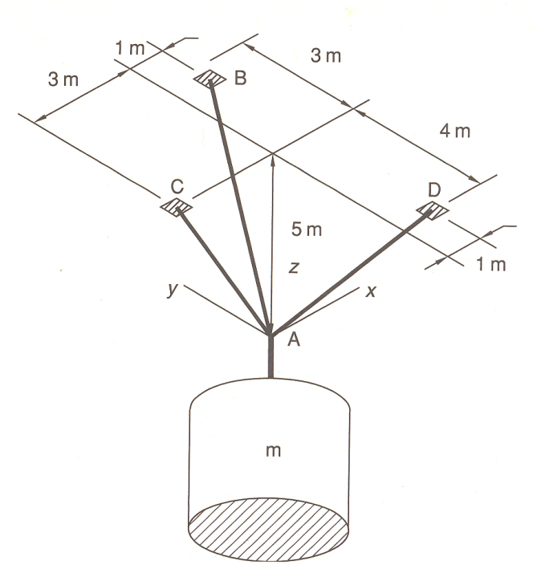
An object weighing 1000 Newton is suspended by three cables attached to the ceiling as shown in the figure. Let T₁, T₂, and T₃ be the tensions in the three cables. The first step in designing the cables is to determine the tension (force) in each cable caused by the 1000 N force. The equilibrium condition states that the sum of the tension components in the x, y, and z directions must be zero. This requirement gives the following three equations:

.179 T₁ - .514 T₂ + .154 T₃ = 0

.507 T₁ - .617 T₃ = 0

.958 T₁ + .857 T₂ + .771 T₃ - 1000= 0

Use the Excel’s Solver to solve this system of simultaneous equations to find T₁, T₂, and T₃.

1000 N

