Solar Cell Characterization Lab Guidelines

**Project Overview**

Various technologies have been used and are under development to harness the energy from the sun and provide an important alternative to fossil fuels. Examples are photovoltaics (solar cells or PVs), concentrating solar power mirrors, and passive solar systems for heating and cooling buildings. Solar cells are used in applications ranging from powering small calculators to space satellites to large industrial facilities. In this lab we explore the efficiency and power output of solar cells

Using a 75W (or 40W) halogen lamp to model energy input from the sun, we

* Use a solar meter to measure the actual power from the “sun.”
* Measure a solar cell’s output voltage, current and power under various loading conditions.
* Determine the solar cell’s maximum output power operating point.
* Evaluate the system efficiency and the power output of a weight lifting setup powered by solar cells.

**Learning Outcomes**

Students will be able to:

* Derive the power output of an energy source by measuring voltage and current
* Identify the maximum power of a system with variable load
* Calculate the efficiency of a system
* Configure a system to match the source to the load so that it operates at maximum efficiency

**Project Grading (25 Points)**

**Data Collection and Plotting (15 points)**

* Use Excel to plot your data as described in the section about the lab report. Full credit requires proper labeling and units on graphs. Calculate the efficiency of the system.

**Written Discussion (10 points)**

* You will need 4-5 pages of text (not including pictures and plots) to document what you did and your conclusions from the data analysis. Your report will be assessed on neatness, and the quality and completeness of your discussion.

**Laboratory Set up**

Figure 1 shows the solar meter and potentiometer that you will use to measure the power intensity of the light source and the potentiometer box to apply the load.

 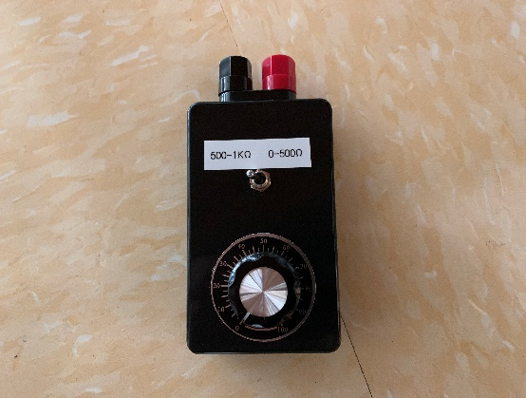

**Figure 1.** Daystar DS-05 Solar meter measures solar intensity in Watts/m2 and Potentiometer box

Figure 2 shows the wiring diagram of the solar panel used in this lab. There are 6 cells per panel. You can make wire connections to the cells through the terminal block (the black strip). Note that the positive output of the cell is connected to the terminal block via a red color wire while the negative one is connected via a black wire.

 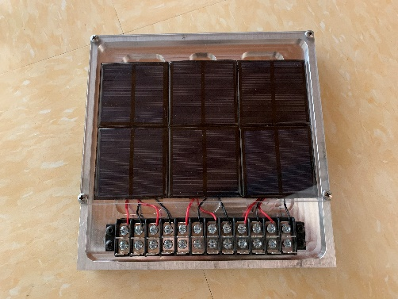

**Figure 2. Solar panel connection.** Connections to the cells are made via the terminal block. The red wires connect to the positive output of the cells, and the black wires to the negative output.

**Task #1: Single Cell Measurement**

When light shines on a solar cell, it produces a voltage across the output wires. This voltage varies with the light intensity and the amount of current drawn from the cell. For a fixed light intensity, this voltage is at the highest value when no current is drawn from the cell. As more current is drawn from the cell, the voltage gradually drops. To characterize the power generation characteristic of the cell, it is necessary to document the variation of the output voltage at different levels of output current.

In this experiment we use a variable resistor (potentiometer or POT) as the load (the device that draws power from the source) to the cell. At a higher resistance value, the POT draws lower current and, at a lower resistance value, the POT draws higher current. A **power meter** is used for measuring output voltage, current, and power. Power meters and POTs are described in the Appendix.

Procedure:

1. Turn on the lamp and position it over the solar cell, the distance from the bulb to the solar panel should be about **20 cm**.
2. Turn on the solar meter. Point the solar meter directly at the light source while it is on. **Position the solar meter 20 cm from the bulb, the distance of the solar cell from the light bulb**. Make sure the meter is directly underneath the light source and not pointing at an angle. Record the power intensity in Watts/m2. **Also, measure the area of the solar cell. Multiply the meter reading by the area to obtain the input power from the halogen bulb (Sun) in Watt (use correct units).**
3. Connect one of the cells (any one) to the Potentiometer box (use the 0-500Ω range to start with) through the power meter as shown in Figure 3.

(4) ‘Sweep’ the POT resistance from 0 to 500Ω to start with. Rotate the POT shaft from end to end using a small increment of rotation. At each increment, record the voltage (V), current (mA), and power (W) from the power meter. **Important:** when you notice the power reading close to the peak, use a smaller step, and search for the maximum power output point. If you don’t see the power peaking at a certain current level, there could be a mistake in your set up. Record results on the supplied data sheet, include this sheet in your report

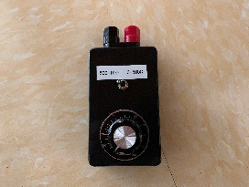

Current

Power

Voltage

Load

Input

**Figure 3. Connection for testing a single solar cell (cell #1 as shown).** The + and – leads from cell #1 are connected to the input of the power meter, and the Potentiometer box is connected to the load terminals of the power meter.

**Task #2: Series and Parallel Connection**

Let’s first review the definition of ‘voltage,’ explained in lecture. ‘Voltage’ is a relative term. The output voltage of a voltage source is the voltage difference between the higher voltage side (marked by ‘+’) and the lower voltage side (marked by ‘-‘) of the source.

This relative concept explains why a bird is not electrocuted when it lands on a high voltage line -- while the high voltage line does have a very high voltage relative to the ground, the bird’s entire body has the same voltage (a very high one with respect to the ground) but the relative voltage between any two points on the bird’s body is zero. When an individual tries to retrieve a kite entangled in a high voltage line with a conducting rod, the voltage on his hands holding the rod is very high relative to the voltage on his feet (because the person is standing on the ground). Unfortunate consequences always result from such a situation!

The two voltage sources (solar cells) in Figure 4 are connected in **series**. Since each source maintains a certain voltage between its output terminals (between + and -), the total relative voltage (between A and B), is the sum of the output voltages from both sources. A hydraulic analogy is also shown in Figure 4. It is intuitive for this system, that the total pressure as seen by the hydraulic motor is the sum of the pressure built-up from the two pumps. This analogy also shows that, while the total voltage is doubled, the current capacity of two source connected in series is the same as that of a single source.



**Figure 4. Two sources connected in series**. The combined voltage (or pressure) is the sum of that from all the sources.

**Important Relationships**

When two cells are connected in series, the *combined voltage* doubles, but the current rating remains the same as that of a single cell.

When two cells are connected in parallel, the *current rating* doubles while the voltage remains the same as that of a single cell. (Convince yourself of this.)

**Procedure for Series Connection:**

(5) Connect two cells (any two cells) in series, and connect them to the Potentiometer box through the power meter as shown in Figure 5. **Note:** it is **VERY** important that sign (polarity) of the cells are identified (red wire from the cell is positive) and connected exactly as shown in the figure. The cells may be damaged if they are connected in the wrong polarity. Repeat Steps (2) through (4).



Voltage

Current

Power

Input

Load

**Figure 5. Connection for testing solar cell #1 and #2 in series.** Make sure that the polarity of the connections between the cells is correct as shown, or else the cells may be damaged.

**Procedure for Parallel Connection:**

(6) Connect two cells in *parallel* as shown in Figure 6. Repeat Steps (2) through (4).



Voltage

Current

Power

Load

Input

**Figure 6. Connection for testing solar cell #1 and #2 in parallel**. Make sure that the polarity of the connections between the cells is correct as shown, or else the cells may be damaged.

**Task #3: Efficient Weight Lifting**

From the data obtained in Task #1 and #2, we can see that the output power peaks at a specific current (or voltage) level. In order to fully utilize the power generation capacity of a cell (or a combination of cells), the load should draw this specific amount of current. Such a condition is called **‘matching’ condition** or **‘peak power’ operating condition**. In practical applications, it is important that the system is designed to operate at this peak power operating point in order to minimize the cost. There are two ways to ‘match’ the solar cells and the load:

(1) Review the data from Task #2. You should see that for a two-cell set,

* the peak power current level is doubled if the cells are connected in parallel, and
* the peak power voltage is doubled if the cells are connected in series.

Since multiple solar cells are required to provide enough power in most applications, the designer can determine how to combine the cells so as to achieve the matching condition.

(2) In most applications, the required power is known (which determines the required number of the solar cells) and hence the amount of power that the load will draw from the cells is known. While the load power depends on the need of the application, the **characteristics of the load can be designed** to match the source. Since, power = voltage × current , for drawing a specified amount of power, the load can either draw a higher current but lower voltage or the other way around. The following description of Task #3 gives an example of how such load characteristic can be changed.

**Load Matching Example**

Suppose you are to design a solar powered deep well pumping system for pumping drinking water for a remote village. The amount of water that needs to be pumped from the well per hour has been determined. This pumping rate determines the power of the pump and also the number of solar cells required for producing the required power.

The **load** in this system is the **electric motor** that turns the pump. You have a choice:

1. Use a bigger diameter pipe with a slower water flow speed, or
2. Use a smaller diameter pipe with a faster water flow speed.

In the first case, the motor can turn slower but it must produce higher force (or torque). For case 2, the motor needs to turn faster but it does not need to provide as much force.

Instead of using different types of motors, it is often more convenient to use a gear boxes with a certain gear ratios to obtain the desired speed/size combination. For a mechanical system the gear box does not increase or decrease power because power only depends on force and speed.

**power = speed × force** (eq. 1)

When a motor operates at different speed/force levels, it draws different amount of current/voltage. More precisely, **the force produced by the motor is proportional to the amount of current it draws** **and the motor speed is proportional to the voltage**. In other words, to achieve the desired pumping rate, we can either draw higher current (higher force, bigger pipe) at a lower voltage (lower speed) or lower current (low force, smaller pipe) at a high voltage (high speed).

For the solar cells, these different choices of pipe size and gear ratio amount to different output current and voltage operating points. Obviously, a **good design should have this operating point at or near the maximum power operating point of the solar cells**.

**Design Parameters**

The goal of this part of the experiment is to achieve the matching condition by properly configuring the solar cells (parallel or series, or both) and selecting motor gear ratio. In other words, the goal of the experiment is to find the configuration that efficiently transfers the maximum amount of solar energy into potential energy (lifting a weight). You have the following design parameters for your weight lifting setup:

* Select one of three ways to combine power from six solar cells.
* Select which motor to use.
* Select which spool to use (smaller diameter spool or bigger diameter spool?).
* Select the amount of weight that you will lift with the setup.

Figure 7 shows three possible ways to combine the power from four solar cells. Choose any one of the configurations to perform your experiment. All three configurations are capable of providing the same amount of **power** but with different voltage vs. current characteristics. Depending on the load (in this case, the motor/gearhead/spool/weight), the one configuration that best matches the characteristic of the solar cells set up will transfer the maximum amount of power to the weight lifting mechanism.



**Figure 7. Three ways to combine the power from four solar cells.** Each configuration is capable of providing the same amount of power, but each will have different current-voltage characteristics.

If you have time, you can repeat the experiment, and try other configurations to find the ‘best’ configuration.

Figure 8 shows the motor/gearhead assembly. There are two motor/gearhead units – one on each end. Both units use the same kind of motor, but the one with red color housing has a lower ratio gearhead (30:1), while the one with the grey color housing has a higher gear ratio (190:1). **A higher gear ratio gives you more torque (a higher lifting force), but the output shaft turns more slowly, while the opposite is true for a lower ratio gearhead.**

For each motor, you also have the choice of using a smaller diameter spool or a larger one for lifting a weight. Similar to the gear ratio, a smaller diameter spool gives you higher lifting force but at a slower speed.



**Figure 8.** **Motor/gearhead assembly**. Choose which motor/gearhead assembly and which spool to use.

The goal is to achieve the highest potential energy gain within 15 seconds with your setup. The efficiency is also a key parameter in this experiment. The efficiency of this experiment is defined as:

**Efficiency = Output energy / Input energy** (eq. 2)

**Where output energy is the potential energy (mgh) (i.e., mass 🞪 9.8m/sec2 🞪 height)**

input energy to the motor/gearhead during the weight lift operation is

**Input energy = electrical power (in W) 🞪 time (in second)** (eq. 3)

You measured the watts per meter2 with the solar meter. Multiply by the area of the solar cells to get your input power.

**Procedure:**

(1) Choose one of the three configurations shown in Figure 7 and connect the wires to the power meter and the motor/gearhead assembly according to Figure 9.

(2) Position the motor assembly near the edge of the workbench (on the upper shelf, if necessary) so that the spool overhangs the bench top and uses the provided string to attach the weight to the spool. The weight can be a small plastic bag with, for example, a candy bar or a water bottle. You should first measure the weight of the weight.

(3) Turn on the lamp.

(4) As the weight is being lifted, record the power reading from the power meter at 15 seconds and record the height of the lift at exactly 15 seconds,



Input

Load

Voltage

Current

Power

**Figure 8 Setup for the weight lifting competition.** Choose the connections to the solar cells, which motor, and which spool to use. The goal is to achieve the highest potential energy gain within 15 seconds with your setup.

**Lab Report (**One report for your group, 4-5 written pages in addition to graphs, number your pages)

* **Title page** lists at minimum: the title of the project (descriptive and specific), the entity for which the report was written, i.e., San José State University, Charles W. Davidson College of Engineering, E10 Introduction to Engineering, names of the team members, E10 section number, instructor’s name, and the date of submission.
* **Introduction** section describes what the project was all about, first in general, but *then the three tasks you performed*. This section should be about 1-2 pages. You may use sketches and other information from the Project Guidelines, but cite your source.
* **Results from Single Cell, Series Cells, and Parallel Cells Measurements**

1. Calculate the maximum efficiency of a single solar cell using the input power and the maximum output power.
2. Enter data obtained from your measurements into an EXCEL file. Plot on the same chart the V vs. I curves for all three cases: single cell, two cells in series, and two cells in parallel. (Current on the horizontal axis)
3. On a different chart, plot the power vs. current curves for all three cases: single cell, two cells in series, and two cells in parallel.
4. Write several paragraphs summarizing the conclusions you drew from the solar cell efficiency calculation and from these two graphs.

* **Results from Weight Lifting**

1. Create a table, similar to the one on the data sheet you used in lab that summarizes the design choices you made and the data you collected
2. Write a paragraph or two indicating why you made your design choices
3. In addition to reporting the experimental data, answer the following questions:

* What is the input and output energy of the system?
* What is the efficiency of your motor/gearhead assembly?
* Does your weight lifting setup use the maximum power that this four-cell panel is capable of producing? (Hint: What is the peak power of a two-cell assembly?)
* **Appendix** Include your original data sheet (raw data) as an appendix.