Tax Induced Cigarette Smuggling in the United States

<Preliminary Draft: please contact authors for updated manuscript before citing.>

Todd M. Nesbit*
Department of Economics and Finance
College of Charleston
66 George Street
Charleston, SC 29424
nesbittm@cofc.edu

Robert A. Lawson
O’Neil Center for Global Markets and Freedom
Cox School of Business
Southern Methodist University
PO Box 750333
Dallas, TX 75275

Abstract:
Given the many recent and, in some cases, large increases in cigarette tax rates, tax differentials across state and international borders can vary substantially. This creates an environment in which consumers can save large sums of money by shopping across the border and in which large-scale commercial smuggling is profitable. We employ a new measure of the incentive to smuggle cigarettes—distance-scaled tax differential—adapted from Hall, Lawson, and Skipton (2011) we estimate cigarette demand controlling for multiple forms of spatial dependence. Consistent with the existing literature, we find that tax differentials predictably lead to changes in legal sales, implying a large degree of cigarette smuggling.

Keywords: Excise Taxation, Cigarettes, Smuggling, Spatial Model

*Corresponding author. We are grateful to the Initiative for Public Choice and Market Process for providing research support for this project.
1. Introduction
In efforts to squash their recent budget shortfalls, states have increasingly opted to raise their excise tax on cigarettes. From year 2000 through 2010, there were a total of 105 increases in state tax rates on cigarettes in addition to the two federal tax rate increases. Furthermore, a total of 27 states have increased their tax rate on cigarettes from 2007 through 2010 (34 total state tax increases over that span). As is indicated in Figure 1, states have been more aggressive with their cigarette tax increases since year 2000, relative to the experience over the previous decade. With these tax increases has come a greater spread in tax rates. For example, in 1990 the lowest state cigarette tax was two cents/pack (NC) while the highest was 20 times greater at 40 cents/pack (CT). In 2009, on the other hand, South Carolina imposed the lowest state tax of seven cents/pack while Rhode Island’s tax was nearly 50 times greater at 346 cents/pack. Given the tax increases and the resulting sizable tax differentials across state lines, the market is prime for smuggling activity.

[Figure 1 about here]

Cigarette smuggling manifests itself in two primary manners: casual smuggling and commercial smuggling. Casual smuggling involves the ultimate consumer crossing geographic borders to purchase cigarettes at a lower price in the neighboring region. Such smuggling is low-volume per trip and primarily for personal consumption. Tax differentials across state lines make for the most prominent opportunity for this type of smuggling. However, as suggested by Galbraith and Kaiserman (1997), smuggling across international borders—namely the U.S.-Canadian border in the aforementioned paper—can be significant. Finally, small purchases from Native American Reservations and from military bases made by or for non-members and non-military personnel would also fall under the category of casual smuggling. Commercial smuggling, on the other hand, occurs on a large scale and is generally carried out by organized crime syndicates. Such smuggling includes: the mass purchase of cigarettes in the low-tax tobacco states (such as North Carolina and South Carolina, neither of which affix a tax-paid stamp on cigarettes), placing a counterfeit tax-paid stamp for another state on the packs, and re-selling the cigarettes in legal markets in high-tax states, profiting on the tax differential—this is known as “over-the-road” smuggling—or counterfeiting the actual cigarettes, packaging, and tax-paid stamps and then illegally selling the cigarettes in legal markets.
The primary goal of this paper is to add to the existing evidence regarding tax-induced smuggling by employing a new gravity-model-type tax differential variable adapted from Hall, Lawson, and Skipton (2011) in the trade openness literature. The paper proceeds as follows: Section 2 will discuss the empirical models of the existing literature and continue by motivating the model and describing the data used in the current analysis. Section 3 discusses the estimation approaches employed and discusses the results. Finally, concluding remarks are offered in Section 4.

2. Model and Data
Numerous methods have been employed empirically to quantify the tax-induced smuggling. The approach used by LaFaive, Fleenor, and Nesbit (2008) and LaFaive and Nesbit (2010) generates individual estimates of casual smuggling, over-the-road commercial smuggling, and international smuggling. The authors use a two-step estimation process in which they estimate per capita legal sales as a function of variables describing in-state consumption. They then use the residual from the first step—the unexplained sales—as a measure of smuggling and use it as the dependent variable in the second step regression against various determinants of smuggling, including the average border tax rate differential, the tax rate differential with North Carolina, and controls for states bordering Canada or Mexico and those with Native American reservations. If smuggling occurred only over-the-road and between states in a closed system in which average net smuggling were zero, the authors’ approach would be more ideal. However, since smuggling does occur across international borders and often involves counterfeit cigarettes, the approach will lead to biased estimates.
The more common approach in the literature is to estimate cigarette demand and include one or more measures of tax or price differentials as independent variables to capture the smuggling effect on legal sales within a state. For instance, Goel and Nelson (2011) include both the state after-tax retail price and the minimum after-tax retail price of all contiguous border states. The authors’ results indicate that a ten percent increase in the minimum border state tax roughly leads to a three percent increase in legal sales in the state, a result that indicates a sizable level of casual smuggling. Lovenheim (2008), using survey data, matches each respondent to the closest lower-taxing state and ultimately finds that between 13 and 25 percent of all U.S. consumers engage in casual cigarette smuggling. Thursby and Thursby (2000) include the average retail price in contiguous border states and the tax differential with North Carolina; they find that commercial smuggling account for roughly 7.3 percent of total sales in the U.S. in 1990.
We construct a model of state-level per capita retail sales of cigarettes similar to those of the existing literature where per capita sales is modeled to be a function of smoking prevalence, median state income, a set of binary variables indicating whether the state borders Canada, borders Mexico, or has Indian Reservations within the state’s borders, pre-tax retail price (exclusive of federal, state, and local taxes), and a scaled tax differential variable (to be described below). Descriptive statistics of all variables used in this analysis can be found in Table 1. Cigarette sales is measured as the annual per capita tax-paid, legal sales in the state. Smoking prevalence was collected from the Center for Disease Control and Prevention’s Behavioral Risk Factor Surveillance System (BRFSS), is defined as the percent of the adult population who are self-identified smokers, and should be positively related to sales. Price should obviously be negatively related to sales; however, there is less agreement in the literature as to the qualitative relationship between income and cigarette sales. Given that cigarette taxes (and therefore after-tax prices) in Canada are higher than those in the U.S., states bordering Canada should experience greater sales. Those states bordering Mexico and those having Native American reservations should experience lower sales due to the greater access to cheaper or tax-free cigarettes.

[Table 1 about here]

Our variable of interest is the scaled tax rate differential variable. This variable is a gravity-model type variable, incorporating both distance and tax differentials in its calculation. Hall, Lawson, and Skipton (2011) use a similarly constructed variable (Distance Adjusted Demand Scalar) to measure “a country’s relative proximity to world concentrations of demand” in their model of international trade. In our case, for each state we compute the paired tax differentials between the home state and all other states, scale them individually by $\frac{1}{{{distance}_{i,j}}^{2}}$, and then sum the scaled tax differentials:
${DSTD}_{i}=\sum_{j=1}^{m}{\frac{\left(T_{j}-T_{i}\right)}{{{distance}_{i,j}}^{2}}}$ for all i = 1…m (1)
where T represents the state cigarette tax. Distance is measured as the “as the crow flies” distance between population-weighted state centroids. All else constant, an increase in ${DSTD}_{i}$ should lead to an increase in legal sales in the state. For instance, a reduction in the home-state tax rate, which will increase the value of ${DSTD}_{i}$, makes it more attractive (less unattractive) for state residents, residents of bordering states, and organized crime syndicates to purchase cigarettes in that state. The same would be true if at least one other state increased their tax on cigarettes. The distance between states does not change over time; however, two states with identical home tax rates can have vastly different values of ${DSTD}_{i}$ if one is more remote than the other or if one is closer to high tax states than is the other.

3. Estimation Approach and Results
3.1 Base Model
Our (non-habit formation) base model can be summarized by Equation 2 in which i denotes state and t denotes the year:

${sales}_{it}=β_{0}{ + β}_{1}{DSTD}_{it}++ε_{it}$ (2)

where $X_{kit}$ includes all previously discussed independent variables other than ${DSTD}_{it}$. A growing body of literature suggests that OLS estimates in studies employing cross-sectional or panel data are biased and/or inconsistent due to spatial dependence in the dependent variable and/or the error term (see, for example, LeSage and Dominguez, 2010; Lacombe and Shaughnessy, 2007; and Hall and Ross, 2010). Spatial dependence in the dependent variable can be modeled via a spatial autoregressive model (SAR) in which a spatial lag ($Wy$) is added to the list of explanatory variables, where $W$ is the row-standardized spatial weight matrix. We define neighbors as those states which are contiguous to each given state. $Wy$, in our case, can be interpreted as the weighted average of neighboring state per capita cigarette sales. Spatial dependence in the error term, which can result from the omission of explanatory variables which happen to be both correlated across space and correlated with other included independent variables, can be modeled via a spatial error model (SEM). Like standard cases of omitted variables, OLS estimates tend to be biased due to spatially correlated omitted variables; however, by accounting for the spatial dependence in the error term which results from the omitted variables this bias can be reduced.
LeSage and Pace (2009) argue that the Spatial Durbin Model (SDM) is often superior to the SAR and SEM for many if not most applied situations. The SDM includes both a spatial lag of the dependent variable ($Wy$) and the spatial lag of the explanatory variables ($WX$) and can be described by Equation 3:

$y=αι_{n}+ ρWy+Xβ+WXθ+ε$ (3)

where $ε$ is assumed to be well behaved: $ε\sim N\left(0, σ^{2}\right)$. $WX$ is interpreted as the weighted average of the explanatory variables of neighboring states. For example, the spatial lag of our median income is interpreted as the average median income of neighboring states.
Interpreting the estimates from any model including $Wy$ on the right-hand-side is more complicated than simply looking at the estimated coefficient because the partial derivative with respect to a given independent variable is an n x n matrix rather than a scalar (see LeSage and Dominguez 2010). In order to interpret such estimation results, one must compute the direct and indirect effects (impacts), a process which is described in LeSage and Pace (2009). The direct effects are interpreted as the own effects—how does a given change impact the sales in the given state (including all feedback). The indirect effects can be interpreted as the spillover effects on other states’ sales. The total effects are the sum of the direct and indirect effects.
Table 2 presents SDM estimates for a pooled model and an identical model with the addition of period fixed effects. State fixed effects could not be estimated given the inclusion of the binary indicator variables for neighbors of Mexico and Canada and for those states in which Native American reservations are present. The sample includes annual data for the 48 contiguous states plus the District of Columbia over the period 1990 – 2009.

[Table 2 about here]

Before turning to the variable of interest, we first summarize the estimated effects of the control variables, all of which are consistent with our priors. A one percentage point increase in smoking prevalence within a given state is estimated to increase sales within that state by a little more than 4 packs per person. A one dollar increase in state-i’s pre-tax price is estimated to reduce per capita sales within that state by over 17 packs per year while decreasing per capita sales by over 7 packs annually in other states (combined). Median income exerts a positive but insignificant impact on state-i’s sales and a relatively small and negative indirect impact on other states. States bordering Canada, where cigarettes are generally more expensive, experience more than a 4 packs per capita increase in sales. Furthermore, the indirect effect is also positive at roughly 7.5 packs per capita, an impact that is mostly experienced in those states closest to the Canadian-border-state. Equally intuitive, the Border Mexico and Indian Reservation binary variables exert negative direct and indirect effects, supporting the claim that consumers are avoiding taxation by purchasing their smokes elsewhere.
Our variable of interest,${DSTD}_{i}$, is estimated to exert statistically significant impacts on per capita sales. Specifically, a one standard deviation increase in ${DSTD}_{i}$ (as would result with a reduction in state-i’s tax rate) is estimated to increase annual per capita sales in that state by nearly 10 packs. The negative indirect effect indicates that the same one standard deviation increase in ${DSTD}_{i}$ reduces sales in other states by a combined 8 packs annually, with most of this reduction being observed in contiguous states. Thus, the total effect (direct + indirect) of a one standard deviation increase in ${DSTD}_{i}$ is to increase annual per capita sales by roughly two packs.

3.2 Habit Formation Model
Cigarette demand commonly accepted in the literature to exhibit habit-formation. Habit formation implies that current demand preferences depend upon or are influenced by past consumption. Galbraith and Kaiserman (1997), Chaloupka (1991), Keeler et al. (1993), Baltagi and Levin (1986), and Goel and Nelson (2011) all discuss various methods for modeling habit-forming effects of cigarette consumption. Common methods include adding lagged consumption as an explanatory variable or addressing the autocorrelation in the error structure. We opt for the latter and adopt the estimation technique described by Elhorst (2008), which allows for both serial and spatial error correlation. The econometric model is described by Equations 4 and 5:

$y_{it}=αι_{n}+X_{it}β+ε_{it}$ (4)
$ε_{it}= λWε_{it}+ ρε_{it-1}+ ν_{it}$ (5)
where $ν\sim N\left(0, σ^{2}\right)$. Estimation results of the serial and spatial error correlation model are presented in Table 3.

[Table 3 about here]

Both the serial and spatial error correlation parameters (rho and lambda, respectively) are found to be highly statistically significant. Allowing for serial error correlation does reduce the statistical significance of many of the control variables; however, the statistical and economic significance of ${DSTD}_{i}$ remains unchanged. While the sign of the coefficients of all control variables maintained the “correct” signs, many are now found to be statistically insignificant. The exception being the Border Mexico variable; states bordering Mexico are estimated to observe a 46 pack reduction in per capita sales, all else constant. Turning to our variable of interest, one standard deviation increase in ${DSTD}_{i}$ is estimated to increase state-i’s annual per capita sales by almost 4 packs per year. While less than half the direct effect estimate from the SDM, the impact is still large in magnitude and should be interpreted as economically significant.

4. Concluding Remarks
Using annual state-level data for the 20 year period 1990 – 2009, this paper examines cigarette demand with specific interest in the effects of tax changes on sales. The contributions of this paper to the existing literature are two-fold. First, we control for various forms of spatial dependence, which, if left unaddressed, can lead to biased and/or inconsistent estimates. Furthermore, the SDM allows for the computation of directed (own) and indirect (spillover) effects, which can serve to further describe the nature of cigarette smuggling across state lines. Second, we employ a new measure adopted from Hall, Lawson, and Skipton (2011) to measure the impact of tax differentials. While many researchers have used the minimum or average tax (or price) of contiguous neighbors and/or the tax differential with North Carolina to control for smuggling, we compute a distance-scaled tax differential. This variable serves as a “gravity-model” type variable in which the paired benefits of purchasing in another location—the tax differential—is scaled by the distance-squared. The ij-paired scaled tax-differentials are then summed for each i, creating a broad measure of tax-induced cigarette smuggling. Our results are consistent with those of the existing literature and thus serve to add to the robustness of the finding. Specifically, we estimate that a one standard deviation increase in the distance-scaled tax differential, which could occur through a reduction in the state’s cigarette tax rate, leads to an increase in the state’s annual per capita sales of between 4 and 10 packs. The same increase in the scaled tax differential variable is also found to decrease per capita sales in other states by a combined 8 packs annually. These results suggest a large degree of cross-border shopping/smuggling of cigarettes.

References

Baltagi, BH. and D. Levin. (1986) Estimating dynamic demand for cigarettes using panel data: the effects of bootlegging, taxation and advertising reconsidered. Review of Economics and Statistics, 68, 148-155.
Chaloupka, F.J. (1991) Rational addictive behavior and cigarette smoking. Journal of Political Economy, 99, 722-742.
Elhorst, J. Paul. (2008). Serial and spatial error correlation. Economics Letters, 100, 422-424.
Galbraith, John, and Murray Kaiserman (1997) Taxation, smuggling and demand for cigarettes in Canada: Evidence from time-series data. Jounal of Health Economics, 16, 287-301.
Goel, Rajeev and Michael Nelson. (2011) Cigarette demand and effectiveness of U.S. smoking control policies: state-level evidence for more than half a century. Empirical Economics.
Hall, Josh, and Justin Ross. (2010) Tiebout competition, yardstick competition, and tax instrument choice: evidence from Ohio school districts, Public Finance Review, 38, 710-737.
Keeler, T, T.W. Hu, P.G. Barnett, and W.G. Manning. (1993) Taxation, regulation and addiction: A demand function for cigarettes based on time series evidence. Journal of Health Economics, 12, 1-18.
Lacombe, Donald, and Timothy Shaughnessy. (2007) Accounting for spatial error correlation in the 2004 presidential popular vote. Public Finance Review, 35, 480-499.
LeSage, James and Matthew Dominguez. (2010) The Importance of Modeling Spatial Spillovers in Public Choice Analysis. Public Choice. Forthcoming
LeSage, James and R. Kelly Pace. (2009). Introduction to spatial econometrics. Boca Raton: CRC Press/Taylor and Francis Group.
Lovenheim, Michael (2007) How far to the border?: The extent and impact of cross-border casual cigarette smuggling. Stanford Institute for Economic Policy Research, SIEPR Discussion Paper No. 06-40.
Thursby, Jerry and Marie Thursby (2000) Interstate cigarette bootlegging: extent, revenue losses, and effects of federal intervention. National Tax Journal, 53, 59-77.

Figure 1: Average State Cigarette Excise Taxes (year 2009 dollars), 1990 – 2009
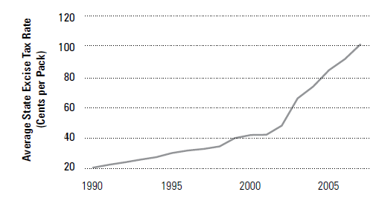
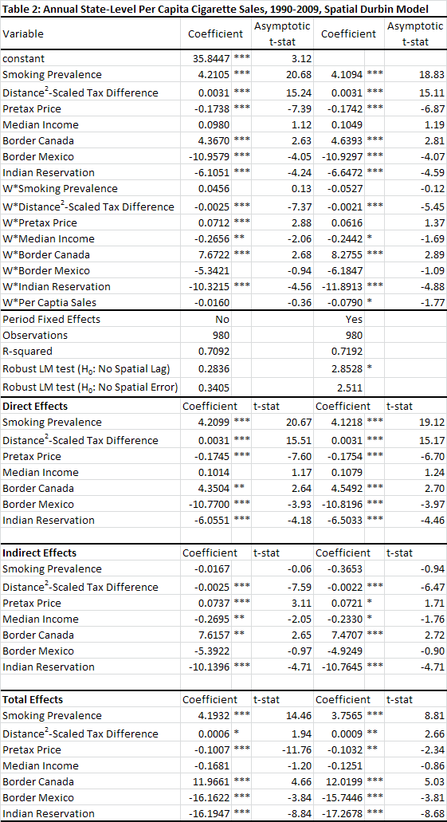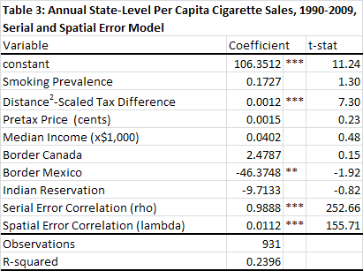

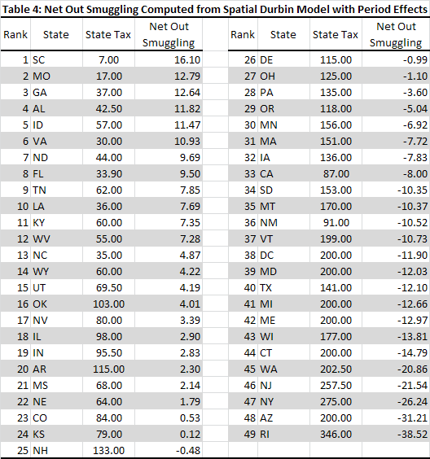

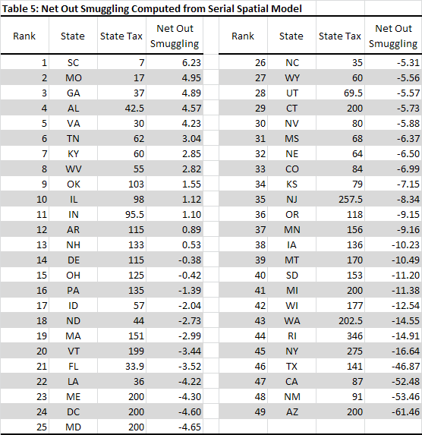

Notes

Galbraith and Kaiserman (1997) estimate that Canadian consumption of contraband cigarettes, which they model as having been purchased in the U.S. and transported back into the country, is predictably responsive to the changes in legal prices.
We also computed this scaled tax differential using distance rather than distance-squared; the results are generally consistent with those presented here and are available from the authors upon request.
This argument is further emphasized in LeSage and Dominguez (2010).

