Journalist and Short Story Author Andrew Lam Announced as the 2015 Lurie Distinguished Visiting Author-In-Residence at SJSU

Contact: Alan Soldofsky, Department of English and Comparative Literature
(408) 924-4432, alan.soldofsky@sjsu.edu
SAN JOSE, CA – Veteran Bay Area journalist, nonfiction writer, and short-story author Andrew Lam has been appointed as San José State University's Connie L. Lurie Distinguished Visiting Author-in-Residence for the 2015 Spring semester. Annually, the Lurie Author-in-Residence is selected by the San José State University Department of English and Comparative Literature in the College of Humanities and the Arts.

Lam will teach the Graduate Nonfiction Workshop (ENGL 242) on Thursday nights, according to SJSU Creative Writing director, Alan Soldofsky. He will also give a public reading from his nonfiction and short stories on Thursday, April 2, at 7:00 PM in the Martin Luther King, Jr. Library 225/229. Admission is free.

Critics consider Andrew Lam to be one of the most influential Vietnamese American writers publishing today. His essays and stories have appeared in dozens of newspapers, magazines, and literary journals including The New York Times, Los Angeles Times, San Francisco Chronicle, Baltimore Sun, Atlanta Journal-Constitution, Mother Jones, The Nation, San Francisco Focus, The Crab Orchard Review, and Zyzzyva. He is a senior editor and writer with New America Media, and is the author of two works of nonfiction: Perfume Dreams: Reflections on the Vietnamese Diaspora and East Eats West: Writing in Two Hemispheres. His latest book, Birds of Paradise Lost, a collection of short stories about Vietnamese-American newcomers struggling to remake their lives in the San Francisco Bay Area, was published in 2013. He frequently writes for the Huffington Post and has been a regular contributor to National Public Radio’s All Things Considered. In 2004 he was the subject for a segment of the PBS documentary film My Journey Home. In the documentary he returns to Vietnam and visits his mother’s ancestral village.

Andrew Lam was born in South Vietnam in 1964, the son of a General in the Army of the Republic of South Vietnam. His family left Vietnam just before Saigon fell in 1975 and settled in the Bay Area, where he grew up. He attended the University of California, Berkeley, and later received his Masters of Fine Arts degree in Creative Writing from San Francisco State University. While still in school he began writing for the Pacific News Service, and then became a founding editor of New American
Media. In 1993 he won “The Outstanding Young Journalist Award,” and in 2004 “Best Commentator Award” from the Society of Professional Journalists. He was named a John S. Knight Fellow at Stanford University in 2001. His other awards include a PEN/Beyond the Margins Award for Perfumed Dreams in 2006. And the PEN Oakland/Josephine Miles Literary Award in 2013 for Birds of Paradise Lost.

He has taught journalism at San Francisco State University and lectured widely at many universities and institutions in the United States and abroad including: Harvard, Yale, Brown, UCLA, USF, UC Berkeley, University of Hawaii, William and Mary, Rice University, Indiana University, Hong Kong University, Loyola University, The World Affairs Council, The Commonwealth Club of California, and many others. He is a member of the Academy of Arts and Sciences.

His stories have been read on National Public Radio’s Selected Shorts recorded at Symphony Space in New York. Several of his stories have been widely anthologized and are taught in many universities and colleges.. He is now at work on a novel.

Dr. Connie L. Lurie is a generous benefactor who has donated to SJSU on numerous occasions, including a major endowment to the Connie L. Lurie School of Education. Dr. Lurie graduated from SJSU in 1964 with a bachelor's degree in both elementary education and psychology after which she taught as an elementary school teacher on the Monterey Peninsula for six years. Lurie is married to Robert Lurie, former owner of the San Francisco Giants.
The Lurie Distinguished Visiting Author-in-Residence in Creative Writing was established in 1999, offering students the opportunity to study with nationally and internationally known authors. Previous Lurie Visiting Authors include some of the most distinguished poets, fiction writers, and nonfiction writers writing in English today. Notable among them are science fiction writer and poet Ursula K. Le Guin; Pulitzer-Prize winning poet Carolyn Kizer; former California Poet Laureate Al Young; international best-selling nonfiction writer and journalist Simon Winchester; acclaimed novelist, essayist, and poet Ishmael Reed; Booker-Prize winning Scottish novelist James Kelman; acclaimed short-story writer Z. Z. Packer; award-winning poet and internationally acclaimed scholar Sandra M. Gilbert; best-selling adventure/outdoor writer Tim Cahill; internationally renown novelist and short-story writer Daniel Alarcón; award-winning memoirist and investigative journalist Julia Scheeres; award-winning Bay Area poet and short story author Kim Addonizio, and award-winning Bay Area novelist Andrew Sean Greer.

* * *
Public Event: An Evening with Andrew Lam, reading selections from his stories and essays, April 2, 7:00 PM, MLK, Jr. Library, Rms. 225/229. Admission free. Co-presented by the SJSU Department of English and Comparative Literature and the Center for Literary Arts.
* * *
MFA Open House: MFA Program in Creative Writing, Faculty Reading and Open House, featuring Andrew Lam and the core MFA Program faculty. January 29, 5:00 – 7:00 PM, Cox Center for Steinbeck Studies, Fifth Floor, MLK, Jr. Library.

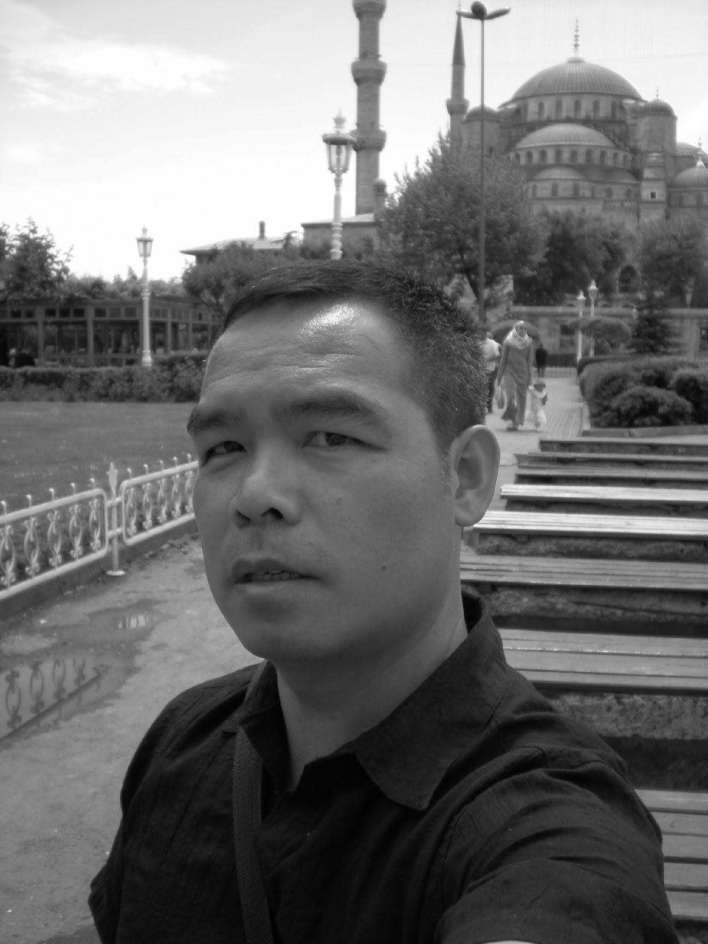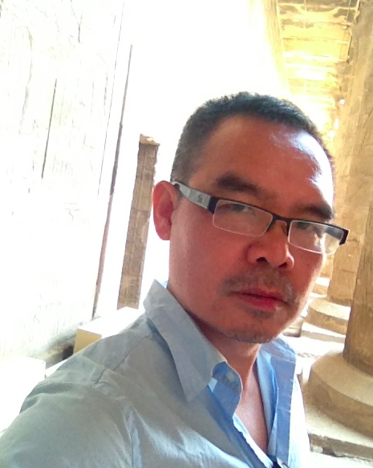
Andrew Lam Andrew Lam

