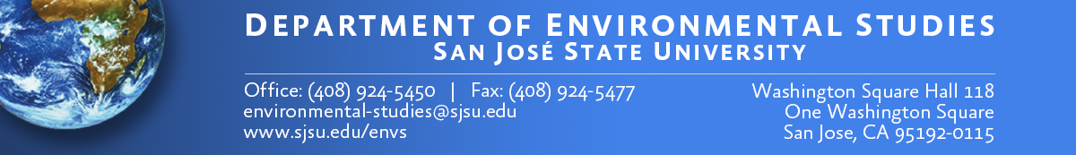

MINORS IN ENVIRONMENTAL STUDIES - ADVISING SHEET

Welcome to the Department  of Environmental Studies!  See the ENVS advisor to help plan your minor. For ENVS students, a minor is required.  For non-ENVS majors, this background in environmental & sustainability issues will be a valuable addition to your major. |  | Name: ______________________________________  SJSU ID: ___________________________________  Email: _____________________________________  ENVS Advisor: _______________________________ | Major: _____________________________  Date: ______________________________  Phone: _____________________________
Important Notes: 1) Declare your minor. 2) At least 12 units of a minor must be completely separate from the major in order for a minor to be awarded.

MINOR for NON-ENVS Students Only |  | MINORS for ENVS and NON-ENVS Students
Environmental Studies (19 units) |  | Sustainable Energy (23 units) | Sustainable Water Resources (21 units) | Environmental Impact Assessment (24 units) | Environmental Restoration (24 units)
ENVS 001 ______  ENVS 124 ______  ENVS 107  or 119 ______  ENVS 185 ______  Two advisor-approved ENVS electives:  ________ ________ |  | PHYS 2A ______  PHYS 2B ______  ENVS 119 ______  ENVS 130 ______  ENVS 132  or 137 ______  ENVS 116 ______  ENVS 133 ______ | ENVS 001 ______  ENVS 128 ______  ENVS 129 ______  ENVS 144 ______  ENVS 154 ______  ENVS 270 ______ | ENVS 010 ______  ENVS 124 ______  ENVS 151 ______  ENVS 185 ______  ENVS 190 ______  ENVS 119, 128, or 129 ______  ENVS 144, 173, 187, or 270 ______ | BIOL 030 ______  ENVS 144 ______  ENVS 154 ______  ENVS 173 ______  ENVS 187 ______  ENVS 191 ______

MINORS for ENVS and NON-ENVS Students
Park Ranger and  Admin. (19-21 units)* | Climate Change  Strategies (18 units)* | Green  Engineering (12 units)* | Environmental Justice  (18 units)
WVC _______  WVC _______  WVC _______  ENVS 187 _______  Choose 2:  ENVS 144, 154, 161, 165, 173, 189 or POLS 114  _______ _______  *Take 3 courses at West Valley College (WVC), Park Management Program | ENVS 119 ______  ENVS 130 ______  ENVS 116  or 133 ______  METR 012 ______  METR 112 ______  METR 113  or METR 115 ______  :*Home Department is Meteorology & Climate Change | ENGR 102  or ME 172 _______  ENGR 103 _______  ENVS 107, 116,  119, 132, 148,  or 167 _______  One elective approved by Green Engineering minor advisor _______  * Home Department is General Engineering | ENVS 001 ______  or MAS/AFAM 025  ENVS 127 ______  ENVS 150  or SOCI 163 ______  AFAM/ENVS 151 _______  Choose one elective:  ENVS 119, 124, 129, 140, 159  Choose one elective  AFAM 130, 133, 142, 145, 159, 160  MAS 120  ________ _______

