Stephanie Galeana
Dr. Warner
Book Talk
Fall 2021

Me and Earl and The Dying Girl
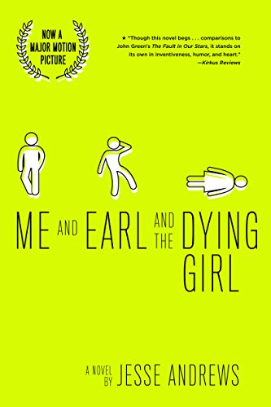
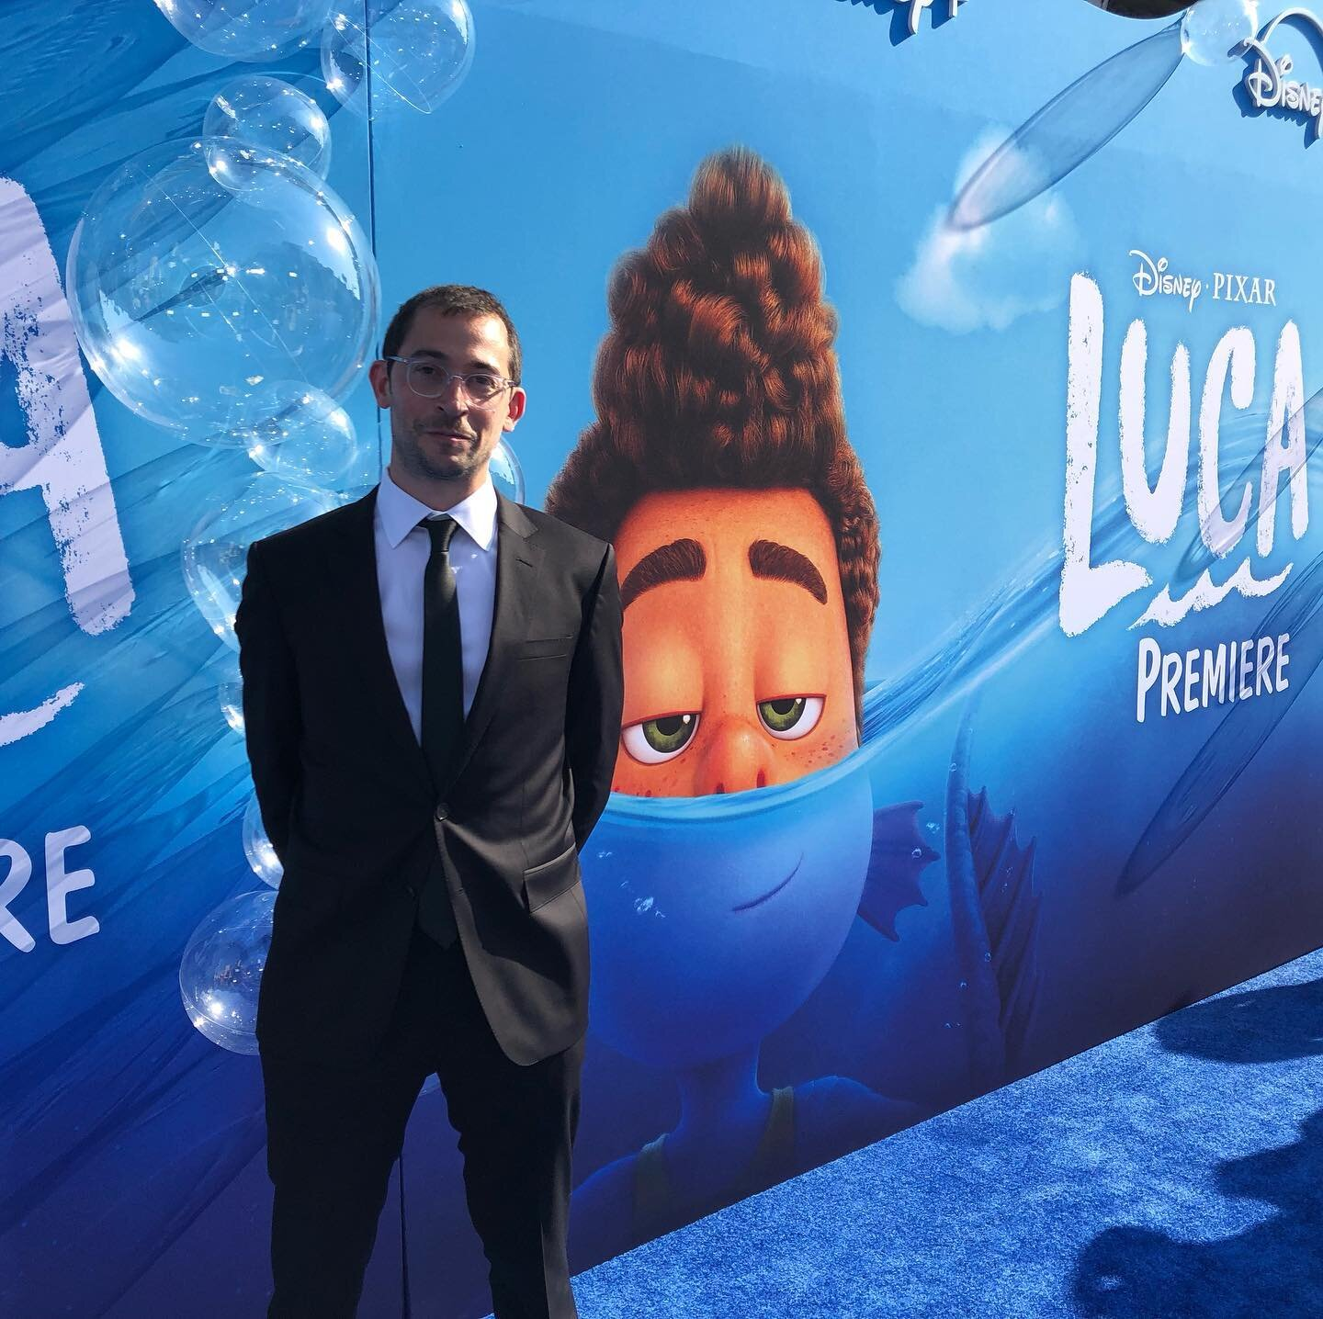
About the Author http://www.jesseandrews.com/ Photo Credit: Author’s website

Jesse Andrews is a New York Times best-selling novelist and award-winning screenwriter. The Pennsylvania native and Harvard alumni’s most recent screenwriting work includes Pixar’s Luca (2021) and MGM’s Every Day (2018). In an interview with Film in Riot, Andrews mentions that his love for writing was influenced by his “mother who was a librarian.” Andrews goes on to say that he feels like “as a recovering ego-addict” and writes as he pleases. Something he was unable to in previous years, due to self-criticism and fear of coming off as “not smart.”

Summary:
Afraid of being bullied and casted as an outsider, Greg Gaines formulates the best plan to protect himself from the horrors of high school: Remain invisible. With this well calculated plan in hand, Greg’s journey with no social ties comes to an end the day he’s forced to befriend Rachel, a newly diagnosed acute myelogenous leukemia patient. Forced to step out of his comfort zone, the unlikely pairing brings out something in Greg that he has spent his whole life trying to avoid: Being himself.
Quotes:
“First things first: Girls like good-looking guys, and I am not very good-looking. In fact, I sort of look like a pudding. I am extremely pale and somewhat overweight. I have kind of a rat face, and my mediocre vision makes me squint a lot. Finally, I have what has been diagnosed as chronic allergic rhinitis…basically just means a constant booger problem.” (21)

This quote is significant because it is the reasoning behind everything Greg does. He’s insecure about himself and this transfer into his social interactions and lack of confidence. He fears being typed as an outcast or forming any real connections in fright of being his true self and getting rejected for that. Greg doesn’t have a sense of self because he has spent his academic years trying to blend in and be one with the crowd. He’s unable to make real connections in his life due to his low self-esteem, lack of trust, and constant worry to not be singled out.

“But if this makes me seem like a good person, it shouldn’t. The reason was that cheering Rachel up was one of the things I had gotten really good at, and when you’re good at something, you want to do it all the time, because it makes you feel good. So if I wanted to hang out with Rachel, it was mostly for selfish reasons.” (180)

This quote is significant because it reveals Greg’s real feelings. He only hangs out with Rachel because he was forced to. Greg’s lack of social interaction and fear of creating bonds has turned him into a selfish, self-absorbed insecure teenager. He lives in constant fear of what people will say about him, so hanging out with Rachel makes him feel good because he treats it as if he’s required to hang out with her for her own health. He refuses to actually care for her, only caring about what he can gain out of the situation.

“Naw, shut the fuck up. You care so fucking much bout what other people think, you gotta be secretive as shit, gotta go round sucking errybody’s dick pretendin like you they friend cuz you care so much bout what they think, lemme fucking tell you: Nobody gives a shit about you. Nobody think shit about you. You ain’t got no friends. You ain’t got nobody who gives a fucking shit about you.” (249)

The fight between Earl and Greg plays a big part in the book because it’s the first time anyone has said anything to Greg that brought him out of his bubble. Greg avoided getting hurt by hiding his true personality in fear of being disliked. He only cared about what he thought was worthy, and was constantly doubting himself and his work. Earl being blunt with him was important because it tied in with how Greg felt about Rachel’s death. Greg simply did not care about anyone but himself. Not even his only friend, and not about Rachel’s health. He just equated everything back to himself.

Teaching:
How might you use this book in a classroom?
Creativity and how you choose to express it is a major theme in this book. Since death and losing someone is another big theme, I would combine these two ideas and create a unit where students are asked to express creatively, in their own terms, a time they dealt with death. In the book, Greg is unable to fully allow himself to feel something. Any emotions are dealt in a humorous matter, ignoring the root of the problem.
Whenever Greg wants to express his feelings, he writes about himself in third person. He has no idea how to deal with these feelings, but he adds them to his script, as a quirky way to invalidate them. Almost like saying, it’s for the script, these aren’t my real feelings. Incorporating a unite where students are asked to create a story, talking about themselves in third person perspective, to reinforce the idea of what scriptwriting is and why it is important to the book.

Text Complexity
Lexile:
820L, Age Range: 14 – 17

Dale-Chall Readability Index:
Raw score 2.3317
Adjusted Score: (3.6365 + 2.3317)
Final Score: 6
Grade level 7-8

The score from Lexile is most accurate. The book should be given to readers who can understand death and grieving. The paragraph I inputted to the Dale-Chall scale was the opening scene from the first chapter. It felt like the easiest read and was filled with the most information/background context. This may have rigged it’s grade level, but both are in the same category for 14 and up audiences.

Adolescents in the Search for Meaning: Tapping the Powerful Resource of Story
Chapter 4: Books about Real-Life Experiences
The book relates to chapter 4 because death is a universal experience that everyone in their life has gone through. Whether that be a literal death, or a symbolic death (Earl giving up film making), the act of losing something is a common theme in everyone’s lives. Although the book specifies on cancer, the way Earl and Greg deal with their emotions is something a lot of kids can relate to. Being an outsider, afraid to be seen as a loser. These feelings are common in high school where bullying runs ramped and kids want to feel like they’re not alone.
Chapter 5: Books about Facing Death and Loss
One of biggest theme in the book is about dealing with loss and the feeling of the unknown. Greg was unsure about his life beyond school, he was dealing with self-hate. Losing Rachel made him realize that there is more to life. Rachel knew she was dying, yet didn’t make her sickness her whole persona. Her strong will to continue being normal is important because it allowed the characters to not show pity in front of her, even though they thought it.

Why should teens read this book?
Teens should read this book because it highlights the feelings so many teenagers feel in high school. They fear rejection, and while Greg decided to isolate himself due to that fear, other kids might fall into peer pressure and make bad decisions. Although Greg didn’t have a sense of who he was, he knew he enjoyed making films. And this wasn’t brought out until the ending when he realized the harm he was causing himself. Another important reason is the relationship between Earl and Greg. They share the fact that they’re not well liked, but Earl is himself and doesn’t hide it. While Greg is the opposite. The fight scene between theme is a great passage. Earl stands up to Greg and Greg is literally hit with reality. This book is a perfect trip from self-hatred and low self-esteem to self-realization.

