Alec McAuley
English 112B
Dr. Warner

Purple Heart
Written By: Patricia McCormick
Website: www.patriciamccormick.com
Biography
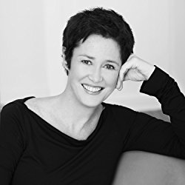
Patricia McCormick is a well-respected journalist and writer of realistic fiction for young adults. She was raised in Central Pennsylvania and grew up in a very strict Catholic home. McCormick’s family did not encourage her career path as a writer, instead, her parents suggested a direction towards nursing or government work. She decided to pursue her passion as a writer and began attending the Columbia University Graduate School of Journalism. She then moved on to Rosemont College and New School located in New York City where she received her MFA. From there she was named a two-time National Book Award finalist, is the author of several critically acclaimed novels that include Never Fall Down, the true story of a boy who survived the Killing Fields of Cambodia and SOLD, a moving piece on the horrors of sexual trafficking. SOLD was eventually released as a feature film on April first of 2016, featuring Gillian Anderson. McCormick’s novels have been noted on the New York Times Notable Books list, iTunes Best Books lists, and many others. Along with her written novels, McCormick’s first picture book, Sergeant Reckless, The Story of the Little Horse Who Became a Hero, was named a rising success by the New York Times. McCormick currently lives in New York City with her cat and her two grown children visit her often.

The Book
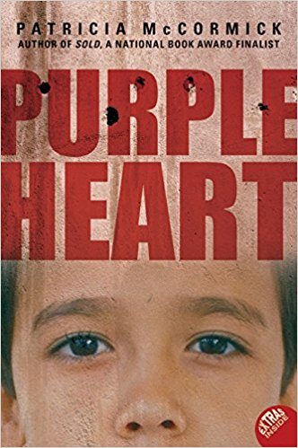
Matt Duffy is a private in the U.S. Army who is serving in the Iraq War. At the beginning of the novel Private Matt Duffy opens his eyes to a doctor testing his nervous system by poking his feet with a sharp object. Duffy begins to have haunting flashbacks from the attack that revolve around an Iraqi boy being shot and an explosion occurring right next to him. The wounded soldier can't seem to shake the feeling that he was somehow involved in the cause of the child's death. Due to his head injury Private Duffy can't quite put all the pieces of his memory back together. Eventually Duffy is sent back into combat with his squadron Justin, Charlene, and Wolf who have become his family during his tour in Iraq. All Duffy wants is to go back to being the fearless soldier he once was. Throughout the novel Duffy finds himself attempting to put the pieces back together of his attack, but finds himself living in a world of fear with a doubt in his mind of not being able to pull the trigger when needed. During war there is no debate between life and death only action, and Duffy soon discovers that the concept of who is guilty is very complicated.
Significant Quotes
1.) “A purple heart. Matt had heard that the biggest, bravest, most badass guys in the army often burst into tears when that medal was pinned on their chests. But Matt didn’t want a medal. He just wanted to know what was wrong with him.” (pg.4)

This quote is significant because is really shows the emotional trauma behind Matts injury. He is so rattled by the incident and how it happened that he will never be the same. The awards means so little to him because of all of the physical and emotional pain he had to endure to receive it.

2.) “This is what war is all about. It wasn't about fighting the enemy. It wasn't about politics or oil or even about terrorists. It was about your buddies; it was about fighting for the guy next to you. And knowing he was fighting for you.” (pg.53)

This is an important quote in the novel because it demonstrates the mindset behind each soldier during war. Each soldier is placed in Iraq with a mission to conquer terrorism and take control of the oil but during the time of battle none of that matters. Politics don’t matter, oil doesn't matter, and race doesn't matter. The only thing a soldier thinks about is surviving through the terror with their fellow squadron each and every day.

3.) “Matt thought about what Charlene had said when Ali stole his sunglasses. That’s what happens when you try to make friends with these people. And he thought about what Wolf had said about being in Iraq. We came over here to help these people and instead we’re killing them. They were both right.” (pg.194)
This quote at the end of the novel sums up Matt’s thoughts about his tour in Iraq quite well. The Iraq war was based on America’s attempt to gain control over oil, terrorism, and to change the religious values of Iraqis as a whole. Duffy and his fellow soldiers did not see the war as a fight for change and control, but a plan to whip out Iraq and its people as a whole. The soldiers did not help the people of Iraq to change and did not help America to gain control, instead, the war caused physical and emotional despair to everyone involved.

Teaching Method
Following reading the novel I would first give my students time in class to write their own one page memoir of what they think it would be like to be a soldier in the Iraq War. Then I would have them discuss their memoir and the topic amongst their peers to further their ideas. Lastly I would have my students write a short research paper on the emotional effects that soldiers can endure during and after their tours. Or, instead, I would have my students write a short paper after interviewing a family member or friend who may be a veteran and talk about the emotional effects the war may have caused upon themselves or their fellow soldiers.

Why Should Teens Read This Novel?
- The novel gives teens a realistic outlook on the horrors of war and that there is not only glory and praise that comes along with the Purple Heart award but emotional/ physical pain and anguish.
- The novel gives the reader an example of the true meaning of friendship and how common tragic experiences can build an unbreakable bond.
- The novel can compare to some experiences kids may endure in ghetto, such as lost loved ones to gun/ gang violence.
- Most teens have a tough time building their own self-esteem, confidence, and character. This novel can humble many students into understanding the goodness in their life and that their experiences could be more tragic, such as Matt Duffy’s

Text Complexity
This novel is meant to read for students around the ages of fifteen to nineteen due to its very realistic look into the Iraq War. Although, I believe this novel can interest many ages higher than nineteen such as myself. The novel is 213 pages and has a typical reading time of about two and half hours. The work is very well written and an easy read, but can be very graphic to elementary school readers. The overall theme is the idea that the effects of war can change a person, Matt Duffy is seen as the hero (protagonist) and the war itself is identified as the evil (antagonist).

Works Cited
Wright, Andrew, et al. Purple Heart by Patricia McCormick: Ordlista. Utbildningsstaden, 2014.

Patricia McCormick | Author of SOLD, Cut & Never Fall Down, www.patriciamccormick.com/about-me.

