Boris Slager
Dr. Mary Warner
112B
Book Talk
Scythe by Neal Shusterman

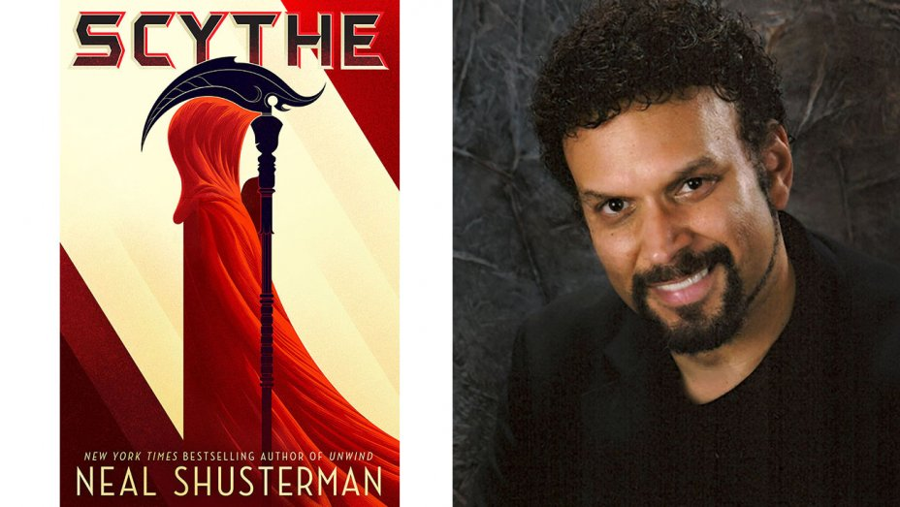

https://www.hollywoodreporter.com/news/universal-adapt-neal-shusterman-ya-891595

Award-winning author Neal Shusterman grew up in Brooklyn, New York, where he began writing at an early age. After spending his junior and senior years of high school at the American School of Mexico City, Neal went on to UC Irvine, where he made his mark on the UCI swim team, and wrote a successful humor column. Within a year of graduating, he had his first book deal, and was hired to write a movie script. In the years since, Neal has made his mark as a successful novelist, screenwriter, and television writer. As a full-time writer, he claims to be his own hardest task-master, always at work creating new stories to tell. His books have received many awards from organizations such as the International Reading Association, and the American Library Association, as well as garnering a myriad of state and local awards across the country. Neal’s talents range from film directing (two short films he directed won him the coveted CINE Golden Eagle Awards) to writing music and stage plays – including book and lyrical contributions to “American Twistory,” which is currently played in several major cities. He has even tried his hand at creating Games, having developed three successful “How to Host a Mystery” game for teens, as well as seven “How to Host a Murder” games. For more information visit: http://www.storyman.com/

Synopsis
Scythe is a fantasy novel. It is set in the future. At this point in time humanity has conquered all things, including death. The Thunderhead, a massive machine with a conscience, runs the world and monitors humanity. It monitors everyone excepts the scythes. Since humanity no longer dies, scythes were created to keep population down. Earth is the only planet humanity can survive on. These scythes are the only ones who can end a life. If you jump off a building, you are taken to a healing center where you will be revived in a few days and as good as new. These scythes kill people in a process known as gleaning. If a scythe gleans someone, then their family gets immunity for one year. Immunity is a treasured thing, so people treat these scythes like royalty; however, a scythe is supposed to only live with the barest of means. After all, no one starves or is poor anymore. The book pits two teenagers, Rowan and Citra, against one another. An older scythe, Scythe Faraday, recruits these two to be his apprentices. Only one of them can get the ring, the ring which allows scythes to carry out gleanings and immunity. The novel has many twists and turns. Moreover, Rowan’s and Citra’s battle is a stand in for the main battle of the book: Old guard scythes versus the new guard. To find out which one comes out on top and which one leaves in disgrace one will have to read the novel.

Quotes

Quote: “Scythe Faraday has chosen a peaceful bloodletting for the man (nameless victim), but that was not what happened. When Citra and the scythe entered the room, he ambushed them” (111). (Note: read until the end of the quote underneath). She wanted to tell him how much she admired him for what he had done. Choosing compassion over obligation. There was a lesson to be learned in every gleaning, and today’s was one she would not soon forget. The sanctity of the law…and the wisdom to know when it must be broken” (114).

Context: Scythes are supposed to kill the family of those individuals who resist gleaning; however, Faraday showed his compassion by letting the family go free. This is an important moment because it reveals Faraday’s humanity to the audience. It also explains that not all laws should be followed all the time; sometimes laws need to be broken for the betterment of humanity. Last, the quote illustrates what kind of scythe the old guard adheres to; scythe Faraday represents the old scythe tradition: To take no pleasure in gleaning; to glean only when it needs to be done and to glean with the utmost compassion.

Quote: “Rowan closed his eyes, wishing he could close his mind as well and hide from his own thoughts. In eight months I will be killed by Citra, he thought. Or I will kill her. And calling it ‘gleaning’ didn’t change the fact of what it was…Scythes were supposed to be above the petty, just as they were above the law. Faraday certainly was. If she (Citra) became a scythe, she would follow his lead…Perhaps there was some sort of twisted wisdom in the decision to have one of them gleaned by the other. Whoever wins will begin their life as a scythe in abject sorrow, never to forget the cost of that ring” (157-8).

Context: This quote sets up the main tension in the book. Before this conclave, where the scythes gather once every four months to discuss issues including apprentices, the one who did not get the ring thought that s/he would go home. Now there is a new twist to their plight. Moreover, Shusterman adds lots of twists and turns in this novel, which keeps me hungry for more. Also, the “twisted wisdom” of this action reveals that there are “twisted” scythes. Citra points out that “scythes are supposed to be above the petty”; however, the actions of the scythes illustrates that when humans are involved “pettiness” will almost always be involved too. In order to pay for “the cost of that ring” one must always keep “sorrow” in his/her heart, which demonstrates that becoming a scythe requires the utmost strength and fortitude.

Quote: “And then Rowan finally understood. On the lawn people weren’t milling around, they were standing, evenly spaced. They were waiting for him. There were to be no more dummies. Now his practice would be the real thing. Killcraft would now truly be killcraft. ‘No,’ Rowan said, shaking his head. ‘I can’t do this!’ ‘Oh, but you will,” Scythe Goddard said calmly… Rowan wanted to protest—insist that he couldn’t do it—but as much as his heart told him he couldn’t, his mind knew the truth. Yes, he could. He had been training for precisely this. All he had to do was dial his conscience down to zero. He knew he was capable of that, and it terrified him” (247-8).

Context: Rowan has been taken on by Scythe Goddard. Scythe Goddard represents the new scythe. Goddard trains Rowan in the art of killing, not killing with compassion. These dueling ideas are the rift between the new and the old. Rowan must put “his conscience” aside in order to inflict these deaths, which shows that the new scythe is without “conscience” or morals. Moreover, the fact that Rowan “was capable of that” further illustrates that the new scythe is and must be “capable” of killing without a “heart [or] conscience,” which turns the scythes into ruthless killing machines. Since “it terrified” Rowan to numb his senses, this shows that he has not yet fully succumb to the teachings of Goddard. Last, Goddard’s name holds some significance because he thinks himself a God among mortals. This quote helps reveal what kind of God he is and what his followers worship.

Quote: “The longer we live, the quicker the days seem to pass. How troublesome that is when we live forever. We become settled in in the inconsequential drudgery of our lives, until suddenly we look at ourselves in the mirror and see a face we barely recognize begging us to turn a corner and be young again. But are we truly young when we turn the corner?... Our bodies may be spry and limber, but toward what end? No end. Never an end. I do believe mortals strived more heartily toward their goals, because they knew that time was of the essence…There are times I feel I am fighting a losing battle against an old-fashioned apocalypse of the living dead. From the gleaning journal of H.S. Curie” (373).

Context: I included the quote because Shusterman ends or begins each chapter with a journal entry from one of the scythes. Scythes must keep a journal of their thoughts. These journals help understand what it is like to take a life; how it is worse that humanity is in charge of death instead of nature. The journals also provide insight into each character. Scythe Curie is one of the most respected scythes in the novel. This quote allows for some discussion topics: Do we think it is “troublesome to live forever”? Do we agree that youth is more than just age; does it require a bit of the unknown and naiveté? The end of the quote reveals something else: Since humanity cannot die without scythes, does this just make immortality a version of zombification?

How I Would Teach the Novel

First, I would use the discussion questions I mentioned earlier. This would lead into some interesting topics and ideas. I would also ask if having humanity in charge of death is worse than nature? Should anyone ever be given the power to kill without laws?
Next, I would have students write about what being a scythe would be like. What kind of scythe, using quotes from the text, would they be? Why? What is the hardest thing about being a scythe?
I would also have students keep a journal of their scythehood, in which they would have to discuss gleanings and any other issues related to the novel. Furthermore, I would have the students write journals from the perspectives of each character. This might help students get into the mindset of each character and his/her role in the novel. I would also have them argue who or what is the monster or antihero in this book. My students would then write a paper explaining who in our society would be the best and worst scythe and why. Students would have to use quotes from the novel as well as articles found online in order to accomplish this task. Students also have to choose a few quotes to illustrate a character and that character’s role in the novel. I would assign different characters to different students. We would also discuss how realistic the novel is and how fantastical it is. We would then compare the novel to other texts of the same type. For instance, what would students find more plausible: A. we run out of food and go to war. The people in power win the war. Those in power create games where anyone under the age of 25 goes to fight each other. They must fight to the death with only one victor. Or B. Humanity conquers death and must assign grim reapers in order to keep the population down. Food and money are not an issue for anyone.

Why Should Teens Read This Novel

- It examines a post apocalyptical world in a new way.
- It pits two teens against one another. These teens reveal the tension of the novel
- It shows that the biggest danger to humanity is humanity itself
- It might allow students to cherish their lives more; our lives are better because of natural death
- It is a fantasy text that tackles an issue present in science fiction texts: a machine running humans; however, unlike sci-fi texts this machine does not harm humans.
- It has many twists and turns, which keep the reader guessing

Text Complexity
This novel is intended for teens from the ages of 14-19; however, I argue it applies to a larger audience as well. Shusterman’s novel does not have complex writings or paragraphs; however, it covers a complex subject: Death. The novel also reveals how power can corrupt even in a society that is supposedly perfect. It features themes such as bullying (When Goddard forces Rowan to commit certain acts), peer pressure (Rowan must do what the scythes he is training with do), loss (the death of loved ones), how those in power are treated like gods among men (scythes), isolation (scythes are cut off from the rest of the world), and how in a world without natural death, death still rules humanity.

Works Cited: Shusterman, Neal. Scythe. Simon & Schuster: New York, London, Toronto, Sydney, and New Delhi. 2016. Print.

