Natalie Logsdon
Warner
Engl 112B
13 March 2018
Book Talk
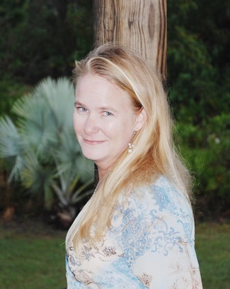
About the author:
As a preteen, Wendy Mills felt the pressure to fit in and gave up on using her imagination to create exceptional stories. She resorted to writing stories in secret on a typewriter in her attic. After sharing her work with her friends, she realized that she found her life calling. Wendy Mills is now an award winning author and currently residing on a tropical island off the west coast of Florida. She spends her times writing novels for both teens and adults. http://www.wendymillsbooks.com/.

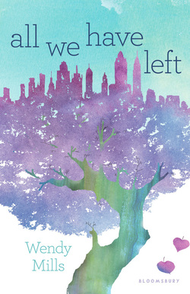
Text Complexity:
All We Have Left falls under a 880L and is for people between the ages of ten and seventeen. I believe that a ten year old would be able to read this book, but would not be able to understand the depth or would struggle with the change in time periods. Individuals fourteen and beyond would be able to get the most out of this book.

Summary:
All We Have Left highlights to stories of two teenage girls during two time periods whose lives are affected by one event. These stories of self discovery, and the power of love and hate, interweave one another throughout the novel.
Alia is a Muslim teenager residing in New York and wants more than anything to attend the NYU art program that she got into. She is a talented artist with a dream to design comic books.
However, due to being caught holding a joint that wasn’t hers, her mother outright refuses to let her go to the program. In hopes to persuade her father, she visits him at work before heading to school. Unfortunately her father wasn’t in his office, so she decides to head to school disappointed and defeated. Alia runs into Travis, a boy a couple years older than her in the elevator that she remembers seeing in the lobby on her way in. All of a sudden everything goes dark and the elevator drops. It is September 1, 2001 and they are in the North Tower.

Fifteen years after the attack on the World Trade Center, we hear the story of Jesse. She is a teenage girl who is filled with anger and hatred that she has internalized her whole life. Jesse’s father is an alcoholic who hates Muslims because they killed his son, Travis, and her mother fills her schedule to ensure she is home as little as possible. Jesse neglects her friends and falls into the wrong crowd at school. She is caught tagging a derogatory statement on the side of the Islam Peace Center. As a result, she has to spend many hours of community service at the center where she is surrounded by Muslims, the people who killed her brother. Her heart begins to soften and she starts to talk about Travis for the first time to anyone other than her close friends. Since her parents refuse to discuss her brother, she goes on a search to find out what happened and why he was in the North Tower that day when he was supposed to be with his family. Jesse talks to a survivor of the attacks to discover the truth behind her brother’s death. She comes across an old recording of Travis and a girl named Alia. Jesse becomes determined to find Alia, and in turn find the truth.

Quotes:
“There were no other mom-and-dad stories, but in my mind I’ve filled in the rest. They were married, moved from the city to the Gunks, and had two boys, first Travis, then three years later, Hank. Everything was fairy dust and perfection. Then, almost seventeen years after Travis was born, an accident came along and they named it Jesse. Two years later Travis died in the Twin Towers and Dad decided to hate everyone and Mom started running so fast she left the rest of us behind. Hank just fell off the freaking page completely, and sometimes I wish I could follow him.” (34-35).
I chose this quote because it exemplifies some of the emotions that Jesse is internalizing.
Her family is on the fringes, her friends are disappointed with her, and she is filled with so
much unexplainable anger. She feels as though she is a burden to her parents, or worse,
invisible completely.
“‘It was Muslims who planted the bomb last time, you know,’ he says suddenly, and it’s like a chasm opens up between us.
‘So?’ I say right back at him. ‘It was white Christians who used to burn crosses on people’s lawns and owned slaves. Does that make all of you bad?’
‘I’m just saying, my religion doesn’t tell me to go out and kill people just because they don’t believe what I believe,’ he says.
‘Neither does mine,’ I say tightly. ‘In fact, mine says, ‘To you your religion, and to me mine.’ Just because people do bad things in the name of religion doesn’t make the religion bad. People do crappy things, people do awesome things. That’s just people.’” (155-156).
The entire novel highlights hatred that stems from a misunderstanding and
overgeneralization of people. Since it was Muslims who attacked the World Trade Center,
all Muslims are terrorists. Instead of responding to Travis’ comment with
rage, Alia decides to inform him that not every Muslim is a terrorist, just like
not every person is necessarily a good or bad person. Overgeneralization leads to
negative thinking that eventually becomes one’s beliefs.
“Nick takes a step towards me, and then he has hold of my arm. ‘You’re just like us,’ he says in a hard voice, right in my face. ‘Nobody cares about you; you’re nothing, just like us. If you want to be someone, you have to make them notice you. Look at you. You’ve become like the rest of them, a stupid sheep that just wants to follow the herd.’” (217-218).
For a majority of the novel, this is exactly how Jesse felt about herself. Nick verbalized her
deep inner thoughts regarding not being good enough or having a purpose in life. I chose
this quote because this was when a light ignited inside Jesse and she found her voice and
realized that she has value.
How to Teach:
All We Have Left is a historical fiction book about 9/11 that presents different perspectives and the lasting impact it had on both survivors and families of lost ones. This would be a good book to teach to high schoolers, specifically freshmen because Mills addresses self value and purpose, which freshmen encounter with the transition into high school. Not only is this book a good source to discuss the tragedy of 9/11, but also to discuss religion and acceptance. Wendy Mills incorporates different religions and gives insight to their beliefs and customs. She also presents the power of how our thoughts about someone or something becomes our beliefs.

