Chris Crutcher Book Talk Deadline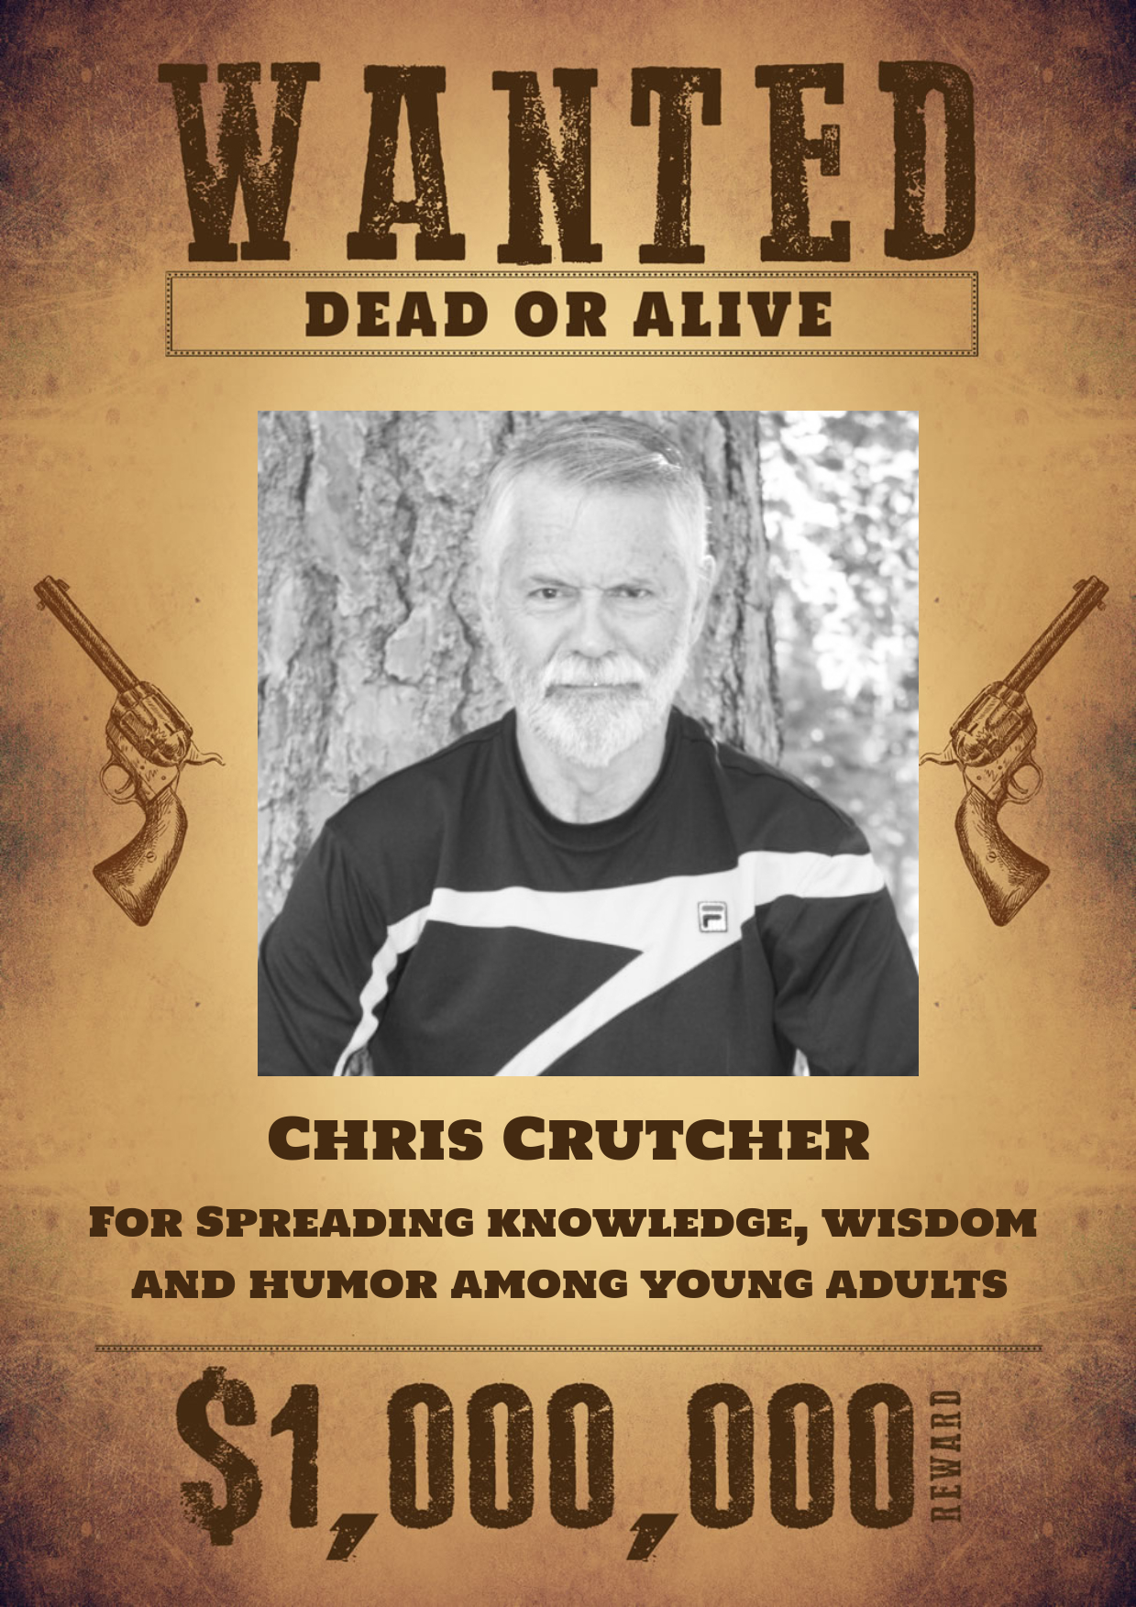
Author

In Cascade, Idaho born and raised, on the sports field where he spent most of his days.
He was exposed to literary writing through the prestigious and infamous Playboy magazine, which featured prominent writers like Ian Fleming, Ray Bradbury and Margaret Atwood.
He was able to morally justify reading Playboy as a teenager by using the same excuse that his father had used on his mother, that the magazine contained some of the best American literature at the time.
At the age of 24, he joined Lakeside Alternative School in Oakland (now defunct or name changed) as a teacher of high school dropouts, but within six years became the director of the school.
Ten years after beginning to teach, Crutcher moved to Spokane, WA as a child and family therapist.
Both as a school teacher/administrator and a therapist, he dealt with children in many different scenarios, including sexual abuse and terminal illness.
Summary

In Trout, Idaho Ben Wolf is an 18 year old track star, who is incredibly well read with an intelligent yet occasionally sexually crude sense of humor. During his routine physical the summer before his senior year, his blood tests indicate that he has an aggressive form of leukemia. Given his desire to leave an impact on the world and the tenuous nature of his household, he decides to avoid immobilizing hospitalization and live his given year to the most of his ability. Inspired by his short time, Ben joins out for the football team, lands the gorgeous mixed race volleyball star with a pregnant secret and discovered that the town drunk was a smart, once righteous man who spent all his free time numbing his demons. His coming death sparks intense conversations with his real life therapist and a strange avatar seen only in his dreams known as Hey-Soos. They cover the topics of death, worth, God and most importantly, love.

Quotes

“Love, in the universal sense, is unconditional acceptance. In the individual sense, the one-on-one sense, try this: we can say we love each other if my life is better because you’re in it and your life is better because I’m in it. The intensity of the love is weighed by how much better.”

Upon the knowledge that he was to die, Ben Wolf began to receive visits in his dreams by a man resembling the Christian Messiah Jesus Christ. Despite Ben’s suspicions, the man admits that he is neither the actual Christ nor is he Ben himself but rather is called Heysoos. Their conversations revolve around Ben’s questions, with Heysoos only responding to questions about more abstract, grander things such as love, while only giving cryptic implications for direct questions. This conversation takes place when Ben comes over to spend the night at Dallas Suzuki's place after homecoming. Ben and Dallas share a non sexual intimate moment and Ben is contemplating the nature of love while he is asleep next to her with Heysoos. These conversations provide the hidden insight that follows unprecedented experiences which people have a hard time initially expressing in words.

“God isn’t a guy. God isn’t a girl. God is a force. You have all these people trying to figure out whether to believe in God or the big bang. Well, God is the big bang. God is the ultimate scientist. If God relegated his thinking to human cognition, it would never get anything done. I mean, look how slow you think, and you’re probably the smartest kid in your class. Just know that everything started as one, everything still is one, and it will end up as one.”

In another conversation with Heysoos, the two are going over Ben's decision not to tell people yet about his terminal illness. Ben's dramatic and impactful decision brings up a conversation about free will and determinism. Ben is wondering whether his fate is has already been determined as he now begins to face the consequences of his actions. However Heysoos reminds Ben of the mysterious yet total nature of God, ultimately reminding him that God is beyond full comprehension and that even for God, the universe isn't predestined in the human definition of the sense.

“Something you learn on the last day of your life is as important as something you learn on the first day of grade school, because you’re not dying, you’re changing. And goddamn it, the truth is a powerful weapon to take into that new frontier.”

In his last act in the book, Dallas Suzuki reconciles with Ben as he is fading away. When she is hesitant due to her personal guilt from abandoning Ben temporarily, Ben reminds her that it was his fault. His late admission came as a betrayal to Dallas as she had become emotionally committed to a long term future with Ben. After rebuking her attempted apology with his own confession, he internally realizes the above quote. Even on his deathbed, Ben still understands and appreciates the lessons from this life, realizing that death is but the next shape of the stardust that is Ben, of the stardust that is the Big Bang and from the beginning, the stardust that is all things.

The Craft

Chapter Five of Adolescents in the search for meaning: Tapping the powerful resource of story could not be a more appropriate fit. From the title to the plight of secondary characters, death is everywhere in this book. While the threat of death looms over Ben Wolf, his interactions with the town drunk, Rudy reveals that they are both on a accelerated destiny with death. Yet the most sudden and jarring death came from Sooner Cowans, the star running back whose abuse from his father allowed Ben to have a starting role on the football team. The interconnected nature of relationships in the small town of Trout reveals a wide variety of loss as well. Ben’s father deals with his wife, who regularly goes through crazy bipolar episodes. Ben attempts to talk and deal with his mother’s mood swings, but it's clear that Wolf family had lost someone very dear to them. Dallas Suzuki had her innocence taken away at a very young age and her initial sexual encounter with Ben was also a way for her to regain her self-esteem.

Chris Crutcher’s Idaho background and his fondness for high school athletics nearly jumps out of the book, serving as its dramatical focal point of the first half. The fullness of the book comes from the meticulously arranged moments of both victory and loss, such as the climactic homecoming game or the sudden deaths of two people Ben knew. Yet these moments are not the only sources of conflict and growth, as the entirety of the story is narrated by the clever, hilarious and dark Ben. The silly, yet intelligent nature of the dialogue brings a sense of energy and urgency, while conveying extremely deep and abstract topics through thoughtful exchange. Crutcher’s writing revolve around some of the themes seen in this book, such as the Idaho setting or the process of being a competing athlete, both of which Crutcher has written multiple books about, including his very first book.

Text Complexity

This book may be disturbing for some teens as there are a highly unusual amount of death, especially in proportion to the small town it is set in. However, no teen will walk away from this book without at least contemplating on the nature of death, love and God. This book is a great introduction to deeper abstract questions, questions that teenagers feel, but have a difficult time expressing articulately. Having a clever protagonist, whose life circumstances force him to find answers, whether it be a dream avatar guiding him or the books concerning the racist past of America allows us to digest and consume much heavier materials that the average young adult is interested in. Compared to other texts concerning teens dealing with death that I’ve read, the dialogue is sharp and rapid, with very little wasted and surprisingly this book covers nearly a year with a terminal person allowing a broad variety of sophisticated topics to be organically discussed as they happen as a result of Ben’s new proactive actions. I would liken this book to a literary shotgun filled not with buckshot, but rather philosophy and meaning that when fired at a group of children, the lesson would be widespread and deeply impactful.

Lexile Score: 820L'
Atos Book Level: 5.1
Interest Level: upper grades

Would highly recommend to seniors, who can relate to the end of high school presented in the book, but also learn lessons from a senior year spent with the utmost urgency and meaning.

